Supplemental Materials
Table S1a. Tuned hyperparameters and probability binary threshold cutoff values for suitability specific to the species and model algorithm. LR: Learning rate (controls the amount each tree contributes to overall model), TC: Tree complexity (sets level of interactions between predictors), mtry: number of predictors tried at each tree node, ntrees: Number of trees in the forest, β: Regularization (model smoothing to prevent overfitting), Penalty: MARS penalty (cost per degree of freedom charged in fitting the model). BRT = boosted regression trees, GLM = generalized linear models, MARS = multivariate adaptive regression splines, MaxEnt = maximum entropy, RF = random forests.
Species | Model | Tuned Parameters | Probability Binary Threshold cutoff values for suitability
Autumn Olive | BRT | LR: 0.01; TC: 2 | 0.54
 | GLM |  | 0.5
 | MARS | Penalty: 2.5 | 0.52
 | MaxEnt | β: 2.0 | 0.19
 | RF | mtry: 5; ntrees: 500 | 0.57
Bush Honeysuckles | BRT | LR: 0.01; TC: 2 | 0.53
 | GLM |  | 0.46
 | MARS | Penalty: 2.5 | 0.47
 | MaxEnt |  | 0.45
 | RF | mtry: 1; ntrees: 500 | 0.51
Canada Thistle | BRT | LR: 0.005; TC: 2 | 0.51
 | GLM |  | 0.53
 | MARS |  | 0.40
 | MaxEnt |  | 0.33
 | RF |  | 0.46
Common Buckthorn | BRT | LR: 2; TC: 0.005 | 0.56
 | GLM |  | 0.40
 | MARS |  | 0.52
 | MaxEnt |  | 0.38
 | RF | mtry: 5; ntrees: 500 | 0.51
Crown Vetch | BRT |  | 0.51
 | GLM |  | 0.42
 | MARS |  | 0.50
 | MaxEnt | β: 2.0 | 0.30
 | RF |  | 0.49
Garlic Mustard | BRT | LR: 0.005; TC: 2 | 0.50
 | GLM |  | 0.53
 | MARS |  | 0.61
 | MaxEnt |  | 0.29
 | RF | mtry: 3; ntrees: 1000 | 0.49
Hedge-parsleys | BRT | LR: 0.01; TC: 2 | 0.50
 | GLM |  | 0.47
 | MARS |  | 0.42
 | MaxEnt |  | 0.24
 | RF | mtry: 5; ntrees: 500 | 0.51
Japanese Barberry | BRT | LR: 0.01; TC: 2 | 0.54
 | GLM |  | 0.47
 | MARS |  | 0.61
 | MaxEnt | β: 2.0 | 0.24
 | RF | mtry: 5; ntrees: 500 | 0.44

Table S1b. Tuned hyperparameters and probability binary threshold cutoff values for suitability specific to the species and model algorithm. LR: Learning rate (controls the amount each tree contributes to overall model), TC: Tree complexity (sets level of interactions between predictors), mtry: number of predictors tried at each tree node, ntrees: Number of trees in the forest, β: Regularization (model smoothing to prevent overfitting), Penalty: MARS penalty (cost per degree of freedom charged in fitting the model). BRT = boosted regression trees, GLM = generalized linear models, MARS = multivariate adaptive regression splines, MaxEnt = maximum entropy, RF = random forests.
Species | Model | Tuned Parameters | Probability Binary Threshold cutoff values for suitability
Knotweeds | BRT | LR: 0.01; TC: 2 | 0.57
 | GLM |  | 0.55
 | MARS |  | 0.53
 | MaxEnt |  | 0.34
 | RF | mtry: 5; ntrees: 500 | 0.51
Leafy Spurge | BRT | LR: 0.005; TC: 2 | 0.52
 | GLM |  | 0.53
 | MARS |  | 0.54
 | MaxEnt |  | 0.19
 | RF | mtry: 5; ntrees: 500 | 0.46
Purple Loosestrife | BRT |  | 0.52
 | GLM |  | 0.53
 | MARS | Penalty: 2.5 | 0.51
 | MaxEnt |  | 0.30
 | RF | mtry: 5; ntrees: 500 | 0.51
Spotted Knapweed | BRT | LR: 0.01; TC: 2 | 0.45
 | GLM |  | 0.53
 | MARS |  | 0.45
 | MaxEnt |  | 0.39
 | RF |  | 0.51
Tansy | BRT | LR: 0.01; TC: 2 | 0.50
 | GLM |  | 0.53
 | MARS |  | 0.41
 | MaxEnt |  | 0.35
 | RF | mtry: 5; ntrees: 500 | 0.55
Teasels | BRT | LR: 0.005; TC: 5 | 0.59
 | GLM |  | 0.47
 | MARS |  | 0.43
 | MaxEnt |  | 0.28
 | RF |  | 0.56
Wild Parsnip | BRT | LR: 0.01; TC: 2 | 0.52
 | GLM |  | 0.48
 | MARS |  | 0.48
 | MaxEnt |  | 0.36
 | RF | mtry: 3; ntrees: 1000 | 0.48

Supplemental Table S2a. Model evaluation metrics for training and cross-validation testing datasets for each of the 15 modeled species. Percent correctly classified, AUC, specificity, sensitivity, and the true skills statistic (TSS).
Parameter | Model Name | Autumn Olive | Bush Honeysuckle Species | Canada Thistle | Common Buckthorn | Common Tansy | Crown Vetch | Garlic Mustard
%CC | BRT_{CV} | 80.0 ± 3.6 | 74.1 ± 2.2 | 75.5 ± 3.1 | 79.8 ± 1.0 | 80.9 ± 1.2 | 82.4 ± 3.0 | 89.52 ± 0.8
AUC | BRT_{CV} | 0.88 ± 0.02 | 0.83 ± 0.02 | 0.86 ± 0.02 | 0.86 ± 0.01 | 0.89 ± 0.01 | 0.89 ± 0.03 | 0.94 ± 0.01
Sensitivity | BRT_{CV} | 0.87 ± 0.12 | 0.77 ± 0.04 | 0.83 ± 0.04 | 0.74 ± 0.04 | 0.84 ± 0.02 | 0.83 ± 0.09 | 0.86 ± 0.01
Specificity | BRT_{CV} | 0.80 ± 0.04 | 0.74 ± 0.03 | 0.75 ± 0.03 | 0.80 ± 0.01 | 0.80 ± 0.01 | 0.82 ± 0.03 | 0.90 ± 0.01
True Skills Stat | BRT_{CV} | 0.59 ± 0.10 | 0.50 ± 0.04 | 0.58 ± 0.04 | 0.54 ± 0.04 | 0.64 ± 0.03 | 0.65 ± 0.07 | 0.76 ± 0.01
%CC | BRT_{Train} | 77.9 | 76.7 | 78.7 | 80.8 | 82.8 | 83.1 | 89.6
AUC | BRT_{Train} | 0.92 | 0.86 | 0.89 | 0.89 | 0.91 | 0.94 | 0.96
Sensitivity | BRT_{Train} | 0.94 | 0.79 | 0.87 | 0.81 | 0.89 | 0.94 | 0.89
Specificity | BRT_{Train} | 0.78 | 0.76 | 0.78 | 0.81 | 0.81 | 0.83 | 0.90
True Skills Stat | BRT_{Train} | 0.72 | 0.56 | 0.65 | 0.62 | 0.70 | 0.77 | 0.79
%CC | GLM_{CV} | 74.3 ± 2.67 | 54.6 ± 3.37 | 73.9 ± 2.46 | 61.5 ± 4.92 | 76.9 ± 1.55 | 76.3 ± 2.02 | 78.7 ± 1.61
AUC | GLM_{CV} | 0.85 ± 0.03 | 0.67 ± 0.02 | 0.81 ± 0.02 | 0.76 ± 0.02 | 0.83 ± 0.01 | 0.85 ± 0.04 | 0.87 ± 0.02
Sensitivity | GLM_{CV} | 0.81 ± 0.11 | 0.74 ± 0.05 | 0.76 ± 0.05 | 0.78 ± 0.08 | 0.72 ± 0.03 | 0.78 ± 0.10 | 0.81 ± 0.03
Specificity | GLM_{CV} | 0.74 ± 0.03 | 0.52 ± 0.04 | 0.74 ± 0.03 | 0.60 ± 0.06 | 0.78 ± 0.02 | 0.76 ± 0.02 | 0.78 ± 0.02
True Skills Stat | GLM_{CV} | 0.56 ± 0.10 | 0.25± 0.04 | 0.49 ± 0.05 | 0.39 ± 0.05 | 0.50 ± 0.02 | 0.54 ± 0.09 | 0.59 ± 0.02
%CC | GLM_{Train} | 74.2 | 52.7 | 74.4 | 60.6 | 77.8 | 74.0 | 78.9
AUC | GLM_{Train} | 0.85 | 0.68 | 0.82 | 0.77 | 0.83 | 0.87 | 0.88
Sensitivity | GLM_{Train} | 0.85 | 0.78 | 0.77 | 0.83 | 0.71 | 0.85 | 0.80
Specificity | GLM_{Train} | 0.74 | 0.49 | 0.74 | 0.59 | 0.79 | 0.74 | 0.79
True Skills Stat | GLM_{Train} | 0.59 | 0.27 | 0.51 | 0.42 | 0.51 | 0.59 | 0.59
%CC | MARS_{CV} | 73.3 ± 4.24 | 61.4 ± 3.33 | 72.9 ± 2.93 | 73.2 ± 3.24 | 75.6 ± 1.54 | 75.0 ± 4.21 | 87.5 ± 1.69
AUC | MARS_{CV} | 0.83 ± 0.04 | 0.73 ± 0.02 | 0.82 ± 0.02 | 0.80 ± 0.02 | 0.86 ± 0.01 | 0.83 ± 0.05 | 0.91 ± 0.01
Sensitivity | MARS_{CV} | 0.82 ± 0.09 | 0.75 ± 0.06 | 0.79 ± 0.07 | 0.73 ± 0.04 | 0.83 ± 0.03 | 0.78 ± 0.11 | 0.81 ± 0.03
Specificity | MARS_{CV} | 0.73 ± 0.04 | 0.59 ± 0.05 | 0.72 ± 0.04 | 0.73 ± 0.04 | 0.74 ± 0.02 | 0.75 ± 0.04 | 0.89 ± 0.02
True Skills Stat | MARS_{CV} | 0.55 ± 0.08 | 0.34 ± 0.03 | 0.51 ± 0.05 | 0.47 ± 0.03 | 0.57 ± 0.02 | 0.53 ± 0.10 | 0.70 ± 0.02
%CC | MARS_{Train} | 75.6 | 63.3 | 68.1 | 76.4 | 73.5 | 76.2 | 89.6
AUC | MARS_{Train} | 0.85 | 0.74 | 0.83 | 0.82 | 0.87 | 0.88 | 0.92
Sensitivity | MARS_{Train} | 0.80 | 0.77 | 0.87 | 0.74 | 0.88 | 0.84 | 0.80
Specificity | MARS_{Train} | 0.75 | 0.61 | 0.66 | 0.77 | 0.70 | 0.76 | 0.91
True Skills Stat | MARS_{Train} | 0.56 | 0.38 | 0.53 | 0.51 | 0.58 | 0.60 | 0.71

Supplemental Table S2b. Model evaluation metrics for training and cross-validation testing datasets for each of the 15 modeled species. Percent correctly classified, AUC, specificity, sensitivity, and the true skills statistic (TSS).
Parameter | Model Name | Autumn Olive | Bush Honeysuckle Species | Canada Thistle | Common Buckthorn | Common Tansy | Crown Vetch | Garlic Mustard
%CC | MAXENT_{CV} | 78.2 ± 4.15 | 74.4 ± 0.87 | 79.0 ± 1.95 | 77.1 ± 3.26 | 79.1 ± 1.58 | 84.7 ± 2.15 | 88.7 ± 1.45
AUC | MAXENT_{CV} | 0.86 ±0.03 | 0.81 ± 0.02 | 0.86 ± 0.02 | 0.85 ± 0.01 | 0.88 ± 0.01 | 0.87 ± 0.05 | 0.94 ± 0.01
Sensitivity | MAXENT_{CV} | 0.75 ±0.12 | 0.71 ± 0.05 | 0.79 ± 0.05 | 0.76 ± 0.07 | 0.84 ± 0.02 | 0.73 ± 0.14 | 0.87 ± 0.02
Specificity | MAXENT_{CV} | 0.78 ± 0.04 | 0.75 ± 0.01 | 0.79 ± 0.02 | 0.77 ± 0.04 | 0.78 ± 0.02 | 0.85 ± 0.02 | 0.89 ± 0.01
True Skills Stat | MAXENT_{CV} | 0.54 ± 0.10 | 0.46 ± 0.05 | 0.58 ± 0.04 | 0.53 ± 0.03 | 0.62 ± 0.03 | 0.58 ± 0.12 | 0.76 ± 0.02
%CC | MAXENT_{Train} | 75.4 | 74.7 | 77.4 | 76.7 | 79.9 | 84.8 | 90.0
AUC | MAXENT_{Train} | 0.91 | 0.84 | 0.89 | 0.89 | 0.89 | 0.91 | 0.95
Sensitivity | MAXENT_{Train} | 0.71 | 0.79 | 0.87 | 0.86 | 0.87 | 0.85 | 0.88
Specificity | MAXENT_{Train} | 0.75 | 0.74 | 0.76 | 0.76 | 0.78 | 0.75 | 0.90
True Skills Stat | MAXENT_{Train} | 0.66 | 0.53 | 0.64 | 0.62 | 0.65 | 0.70 | 0.79
%CC | RF_{CV} | 93.6 ± 0.82 | 87.5 ± 1.01 | 86.5 ± 1.60 | 91.3 ± 0.86 | 87.2 ± 1.24 | 91.6 ± 1.25 | 93.8 ± 0.39
AUC | RF_{CV} | 0.90 ± 0.03 | 0.87 ± 0.02 | 0.89 ± 0.02 | 0.89 ± 0.01 | 0.92 ± 0.01 | 0.92 ± 0.03 | 0.97 ± 0.003
Sensitivity | RF_{CV} | 0.51 ± 0.09 | 0.51 ± 0.06 | 0.65 ± 0.04 | 0.57 ± 0.05 | 0.67 ± 0.04 | 0.60 ± 0.16 | 0.84 ± 0.03
Specificity | RF_{CV} | 0.94 ± 0.01 | 0.93 ± 0.01 | 0.89 ± 0.01 | 0.93 ± 0.01 | 0.92 ± 0.01 | 0.92 ± 0.01 | 0.96 ± 0.01
True Skills Stat | RF_{CV} | 0.45 ± 0.09 | 0.44 ± 0.06 | 0.53 ± 0.04 | 0.50 ± 0.06 | 0.59 ± 0.04 | 0.53 ± 0.17 | 0.80 ± 0.02
%CC | RF_{Train} | 81.8 | 78.5 | 78.1 | 81.2 | 85.4 | 82.6 | 92.0
AUC | RF_{Train} | 0.90 | 0.87 | 0.89 | 0.90 | 0.92 | 0.92 | 0.97
Sensitivity | RF_{Train} | 0.82 | 0.82 | 0.87 | 0.81 | 0.86 | 0.89 | 0.91
Specificity | RF_{Train} | 0.82 | 0.78 | 0.77 | 0.81 | 0.85 | 0.82 | 0.92
True Skills Stat | RF_{Train} | 0.63 | 0.60 | 0.64 | 0.62 | 0.71 | 0.71 | 0.83

Supplemental Table S2c. Model evaluation metrics for training and cross-validation testing datasets for each of the 15 modeled species. Percent correctly classified, AUC, specificity, sensitivity, and the true skills statistic (TSS).
Parameter | Model Name | Hedge-parsley Species | Japanese Barberry | Knotweed Species | Leafy Spurge | Purple Loosestrife | Spotted Knapweed | Teasel Species | Wild Parsnip
%CC | BRT_{CV} | 85.7 ± 2.20 | 83.2 ± 2.32 | 85.1 ± 1.37 | 87.3 ± 2.30 | 85.8 ± 2.45 | 79.1 ± 1.67 | 84.1 ± 1.17 | 86.2 ± 1.18
AUC | BRT_{CV} | 0.93 ± 0.02 | 0.90 ± 0.04 | 0.89 ± 0.02 | 0.91 ± 0.03 | 0.90 ± 0.01 | 0.88 ± 0.02 | 0.91 ± 0.01 | 0.92 ± 0.01
Sensitivity | BRT_{CV} | 0.86 ± 0.06 | 0.80 ± 0.10 | 0.77 ± 0.05 | 0.81 ± 0.07 | 0.74 ± 0.05 | 0.79 ± 0.02 | 0.81 ± 0.03 | 0.86 ± 0.02
Specificity | BRT_{CV} | 0.86 ± 0.02 | 0.83 ± 0.03 | 0.85 ± 0.01 | 0.87 ± 0.02 | 0.86 ± 0.03 | 0.79 ± 0.02 | 0.85 ± 0.01 | 0.86 ± 0.01
True Skills Stat | BRT_{CV} | 0.72 ± 0.07 | 0.64 ± 0.09 | 0.63 ± 0.05 | 0.69 ± 0.07 | 0.60 ± 0.05 | 0.59 ± 0.03 | 0.65 ± 0.03 | 0.72 ± 0.02
%CC | BRT_{Train} | 86.2 | 83.4 | 86.1 | 87.1 | 83.9 | 80.3 | 84.3 | 87.1
AUC | BRT_{Train} | 0.95 | 0.94 | 0.93 | 0.95 | 0.96 | 0.90 | 0.93 | 0.93
Sensitivity | BRT_{Train} | 0.94 | 0.90 | 0.86 | 0.89 | 0.94 | 0.86 | 0.85 | 0.88
Specificity | BRT_{Train} | 0.86 | 0.83 | 0.86 | 0.87 | 0.83 | 0.79 | 0.84 | 0.87
True Skills Stat | BRT_{Train} | 0.79 | 0.73 | 0.72 | 0.76 | 0.77 | 0.66 | 0.69 | 0.74
%CC | GLM_{CV} | 81.4 ± 1.90 | 76.1 ± 4.16 | 76.1 ± 3.74 | 83.2 ± 2.24 | 70.6 ± 3.01 | 72.0 ± 2.25 | 77.1 ± 1.87 | 78.5 ± 1.43
AUC | GLM_{CV} | 0.91 ± 0.03 | 0.83 ± 0.04 | 0.80 ± 0.03 | 0.84 ± 0.04 | 0.79 ± 0.02 | 0.75 ± 0.02 | 0.90 ± 0.01 | 0.84 ± 0.01
Sensitivity | GLM_{CV} | 0.84 ± 0.08 | 0.76 ± 0.07 | 0.69 ± 0.06 | 0.73 ± 0.08 | 0.75 ± 0.06 | 0.67 ± 0.04 | 0.89 ± 0.03 | 0.83 ± 0.03
Specificity | GLM_{CV} | 0.81 ± 0.02 | 0.76 ± 0.04 | 0.76 ± 0.04 | 0.83 ± 0.02 | 0.70 ± 0.03 | 0.73 ± 0.03 | 0.76 ± 0.02 | 0.77 ± 0.02
True Skills Stat | GLM_{CV} | 0.66 ± 0.07 | 0.52 ± 0.07 | 0.46 ± 0.06 | 0.57 ± 0.07 | 0.45 ± 0.05 | 0.40 ± 0.03 | 0.64 ± 0.03 | 0.60 ± 0.02
%CC | GLM_{Train} | 82.5 | 72.9 | 77.0 | 82.8 | 70.0 | 73.0 | 77.1 | 78.1
AUC | GLM_{Train} | 0.92 | 0.84 | 0.82 | 0.86 | 0.81 | 0.75 | 0.90 | 0.84
Sensitivity | GLM_{Train} | 0.84 | 0.84 | 0.72 | 0.73 | 0.78 | 0.66 | 0.90 | 0.83
Specificity | GLM_{Train} | 0.82 | 0.73 | 0.77 | 0.83 | 0.70 | 0.74 | 0.76 | 0.77
True Skills Stat | GLM_{Train} | 0.66 | 0.57 | 0.49 | 0.56 | 0.47 | 0.40 | 0.66 | 0.60
%CC | MARS_{CV} | 82.2 ± 1.95 | 78.9 ± 3.78 | 80.2 ± 3.45 | 83.7 ± 3.15 | 74.0 ± 1.61 | 73.6 ± 2.47 | 78.8 ± 2.03 | 81.9 ± 0.72
AUC | MARS_{CV} | 0.90 ± 0.07 | 0.86 ± 0.04 | 0.85 ± 0.02 | 0.86 ± 0.05 | 0.83 ± 0.01 | 0.81 ± 0.02 | 0.90 ± 0.01 | 0.88 ± 0.01
Sensitivity | MARS_{CV} | 0.82 ± 0.08 | 0.80 ± 0.08 | 0.76 ± 0.06 | 0.81 ± 0.08 | 0.78 ± 0.06 | 0.75 ± 0.04 | 0.87 ± 0.05 | 0.85 ± 0.02
Specificity | MARS_{CV} | 0.82 ± 0.02 | 0.79 ± 0.04 | 0.80 ± 0.04 | 0.84 ± 0.03 | 0.74 ± 0.02 | 0.73 ± 0.03 | 0.78 ± 0.03 | 0.81 ± 0.01
True Skills Stat | MARS_{CV} | 0.64 ± 0.06 | 0.59 ± 0.06 | 0.56 ± 0.05 | 0.64 ± 0.07 | 0.51 ± 0.05 | 0.49 ± 0.04 | 0.64 ± 0.04 | 0.66 ± 0.02
%CC | MARS_{Train} | 81.2 | 81.2 | 81.3 | 86.1 | 75.6 | 72.0 | 77.5 | 82.9
AUC | MARS_{Train} | 0.92 | 0.89 | 0.87 | 0.90 | 0.85 | 0.81 | 0.91 | 0.88
Sensitivity | MARS_{Train} | 0.90 | 0.81 | 0.79 | 0.82 | 0.81 | 0.79 | 0.91 | 0.85
Specificity | MARS_{Train} | 0.81 | 0.81 | 0.81 | 0.86 | 0.75 | 0.71 | 0.76 | 0.82
True Skills Stat | MARS_{Train} | 0.71 | 0.63 | 0.60 | 0.68 | 0.56 | 0.50 | 0.67 | 0.67

Supplemental Table S2d. Model evaluation metrics for training and cross-validation testing datasets for each of the 15 modeled species. Percent correctly classified, AUC, specificity, sensitivity, and the true skills statistic (TSS).
Parameter | Model Name | Hedge-parsley Species | Japanese Barberry | Knotweed Species | Leafy Spurge | Purple Loosestrife | Spotted Knapweed | Teasel Species | Wild Parsnip
%CC | MAXENT_{CV} | 86.8 ± 1.62 | 83.9 ± 2.36 | 84.2 ± 2.76 | 90.1 ± 1.55 | 81.1 ± 2.79 | 78.9 ± 2.35 | 81.0 ± 1.68 | 84.7 ± 1.28
AUC | MAXENT_{CV} | 0.92 ± 0.02 | 0.88 ± 0.04 | 0.89 ± 0.03 | 0.91 ± 0.03 | 0.87 ± 0.03 | 0.85 ± 0.02 | 0.91 ± 0.01 | 0.90 ± 0.01
Sensitivity | MAXENT_{CV} | 0.80 ± 0.06 | 0.77 ± 0.11 | 0.78 ± 0.04 | 0.77 ± 0.06 | 0.73 ± 0.07 | 0.74 ± 0.03 | 0.86 ± 0.04 | 0.85 ± 0.02
Specificity | MAXENT_{CV} | 0.87 ± 0.02 | 0.84 ± 0.03 | 0.84 ± 0.03 | 0.90 ± 0.02 | 0.82 ± 0.03 | 0.80 ± 0.03 | 0.80 ± 0.02 | 0.85 ± 0.01
True Skills Stat | MAXENT_{CV} | 0.67 ± 0.07 | 0.61 ± 0.10 | 0.62 ± 0.03 | 0.70 ± 0.06 | 0.55 ± 0.06 | 0.54 ± 0.04 | 0.66 ± 0.03 | 0.70 ± 0.03
%CC | MAXENT_{Train} | 88.1 | 81.4 | 87.2 | 91.8 | 79.5 | 80.1 | 81.0 | 85.1
AUC | MAXENT_{Train} | 0.95 | 0.91 | 0.92 | 0.96 | 0.91 | 0.88 | 0.93 | 0.91
Sensitivity | MAXENT_{Train} | 0.91 | 0.84 | 0.82 | 0.89 | 0.85 | 0.79 | 0.91 | 0.87
Specificity | MAXENT_{Train} | 0.88 | 0.81 | 0.87 | 0.92 | 0.79 | 0.80 | 0.80 | 0.85
True Skills Stat | MAXENT_{Train} | 0.79 | 0.66 | 0.69 | 0.81 | 0.64 | 0.59 | 0.71 | 0.72
%CC | RF_{CV} | 93.8 ± 1.13 | 92.0 ± 0.94 | 93.9 ± 0.57 | 96.1 ± 0.83 | 92.5 ± 0.59 | 90.2 ± 1.02 | 91.1 ± 0.98 | 90.4 ± 0.64
AUC | RF_{CV} | 0.94 ± 0.02 | 0.92 ± 0.03 | 0.91 ± 0.02 | 0.93 ± 0.03 | 0.90 ± 0.01 | 0.92 ± 0.01 | 0.93 ± 0.01 | 0.95 ± 0.01
Sensitivity | RF_{CV} | 0.69 ± 0.07 | 0.70 ± 0.09 | 0.61 ± 0.06 | 0.67 ± 0.08 | 0.59 ± 0.04 | 0.67 ± 0.03 | 0.65 ± 0.04 | 0.81 ± 0.02
Specificity | RF_{CV} | 0.95 ± 0.01 | 0.93 ± 0.01 | 0.95 ± 0.01 | 0.97 ± 0.01 | 0.94 ± 0.01 | 0.95 ± 0.01 | 0.94 ± 0.01 | 0.93 ± 0.01
True Skills Stat | RF_{CV} | 0.64 ± 0.08 | 0.62 ± 0.08 | 0.56 ± 0.06 | 0.64 ± 0.08 | 0.54 ± 0.04 | 0.61 ± 0.03 | 0.59 ± 0.04 | 0.74 ± 0.02
%CC | RF_{Train} | 87.5 | 81.0 | 84.0 | 85.5 | 83.4 | 86.7 | 85.7 | 88.1
AUC | RF_{Train} | 0.95 | 0.93 | 0.91 | 0.93 | 0.91 | 0.92 | 0.93 | 0.95
Sensitivity | RF_{Train} | 0.77 | 0.90 | 0.84 | 0.85 | 0.84 | 0.83 | 0.85 | 0.89
Specificity | RF_{Train} | 0.78 | 0.81 | 0.84 | 0.85 | 0.83 | 0.87 | 0.86 | 0.88
True Skills Stat | RF_{Train} | 0.76 | 0.71 | 0.68 | 0.71 | 0.68 | 0.70 | 0.71 | 0.77

Figure Legends
Figure S1. Occurrence records for model development and assessment (a), the binary ensemble habitat suitability model (HSM) created using five model algorithms (b) and a final binary HSM representation (c) of the ensemble model for autumn olive (Elaeagnus umbellata) in the state of Wisconsin.

Figure S2. Occurrence records for model development and assessment (a), the binary ensemble
habitat suitability model (HSM) created using five model algorithms (b) and a final binary
HSM representation (c) of the ensemble model for the bush honeysuckles (Lonicera spp.) in the
state of Wisconsin.

Figure S3. Occurrence records for model development and assessment (a), the binary ensemble
habitat suitability model (HSM) created using five model algorithms (b) and a final binary
HSM representation (c) of the ensemble model for Canada thistle (Cirsium arvense) in the
state of Wisconsin.

Figure S4. Occurrence records for model development and assessment (a), the binary ensemble
habitat suitability model (HSM) created using five model algorithms (b) and a final binary
HSM representation (c) of the ensemble model for common buckthorn (Rhamnus cathartica) in
the state of Wisconsin.

Figure S5. Occurrence records for model development and assessment (a), the binary ensemble
habitat suitability model (HSM) created using five model algorithms (b) and a final binary
HSM representation (c) of the ensemble model for common tansy (Tanacetum vulgare) in the
state of Wisconsin.

Figure S6. Occurrence records for model development and assessment (a), the binary ensemble
habitat suitability model (HSM) created using five model algorithms (b) and a final binary
HSM representation (c) of the ensemble model for crown vetch (Securigera varia) in the
state of Wisconsin.

Figure S7. Occurrence records for model development and assessment (a), the binary ensemble
habitat suitability model (HSM) created using five model algorithms (b) and a final binary
HSM representation (c) of the ensemble model for garlic mustard (Alliaria petiolata) in the
state of Wisconsin.

Figure S8. Occurrence records for model development and assessment (a), the binary ensemble
habitat suitability model (HSM) created using five model algorithms (b) and a final binary
HSM representation (c) of the ensemble model for hedgeparsleys (Torillis spp.) in the
state of Wisconsin.

Figure S9. Occurrence records for model development and assessment (a), the binary ensemble
habitat suitability model (HSM) created using five model algorithms (b) and a final binary
HSM representation (c) of the ensemble model for Japanese barberry (Berberis thunbergii) in
the state of Wisconsin.

Figure S10. Occurrence records for model development and assessment (a), the binary ensemble habitat suitability model (HSM) created using five model algorithms (b) and a final binary HSM representation (c) of the ensemble model for knotweeds (Reynoutria spp.) in
the state of Wisconsin.

Figure S11. Occurrence records for model development and assessment (a), the binary ensemble habitat suitability model (HSM) created using five model algorithms (b) and a final binary HSM representation (c) of the ensemble model for leafy spurge (Euphorbia esula) in the
state of Wisconsin.

Figure S12. Occurrence records for model development and assessment (a), the binary ensemble habitat suitability model (HSM) created using five model algorithms (b) and a final binary HSM representation (c) of the ensemble model for purple loosestrife (Lythrum salicaria) in the state of Wisconsin.

Figure S13. Occurrence records for model development and assessment (a), the binary ensemble habitat suitability model (HSM) created using five model algorithms (b) and a final binary HSM representation (c) of the ensemble model for spotted knapweed (Centaurea stoebe) in the state of Wisconsin.

Figure S14. Occurrence records for model development and assessment (a), the binary ensemble habitat suitability model (HSM) created using five model algorithms (b) and a final binary HSM representation (c) of the ensemble model for teasels (Dipsacus spp.) in the
state of Wisconsin.

Supplementary Figures
Figure S1.
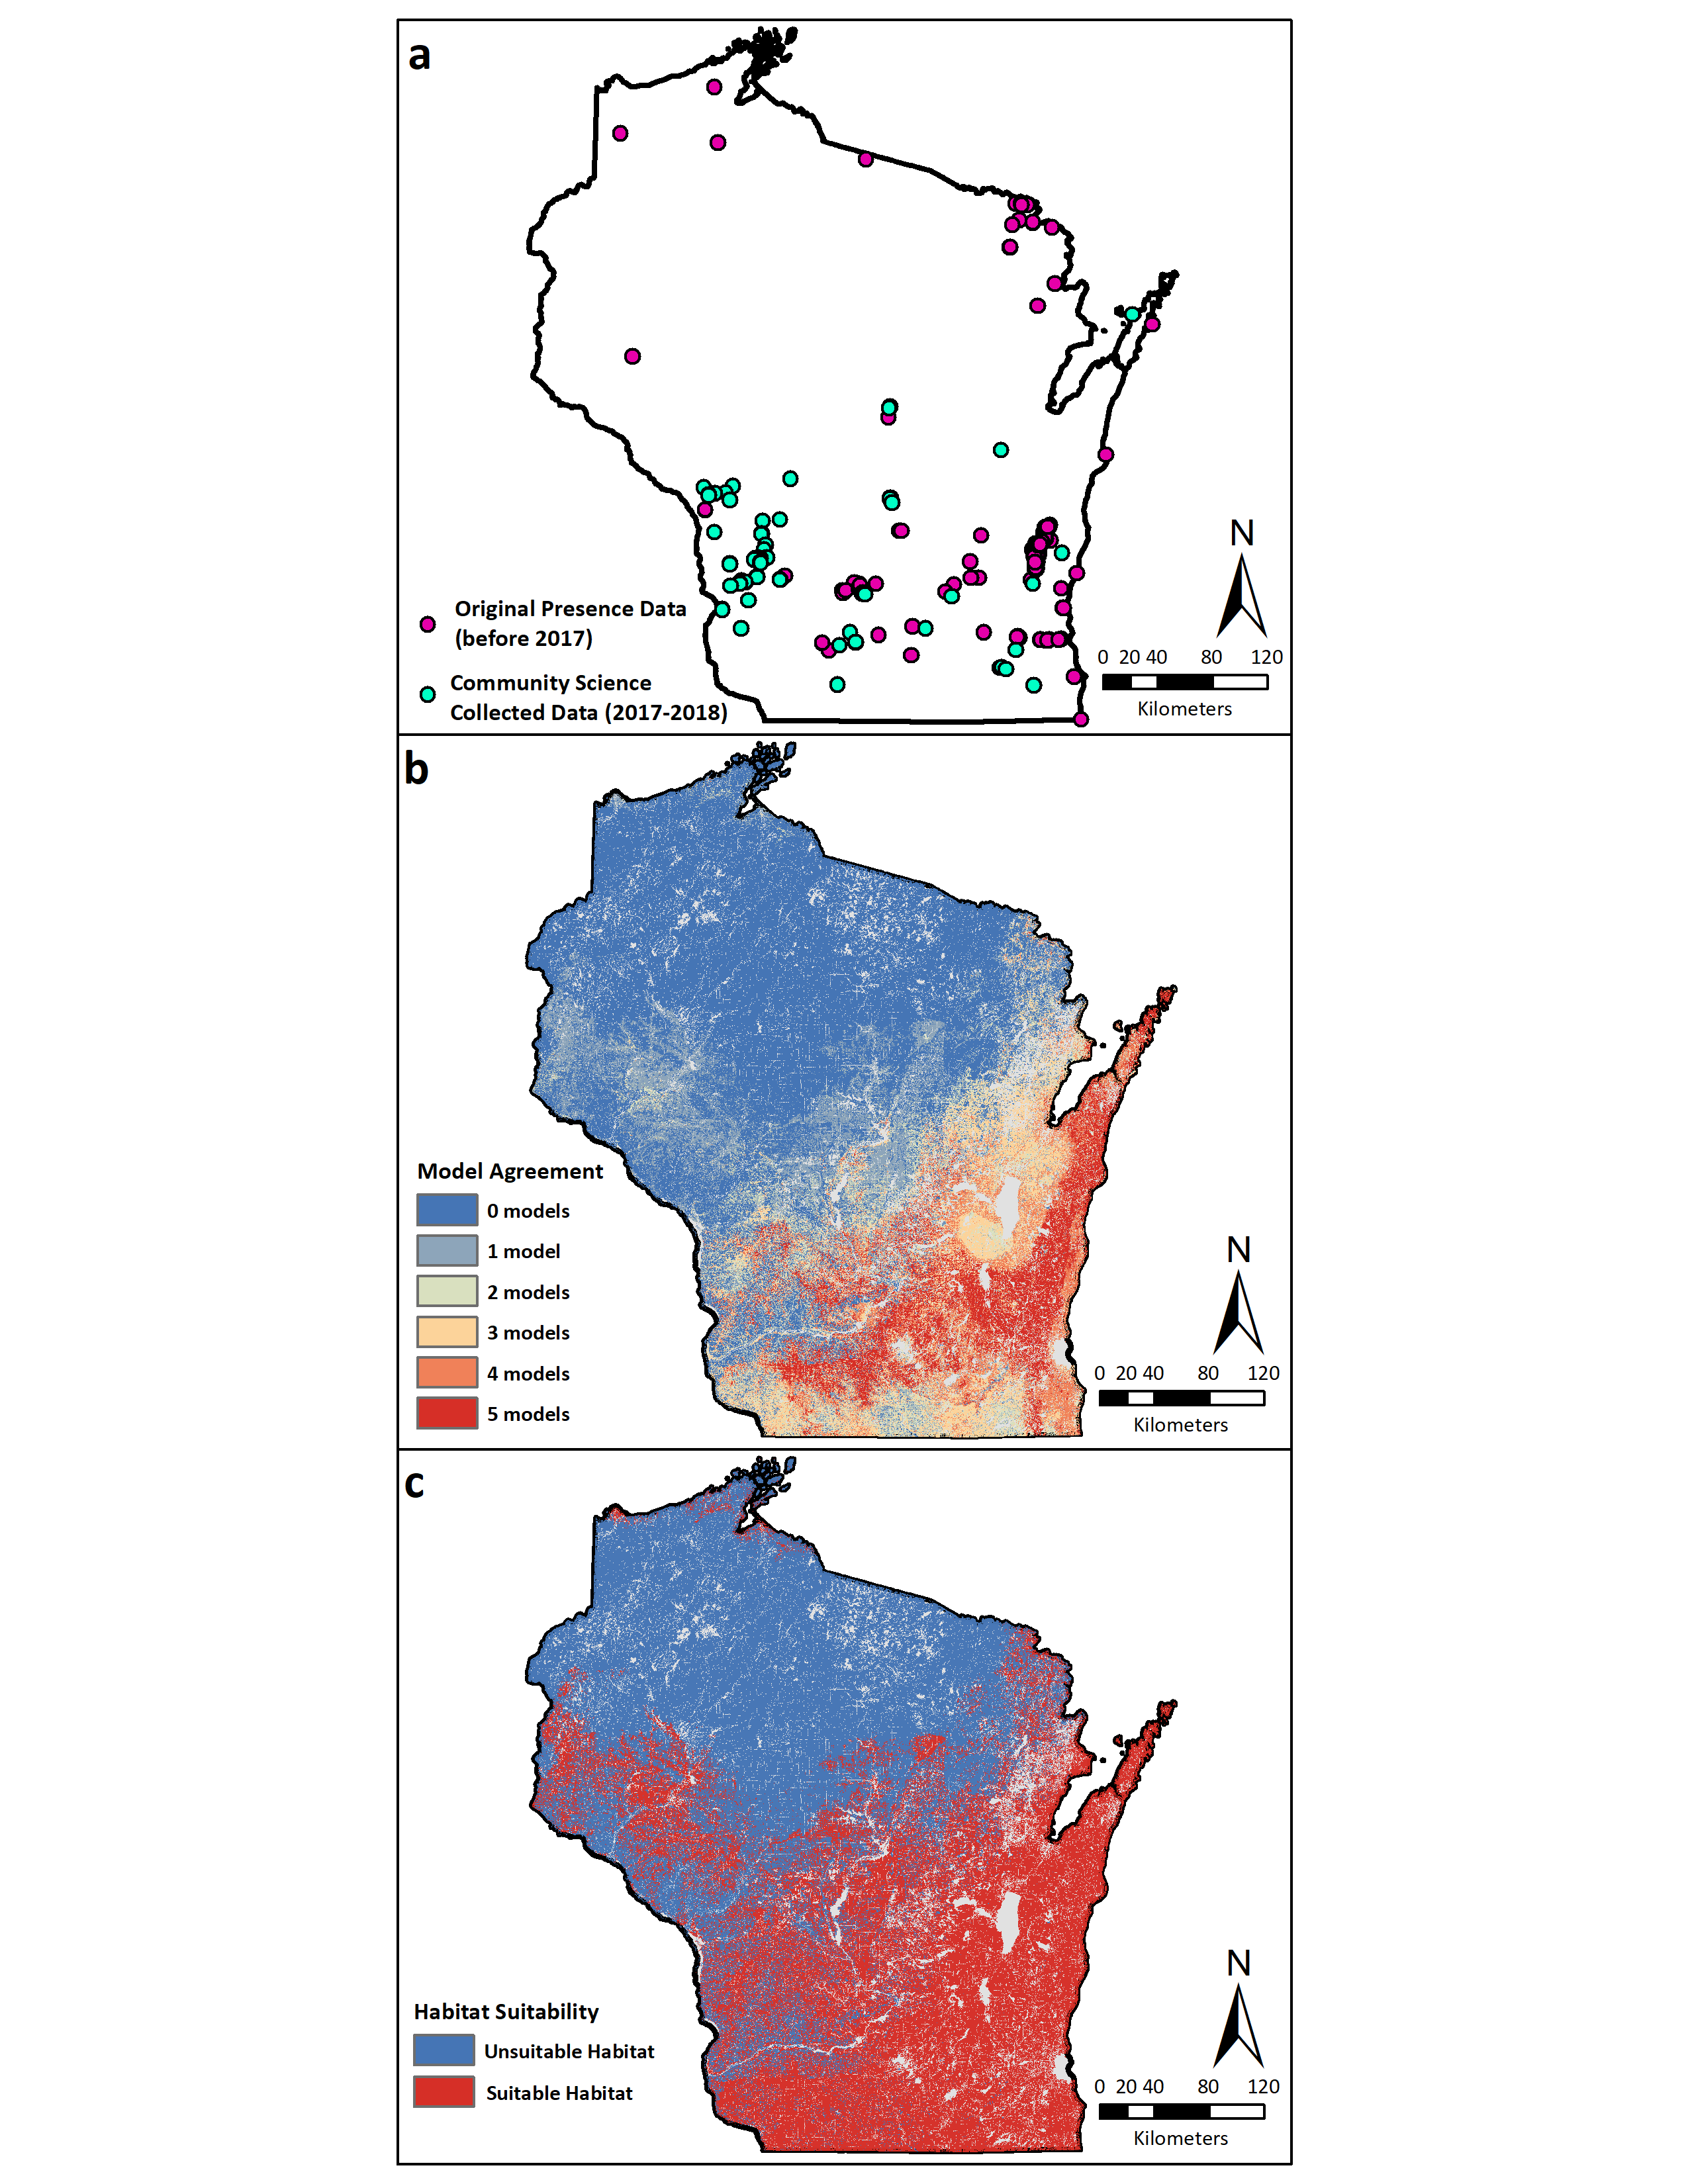
Figure S2.
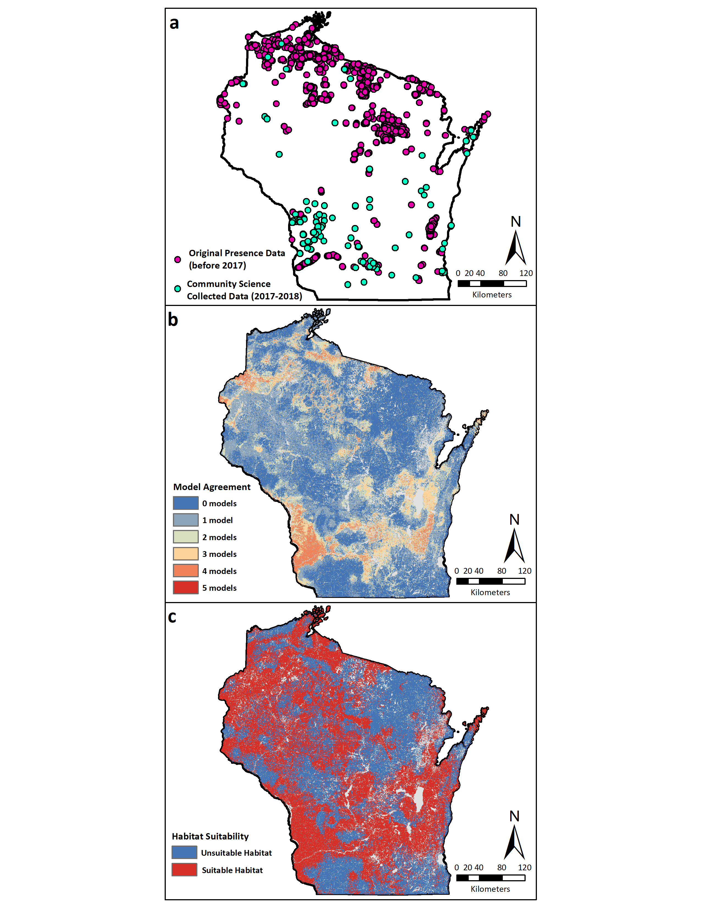
Figure S3.
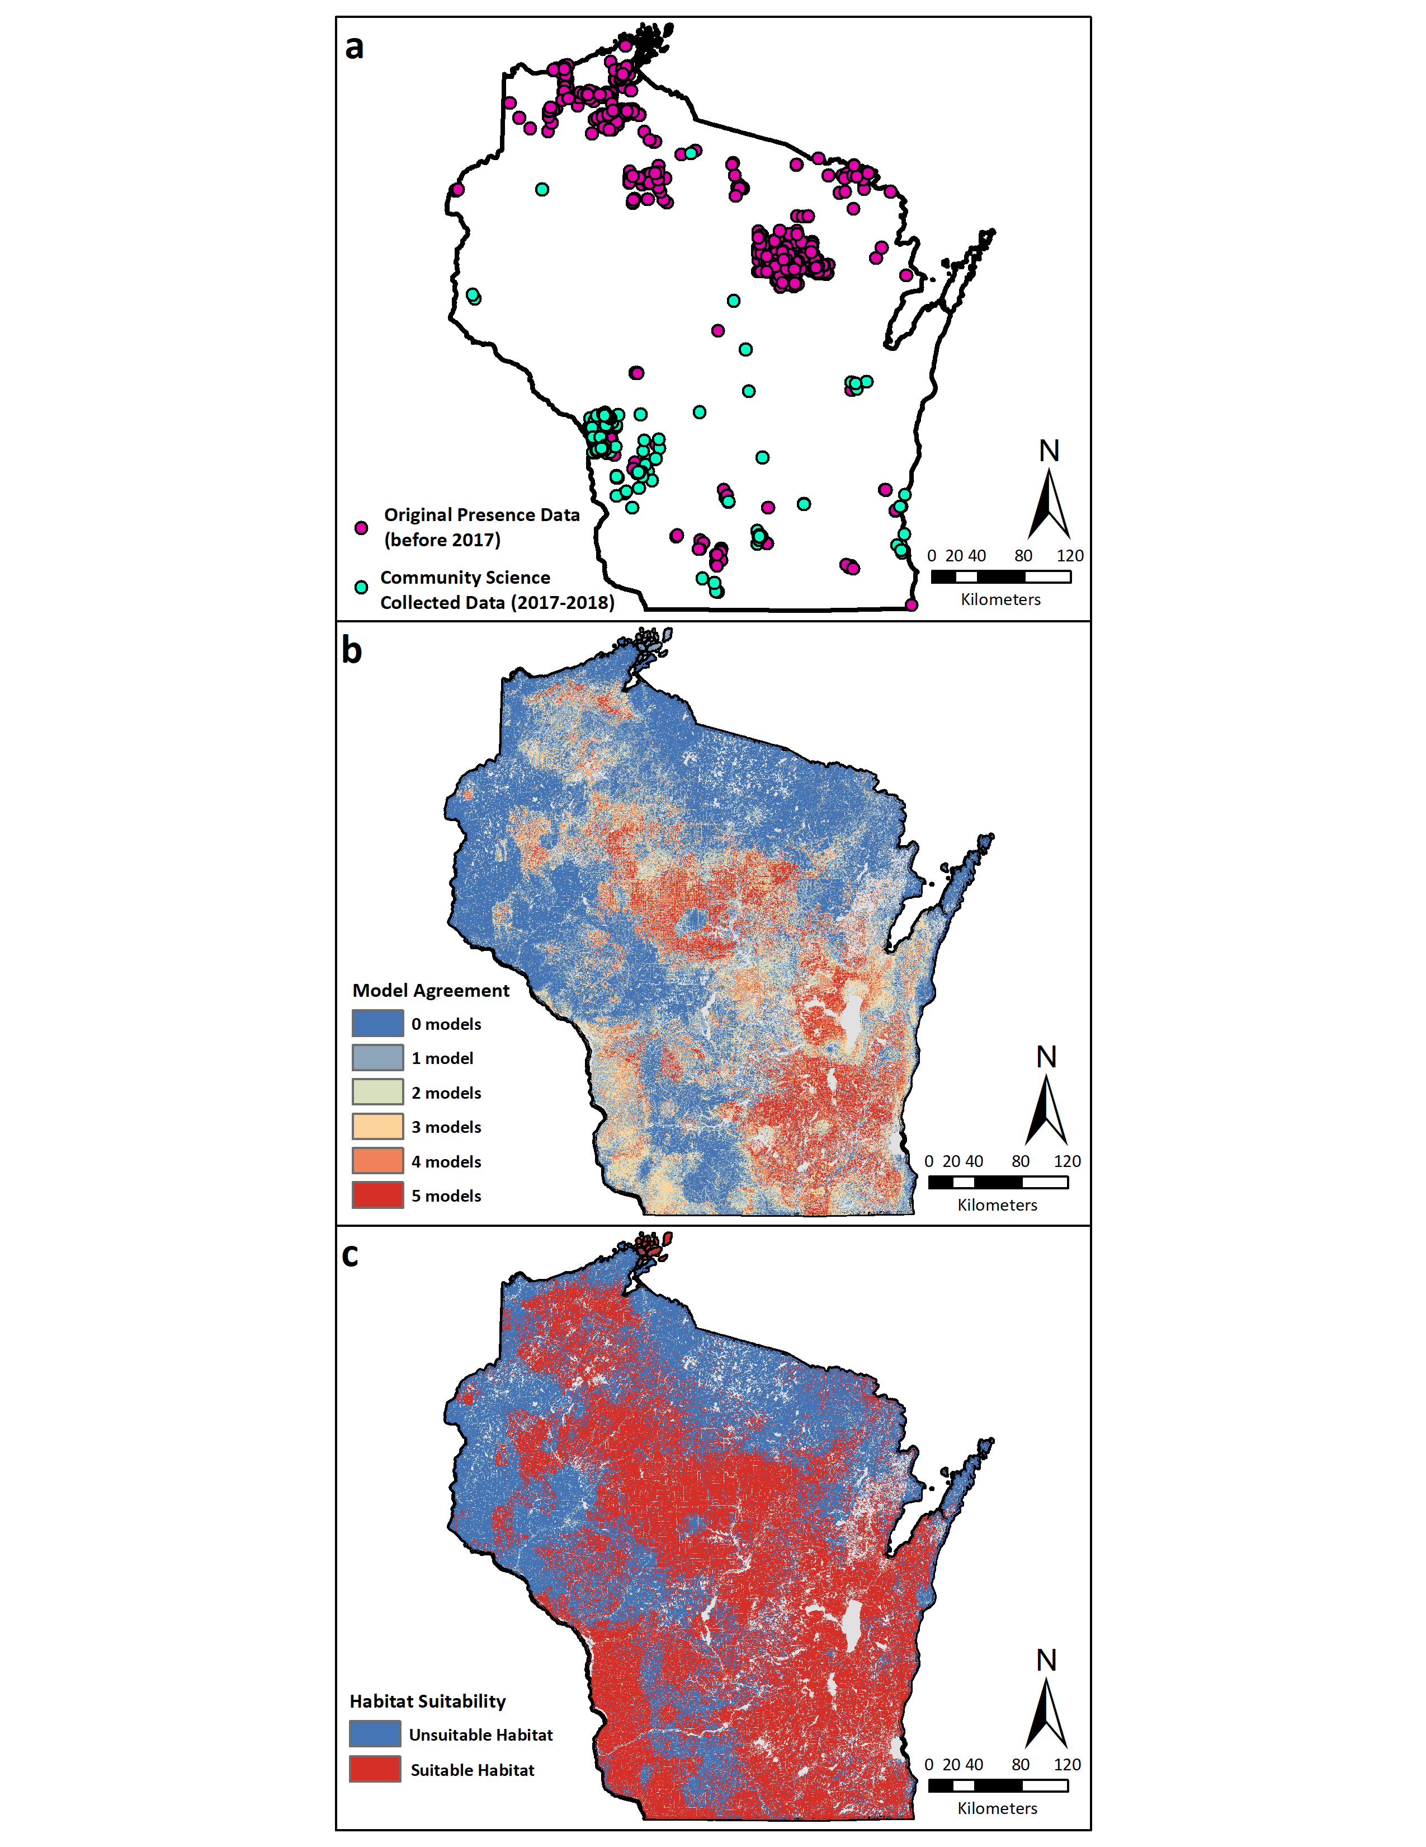
Figure S4.
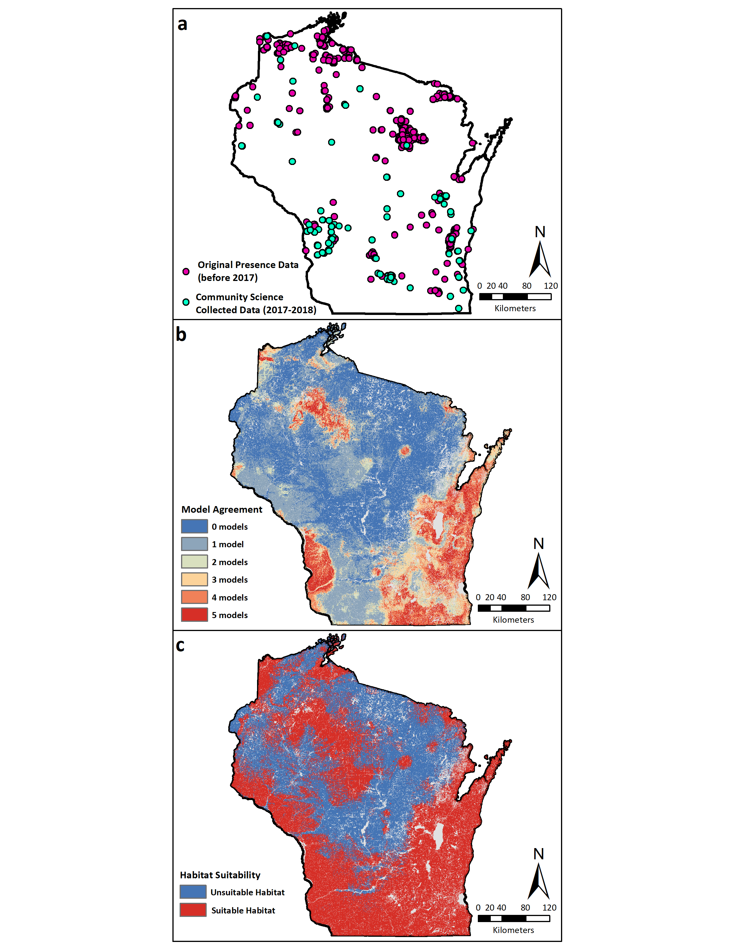
Figure S5.
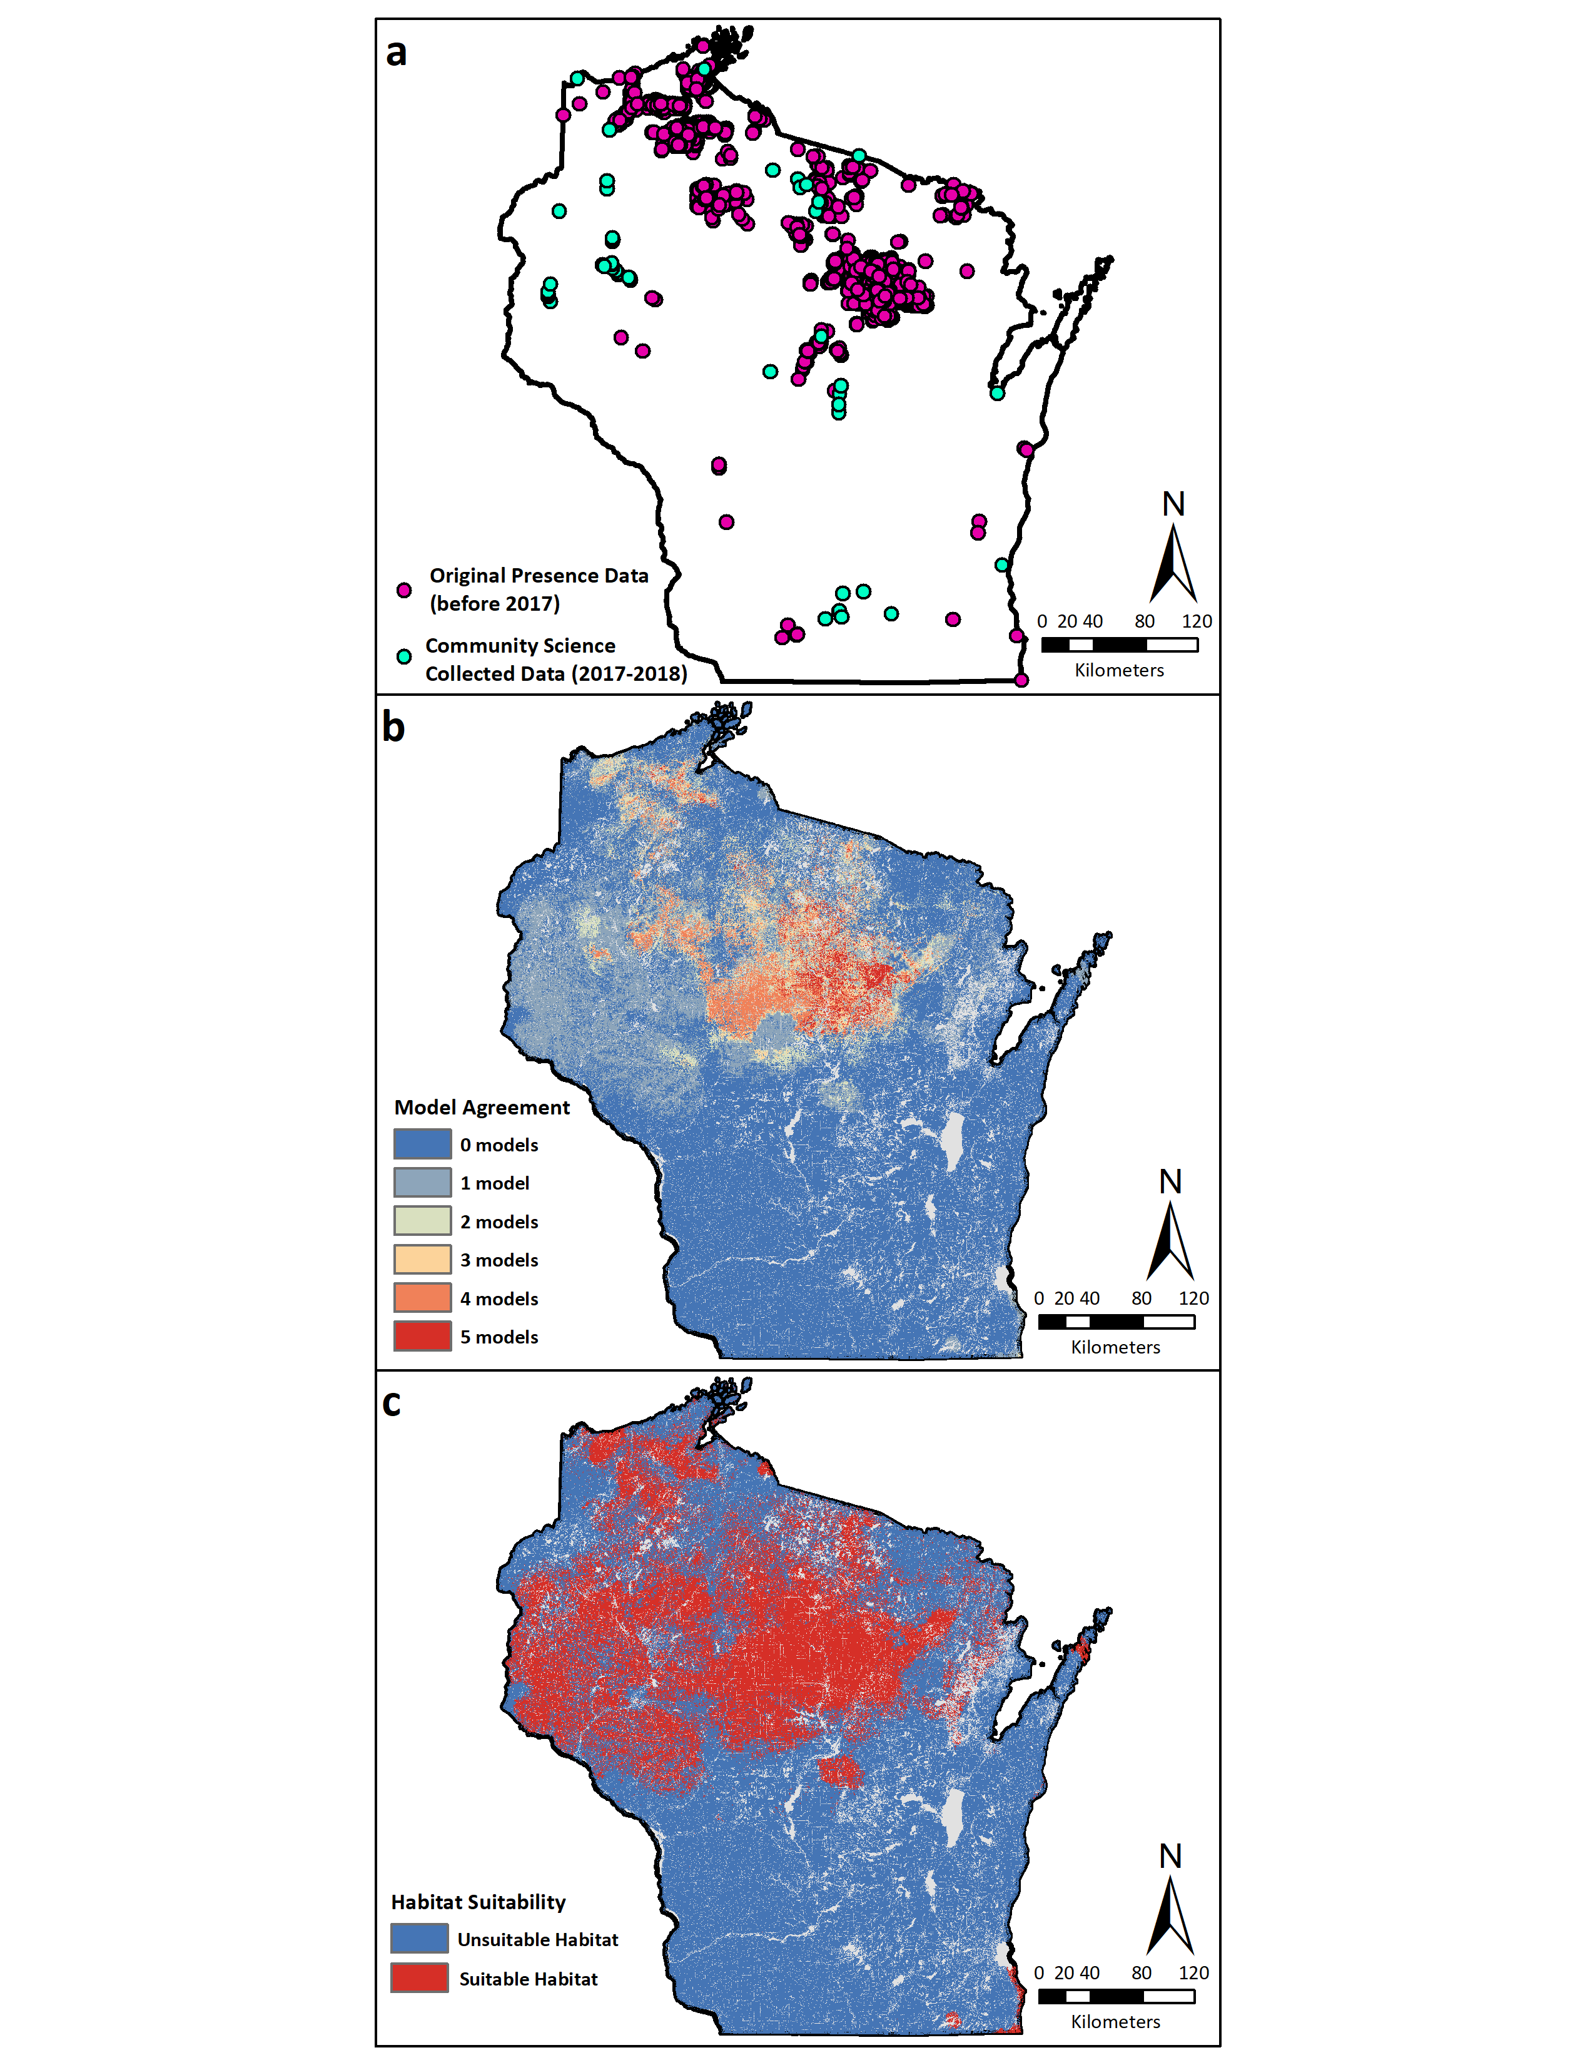
Figure S6.
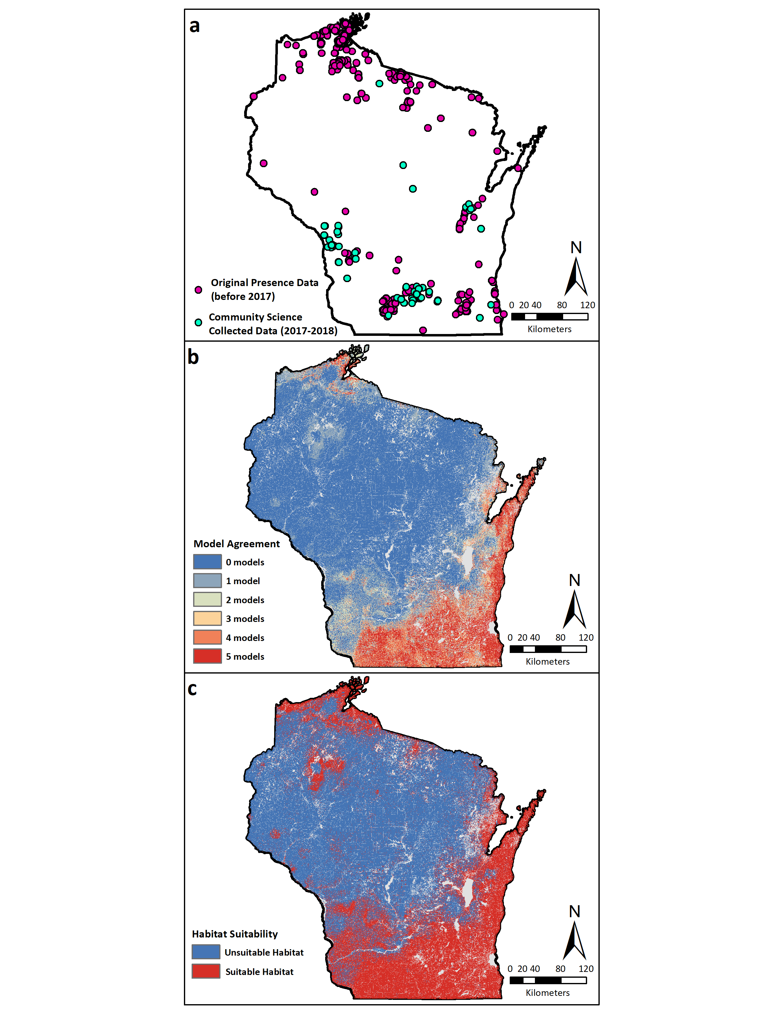
Figure S7.
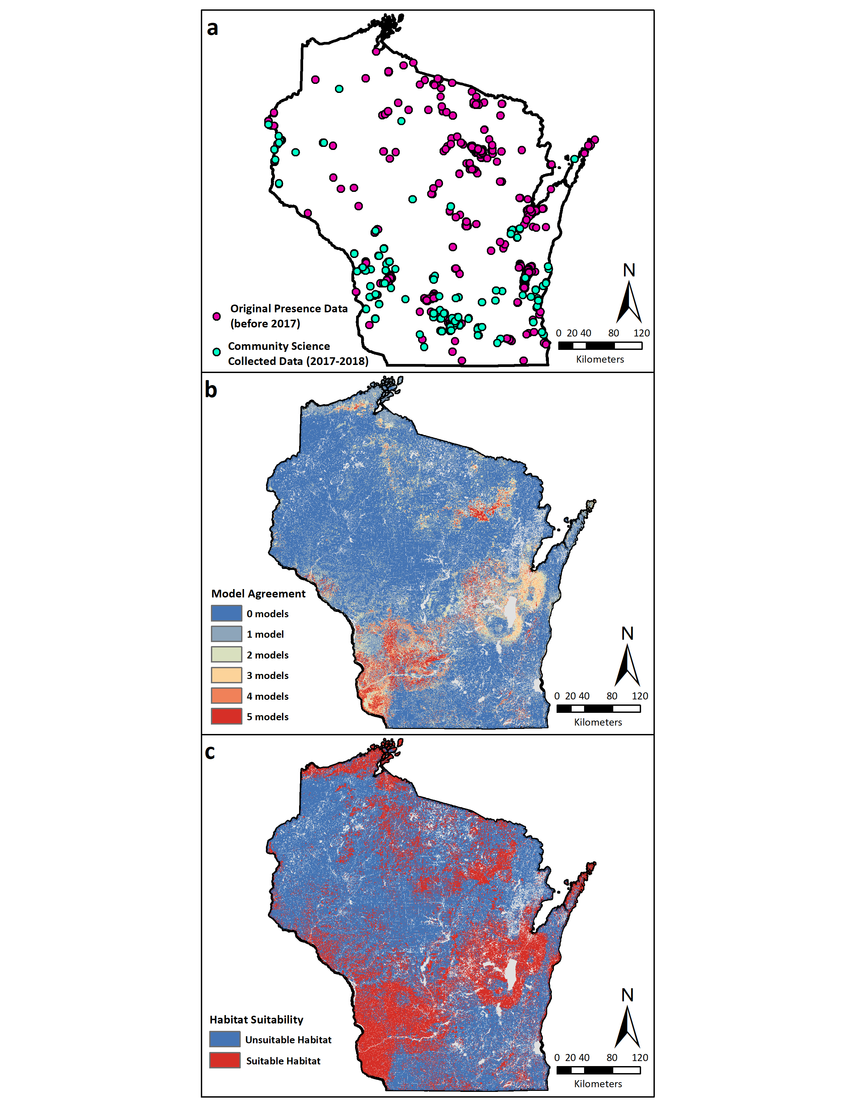
Figure S8.
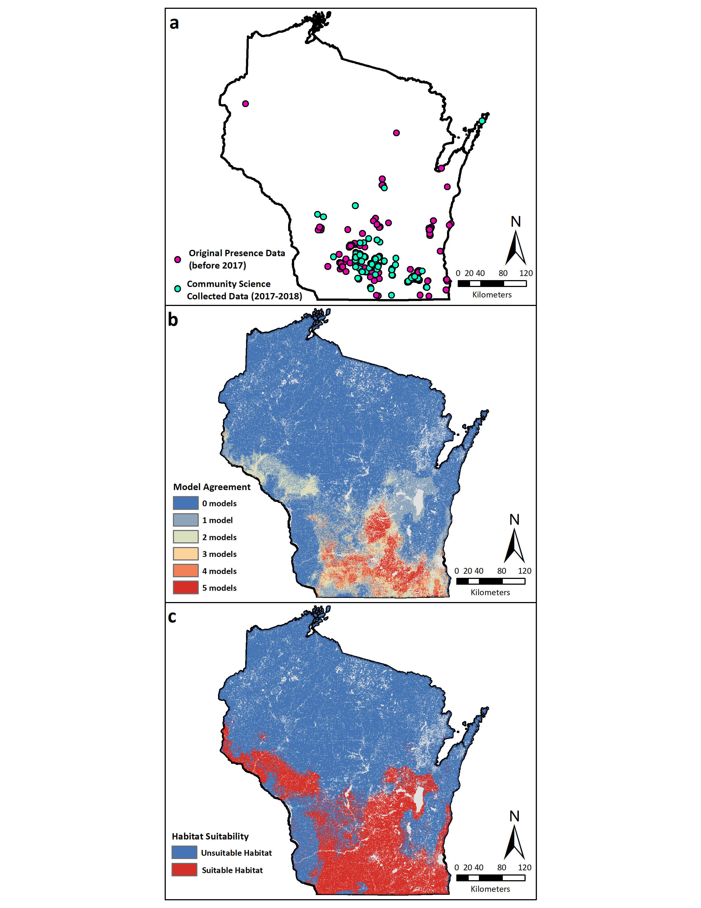
Figure S9.
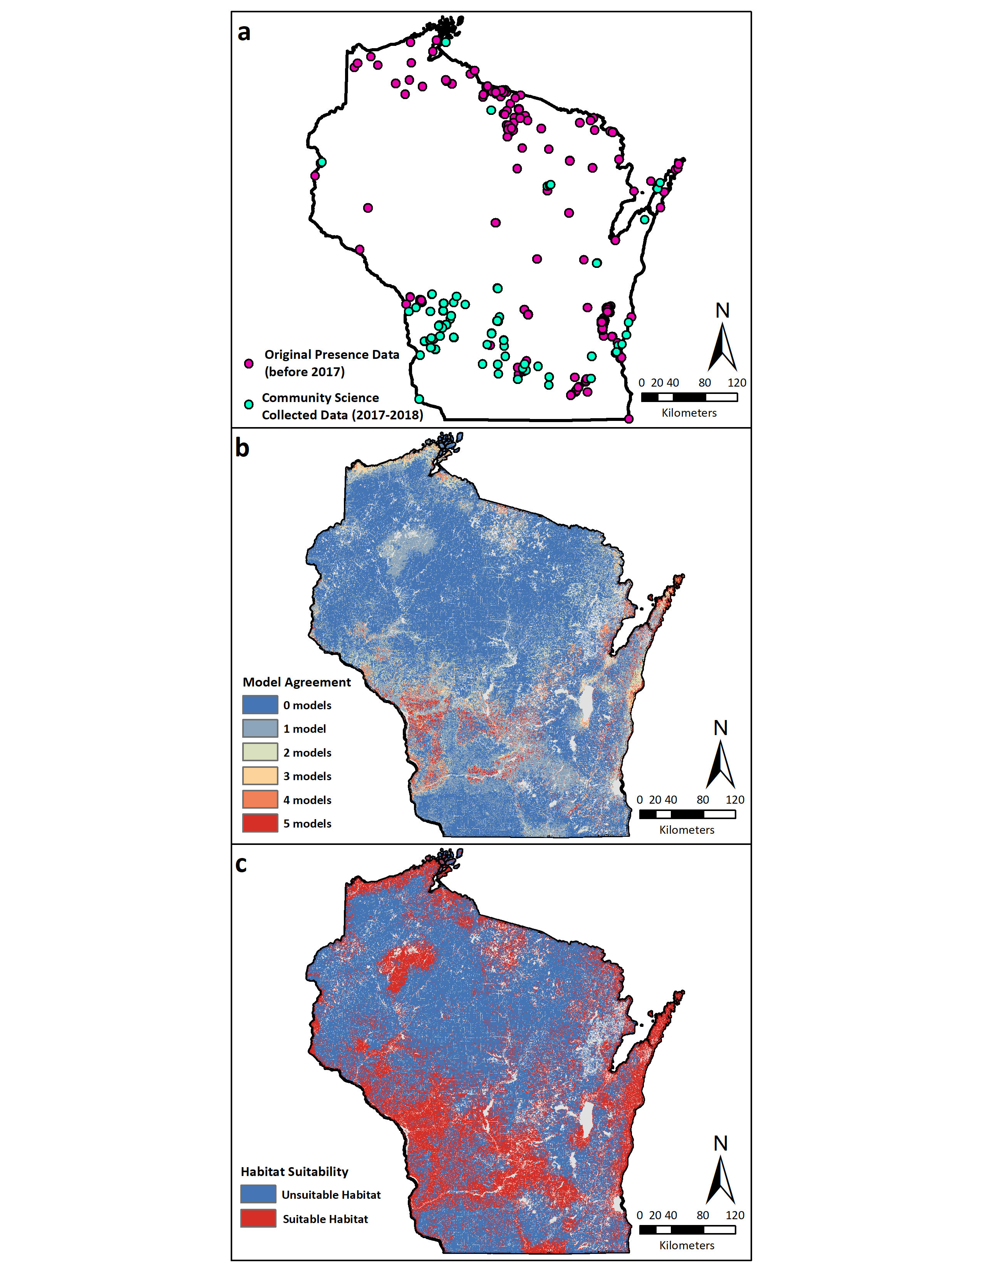
Figure S10.
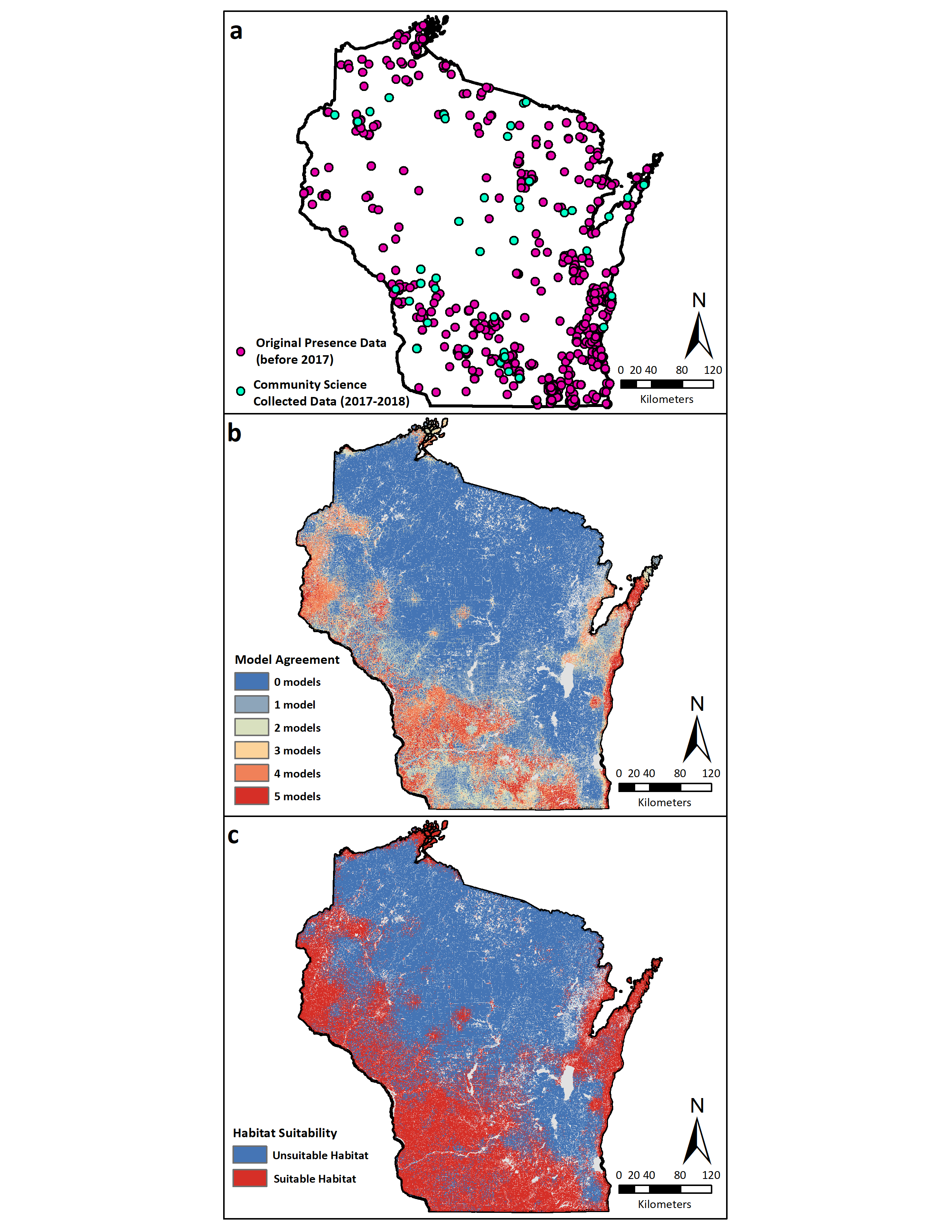
Figure S11.
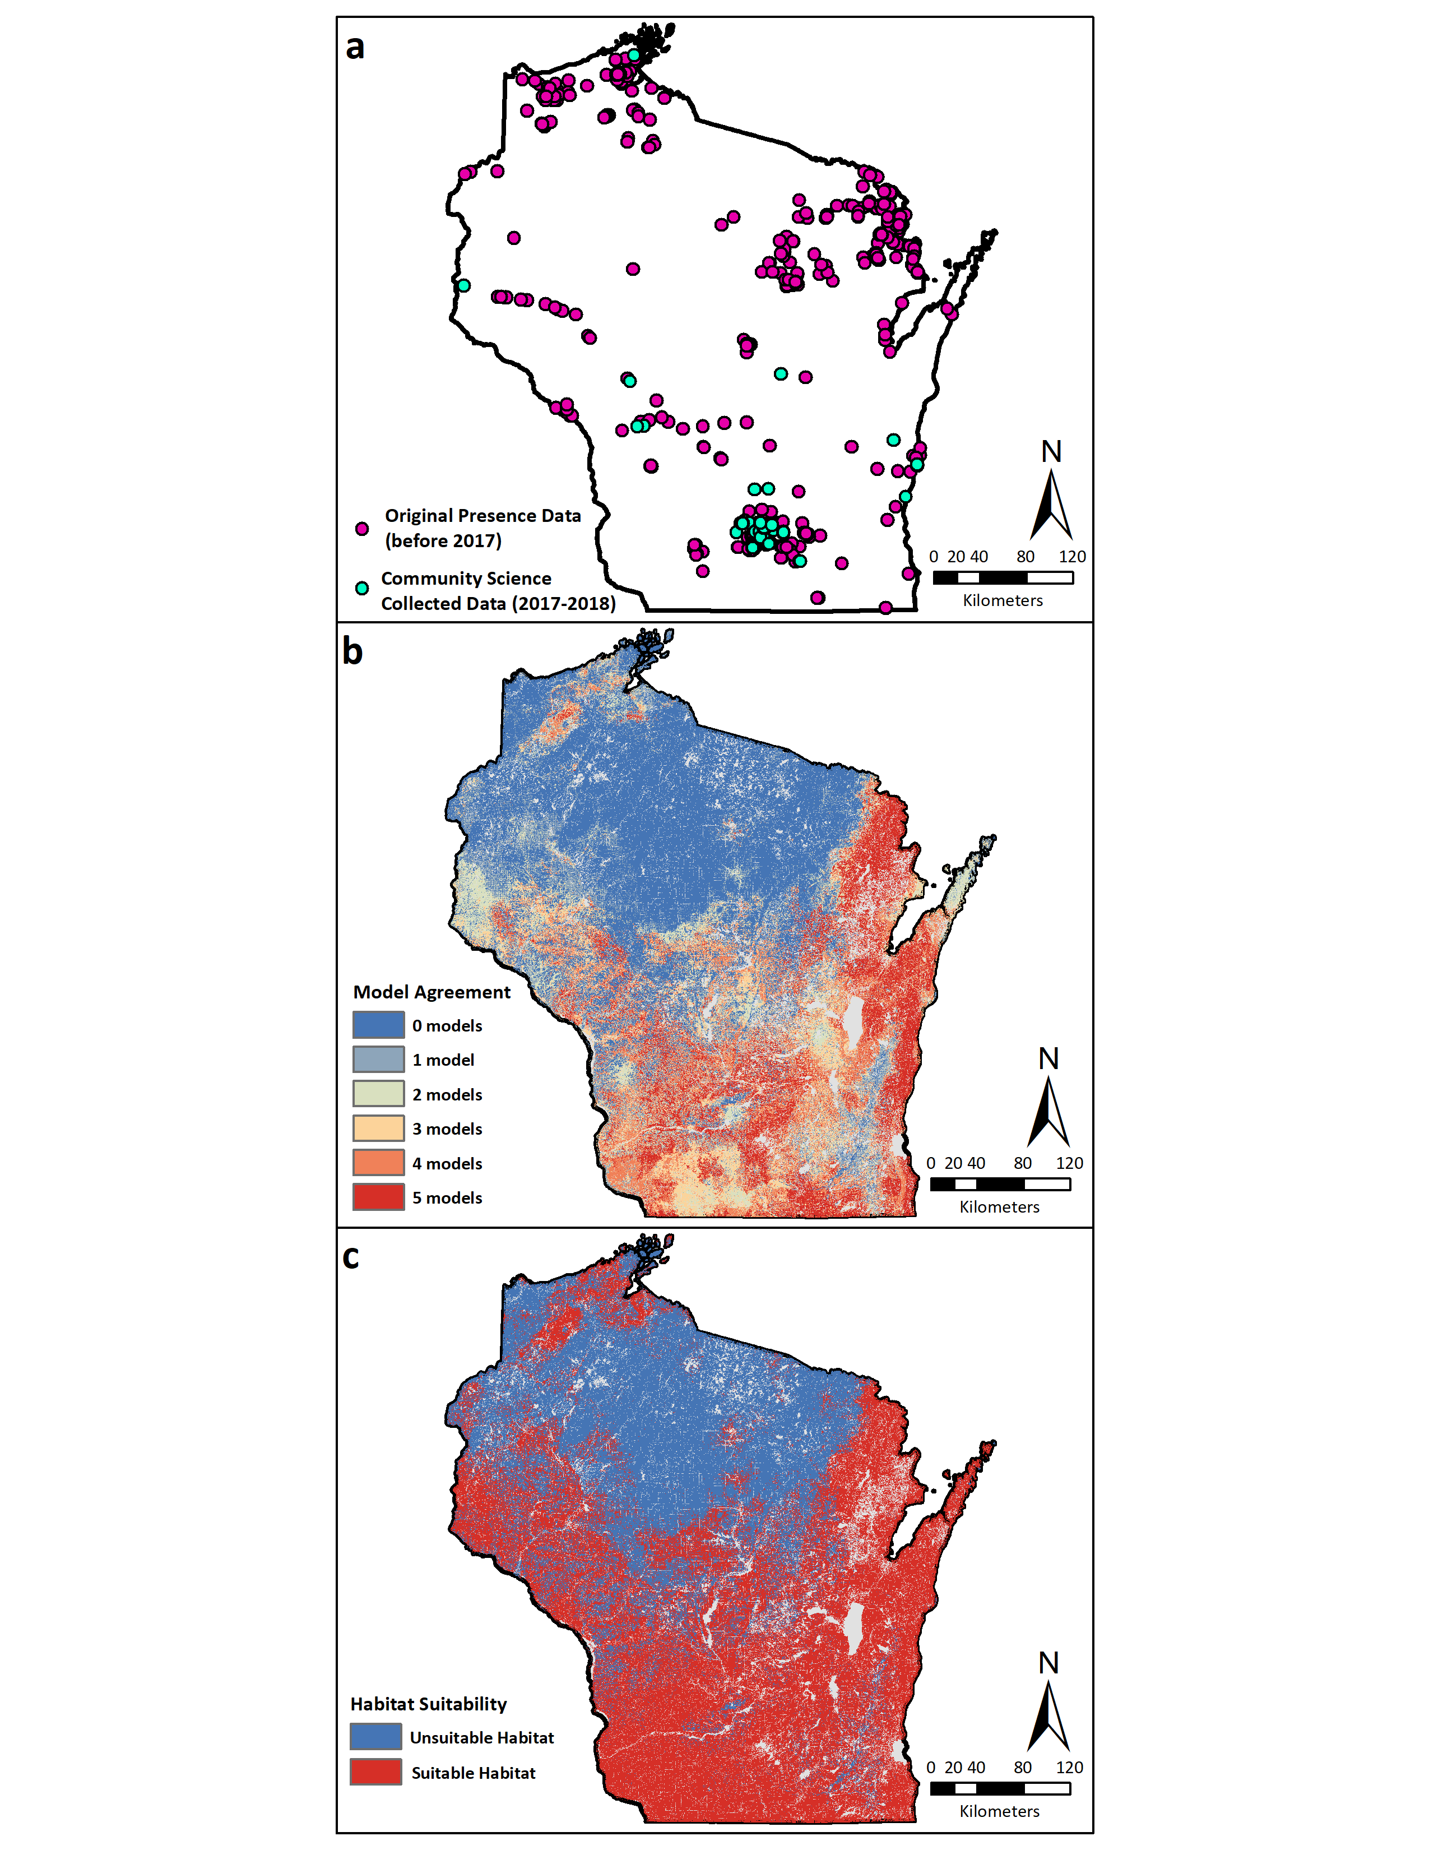
Figure S12.
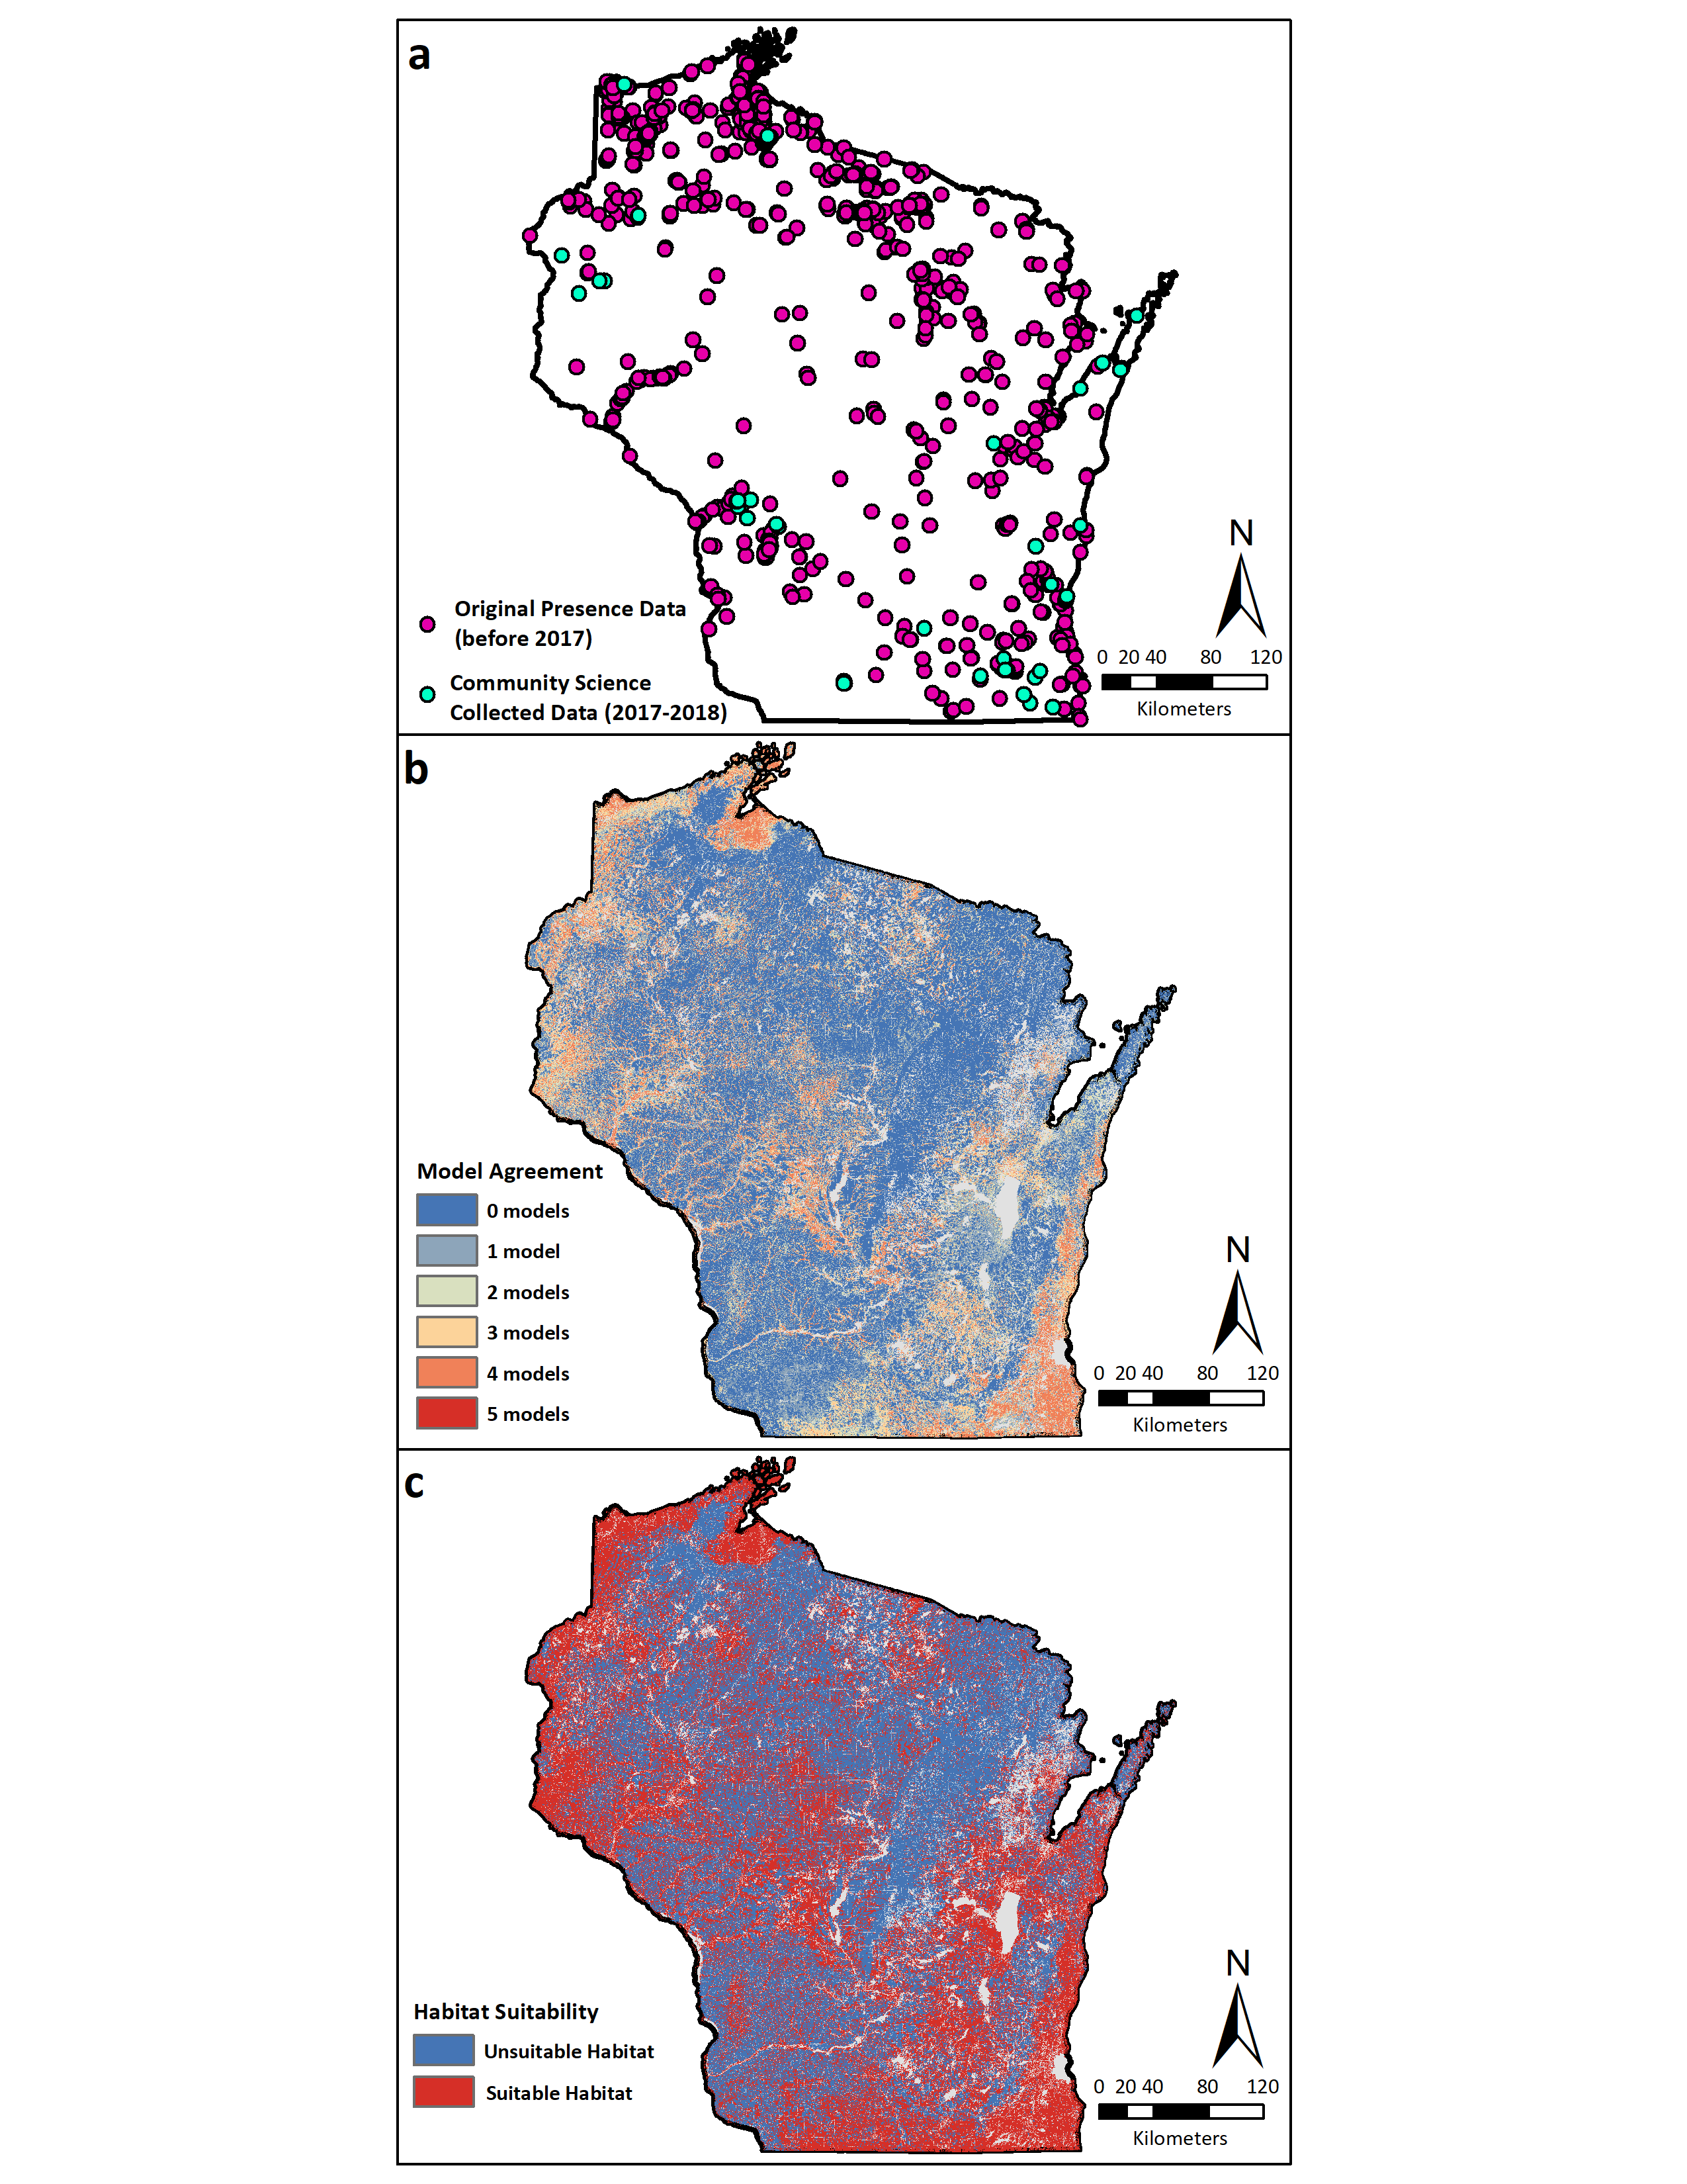
Figure S13.
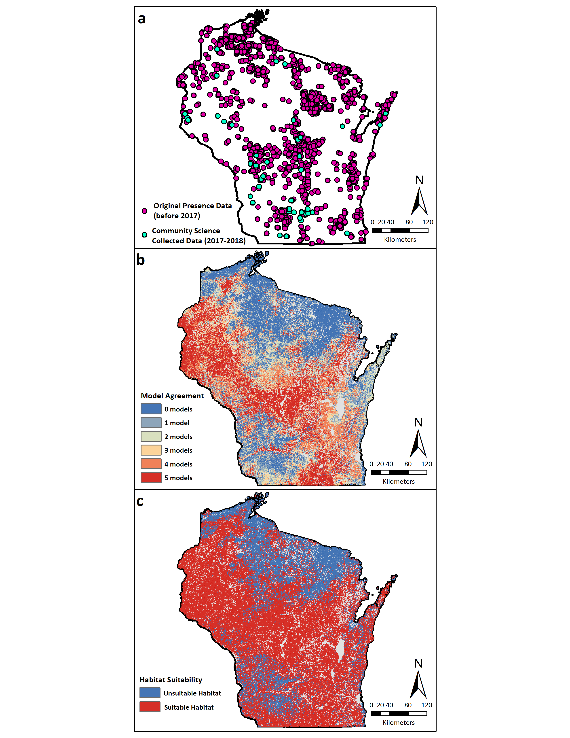
Figure S14.
