Supplementary Table S1. Water depths from every control and treatment plot in Long Point (LP) and Rondeau Provincial Park (RPP). Control (n = 39) and treatment (n = 41) plots were paired by August 2016 water depths across the range occupied by invasive P. australis at sufficient density to warrant herbicide application (> 20 stem m⁻²). Control plot RCP16 was mistakenly treated and thus was re-coded. Further, control plot RPC41 became inaccessible in 2018, reducing the number of control plots to 38.
SiteID | Location | Treatment | Water Depth (cm)
 |  |  | 2016 | 2017 | 2018
LPC25 | LP | Control | 10 | 38 | 27
LPC24 | LP | Control | 13 | 36 | 44
LPC39 | LP | Control | 13 | 28 | 20
RPC04 | RPP | Control | 13 | 29 | 37
RPC15 | RPP | Control | 13 | 14.5 | 34
LPC26 | LP | Control | 14 | 39 | 52
LPC27 | LP | Control | 17 | 42 | 50
RPC14 | RPP | Control | 17 | 36 | 56
LPC33 | LP | Control | 18 | 32 | 34
LPC37 | LP | Control | 18 | 46 | 40
LPC32 | LP | Control | 19 | 40 | 46
LPC31 | LP | Control | 20 | 46 | 36
RPC05 | RPP | Control | 20 | 37 | 50
RPC08 | RPP | Control | 20 | 45 | 46
RPC18 | RPP | Control | 20 | 39 | 53
LPC21 | LP | Control | 21 | 52 | 60
RPC12 | RPP | Control | 21 | 42 | 50
LPC28 | LP | Control | 23 | 44 | 54
RPC11 | RPP | Control | 23 | 46 | 43
RPC20 | RPP | Control | 23 | 40 | 43
LPC23 | LP | Control | 24 | 59 | 52
LPC36 | LP | Control | 24 | 45 | 45
RPC10 | RPP | Control | 24 | 41 | 48.5
RPC07 | RPP | Control | 25 | 46 | 53.5
LPC30 | LP | Control | 26 | 49 | 41
LPC35 | LP | Control | 28 | 54 | 43
LPC40 | LP | Control | 28 | 33 | 35
LPC29 | LP | Control | 29 | 53 | 61
RPC03 | RPP | Control | 32 | 49 | 60.5
RPC06 | RPP | Control | 32 | 42 | 62
RPC09 | RPP | Control | 32 | 37 | 53
RPC17 | RPP | Control | 32 | 49.5 | 61
LPC38 | LP | Control | 34 | 53 | 35
RPC13 | RPP | Control | 34 | 42 | 42
LPC22 | LP | Control | 36 | 48 | 63
LPC34 | LP | Control | 38 | 61 | 44
RPC02 | RPP | Control | 42 | 53.5 | 54
RPC19 | RPP | Control | 44 | 48 | 55
RPC41 | RPP | Control | 48 | 79 | NC
LPT13 | LP | Treatment | 13 | 43 | 39
LPT41 | LP | Treatment | 13 | 43 | 32
RPT28 | RPP | Treatment | 16 | 35 | 39
RPT34 | RPP | Treatment | 16 | 28.5 | 45
LPT15 | LP | Treatment | 17 | 44.5 | 35
RPT32 | RPP | Treatment | 17 | 39 | 34
LPT12 | LP | Treatment | 18 | 46.5 | 39
LPT19 | LP | Treatment | 18 | 52 | 62
RPT22 | RPP | Treatment | 18 | 52 | 53
RPT37 | RPP | Treatment | 18 | 41 | 47
LPT16 | LP | Treatment | 19 | 42 | 31
RPT31 | RPP | Treatment | 20 | 38 | 45
LPT08 | LP | Treatment | 21 | 45 | 40
LPT18 | LP | Treatment | 21 | 55 | 40
RPT25 | RPP | Treatment | 21 | 45 | 53
RPT39 | RPP | Treatment | 21 | 42.5 | 45
LPT07 | LP | Treatment | 22 | 43.5 | 44
LPT10 | LP | Treatment | 22 | 60 | 41
LPT14 | LP | Treatment | 22 | 43.5 | 43
RPT30 | RPP | Treatment | 22 | 46 | 58
LPT09 | LP | Treatment | 24 | 49 | 34
LPT20 | LP | Treatment | 24 | 43 | 38
LPT42 | LP | Treatment | 24 | 55 | 47
RPT40 | RPP | Treatment | 24 | 44 | 46
LPT43 | LP | Treatment | 25 | 50 | 39
RPT24 | RPP | Treatment | 26 | 49 | 58
LPT11 | LP | Treatment | 28 | 58 | 44
LPT06 | LP | Treatment | 30 | 43 | 43
LPT05 | LP | Treatment | 31 | 65 | 43
RPT23 | RPP | Treatment | 31 | 55 | 61
RPT33 | RPP | Treatment | 31 | 46 | 57
RPT29 | RPP | Treatment | 32 | 45 | 40
LPT44 | LP | Treatment | 33 | 61.5 | 29
RPT21 | RPP | Treatment | 33 | 62 | 64
RPT38 | RPP | Treatment | 33 | 48 | 61
RPC16 | RPP | Treatment | 41 | 25 | 48
LPT17 | LP | Treatment | 42 | 62 | 5
RPT27 | RPP | Treatment | 44 | 57.5 | 65
RPT36 | RPP | Treatment | 45 | 44 | 92
RPT35 | RPP | Treatment | 46 | 48 | 61
RPT26 | RPP | Treatment | 47 | 65.5 | 86

Supplementary Table S2. Two-way ANOVA results, type III SS with year (2016, 2017, 2018) and treatment as fixed factors. The percent of PAR penetrating the canopy was log₁₀ transformed. There was a significant interaction for every measured variable.
 | Live stems (per m²) |  |  | Total stems (per m²) |  |  | Canopy Height (cm) |  |  | PAR penetration (% incident light)
 | df | F | p | df | F | p | df | F | p | df | F | p
Year | 2 | 3.62 | 0.03 | 2 | 0.45 | 0.64 | 2 | 0.27 | 0.77 | 2 | 1.70 | 0.19
Treatment | 1 | 0.74 | 0.39 | 1 | 0.31 | 0.58 | 1 | 0.05 | 0.84 | 1 | 1.24 | 0.27
Year x Treatment | 2 | 60.61 | < 0.001 | 2 | 19.29 | < 0.001 | 2 | 138.25 | < 0.001 | 2 | 51.21 | < 0.001
Error | 233 |  |  | 233 |  |  | 233 |  |  | 233

Supplementary Table S3. The average, standard deviation, minimum and maximum live invasive P. australis stem density, total (live & dead) stem density, canopy height and photosynthetically active radiation (PAR) penetration in both treatments over the three years; pre-treatment (2016) and two years post-treatment (2017 and 2018).
 |  | Live Stems (per m⁻²) |  |  | Total Stems (per m⁻²) |  |  | Canopy Height (cm) |  |  | PAR penetration  (% incident light)
 |  | Avg. (std.) | Min. | Max. | Avg. (std.) | Min. | Max. | Avg. (std.) | Min. | Max. | Avg. (std.) | Min. | Max.
Control | 2016 | 34.7 (13.1) | 13 | 68 | 102 (46.2) | 20 | 193 | 362 (61.1) | 237 | 526 | 4.1 (4.3) | 0.4 | 17.0
 | 2017 | 36.8 (15.3) | 14 | 82 | 112 (49.0) | 15 | 229 | 372 (50.4) | 270 | 470 | 6.0 (7.5) | 0.6 | 33.8
 | 2018 | 29.8 (12.3) | 10 | 66 | 105 (49.5) | 37 | 200 | 367 (47.4) | 260 | 460 | 6.0 (8.6) | 0.7 | 50.6
Treatment | 2016 | 37.0 (15.8) | 11 | 81 | 108 (47.5) | 23 | 229 | 358 (41.5) | 285 | 470 | 4.7 (3.9) | 0.3 | 13.6
 | 2017 | 0.1 (0.6) | 0 | 4 | 50.2 (52.3) | 0 | 120 | 40.7 (65.5) | 0 | 207 | 56.3 (27.4) | 11.0 | 99.6
 | 2018 | 1.5 (5.6) | 0 | 28 | 24.3 (30.5) | 0 | 198 | 121 (102) | 0 | 275 | 61.1 (26.6) | 9.0 | 99.4

Supplementary Table S4. Two-way ANOVA results, type III SS, comparing total stem density, live stem density, and photosynthetically active radiation (PAR) penetration in 2017 and 2018 between Long Point and Rondeau Provincial Park. Secondary treatment (e.g. rolling and mowing) occurred in Long Point but not Rondeau. The percent of PAR penetrating the canopy was log₁₀ transformed.
 | Total stems (per m⁻²) |  |  | Live stems (per m⁻²) |  |  | PAR penetration (% incident light)
 | df | F | P | df | F | P | df | F | P
Year | 1 | 1.26 | 0.27 | 1 | 0.88 | 0.35 | 1 | 2.48 | 0.12
Location | 1 | 51.91 | < 0.001 | 1 | 0.02 | 0.88 | 1 | 7.09 | 0.01
Year x Location | 1 | 4.29 | 0.04 | 1 | 0.06 | 0.82 | 1 | 8.46 | 0.01
Error | 78 |  |  | 78 |  |  | 78

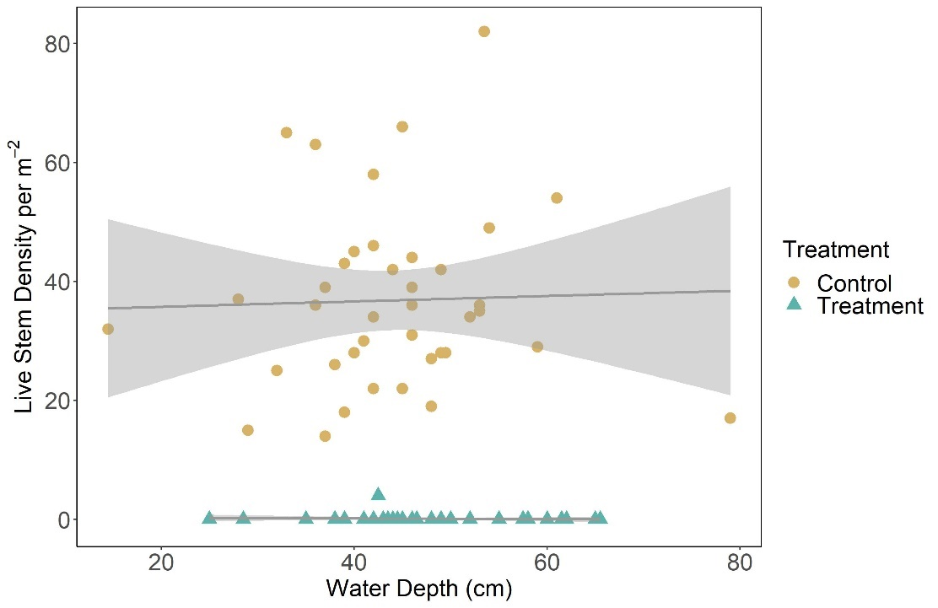
Supplementary Figure S1. Glyphosate-based herbicide was effective at suppressing invasive P. australis along the entire water depth gradient. The number of live invasive P. australis stems (per m²) in the control plots one year after treatment occurred were significantly higher than in the herbicide-treated plots and there was no difference in live invasive P. australis stem density along the water depth gradient (cm). Shaded area represents 95% confidence intervals. Made with ggplot2 (Whickham 2016).

Supplementary Table S5. A significant difference in vegetation community composition arose between treatment and control plots after the herbicide was applied (i.e. the interaction term was significant). Thus, we conclude that treatment had an effect on the vegetation community structure. Results represent the average test statistics taken from 500 runs of a perMANOVA performed using stratified random sampling with replacement. Values in parentheses are the standard deviation.
 | df | Average Pseudo-F | Average p-value
Treatment | 1 | 170.20 (± 14.90) | 0.001 (< 0.001)
Year | 2 | 61.51 (± 6.13) | 0.001 (< 0.001)
Treatment x year | 2 | 44.77 (± 5.33) | 0.001 (< 0.001)
Residual | 222

Supplementary Table S6. The correlation coefficients (r) and coefficient of determination (r²) of all the vectors in the 3D NMDS ordination for the control, treatment, and reference condition plots. Vectors with an r² ≥ 0.150 are considered reasonably correlated with points and were included in Figure 4.
 |  | Axis 1 |  | Axis 2 |  | Axis 3
Full name | Taxonomic Authority | r | r² | r | r² | r | r²
Water depth |  | -0.271 | 0.073 | 0.215 | 0.046 | 0.144 | 0.021
Open water |  | -0.685 | 0.469 | -0.507 | 0.257 | -0.141 | 0.020
Litter |  | -0.012 | 0.000 | 0.055 | 0.003 | -0.549 | 0.301
Standing dead |  | -0.438 | 0.192 | -0.264 | 0.070 | 0.529 | 0.280
Calamagrostis canadensis | (Michx.) P. Beauv. | -0.145 | 0.021 | -0.330 | 0.109 | -0.249 | 0.062
Campanula aparinoides | Pursh | -0.037 | 0.001 | -0.105 | 0.011 | -0.042 | 0.002
Calystegia sepium | (L.) R. Br. | -0.070 | 0.005 | -0.090 | 0.008 | 0.055 | 0.003
Carex aquatilis | Wahlenb. | -0.050 | 0.003 | -0.169 | 0.029 | -0.220 | 0.048
Carex buxbaumii | Wahlenb. | -0.149 | 0.022 | -0.157 | 0.025 | -0.298 | 0.089
Carex crawei | Dewey | -0.102 | 0.010 | -0.128 | 0.016 | -0.058 | 0.003
Carex comosa | Boott | 0.063 | 0.004 | 0.014 | 0.000 | -0.010 | 0.000
Carex lacustris | Willd. | -0.036 | 0.001 | 0.026 | 0.001 | 0.206 | 0.043
Carex lasiocarpa | Ehrh. | 0.017 | 0.000 | -0.119 | 0.014 | -0.134 | 0.018
Carex sartwellii | Olney | -0.055 | 0.003 | -0.054 | 0.003 | -0.291 | 0.085
Carex spp. | L. | 0.055 | 0.003 | -0.004 | 0.000 | -0.045 | 0.002
Cladium mariscoides | (Muhl.) Torr. | -0.130 | 0.017 | -0.109 | 0.012 | -0.392 | 0.154
Cornus sericea spp. sericea | L. | -0.146 | 0.021 | -0.172 | 0.030 | 0.005 | 0.000
Decodon verticillatus | (L.) Elliott | -0.010 | 0.000 | 0.058 | 0.003 | -0.009 | 0.000
Dulichium arundinaceum | (L.) Britton | 0.091 | 0.008 | -0.006 | 0.000 | 0.007 | 0.000
Eleocharis palustris | (L.) Roem. & Schult. | 0.173 | 0.030 | -0.023 | 0.001 | -0.017 | 0.000
Elodea canadensis | Michx. | 0.041 | 0.002 | -0.056 | 0.003 | -0.010 | 0.000
Eleocharis spp. | R. Br. | -0.056 | 0.003 | -0.058 | 0.003 | -0.104 | 0.011
Equisetum fluviatile | L. | -0.071 | 0.005 | 0.183 | 0.034 | 0.017 | 0.000
Fontinalis sp. | Hedw. | -0.103 | 0.011 | -0.028 | 0.001 | -0.016 | 0.000
Galium aparine | L. | 0.079 | 0.006 | -0.013 | 0.000 | -0.001 | 0.000
Hydrocharis morsus-ranae | L. | -0.384 | 0.147 | 0.866 | 0.749 | -0.056 | 0.003
Hypericum kalmianum | L. | -0.128 | 0.016 | -0.174 | 0.030 | -0.081 | 0.007
Iris versicolor | L. | -0.101 | 0.010 | -0.127 | 0.016 | -0.103 | 0.011
Juncus balticus | Willd. | -0.059 | 0.003 | -0.054 | 0.003 | -0.226 | 0.051
Lemna minor | L. | -0.042 | 0.002 | 0.137 | 0.019 | -0.073 | 0.005
Lysimachia thyrsiflora | L. | -0.145 | 0.021 | -0.156 | 0.024 | -0.156 | 0.024
Achillea millefolium | L. | -0.132 | 0.017 | -0.016 | 0.000 | -0.096 | 0.009
Myriophyllum sibiricum | Kom. | -0.082 | 0.007 | 0.022 | 0.000 | -0.046 | 0.002
Myriophyllumspp. | L. | -0.088 | 0.008 | 0.013 | 0.000 | 0.136 | 0.019
Nuphar variegata | Durand | 0.029 | 0.001 | 0.037 | 0.001 | -0.094 | 0.009
Nymphaea odorata | Aiton | 0.006 | 0.000 | 0.148 | 0.022 | -0.031 | 0.001
Phragmites australis ssp. australis | (Trin.) ex | 0.968 | 0.937 | -0.078 | 0.006 | 0.080 | 0.006
Persicaria amphibia | (L.) Delarbre | 0.102 | 0.011 | -0.017 | 0.000 | 0.071 | 0.005
Polygonumspp. | (L.) Mill. | -0.133 | 0.018 | -0.071 | 0.005 | 0.198 | 0.039
Potamogeton spp. | L. | -0.083 | 0.007 | -0.067 | 0.004 | -0.058 | 0.003
Sagittaria spp. | L. | 0.054 | 0.003 | -0.028 | 0.001 | 0.026 | 0.001
Sagittaria latifolia | Willd. | -0.068 | 0.005 | 0.112 | 0.013 | -0.057 | 0.003
Schoenoplectus acutus var. acutus | (Muhl. Ex Bigelow) A. Love & D. Love | -0.028 | 0.001 | -0.079 | 0.006 | -0.007 | 0.000
Bolboschoenus fluviatilis | (Torr.) Sojak | 0.074 | 0.006 | 0.004 | 0.000 | -0.047 | 0.002
Schoenoplectus tabernaemontani | (C.C. Gmel.) Palla | 0.046 | 0.002 | 0.010 | 0.000 | -0.004 | 0.000
Sparganium eurycarpum | Engelm. | -0.072 | 0.005 | 0.209 | 0.044 | 0.026 | 0.001
Sparganium spp. | L. | -0.075 | 0.006 | 0.005 | 0.000 | -0.052 | 0.003
Spirodela polyrrhiza | (L.) Schleid. | 0.065 | 0.004 | 0.010 | 0.000 | 0.005 | 0.000
Solanum spp. | L. | 0.046 | 0.002 | 0.030 | 0.001 | -0.027 | 0.001
Solidago spp. | L. | -0.113 | 0.013 | -0.143 | 0.020 | -0.051 | 0.003
Typha spp. | L. | -0.313 | 0.098 | 0.048 | 0.002 | 0.595 | 0.354
Typha angustifolia | L. | 0.220 | 0.048 | -0.016 | 0.000 | -0.125 | 0.016
Typha x glauca | Godr. (pro sp.) | 0.180 | 0.032 | 0.065 | 0.004 | -0.231 | 0.053
Typha latifolia | L. | 0.060 | 0.004 | -0.022 | 0.001 | -0.049 | 0.002
Utricularia intermedia | Hayne | -0.111 | 0.012 | 0.004 | 0.000 | -0.222 | 0.049
Utricularia vulgaris | L. | -0.157 | 0.025 | -0.052 | 0.003 | -0.045 | 0.002
Unknown |  | -0.093 | 0.009 | -0.069 | 0.005 | -0.083 | 0.007
Zizania palustris | L. | -0.085 | 0.007 | -0.115 | 0.013 | -0.033 | 0.001

