Supplemental Information:

Supplementary Table S1 Results of AIC model selection for Hymenachne amplexicaulis presence. K value indicates the number of parameters in the model. (*) indicates the main effects and an interaction. R: region; P: pasture type; A_{Wetland}: wetland area; I_{Hanski}: log₁₀(Hanski isolation); ED_{min}: Euclidean distance; DC: ditch connection presence
Model | K | AICc | ΔAICc | AICc Weight
R + P + DC | 5 | 159.66 | 0.00 | 0.22
R + P + ED_{min}*DC | 7 | 160.31 | 0.64 | 0.16
R + P + ED_{min} + DC | 6 | 160.79 | 1.12 | 0.13
R + P | 4 | 160.92 | 1.26 | 0.12
R + P +DC + I_{Hanski} | 6 | 161.82 | 2.16 | 0.08
R + P + A_{Wetland} + ED_{min}*DC | 8 | 162.52 | 2.86 | 0.05
R + P + I_{Hanski} + ED_{min}*DC | 8 | 162.52 | 2.86 | 0.05
R + P + A_{Wetland} + DC + ED_{min} | 7 | 162.97 | 3.31 | 0.04
R + P + I_{Hanski} | 5 | 163.06 | 3.39 | 0.04
R + ED_{min} | 4 | 164.66 | 5.00 | 0.02
R + P + A_{Wetland} + I_{Hanski} + ED_{min}*DC | 9 | 164.76 | 5.10 | 0.02
R | 3 | 165.17 | 5.51 | 0.01
R + P + A_{Wetland} + I_{Hanski} + ED_{min} + DC | 8 | 165.19 | 5.53 | 0.01
R + I_{Hanski} + ED_{min} | 5 | 165.99 | 6.33 | 0.01
R + DC | 4 | 166.03 | 6.37 | 0.01
R + I_{Hanski} | 4 | 166.29 | 6.62 | 0.01
R + I_{Hanski} + DC | 5 | 166.87 | 7.20 | 0.01
R + A_{Wetland} + DC | 5 | 167.94 | 8.27 | 0.00
R + A_{Wetland} + I_{Hanski} + ED_{min} | 6 | 168.13 | 8.47 | 0.00
R + A_{Wetland} + I_{Hanski} | 5 | 168.42 | 8.75 | 0.00
R + A_{Wetland} + I_{Hanski} + DC | 6 | 168.88 | 9.21 | 0.00
P + I_{Hanski} | 3 | 197.52 | 37.86 | 0.00
I_{Hanski} | 2 | 202.22 | 42.55 | 0.00
P + DC | 3 | 202.26 | 42.60 | 0.00
I_{Hanski} + DC | 3 | 202.84 | 43.17 | 0.00
P | 2 | 203.89 | 44.23 | 0.00
1 | 1 | 204.96 | 45.30 | 0.00
DC | 2 | 205.24 | 45.57 | 0.00
A_{Wetland} | 2 | 205.67 | 46.01 | 0.00
ED_{min} | 2 | 206.27 | 46.61 | 0.00
ED_{min}*DC | 4 | 207.44 | 47.78 | 0.00

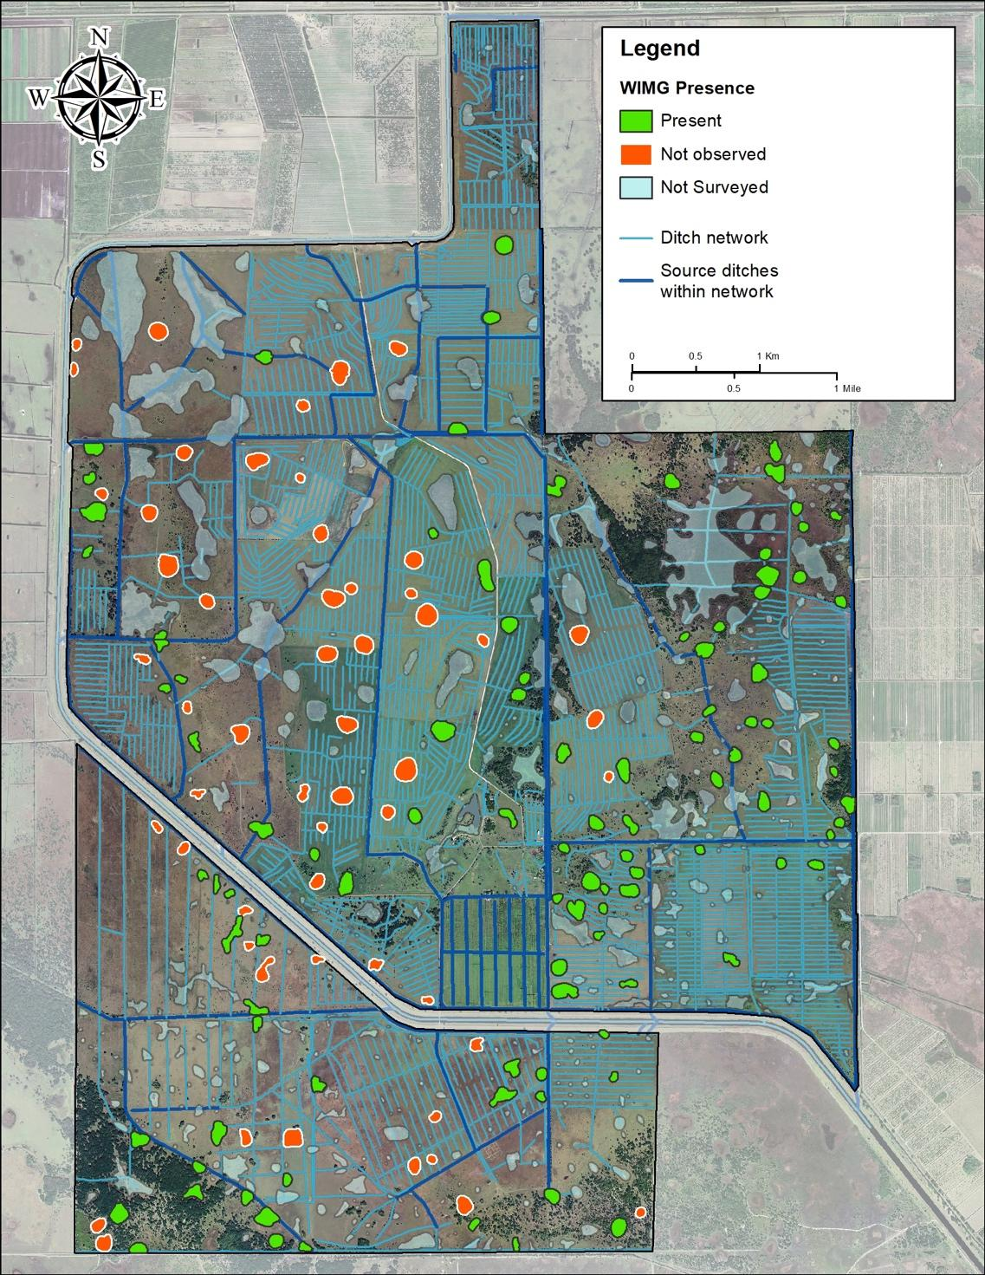
Supplementary Figure S1 Map of Archbold Biological Station’s Buck Island Ranch (BIR), showing the presence (green) and the absence (red) of West Indian Marsh Grass (WIMG) in the 158 investigated wetlands. Blue lines represent the ditch network, the system of intersecting ditches and wetlands, with thick dark blue lines indicating assumed source ditches of H. amplexicaulis

