**Supplementary materials**

# S1: Validation of log normal distribution of the seed dispersion of *Vincetoxicum nigrum* and *Vincetoxicum rossicum*.



## ***Vincetoxicum nigrum*, height = 0.75m**

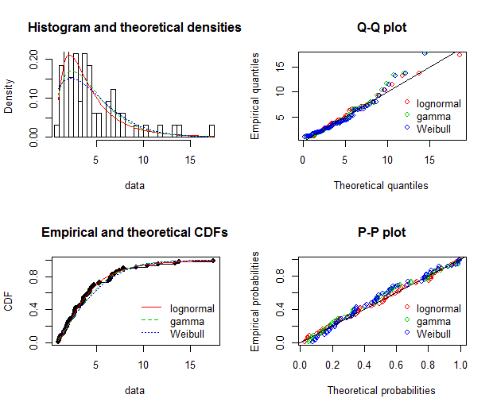

Goodness-of-fit statistics

lognormal gamma Weibull

Kolmogorov-Smirnov statistic 0.06353582 0.08687175 0.09950844

Cramer-von Mises statistic 0.02843157 0.09184036 0.12759743

Anderson-Darling statistic 0.20941256 0.59582746 0.89436066

Goodness-of-fit criteria

lognormal gamma Weibull

Aikake's Information Criterion 302.3850 307.6571 312.3705

Bayesian Information Criterion 306.7337 312.0059 316.7193

## *Vincetoxicum nigrum*, height = 2m

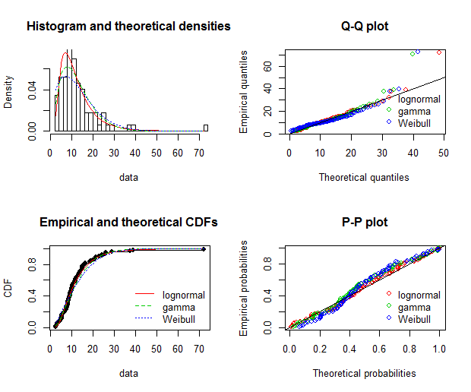

Goodness-of-fit statistics

lognormal gamma Weibull

Kolmogorov-Smirnov statistic 0.06615111 0.09262085 0.1177544

Cramer-von Mises statistic 0.05992748 0.17153099 0.3415255

Anderson-Darling statistic 0.35788148 0.95021837 2.1083846

Goodness-of-fit criteria

lognormal gamma Weibull

Aikake's Information Criterion 565.9795 575.4431 587.4935

Bayesian Information Criterion 570.8882 580.3518 592.4022

## *Vincetoxicum rossicum*, height = 0.75m

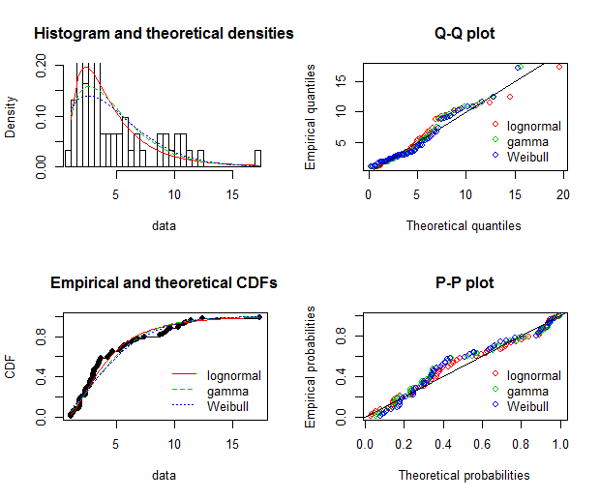

Goodness-of-fit statistics

lognormal gamma Weibull

Kolmogorov-Smirnov statistic 0.1047302 0.1500743 0.1548580

Cramer-von Mises statistic 0.1147661 0.2355192 0.2557639

Anderson-Darling statistic 0.6705462 1.2840843 1.4542371

Goodness-of-fit criteria

lognormal gamma Weibull

Aikake's Information Criterion 292.5707 298.0887 302.0948

Bayesian Information Criterion 296.7925 302.3104 306.3166

## *Vincetoxicum rossicum*, height = 2m

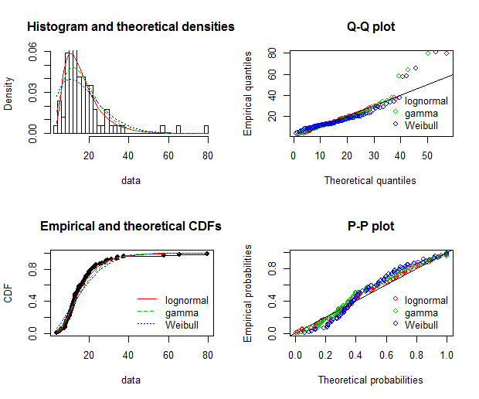

Goodness-of-fit statistics

lognormal gamma Weibull

Kolmogorov-Smirnov statistic 0.07650569 0.1071306 0.1404546

Cramer-von Mises statistic 0.08484644 0.2675693 0.5057427

Anderson-Darling statistic 0.56664301 1.6362403 3.2146776

Goodness-of-fit criteria

lognormal gamma Weibull

Aikake's Information Criterion 597.1556 610.1092 625.6313

Bayesian Information Criterion 602.0410 614.9945 630.5166