Electronic Supplemental Material

Title: Removal of the Invasive Shrub Lonicera maackii (Amur honeysuckle) from a Headwater Stream Riparian Zone Shifts Taxonomic and Functional Composition of the Aquatic Biota

Authors: R.E. McNeish∗, M.E. Benbow, and R.W. McEwan

Table S1: Description of functional trait states assigned to each taxonomic identification. Taxonomic names in parenthesis indicates taxa that were used to substitute unknown traits states for the corresponding taxon. Trophic habitat letter represent collector-gatherer (CG), collector-filterer (CF), herbivore (H), predator (P), and detritivore/shredder (D)
 |  | Ecology |  |  |  | Life History |  |  | Morphology
Order | Taxa | Trophic Habitat | Thermal Preference | Habitat |  | Voltinism | Development |  | Respiration | Size at Maturity | Citations
Diptera | Chironomidae (Diamesinae) | CG | Cold/Cool Stenothermal | Sprawler |  | Univoltine | Fast Seasonal |  | Gill | Small | 5, 6
Diptera | Simulium (Simuliidae) | CF | Cool/Warm Eurythermal | Clinger |  | Bi- or Multivoltine | Fast Seasonal |  | Tegument | Small | 5, 6, 9
Diptera | Tipulidae | D | Cool/Warm Eurythermal | Burrower |  | Univoltine | Slow Seasonal |  | Gill | Medium | 5, 6
Diptera | Dasyhelea (Ceratopogonidae) | CG | Cold/Cool Stenothermal | Sprawler |  | Univoltine | Fast Seasonal |  | Gill | Small | 6, 9
Diptera | Empididae | P | Cool/Warm Eurythermal | Sprawler |  | Univoltine | Slow Seasonal |  | Tegument | Medium | 5, 6
Diptera | Ceratopogon (Ceratopogonidae) | P | Cool/Warm Eurythermal | Sprawler |  | Univoltine | Fast Seasonal |  | Tegument | Small | 5, 6
Diptera | Psychoda (Maruina) | CG | Cold/Cool Stenothermal | Burrower |  | Bi- or Multivoltine | Fast Seasonal |  | Tegument | Small | 5, 6, 9
Diptera | Forcipomyia (Ceratopogonidae) | CG | Cold/Cool Stenothermal | Sprawler |  | Univoltine | Fast Seasonal |  | Gill | Small | 6, 9
Diptera | Atrichopogon (Ceratopogonidae) | P | Cool/Warm Eurythermal | Sprawler |  | Semivoltine | Fast Seasonal |  | Tegument | Small | 6, 9
Diptera | Culicoides (Ceratopogonidae) | P | Cold/Cool Stenothermal | Burrower |  | Univoltine | Fast Seasonal |  | Gill | Small | 6, 9
Diptera | Maruina | H | Cold/Cool Stenothermal | Clinger |  | Univoltine | Fast Seasonal |  | Tegument | Small | 6
Haplotaxida | Naididae | D | Cool/Warm Eurythermal | Burrower |  | Bi- or Multivoltine | Non-Seasonal |  | Tegument | Small | 8, 9
Cerithioidea | Pleurocera (Pleuroceridae) | H | Cool/Warm Eurythermal | Clinger |  | Bi- or Multivoltine | Non-Seasonal |  | Gill | Large | 8, 9
Trichoptera | Cheumatopsyche | CF | Cold/Cool Stenothermal | Clinger |  | Univoltine | Slow Seasonal |  | Gill | Medium | 5, 6
Trichoptera | Hydropsyche | CF | Cool/Warm Eurythermal | Clinger |  | Univoltine | Slow Seasonal |  | Gill | Medium | 5, 6
Trichoptera | Ceratopsyche | CF | Cool/Warm Eurythermal | Clinger |  | Univoltine | Slow Seasonal |  | Gill | Medium | 5, 6
Trichoptera | Hydroptila | H | Cool/Warm Eurythermal | Clinger |  | Univoltine | Slow Seasonal |  | Gill | Small | 5, 6
Planorboidea | Physella | H | Cool/Warm Eurythermal | Clinger |  | Bi- or Multivoltine | Fast Seasonal |  | Aerial | Medium | 8, 9
Planorboidea | Menetus dilatatus | H | Cool/Warm Eurythermal | Clinger |  | Bi- or Multivoltine | Fast Seasonal |  | Aerial | Small | 8, 9
Basommatophora | Ferrissia (Ferrissia rivularis) | H | Cool/Warm Eurythermal | Clinger |  | Univoltine | Non-Seasonal |  | Aerial | Small | 1, 4
Veneroidea | Pisidium | CF | Cool/Warm Eurythermal | Burrower |  | Univoltine | Non-Seasonal |  | Gill | Small | 8, 9, 2
Coleoptera | Stenelmis (Elmidae) | CG | Cool/Warm Eurythermal | Clinger |  | Semivoltine | Non-Seasonal |  | Tegument | Small | 6, 9
Coleoptera | Ectopria | H | Cool/Warm Eurythermal | Clinger |  | Semivoltine | Slow Seasonal |  | Gill | Medium | 5, 6
Coleoptera | Haliplidae (Brychius) | H | Cold/Cool Stenothermal | Clinger |  | Bi- or Multivoltine | Slow Seasonal |  | Gill | Small | 7, 9
Coleoptera | Lampyridae (Luciola ficta) | P | Cool/Warm Eurythermal | Climber |  | Univoltine | Slow Seasonal |  | Tegument | Medium | 9, 3
Arhynchobdellida | Erpobdella punctata | P | Warm Eurythermal | Climber |  | Semivoltine | Slow Seasonal |  | Tegument | Large | 9
Rhynchobdellida | Helobdella fusca (H. stagnalis) | P | Warm Eurythermal | Climber |  | Bi- or Multivoltine | Non-Seasonal |  | Tegument | Medium | 9
Rhynchobdellida | Helobdella stagnalis | P | Warm Eurythermal | Climber |  | Bi- or Multivoltine | Non-Seasonal |  | Tegument | Medium | 8, 9
Lumbriculida | Lumbriculidae | D | Cold/Cool Stenothermal | Burrower |  | Bi- or Multivoltine | Non-Seasonal |  | Tegument | Large | 8, 9
Tricladida | Planariidae (Turbellaria) | P | Cool/Warm Eurythermal | Climber |  | Bi- or Multivoltine | Fast Seasonal |  | Tegument | Medium | 8
Ephemoropetera | Baetidae (Baetis) | CG | Cool/Warm Eurythermal | Swimmer |  | Bi- or Multivoltine | Fast Seasonal |  | Gill | Small | 6
Hemiptera | Microvelia (Planorbidae) | P | Cool/Warm Eurythermal | Skater |  | Bi- or Multivoltine | Fast Seasonal |  | Aerial | Small | 5, 6
Zygoptera | Agria | P | Cool/Warm Eurythermal | Clinger |  | Semivoltine | Slow Seasonal |  | Tegument | Medium | 6
Zygoptera | Calopteryx | P | Cool/Warm Eurythermal | Climber |  | Semivoltine | Slow Seasonal |  | Gill | Large | 5, 6
Amphipoda | Gammarus | D | Cold/Cool Stenothermal | Swimmer |  | Univoltine | Non-Seasonal |  | Gill | Medium | 8, 9
Amphipoda | Hyalella | D | Cold/Cool Stenothermal | Climber |  | Bi- or Multivoltine | Non-Seasonal |  | Gill | Small | 8, 9
Copepoda | Copepoda | D | Cool/Warm Eurythermal | Swimmer |  | Bi- or Multivoltine | Non-Seasonal |  | Tegument | Small | 8
Decapoda | Orconectes rusticus | D | Cool/Warm Eurythermal | Climber |  | Semivoltine | Non-Seasonal |  | Gill | Large | 7, 8, 9
Isopoda | Caecidotea | D | Cold/Cool Stenothermal | Clinger |  | Bi- or Multivoltine | Non-Seasonal |  | Gill | Medium | 8, 9

Table S1 References

- Burky, A. J. 1971. Biomass turnover, respiration, and interpopulation variation in the stream limpet Ferrissia rivularis (Say). Ecol. Monographs. 41:235-251.

- Burky, A.J., D. J. Hornbach, and C. M. Way. 1981. Brief note: Growth of Pisidium casertanum (Poli) in West Central Ohio. The Ohio J. Sci. 81:41-44.

- Buschman, L. L. 1984. Biology of the firefly Pyractomena lucifera (Coleoptera: Lampyridae). The Florida Ent. 67:529-542.

- Dillon, R. T. and J. J. Herman. 2008. Genetics, shell morphology, and life history of the freshwater pulmonate limpets Ferrissia rivularis and Ferrissia fragilis. J. Freshwater Ecol. 24:261-271.

- Merritt R. W., Cummins K. W., Berg M. B. (2008) An introduction to the aquatic insects of North America, 4th edn. Kendall/Hunt, Iowa.

- Poff, N. L., J. D. Olden, N. K. M. Vieira, D. S. Finn, M. P. Simmons, and B. C. Kondratieff. 2006. Functional trait niches of North American lotic insects: traits-based ecological applications in light of phylogenetic relationships. J. North Am. Benthol. Soc. 25:730–755.

- Prins, R. 1968. Comparative ecology of the crayfishes Orconectes rusticus and Cambarus tenebrosus in Doe Run, Meade County, Kentucky. Int. Rev. gesamten Hydrobiol. 53:667-714.

- Thorp J. W., Covich A. P. (2001) Ecology and classification of North American freshwater invertebrates, 2nd edn. Academic Press, San Diego.

- Vieiran N. K. M., N. L. Poff, D. M. Carlisle, S. R. Moulton, M. L. Koski, B. C. Kondratieff. 2006. A database of lotic invertebrate traits for North America. U.S. Geological Survey Data Series 187. US Geological Survey, US Department of the Interior, Reston, Virgina.

Table S2: Taxonomic and functional diversity metrics, FFG relative abundance, and ambient conditions statistical comparisons between honeysuckle and removal stream reaches.
Parameter | W-Value | P-Value
Density | 1807.5 | < 0.0010
Diversity | 2460.0 | 0.4434
Richness | 0167.5 | < 0.0001
Functional Richness | 0188.0 | 0.5077
Functional Evenness | 0200.0 | 0.9553
Functional Dispersion | 0271.0 | 0.4400
Collector-Gatherer | 2008.5 | 0.0760
Collector-Filterer | 2190.0 | 0.6453
Herbivore | 3241.0 | 0.0138
Predator | 1380.5 | 0.3023
Detritivore | 2014.5 | 0.9625
Canopy Cover | 4986.0 | < 0.0001
Light Availability | 0063.0 | < 0.0001
Phosphorous | 0445.5 | 0.7444
Nitrite | 0296.5 | 0.9932
Nitrate | 0352.5 | 0.3145
Ammonia | 0422.0 | 0.1642
TSS | 0365.0 | 0.9419

Table S3: Macroinvertebrate taxonomic and abundance list that were sampled over a 31 month period in both the removal and honeysuckle stream reaches at BO park.
 |  | Honeysuckle Reach |  |  | Removal Reach
Order | Taxa | Total Abundance | Relative Abundance |  | Total Abundance | Relative  Abundance
Diptera | Chironomidae | 4032 | 47.98 |  | 9797 | 55.05
Diptera | Simulium | 104 | 01.24 |  | 448 | 02.52
Diptera | Tipulidae | 24 | 00.29 |  | 109 | 00.61
Diptera | Dasyhelea | 18 | 00.21 |  | 25 | 00.14
Diptera | Empididae | 13 | 00.15 |  | 46 | 00.26
Diptera | Ceratopogon | 3 | 00.04 |  | 2 | 00.01
Diptera | Cyclorrhaphas-Brachycera | 2 | 00.02 |  | 1 | 00.01
Diptera | Psychoda | 2 | 00.02 |  | 6 | 00.03
Diptera | Forcipomyia | 1 | 00.01 |  | 2 | 00.01
Diptera | Atrichopogon | 0 | 00.00 |  | 2 | 00.01
Diptera | Culicoides | 0 | 00.00 |  | 4 | 00.02
Diptera | Dolchopodidae | 0 | 00.00 |  | 1 | 00.01
Diptera | Ephydridae | 0 | 00.00 |  | 1 | 00.01
Diptera | Maruina | 0 | 00.00 |  | 2 | 00.01
Diptera | Muscidae | 0 | 00.00 |  | 1 | 00.01
Haplotaxida | Naididae | 3066 | 36.49 |  | 5601 | 31.47
Cerithioidea | Pleurocera | 433 | 05.15 |  | 236 | 01.33
Trichoptera | Cheumatopsyche | 186 | 02.21 |  | 326 | 01.83
Trichoptera | Hydroptila | 93 | 01.11 |  | 495 | 02.78
Trichoptera | Hydropsyche | 41 | 00.49 |  | 132 | 00.74
Trichoptera | Ceratopsyche | 6 | 00.07 |  | 64 | 00.36
Planorboidea | Physella | 89 | 01.06 |  | 170 | 00.96
Planorboidea | Menetus dilatatus | 4 | 00.05 |  | 0 | 00.00
Basommatophora | Ferrissia | 1 | 00.01 |  | 1 | 00.01
Veneroidea | Pisidium | 77 | 00.92 |  | 25 | 00.14
Coleoptera | Stenelmis | 65 | 00.77 |  | 79 | 00.44
Coleoptera | Ectopria | 3 | 00.04 |  | 3 | 00.02
Coleoptera | Haliplidae | 2 | 00.02 |  | 0 | 00.00
Coleoptera | Lampyridae | 1 | 00.01 |  | 0 | 00.00
Arhynchobdellida | Erpobdella punctata | 41 | 00.49 |  | 51 | 00.29
Lumbriculida | Lumbriculidae | 26 | 00.31 |  | 26 | 00.15
Tricladida | Planariidae | 25 | 00.30 |  | 34 | 00.19
Rhynchobdellida | Helobdella stagnalis | 17 | 00.20 |  | 10 | 00.06
Rhynchobdellida | Helobdella fusca | 1 | 00.01 |  | 2 | 00.01
Ephemeroptera | Baetidae | 12 | 00.14 |  | 21 | 00.12
Hemiptera | Microvelia | 3 | 00.04 |  | 0 | 00.00
Hemiptera | Homoptera | 2 | 00.02 |  | 3 | 00.02
Collembola | Actaletidae | 2 | 00.02 |  | 0 | 00.00
Collembola | Bourletiella | 1 | 00.01 |  | 0 | 00.00
Collembola | Spinactaletes | 1 | 00.01 |  | 2 | 00.01
Collembola | Hypogastruridae | 0 | 00.00 |  | 1 | 00.01
Zygoptera | Argia | 1 | 00.01 |  | 2 | 00.01
Zygoptera | Calopteryx | 1 | 00.01 |  | 4 | 00.02
Amphipoda | Gammarus | 1 | 00.01 |  | 4 | 00.02
Amphipoda | Hyalella | 0 | 00.00 |  | 1 | 00.01
Copepoda | Copepoda | 1 | 00.01 |  | 51 | 00.29
Decapoda | Orconectes rusticus | 1 | 00.01 |  | 3 | 00.02
Lepidoptera | Noctuidae | 1 | 00.01 |  | 0 | 00.00
Hydrachnidia | Hydrachnidia | 0 | 00.00 |  | 3 | 00.02
Isopoda | Caecidotea | 0 | 00.00 |  | 1 | 00.01
 | Total | 8403 | 100.00 |  | 17798 | 100.00
 | Species Richness | 40 |  |  | 43

Table S4: ADONIS multiple permutation result for taxonomic and functional trait community dynamics between stream reaches, season, and their interaction and between stream reaches for each season.
 | Taxonomic |  |  |  | Functional
Grouping Factor | R² | F-Statistic | P-Value |  | R² | F-Statistic | P-Value
Stream Reach | 0.0135 | 3.8056 | 0.0004 |  | 0.0096 | 2.3969 | 0.0402
Season | 0.0650 | 6.0897 | 0.0001 |  | 0.0429 | 3.5704 | 0.0001
Reach × Season | 0.0166 | 1.5550 | 0.0357 |  | 0.0093 | 0.7769 | 0.6820
Spring | 0.0459 | 2.6014 | 0.0190 |  | 0.0125 | 0.6859 | 0.5786
Summer | 0.0451 | 1.6064 | 0.0979 |  | 0.0649 | 2.3606 | 0.0471
Autumn | 0.0344 | 2.8554 | 0.0047 |  | 0.0089 | 0.7196 | 0.6032
Winter | 0.1459 | 0.7551 | 0.6253 |  | 0.2294 | 1.1973 | 0.3092

Table S5: Functionally relevant macroinvertebrate taxa for each season. An asterisk indicates taxa that were unique to that season.

Grouping Factor | Order |  | Taxa | Observed Value | P-Value
Spring | Diptera |  | Atrichopogon* | 0.226 | 0.010
 | Diptera |  | Ceratopogon* | 0.182 | <0.001
 | Diptera |  | Culicoides | 0.217 | <0.001
 | Tricladidae |  | Planariidae | 0.258 | <0.001
 | Ephemeroptera |  | Baetidae | 0.253 | <0.001
 | Amphipoda |  | Hyalella* | 0.210 | <0.001
 | Hydrachnidia |  | Hydrachnidia* | 0.200 | 0.020
Summer | Diptera |  | Empididae* | 0.132 | <0.001
 | Diptera |  | Tipulidae* | 0.201 | <0.001
 | Coleoptera |  | Stenelmis* | 0.197 | <0.001
 | Coleoptera |  | Ectopria | 0.129 | <0.001
 | Coleoptera |  | Haliplidae | 0.143 | <0.001
 | Coleoptera |  | Lampyridae* | 0.160 | <0.001
 | Cerithioidea |  | Pleurocera | 0.142 | <0.001
 | Planorboidea |  | Menetus dilatatus | 0.184 | <0.001
 | Planorboidea |  | Physella | 0.158 | <0.001
 | Basommatophora |  | Ferrissia* | 0.163 | <0.001
 | Arhynchobdellida |  | Erpobdella punctata* | 0.237 | <0.001
 | Rhynchobdellida |  | Helobdella fusca* | 0.210 | <0.001
 | Rhynchobdellida |  | Helobdella stagnalis* | 0.210 | <0.001
 | Trichoptera |  | Hydroptila | 0.118 | <0.001
 | Trichoptera |  | Ceratopsyche | 0.094 | <0.001
 | Trichoptera |  | Cheumatopsyche | 0.106 | <0.001
 | Trichoptera |  | Hydropsyche | 0.126 | <0.001
 | Lumbriculida |  | Lumbriculidae* | 0.278 | 0.020
 | Zygoptera |  | Agria | 0.176 | <0.001
 | Zygoptera |  | Calopteryx* | 0.217 | <0.001
 | Amphipoda |  | Gammarus | 0.195 | <0.001
 | Copepod |  | Copepoda* | 0.237 | 0.041
 | Decapoda |  | Orconectes rusticus* | 0.227 | <0.001
 | Hemiptera |  | Microvelia* | 0.249 | <0.001
 | Isopoda |  | Caecidotea* | 0.181 | <0.001
Autumn | Diptera |  | Psychoda* | 0.183 | <0.001
 | Coleoptera |  | Ectopria | 0.174 | 0.010
 | Coleoptera |  | Haliplidae | 0.149 | 0.010
 | Cerithioidea |  | Pleruocera | 0.180 | 0.041
 | Planorboidea |  | Menetus dilatatus | 0.191 | 0.020
 | Planorboidea |  | Physella | 0.185 | <0.001
 | Trichoptera |  | Hydropsyche | 0.148 | 0.010
 | Trichoptera |  | Ceratopsyche | 0.128 | 0.011
 | Trichoptera |  | Cheumatopsyche | 0.127 | <0.001
 | Trichoptera |  | Hydroptila | 0.140 | 0.010
 | Zygoptera |  | Agria | 0.224 | 0.041
 | Amphipoda |  | Gammarus | 0.225 | 0.020
Winter | Diptera |  | Chironomidae* | 0.132 | 0.010
 | Diptera |  | Culicoides | 0.222 | <0.001
 | Diptera |  | Dasyhelea | 0.199 | <0.001
 | Tricladida |  | Planariidae | 0.247 | <0.001
 | Ephemeroptera |  | Baetidae | 0.252 | <0.001

Supplemental Figures
Figure S1: Mean light at the surface of the stream between honeysuckle and removal stream reaches. Letters on the x-axis represent sampling months for years indicated.

Figure S2: Ambient nutrient and total suspended solid dynamics honeysuckle and removal stream reaches. Letters on the x-axis represent sampling months for years indicated.

Figure S3: Taxonomic richness and diversity for honeysuckle and removal stream reaches. Letters on the x-axis represent sampling months for years indicated.

Figure S4: Functional diversity metrics for honeysuckle and removal stream reaches. Letters on the x-axis represent sampling months for years indicated.

Figure S5: Mean macroinvertebrate functional feeding group (FFG) relative abundance between honeysuckle and removal stream reaches. Letters on the x-axis represent sampling months for years indicated.

Fig. S1

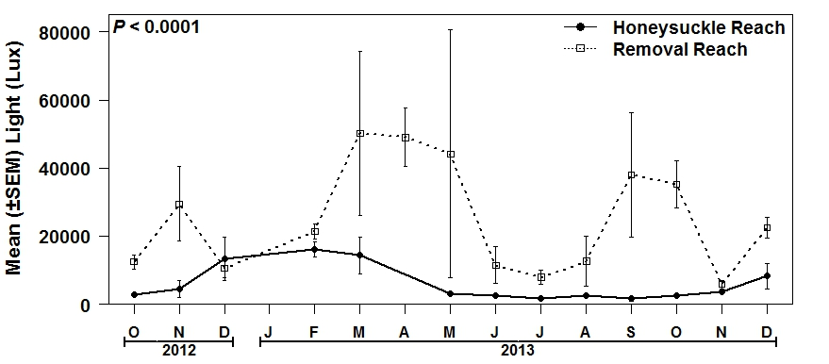

Fig. S2
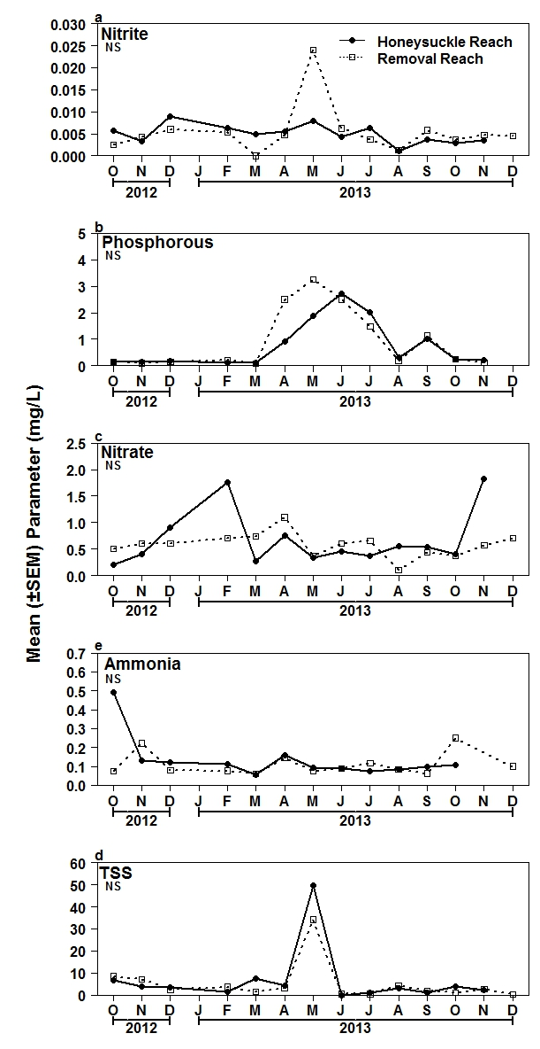

Fig. S3
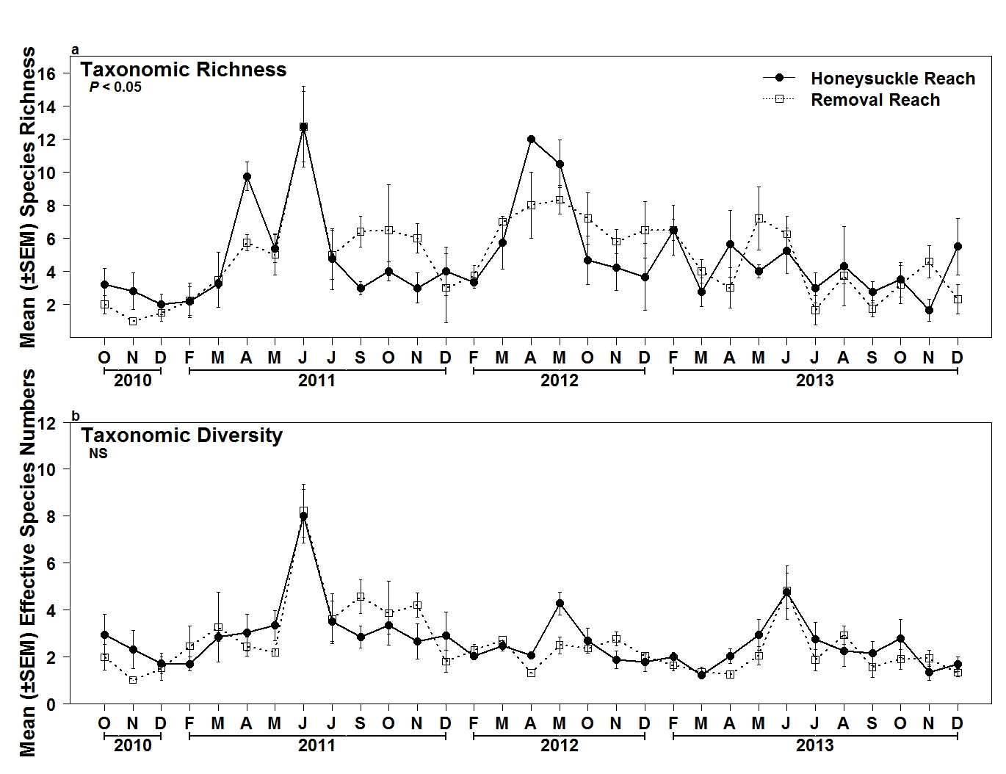

Fig. S4
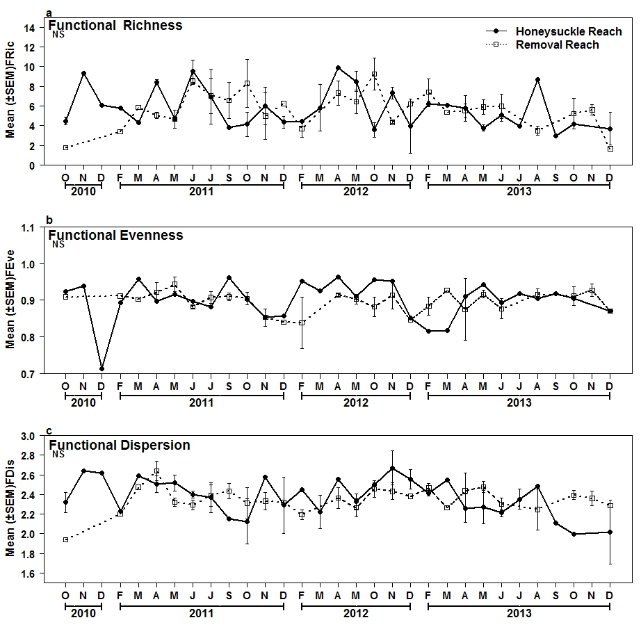

Fig. S5

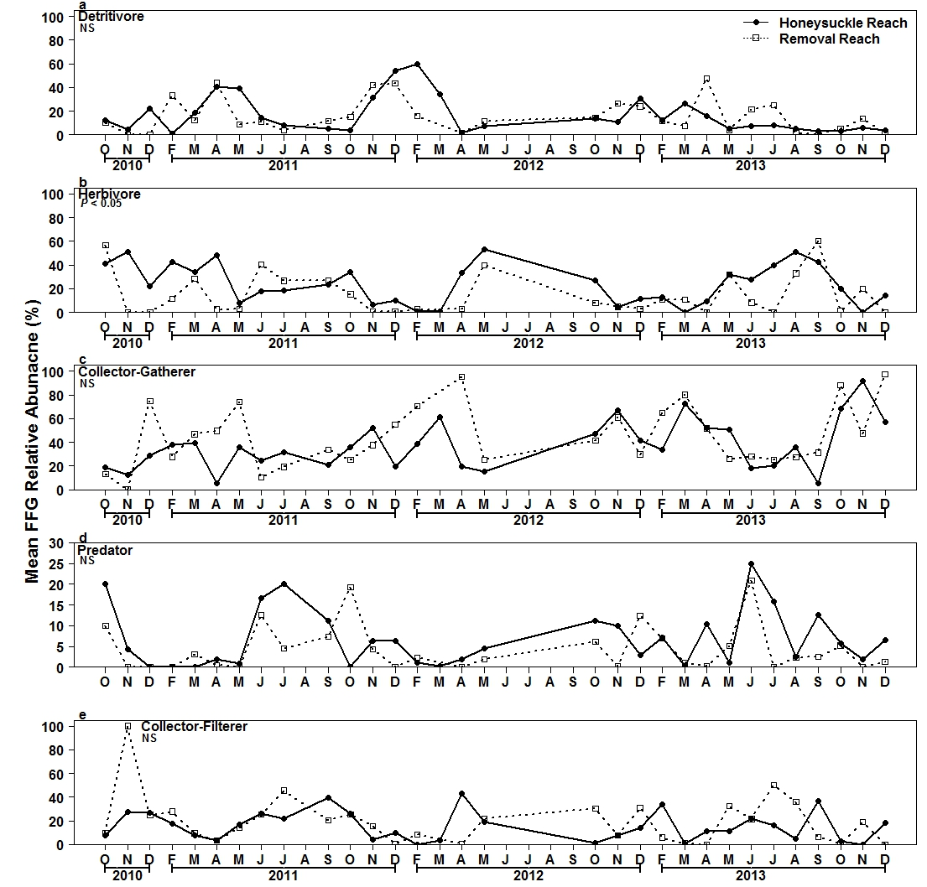

∗ First and third authors: PhD student and Associate Professor, Department of Biology, University of Dayton, Dayton, OH 45469; Second author: Associate Professor, Department of Entomology and Department of Osteopathic Medical Specialties, Michigan State University, East Lansing, MI 48824. Current address of first author: Post-doctoral Fellow, Department of Biology, Loyola University Chicago, Chicago, IL 60660. Corresponding author’s E-mail: rachel.e.mcneish@gmail.com

