Supplementary Table and Figures

Table S1 Pearson's correlation matrix of the Worldclim environmental variables calculated in ENMTools v. 1.3. Alt = altitude, BIO4 = temperature seasonality, BIO5 = maximum temperature of warmest month, BIO11 = mean temperature of coldest quarter, BIO12 = annual precipitation, BIO14 = precipitation of driest month, BIO15 = precipitation seasonality, BIO18 = precipitation of warmest quarter.

 | Alt | BIO1 | BIO4 | BIO5 | BIO6 | BIO11 | BIO12 | BIO14 | BIO15 | BIO18
Alt | 1.000
BIO1 | -0.529 | 1.000
BIO4 | -0.092 | -0.510 | 1.000
BIO5 | -0.377 | 0.829 | -0.125 | 1.000
BIO6 | -0.375 | 0.908 | -0.800 | 0.602 | 1.000
BIO11 | -0.335 | 0.941 | -0.768 | 0.680 | 0.986 | 1.000
BIO12 | -0.572 | 0.294 | -0.287 | -0.139 | 0.377 | 0.301 | 1.000
BIO14 | -0.483 | 0.293 | -0.197 | -0.055 | 0.320 | 0.269 | 0.814 | 1.000
BIO15 | 0.135 | -0.040 | 0.056 | 0.116 | -0.084 | -0.037 | -0.423 | -0.756 | 1.000
BIO18 | -0.604 | 0.276 | 0.104 | 0.001 | 0.147 | 0.135 | 0.721 | 0.715 | -0.373 | 1.000

Table S2 Minimum and maximum levels of all Worldclim bioclimatic variables, defined in Table 2, under current, 2040, and 2080 projections for all 7 climate models

 | BIO4 |  | BIO5 |  | BIO11 |  | BIO12 |  | BIO14 |  | BIO15 |  | BIO18
 | Min | Max | Min | Max | Min | Max | Min | Max | Min | Max | Min | Max | Min | Max
Alternanthera philoxeroides Current | 1659 | 10683 | 134 | 456 | -79 | 212 | 46 | 2066 | 0 | 154 | 7 | 104 | 1 | 660
Limnophila sessiliflora Current | 2878 | 9241 | 258 | 394 | 15 | 212 | 170 | 1994 | 1 | 142 | 9 | 91 | 84 | 660
Salvinia molesta Current | 1659 | 10554 | 134 | 456 | -127 | 212 | 46 | 2066 | 0 | 154 | 6 | 104 | 1 | 660
CCCMA_CGCM31 2040 | 1639 | 12689 | 85 | 480 | -123 | 225 | 39 | 3620 | 0 | 159 | 6 | 121 | 1 | 660
CSIRO_MK30 2040 | 1778 | 12402 | 83 | 477 | -120 | 226 | 49 | 3643 | 0 | 156 | 5 | 137 | 0 | 645
IPSL_CM4 2040 | 1554 | 12626 | 87 | 478 | -117 | 222 | 43 | 3645 | 0 | 158 | 6 | 127 | 1 | 652
MPI_ECHAM5 2040 | 1733 | 12483 | 82 | 475 | -125 | 228 | 46 | 3424 | 0 | 163 | 4 | 107 | 1 | 698
NCAR_CCSM30 2040 | 1676 | 13024 | 89 | 483 | -127 | 224 | 23 | 3276 | 0 | 155 | 6 | 142 | 0 | 602
UKMO_HADCM3 2040 | 1834 | 13265 | 117 | 488 | -133 | 227 | 50 | 3205 | 0 | 162 | 7 | 108 | 1 | 633
UKMO_HADGEM1 2040 | 1969 | 12570 | 96 | 481 | -122 | 226 | 59 | 3315 | 0 | 156 | 5 | 142 | 1 | 658
CCCMA_CGCM31 2080 | 1607 | 12480 | 111 | 503 | -99 | 237 | 35 | 3856 | 0 | 153 | 7 | 142 | 1 | 645
CSIRO_MK30 2080 | 1888 | 11912 | 106 | 505 | -104 | 239 | 51 | 3900 | 0 | 152 | 6 | 154 | 0 | 651
IPSL_CM4 2080 | 1445 | 12358 | 115 | 498 | -92 | 231 | 37 | 3904 | 0 | 153 | 7 | 154 | 0 | 635
MPI_ECHAM5 2080 | 1811 | 12050 | 106 | 493 | -98 | 242 | 44 | 3468 | 0 | 164 | 4 | 124 | 1 | 732
NCAR_CCSM30 2080 | 1692 | 13044 | 119 | 509 | -101 | 235 | 39 | 3206 | 0 | 151 | 8 | 148 | 0 | 650
UKMO_HADCM3 2080 | 1994 | 13530 | 174 | 518 | -111 | 240 | 56 | 3108 | 0 | 166 | 9 | 123 | 0 | 657
UKMO_HADGEM1 2080 | 2296 | 12206 | 132 | 505 | -108 | 239 | 67 | 3283 | 0 | 152 | 6 | 167 | 1 | 567

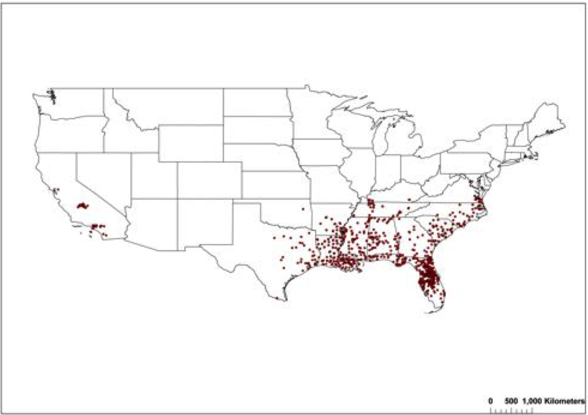
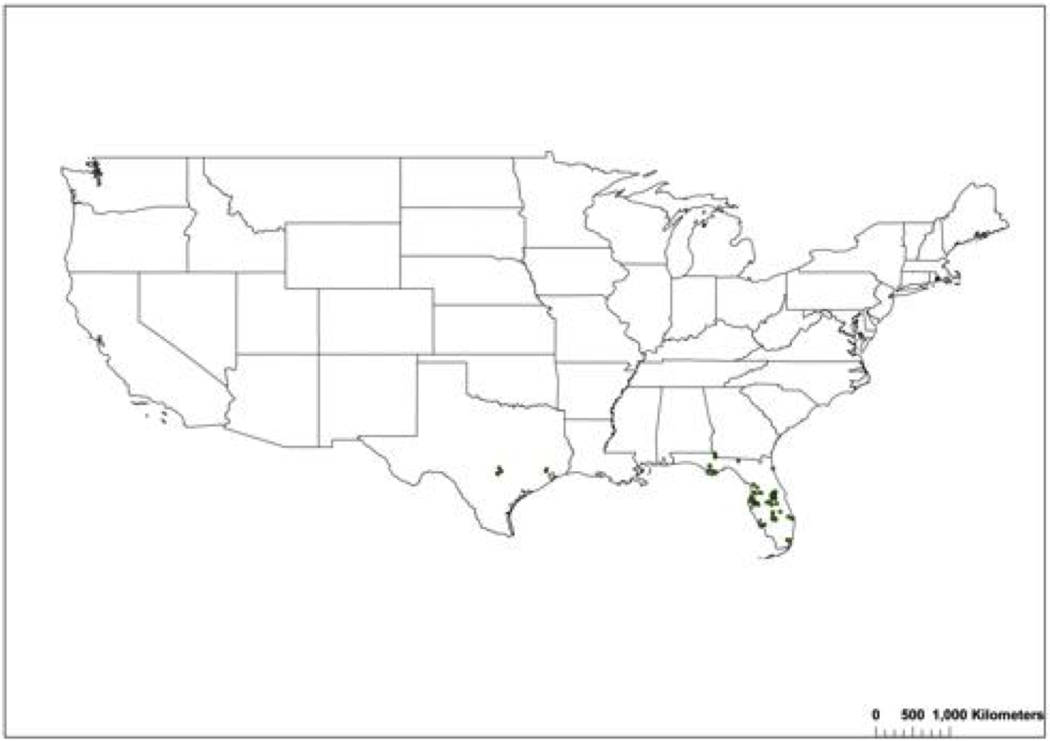
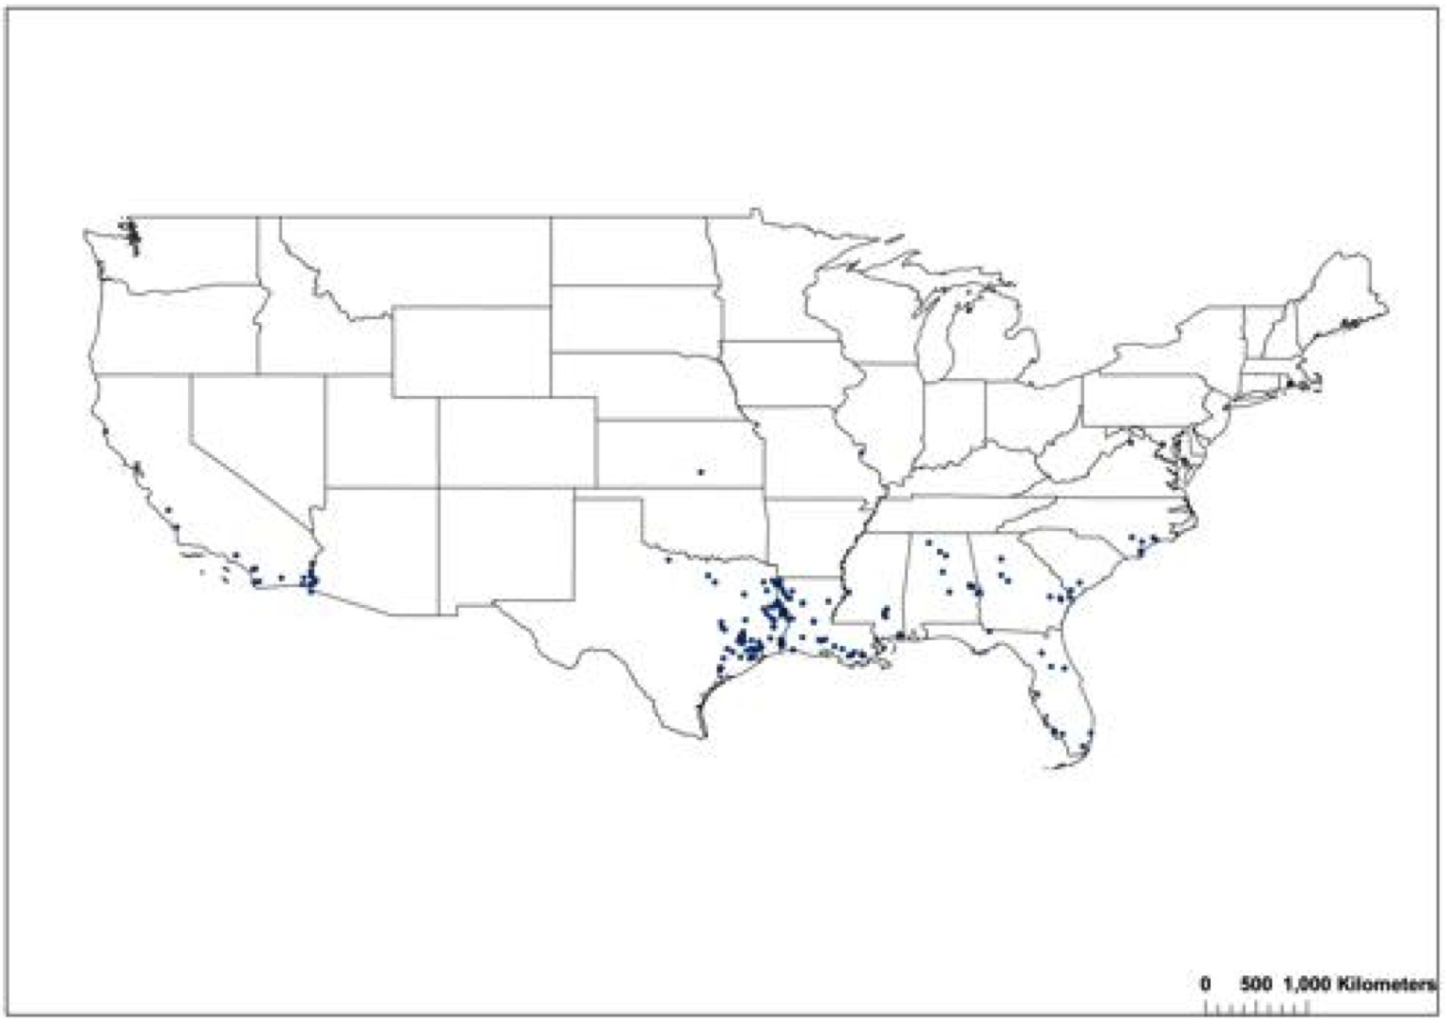
Fig. S1 Current point locations in the continental United States of three aquatic non-native invasive plants: Alternanthera philoxeroides (a), Limnophila sessiliflora (b), and Salvinia molesta (c)

