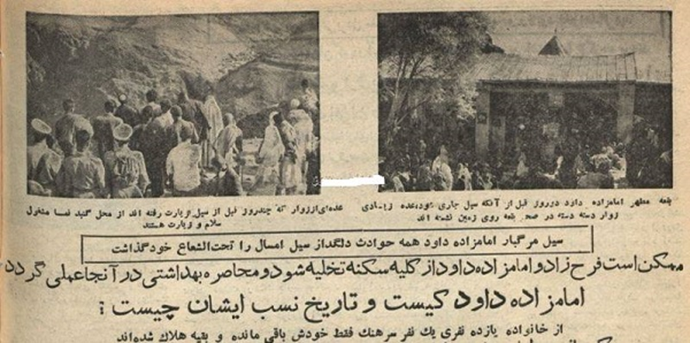
Figure 1: Newspaper image showing the deadly flood of Emamzadeh Davood in 1945.

