Online Supplementary Figure S1:
Theoretical Model of Pandemic Preparedness

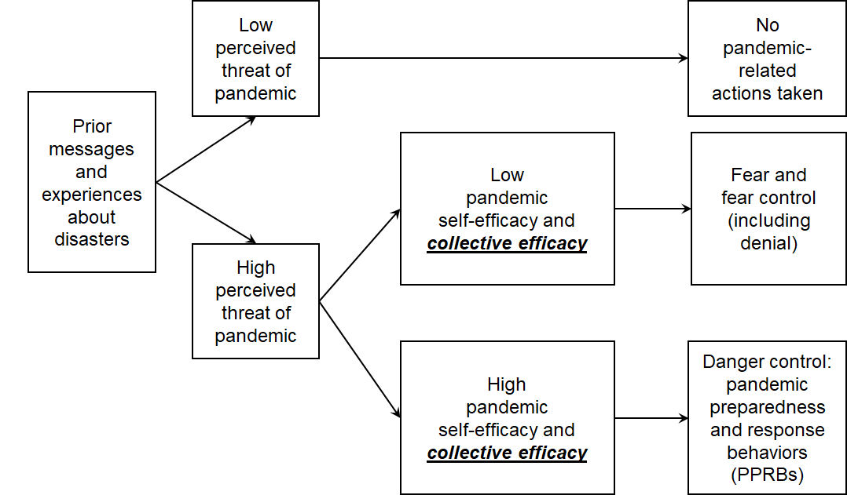

Figure notes. Adapted with permission, from Witte’s Extended Parallel Process Model¹ to be pandemic-specific and to incorporate collective efficacy.

SUPPLEMENTARY REFERENCE

¹ Witte K. Putting the fear back into fear appeals: The Extended Parallel Process Model. Commun Monogr. 1992;59(4):329-349. https://doi.org/10.1080/03637759209376276)

Online Supplementary Figure S2:
Components of the theoretical model supported in the present study

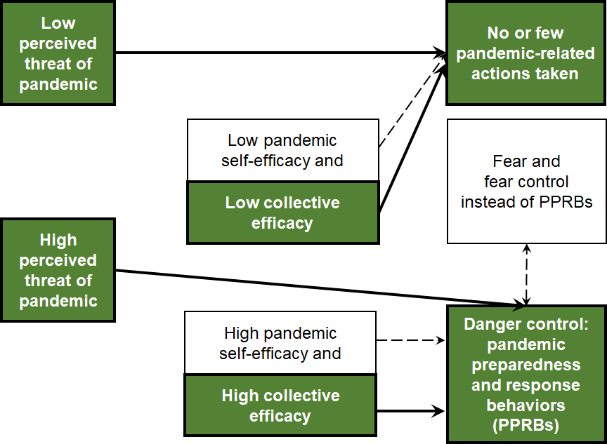

Figure notes. Adapted with permission, from Witte’s Extended Parallel Process Model¹ to be pandemic-specific and to incorporate collective efficacy. Bolded paths and green boxes show aspects of model that were supported for within-person effects; no between-person effects were supported. White boxes and dashed lines show aspects of the model that were not supported.

SUPPLEMENTARY REFERENCE

¹ Witte K. Putting the fear back into fear appeals: The Extended Parallel Process Model. Commun Monogr. 1992;59(4):329-349. https://doi.org/10.1080/03637759209376276)

Online Supplementary Material S3:
Questionnaire

These data were part of a larger study which included additional questionnaires in the survey. For more information on the questionnaire, please visit [redacted for blind review] or contact the corresponding author: [redacted].

Perceived Pandemic Severity

Compared to the “flu” (influenza) outbreaks each year, how severe do you think the COVID-19 outbreak is?
1 - Less serious than the yearly flu outbreak
2 - No more serious than the yearly flu outbreak
3 - A little more serious than the yearly flu outbreak
4 - Moderately more serious than the yearly flu outbreak
5 - Much more serious than the yearly flu outbreak

Scoring: this item should be scored on its own; do not combine with fear items. If used when a disaster or hazard is not ongoing, combination with perceived likelihood items is appropriate, such as those used in Tkachuck et al (2018) (as referenced for the self-efficacy questionnaire).

Recommended Citation: [redacted].

Fear of the Pandemic

How true have the following statements been about you over the past 7 days?

- Thinking about the coronavirus (COVID-19) makes me feel threatened.
- I am afraid of the coronavirus (COVID-19).
- I am not worried about the coronavirus (COVID-19). (R)
- I am worried that I or people I love will get sick from the coronavirus (COVID-19).
- I am stressed around other people because I worry I’ll catch the coronavirus (COVID-19).

Response options for all fear items:
1 - Not true of me at all | 2 - A little true | 3 - Somewhat true | 4 - True | 5 - Very true

Scoring: Item 3 is reverse scored as indicated; do not include “(R)” in survey text. Items are then summed, with higher scores indicating greater fear of the pandemic.

Recommended Citation for this version: [redacted].
Original citation: Conway LG, Woodard SR, Zubrod A. Social Psychological Measurements of COVID-19: Coronavirus Perceived Threat, Government Response, Impacts, and Experiences Questionnaires. Published April 7, 2020 [preprint]. Accessed April 15, 2020. https://doi.org/10.31234/osf.io/z2x9a

Pandemic Self-Efficacy Questionnaire

- I believe I can protect myself from the Coronavirus (COVID-19).
- I believe I can protect others from the Coronavirus (COVID-19).
- How confident are you that you know what to do in response to the Coronavirus (COVID-19) pandemic?

Response options for self-efficacy items 1-2 and collective efficacy items 1-4:
1 - Strongly disagree | 2 - Disagree | 3 - Neither/neutral | 4 - Agree | 5 - Strongly agree

Response options for self-efficacy item 3 and collective efficacy item 5:
1 - Not at all confident | 2 - Mostly not confident | 3 - Somewhat confident | 4 - Mostly confident | 5 - Very confident

Scoring: Items are summed. Higher scores indicate greater pandemic self-efficacy.

Recommended Citation for this version: [redacted].
Original citation for items 1-2: Krzyzanowski MC, Terry I, Williams D, West P, Gridley LN, Hamilton CM. The PhenX Toolkit: Establishing standard measures for COVID-19 research. Current Protocols. 2021;1:e111. https://doi.org/10.1002/cpz1.111/
Original citation for item 3: Tkachuck MA, Schulenberg SE, Lair EC. Natural disaster preparedness in college students: Implications for institutions of higher learning. J Am College Health. 2018;66(4):269-279. https://doi.org/10.1080/07448481.2018.1431897

Pandemic Collective Efficacy Questionnaire

Directions: Please respond to these questions about your community at [the University].

- During the Coronavirus (COVID-19) outbreak, despite work and family obligations, we can commit ourselves to common community goals.
- During the Coronavirus (COVID-19) outbreak, as a community, we can handle mistakes and setbacks without getting discouraged.
- During the Coronavirus (COVID-19) outbreak, I am confident that we can be united in the community vision we present to outsiders.
- During the Coronavirus (COVID-19) outbreak, the people of our community can continue to work together, even when it requires a great deal of effort.
- How confident are you that your community can work together to prevent the spread of COVID-19?

Response options for self-efficacy items 1-2 and collective efficacy items 1-4:
1 - Strongly disagree | 2 - Disagree | 3 - Neither/neutral | 4 - Agree | 5 - Strongly agree

Response options for self-efficacy item 3 and collective efficacy item 5:
1 - Not at all confident | 2 - Mostly not confident | 3 - Somewhat confident | 4 - Mostly confident | 5 - Very confident

Scoring: Items are summed. Higher scores indicate greater pandemic collective efficacy.

Recommended Citation for this version: [redacted].
Original citation for items 1-4: 10. Carroll JM, Rosson MB, Zhou J. Collective efficacy as a measure of community. Proc SIGCHI Conf Hum Factor Comput Syst. April 2005:1-10. https://doi.org/10.1145/1054972.1054974
Original citation for item 5: Tkachuck MA, Schulenberg SE, Lair EC. Natural disaster preparedness in college students: Implications for institutions of higher learning. J Am College Health. 2018;66(4):269-279. https://doi.org/10.1080/07448481.2018.1431897

Pandemic Preparedness and Response Behaviors (PPRBs) Checklist

Social Checklist

In the past 7 days, have you...? (Check all that apply)
- 1. Gone to a friend, neighbor or relative’s house (that is not your own) (R)
- 2. Had more than 10 friends, neighbors or relatives over to your housing (R)
- 3. Gone to a gathering where there were more than 10 people (R)
- 4. Remained in your residence at all times, except for essential activities or exercise (4)
- 5. Shared items like towels or utensils with other people (R)
- 6. Had close contact (within 6 feet) with people who do not live in your dorm room or apartment (R)
- 7. Cancelled travel you were supposed to do this week
- 8. Been in complete isolation/quarantine, with no face-to-face contact with any people at all

Sanitation Checklist

In the past 7 days, have you...? (Check all that apply)
- 1. Cleaned high-touch surfaces in the home like door handles, faucets, and remote controls
- 2. Cleaned high-touch electronics like your smart phone, computer, tablet or laptop
- 3. Increased your use of alcohol-based hand sanitizer
- 4. Washed hands for 20 seconds or more after being in public

Other Pandemic Behaviors Checklist

In the past 7 days, have you...? (Check all that apply)
- 1. Worn a face mask around people you don’t live with
- 2. Tried to touch your face less
- 3. Stayed at home when you were sick
- 4. Read or watched guidelines for what to do to prevent COVID-19
- 5. Read or watched guidelines for what to do if you have COVID-19
- 6. Followed other government guidelines or rules to stay at home and limit contacts with other people

Scoring: Endorsed items are scored 1 and items can be summed. (R) indicates reverse-scored item in which endorsement of item = score of 0, no endorsement = score of 1. Do not include “(R)” in survey text.

Recommended Citation: [redacted].
Items are based on CDC guidelines spring 2020: Centers for Disease Control. Coronavirus (COVID-19). Published March 2020. Accessed March and April 2020. https://www.cdc.gov/coronavirus/2019-ncov/index.html

