Supplementary Materials: Late surges in COVID-19 cases and varying transmission potential partially due to public health policy changes in 5 Western states, March 10, 2020–January 10, 2021

Xinyi Hua†, MPH; Aubrey R. D. Kehoe†, MPH; Joana Tome†, MPH; Mina Motaghi†, MD, MPH; Sylvia K. Ofori, DrPH; Po-Ying Lai, MS; Sheikh Taslim Ali, PhD; Gerardo Chowell, PhD; Anne C. Spaulding, MD, MPH; Isaac Chun-Hai Fung*, PhD.

Affiliations:
- Department of Biostatistics, Epidemiology and Environmental Health Sciences, Jiann-Ping Hsu College of Public Health, Georgia Southern University, Statesboro, GA, USA (X. Hua, A. R. D. Kehoe, J. Tome, M. Motaghi, S. K. Ofori, I.C.H. Fung)
- Department of Biostatistics, School of Public Health, Boston University, Boston, MA, USA (P.Y. Lai)
- WHO Collaborating Centre for Infectious Disease Epidemiology and Control, Division of Epidemiology and Biostatistics, School of Public Health, LKS Faculty of Medicine, The University of Hong Kong, Hong Kong Special Administrative Region, China (S.T. Ali)
- Laboratory of Data Discovery for Health, Hong Kong Science and Technology Park, Hong Kong Special Administrative Region, China (S.T. Ali)
- Department of Population Health Sciences, School of Public Health, Georgia State University, Atlanta, GA, USA (G. Chowell)
- Department of Epidemiology, Rollins School of Public Health, Emory University, Atlanta, GA, USA (A.C. Spaulding)
*Corresponding author: Isaac Chun-Hai Fung, PhD. Email: cfung@georgiasouthern.edu
† Xinyi Hua, Aubrey R. D. Kehoe, Joana Tome, and Mina Motaghi serve as co-first authors.

Appendix A. Data cleaning: handling negative incident case counts

Dates with negative case counts were identified (i.e., when public health agencies made corrections to their cumulative case counts at a specific date or dates). Daily case counts were adjusted to remove negative counts that were created when states adjusted their positive cases; for instance, a state would record negative cases in order to account for a previous over-count. To remove these negative counts all data was reviewed, and negative counts were transformed into a zero count by removing this number from the previous days with positive cases until there was no discrepancy. We adjusted the negative daily case counts at both state and county levels in all five states in this study.

Appendix B. Assessing power-law relationship using linear regression of log-transformed per capita cumulative case count and log-transformed population size.

If we assume that a power-law relationship exists between the cumulative case count (C) and the population size (N), with an exponent g, i.e., C = N^g, and that per capita cumulative case count, P = C/N, then,

$$g=\frac{log C }{log N }=\frac{log (PN) }{log N }=\frac{log P }{log N }+\frac{log N }{log N }=\frac{log P }{log N }+1$$
Thus,
$$\frac{log P }{log N }=g-1=m$$

Where m is the slope of the regression line between log₁₀-transformed per capita cumulative case count and log₁₀-transformed population size.

In contrast, it is important to note that the regression model between log₁₀-transformed per capita cumulative case count and log₁₀-transformed population density does not assume a power-law relationship between cumulative case count and population density.

Appendix C. The detailed description for R_{t} in North Dakota, South Dakota, Idaho, Montana, and Wyoming.

North Dakota. The daily reported cases of COVID-19 in North Dakota started to increase since July 2020, reaching a peak of 2,270 new cases in early November and 2,340 new cases in early December (Figure 3). The 7-day-sliding-window R_{t} stayed above 1 almost all year around and went below 1 in late May and in December. The governor’s executive orders and State Health Officers’ orders (Supplemental Table 2) throughout 2020 were chosen to create the policy change R_{t} throughout the year (Figure 3). From March 16, 2020 till April 4, 2020, the 7-day-sliding-window R_{t} decreased toward 1 but was still above 1 meaning that the promotion of physical distance was working. On April 18, 2020, the State Health Officer released the quarantine order for the Grand Forks county, and subsequently on May 14, 2020, they issued the testing order for Grand Forks county. In late May, the 7-day-sliding-window R_{t} fell below 1 where the coverage of the testing order expanded further. From June till November both the 7-day-sliding-window R_{t} and policy change R_{t} maintained a level above 1 which corresponded to the lifted quarantine order, the rescinded close contact quarantine order, and the permission of health care workers who are asymptomatically infected with SARS-CoV-2 to work in care facilities. From mid-November, the 7-day-sliding-window R_{t} and policy change R_{t} fell below 1, which corresponded to the release of the first mask order, and the allowance of team practice, bars and restaurant to resume normal hours.

South Dakota. From March 1, 2020 through January 1, 2021 South Dakota had 103,318 confirmed COVID-19 cases cumulatively. The daily reported cases of South Dakota had one late surge, peaking in November 2020 (Figure 3). Within South Dakota, there were eight policies or recommendations for COVID-19 precautions were implemented, five major ones can be found in Supplemental Table 2. The 7-day-sliding window R_{t} estimate fell below 1 on April 4, 2020 following the closure of the Smithfield pork processing plant in Sioux Falls, Minnehaha, South Dakota.¹ The policy change R_{t} estimate remained below 1 until April 28, 2020 when South Dakota implemented their Back to Normal Plan which largely focuses on good hygiene practices and limiting persons in large numbers. From August 13 till September 25, 2020 the policy change R_{t} estimates increased to above 1 when South Dakota K-12 school reopened in person. The 95% credible intervals (CrI) of 7-day-sliding window R_{t} estimates in March 2020 were wide due to the small numbers of daily new cases. Meanwhile, during the periods between April 28, 2020 and August 13, 2020 and between September 25, 2020 and January 10, 2021 there were very few policy changes; the policy change R_{t} estimates may not accurately depict the true R_{t} estimates during those periods.
Idaho. From March 1, 2020 to January 1, 2021, Idaho’s daily reported case number revealed two major surges of new cases in July and November 2020 (Figure 3). The policy change R_{t} estimates based on statewide policy changes demonstrate the effectiveness of the non-pharmaceutical interventions (face masking, social distancing, prohibited gathering of more than 10 people, etc.) of controlling the spread of COVID-19 within the state of Idaho. The policy change R_{t} estimates dropped below 1 after the Statewide Stay Home order was in place between March 25, 2020 and April 30, 2020. The statewide policy change R_{t} estimates increased above 1 between May 1, 2020 and October 26, 2020, with the Stay Healthy Order relaxation of the controlling measures from stage 1 (encourage vulnerable individuals to stay at home, avoid public and private gathering, and avoid and minimize non-essential travels) to stage 4 (open all business, allow public gathering with any size and resume non-essential travel). With the Stay Healthy Order stage 3 in effect on October 27, 2020, the policy change R_{t} estimates dropped again and continued to drop below one, after the Stay Healthy Order moved from stage 3 back to stage 2 with more restrictions on November 14, 2020. Overall, Idaho demonstrated an extensive community transmission of SARS-CoV-2 transmission in the study period.

Montana. The number of incident cases in Montana had a surge in November 2020 with up to 1,622 daily cases in mid-November (Figure 3). The 7-day-sliding-window R_{t} curve and the policy change R_{t} curve show some significant changes over time parallel with implementing different COVID-19 related policies (Figure 3). There was a drastic drop in the 7-day-sliding-window R_{t} estimates after closing businesses and the stay-at-home orders at the end of March, leading to R_{t} estimates under 1 from late March until early May. An increase in 7-day-sliding-window R_{t} was observed in the first days of May as the state lifted the stay-at-home order, reopened schools and started the first phase of reopening businesses (such as some retails, restaurants, casinos, and bars). There was a decrease in policy change R_{t} estimates in mid-July after the statewide mask requirement was applied, with a slight rise in September, probably due to the start of schools’ Fall semester. In November after applying new restrictions on gatherings and also placing time and capacity limitations for bars and restaurants, the policy change R_{t} estimates dropped again below 1 and remained low, mostly till late December.
Wyoming. From March 1, 2020 to January 1, 2021, Wyoming’s daily reported case number revealed one major surge of new cases in October and November 2020 (Figure 3). The policy change R_{t} estimates based on statewide policy changes demonstrated the necessity of the non-pharmaceutical interventions (face masking, social distancing, reduction in the size of public gathering, etc.) of controlling the spreading of COVID-19 within the state of Wyoming. For instance, the R_{t} estimates stayed around and above 1 while the state opened up all businesses without face mask mandate and public gathering restrictions. The 7-day-sliding-window R_{t} estimates then dropped below 1 after the Seventeenth Continuation and Modification Statewide Public Health Order regarding the public gathering with no more than 25 people on November 19, 2020. With the first public health order regarding mandatory face covering in effect on December 7, 2020, the policy change R_{t} estimates maintained below one. Overall, Wyoming demonstrated an extensive community transmission of SARS-CoV-2 transmission in the study period.

Appendix D: Detailed R_{t} description for North Dakota, South Dakota, Idaho, Montana, and Wyoming regarding School reopening.

North Dakota. North Dakota decided to reopen schools and universities on June 1st, 2020.² There are around 21 universities in the state located in Cass, Grand Forks, Ward, Burleigh, Stark, Stutsman, Trail, Mountrail, Bottineau, Benson, Barnes, Pierce, Dickey, Sioux, and Rolette counties.³ During the year of 2020, in most of the counties, the case number starts to increase at the end of the summer, peaking in November. Concretely, in Ward, Burleigh, Stark, Trail, and Sioux counties, the reported cases started to increase in July; in Cass, Grand Forks, Stutsman, Barnes counties, the reported cases started to increase in August; in Mountrail, Bottineau, and Benson counties the reported cases started to increase in September, while for the Pierce, Dickey, and Rolette counties, the daily reported case count started to increase in October, peaking in November. For most of the counties, the R_{t} stays at one during all the summer-fall period, except for some fluctuations (above and below one) in Grand Forks, and an R_{t} greater than one for Burleigh (where the state capital is located), and Dickey or Pierce (over one till the end of October). This description may be related to college students returning to school because the increase in the daily reported case count corresponds to the start of the fall semester in North Dakota. However, after November, new cases infected with SARS-CoV-2 and R_{t} starts to fall, which correspond to the issued mask order.

South Dakota. Some South Dakota schools began to offer in-person classes in June, but most schools did not begin face-to-face instruction for the mid-August fall semester.⁴ The state is home to four technical institutes, six state universities, six tribal colleges and universities, and six private colleges and universities; of these, six located in Minnehaha county, three in Pennington county, two schools located in Davison and Brown counties respectively, and one in Lawrence, Lake, Codington, Yankton, Oglala Lakota, Todd, Roberts, Brookings, and Clay counties respectively.⁵ Following the mid-August openings nine of these counties had an R_{t} that remained above 1 for between 7-14 days and four had R_{t} values that fluctuated both below and above 1. However, it is important to note that many of these counties have a very small population with small daily incident case count, which resulted in wide CrIs for R_{t} estimates around this time period. This initial increases in R_{t} and case count might be related to the return of students to in-person learning. In most counties with colleges and universities the epidemiologic increases seen in mid-August transitioned into the overall state-level fall surge that peaked around November. It is also noteworthy that the Sturgis Motorcycle Rally was held in Meade County, South Dakota, August 7-16, 2020, which coincide with the school reopening on August 13, 2020. Therefore, it is difficult to attribute the increase in Rt to a single policy decision (schools reopening) or a single mass gathering (Sturgis Motorcycle Rally). Both could have been factors involved; please refer to the discussion in the Limitations section in the main text.

Idaho. Idaho schools opened on-site instruction for the fall 2020 semester with a framework on decision making based on four different levels of community transmission.⁶ The state is home for four public colleges and 4-year universities, four regional community colleges, and eight private colleges and universities. Of these, four located in Boise, two in Moscow, two in Nampa, two in Idaho Falls, and one in Rexburg, Caldwell, Meridian, Twin Falls, Pocatello, Lewiston, McCall, and Coeur d’Alene respectively.⁷ Following the mid-August openings, Boise County had an R_{t} fluctuated below and above 1 but mainly above 1; however, the daily case counts were very small, less than 15, therefore the CrI of R_{t} was wide. Boise County is a college town for four colleges and universities. These small daily case counts may relate to effective non-pharmaceutical interventions or issues of underreporting.

Montana. Montana was one of the 2 states that resumed in-person instructions in schools in the academic year 2019-2020, on May 7, 2020.⁸ As seen in Figure 3, R_{t} rose above one from early May and stayed high until mid-July which reflected the impact of this policy in the state, in contrast to most of the other states of the county. There are more than 20 colleges and universities in Montana, with approximately 40,000 students, in Gallatin county, Yellowstone county, Hill county, Missoula county, Silver Bow county, Beaverhead county, Dawson county, Flathead county, Custer county, Lewis and Clark county, Cascade county, and tribal colleges in the counties of Blaine, Glacier, Rosebud, Roosevelt, Big Horn, Lake and Hill.⁹ Fall semester 2020 started in the second half of August in almost all of these academic institutions with online and on campus courses, using new guidelines to improve safety of students. No significant change in R_{t} was observed in these counties after the Fall openings.

Wyoming. Wyoming K-12 schools, colleges and universities, and trade schools were reopened in limited on-site instructions on May 7, 2020, and later fully opened for face-to-face on-site instruction on June 10, 2020.¹⁰ The state is home for one 4-year university, eight public colleges, one tribal college, and two private colleges. Except for the University of Wyoming and Wyoming Technical Institute located in Laramie, the rest of the colleges scatter across different counties.¹¹ Following the reopening in June, Laramie County had an R_{t} spike of 4 and R_{t} fluctuated below and above 1 but mainly above 1 between June and December, and R_{t} dropped below 1 between December and January. The largest daily case count was 246 on November 14, 2020. The trend of R_{t} and case count increase might be related to the school resumed face-to-face instruction in June and following fall semester.

Linear regression between log₁₀-transformed per capita cumulative case number (ccn) and log₁₀-transformed population size by county for North Dakota, South Dakota, Idaho, Montana, and Wyoming, on June 30th, August 31st, October 31st, and December 31st, 2020 (date of report) are presented in Figures S1-S5.

Figure S1. Linear regression between log₁₀-transformed per capita cumulative case number (ccn) and log₁₀-transformed population size by county for North Dakota (53 counties), on June 30th, August 31st, October 31st, and December 31st, 2020 (date of report). Counties that were outliers (defined as below 2.5 percentile or above 97.5 percentile of the distribution of the log₁₀-transformed per capita ccn) were marked in red.

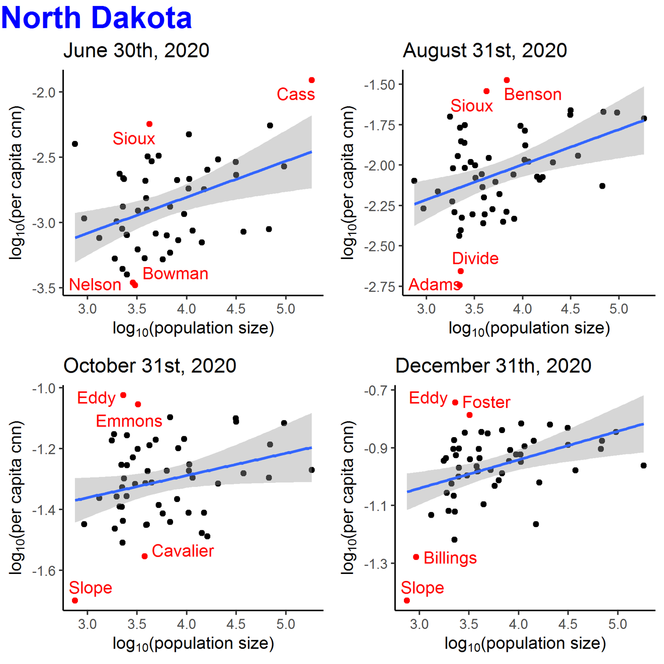

Figure S2. Linear regression between log₁₀-transformed per capita cumulative case number (ccn) and log₁₀-transformed population size by county for South Dakota (66 counties), on June 30th, August 31st, October 31st, and December 31st, 2020 (date of report). Counties that were outliers (defined as below 2.5 percentile or above 97.5 percentile of the distribution of the log₁₀-transformed per capita ccn) were marked in red.

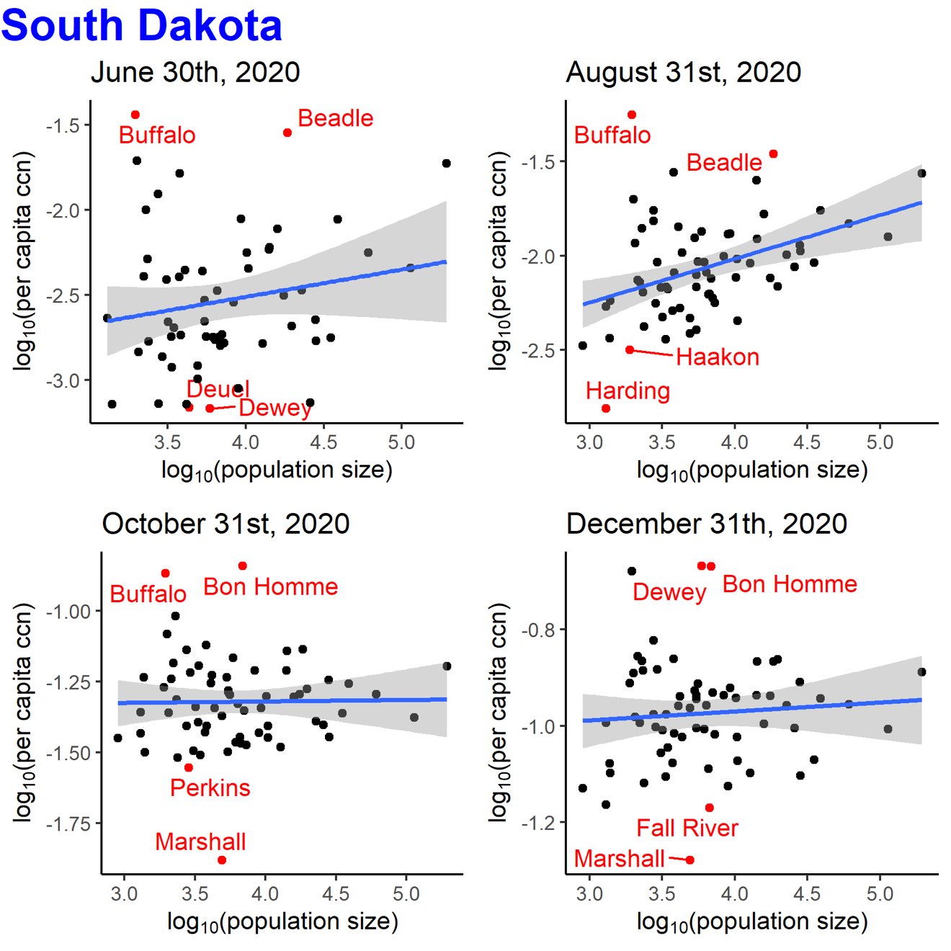

Figure S3. Linear regression between log₁₀-transformed per capita cumulative case number (ccn) and log₁₀-transformed population size by county for Idaho (44 counties), on June 30th, August 31st, October 31st, and December 31st, 2020 (date of report). Counties that were outliers (defined as below 2.5 percentile or above 97.5 percentile of the distribution of the log₁₀-transformed per capita ccn) were marked in red.

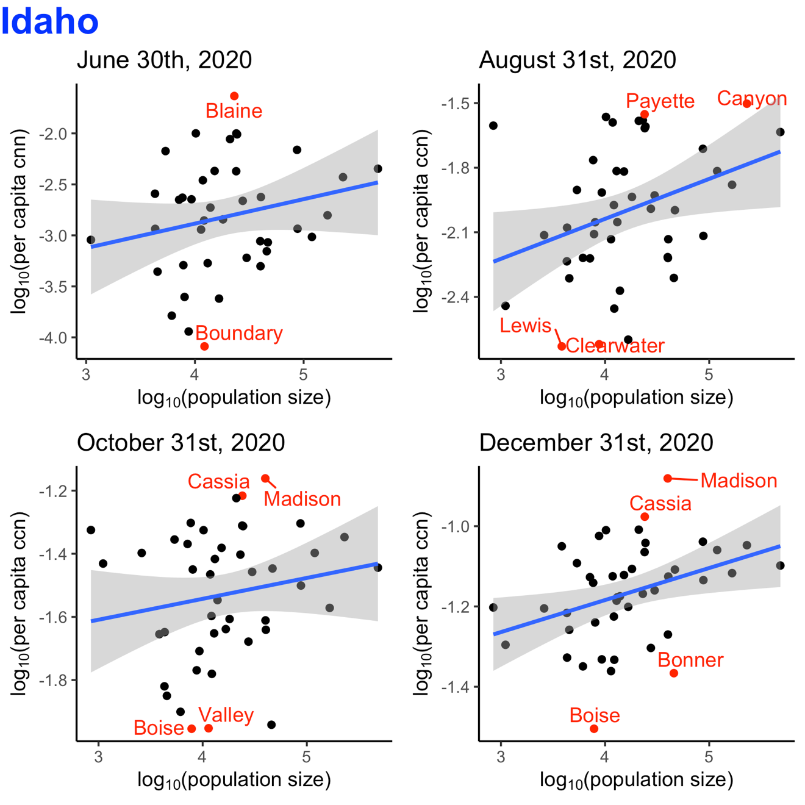

Figure S4. Linear regression between log₁₀-transformed per capita cumulative case number (ccn) and log₁₀-transformed population size by county for Montana (56 counties), on June 30th, August 31st, October 31st, and December 31st, 2020 (date of report). Counties that were outliers (defined as below 2.5 percentile or above 97.5 percentile of the distribution of the log₁₀-transformed per capita ccn) were marked in red.

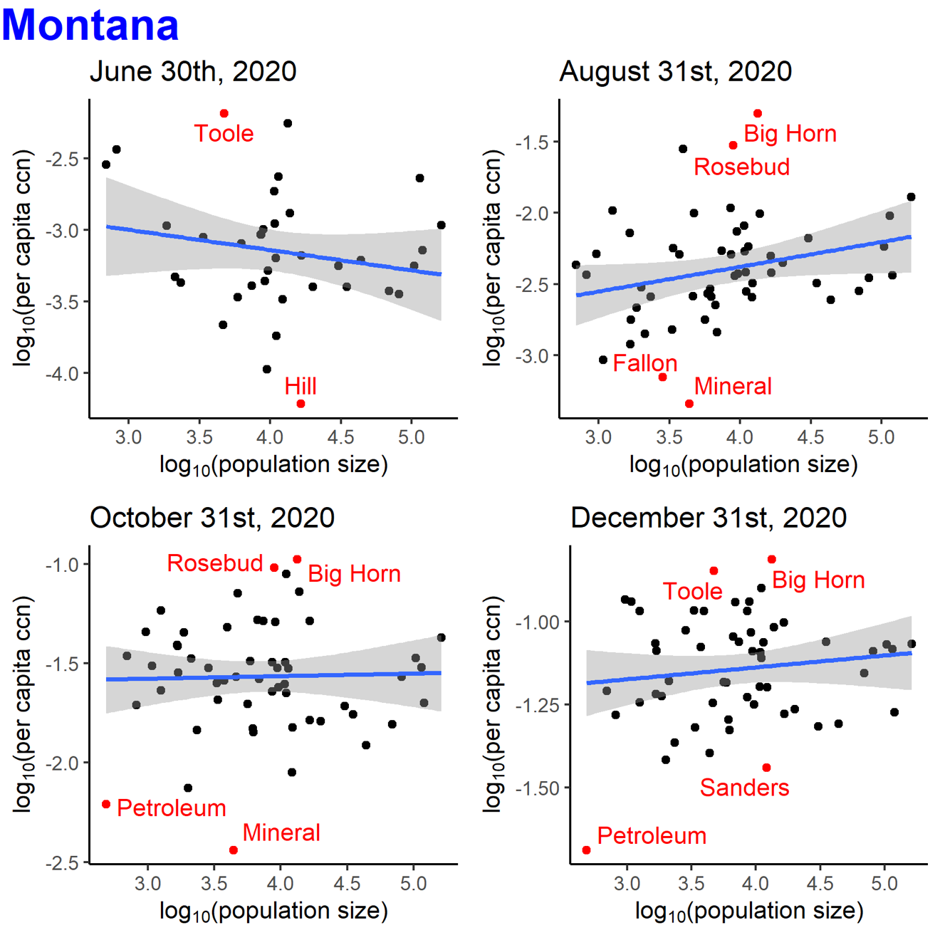

Figure S5. Linear regression between log₁₀-transformed per capita cumulative case number (ccn) and log₁₀-transformed population size by county for Wyoming (23 counties), on June 30th, August 31st, October 31st, and December 31st, 2020 (date of report). Counties that were outliers (defined as below 2.5 percentile or above 97.5 percentile of the distribution of the log₁₀-transformed per capita ccn) were marked in red.

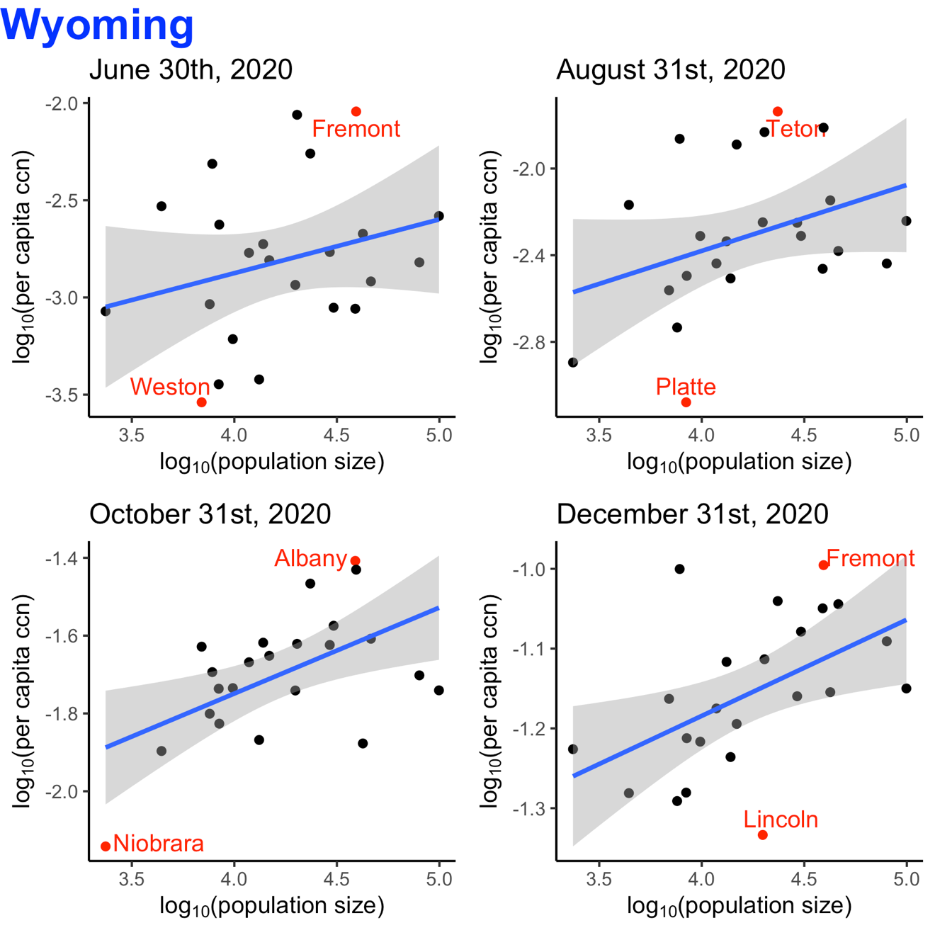

Figure S6. Correlation plots of the variables in the linear regression model between log₁₀-transformed per capita incident case count and log₁₀-transformed population size in Idaho.

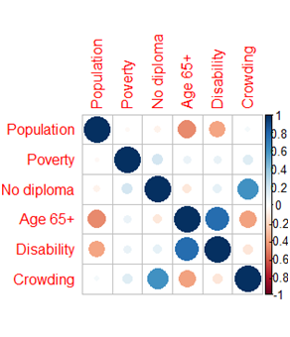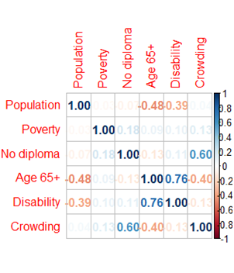

Figure S7. Correlation plots of the variables in the linear regression model between log₁₀-transformed per capita incident case count and log₁₀-transformed population size in Montana.

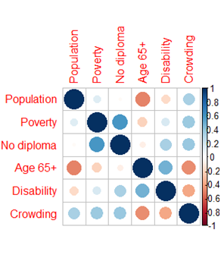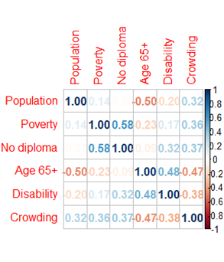

Figure S8. Correlation plots of the variables in the linear regression model between log₁₀-transformed per capita incident case count and log₁₀-transformed population size in North Dakota.

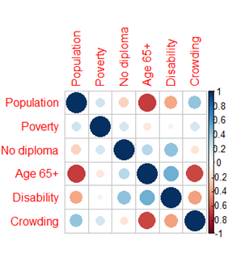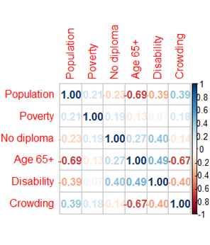

Figure S9. Correlation plots of the variables in the linear regression model between log₁₀-transformed per capita incident case count and log₁₀-transformed population size in South Dakota.

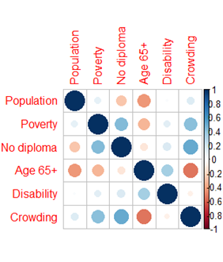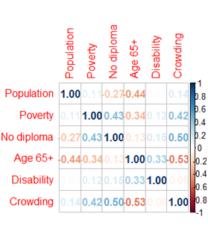

Figure S10. Correlation plots of the variables in the linear regression model between log₁₀-transformed per capita incident case count and log₁₀-transformed population size in Wyoming.

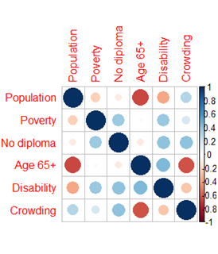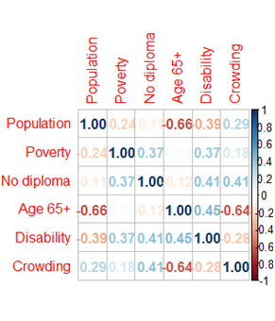

Supplemental Table 1. List of counties in North Dakota, South Dakota, Idaho, Montana, and Wyoming (organized by state).¹²
State | Counties
North Dakota (53 counties) | Adams, Barnes, Benson, Billings, Bottineau, Bowman, Burke, Burleigh, Cass, Cavalier, Dickey, Divide, Dunn, Eddy, Emmons, Foster, Golden Valley, Grand Forks, Grant, Griggs, Hettinger, Kidder, LaMoure, Logan, McHenry, McIntosh, McKenzie, McLean, Mercer, Morton, Mountrail, Nelson, Oliver, Pembina, Pierce, Ramsey, Ransom, Renville, Richland, Rolette, Sargent, Sheridan, Sioux, Slope, Stark, Steele. Stutsman, Towner, Traill, Walsh, Ward, Wells, Willams.
South Dakota (66 counties) | Aurora, Beadle, Bennett, Bon Homme, Brookings, Brown, Brule, Buffalo, Butte, Campbell, Charles Mix, Clark, Clay, Codington, Corson, Custer, Davison, Day, Deuel, Dewey, Douglas, Edmunds, Fall River, Faulk, Grant, Gregory, Haakon, Hamlin, Hand, Hanson, Harding, Hughes, Hutchinson, Hyde, Jackson, Jerauld, Jones, Kingsbury, Lake, Lawrence, Lincoln, Lyman, McCook, McPherson, Marshall, Meade, Mellette, Miner, Minnehaha, Moody, Oglala Lokota, Pennington, Perkins, Potter, Roberts, Sanborn, Spink, Stanley, Sully, Todd, Tripp, Turner, Union, Walworth, Yankton, Ziebach.
Idaho (44 counties) | Ada, Adams, Bannock, Bear Lake, Benewah, Bingham, Blaine, Boise, Bonner, Bonneville, Boundary, Butte, Camas, Canyon, Caribou, Cassia, Clark, Clearwater, Custer, Elmore, Franklin, Fremont, Gem, Gooding, Idaho, Jefferson, Jerome, Kootenai, Latah, Lemhi, Lewis, Lincoln, Madison, Minidoka, Nez Perce, Oneida, Owyhee, Payette, Power, Shoshone, Teton, Twin Falls, Valley, Washington.
Montana (56 counties) | Beaverhead, Big Horn, Blaine, Broadwater, Carbon, Carter, Cascade, Chouteau, Custer, Daniels, Dawson, Dear Lodge, Fallon, Fergus, Flathead, Gallatin, Garfield, Glacier, Golden Valley, Granite, Hill, Jefferson, Judith Basin, Lake, Lewis and Clark, Liberty, Lincoln, McCone, Madison, Meagher, Mineral, Missoula, Musselshell, Park, Petroleum, Phillips, Pondera, Powder River, Powell, Prairie, Ravalli, Richland, Roosevelt, Rosebud, Sanders, Sheridan, Silver Bow, Stillwater, Sweet Grass, Teton, Toole, Treasure, Valley, Wheatland, Wibaux, Yellowstone.
Wyoming (23 counties) | Albany, Big Horn, Campbell, Carbon, Converse, Crook, Fremont, Goshen, Hot Springs, Johnson, Laramie, Lincoln, Natrona, Niobrara, Park, Platte, Sheridan, Sublette, Sweetwater, Teton, Uinta, Washakie, Weston.

Supplemental Table 2: Control measures implemented by state government agencies in North Dakota, South Dakota, Idaho, Montana, and Wyoming, USA
 | Label | Date (mm/dd/yyyy) | Implemented measure(s)
North Dakota | A | 03/16/2020 | Executive Order 2020-04.1. The governor amended school closure order for certain schools and programs.¹³
 | B | 03/30/2020 | Executive Order 2020-10.1. The governor enabled remote participation for public meetings to promote physical distancing. He amended school facilities closure to accommodate child care needs and suspended deadlines for livestock auctions, pesticide applicators, and public libraries.¹⁴
 | C | 05/26/2020 | Testing Order | Long Term Care. The State Health Officer Order for testing for 2019-nCoV/COVID-19 as a Disease Control Measures to prevent the spread 2019-nCoV/COVID-19.¹⁵
 | D | 09/21/2020 | Order #2020-02.4 | Lifted Travel Quarantine Order. The State Health Officer Order lifted the 14-day quarantine order for those returning from international travel.¹⁶
 | E | 11/13/2020 | Order #2020-08 | Mask Order. The mask order required face coverings in indoor businesses and indoor public settings, as well as in outdoor business and public settings when it was not possible to maintain physical distancing.¹⁷  Executive Order 2020-43. The governor enacted mitigation measures for food service, events, sports, and extracurricular activities.¹⁸
 | F | 12/21/2020 | The governor amended the order to allow restaurants and bars to resume normal hours.¹⁹
South Dakota | A | 3/13/2020 | State of emergency declared, executive state government workers given work from home order and restricted out of state travel (EO# 2020-05); K-12 schools closed for the rest of the year; higher education encouraged to close campus; and long-term care facilities implemented visitor restrictions.²⁰
 | B | 4/6/2020 | All residents shall review and practice CDC COVID-19 guidelines; all employers, local, and municipal government shall implement CDC COVID-19 guidelines to encourage telework, social distancing, and reduced numbers; all healthcare workers shall prepare for increased COVID-19 cases (EO# 2020-12)²¹; stay-at-home order except for essential workers and essential outings for all Minnehaha and Lincoln “vulnerable individuals” (EO# 2020-13).²²
 | C | 4/28/2020 | All citizens shall implement “back to normal plan” leaving COVID-19 precautions up to each resident, employers, and schools; ended Minnehaha and Lincoln “vulnerable individuals” stay-at-home order; (EO# 2020-20).²³
 | D | 8/13/2020 | All K-12 schools were mandated by the South Dakota Governor to start in-person classes again.²⁴
 | E | 9/25/2020 | Long-term care facilities began to relax visitor restrictions.²⁴
Idaho | A | 3/25/2020 | Statewide stay-home order. This isolation order required Idaho residents to stay and work from home as much as possible while ensuring all essential services and business remain available. This isolation order did not prohibit outdoor activity such as walking, hiking, running, and biking, but a safe distance of six (6) feet must be kept between those who do not live in the same household.²⁵
 | B | 5/1/2020 | Stay Healthy Order-Stage 1: Businesses and governmental agencies resumed operations at physical locations in the state of Idaho except for those businesses identified in this order. All businesses must adhere to the social distancing and sanitation requirement. Certain individuals entering Idaho required self-quarantine for 14 days. Gathering, both public and private, should be avoided. Non-essential travel should be avoided or minimized.²⁶
 | C | 6/13/2020 | Stay Healthy Guidelines-Stage 4: Gathering of any sizes were allowed but should adhere to the physical distancing and sanitation requirements. Non-essential travel could resume.²⁷
 | D | 10/27/2020 | Stay Health Order-Stage 3: Indoor and outdoor gathering, both public and private must adhere to the requirement identified in this order. Patrons of bars, nightclubs, and restaurants must remain seated. Face coverings were required at long-term care facilities.²⁸
 | E | 11/14/2020 | Stay Health Order-Stage 2: Gathering of more than 10 people, both public and private, were prohibited, including attendance at extracurricular activities such as sporting events. People at increased risk for severe illness living in the state of Idaho were strongly encouraged to stay home and limit their movement outside of their place of residence.²⁹
Montana³⁰ | A | 3/13/2020 | State of Emergency declared and directive implementing Executive Orders 2-2020 and 3-2020 and providing for measures to combat the spread of COVID-19 Novel Coronavirus.  Court closure.
 | B | 5/7/2020 | School reopened.
 | C | 7/15/2020 | Statewide mask requirement required individuals to wear masks inside certain businesses and at outdoor gatherings of greater than 50 people where social distancing was not possible.
 | D | 9/1/2020 | Schools’ Fall semester began.
 | E | 11/18/2020 | Additional mitigation measures. Gatherings were limited to 25 people when social distancing is not possible. Bars, restaurants, and casinos will have a 10 p.m. curfew every night and were limited to 50% capacity.
Wyoming | A | 3/13/2020 | Statewide Public Health Order #1. Closed all restaurants, bars, theaters, gymnasiums, childcare facilities, K-12 schools, colleges, universities, and trade schools, in the State of Wyoming, with certain exceptions. This Order was effective immediately and shall remain in effect until April 3, 2020.³¹
 | B | 4/28/2020 | Statewide Public Health Order, 3rd Continuation and Modification. This order authorized gymnasiums and childcare facilities to reopen under certain conditions. This order was effective on May 1, 2020 and shall remain in effect through May 15, 2020. Forbade gathering for 10 people or more.^{32,33}
 | C | 6/10/2020 | Statewide Public Health Order, 6th Continuation and Modification. This order authorized K-12 schools, colleges, universities, and trade schools to provide on-site instruction to students and allow others to use of their facilities under certain conditions. Forbade gathering for 50 people or more.^{10,34}
 | D | 7/13/2020 | Statewide Public Health Order, 8th Continuation and Modification. This order removed some conditions and restrictions that were applicable to restaurants.^{35,36}
 | E | 10/14/2020 | Statewide Public Health Order, 13th Continuation and Modification. This order required patrons at different tables (at restaurants/bars) to be seated at least 6 feet apart and did not apply to booths, and patrons could be in groups up to 8 instead of 6. This order also authorized groups of attendees seated or standing together during an event in groups of 8 instead of 6. Forbade gathering for 50 people or more.^{37,38}
 | F | 12/7/2020 | Statewide Public Health Order #4. Required face coverings in certain places, with exceptions. This order was effective on December 9, 2020, and shall remain in effect through January 8, 2021.³⁹

Supplemental Table 3. The slope (and 95% Confidence Intervals) of the regression line between log₁₀- transformed per capita cumulative case count and log₁₀-transformed population size, by state: North Dakota, South Dakota, Idaho, Montana, and Wyoming, USA, on June 30, August 31, October 31, and December 31, 2020.
 | June 30, 2020 | August 31, 2020 | October 31, 2020 | December 31, 2020
North Dakota | 0.2758  (0.0961, 0.4554) | 0.2171  (0.0846, 0.3496) | 0.0729  (0.0014, 0.1443) | 0.0986  (0.0366, 0.1605)
South Dakota | 0.1603  (-0.0766, 0.3972) | 0.2322  (0.1018, 0.3627) | 0.0052  (-0.0794, 0.0898) | 0.0186  (-0.0402, 0.0774)
Idaho | 0.2398  (-0.1067, 0.5863) | 0.1857  (0.0261, 0.3497) | 0.0662  (-0.0498, 0.1822) | 0.0798  (0.0150, 0.1446)
Montana | -0.1423  (-0.3975, 0.1130) | 0.1741  (-0.0028, 0.3510) | 0.0129  (-0.1170, 0.1428) | 0.0359  (-0.0397, 0.1116)
Wyoming | 0.2765  (-0.1647, 0.7178) | 0.3043  (-0.0544, 0.6630) | 0.2210  (0.0659, 0.3761) | 0.1206  (0.0274, 0.2138)

Supplemental Table 4. The slope (and 95% Confidence Intervals) of the regression line between log₁₀-transformed per capita cumulative case count and log₁₀-transformed population per kilometer, by state: North Dakota, South Dakota, Idaho, Montana, and Wyoming, USA, on June 30, August 31, October 31, and December 31, 2020.
 | June 30, 2020 | August 31, 2020 | October 31, 2020 | December 31, 2020
North Dakota | 0.2986  (0.0888, 0.5084) | 0.2495  (0.0953, 0.4038) | 0.0974  (0.0155, 0.1793) | 0.1473  (0.0803, 0.2144)
South Dakota | 0.1797  (-0.0383, 0.3977) | 0.2273  (0.1127, 0.3418) | 0.0316  (-0.0438, 0.1069) | 0.0369  (-0.0152, 0.0889)
Idaho | 0.2338  (-0.0369, 0.5045) | 0.1455  (0.0093, 0.2817) | 0.0741  (-0.0204, 0.1685) | 0.0808  (0.0293, 0.1322)
Montana | -0.1323  (-0.4108, 0.1462) | -0.0071  (-0.1973, 0.1831) | -0.0265  (-0.1631, 0.1100) | 0.0273  (-0.0526, 0.1073)
Wyoming | 0.1995  (-0.3225, 0.7215) | 0.2150  (-0.2181, 0.6481) | 0.2084  (0.0172, 0.3996) | 0.1285  (0.0182, 0.2389)

Supplemental Table 5. The adjusted linear regression model between log₁₀-transformed per capita incident case count and log₁₀-transformed population size for Idaho, March 2020 -January 2021*
Variables | Parameter Estimate | Standard Error | t-Statistic | P-value
Population | 0.102 | 0.029 | 3.472 | 0.0005
Below poverty estimate percentage | 0.005 | 0.003 | 1.687 | 0.0917
No high school diploma percentage | 0.018 | 0.003 | 5.752 | <0.0001
Age 65+ percentage | -0.096 | 0.005 | -1.880 | 0.0603
Population with disability percentage | 0.003 | 0.005 | 0.693 | 0.4883
Above minority cut-off point | 0.155 | 0.041 | 3.825 | 0.0001
Crowding percentage | -0.034 | 0.010 | -3.422 | 0.0006
*Note: adjusted for weeks

Supplemental Table 6. The adjusted linear regression model between log₁₀-transformed per capita incident case count and log₁₀-transformed population size for Montana, March 2020 -January 2021*
Variables | Parameter Estimate | Standard Error | t-Statistic | P-value
Population | 0.008 | 0.025 | 0.309 | 0.7570
Below poverty estimate percentage | -0.008 | 0.003 | -2.564 | 0.0104
No high school diploma percentage | 0.005 | 0.004 | 1.509 | 0.1314
Age 65+ percentage | -0.004 | 0.004 | -0.958 | 0.3384
Population with disability percentage | -0.112 | 0.005 | -2.101 | 0.0357
Above minority cut-off point | 0.113 | 0.035 | 3.263 | 0.0011
Crowding percentage | 0.033 | 0.007 | 4.636 | <0.0001
*Note: adjusted for weeks

Supplemental Table 7. The adjusted linear regression model between log₁₀-transformed per capita incident case count and log₁₀-transformed population size for North Dakota, March 2020 -January 2021*
Variables | Parameter Estimate | Standard Error | t-Statistic | P-value
Population | 0.165 | 0.038 | 4.370 | 0.0003
Below poverty estimate percentage | -0.0001 | 0.003 | -0.484 | 0.6286
No high school diploma percentage | 0.006 | 0.004 | 1.481 | 0.1387
Age 65+ percentage | -0.001 | 0.004 | -0.182 | 0.8556
Population with disability percentage | 0.005 | 0.006 | 0.914 | 0.3610
Above minority cut-off point | 0.066 | 0.039 | 1.702 | 0.0889
Crowding percentage | 0.008 | 0.011 | 1.749 | 0.4537
*Note: adjusted for weeks

Supplemental Table 8. The adjusted linear regression model between log₁₀-transformed per capita incident case count and log₁₀-transformed population size for South Dakota, March 2020 -January 2021*
Variables | Parameter  Estimate | Standard Error | t-Statistic | P-value
Population | 0.120 | 0.003 | 3.815 | 0.0293
Below poverty estimate percentage | -0.003 | 0.001 | -2.181 | 0.0001
No high school diploma percentage | 0.017 | 0.005 | 3.731 | 0.0002
Age 65+ percentage | -0.012 | 0.004 | -3.417 | 0.0006
Population with disability percentage | 0.000 | 0.005 | 0.004 | 0.9971
Above minority cut-off point | 0.009 | 0.025 | 0.351 | 0.7260
Crowding percentage | -0.006 | 0.004 | -1.508 | 0.1318
*Note: adjusted for weeks

Supplemental Table 9. The adjusted linear regression model between log₁₀-transformed per capita incident case count and log₁₀-transformed population size for Wyoming, March 2020 -January 2021*
Variables | Parameter Estimate | Standard Error | t-Statistic | P-value
Population | 0.281 | 0.063 | 4.435 | <0.0001
Below poverty estimate percentage | 0.007 | 0.005 | 1.385 | 0.1665
No high school diploma percentage | -0.015 | 0.011 | -1.334 | 0.0183
Age 65+ percentage | 0.007 | 0.007 | 1.026 | 0.3050
Population with disability percentage | 0.027 | 0.105 | 2.605 | 0.0093
Above minority cut-off point | 0.032 | 0.052 | 0.628 | 0.5301
Crowding percentage | 0.107 | 0.016 | 6.533 | <0.0001
*Note: adjusted for weeks

References:

1. Smithfield Foods. Smithfield Foods To Close Sioux Falls, SD Plant Indefinitely Amid COVID-19. https://www.smithfieldfoods.com/press-room/company-news/smithfield-foods-to-close-sioux-falls-sd-plant-indefinitely-amid-covid-19. Published 2020. Accessed February 28, 2021, 2021.
2. School responses in North Dakota to the coronavirus (COVID-19) pandemic during the 2020-2021 school year. https://ballotpedia.org/School_responses_in_North_Dakota_to_the_coronavirus_(COVID-19)_pandemic_during_the_2020-2021_school_year. Accessed March 1, 2021.
3. National Center for Education Statistics. College Navigator for North Dakota. https://nces.ed.gov/collegenavigator/?s=ND&pg=1. Accessed March 1, 2021.
4. Toman J, Mercer T. Public Universities Adjust Fall Semester Schedule https://www.sdbor.edu/mediapubs/New%20Press%20Releases/060320FallAdjust.pdf. Published 2020. Accessed February 28, 2021.
5. South Dakota Board of Regents Public Universities & Special Schools. Higher Education Institutions Web site. https://www.sdbor.edu/administrative-offices/infogovtrelations/Pages/South-Dakota-Higher-Education-Institutions.aspx. Published 2021. Accessed February 28, 2021.
6. Idaho State Board of Education. Idaho Back to School Framework Published 2021. Accessed February 28, 2021.
7. Idaho State Government. Colleges and Universities https://www.idaho.gov/education/colleges-universities/. Accessed February 28, 2021.
8. School responses to the coronavirus (COVID-19) pandemic during the 2020-2021 academic year https://ballotpedia.org/School_responses_to_the_coronavirus_(COVID-19)_pandemic_during_the_2020-2021_academic_year. Published 2021. Accessed February 28, 2021.
9. Montana University System. Colleges and Universities https://mus.edu/Universities/. Accessed February 28, 2021.
10. Wyoming State Health Officer. Statewide Public Health Order, 6th Continuation and Modification. . https://drive.google.com/file/d/1sQJbSSvr0ZnRKuKQ0kNbqsyyhYe99OzG/view. Published 2020. Accessed February 28, 2021.
11. List of Colleges and Universities in Wyoming. https://myschoolhelp.com/colleges-in-wyoming/. Accessed February 28, 2021.
12. The United States Census Bureau. County population totals 2010-2019. United States Census Bureau. https://www.census.gov/data/tables/time-series/demo/popest/2010s-counties-total.html. Published 2019. Accessed January 11, 2021.
13. North Dakota State Government. Executive Order 2020-04.1. https://www.governor.nd.gov/sites/www/files/documents/executive-orders/Executive%20Order%202020-04.1%20COVID-19.pdf. Published 2020. Accessed February 28, 2021.
14. North Dakota State Government. Executive Order 2020-10.1. https://www.governor.nd.gov/sites/www/files/documents/executive-orders/Executive%20Order%202020-10.1.pdf. Published 2020. Accessed February 28, 2021.
15. State of north Dakota Department of Health. Testing orders, Long Term Care. https://www.health.nd.gov/sites/www/files/documents/Files/MSS/coronavirus/State%20Health%20Officer%20Orders/05-27-2020%20Testing%20Orders.pdf. Published 2020. Accessed February 28, 2021.
16. State of North Dakota Department of Health. Lifted Travel Quarantine Order https://www.health.nd.gov/sites/www/files/documents/Files/MSS/coronavirus/State%20Health%20Officer%20Orders/2020_02.4_Lifted_Travel_Order.pdf. Published 2020. Accessed February 28, 2021.
17. State of North Dakota Department of Health. Mask Order. https://www.health.nd.gov/sites/www/files/documents/Files/MSS/coronavirus/State%20Health%20Officer%20Orders/2020-08_Mask_Order.pdf. Published 2020. Accessed February 28, 2021.
18. North Dakota State Government. Executive Order 2020-43. https://www.health.nd.gov/sites/www/files/documents/Files/MSS/coronavirus/State%20Health%20Officer%20Orders/2020-08_Mask_Order.pdf. Published 2020. Accessed February 28, 2021.
19. North Dakota State Government. Executive Order 2020-43.3. https://www.governor.nd.gov/sites/www/files/documents/Executive%20Order%202020-43.3.pdf. Published 2020. Accessed February 28, 2021.
20. State of South Dakota Office of the Governor. Executive Order 2020-05. https://covid.sd.gov/docs/2020-05.pdf. Published 2020. Accessed February 28, 2021.
21. State of South Dakota Office of the Governor. Executive Order 2020-12. https://covid.sd.gov/docs/2020-12.PDF. Published 2020. Accessed February 28, 2021.
22. State of South Dakota Office of the Governor. Executive Order 2020-13. https://covid.sd.gov/docs/2020-13.PDF. Published 2020. Accessed February 28, 2021.
23. State of South Dakota Office of the Governor. Executive Order 2020-20. https://covid.sd.gov/docs/2020-20.pdf. Published 2020. Accessed February 28, 2021.
24. Documenting South Dakota's path to recovery from the coronavirus (COVID-19) pandemic, 2020-2021. https://ballotpedia.org/Documenting_South_Dakota%27s_path_to_recovery_from_the_coronavirus_(COVID-19)_pandemic,_2020-2021. Published 2020. Accessed February 28, 2021.
25. Idaho Department of Health and Welfare. Statewide Stay Home Order. https://coronavirus.idaho.gov/wp-content/uploads/2020/06/statewide-stay-home-order_032520.pdf. Published 2020 Accessed February 28, 2021.
26. Idaho Department of Health and Welfare. Stay Healthy Order, Stage 1. https://coronavirus.idaho.gov/wp-content/uploads/2020/06/stay-healthy-order-stage1.pdf. Published 2020. Accessed February 28, 2021.
27. Idaho Department of Health and Welfare. Stay Healthy Guidelines, stage 4. https://rebound.idaho.gov/wp-content/uploads/stage4-stay-healthy-guidelines.pdf. Published 2020. Accessed February 28, 2021.
28. Idaho Department of Health and Welfare. Stay Healthy Order, Stage 3 Modified https://coronavirus.idaho.gov/wp-content/uploads/2020/10/stay-healthy-order-stage3_2020oct27.pdf. Published 2020. Accessed February 28, 2021.
29. Idaho Department of Health and Welfare. Stay Healthy Order, Stage 2 Modified https://coronavirus.idaho.gov/wp-content/uploads/2020/11/stage-2-modified-order.pdf. Published 2020. Accessed February 28, 2021.
30. Documenting Montana's path to recovery from the coronavirus (COVID-19) pandemic, 2020-2021. https://ballotpedia.org/Documenting_Montana%27s_path_to_recovery_from_the_coronavirus_(COVID-19)_pandemic,_2020-2021. Published 2020. Accessed February 28, 2021.
31. Wyoming State Health Officer. Statewide Public Health Order #1, Closures. https://drive.google.com/file/d/1qZ4MrBFvBxAXnyi4-vNo6CHCfGgS1wgO/view. Published 2020. Accessed February 28, 2021.
32. Wyoming State Health Officer. Statewide Public Health Order, 3rd Continuation and Modification. https://drive.google.com/file/d/1kDaNfjmewmUSuGscRQlI93SRPCzDduX_/view. Published 2020. Accessed February 28, 2021.
33. Wyoming State Health Officer. Statewide Public Health Order, 3rd Continuation and Modification (Gathering). https://drive.google.com/file/d/1BrGn4eoQCHG3-Prm87sqUOxG2Vp-whlM/view. Published 2020. Accessed February 28, 2021.
34. Wyoming State Health Officer. Statewide Public Health Order, 6th Continuation and Modification (Gathering). https://drive.google.com/file/d/1WBQpBzmWL3neZJKSdHlo-lin8C1msEqw/view. Published 2020. Accessed February 28, 2021.
35. Wyoming State Health Officer. Statewide Public Health Order, 8th Continuation and Modification. https://drive.google.com/file/d/1rDsIe2HHxZYybtuXpABimw8rUFoSyOIq/view. Published 2020. Accessed February 28, 2021.
36. Wyoming State Health Officer. Statewide Public Health Order, 8th Continuation and Modification (Gathering) https://drive.google.com/file/d/1LIm6_UudyJEbTK3NGL_x6KamMDzIZ4jl/view. Published 2020. Accessed February 28, 2021.
37. Wyoming State Health Officer. Statewide Public Health Order, 13th Continuation and Modification. https://drive.google.com/file/d/1J6VGUYFN3-N4I8NNO8-ci5_TwrheA1lT/view. Published 2020. Accessed February 28, 2021.
38. Wyoming State Health Officer. Statewide Public Health Order, 13th Continuation and Modification (Gathering). https://drive.google.com/file/d/1D-fu6mv72ZXIrcHJTDlrM3jzNyceXUQV/view. Published 2020. Accessed February 28, 2021.
39. Wyoming State Health Officer. Statewide Public Health Order#4: Requiring Face Coverings in Certain Places, with Exceptions. https://drive.google.com/file/d/1zDkPo6KLZ2HnJAZFYYQNH87wHS5jxCTq/view. Published 2020. Accessed February 28, 2021.

