Supplemental Materials: SARS-CoV-2 Transmission Potential and Policy Changes in South Carolina, February 2020 – January 2021

Margaret R. Davies, MPH†, Xinyi Hua, MPH†, Terrence D. Jacobs, MPH, Gabi I. Wiggill, Po-Ying Lai, MS, Zhanwei Du, PhD, Swati DebRoy, PhD, Sara Wagner Robb, PhD, Gerardo Chowell, PhD, Isaac Chun Hai Fung, PhD*
Department of Biostatistics, Epidemiology and Environmental Health Sciences, Jiann-Ping Hsu College of Public Health, Georgia Southern University (M. R. Davies, X. Hua, T. D. Jacobs, Gabi I. Wiggill, I.C.H. Fung); Department of Biostatistics, School of Public Health, Boston University (P.Y. Lai); Division of Epidemiology and Biostatistics, School of Public Health, LKS Faculty of Medicine, The University of Hong Kong (Z. Du); School of Science and Mathematics, University of South Carolina Beaufort (S. DebRoy); Department of Public Health Sciences, Clemson University (S. Wagner Robb); Department of Population Health Sciences, School of Public Health, Georgia State University (G. Chowell)

Corresponding author: Isaac Chun-Hai Fung, PhD. Email: cfung@georgiasouthern.edu

† MRD and XH contributed equally and they are co-first authors.

Appendix A: Handling of negative incident case count

A negative incident case count means the daily number of new cases reported being negative. This happened when the local public health department made an adjustment to the previously reported data by removing the duplicated cases or cases introduced by human errors. This usually resulted in a cumulative case count of the day being lower than the cumulative case count of the previous day, which translates into a negative incident case count. When negative cases appeared in the downloaded data, we used the previous day’s case data to bring the negative incidence to zero. In the instance when the previous day did not have enough cases to make the negative incidence zero, we worked backward until there were enough cases brought to the negative case count to equal it to zero.

Appendix B: Cumulative case count and Population size of a County

The power-law relationship between the county-level cumulative number of COVID-19 cases and population size can be transformed into a linear relationship between the log₁₀-transformed cumulative case count and the log₁₀-transformed population size as follows:^{1,2}

$$C=N^{g}$$
$$\log_{10}{C}=g\log_{10}{N}$$
$$\log_{10}{C}-\log_{10}{N}=g\log_{10}{N}-\log_{10}{N}$$
$$\log_{10}\left(C/N\right)=(g-1)\log_{10}{N}$$
$$\log_{10}{A}=m\log_{10}{N}$$

where the per capita cumulative case count A=C/N and the slope of the regression line, m = g-1.

In this paper, we performed linear regression models between log₁₀-transformed per capita cumulative case count and log₁₀-transformed population size of counties in South Carolina. The data analyzed were by the dates of report of June 30, August 31, October 31 and December 31, 2020. If the slope m is positive, it implies that counties with higher populations (i.e., urban counties) had a higher attack rate. If the slope is negative, it implied that counties with lower populations (i.e., rural counties) had a higher attack rate. If the slope is 0 (or if the 95% confidence interval includes 0), it implied that the attack rate was the same across the counties regardless of their population size.

Supplemental Figure 1: South Carolina Department of Health and Environmental Control (DHEC) region map. Regions are shown by color. Counties are labeled by name.
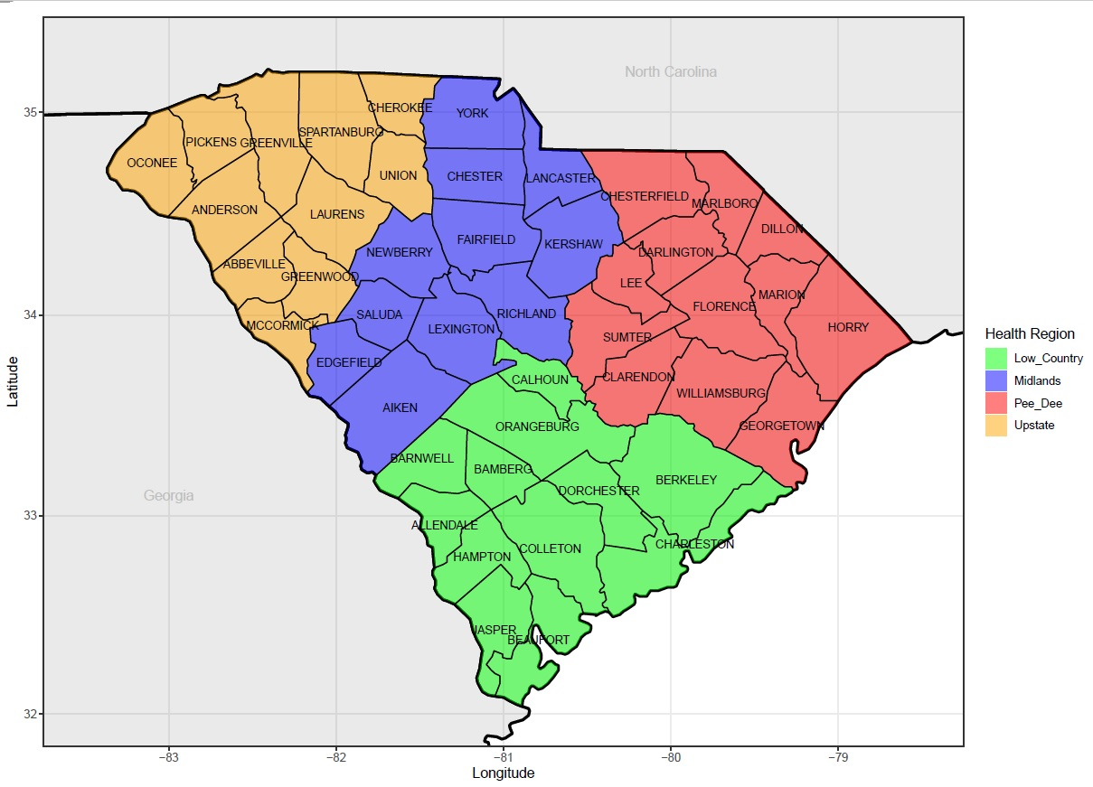

Supplemental Figure 2. Population map of South Carolina. The Department of Health and Environmental Control (DHEC) health regions are outlined by color as shown in the previous figure.
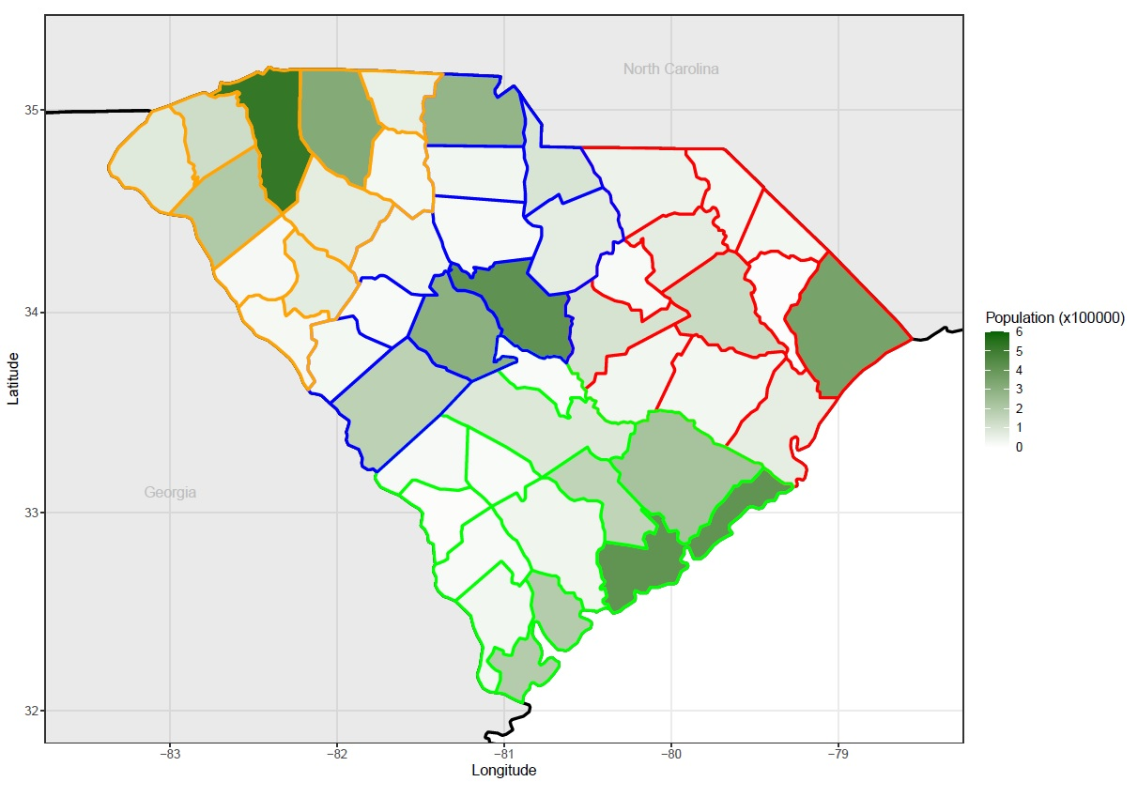

Supplemental Figure 3: Maps of South Carolina counties group in Public Health Districts (county line color: Low Country: Green; Midlands: Blue; Pee Dee: Red; Upstate: Yellow) by cumulative case count (top 4 maps), and cumulative case counts per 100,000 population (bottom 4 maps) in April, August, October, and December, 2020.
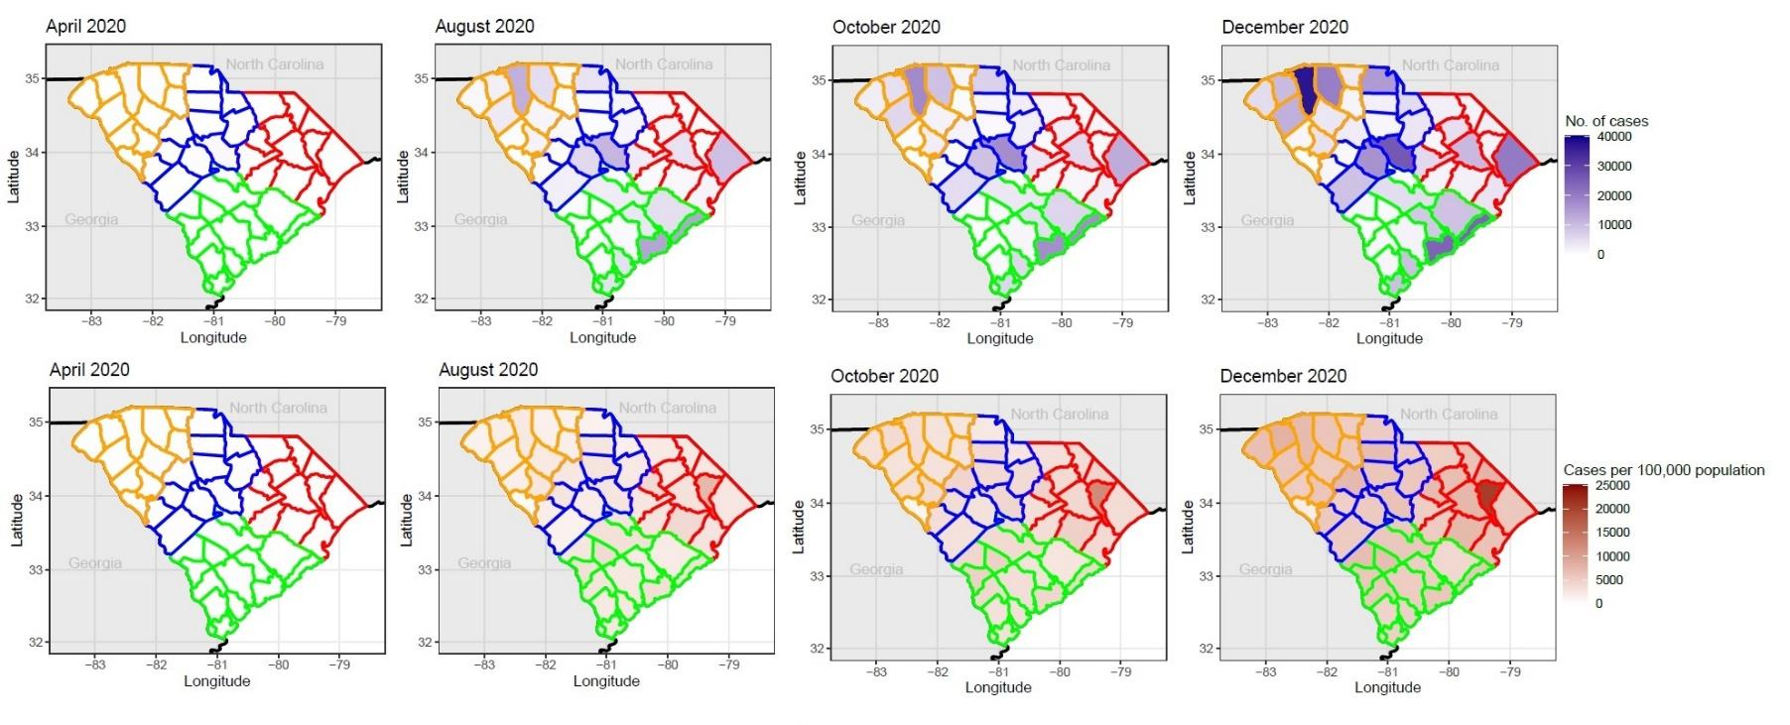

Supplemental Figure 4: Sensitivity analysis: The incidence data is shifted backward by 15 days to approximate the date of infection, assuming a combined 15-day time lag of the incubation period and delay in testing.

Supplemental Figure 5: Sensitivity analysis: The incidence data is shifted backward by 4 days to approximate the date of infection, assuming a combined 4-day time lag of the incubation period and delay in testing.

Supplemental Table 1. Difference in Policy Change R_{t} as policies changed at South Carolina (state level)

CrI, credible intervals. Policy Change R_{t} labels: C: Closure of schools, N: Closure of non-essential businesses, R: Reopening of non-essential businesses, M: state level mask mandate, S: Re-opening of schools (earliest reported date), L: Capacity limits on public gathering changed to 250.
 | Median Rt and 95%CrI | Median Rt difference percentage changes comparing with previous policy interval and 95% CrI
Before policy C | 1.991 (1.787, 2.21)
C N | 1.285 (1.24, 1.33) | -35.59% (-27.9%, -42.7%)
N R | 1.028 (1.01, 1.05) | -20.01% (-18.8% -21.2%)
R M | 1.05 (1.04, 1.06) | 2.07% (-0.217%, 4.2%)
M S | 0.889 (0.873, 0.905) | -15.3% (-13.6%, -16.8%)
S L | 0.998 (0.989, 1.01) | 12.3% (10.1%, 14.4%)
Beyond L | 1.098 (1.09, 1.1) | 9.994% (9.47%, 10.5%)

Supplemental Table 2. Difference in Policy Change R_{t} as policies changed at county levels in selected counties South Carolina. These nine counties were the only counties with an active mask ordinance during the study period.
 | Median Rt and 95%CrI | Median Rt difference percentage changes comparing with previous policy interval and 95%CrI
Beaufort
Before policy C | 1.5853 (0.985, 2.392)
C N | 1.1551 (0.99, 1.34) | -26.74% (-54.6%, 16.9%)
N R | 1.0214 (0.881, 1.175) | -11.58% (-11.0%, -12.1%)
R A | 1.2282 (1.17, 1.29) | 20.04% (2.54%, 40.03%)
A M | 0.9856 (0.946, 1.027) | -19.76% (-16.7%, -22.9%)
M S | 0.8903 (0.839, 0.944) | -9.65% (-5.07%, -13.29%)
S | 1.0916 (1.06, 1.12) | 22.57% (16.7%, 27.7%)
Calhoun
Before policy C | 0.6787 (0.0248, 3.6122)
C N | 1.2254 (0.426, 2.687) | 82.83% (-74.7%, 3840.2%)
N R | 1.6951 (0.841, 2.995) | 39.55% (-50.2%, 331.3%)
R M | 1.0495 (0.945, 1.161) | -38.51% (-66.4%, 24.1%)
M S | 0.6857 (0.461, 0.974) | -34.53% (-6.73%, -54.98%)
S A | 1.0737 (0.965, 1.19) | 56.29% (9.66%, 127. 21%)
A | 1.1009 (0.941, 1.278) | 2.82% (-12.8%, 22.0%)
Charleston
Before policy C | 2.4407 (1.73, 3.33)
C N | 1.1092 (0.987, 1.24) | -54.63% (-37.5%, -67.2%)
N R | 0.9840 (0.873, 1.104) | -11.28% (-11.0%, -11.6%)
R A | 1.2526 (1.22, 1.28) | 27.20% (12.3%, 42.8%)
A M | 0.8774 (0.855, 0.9) | -29.95% (-29.9%, -30.0%)
M S | 0.9621 (0.927, 0.998) | 9.68% (8.48%, 10.93%)
S | 1.0878 (1.07, 1.11) | 13.03% (10.9%, 15.1%)
Colleton
Before policy C | N/A
C N | 1.3111 (0.75, 2.1)
N R | 1.2956 (1.04, 1.59) | -0.39% (-41.5%, 76.4%)
R M | 1.0228 (0.95, 1.10) | -21.20% (-2.42%, -35.47%)
M S | 0.8782 (0.74, 1.03) | -13.97% (-27.06%, 0.89%)
S A | 1.0353 (0.943, 1.133) | 17.78% (-1.33%, 38.12%)
A | 1.1287 (1.05, 1.21) | 9.0% (-0.72%, 19.01%)
Georgetown
Before policy C | N/A
C N | 1.3747 (0.938, 1.93)
N R | 0.9440 (0.689, 1.256) | -31.32% (-49.23%, -8.12%)
R A | 1.1980 (1.11, 1.29) | 26.38% (-5.19%, 69.56%)
A M | 0.9596 (0.891, 1.032) | -19.90% (-12.8%, -26.5%)
M S | 0.8468 (0.762, 0.937) | -11.70% (-1.96%, -20.34%)
S | 1.1016 (1.06, 1.14) | 29.90% (15.6%, 45.1%)
Oconee
Before policy C | N/A
C N | 1.2685 (0.674, 3.497)
N R | 1.0058 (0.718, 2.06) | -20.10% (-58.8%, 60.5%)
R M | 1.0645 (0.992, 1.362) | 5.19% (-21.9%, 44.3%)
M A | 1.0591 (0.901, 1.235) | -0.31% (-14.8%, 16.0%)
A S | 1.0259 (0.89. 1.17) | -3.16% (-1.21%, -4.91%)
S | 1.0710 (1.04, 1.1) | 4.25% (-9.85%, 20.29%)
Orangeburg
Before policy C | 1.7667 (0.745, 3.459)
C N | 1.0927 (0.746, 1.534) | -38.22% (-71.0%, 49.6%)
N R | 1.1872 (1.0, 1.39) | 8.24% (-22.3%, 52.5%)
R A | 1.2002 (1.13, 1.28) | 0.86% (-13.8%, 18.7%)
A M | 0.9585 (0.908, 1.011) | -20.16% (-13.5%, -26.7%)
M S | 0.8447 (0.763, 0.932) | -11.86% (-0.553%, -21.27%)
S | 1.0972 (1.06, 1.14) | 29.67% (16.0%, 44.1%)
Richland
Before policy C | 1.7828 (1.31, 2.36)
C N | 1.3423 (1.22, 1.47) | -24.77% (-0.05%, -43.81%)
N R | 0.9701 (0.911, 1.031) | -27.73% (-19.2%, -35.8%)
R A | 1.1729 (1.14, 1.21) | 20.86% (15.3%, 26.0%)
A M | 0.9529 (0.922, 0.984) | -18.76% (-18.7%, -18.8%)
M S | 1.0434 (1.01, 1.08) | 9.49% (9.39%, 9.6%)
S | 1.0439 (1.03, 1.06) | 0.016% (-1.78%, 1.79%)
Williamsburg
Before policy C | N/A
C N | 1.2495 (0.715, 2.001)
N R | 1.0775 (0.941, 1.227) | -13.65% (-48.1%, 52.1%)
R A | 1.1342 (1.02, 1.26) | 5.21% (-2.99%, 13.39%)
A M | 1.0013 (0.912, 1.096) | -11.75% (-1.1%, -21.4%)
M S | 0.8692 (0.767, 0.98) | -13.14% (-1.43%, -23.29%)
S | 1.1264 (1.07, 1.19) | 29.54% (12.4%, 48.3%)
CrI, credible intervals. Labels – C: Closure of schools, N: Closure of non-essential businesses, R: reopening of nonessential businesses, A: County level mask mandate, M: state mask mandate, S: start of school, based on earliest date in the county. *N/A indicates there is no reported case before Policy C (school closure) in the data after the 9-day shift to approximate the date of infection.

References

1. Ogwara CA, Mallhi AK, Hua X, et al. Spatially Refined Time-Varying Reproduction Numbers of COVID-19 by Health District in Georgia, USA, March–December 2020. Epidemiologia. 2021;2(2):179-197.
2. Fung IC-H, Zhou X, Cheung C-N, et al. Assessing Early Heterogeneity in Doubling Times of the COVID-19 Epidemic across Prefectures in Mainland China, January–February, 2020. Epidemiologia. 2021;2(1):95-113.

