Monitoring Different Social Media Platforms to Report Unplanned School Closures due to Wildfires in California, October & December 2017
Online Supplementary Materials
Brittany M. Buchanan, Haley I. Evans, Ngozi P. Chukwudebe, Emily A. Duncan, Jingjing Yin, Bishwa B. Adhikari, Xiaolu Zhou, Zion Tsz Ho Tse, Gerardo Chowell, Martin I. Meltzer, Isaac Chun-Hai Fung*

Outline

Part I: Data Collection and Documentation
Part II: Supplementary Text
Part III: Supplementary Tables
Part IV: Supplementary Figures

Acronyms:

aRR: Adjusted risk ratio

CA: The state of California in the United States of America

CDC: Centers for Disease Control and Prevention

CI: Confidence interval

GSU: Georgia Southern University

IQR: Inter-quartile range

NCES: National Center for Education Statistics

OSS: Online Systematic Search

PI: Principal Investigator

SD: Standard deviation

USC: Unplanned School Closure

Part I: Data Collection and Documentation

Manual Codebook Creator: Brittany M. Buchanan
Lead Manual Data Collectors: Brittany M. Buchanan, Haley Evans, and Emily Duncan
Project PI (and liaison with CDC): Isaac Chun-Hai Fung (GSU)
Project Co-PI(s): Jingjing Yin, Bishwa B. Adhikari, Xiaolu Zhou, Zion Tsz Ho Tse, Gerardo Chowell, Martin I. Meltzer
GSU=Georgia Southern University
Adapted from: Jackson, A. et al. and Ahweyevu, J. et al.

Project Objective
The aim of this study was to investigate the possibility of using Facebook and Twitter to expand available data pertinent to unplanned school closures (USC) in California due to the October and December wildfires in 2017. By comparing USC data extracted via online systematic searches (OSS) of news and other sources, along with Facebook and Twitter, we will be able to demonstrate the potential for a comprehensive USC monitoring system that will provide a more complete picture of USCs across the United States.

- Procedure Data Collection, Processing, and Editing

Component description

Data downloaded from the National Center for Education Statistics (NCES) website (https://nces.ed.gov/) contained demographic school information such as district name, county the district is located in, total number of students, number of students on free lunch, number of students on reduced lunch, student-teacher ratio, etc. Each of the following spreadsheets contained the school name, district name, school address, locality (city, suburb, town, or rural), Facebook account, Twitter account, both accounts, Facebook announcements, Twitter announcements, announcements on both, and the data collected by the CDC.
- Northern Public-School Districts
- Northern Public Schools
- Northern Private Schools
- Southern Public-School Districts
- Southern Public Schools
- Southern Private Schools
- Combined Public-School Districts
- Combined Public Schools
- Combined Private Schools
(Notes: In this paper, we only presented our results for the combined data sets.)

Phase 1
- Public-school districts and public schools
  - Identify counties that were affected by the wildfires.
  - Download public-school district and public school data from the NCES website.
  - Manually search for Facebook and/or Twitter accounts for each public-school district.
  - Verify Facebook accounts and Twitter handles by clicking on links on the school district webpage.
  - If the webpage is not found, OR a Facebook account and/or Twitter handle is not located on the webpage, search for the school/district name and address on Google with the word “Twitter” or “Facebook.”
  - Verify Facebook account and/or Twitter handle by checking the school address/location.
  - If the above methods are still unsuccessful, use the search function on the Facebook and Twitter homepage (www.facebook.com, www.twitter.com) to search the name and address of the school/district.
  - Only Facebook accounts and/or Twitter handles owned by the superintendent or school district are accepted.
  - Enter True or False on the data spreadsheets stratified by district.
- “Facebook” = Facebook accounts owned by superintendent or school district.
- “Twitter” = Twitter accounts owned by superintendent or school district.
- “Both Accts” = Facebook AND Twitter accounts owned superintendent or school district.
  - Individual public schools were assigned the Facebook and/or Twitter account that belonged to their district.
- Private schools
  - Identify counties that were affected by the wildfires.
  - Download private school data from the NCES website.
  - Manually search for Facebook and/or Twitter accounts for each private school.
  - Verify Facebook accounts and/or Twitter handles by clicking on links on the private school webpage.
  - If the webpage is not found, OR a Facebook account and/or Twitter handle is not located on the webpage, search for the school/district name and address on Google with the word “Twitter” or “Facebook.”
  - Verify Facebook account and/or Twitter handle by checking the school address/location.
  - If the above methods are still unsuccessful, use the search function on the Facebook and Twitter homepage (www.facebook.com, www.twitter.com) to search the name and address of the school/district.
  - Only Facebook accounts and/or Twitter handles owned by the school or principal/headmaster are accepted.
  - Enter True or False on the data spreadsheets stratified by private schools.
- “Facebook” = Facebook accounts owned by individual private schools or school principal/headmaster.
- “Twitter” = Twitter accounts owned by individual private schools or school principal/headmaster.
- “Both Accts” = Facebook AND Twitter accounts owned individual private schools or school principal/headmaster.
Phase 2
- Manually identify whether or not each school or district closed at least once due to the fires and document as True or False in the appropriate spreadsheet under the appropriate column/variable:
  - “Facebook Announcement” = USC announcement made on Facebook
  - “Twitter Announcement” = USC announcement made on Twitter
  - “Both Announce” = USC announcement made on Facebook AND Twitter
- Create a new variable for the proportion of students on free/reduced lunch.
- Using the data provided by CDC, indicate whether each school had a USC identified by OSS with “True” or “False.”

Part II: Supplementary Text

Individual Public Schools
Among the public school districts studied, there were 4,622 individual public schools. Of these, 4,327 had active social media accounts; 1,058 (24%) had Facebook accounts, 630 (15%) had Twitter accounts, and 2,639 (61%) had both. USC announcements were identified for 888 public schools, 22 (2%) were on Facebook only, 137 (15%) were on Twitter only, and 7 (1%) were on Facebook and Twitter but not OSS. OSS alone identified 174 (20%) announcements, 389 (44%) announcements were identified on Facebook and by OSS but not Twitter, 87 (10%) were identified by Twitter and OSS but not Facebook, and 72(8%) announcements were identified by all 3 methods (Figure S1a, S1b, S1c). Ninety-one of the 295 public schools in districts without Facebook or Twitter accounts were identified with USCs by OSS (Figure S1d).

Facebook
Of the 4,622 public schools, 3,697 had active Facebook accounts of which 490 made an announcement. Schools in non-city localities were significantly less likely to have Facebook accounts (Suburb: aRR=0.84, 95% CI, 0.79, 0.88, P<0.01, Town: aRR=0.48, 95% CI, 0.39, 0.58, P<0.01, Rural: aRR=0.49, 95% CI, 0.41, 0.58, P<0.01) (Table S2). Geographic location varied for public schools with Facebook announcements: 238 (49%) were in cities, 177 (36%) were in suburbs, 37 (8%) were in towns, and 38 (8%) were rural. Compared with city schools, suburban schools were 41% less likely to make Facebook announcements (aRR=0.59, 95% CI, 0.48, 0.72, P<0.01). For every increase of 1000 students in the total student population, there was a 3% decrease in risk, after adjusting for other factors (aRR=0.97, 95%CI, 0.95-0.99, P<0.01). For every 1% increase in student teacher ratio, there was a 2% decrease in risk, after adjusting for other factors (aRR=0.98, 95% CI, 0.96-0.99, P=0.03). For every 10% increase of students with free/reduced-priced lunch proportion, there was a 16% decrease in risk of making a Facebook announcement (aRR=0.84, 95% CI 0.81-0.86, P<0.01) (Table S3).

Twitter
3,269 of the 4,622 public schools had active Twitter accounts, of which 303 made announcements (Figures S1b, S1c). Schools in non-city localities were significantly less likely to have Twitter accounts (Suburb: aRR=0.85, 95% CI, 0.80, 0.90, P<0.01, Town: aRR=0.12, 95% CI, 0.08, 0.18, P<0.01, Rural: aRR=0.36, 95% CI, 0.29, 0.45, P<0.01). After adjusting for other factors, a 10% increase in students with free/reduced-priced lunch proportion led to a 1% reduction in the risk of having a Twitter account (aRR=0.99; 95% CI, 0.98, 0.99; P<0.01) (Table S2). Locality varied for school with Twitter announcements: 93 (31%) in cities, 178 (59%) in suburbs, 11 (4%) in towns, and 21 (7%) in rural areas. After adjusting for other factors, non-city schools were less likely than city schools to make Twitter USC announcements (Suburb: aRR=0.84, 95% CI, 0.79, 0.88, P=<0.01; Town: aRR=0.48, 95% CI, 0.39, 0.58, P<0.0001; Rural: aRR=0.491 95% CI, 0.41, 0.58, P=<0.01) (Table S3).

Facebook and Twitter
2,639 public schools had Facebook and Twitter accounts, of which 310 were identified with a USC announcement. Among these 310 public schools, zero announcements were made on Facebook only, 55 (18%) were on Twitter only, and 7 (2%) were on both Facebook and Twitter. Twenty (6%) announcements were identified by OSS only, 88 (28%) were identified by OSS and Facebook, 68 (22%) were identified by OSS and Twitter, and 72 (23%) were identified by all three (Figure S1b, S1e). Of the 2,639 schools with both Facebook and Twitter accounts, there were 78 Facebook announcements and 60 Twitter announcements among those in the city; 69 Facebook announcements and 124 Twitter announcements among suburban schools, 9 Facebook announcements and 9 Twitter announcements among schools in towns, and 11 Facebook announcements and 9 Twitter announcements among rural schools. After adjusting for other factors, schools in districts with Facebook and Twitter that made an announcement on Facebook were 788% and 274% more likely to be located in towns and rural areas than in cities (Town: aRR=8.9, 95% CI, 5.1, 2.2, P<0.01; Rural aRR=3.7, 95% CI, 1.9, 6.1, P<0.01), and those that announced on Twitter were 111% and 777% more likely than city districts to be located in suburban areas and towns (Suburb: aRR=2.1, 95% CI, 1.6, 2.8, P<0.01; Town: aRR=8.8, 95% CI, 5.6, 11, P<0.01) (Table S4). For every increase of 1000 students in the total student population, there was a 4% decrease of having an announcement made on Facebook, after adjusting for other factors. (aRR= 0.96, 95% CI, 0.92, 0.99, P=0.02). For every 10% increase in the proportion of students with free/reduced-priced lunch proportion, there was an 18% decrease in risk of making an announcement on Facebook, after adjusting for other factors (aRR=0.82, 95% CI, 0.78-0.86, P<0.01) (Table S4).

OSS
Of the 4,622 public schools, 722 had a USC announcement identified by OSS (Table S4). After adjusting for other factors, schools in the suburbs were less likely than those in the city to have an announcement captured by OSS (Suburb: aRR: 0.79, CI 0.67,0.93, P<0.01) while announcements were more likely to have been made in towns and rural areas (Town: aRR= 2.5; CI: 2.0, 3.0; P<0.01; Rural: aRR:2.1; CI: 1.7, 2.6; P<0.01). For every 1% increase in student teacher ratio, there was a 4% decrease in risk to have announcements captured by OSS, after adjusting for other factors (aRR=0.96; 95% CI, 0.95, 0.98, P<0.01) For every 10% increase in the proportion of students with free/reduced-priced lunch proportion, there was a 17% decrease in risk to have an announcement captured by OSS (aRR= 0.83; CI: 0.81, 0.85; P<0.01) (Table S5).

Limitations of the analysis of individual public schools. Our analysis of individual public schools was based on whether the individual public schools were part of a school district that had a Facebook or Twitter account through their school district. If the district had an account, all the schools in the district were counted as having one. We did not investigate if an individual public school had their individual public school social media account independent of their school district. This implied that our analysis would have missed those social media accounts that were managed by an individual public school independent of their school district.

Importance of the analysis of individual public schools despite its caveats. The analysis of individual public schools provided additional insights into our analysis of public school districts that are presented in the main text. Based on our observations and prior studies, individual public schools’ decision to close may be announced via their school district social media accounts (4,5). Our analysis of individual public schools allowed us to see if variables, such as the proportion of students with free/reduced-priced lunch proportion, at the individual school level may be associated with having Facebook or Twitter coverage via their district, having Facebook or Twitter USC announcement, and having USC announcements identified via OSS.

Part III: Supplementary Tables
Table S1. List of all fires from October to December 2017
Fire Name | Counties Affected | Start Date | Acres Burned
Timm Fire | Solano | 10/2/2017 | 100
Ramblin Fire | Mariposa | 10/3/2017 | 17
36 Fire | Tehama | 10/3/2017 | 20
Ridge Fire | Lake | 10/6/2017 | 87
Fort Fire | Sonoma | 10/7/2017 | 20
Jones Fire | Shasta | 10/7/2017 | 40
Freeway Fire | Tehama | 10/8/2017 | 10
Blue Fire | Humboldt | 10/8/2017 | 20
Cherokee Fire | Butte | 10/8/2017 | 8,417
Tubbs Fire (Central LNU Complex) | Napa and Sonoma | 10/8/2017 | 36,807
Atlas FIre (Southern LNU Complex) | Napa and Solano | 10/8/2017 | 51,624
Nuns / Adobe / Norrbom/ Pressley / Partrick Fires / Oakmont (Central LNU Complex) | Napa and Sonoma | 10/8/2017 | 56,556
Cascade Fire (Wind Complex) | Yuba | 10/8/2017 | 9,989
Redwood Valley Fire (Mendocino Lake Complex) | Mendocino | 10/8/2017 | 36,523
Partrick Fire (Central LNU Complex) | Napa | 10/8/2017
Sulphur Fire | Lake | 10/8/2017 | 2,207
McCourtney Fire (Wind Complex) | Nevada | 10/8/2017 | 76
Lobo Fire (Wind Complex) | Nevada | 10/8/2017 | 821
LaPorte Fire (Wind Complex) | Butte | 10/8/2017 | 6,151
Adobe Fire (Central LNU Complex) | Sonoma | 10/8/2017 | 1.868
Point Fire | Calaveras | 10/8/2017 | 130
Pressley Fire (Central LNU Complex) | Sonoma | 10/8/2017
Pocket Fire (Central LNU Complex) | Sonoma | 10/8/2017 | 17,357
Canyon 2 Fire | Orange | 10/9/2017 | 9,217
37 Fire | Sonoma | 10/9/2017 | 1,660
Pozo Fire | San Luis Obispo | 10/9/2017 | 45
Honey Fire | Butte | 10/9/2017 | 150
Garden Fire | Nevada | 10/10/2017 | 1,660
Portola Fire | Riverside | 10/10/2017 | 23
Ice Fire | El Dorado | 10/10/2017 | 29
Silver Fire | Fresno | 10/11/2020 | 58
Quarry Fire | Kern | 10/12/2017 | 183
Lynch Fire | San Luis Obispo | 10/13/2017 | 73
Table Fire | El Dorado | 10/13/2017 | 426
Loma Fire | San Diego | 10/13/2017 | 81
Long Fire | Lake | 10/14/2017 | 100
River Fire | Trinity | 10/14/2017 | 148
Oakmont Fire (Central LNU Complex) | Sonoma | 10/15/2017 | 100
Wilson Fire | San Diego | 10/15/2017 | 25
York Fire | Monterey | 10/15/2017 | 31
Rolling Fire | Kern | 10/15/2017 | 184
Bear Fire | Santa Cruz | 10/16/2017 | 391
Wilson Fire | Los Angeles | 10/16/2017 | 50
Buffalo Fire | San Diego | 10/17/2017 | 1,088
Fallon Fire | Alameda | 10/17/2017 | 116
Milton Fire | Stanislaus | 10/18/2017 | 13
Soda Fire | San Luis Obisp | 10/20/207 | 21
Church Fire | San Diego | 10/21/2017 | 100
Extension Fire | Riverside | 10/23/2017 | 50
Freeway Fire | San Bernardino | 10/24/2017 | 40
Vista Fire | Ventura | 10/24/2017 | 86
Tank Fire | Kern | 10/26/2017 | 50
Wildomar Fire | Riverside | 10/26/2017 | 866
Tehama Fire | Tehama | 10/26/2017 | 194
Bridge Fire | Shasta | 10/31/2017 | 37
Roser Fire | Tehama | 11/2/2017 | 43
Chris Fire | Mono | 11/13/2017 | 370
Palm Fire | Riverside | 11/14/2017 | 40
Bitterwater Fire | San Benito | 11/25/2017 | 47
Oak Fire | San Bernardino | 11/29/2017 | 99
Riverdale Fire | Riverside | 12/4/2017 | 40
Thomas Fire | Santa Barbara and Ventura | 12/4/2017 | 281,893
Creek Fire | Los Angeles | 12/4/2017 | 15,619
Rye Fire | Los Angeles | 12/5/2017 | 6,049
Meyers Fire | San Bernardino | 12/5/2017 | 34
Little Mountain Fire | San Bernardino | 12/5/2017 | 260
Skirball Fire | Los Angeles | 12/6/2017 | 422
Lilac Fire | San Diego | 12/7/2017 | 4,100
Liberty Fire | Riverside | 12/7/2017 | 300
Longhorn Fire | Riverside | 12/13/2017 | 19
Coast Fire | Santa Barbara | 12/14/2017 | 14
Drum Fire | Santa Barbara | 12/16/2017 | 14
Riverbottom Fire | Riverside | 12/21/2017 | 45
Holiday Fire | El Dorado | 12/28/2017 | 80

Table S2. Adjusted relative risk of schools with active Facebook accounts (N=4,622, n=3,697) and active Twitter accounts (N=4,622, n=3,269) among all individual public schools in our sample
 | Facebook Accounts |  | Twitter Accounts
Predictor Variable | Adjusted Relative Risk (95% CI) | P-value | Adjusted Relative Risk (95% CI) | P-value
Locality  City  Suburb  Town  Rural | Reference  0.84 (0.79–0.88)  0.48 (0.39–0.58)  0.49 (0.41–0.58) | ⎯⎯⎯  <0.01  <0.01  <0.01 | Reference  0.85 (0.80–0.90)  0.12 (0.08–0.18)  0.36 (0.29–0.45) | ⎯⎯⎯  <0.01  <0.01  <0.01
Student Population | 0.99 (0.99–1.0) | 0.10 | 0.99 (0.99–1.0) | 0.64
Student Teacher Ratio | 0.99 (0.99–1.0) | 0.09 | 1.0 (0.99–1.0) | 0.33
Free/Reduced-Priced Lunch Proportion | 1.0 (1.0–1.0) | <0.01 | 0.99 (0.98–0.99) | 0.03

Table S3. Adjusted relative risk of announcements on Facebook (N=3,697, n=490) and announcements on Twitter (N=3,269, n=303) among individual public schools with Facebook accounts in our sample
 | Facebook Announcements |  | Twitter Announcements
Predictor Variable | Adjusted Relative Risk (95% CI) | P-value | Adjusted Relative Risk  (95% CI) | P-value
Locality  City  Suburb  Town  Rural | Reference  0.59 (0.48–0.72)  1.4 (0.96–1.9)  1.2 (0.82–1.6) | ⎯⎯⎯  <0.01  0.07  0.35 | Reference  0. 84 (0.79–0.88)  0. 48 (0.39–0.58)  0. 49 (0.41–0.58) | ⎯⎯⎯  <0.01  <0.01  <0.01
Student Population | 0.97 (0.95–0.99) | <0.01 | 0.99 (0.99–1.0) | 0.10
Student Teacher Ratio | 0.98 (0.96–0.99) | 0.03 | 0.99 (0.99–1.0) | 0.09
Free/Reduced-Priced Lunch Proportion | 0.84 (0.81–0.86) | <0.01 | 1.0 (1.0–1.0) | <0.01

Table S4. Adjusted relative risk of announcements on Facebook (N=2,639, n=167) and announcements on Twitter (N=2,639, n=202) among individual public schools with Facebook and Twitter accounts in our sample
 | Facebook Announcements Among Schools with both Facebook and Twitter Accounts |  | Twitter Announcements Among Schools with both Facebook and Twitter Accounts
Predictor Variable | Adjusted Relative Risk (95% CI) | P-value | Adjusted Relative Risk (95% CI) | P-value
Locality  City  Suburb  Town  Rural | Reference  0.86 (0.62–1.2)  8.9 (5.1–12)  3.7 (2.0–6.1) | ⎯⎯⎯  0.36  <0.01  <0.01 | Reference  2.1 (1.6–2.8)  8.8 (5.6–11)  3.3 (1.6–5.5) | ⎯⎯⎯  <0.01  <0.01  <0.01
Student Population | 0.96 (0.92–0.99) | 0.02 | 0.98 (0.95–1.0) | 0.21
Student Teacher Ratio | 0.99 (0.96–1.0) | 0.54 | 0.99 (0.96–1.0) | 0.47
Free/Reduced-Priced Lunch Proportion | 0.82 (0.78–0.86) | <0.01 | 0.86 (0.82–0.90) | <0.01

Table S5. Adjusted relative risk of announcements captured by OSS among all individual public schools in our sample (N=4,622, n=722)
 | OSS Captured
Predictor Variable | Adjusted Relative Risk  (95% CI) | P-value
Locality  City  Suburb  Town  Rural | Reference  0.79 (0.67–0.93)  2.5 (2.0–3.0)  2.1 (1.7–2.6) | ⎯⎯⎯  <0.01  <0.01  <0.01
Student Population | 0.98 (0.96–0.99) | 0.33
Student Teacher Ratio | 0.96 (0.95–0.98) | <0.01
Free/Reduced-Priced Lunch Proportion | 0.83 (0.81–0.85) | <0.01

Part IV: Supplementary Figures

Figure S1. Unplanned school closure (USC) data pertinent to public schools (combined for both northern and southern California in the two respective wildfires in October and December 2017): with (a) USC announcements identified; (b) social media accounts identified; (c) USC announcements identified among public schools in districts with social media accounts; (d) USC announcements identified via OSS among public schools in districts without social media accounts; (e) USC announcements among public schools in districts with both Facebook and Twitter accounts.

Figure S1. This map shows the distribution of public school districts that have neither Facebook nor Twitter accounts, only a Facebook account, only a Twitter account, or both Facebook and Twitter accounts.
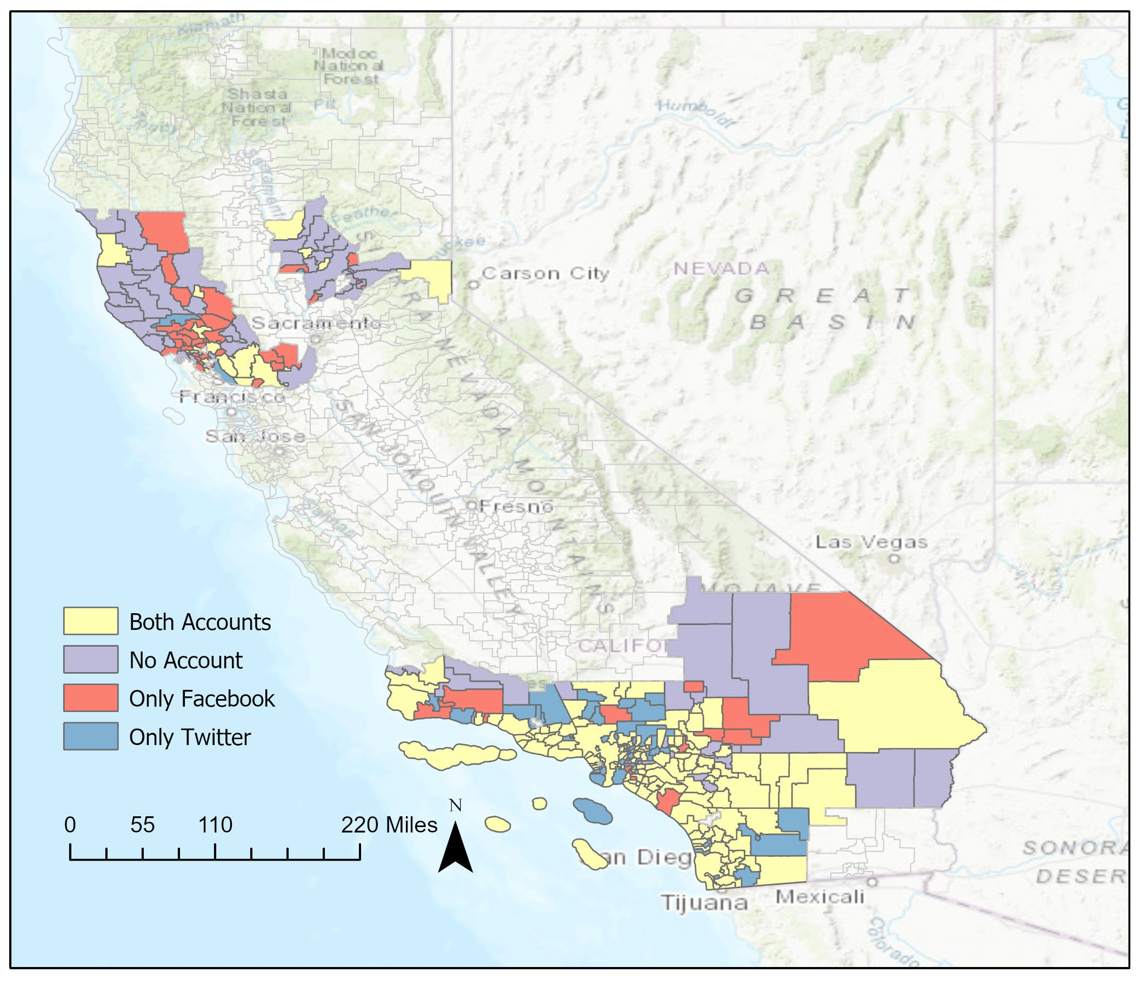
Figure S2. This map shows the distribution of public school districts that have made neither Facebook nor Twitter unplanned school closure announcements, only Facebook announcements, only Twitter announcements, or both Facebook and Twitter announcements.

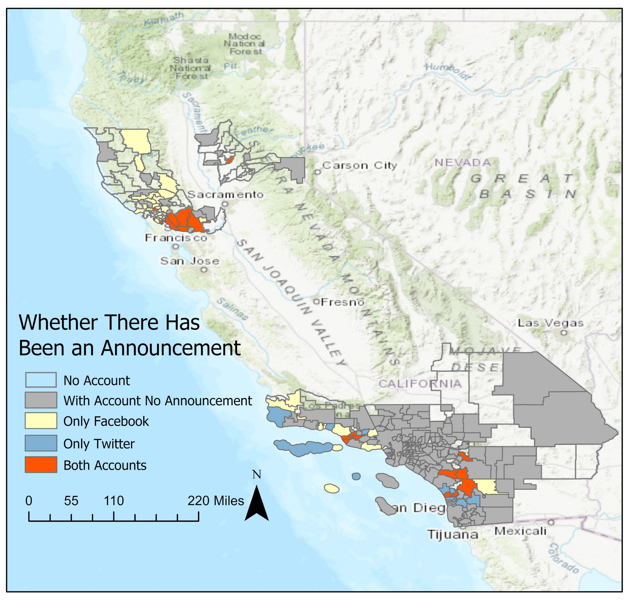

Figure S3. This map shows the distribution of public school districts that have unplanned school closure announcements either been identified by OSS or not.
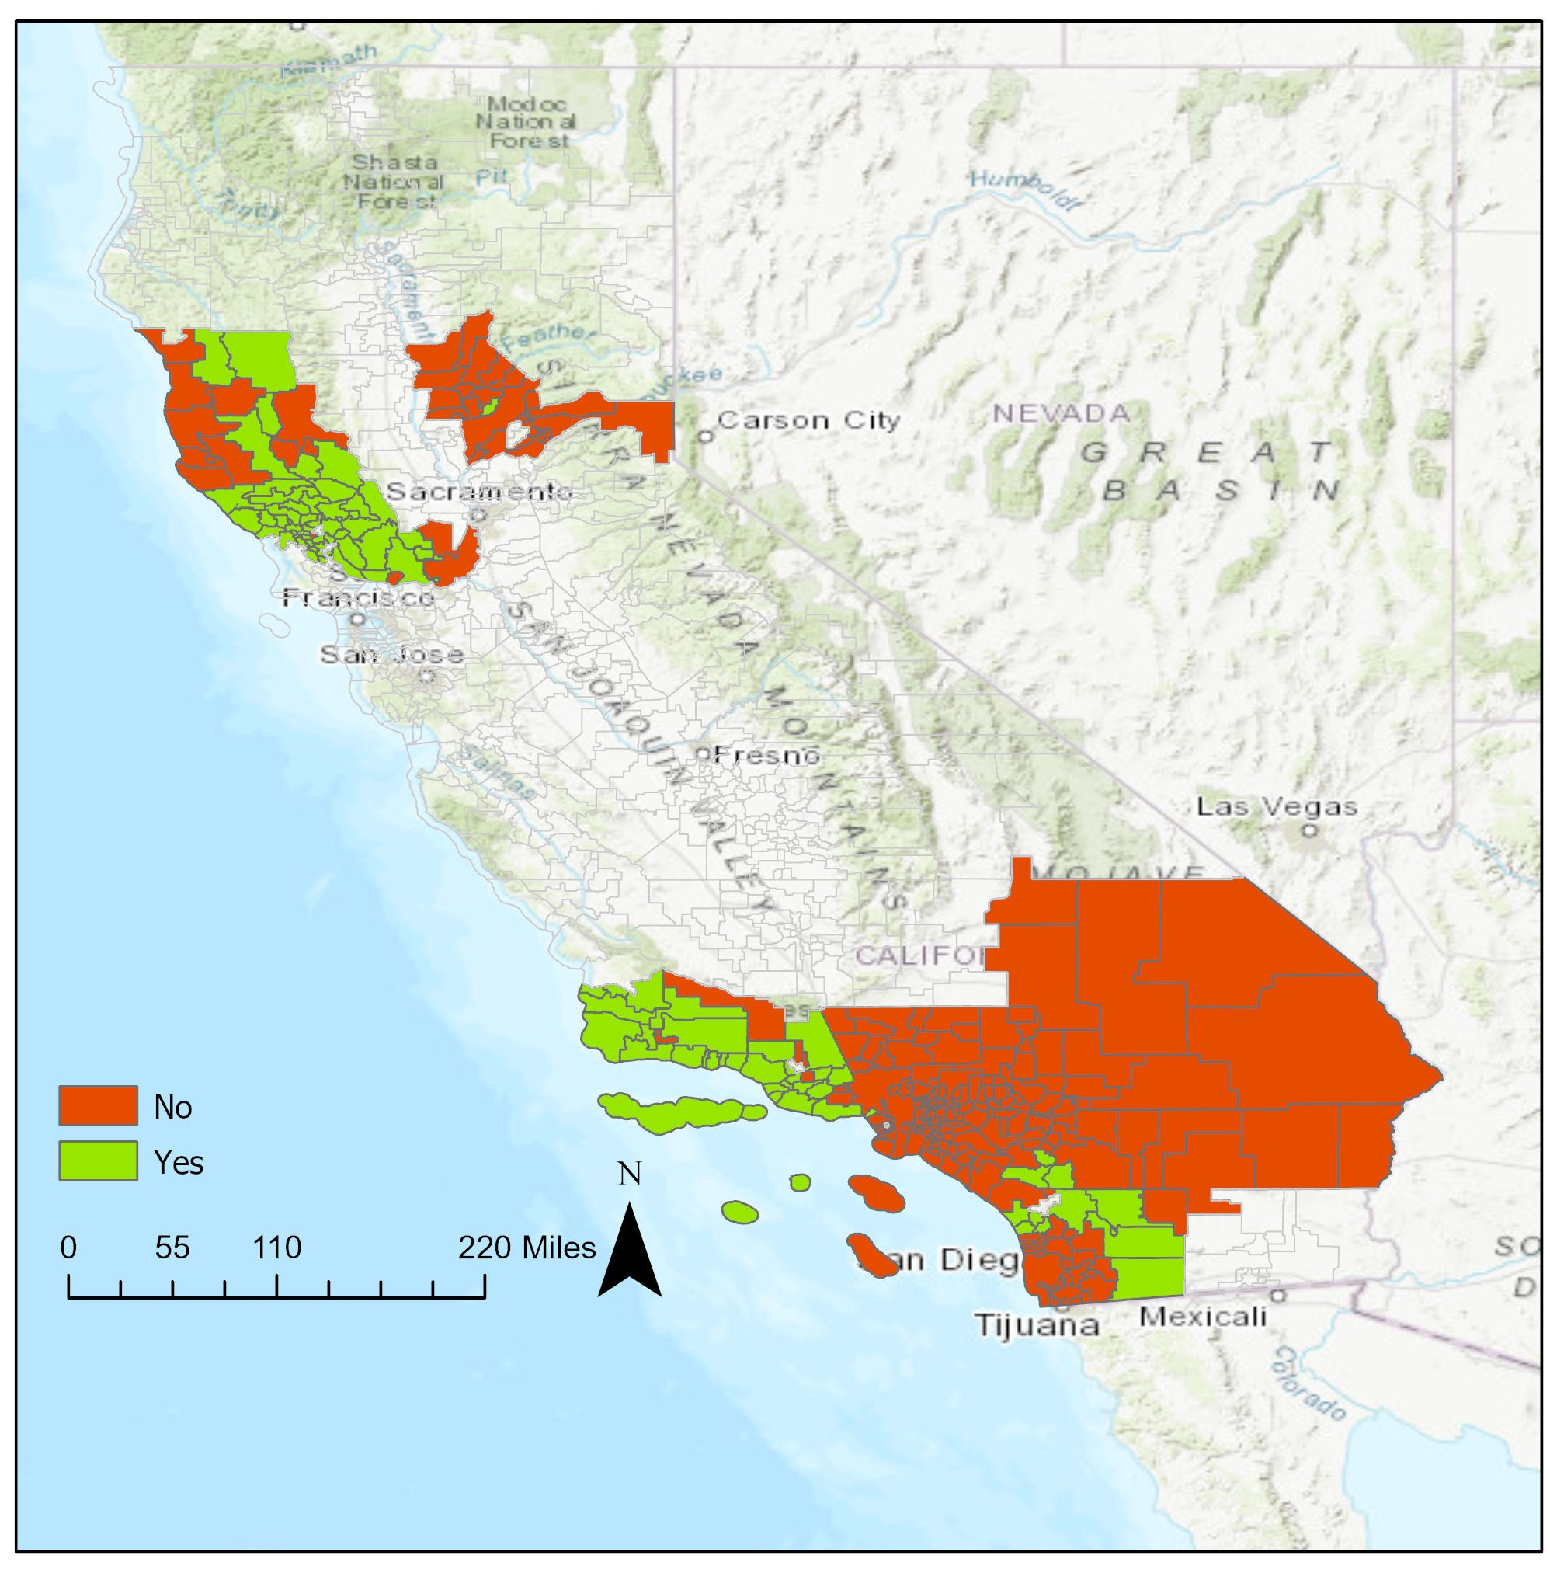
Fig S4. This map shows the distribution of private schools that have neither Facebook nor Twitter accounts, only a Facebook account, only a Twitter account, or both Facebook and Twitter accounts.

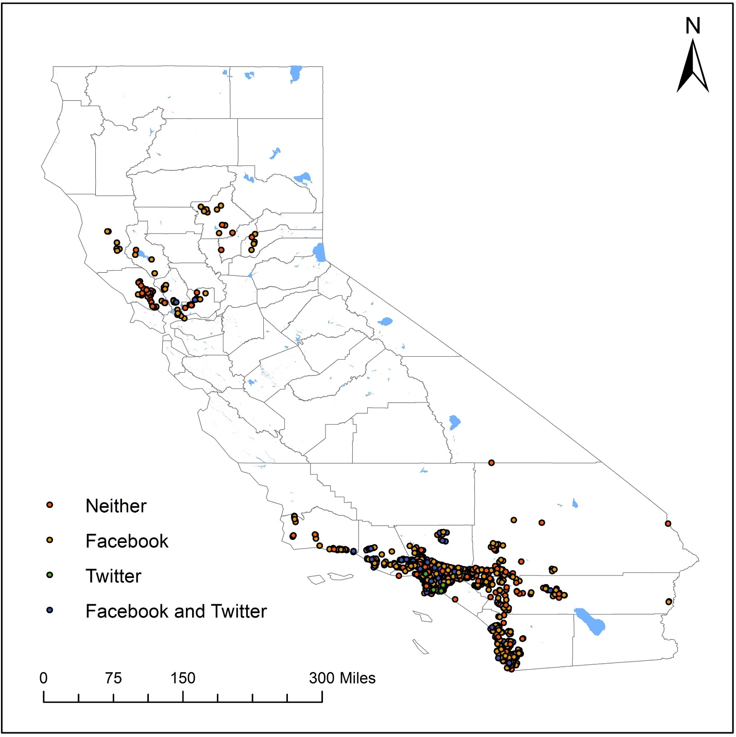

Fig S5. This map shows the distribution of private schools that have made neither Facebook nor Twitter announcements, only Facebook announcements, only Twitter announcements, or both Facebook and Twitter announcements.

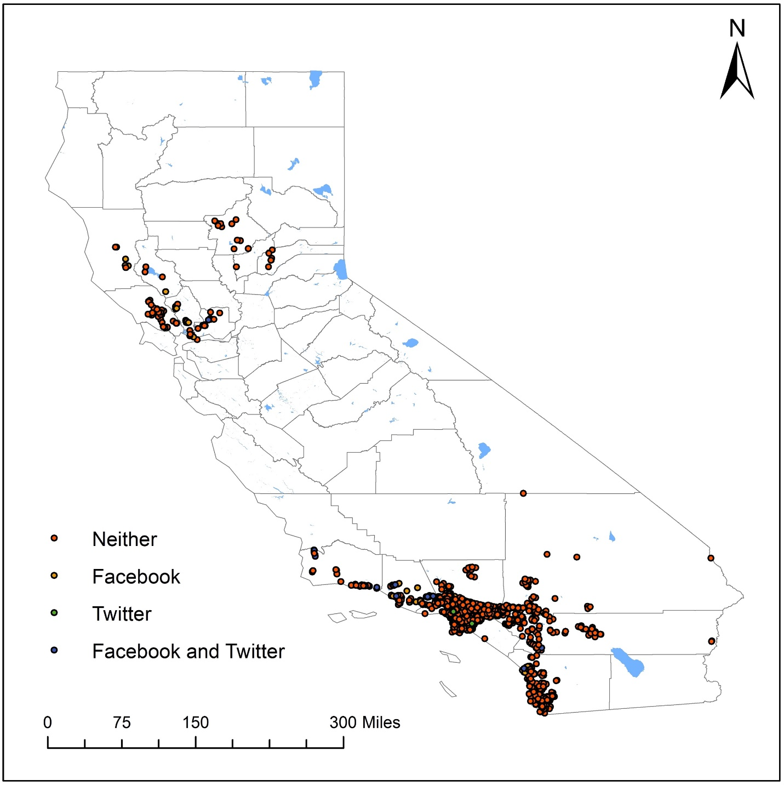

Fig S6. This map shows the distribution of private schools that have either been identified by OSS or not.

