**TITLE**

Implementation of SARS-CoV-2 monoclonal antibody infusion sites at three medical centers in the United States: Strengths and challenges assessment to inform COVID-19 pandemic and future public health emergency use

**AUTHORS**

Anastasia S. Lambrou1,2, John T. Redd1, Miles A. Stewart1,2, Kaitlin Rainwater-Lovett1,2, Jonathan K. Thornhill1,2, Lynn Hayes1, Gina Smith1, George M. Thorp1, Christian Tomaszewski3,4, Adolphe Edward3,4, Natalia Elías Calles5, Mark Amox6, Steven Merta6, Tiffany Pfundt1, Victoria Callahan1, Adam Tewell1, Helga Scharf-Bell1, Samuel Imbriale1, Jeffrey D. Freeman1,2, Michael Anderson1**,** Robert P. Kadlec1

**AFFILIATIONS**

1Office of the Assistant Secretary for Preparedness and Response, U. S. Department of Health and Human Services, Washington, DC, U.S.

2Johns Hopkins University Applied Physics Laboratory, Laurel, Maryland, U.S.

3El Centro Regional Medical Center, El Centro, CA, U.S.

4UC San Diego Health, San Diego, CA, U.S.

5TMC HealthCare, Tucson, AZ, U.S.

6Sunrise Hospital and Medical Center, Las Vegas, NV, U.S.

**CORRESPONDING AUTHOR**

John T. Redd, MD, MPH, FACP

[John.Redd@hhs.gov](mailto:John.Redd@hhs.gov)

U.S. Department of Health and Human Services, 200 Independence Ave, SW,

Washington, DC 20201

**RUNNING TITLE**

Monoclonal antibody infusion site assessment

**SOURCES OF SUPPORT**

This study was supported by the U.S. Department of Health and Human Services (HHS), Office of the Assistant Secretary of Preparedness and Response (ASPR) through HHS/ASPR contract #: 75A50121C00003.

**SUPPLEMENTARY INFORMATION**

**TABLES**

**SI Table 1.** Monoclonal antibody US Food and Drug Administration (FDA) Emergency Use Agreement EUA prospective patient criteria as of February 2021.

|  |  |
| --- | --- |
| **Prospective Patient Age** | **Risk Factors** |
| **≥18 years of age**  *and at least one of the following risk factors* | * Have a body mass index (BMI) ≥35 * Have chronic kidney disease * Have diabetes * Have immunosuppressive disease Are currently receiving immunosuppressive treatment * Are ≥65 years of age |
| **≥55 years of age**  *and at least one of the following risk factors* | * Cardiovascular disease * Hypertension * Chronic obstructive pulmonary disease/other chronic respiratory disease |
| **12 – 17 years of age**  *and at least one of the following risk factors* | * BMI ≥85th percentile for their age and gender based on CDC growth charts * Sickle cell disease * Congenital or acquired heart disease * Neurodevelopmental disorders, for example, cerebral palsy * Medical-related technological dependence, for example, tracheostomy, gastrostomy, or positive pressure ventilation (not related to COVID-19) * Asthma, reactive airway or other chronic respiratory disease that requires daily medication for control |

**SI Table 2.** Monoclonal antibody infusion site process assessment metric descriptions and corresponding semi-structured interview questions.

|  |  |  |
| --- | --- | --- |
| **Metric** | **Definition** | **Data** |
| **Engagement & Workflow Logistics** | Components, steps, and official procedures of engaging with all stakeholders and the workflow of the infusion process to assess areas of improvement. | List the steps of the infusion process from recruitment to scheduling and receiving the therapy |
| How long does each step take from the perspective of patients and staff? |
| What are the current patient/community engagement/outreach mechanisms? |
| What are the current provider/clinical engagement/outreach mechanisms? |
| What forms of transportation do patients use to travel to and from their appointment? |
| What barriers do patient face when scheduling or attending the appointment? |
| How can the site increase provider/prescriber buy-in? |
| What are the hard vs. soft constrains of the process? |
| **Timing** | Metrics related to timing of steps and engagement and therapy-quality related metrics such as preparation and temperature. | Time from registration/scheduling to appointment (mean, individual data if available) |
| Time from symptom onset to infusion |
| Time from positive test to infusion |
| Total appointment time |
| Estimated time for each infusion process step |
| Transition time between patients/infusions |
| Infusion site hours of operation |
| Infusion site staff shift hours/timing |
| List mAb therapy quality assurance process |
| Pharmacist preparation timing and location |
| Average amount of time between pharmacist preparation/cooling conditions to infusion |
| **Staffing** | Information on staff, their roles, and requirements to inform staffing models and process improvements. | List the number and types of workers maintaining the infusion site |
| What is the level of training needed for specific infusion site workers? |
| Is there a minimum staffing requirement? |
| Is there a maximum number of individuals allowed in the space at once? |
| What is the role of each type of worker? |
| Can any worker take on multiple roles? |
| How does process timing and steps change if the staff is down one nurse/physician/etc.? |
| Which process steps are staff dependent? |
| What is the most labor-intensive step for workers? |
| Which process step requires the most skills/training? |
| **Physical Environment** | Information, layout, and interactions within the facilities/physical environment in the infusion site to inform process improvements and prototype set-ups. | Map infusion site and logistics environment |
| Locations/direction of chairs/patients |
| Dimensions of infusion site |
| Infection control/distancing in physical environment |
| Can the size or shape of the space be altered? |
| Is any daily setup or deconstruction required? |
| **Resources** | All resources needed that are not staff to inform process model, scale-up, and process improvements. | List all physical resources needed for the infusion process |
| PPE resources needed |
| Infusion site/tent resources |
| Information systems resources |
| Could the patient be observed in another setting, i.e., car? What parts of the process do not have to occur in the tent/site? |
| **Monitoring & Resilience** | Flexibility and resilience of system to process disturbances, emergencies, and capacity changes. | What happens if an emergency/adverse event occurs? |
| How common are emergency/adverse events and how do they impact staffing/flow/etc.? |
| What happens if a patient does not show up for their appointment? |
| How common are “no shows” and how do they impact staffing/flow/etc.? |
| Describe the system that is currently being used for patient scheduling |
| Describe the system currently used to monitor and evaluate (M&E) the infusion process |
| Describe the system that is currently being used to |
| Describe the system that is currently being used to monitor logistics and resource allocation |

**FIGURES**



**SI Figure 1.** External physical environments of the temporary tent monoclonal antibody infusion sites.

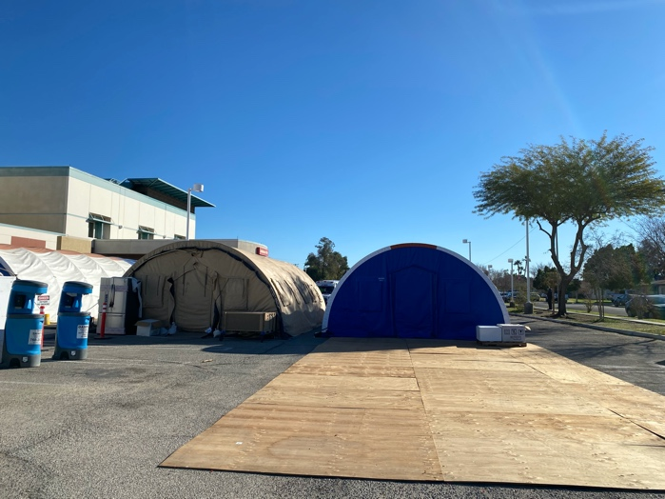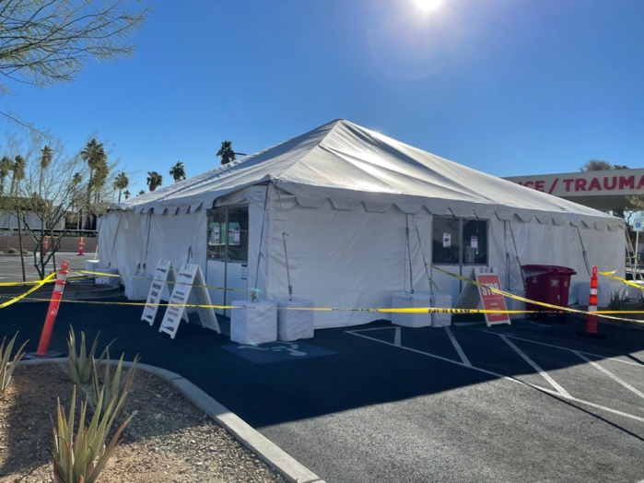

**SI Figure 2.** External physical environments of the temporary tent monoclonal antibody infusion sites.

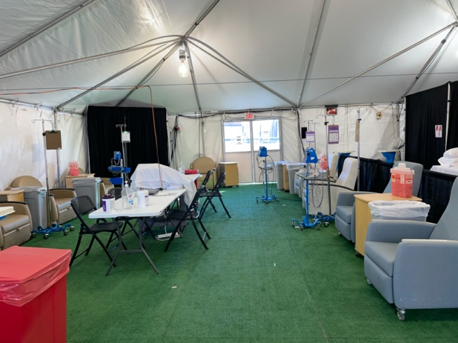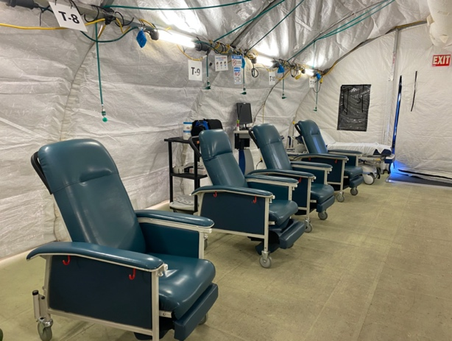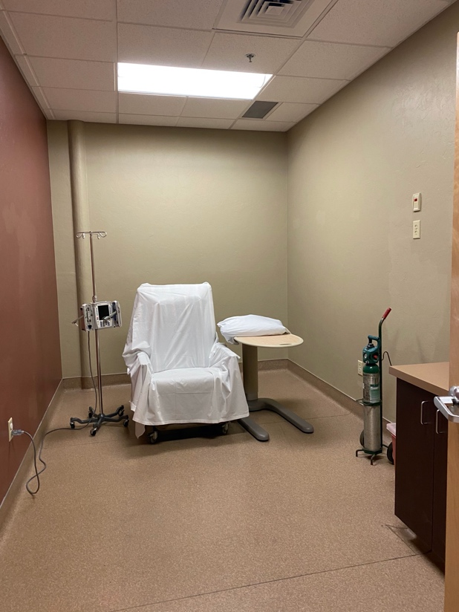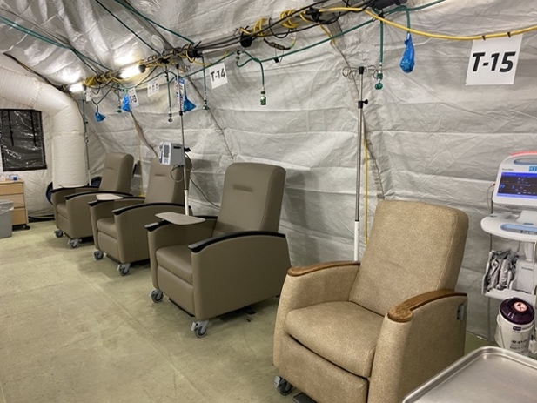

**SI Figure 3.** Examples of the internal physical environments of the three monoclonal antibody infusion sites exhibiting both open-concept and individual patient room layouts for the infusion process.