Appendix 1. Questionnaire (original language: Brazilian Portuguese).
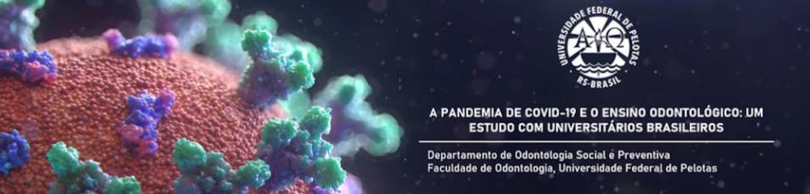
BRAZILIAN DENTAL EDUCATION IN THE COVID-19 PANDEMIC:
A CROSS-SECTIONAL STUDY WITH UNIVERSITY STUDENTS
Dear undergraduate dental student,

The impact of the coronavirus-2019 (COVID-19) disease pandemic on Dentistry is a reality, since due to the characteristics of dental environments and procedures, there is an increased risk of cross-infection between the oral health team and users of this service.

In the university context, dental teaching institutions are now faced with the challenge of reorganising their infrastructure and teaching methods to face the possible consequences of this scenario, preserving, and fostering the continuous progress of their future professionals, considering mainly the social context of their students.

You are being invited to participate in this research by answering this form, which is exclusively for academics duly enrolled in Dentistry degree courses at public and private institutions in Brazil.

Overall, the aim of the present study is to investigate the strategic actions adopted by the Faculties of Dentistry in Brazil during the COVID-19 pandemic, use of resources, equipment, and home infrastructure to maintain distance education, knowledge about new biosafety standards for dental patient care and to explore the levels of anxiety and alcohol abuse among students.

Your participation in this study is voluntary!

If you feel uncomfortable answering a question, the "prefer not to answer" option is available. Similarly, the "not applicable" alternative can be used to answer questions that do not corroborate with your reality.

If you agree to participate in the research and complete this questionnaire to the end, this page will be your Informed Consent Form. If you are accessing this page with a Google login, upon completion of the survey, a copy of your answers will be sent to your email address. If not, please print this page or save it as a PDF to keep a copy.

Any questions related to this research can be clarified through contact with those responsible for the study, whose information is available below. In addition, contact can also be made if you wish to withdraw your consent to participate in the study.

The average response time for full questionnaire is 10 minutes.
Federal University of Pelotas (UFPel), School of Dentistry
Department of Social and Preventive Dentistry
St. Gonçalves Chaves, 457, room 512; 96015-560 - Centro; Pelotas, RS, Brazil

RESEARCHERS INVOLVED
Prof. Alexandre Emidio Ribeiro Silva - aemidiosilva@gmail.com
Matheus dos Santos Fernandez - mathsantos.f@gmail.com
Nathalia Ribeiro Jorge da Silva - nathaliarjs@yahoo.com.br
Camilla Hubner Bielavski - camillahbie@gmail.com

1. DO YOU CONFIRM THAT YOU ARE REGULARLY ENROLLED IN AN UNDERGRADUATE DENTAL COURSE AT A BRAZILIAN HIGHER EDUCATION INSTITUTION?
- Yes
- No

2. DO YOU AGREE TO PARTICIPATE IN THIS RESEARCH?
- Yes
- No

BLOCK 1

3. Gender identity*
Check only one alternative.

- Female
- Male
- Non-binary
- Other: _________________________
- I prefer not to say

4. Skin color*
Check only one alternative.

- White
- Brown
- Black
- Yellow
- Indigenous
- I prefer not to say

5. How old are you? (complete years)*
Example: 17, 18, 19, 20, among others
_______________________________

6. In which state do you attend university/college?*
Example: RS, SP, MT, RO, among others
_______________________________

7. You live in an area that is:*
Check only one alternative.

- Rural
- Urban
- I prefer not to say

8. How many people live in your household?*
Check only one alternative.

- 1
- 2
- 3
- 4
- 5
- Other: _________________________
- I prefer not to say

9. What type of undergraduate educational institution are you enrolled in?*
Check only one alternative.

- Public
- Private
- Other: _________________________
- I prefer not to say

10. Which semester are you currently studying?
Check only one alternative.

1 | 2 | 3 | 4 | 5 | 6 | 7 | 8 | 9 | 10

BLOCK 2

11. What was the main teaching methodology adopted by your educational institution during the pandemic?*
Mark only one alternative.

- Distance Learning (daily activities, virtual exams and evaluative work, among others)
- The institution has completely halted its activities and classes will be held after the pandemic
- Other: _________________________
- I prefer not to say

12. Have you received guidance on droplet control and/or aerosol generation in clinical procedures in graduation before the pandemic of COVID-19?*
Mark only one alternative.

- Yes
- No
- I prefer not to say

13. During quarantine did you receive any training on the preventive measures that should be adopted in dental setting during the COVID-19 pandemic?*
Mark only one alternative.

- No training
- Theoretical training
- Theoretical-practical training
- Other: _________________________
- I prefer not to say

14. What sources of information do you usually use to guide the actions that should be carried out in dental care?*
Check all that apply.

- Official regulatory agencies (Anvisa, Ministry of Health) and/or class associations (Federal Council of Dentistry).
- Scientific literature.
- Internet (health websites and blogs).
- Other: _________________________
- I prefer not to say

BLOCK 3

15. The alternatives below are related to different attitudes that the oral health professional (dental students, dentists, and oral health technicians) can adopt during clinical practice. Read the statements carefully and mark YES or NO on the actions you believe are essential for the performance of dental care during the pandemic.
Mark only one alternative per line.

 |  | YES | NO
#1 | Tele-screening is the first line of action to identify patients potentially carrying or with symptoms of SARS-CoV-2.
#2 | Periodontal maintenance sessions and aesthetic and prosthetic adjustments are the main elective procedures to emergency treatment in dental clinical practice during the COVID-19 pandemic.
#3 | Pre-procedure mouth rinsing with Povidone-Iodine solution (0.02%, 0.04%, 0.05% - 9mL) for 30 seconds is essential to reduce the viral load in the patient's saliva.
#4 | The use of PPE should be complete for all oral health professionals in the clinical practice. Disposable gloves, caps and props, surgical mask overlaid with N95/PFF2 mask or equivalent, face shield, and long-sleeved, waterproof apron are the main equipment that should be used together in the clinical setting during the COVID-19 pandemic.
#5 | For better infection control in clinical practice, dental care should be performed with the assistance of another operator (four-handed technique).
#6 | Control of aerosol production and dissemination in dental clinical practice should be achieved with the use of manual instruments, rubber dam and a high-powered hoover.
#7 | Dental panoramic radiographs and cone beam computed tomography are techniques prioritized to replace the intraoral radiographs in patients carrying SARS-CoV-2 or with symptoms of COVID-19.
#8 | Ideally, the box for dental treatment should be individualized. If this is not possible, in open plan clinics (e.g., community university clinics), a minimum distance of one meter at the head and one meter beside each dental chair should be considered; between two chairs, there should be two meters, with a mechanical barrier between them.

THANK YOU FOR YOUR PARTICIPATION!
Soon the results of this research will be disseminated through the publication of scientific articles in Open Access modality and through social networks and institutional websites of the Federal University of Pelotas

@ensino.odonto_COVID19

