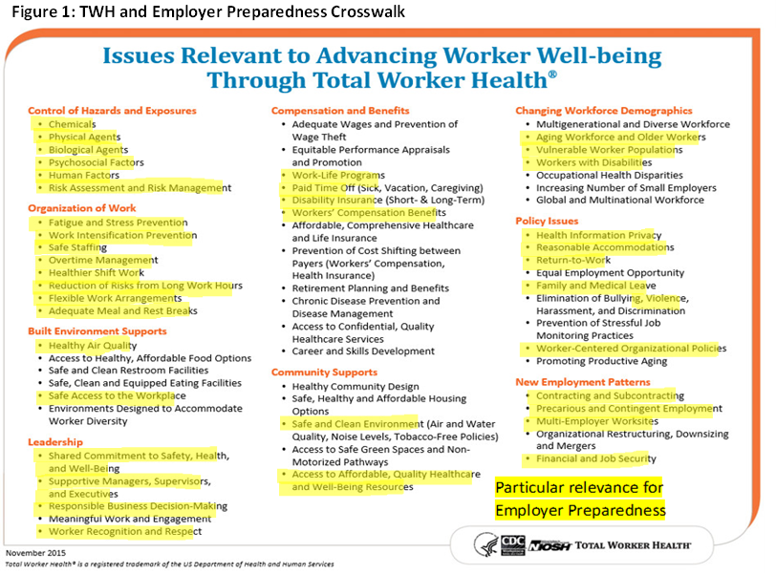
Cross over TWH and Employer Preparedness Domains
In the first category of “Control of Hazards and Exposures,” Employer Preparedness considers control of exposures during unanticipated events such as weather-related disasters. There may be hazards that would only exist during an emergency or disaster, and employers may need to consider what can be handled by their own staff and what would require outside assistance of emergency responders and hazardous materials specialists.
The “Organization of Work” TWH category is particularly relevant to TWH Employer Preparedness as it includes the impact of understaffing, rotating shifts, overtime, and long work hours. Management policies on preparedness would be an example of a TWH “Leadership” issue. For example, employers can provide clarity and reassurance regarding operational continuity or access to worksites to retrieve personal belongings. Employers can recognize that employees will have work-life balance challenges and assist them in meeting them without excessive conflict. Employers can anticipate that some of their employees may participate in civic preparedness and response activities that keep them out of work and can recognize their contributions to the community. Employers’ inclusion of employees in on-going cycles of preparedness planning is also a relevant TWH leadership strategy.
There are many significant “Compensation and Benefits” issues related to human resources management post-disaster. Most importantly, employees will want to know that if their place of employment is closed due to a disaster, they will continue to receive pay and benefits for a designated time. Employees who will be required to work through disasters many need or deserve “hazard pay.” Work-life or health promotion programs could include training to help employees prepare their communities and families for emergencies and disasters. In the event of an emergency, impacted employees may need access to both physical and mental health resources and to be assured that their community is returning to safety. Employers may need to consider whether employees need to relocate until basic safe conditions are restored. These are cross-over elements from the TWH “Community Supports” domain.
In the “Changing Workforce Demographics” category, prepared employers will assure that all members of the workforce, included disabled and older employees, are able to cope and escape, if necessary. Workers with chronic health conditions may need medical surveillance if their work exposes them to excess heat (Coco et al., 2016). Vulnerable worker populations may be more impacted than others during disasters. For instance, if employees have family members without documented immigration status, they may be hesitant to access emergency services such as the Red Cross (Fussell et al., 2018). Employers may need to step in in response. There are also several TWH “Policy Issues” that have Employer Preparedness dimensions. Employees who have experienced injuries or illnesses either at work or from exposures in their communities will need accommodations and effective return to work programs. Leave policies may need to be put in place to assure that impacted employees can attend to their and their family’s health and personal needs that disasters have made urgent.
Disasters may accelerate “New Employment Patterns.” Employers may need to expand or shrink their workforce in response to emergencies and these policies may need to assure that responsibility for employee well-being is maintained for regular and contingent workers. While we are well-aware of the negative workforce impacts of the COVID-19 epidemic, where entire sectors of workers faced unemployment, crises can also lead to new business and employment patterns. Many recent weather-related disasters lead to an increase in recovery-oriented small business and labor contracting opportunities (Ochsner et al., 2018). However, these individuals and companies may not be well-prepared to protect themselves or their employees in the face of new hazardous environments. Owners of facilities and public agencies responding to crises such as wildland fires, will need to assure that contractors and recruits are adequately trained and protected to be able to work safely (Koopmans et al., 2020). These cross-over issues are examples of how TWH and Employer Preparedness intersect with community emergency preparedness and response.

