**ANNEX – QUESTIONNAIRES**

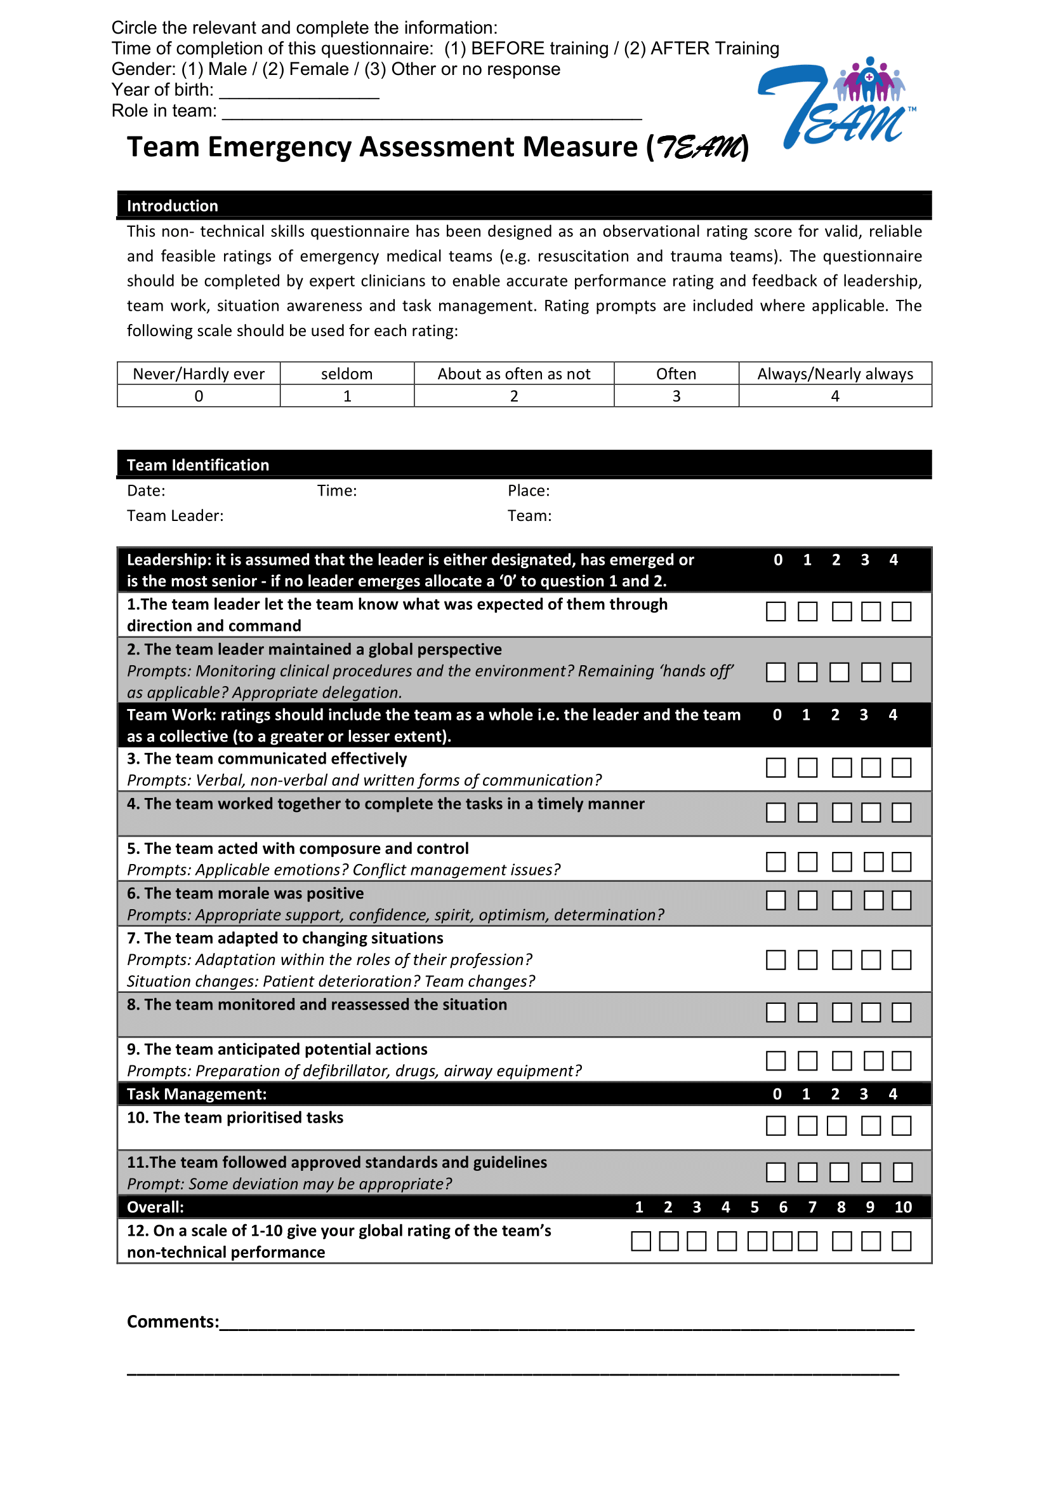

**Self-Efficacy Questionnaire**

Dear participant,

**Circle the relevant and complete the information:**

Time of completion of this questionnaire: (1) BEFORE training / (2) AFTER Training

Gender: (1) Male / (2) Female / (3) Other or no response

Year of birth: ________________

Role in team: ___________________________________________________________

Please respond to these items assessing **your self-efficacy as a team** concerning your recent training. Rate each of the following statements by circling the appropriate number on a scale of 1 to 5 where 1 means you strongly disagree and 5 means you strongly agree.

|  |  |  |  |  |  |
| --- | --- | --- | --- | --- | --- |
|  | Strongly  Disagree | Somewhat Disagree | Neutral | Somewhat Agree | Strongly Agree |
| 1. Our team will be able to achieve most of the goals that we have set for the team | 1 | 2 | 3 | 4 | 5 |
| 2. When facing difficult tasks, our team is certain that we will accomplish them | 1 | 2 | 3 | 4 | 5 |
| 3. In general, our team thinks that we can obtain outcomes that are important to the team | 1 | 2 | 3 | 4 | 5 |
| 4. Our team believes that we can succeed at most any endeavor to which we set our minds | 1 | 2 | 3 | 4 | 5 |
| 5. Our team will be able to successfully overcome many challenges | 1 | 2 | 3 | 4 | 5 |
| 6. Our team is confident that we can perform effectively on many different tasks | 1 | 2 | 3 | 4 | 5 |
| 7. Compared to other teams, our team can do most tasks very well | 1 | 2 | 3 | 4 | 5 |
| 8. Even when things are tough, our team can perform quite well | 1 | 2 | 3 | 4 | 5 |

**Quality of Training Questionnaire (Trainees)**

Dear participant,

Please respond to these items assessing **your perception of the quality of the training package** used in your recent training. Rate each of the following statements by circling the appropriate number on a scale of 1 to 5 where 1 means you strongly disagree and 5 means you strongly agree.

|  |  |  |  |  |  |
| --- | --- | --- | --- | --- | --- |
|  | Strongly  Disagree | Somewhat Disagree | Neither Agree  Nor Disagree | Somewhat Agree | Strongly Agree |
| 1. The content of the exercises is relevant for EMT deployments | 1 | 2 | 3 | 4 | 5 |
| 1. I found the scenarios to be realistic (i.e. simulating real situations that can happen in the field) | 1 | 2 | 3 | 4 | 5 |
| 1. I found the instructions provided for the exercises to be clear | 1 | 2 | 3 | 4 | 5 |
| 1. The training experience helps to improve the team's performance | 1 | 2 | 3 | 4 | 5 |
| 1. The time allotted to each exercise was sufficient and appropriate | 1 | 2 | 3 | 4 | 5 |
| 1. The training was appropriate to the team's level of experience and knowledge | 1 | 2 | 3 | 4 | 5 |
| 1. The exercises were relevant for my professional role in the EMT | 1 | 2 | 3 | 4 | 5 |
| 1. This training was beneficial for the EMT | 1 | 2 | 3 | 4 | 5 |
| 1. Debriefing after the exercises was useful to the learning process | 1 | 2 | 3 | 4 | 5 |
| 1. Overall, this training was effective and useful to the team | 1 | 2 | 3 | 4 | 5 |

In addition, please provide some additional information for the following items:

1. Which aspects of the training contributed the most to you and/or the team?

_____________________________________________________________________________________________________________________________________________________________________________________________________________________________________________________________________________________________________________________________________________________________________________________________________________________________________________________________________________________________________

1. Which aspects of the training should be improved?

_____________________________________________________________________________________________________________________________________________________________________________________________________________________________________________________________________________________________________________________________________________________________________________________________________________________________________________________________________________________________________

1. Please share any additional comments you may have:

_____________________________________________________________________________________________________________________________________________________________________________________________________________________________________________________________________________________________________________________________________________________________________________________________________________________________________________________________________________________________________

**Thank you for your feedback!**

**ANNEX 4b – Quality of Training Questionnaire (Trainers)**

Dear Trainer,

Please respond to these items assessing **your perception of the quality of the training package** used in your recent training. Rate each of the following statements by circling the appropriate number on a scale of 1 to 5 where 1 means you strongly disagree and 5 means you strongly agree.

|  |  |  |  |  |  |
| --- | --- | --- | --- | --- | --- |
|  | Strongly  Disagree | Somewhat Disagree | Neither Agree  Nor Disagree | Somewhat Agree | Strongly Agree |
| 1. The content of the exercises is relevant for EMT deployments | 1 | 2 | 3 | 4 | 5 |
| 1. I found the scenarios to be realistic (i.e., simulating real situations that can happen in the field) | 1 | 2 | 3 | 4 | 5 |
| 1. The training materials are easy to understand | 1 | 2 | 3 | 4 | 5 |
| 1. The training experience helps to improve the team's performance | 1 | 2 | 3 | 4 | 5 |
| 1. The time allotted to each exercise was sufficient and appropriate | 1 | 2 | 3 | 4 | 5 |
| 1. The training was relevant for all team members | 1 | 2 | 3 | 4 | 5 |
| 1. The exercises were well designed to meet the learning objectives | 1 | 2 | 3 | 4 | 5 |
| 1. The exercises are feasible and easy to implement | 1 | 2 | 3 | 4 | 5 |
| 1. The training package is flexible and can be adapted to varied EMT characteristics | 1 | 2 | 3 | 4 | 5 |
| 1. Debriefing after the exercises was useful to the learning process | 1 | 2 | 3 | 4 | 5 |
| 1. Overall, this training was effective and useful to the team | 1 | 2 | 3 | 4 | 5 |
| 1. The supplementary materials/ references suggested in the package were appropriate and useful to the training | 1 | 2 | 3 | 4 | 5 |

In addition, please provide some additional information for the following items:

1. Which aspects of the training contributed the most to you and/or the team?

_____________________________________________________________________________________________________________________________________________________________________________________________________________________________________________________________________________________________________________________________________________________________________________________________________________________________________________________________________________________________________

1. Which aspects of the training should be improved?

_____________________________________________________________________________________________________________________________________________________________________________________________________________________________________________________________________________________________________________________________________________________________________________________________________________________________________________________________________________________________________

1. Please share any additional comments you may have:

_____________________________________________________________________________________________________________________________________________________________________________________________________________________________________________________________________________________________________________________________________________________________________________________________________________________________________________________________________________________________________

**Thank you for your feedback!**