**Figures:**

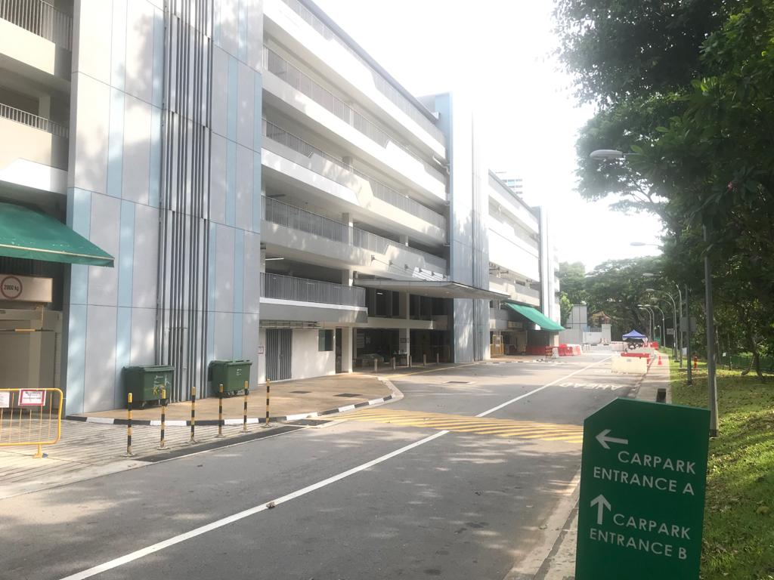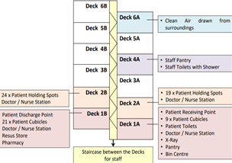

*Fig 4*. MSCP deck layout as a Flu Screening Area (FSA).

*Fig 3*. Multi-story carpark (MSCP).

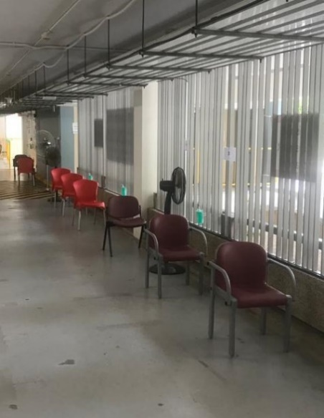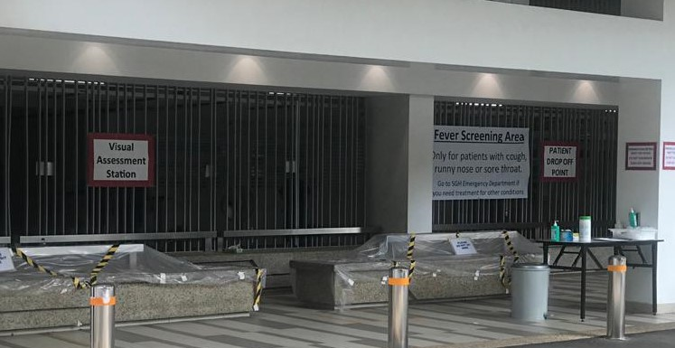

*Fig 9.* Chairs placed 1 meter apart for patients waiting to be seen .

*Fig 8.* Visual assessment station (VAS).

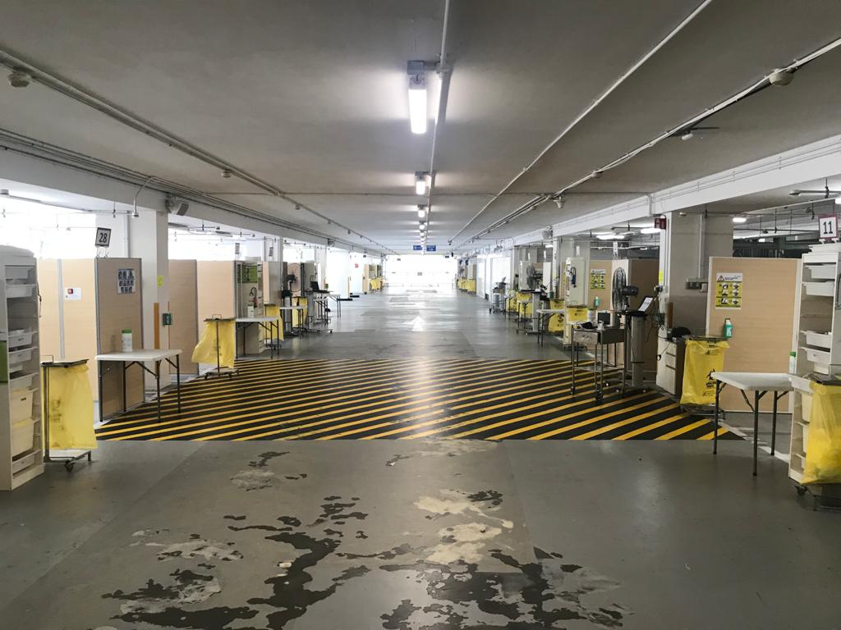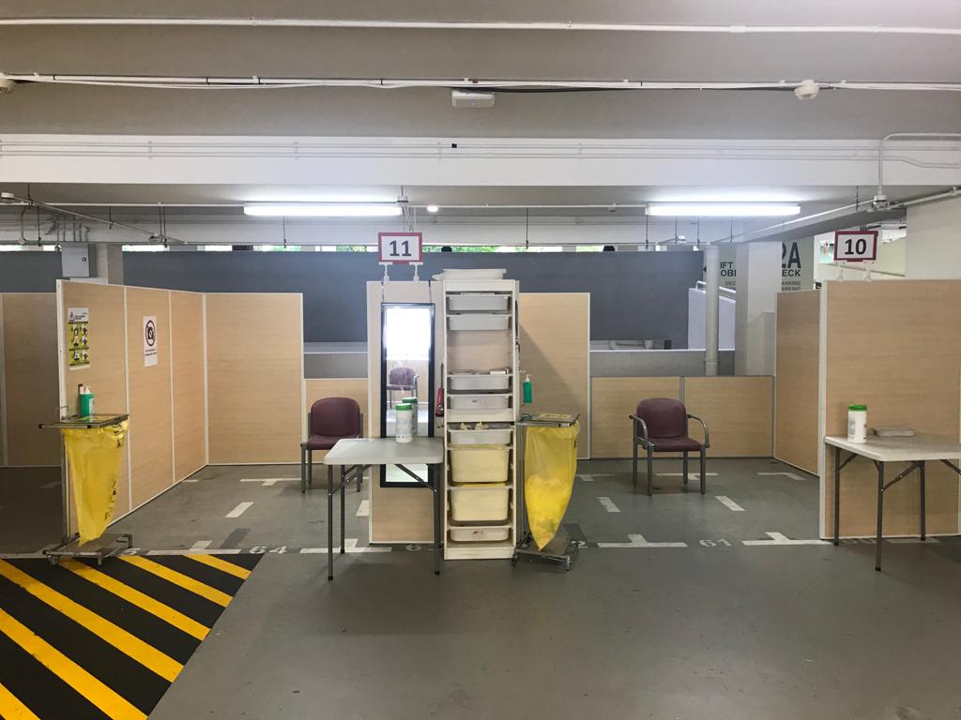

*Fig 5.* Cubicles replete with chairs, IT equipment, PPE, disinfectants, and waste disposal.

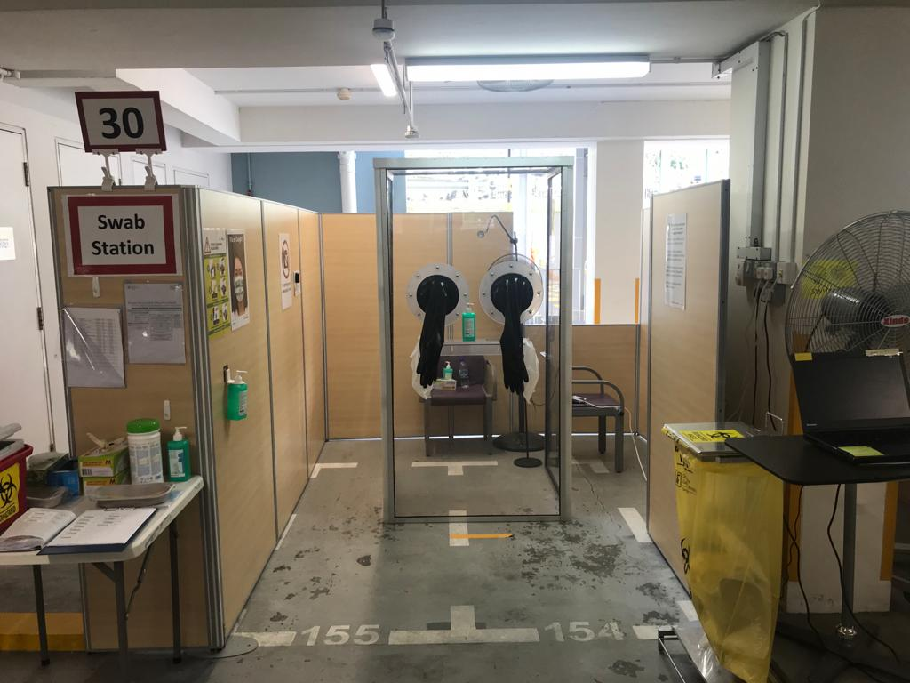 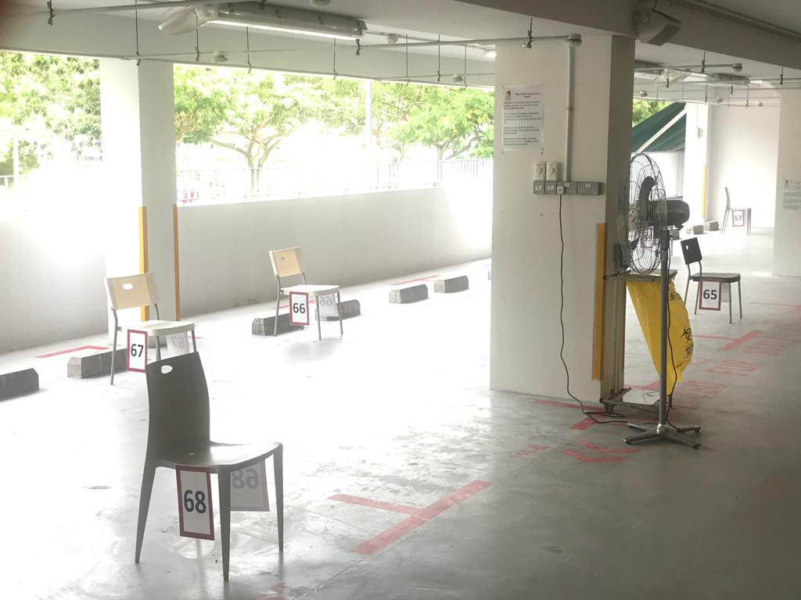

*Fig 10.* Waiting areas for patients.

*Fig 2*. Swab booth.

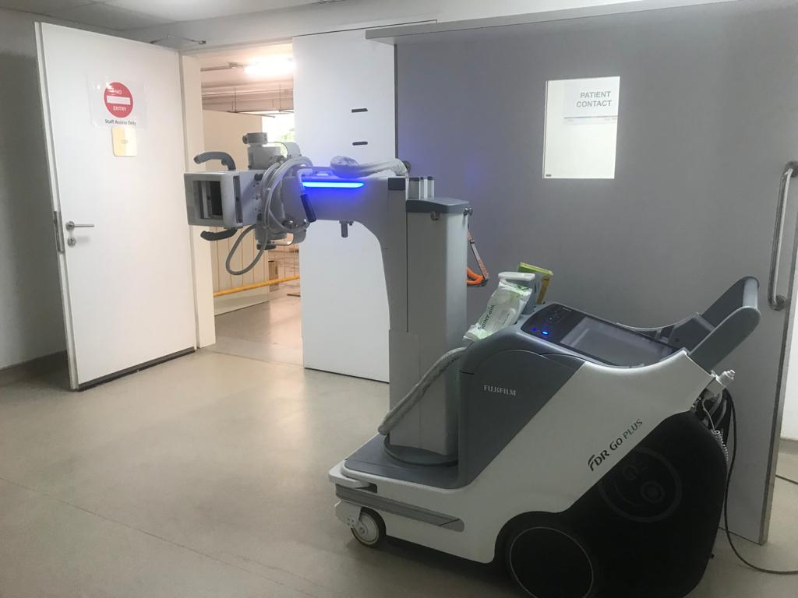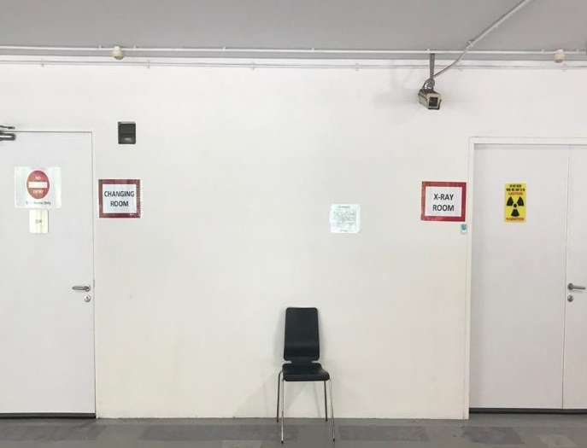

*Fig 1.* Radiology facilities in the flu screening area (FSA).

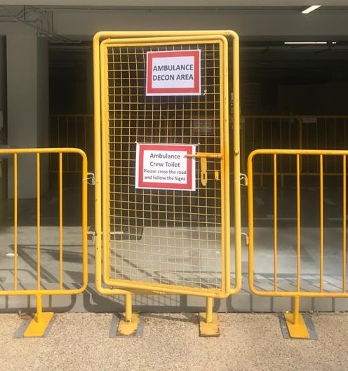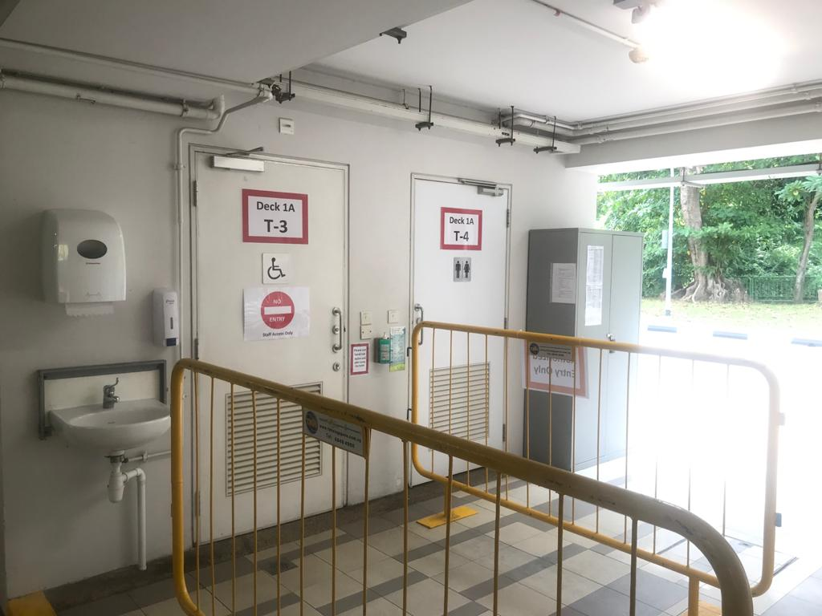

*Fig 11.* Ambulance crew decontamination areas. outside the FSA

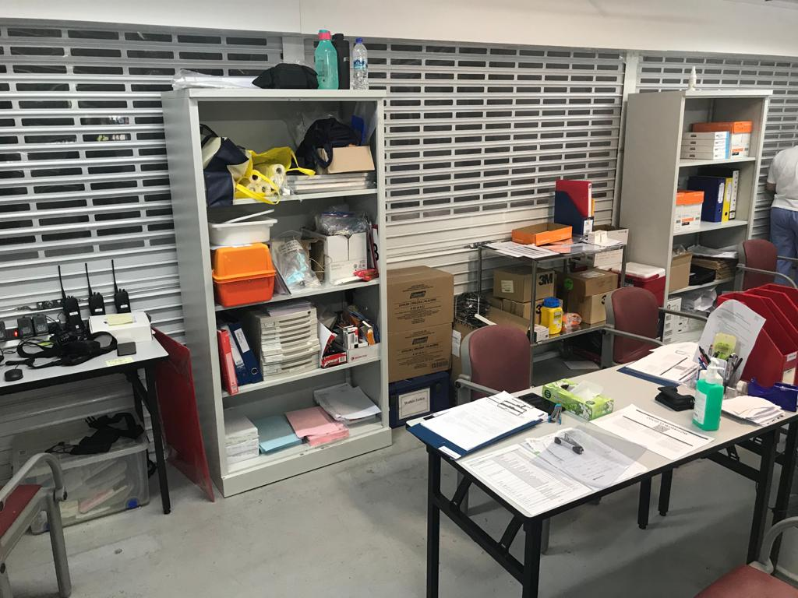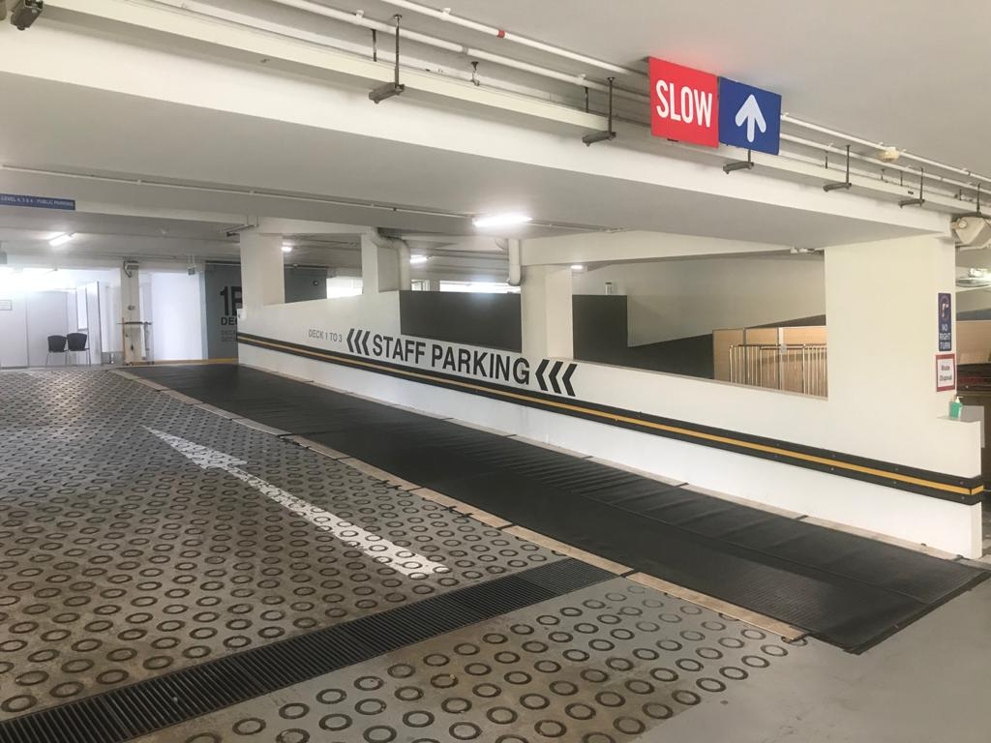

*Fig 6.* Air-conditioned, shuttered staff clinical work areas

*Fig 7.* Modified ramp

**Appendix**

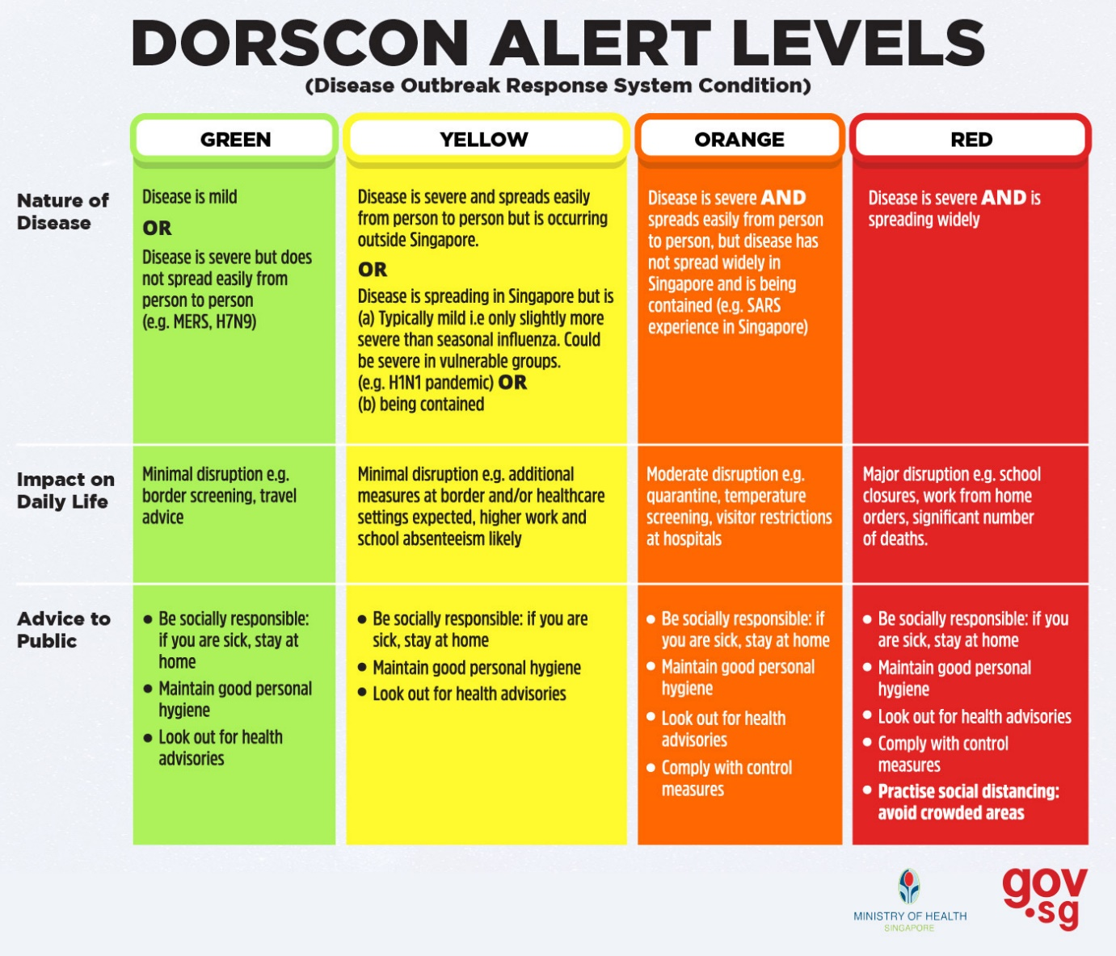Source: <https://www.gov.sg/article/what-do-the-different-dorscon-levels-mean>