Social Media Use in Emergency Response to Natural Disasters: A Systematic Review with a Public Health Perspective
Supplementary Materials
Kamalich Muniz-Rodriguez, MPH ¹
Sylvia K. Ofori, MPH ¹
Lauren C. Bayliss, PhD ²
Jessica S. Schwind, PhD ¹
Kadiatou Diallo, MPH ¹
Manyun Liu, MS ¹
Jingjing Yin, PhD ¹
Gerardo Chowell, PhD ³
Isaac Chun-Hai Fung, PhD ¹*
¹ Department of Biostatistics, Epidemiology and Environmental Health Sciences, Jiann-Ping Hsu College of Public Health, Georgia Southern University, Statesboro, Georgia, USA
² Department of Communication Arts, College of Arts and Humanities, Georgia Southern University, Statesboro, Georgia, USA
³ Department of Population Health Sciences, School of Public Health, Georgia State University, Atlanta, Georgia, USA

*Corresponding author: Isaac Chun-Hai Fung, PhD, P.O. Box 7989, Department of Biostatistics, Epidemiology and Environmental Health Sciences, Jiann-Ping Hsu College of Public Health, Georgia Southern University, Statesboro, Georgia 30460, USA; Telephone: +1 912 478 5079; Fax: +1 912 478 0171; Email: cfung@georgiasouthern.edu
SUPPLEMENTARY METHODS
Keyword selection
The keywords used to retrieve the data were: “social media”, (“natural disaster” OR “natural disasters”), (“natural hazard” OR “natural hazards”), (emergency OR emergencies), and (crisis OR crises). For the (emergency OR emergencies), it was specified not to include “emergency medicine” or “emergency departments” given the objective of the study. For all databases, three different keywords combinations were used with a search period from 2015/01/01 to 2018/09/18.

The keywords for the literature search include the global term "natural disaster" and not each specific event as a search term. The two major reasons for the decision were the definition of natural disasters by the CDC and the National Center for Biotechnology Information (NCBI).^{1,2} NCBI defines the Medical Subject Headings (MeSH) term natural disasters as “Disasters linked to natural hazards including widespread fires, floods, storms, earthquakes and drought. These events may result in significant damage and loss of lives”.² It includes events such as avalanches, cyclonic storms, droughts, earthquakes, floods, landslides, tidal waves, tornados, and wildfires. The definition of the CDC identifies natural disasters like earthquakes, floods, hurricanes, landslides or mudslides, tornados, heat waves, cold waves, tsunamis, volcanos, and wildfires.¹ The terms “natural hazard” OR “natural hazards” were also included in the search based on the definition from NCBI were the term used to define natural disasters. Including these four terms as keywords allows for the literature search to include every natural disaster and not just specific events.

Keywords and Search strategy
The specific keywords used to retrieve the data were: “social media”, (“natural disaster” OR “natural disasters”), (“natural hazard” OR “natural hazards”), (emergency OR emergencies), and (crisis OR crises). For all databases, three different keywords combinations were used with a search period from January 1, 2015 to September 18, 2018. A total of 2,126 articles were downloaded from the keywords search.

For PubMed, the search strategy included the following keywords combination with a search period from 2015/01/01 to 2018/09/18: (1) "social media" AND ("natural disaster" OR "natural disasters" OR "natural hazard" OR "natural hazards") (2) “social media” AND ("emergency" OR "emergencies" NOT "emergency department" NOT "emergency departments" NOT "emergency medicine"), and (3) ("social media"[All Fields]) AND ("crisis" [All fields] OR "crises" [All Fields]).

For Web of Science the search strategy included the following keywords combination with a search period from 2015/01/01 to 2018/09/18: (1) "social media" AND ("natural disaster" OR "natural disasters" OR "natural hazard" OR "natural hazards") (2) “social media” AND ("emergency" OR "emergencies" NOT "emergency department" NOT "emergency departments" NOT "emergency medicine"), and (3) ("social media") AND ("crisis" OR "crises").

For the database IEEE Xplore the Journals and Magazines database was searched with the following keywords combination with a search period from 2015/01/01 to 2018/09/18 : (1) "social media" AND ("natural disaster" OR "natural disasters" OR "natural hazard" OR "natural hazards") (2) “social media” AND ("emergency" OR "emergencies" NOT "emergency department" NOT "emergency departments" NOT "emergency medicine"), and (3) ("social media") AND ("crisis" OR "crises").

Collected data items
The spreadsheet for data collection included filled entry lines with the authors’ name, title, digital object identifier (DOI), identification number, and year of publication. Empty columns were available in the file for the data items of interest to be extracted by the reviewers. These include the study objectives or research questions, type of natural disasters and name, if available, social media platform, study design, keywords used for data extraction, methods, inclusion or exclusion criteria for analyzed data, main results, public health implications, and funding.

SUPPLEMENTARY TABLE

Table S1. Excluded articles that did not meet the inclusion criteria for the systematic review and the reason for exclusion
Author(s) (Year) | DOI | Title | Type of natural disaster | Reason for exclusion
Al-Saggaf, Y., & Simmons, P. (2015)³ | 10.1016/j.techfore.2014.08.013 | Social media in Saudi Arabia: Exploring its use during two natural disasters. | Floods | The research article used social media data and a natural disaster for the analysis, but it was focused on the evolution of the relationship between citizens and their government. Despite mentioning of response efforts organization via Facebook, the focus of the analysis was on openness to discuss the government response and actions in a culture that was characterized by formality.
Ajao, O., Hong, J., & Liu, W. (2015)⁴ | 10.1177/0165551515602847 | A survey of location inference techniques on Twitter. | Overall (Review) | The research article was a review of social media use during natural disasters, and this type of article was specified as part of the exclusion criteria.
Alam, F., Ofli, F., & Imran, M. (2018)⁵ | 10.1080/10447318.2018.1427831 | Processing Social Media Images by Combining Human and Machine Computing during Crises. | Typhoon, Earthquake, Hurricane, Earthquake | The article used Twitter data from natural disasters to test the reliability and effectiveness of a new research method, but it was not focused on disasters response analysis using social media.
Alshareef, H. N., & Grigoras, D. (2017)⁶ | 10.1002/cpe.4151 | Using Twitter and the mobile cloud for delivering medical help in emergencies. | Fires and Earthquake | The article used social media data and a natural disaster for the analysis, but it was focused on testing the developed application and the classification learning machine created for the cloud. Results related to emergency response were not included in the article.
Arthur, R., Boulton, C. A., Shotton, H., & Williams, H. T. P. (2018)⁷ | 10.1371/journal.pone.0189327 | Social sensing of floods in the UK. | Floods | The research used social media data from Twitter and studied floods as natural disasters, but it was not relevant to the focus of the review. The authors presented a case study to demonstrate the feasibility of the methodology they proposed. The focus of the article was presenting the results of each step taken to improve data and it was not focused on the collection of data for situational awareness. Although they mentioned one specific day when data was mapped, the focus of the results was to validate it with the Flood Forecasting Center data.
Auxilia, R., & Gandhi, M. (2016)⁸ | 10.5829/idosi.ejas.2016.8.3.23003 | Earthquake Reporting System Development by Tweet Analysis with Approach Earthquake Alarm Systems. | Earthquake | The research article proposed a method for Twitter data analysis on a natural disaster, but it did not present any results. The theory of the methods was explained but the authors did not share the details of how they were applied to their acquired data.
Black, D. R., Dietz, J. E., Stirratt, A. A., & Coster, D. C. (2015)⁹ | 10.5055/jem.2015.0235 | Do social media have a place in public health emergency response? | Earthquake and Tsunami | The research article focused on the time trends related to the natural disaster event for preparedness advocacy. The keyword of emergency response was used for the analysis and results presented the awareness of the platform users for the need of that response, but it did not focus on the use of the platform for this phase of emergency management.
Boulianne, S., Minaker, J., & Haney, T. J. (2018)¹⁰ | 10.1080/1369118X.2018.1428651 | Does compassion go viral? Social media, caring, and the Fort McMurray wildfire. | Wildfire | The research article focused on the concern and care related to a wildfire as expressed by individuals on social media, but it did not focus on using social media during the response phase of a disaster. The research brought awareness about communication post-disaster that could help in raising donations but not in the aftermath of the disaster.
Cooper, G. P., Jr., Yeager, V., Burkle, F. M., Jr., & Subbarao, I. (2015)¹¹ | 10.1371/currents.dis.f2e5b9e979af6174d2f97c1f0349be5c | Twitter as a Potential Disaster Risk Reduction Tool. Part II: Descriptive Analysis of Identified Twitter Activity during the 2013 Hattiesburg F4 Tornado. | Tornado | The article focuses on the detailed description of the methods used to download and analyzed the data. Results related to the analysis are presented on “Part III” of the publication series with a summary of the methods followed to acquired them. “Part III” is included in our review.
Fersini, E., Messina, E., & Pozzi, F. A. (2017)¹² | 10.1007/s12652-016-0373-4 | Earthquake management: a decision support system based on natural language processing. | Earthquakes | The research used social media data and a natural disaster event, but the article is not related to the analysis of the data for a response. The article presented results of precision, accuracy and statistics to evaluate the effectiveness of the model and the results presented were not related to the objective of the review.
Ghosh, S., Srijith, P. K., & Desarkar, M. S. (2017)¹³ | 10.1007/s12572-017-0197-2 | Using social media for classifying actionable insights in disaster scenario. | Earthquake | The publication mentioned the use of natural disaster data to test their methodology and social media data, but the article focused on the presentation of the precision, recall and effectiveness of the method. It did not share how social media data could be used to aid in a response. It focuses on presenting a methodology that might be useful for that type of analysis.
Murphy, R. R. (2016)¹⁴ | 10.1109/MC.2016.135 | Emergency Informatics: Using Computing to Improve Disaster Management. | Floods | The publication was a summary of the topics discussed during the 2015 Summer Institute of Texas A&M Engineering Experiment Station’s Center for Emergency Informatics. It was not an original research article and it did not meet our inclusion criteria.
Panteras, G., Wise, S., Lu, X., Croitoru, A., Crooks, A., & Stefanidis, A. (2015)¹⁵ | 10.1111/tgis.12122 | Triangulating Social Multimedia Content for Event Localization using Flickr and Twitter. | Wildfire | The article used social media data and identified hotspots during wildfires, but the focal point of the article was to present the accuracy of their approach and not the uses it could have during an event. It was not relevant to our topic due to its geography focus and it was not focused at the emergency response to wildfires.
Xu, Z., Liu, Y., Yen, N., Mei, L., Luo, X., Wei, X., & Hu, C. (2018)¹⁶ | 10.1109/TCC.2016.2517638 | Crowdsourcing based Description of Urban Emergency Events using Social Media Big Data | Urban fire and Hijack subway events | The research article focused at urban emergencies and not natural disasters. The paper used a fire as a case study, but it was evidenced that the cause was an electric wire.

SUPPLEMENTARY FIGURES
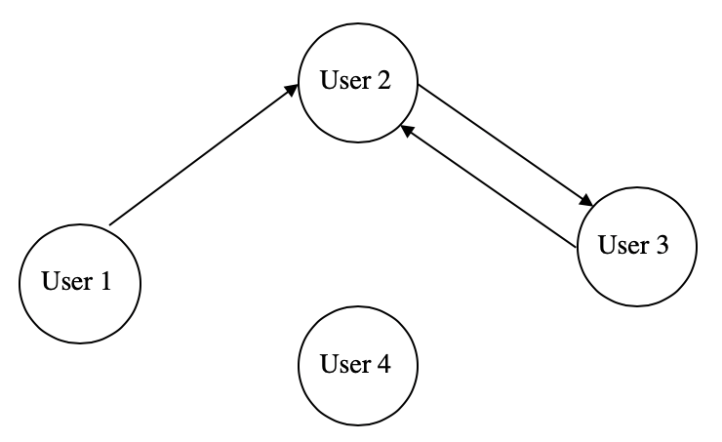
Figure S1. An illustration of possible social network interactions on social media platforms. Users are identified as nodes in the network. Relationships can be unidirectional, such as in the case if user 1 and user 2, or mutual (bi-directional) as in the case of user 2 and user 3. Each relationship is represented by an edge, line or link. Social networks can also have nodes that are not connected to other network members and they are identified as isolates.¹⁷

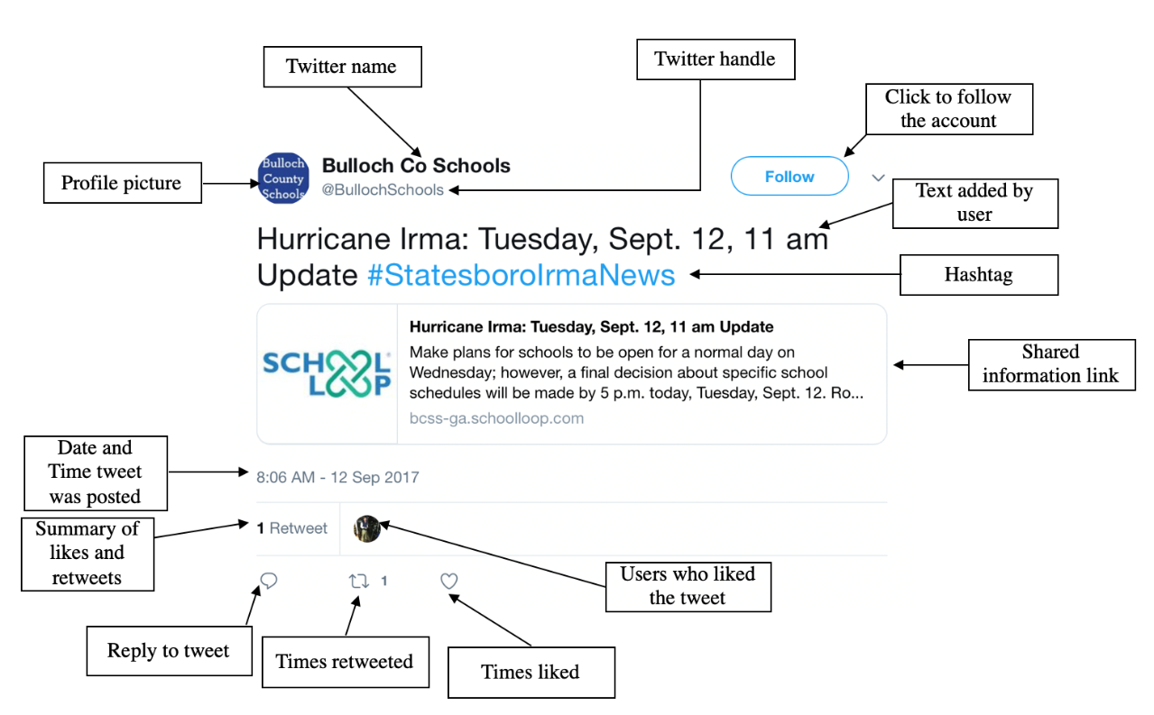
Figure S2. Tweet data (meta-data) that can be identified for social media data analysis. Posts can include information identifying the user account, date of publication, number of likes, shares and replies, body text, and a hashtag to connect the tweet to one topic.
REFERENCES

1. Centers for Disease Control and Prevention. Natural Disasters and Severe Weather. https://www.cdc.gov/disasters/index.html. Published 2018c. Accessed December 13, 2018, 2018.
2. National Center for Biotechnology Information. Natural Disasters https://www.ncbi.nlm.nih.gov/mesh/?term=natural+disasters+. Published 2019. Updated 2019. Accessed January 7, 2019, 2019.
3. Al-Saggaf Y, Simmons P. Social media in Saudi Arabia: Exploring its use during two natural disasters. Technological Forecasting and Social Change. 2015;95:3-15.
4. Ajao O, Hong J, Liu W. A survey of location inference techniques on Twitter. Journal of Information Science. 2015;41(6):855-864.
5. Alam F, Ofli F, Imran M. Processing Social Media Images by Combining Human and Machine Computing during Crises. International Journal of Human-Computer Interaction. 2018;34(4):311-327.
6. Alshareef HN, Grigoras D. Using Twitter and the mobile cloud for delivering medical help in emergencies. Concurrency and Computation-Practice & Experience. 2017;29(24).
7. Arthur R, Boulton CA, Shotton H, Williams HTP. Social sensing of floods in the UK. PloS one. 2018;13(1):e0189327.
8. Auxilia R, Gandhi M. Earthquake Reporting System Development by Tweet Analysis with Approach Earthquake Alarm Systems. Research Journal of Pharmaceutical Biological and Chemical Sciences. 2016;7(3):501-506.
9. Black DR, Dietz JE, Stirratt AA, Coster DC. Do social media have a place in public health emergency response? Journal of emergency management (Weston, Mass). 2015;13(3):217-226.
10. Boulianne S, Minaker J, Haney TJ. Does compassion go viral? Social media, caring, and the Fort McMurray wildfire. Information Communication & Society. 2018;21(5):697-711.
11. Cooper GP, Jr., Yeager V, Burkle FM, Jr., Subbarao I. Twitter as a Potential Disaster Risk Reduction Tool. Part II: Descriptive Analysis of Identified Twitter Activity during the 2013 Hattiesburg F4 Tornado. PLoS currents. 2015;7.
12. Fersini E, Messina E, Pozzi FA. Earthquake management: a decision support system based on natural language processing. Journal of Ambient Intelligence and Humanized Computing. 2017;8(1):37-45.
13. Ghosh S, Srijith PK, Desarkar MS. Using social media for classifying actionable insights in disaster scenario. International Journal of Advances in Engineering Sciences and Applied Mathematics. 2017;9(4):224-237.
14. Murphy RR. Emergency Informatics: Using Computing to Improve Disaster Management. Computer. 2016;49(5):19-27.
15. Panteras G, Wise S, Lu X, Croitoru A, Crooks A, Stefanidis A. Triangulating Social Multimedia Content for Event Localization using Flickr and Twitter. Transactions in Gis. 2015;19(5):694-715.
16. Xu Z, Liu Y, Yen N., et al. Crowdsourcing based Description of Urban Emergency Events using Social Media Big Data. IEEE Transactions on Cloud Computing. 2018:1-11.
17. Valente TW. Social Networks and Health: Models, Methods, and Applications. University Press Scholarship Online; 2010.

