Supplement 1. Institutional Review Board approvals

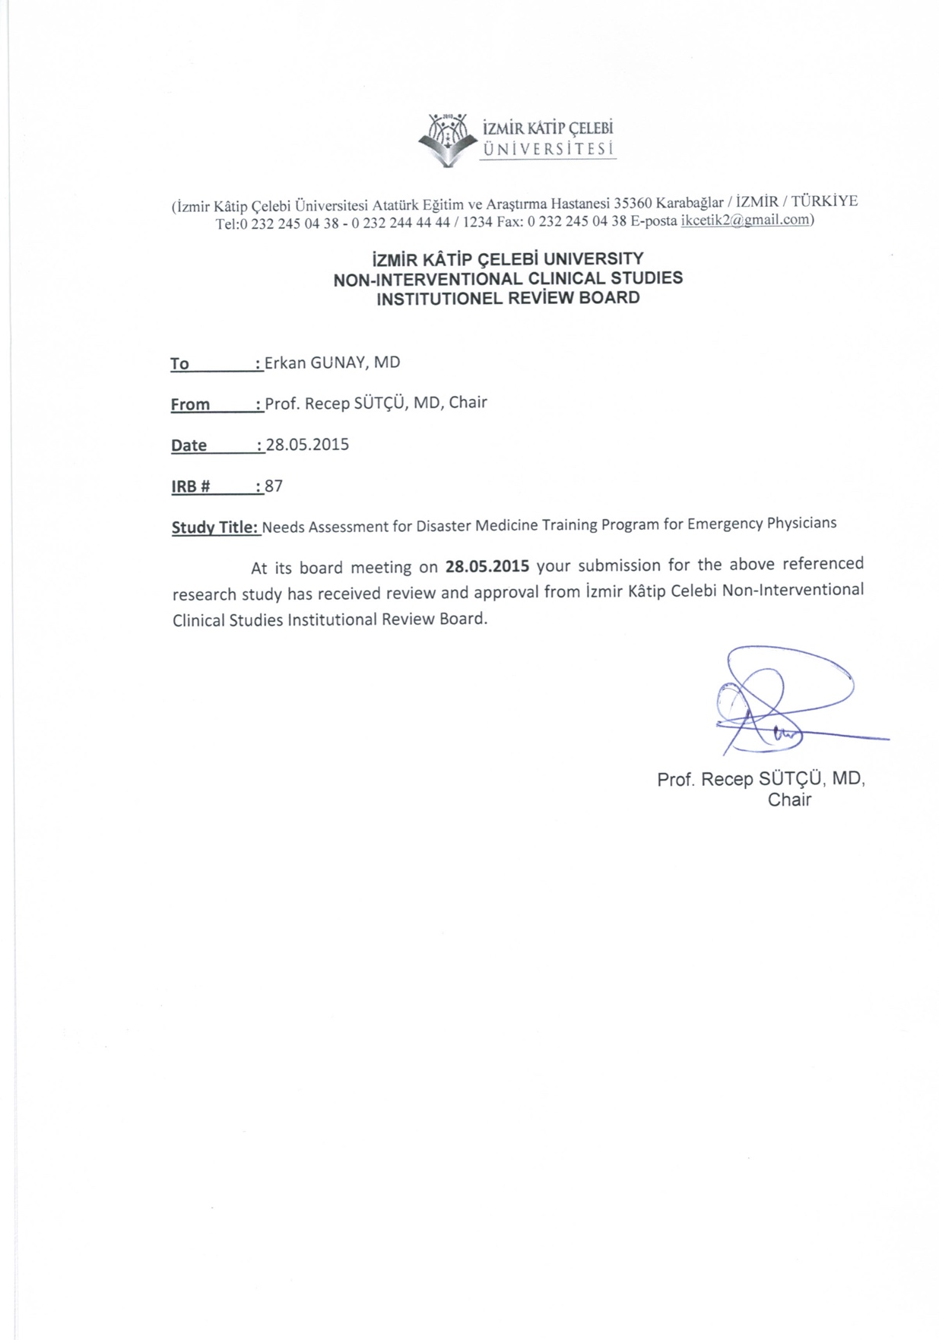

../../../../Dropbox/mph%20capstone/IRB/Outcome_Letter.pdf