**Supplementary Material**

**Inter-regional system collection and utilization data implementation**

The US inter-regional blood supply model divides the US into four regions East, South, Midwest and West according to America’s Blood Centers (ABC) spotlight report1 with 20%, 24%, 25% and 31% of the national blood collected by each region, respectively. In 2010, it is estimated that 15,721,000 blood units were collected in the US (NBCUS 2011). We, then, estimated the average daily blood units collected at about 43,071 units (15,721,000/365). To obtain the number of units collected at each region, we distributed the national daily blood collected among the regions according to the percentages shown above. For the same regions we obtained the percentages of blood utilized in each region from the Centers for Medicare and Medicaid 25%, 21%, 20% and 34%

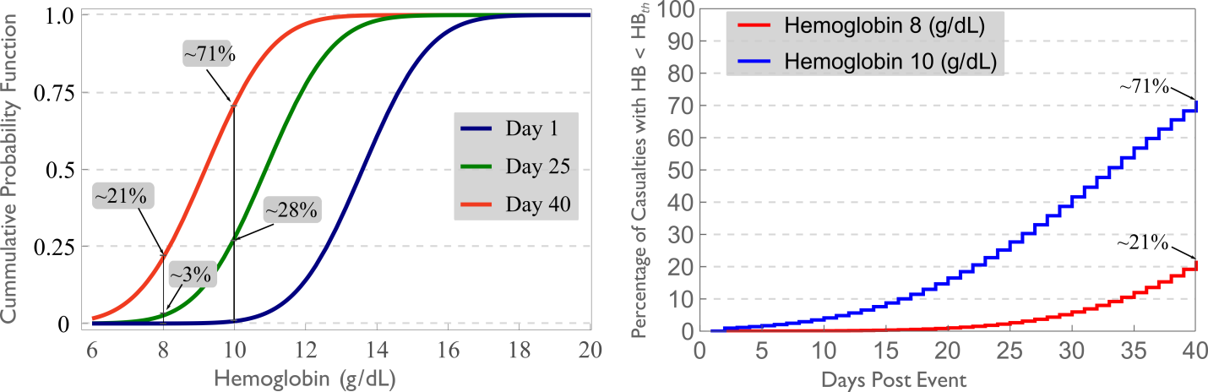

Figure S1 (a) Cumulative probability function (CDF) for casualties at day 1, 25 and 40 with hemoglobin 6 to 20 g/DL, (b) the percentage of casualties with hemoglobin lower than a threshold of 8 g/dL (red) and 10 g/dL (blue).

Figure S1a shows the cumulative probability function for three normal distributions of hemoglobin levels at days 1, 25 and 40 post-event. On day 1, we assumed the hemoglobin level of the casualties is normally distributed with a mean of 13.5 g/dL and standard deviation of 1.48 g/dL (blue curve), same as that one reported for the US population.2 Due to senescence, the hemoglobin of this cohort diminishes at a rate of 1/120 (0.83%) everyday, therefore, after 25 days the mean hemoglobin level of the cohort of casualties is =13.5 – (25/120*13.5) = 10.687 g/dL (green curve). At day 40, the mean hemoglobin is 9 g/dL (red curve). Each of these lines shows the probability of someone having hemoglobin equal to or less than a certain value. For example, if the threshold we are interested in is 8 g/dL, a vertical line at 8 intersects with the three lines provide the probability of someone having hemoglobin of 8 g/dL or less. We can generate a curve for each day from day 1 to day 40, from which we can obtain the daily percentage of casualties falling under the threshold and that might need transfusion. If we subtract the daily percentage of casualties below the preset threshold (8 g/dL in this case) we compute the daily increments of casualties that need transfusion as shown in Figure S1b.

Table S1 Additional daily demand of RBC units (from day 1 to day 40 post event) corresponding to the 50th and 95th percentile estimated casualties reported by Knebel et al.3 and used in our MC1 and MC2 simulated scenarios.

|  |  |  |  |  |  |
| --- | --- | --- | --- | --- | --- |
| day | Daily demand of RBC units  (50th percentile IND) | Daily demand of RBC units (95th percentile IND) | day | Daily demand of RBC units (50th percentile IND) | Daily demand of RBC units (95th percentile IND) |
| 1 | 12800 | 90400 | 21 | 2419 | 9877 |
| 2 | 12805 | 90420 | 22 | 2220 | 9106 |
| 3 | 0 | 10 | 23 | 2021 | 8350 |
| 4 | 214 | 866 | 24 | 1822 | 7604 |
| 5 | 428 | 1727 | 25 | 1628 | 6873 |
| 6 | 647 | 2583 | 26 | 1434 | 6162 |
| 7 | 861 | 3450 | 27 | 1245 | 5461 |
| 8 | 1075 | 4311 | 28 | 1056 | 4775 |
| 9 | 1289 | 5172 | 29 | 867 | 4108 |
| 10 | 1503 | 6043 | 30 | 683 | 3457 |
| 11 | 1722 | 6909 | 31 | 504 | 2821 |
| 12 | 1936 | 7780 | 32 | 320 | 2200 |
| 13 | 2155 | 8656 | 33 | 360 | 2450 |
| 14 | 2369 | 9537 | 34 | 395 | 2715 |
| 15 | 2588 | 10418 | 35 | 435 | 2985 |
| 16 | 2807 | 11310 | 36 | 480 | 3265 |
| 17 | 3026 | 12206 | 37 | 520 | 3550 |
| 18 | 3036 | 12251 | 38 | 560 | 3840 |
| 19 | 2827 | 11450 | 39 | 605 | 4130 |
| 20 | 2623 | 10658 | 40 | 645 | 4415 |

The estimated daily demand of additional RBC units is obtained as the sum of the demand derived for each type of injury considered, such as trauma, radiation injury and combined injury. Only trauma and combined injuries contributed to the additional demand of RBC units in day 1 and 2. As described in the manuscript, 8% of the potential casualties from trauma and combined injury potential casualties are assumed to require transfusion. We assumed that 5 RBC units8 would be transfused for each potential moderate trauma casualty, while 10 RBC units for each potential severe trauma casualty7.

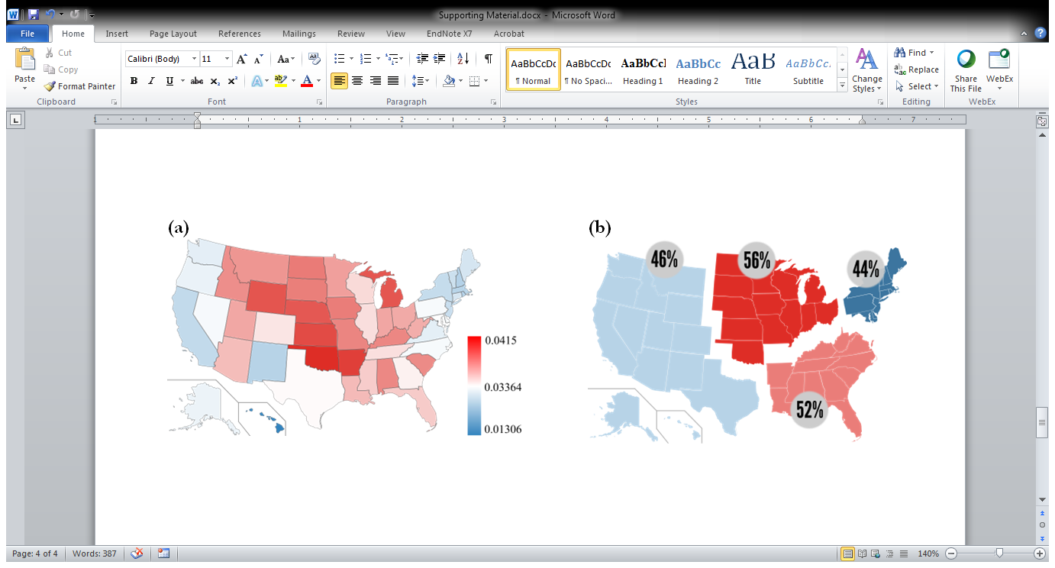 Figure S2 (a) Rates of elective surgeries per 1000 Medicare beneficiaries across the US: national rate (0.0336, white) , states with higher rates (red), states with lower rates (blue). (b) Percentages of blood utilized for transfusion during elective surgeries among the US regions according to the ABC’s subdivision1: East, Midwest, South and West.

For example, for the East we obtained a rate of 0.029 surgeries per 1000 Medicare beneficiaries, while the US rate is 0.0336. We calculated the percentage of BTES in the East by multiplying the national BTES rate by the ratio East-to-US, 50%*0.029/0.0336 = 44%. Similarly, we calculated the percentage of BTES for the South, West and Midwest, as 52%, 55% and 46%, respectively.

**Linear Mixed Model for Pandemic Influenza in the US**

|  |  |  |
| --- | --- | --- |
| Table S2 Summary of the *M2* model showing the effect of the *region* term on the Influenza activity *level*. | | |
| Effect | Estimate (±SE) | *Pr > |t|* |
| Week2 | -0.00100 (0.000350) | 0.0044 |
| Region-Midwest | 1.1948 (0.02688) | <.0001 |
| Region-South | 1.1330 (0.03583) | <.0001 |
| Region-West | 1.1908 (0.03000) | <.0001 |
| Region-East † | 1.1278 (0.02542) | <.0001 |

† Reference categorical variable.

We started with a simple model, M1, where the Influenza activity log of *level* is a function of the square of the *week*. Afterwards, in model *M2*, we investigated the spatial effect by including a *region* term to the model formula. We obtained better fit statistics for *M2* compared to *M1*. Additionally, the Null Model Likelihood Ratio Test and Type 3 Tests of Fixed Effects were significant; demonstrating that the addition of the *region* term enhanced the regression model.

*M1*

Formula: log-level ~ week2

*M2*

Formula: log-level ~ week2 + region | state (region)

Log-level for each state is a linear function in the week squared and the region, where the state is nested in the region.



Figure S3 Heat map for the average daily change of blood transfers within and among regions for East impacted scenarios, MC1E (a) and MC2E and (b) South impacted scenarios, MC1S (c) and MC2S (d) with respect to baseline. Red shades means an increase in transfer with respect to baseline, while blue shades indicate less units transferred compared to baseline. Change = MCi- Baseline, where i=1,2, 3 and 4, referring to MC1, MC2.

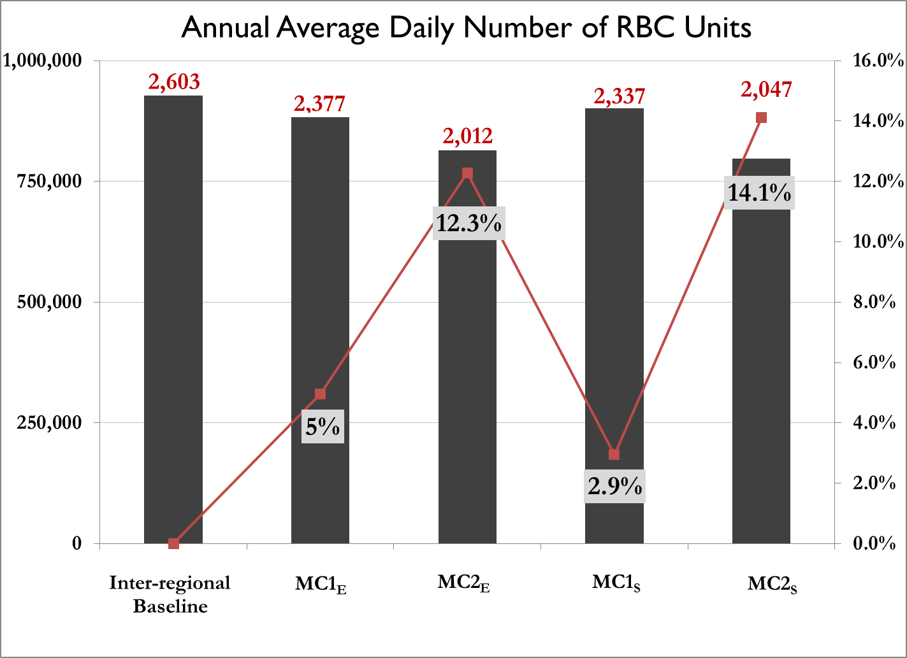

Figure S4 Annual Average Daily number of RBC units in total supply (left axis) and percent reduction (right axis) among scenarios MC1E versus MC1S and MC2E versus MC2S. MC1 and MC2 are scenarios with 50th and 95th percentile casualties. E and S indicate East and South as the impacted region in the scenario. Annual average daily number of expired RBC units is shown above the bars in red

Figure S4 shows the AAD of total supply and the percent reduction in total supply with respect to baseline due to changing the impacted region from East to South for all MC scenarios considered. Assuming that the additional number of RBC units requested for transfusion for MC1 and MC2 were the same regardless of the impacted region, we observed that for scenario MC1 a 5.0% reduction in AAD total supply was found in MC1E compared to a 2.9% in MC1S. The opposite was observed for scenario MC2 in which a reduction of 14.1% was observed in MC2S compared to a 12.3% reduction in MC2E. The same trend was observed in the AAD expired number of RBCs, which were 1.5% higher in scenario MC1E compared to scenario MC1S, (2,377 and 2,337, respectively) and 1.3% lower for MC2E compared to MC2S (2,012 and 2,047, respectively.

Reference list

1. *America's Blood Centers website [monograph on the internet]*. 2014. Available from: <http://www.americasblood.org/stoplight.aspx>

2. Centers for Disease Control and Prevention (CDC). National Center for Health Statistics (NCHS). National Health and Nutrition Examination Survey Data. Hyattsville, MD: U.S. Department of Health and Human Services, Centers for Disease Control and Prevention, 2011-2012.

3. Knebel AR, Coleman CN, Cliffer KD, Murrain-Hill P, McNally R, Oancea V, Jacobs J, Buddemeier B, Hick JL, Weinstock DM. Allocation of scarce resources after a nuclear detonation: setting the context. Disaster. medicine and public health preparedness 2011;**5**: S20-S31.