Appendix B. Mental health related diagnosis service areas of three closed hospitals during Hurricane Sandy
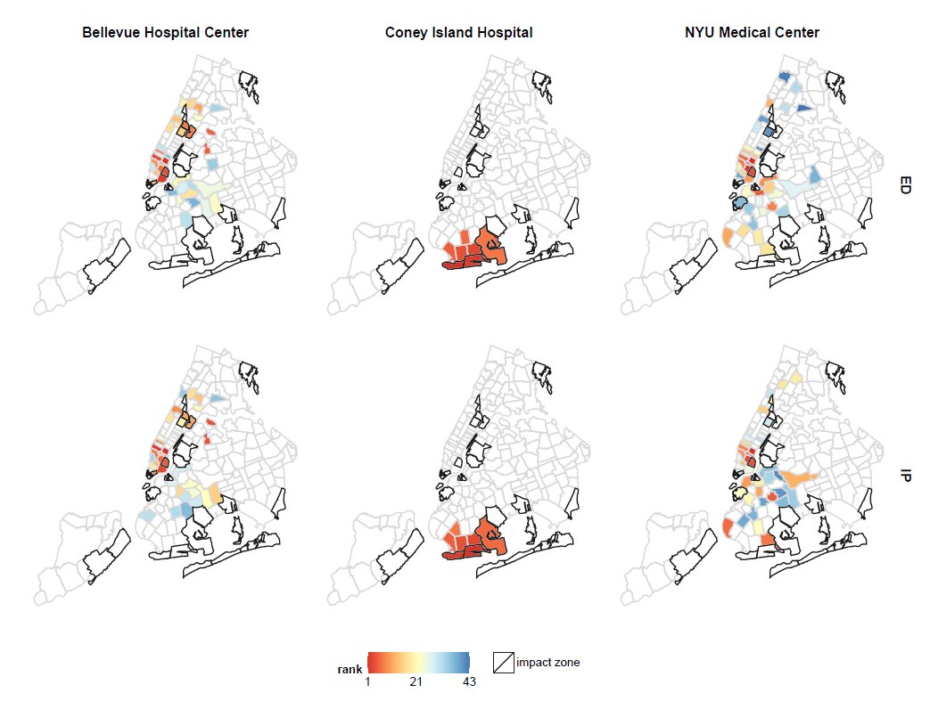
Note: the rank represents the ranking of zip codes where number of patients among 6 months prior to Hurricane Sandy of each hospital resided

