**Table 1 (Appendix): Prevalence estimates for type of insurance and chronic conditions in HAZEL. The source for the estimates is shown.**

|  |  |  |  |
| --- | --- | --- | --- |
| **Characteristic** |  | **Percent of population** | **Source** |
| Type of health insurance | Private | 50 | NYC Community Health Survey, Rockaways population (2010-2012). |
|  | Medicare | 11 |
|  | Medicaid | 26 |
|  | Uninsured | 13 |
| Chronic disease prevalence |  |  |  |
| Asthma | 0-4 | 5.4 | Table 1 http://www.cdc.gov/nchs/data/series/sr_10/sr10_258.pdf |
|  | 5-11 | 11 |
|  | 12-17 | 10.5 |
|  | 18-24 Years | 4.5 | NYC CHS 2012 (entire city) EpiQuery |
|  | 25-44 Years | 4.6 |
|  | 45-64 Years | 5.7 |
|  | 65 and over | 2.4 |
| Hypertension | 25-44 Years | 43.4 | NYC CHS 2012 (entire city) EpiQuery |
|  | 45-64 Years | 77.4 |
|  | 65 and over | 89.5 |
| Diabetes | 0-4 | 0.28 | http://jama.jamanetwork.com/article.aspx?articleid=1866098#Results |
|  | 5-9 | 1.17 |
|  | 10-14 | 1.95 |
|  | 15-19 | 2.42 |
|  | 18-24 Years | 1.7 | NYC CHS 2012 (entire city) EpiQuery |
|  | 25-44 Years | 3.3 |
|  | 45-64 Years | 16.4 |
|  | 65 and over | 25.1 |

**Table 2 (Appendix): Daily probability of accessing a primary care provider based on age and insurance type.**

|  |  |  |
| --- | --- | --- |
| **Agent characteristic** | **Parameter** | **Source** |
| **Private health insurance** | Daily probability of visiting a primary care provider |  |
| **0-4** | 0.011 | Petterson et al. 2012 |
| **5-17** | 0.005 |
| **18-24** | 0.003 |
| **25-44** | 0.004 |
| **45-64** | 0.007 |
| **Medicaid insurance** |  |  |
| **0-4** | 0.010 | Lynch and Honigfeld, 2008; Petterson et al. 2012 |
| **5-17** | 0.004 |
| **18-24** | 0.003 |
| **25-44** | 0.004 |
| **45-64** | 0.007 |
| **Medicare insurance** |  |  |
| **>=65y** | 0.011 | Petterson et al. 2012 |
| **Uninsured** |  |  |
| **0-4** | 0.006 | Petterson et al. 2012 |
| **5-17** | 0.002 |
| **18-24** | 0.001 |
| **25-44** | 0.002 |
| **45-64** | 0.004 |

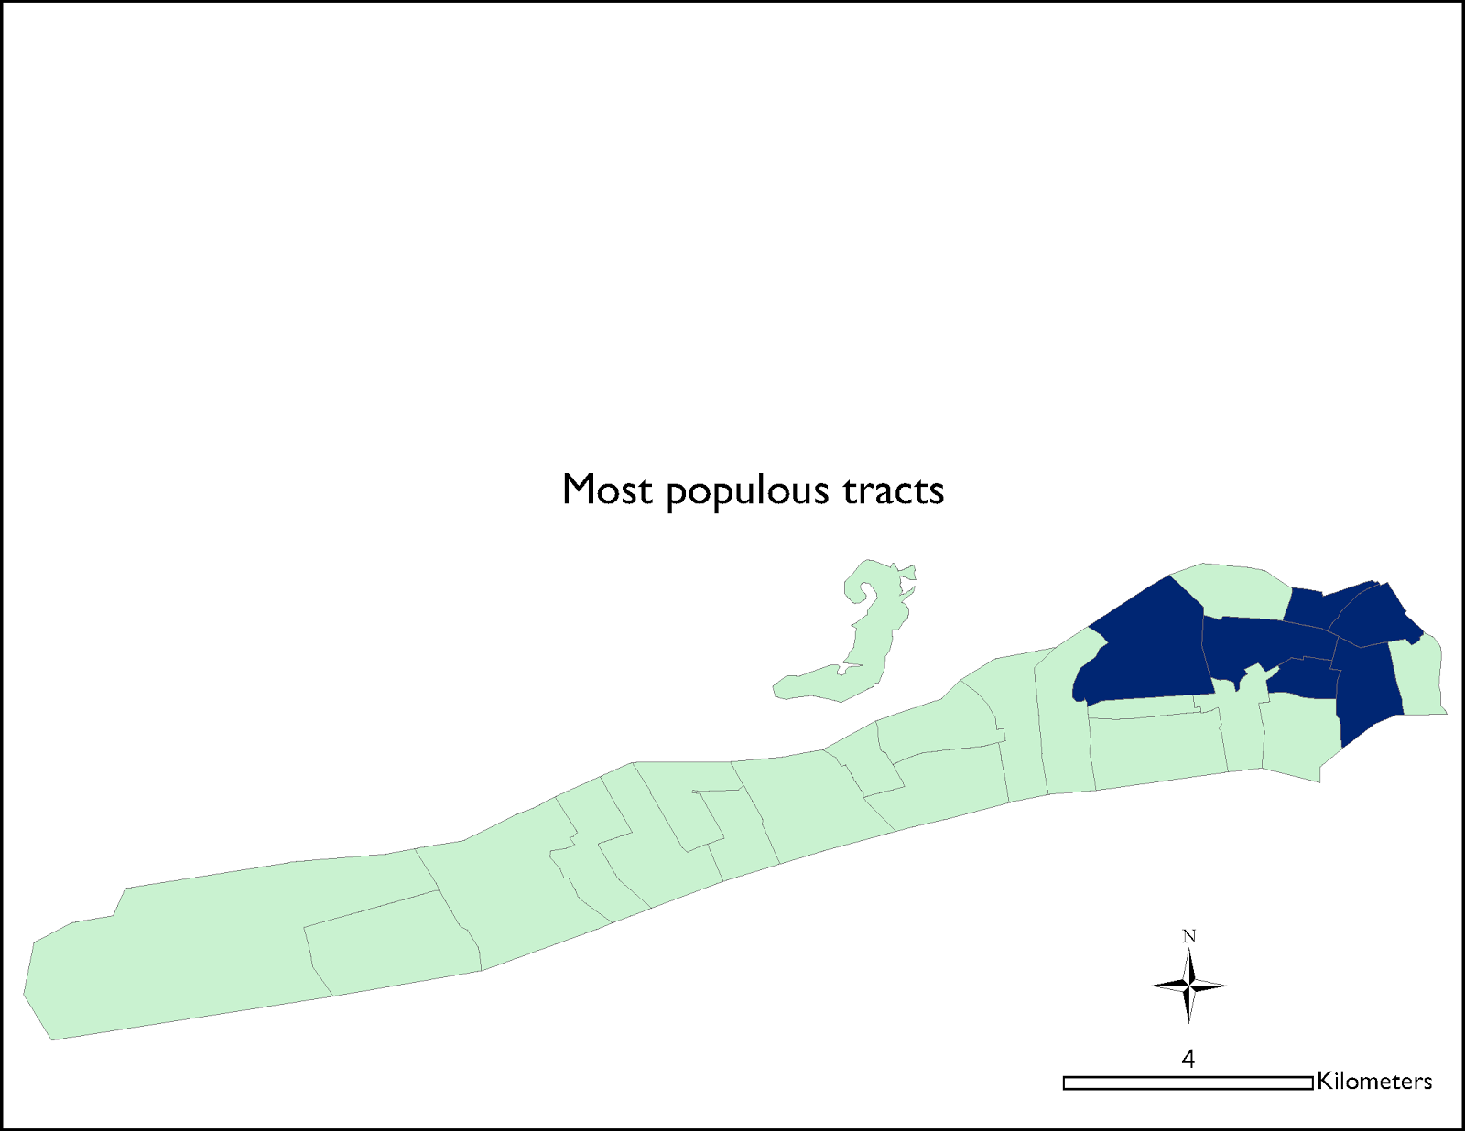

A

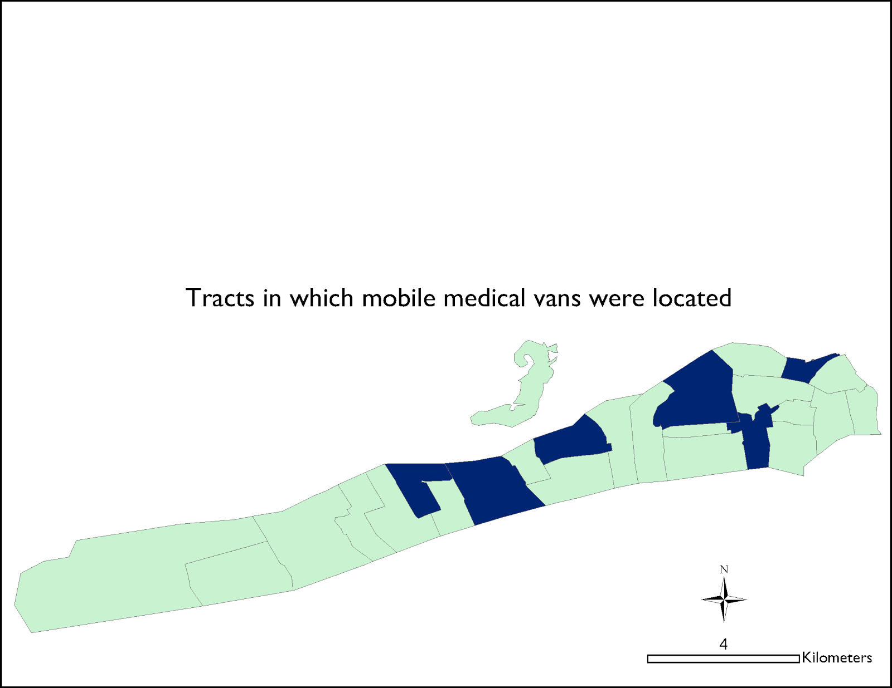

B

Figure S1. Census tracts in which mobile health clinics were located: the six most populous tracts in the Rockaways (A) or actual locations in 2012 after Hurricane Sandy (B).



**Figure S2. Primary care access deficit under two alternative MHC (mobile health clinic) scenarios: mobile health clinics were placed in the six most populous census tracts of the Rockaways (blue) or mobile health clinics were placed in the locations actually used by NYC during the hurricane (green).**