Supplemental Figure 1–Flow chart depicting surveillance process after Hurricane Sandy — New Jersey, November 4–21, 2012.
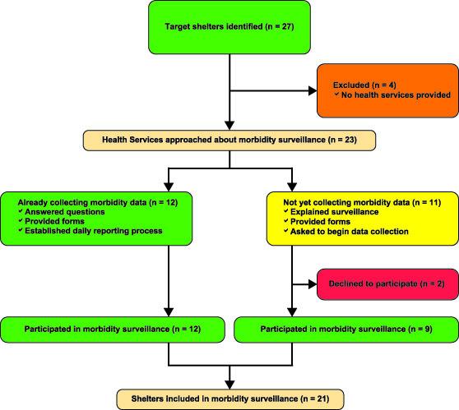

Supplemental Figure 2–Aggregate morbidity form used by independent shelters. The aggregate form used in Red Cross shelters included the same variables.
