Supplemental Figure 1: Example of a study email/FAX message (A), its equivalent SMS (restricted to 160 characters) message (B), and web page (C) to which the embedded hyperlink points.

A. Email/FAX message
From: [BLINDED SITE HEALTH OFFICER]
Subject: [BLINDED SITE]: ROCKY MOUNTAIN SPOTTED FEVER

[BLINDED SITE] Information / Recommendations:

Action requested:
-- Consider that infection with R. rickettsii can lead to Rocky Mountain Spotted Fever (RMSF). RMSF typically begins with the abrupt onset of fever and headache. Clinical presentation varies among patients, but symptoms might include rash, headache, nausea, vomiting, abdominal pain, muscle pain, lack of appetite, and conjunctival injection.
-- Diagnosis of RMSF must be made on clinical signs and symptoms and can later be confirmed using specialized laboratory testing; treatment should not be delayed while awaiting laboratory results or because of initially negative laboratory findings.
-- Definitive diagnosis occurs by serological testing using an indirect immunofluorescence assay (IFA) to demonstrate at least a four-fold rise in immunoglobulin G (IgG) levels in paired serum samples; the first serum sample should be collected within 7 days of symptom onset and the second serum sample collected 2 to 4 weeks after symptom onset.
-- Suspected cases should be reported immediately to local public health authorities.

Background:
R. rickettsii, the causative agent of Rocky Mountain Spotted Fever (RMSF), is a small, rod-shaped bacterium endemic in Montana and transmitted to humans primarily through the bite of an infected tick. In Montana and the Rocky Mountain west, Dermacentor andersoni (Rocky
Mountain wood tick) typically transmits R. rickettsii to humans, and must be attached to human skin for at least 4 to 6 hours for infection to occur. Symptom onset usually begins about 2 to 14 days after the bite of an infected tick. RMSF can lead to death in the first eight days of illness if not treated properly. Treatment consists of supportive care and the use of antibiotics; doxycycline is the antibiotic of choice for adults and children of all ages. Treatment with antibiotics other than doxycycline is associated with an increased risk of death. Public health
investigates RMSF cases to inform individuals how they can reduce their risk of exposure and to educate potentially exposed persons about possible signs and symptoms. Since 2000, 1 to 10 cases of RMSF have been reported annually to [BLINDED SITE] — cases have been reported statewide.

More information and resources about this [BLINDED SITE] Advisory at http://[BLINDED SITE CLICKABLE TINIFIED URL]

---------------------------------------------------------------
[BLINDED SITE HEALTH OFFICER AND CONTACT INFORMATION]

B. SMS message
[BLINDED SITE] ADVISORY: ROCKY MOUNTAIN SPOTTED FEVER typically presents with fever & headache. More info at http://[BLINDED SITE CLICKABLE TINIFIED URL]

C. Web page
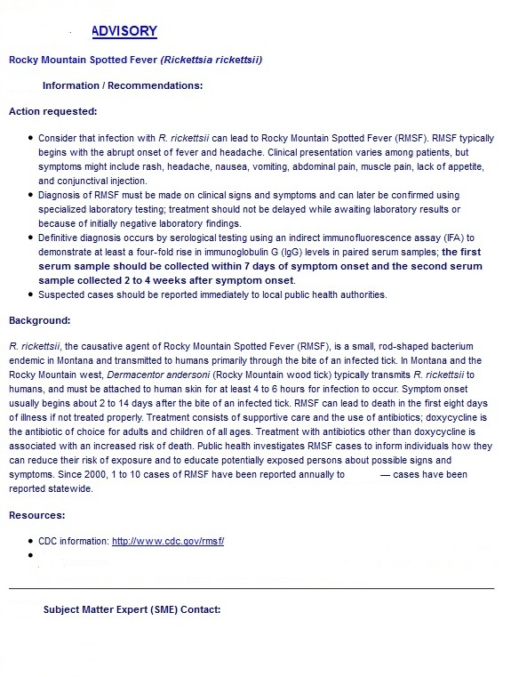
[BLINDED SITE]
[BLIND-ED SITE]
[BLIND-ED SITE]
[CONTACT INFO BLINDED]
[BLINDED SITE RESOURCES]
[BLIND-ED SITE]

