Supplementary Online Material

for

Evolving Consumption Patterns in the U.S. Alcohol Market:
Disaggregated Spatial Analysis

Jarrett Hart and Julian M. Alston

July 4, 2019

Jarrett Hart is a Postdoctoral Scholar in the Department of Agricultural and Resource Economics at the University of California, Davis, One Shields Avenue, Davis, CA 95616, USA; jdhart@.ucdavis.edu. Julian Alston is a distinguished professor in the Department of Agricultural and Resource Economics and Director of the Robert Mondavi Institute Center for Wine Economics at the University of California, Davis, One Shields Avenue, Davis, CA 95616, USA; jmalston@ucdavis.edu.
The work for this project was partially supported by the USDA National Institute of Food and Agriculture Specialty Crop Research Initiative through Award Nos. 2011-51181-30635 and 2017-51181-26829 (the VitisGen project), and Award No. 2015-51181-24393 (the Efficient Vineyard project), and by the Giannini Foundation of Agricultural Economics. The authors gratefully acknowledge helpful comments and advice from Kym Anderson, Tim Beatty, James Fogarty, Jim Lapsley, an anonymous reviewer, and various participants at workshops and conferences.

© Copyright 2019 by Jarrett Hart and Julian M. Alston. All rights reserved. Readers may make verbatim copies of this document for non-commercial purposes by any means provided that this copyright notice appears on all such copies.

To complement the analysis reported in the paper, in this Supplement we report additional evidence on convergence (or the lack thereof), graphical depictions of factors correlated with alcohol consumption, and supplementary and additional estimation results. The additional evidence on convergence demonstrates geographic patterns in the similarity of consumption across the United States, as well as the increase in variance of consumption intensity and decrease in similarity of consumption across states over time. We examine geographic patterns of beer and wine consumption, highlighting the correlation of these patterns with home brewing legalization, excise taxes, ancestry, obesity, income, education, and political affiliation. We provide regression output used to derive elasticities in the main text, and we perform additional estimations to demonstrate the importance of including socio-demographic variables in our model. We compare our estimates of elasticities from the main text and this Supplement with estimates of elasticities from the literature.

Evidence Regarding Convergence
The eight maps in Figure S1 display visually our estimates of the index of similarity, $ω_{jk}$ in five-year averages for 1977–1981 and 2012–2016 comparing each state (a) with the nation, (b) with a typical “beer-drinking” state Ohio, (c) with a typical “spirits-drinking” state Delaware, and (d) with a typical “wine-drinking” state California. If all states were identical, in terms of their vectors of shares of alcoholic beverage consumption, then all of the entries $ω_{jk}$ in the matrix, $Ω_{\overline{t}}$, would be equal to 1 and the maps would be all black; if they were all totally dissimilar, all the entries would be zero, and the maps would be all clear (except for the base state).
[Figure S1. Alcoholic Beverage Consumption Similarity Index, Selected Comparisons among U.S. States, Five-Year Averages, 1977–81 and 2012–2016]
Figure S1 Panel a shows that states have not generally become more similar to the national average over time; it is difficult to discern from the map any distinct change, but the average similarity index decreased slightly from 0.976 to 0.970 between the two periods. Panels b, c, and d better illustrate the consumption differences across the United States. Figure S1 Panel b uses Ohio, a comparatively heavy beer-drinking state, as the base for comparison. In the map for 1977–1981, many states are highly similar to Ohio, but the majority are more dissimilar during 2012–2016. This shift in similarity suggests that states have become more diverse in their consumption mixes relative to a beer-drinking state. In Figure S1 Panel c, which uses Delaware, a comparatively heavy spirits-drinking state, as the base for comparison, a similar pattern is found; there are significantly more highly similar states to Delaware in the map for 1977–1981 than in 2012–2016. In contrast, Figure S1 Panel d shows an increase the similarity of states to California, a state with comparatively high wine consumption. Most states have become somewhat more similar to California over time, in terms of their alcoholic beverage mix, but there remains a great deal of variation across the country, and it is systematic: the coastal states have generally tended to become more similar to the California, but the inland states have generally remained dissimilar.
Figure S2 shows plots of CV_{i} and five-year averages of the annual estimates of CI_{in} based on shares of total per capita alcohol consumption coming from beer, spirits, and wine for the period 1970–2016. There is no apparent trend in variation of this index among states to suggest a convergence in alcohol consumption patterns—which would be visible as a shrinkage of the height of the box in the box and whiskers plot. Plots of annual estimates of CV_{i} are based on state-level data for beer, spirits, and wine, as well as total per capita consumption of alcohol, for the period 1970–2016.
[Figure S2. Beverage consumption intensity index among U.S. states in alcohol consumed per adult, and shares of beer, spirits, and wine, five-year averages, 1970 to 2016]
Figure S3 presents a box and whiskers plot of the state-level estimates of the consumption similarity index, ${\overline{ω}}_{j}$, as five-year averages of the annual estimates, as well as a line plot of the five-year averages of the overall national $\overset{̿}{ω}$ for the period 1970–2016. The plot reveals that states’ consumption mix became more similar from 1970 through the early 1990s, but since then, they have become more dissimilar.
[Figure S3. Average values of alcoholic beverage consumption similarity index, selected comparisons among U.S. states, five-year averages, 1970 to 2016]

S-II Correlations with Consumption
Figure S4 maps beer to wine consumption ratios for the United States. In general, states in Western and Northeastern regions drink relatively less beer than wine compared to other states. Next, we geographically depict several socio-economic variables that may be correlated with consumption patterns. These maps serve as motivation to include socio-economic variables in the estimations in the main text.
Figure S5 contains four maps; Panel a shows, state-by-state, the year when homebrewing was legalized, across the United States, and Panels b, c, and d illustrate beer, wine, and spirits excise taxes. Figure S6 depicts the ancestral consumption for beer in gallons of ethanol at the state-level (county-level) based on U.S. Census ancestral data for 2005–2009 in Panel a (Panel b); immediately apparent is the large ancestral beer consumption among states in the Midwest region owing to their predominantly Northern European populations. Conversely, states in the Southeast typically have lower ancestral beer consumption owing to large Southern European population shares. Also of note is the large degree of heterogeneity within states, evidenced by Panel b, illustrating potential issues that may arise from aggregation.
[Figure S4. Ratio of Beer to Wine Consumption across States, Five-Year Average, 2012–2016]
[Figure S5. State Legalization of Home Brewing and Excise Taxes by Alcohol Type]
[Figure S6. Ancestral Beer Consumption Shares, 2005–2009]
Table S1 ranks states by measures of obesity prevalence, per capita income, educational attainment, and political orientation, as well as their ratio of beer to wine consumption (used to order the entries in the table). Some clear patterns are evident. Specifically, those states that consume relatively more wine tend to have a lower prevalence of obesity, higher income per capita, higher educational attainment, and a lower rate of voter support for Donald Trump in the 2016 national election! These patterns are borne out in the results from estimating demand models using these state-level data, reported in Section V, as well as the results from further analysis using much more detailed and spatially disaggregated data, reported in Section VI.
[Table S1. Ratio of Beer to Wine Consumption and Selected Demographic Variables, 2016]
Figure S7 charts obesity, per capita income, educational attainment, and political orientation across the United States. These maps are noticeably comparable, with each other as well as the with the map of the ratio of beer-to-wine consumption (Figure S4). Specifically, those states that consume relatively more wine tend to have a lower prevalence of obesity, higher income per capita, higher educational attainment, and lower rate of voter support for Donald Trump in the 2016 national election. The visual evidence from the maps is tested more formally in sections V and VI.
[Figure S7. State-Level Measurements of Health, Wealth, and Wisdom, 2016]

S-III Estimation Results
Table S2 provides the results of the first stage estimation using state-level data when demographic variables are excluded from the model. In comparison to Table 5, the elasticities are substantially different. This result highlights the importance of considering demographic variables when deriving elasticities, as their exclusion leads to substantial omitted variable bias.
[Table S2. Estimates of Single-Equation Models of Demand Using State-Level Data, 1970–2016]
Table S3 contains regression output used to derive Marshallian elasticities in the second stage estimation using state-level data. Regressions are estimated according to equation (8), and descriptions of the model and elasticity derivations can be found in section V. Table S4 lists the derived Marshallian elasticities in the second stage estimation using state-level data when demographic variables are excluded. Once again, we find strong evidence of omitted variable bias, as the elasticities are substantially different compared to those in Table 5.
[Table S3. Regression Output for the Rotterdam Model Estimated Using State-Level Data, 1970–2016]
[Table S4. Elasticities of Demand for Alcohol from the Rotterdam Model Estimated Using State-Level Data, No Demographics, 1970–2016]
Table S5 provides the first stage estimation results using DMA-level data when excluding demographic variables. The own-price and income elasticities for wine are substantially different from those reported in Table 8, providing further evidence of significant omitted variable bias when ignoring sociodemographic factors.
[Table S5. Elasticities from the Single-Equation Model and DMA-Level Data, No Demographics, 2006–2015]
The Marshallian elasticities derived from the second stage estimation using DMA-level data and excluding demographic variables are provided in Table S6. The corresponding elasticities when including demographics can be found in Table 9. To demonstrate the effect of omitting demographic variables, Table S7 provides the ratio of the elasticities from Tables 9 and S6. Excluding demographic variables substantially changes many of the price and income elasticities.
[Table S6. Elasticities from the Rotterdam Model Estimated Using DMA-Level Data, 2006–2015]
[Table S7. Ratio of Elasticities Including Demographic Variables over Elasticities Excluding Demographic Variables, Rotterdam Model Estimated Using DMA-Level Data, 2006–2015]
The regression output used to calculate Marshallian elasticities in the second stage estimation using state-level (DMA-level) data are provided in Table S8. The corresponding elasticities are reported in Table 9, and their derivations are described in section V. Regression output for other second stage estimations are available upon request.
[Table S8. Regression Output for the Rotterdam Model Estimated Using DMA-Level Data, 2006–2015]
Table S9 provides a side-by-side comparison of own-price and income elasticities of demand for beer and wine from models with and without demographic variables, as well as the meta-analysis elasticities from Fogarty (2010). In general, the exclusion of demographic variables results in more elastic estimates. Our elasticity estimates vary substantially from the mean of the meta-analysis, but they generally fall within a standard deviation of the mean in the meta-analysis (except for the own-price elasticity of demand for wine).
[Table S9. Comparison of Own-Price and Income Elasticities with Fogarty Meta-Analysis]
In Table S10, we report the estimates from a model excluding wine and treating the three beer categories as comprising a weakly separable group, and a model excluding beer and treating the three different types of wine as a weakly separable group. It is important to recall that the coefficients for demand shifters across goods included in the model must still sum to zero, therefore we cannot expect to find coefficients having the same signs and sizes as in the previous estimation.
[Table S10. Elasticities from Separate Rotterdam Models for Beer and Wine, 2006 to 2015]
The own-price elasticities of demand for the beer and wine categories are generally consistent with the previous estimation, suggesting elastic demand for each category (except other wine). Within the beer group, there are no statistically significant cross-price relationships between craft, macro, and imported beer. Within the wine group, low- and high-priced wine are substitutes, while other wine is highly substitutable with low-priced wine and is complementary to high-priced wine. This is not entirely surprising; the category “other wine” includes many lower-priced products, and products that are not traditionally interchangeable with high-priced wine, such as sangria, vermouth, and dessert wine. The expenditure elasticity is greater for high-priced wine than low-priced wine and other wine, and the elasticities are smaller than the results from the model for the six categories of beer and wine combined—a more reasonable finding that is consistent with expectations. The expenditure elasticities for the beer categories are not substantially different from the estimates in the model with six. Ultimately, there are no strong indications that estimating demand systems for beer and wine separately is inappropriate. The estimates from the separate models may be more reliable than the results in Table 10, as they avoid the issues that arise from including a greater number of product categories in the model.
Again, the within-beer and within-wine demand responses to changes in socio-demographic variables are of greater interest. The elasticities with respect to the “Trump” variable suggest that in those areas where more voters supported Trump, within the group “beer” consumers tend to demand substantially less craft and imported beer and more macro beer; within the group “wine” they demand less low-priced wine but not significantly more or less high-priced and other wine. The results for the ancestral preference variables indicate that consumers in areas with stronger historical and cultural links to beer-drinking countries demand more craft and macro beer and less imported beer and low-priced wine. Individuals in areas with greater ancestral demand for wine demand more low-priced wine and less macro beer and high-priced wine. The elasticities with respect to the Hispanic population share are typically close to zero, but people in areas with higher Hispanic population shares demand less craft beer (holding beer expenditure constant), and less high-priced wine and more low-priced wine (holding total wine expenditure constant). Consumers in more urban areas demand less craft beer and low-priced wine, and they demand more high-priced wine.
Table S11 reports elasticities of demand for each type of beer and wine with respect to income (total expenditure on all goods) and with respect to prices conditional on income, calculated according to equations (9) and (10) and thus combining the first-stage estimates from Table 8 and the second-stage estimates from Table S10. These elasticities are intuitive and are directly comparable to their counterparts in Table 10. Notably, the expenditure elasticities in the beer category are all inelastic, whereas the expenditure elasticities in the wine category are elastic. The own-price elasticities of demand are most elastic for imported beer, low-priced wine, and high-priced wine; the own-price elasticity of demand for macro beer is the most inelastic.
[Table S11. Marshallian Price and Expenditure Elasticities, Conditional on Total Expenditure on All Goods, and Separate Beer and Wine Systems]
Figure S1
Alcoholic Beverage Consumption Similarity Index, Selected Comparisons among U.S. States, Five-Year Averages, 1977–81 and 2012–2016
  - Similarity to United States, 1977–81
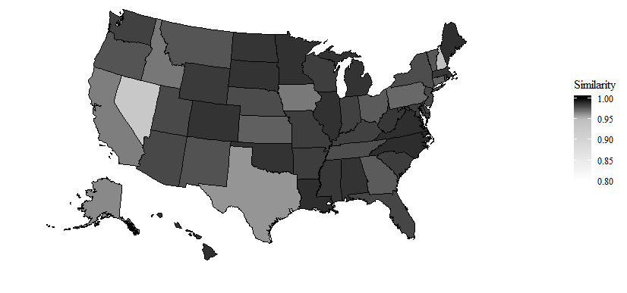
  - Similarity to United States, 2012–16
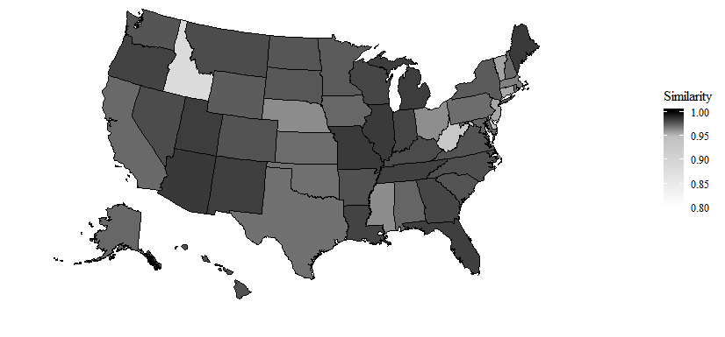

- Similarity to Ohio, 1977–81
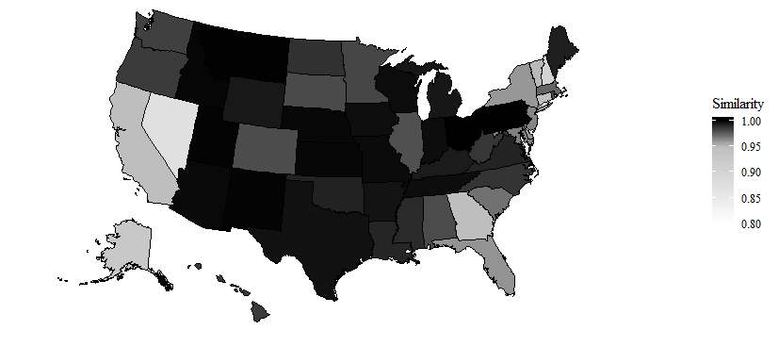
- Similarity to Ohio, 2012–16
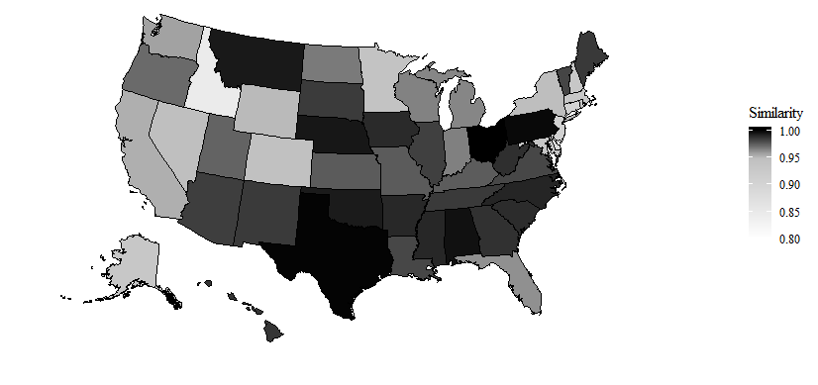

- Similarity to Delaware, 1977–81
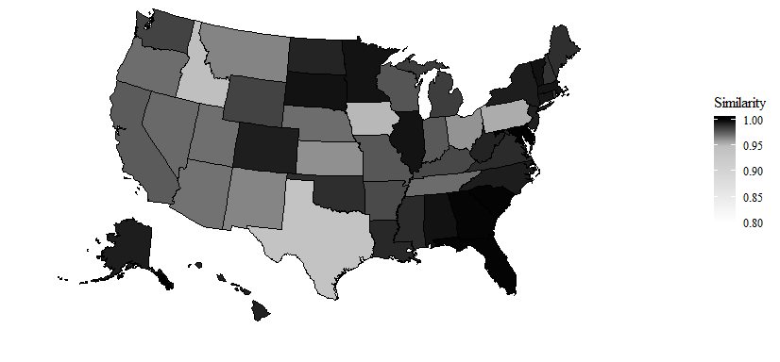
- Similarity to Delaware, 2012–16
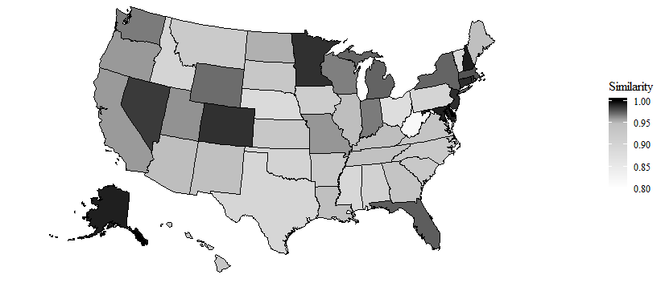

- Similarity to California, 1977–81
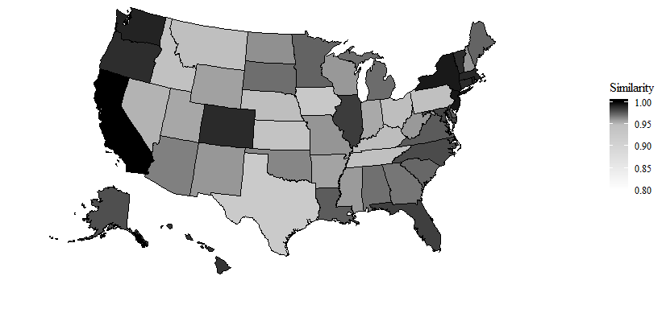
- Similarity to California, 2012–16
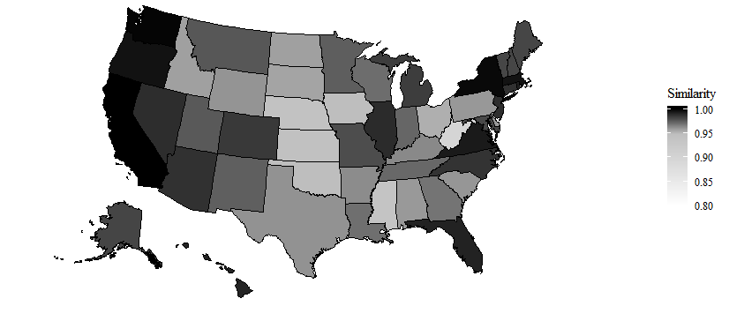
Source: Created by the authors using data from Haughwout and Slater (2018).
Notes: Based on population aged above 13 years.

Figure S2
Beverage Consumption Intensity Index among U.S. States in Alcohol Consumed per Adult, and Shares of Beer, Spirits, and Wine, Five-Year Averages, 1970 to 2016
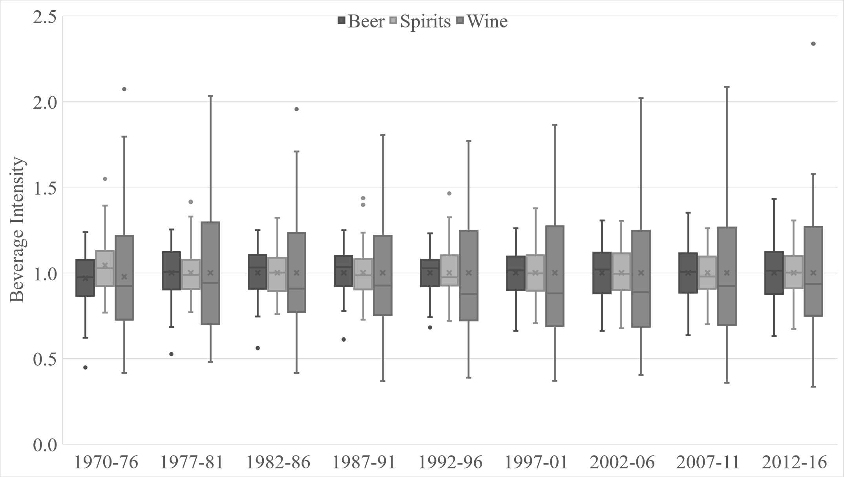
Source: Created by the authors using data from Haughwout and Slater (2018).
Notes: Based on population aged above 13 years. Boxes represent quartiles, whiskers 95% confidence intervals, and dots are outliers.

Figure S3
Average Values of Alcoholic Beverage Consumption Similarity Index, Selected Comparisons among U.S. States, Five-Year Averages, 1970 to 2016
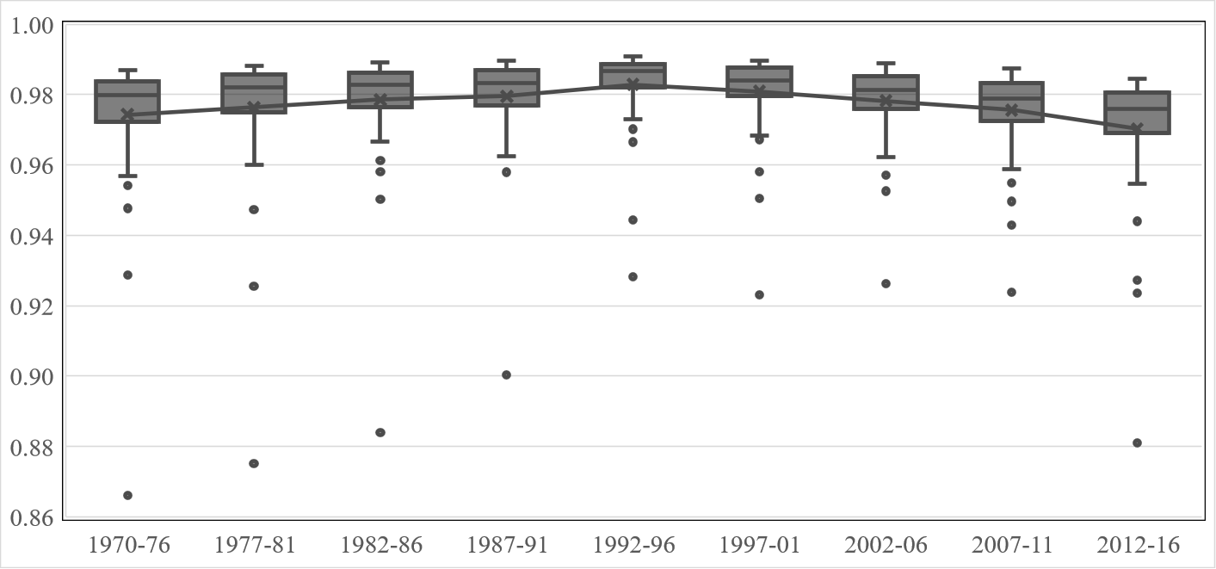
Source: Created by the authors using data from Haughwout and Slater (2018).
Notes: States are more similar as the value approaches 1. Boxes represent quartiles, whiskers 95% confidence intervals, and dots are outliers. Based on population aged above 13 years.

Figure S4
Ratio of Beer to Wine Consumption across States, Five-Year Average, 2012–2016
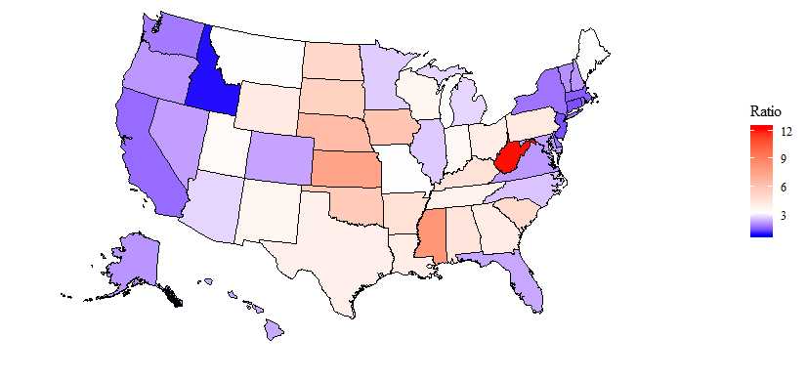
Source: Created by the authors using data from Haughwout and Slater (2018).
Notes: Based on population aged above 13 years.
Figure S5
State Legalization of Home Brewing and Excise Taxes by Alcohol Type
- Home brewing legalization
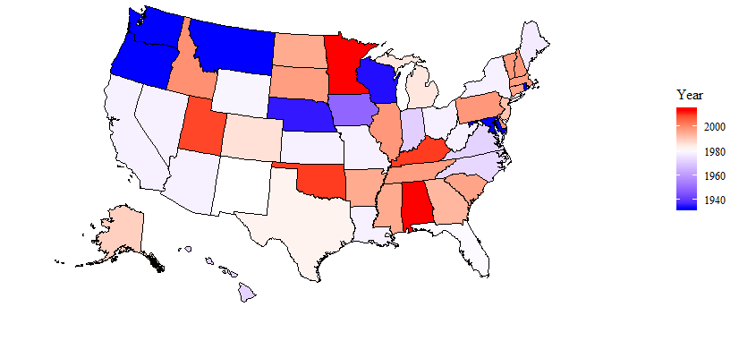

- State excise tax rate, beer
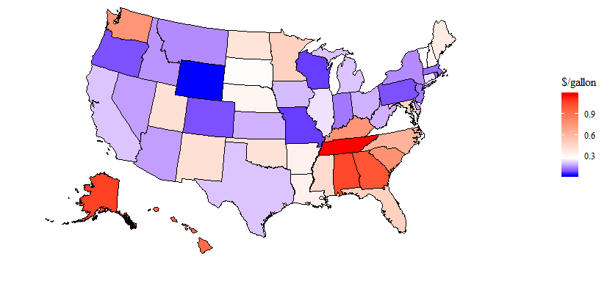

- State excise tax rate, wine
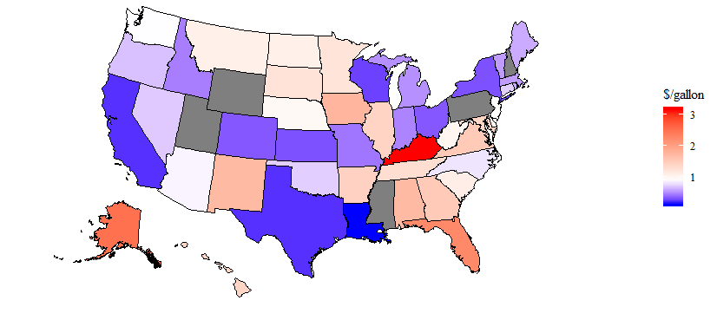
- State excise tax rate, spirits
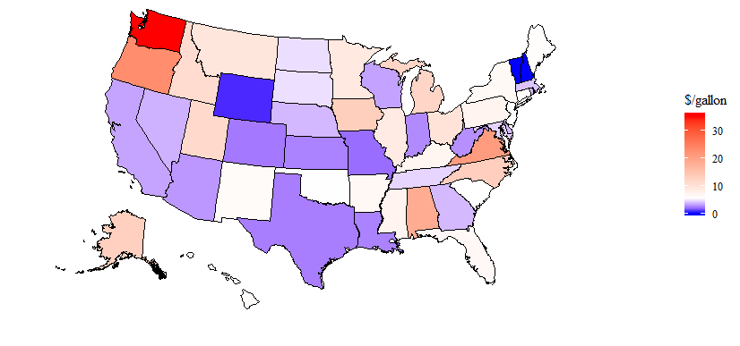Source: Created by the authors using data from various sources as described in Table 4.4.
Notes: States in grey have state-controlled alcohol sales for the relevant alcohol category.
Figure S6
Ancestral Beer Consumption Shares, 2005–2009
- States
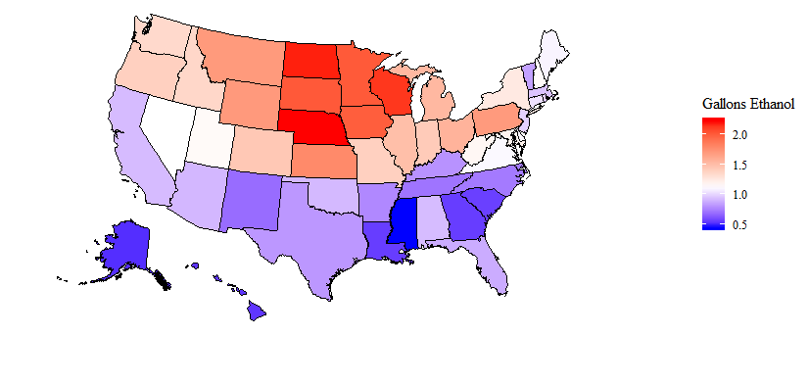
- Counties
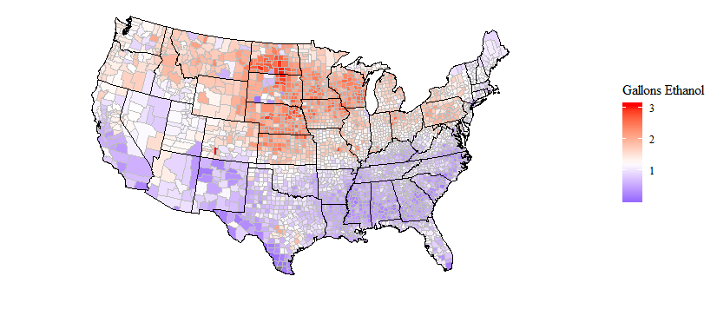
Source: Created by the authors using data from various sources as described in Table 4.4.
Notes: Alaska and Hawaii are omitted from the county-level map since there are no DMA-levels sales data for the states, therefore the differences in aggregated and disaggregated data are irrelevant.
Figure S7
State-Level Measurements of Health, Wealth, and Wisdom, 2016
              - Obesity
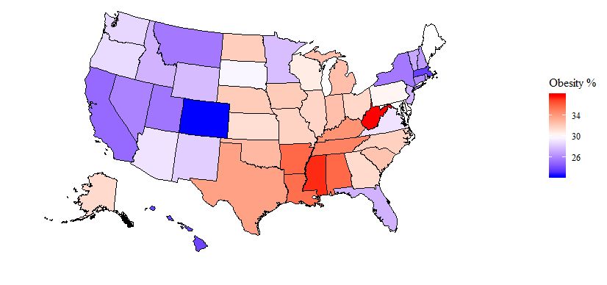
              - Income per capita
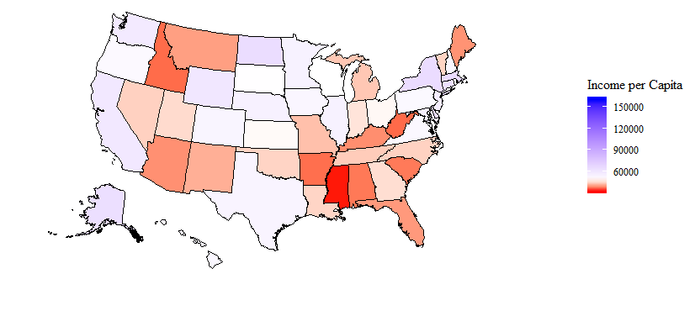

              - % of population 25+ with Bachelor’s degree
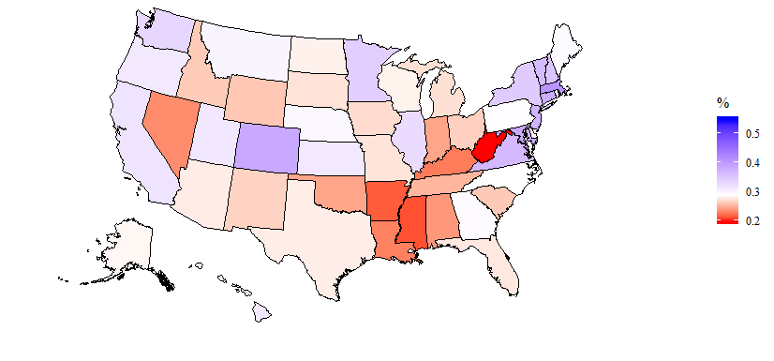
              - Ratio of Trump to Clinton votes 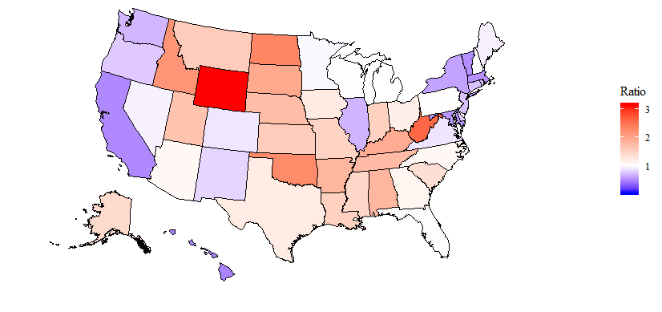
Source: Created by the authors using data from various sources as described in Table 4.
Notes: Obesity rate is for adults only.

Table S1
Ratio of Beer to Wine Consumption and Selected Demographic Variables, 2016
 |  | Beer/Wine |  |  |  | Obesity |  |  |  | Income |  |  |  | Education |  |  |  | GOP
State |  | Ratio |  | Decile |  | % |  | Decile |  | $ |  | Decile |  | % |  | Decile |  | % |  | Decile
WV |  | 11.08 |  | 10 |  | 0.38 |  | 10 |  | 36,155 |  | 1 |  | 0.19 |  | 1 |  | 0.72 |  | 10
MS |  | 7.33 |  | 10 |  | 0.37 |  | 10 |  | 32,334 |  | 1 |  | 0.21 |  | 1 |  | 0.59 |  | 7
KS |  | 7.11 |  | 10 |  | 0.31 |  | 6 |  | 47,548 |  | 5 |  | 0.31 |  | 7 |  | 0.61 |  | 8
NE |  | 5.96 |  | 10 |  | 0.32 |  | 8 |  | 54,660 |  | 8 |  | 0.29 |  | 6 |  | 0.64 |  | 9
IA |  | 5.56 |  | 10 |  | 0.32 |  | 8 |  | 52,248 |  | 7 |  | 0.27 |  | 4 |  | 0.55 |  | 7
OK |  | 5.38 |  | 10 |  | 0.33 |  | 9 |  | 44,418 |  | 4 |  | 0.24 |  | 2 |  | 0.69 |  | 10
ND |  | 4.88 |  | 9 |  | 0.32 |  | 8 |  | 64,257 |  | 10 |  | 0.28 |  | 5 |  | 0.70 |  | 10
SD |  | 4.66 |  | 9 |  | 0.30 |  | 5 |  | 48,306 |  | 6 |  | 0.27 |  | 4 |  | 0.66 |  | 10
SC |  | 4.63 |  | 9 |  | 0.32 |  | 8 |  | 37,269 |  | 2 |  | 0.26 |  | 3 |  | 0.57 |  | 7
KY |  | 4.39 |  | 9 |  | 0.34 |  | 9 |  | 38,736 |  | 2 |  | 0.22 |  | 1 |  | 0.66 |  | 9
AR |  | 4.28 |  | 9 |  | 0.36 |  | 10 |  | 36,502 |  | 1 |  | 0.21 |  | 1 |  | 0.64 |  | 9
AL |  | 4.21 |  | 8 |  | 0.36 |  | 10 |  | 37,158 |  | 1 |  | 0.24 |  | 2 |  | 0.64 |  | 9
PA |  | 4.00 |  | 8 |  | 0.30 |  | 6 |  | 50,978 |  | 6 |  | 0.29 |  | 6 |  | 0.50 |  | 5
GA |  | 3.95 |  | 8 |  | 0.31 |  | 7 |  | 45,238 |  | 5 |  | 0.29 |  | 6 |  | 0.53 |  | 6
TX |  | 3.79 |  | 8 |  | 0.34 |  | 9 |  | 53,104 |  | 8 |  | 0.28 |  | 5 |  | 0.55 |  | 6
OH |  | 3.76 |  | 8 |  | 0.32 |  | 7 |  | 47,419 |  | 5 |  | 0.26 |  | 3 |  | 0.54 |  | 6
WY |  | 3.72 |  | 7 |  | 0.28 |  | 4 |  | 59,327 |  | 9 |  | 0.26 |  | 3 |  | 0.76 |  | 10
LA |  | 3.71 |  | 7 |  | 0.36 |  | 10 |  | 44,440 |  | 4 |  | 0.23 |  | 1 |  | 0.60 |  | 8
NM |  | 3.56 |  | 7 |  | 0.28 |  | 4 |  | 41,334 |  | 3 |  | 0.26 |  | 3 |  | 0.45 |  | 3
WI |  | 3.38 |  | 7 |  | 0.31 |  | 6 |  | 48,063 |  | 6 |  | 0.28 |  | 5 |  | 0.50 |  | 5
IN |  | 3.34 |  | 7 |  | 0.33 |  | 9 |  | 45,717 |  | 5 |  | 0.24 |  | 2 |  | 0.60 |  | 8
UT |  | 3.31 |  | 6 |  | 0.25 |  | 2 |  | 44,947 |  | 5 |  | 0.31 |  | 8 |  | 0.62 |  | 8
TN |  | 3.14 |  | 6 |  | 0.35 |  | 10 |  | 43,720 |  | 3 |  | 0.25 |  | 2 |  | 0.64 |  | 9
MT |  | 3.14 |  | 6 |  | 0.26 |  | 2 |  | 40,041 |  | 3 |  | 0.30 |  | 7 |  | 0.61 |  | 8
ME |  | 3.09 |  | 6 |  | 0.30 |  | 6 |  | 39,125 |  | 2 |  | 0.29 |  | 6 |  | 0.48 |  | 4
MO |  | 3.07 |  | 6 |  | 0.32 |  | 7 |  | 42,736 |  | 3 |  | 0.27 |  | 4 |  | 0.60 |  | 7
AZ |  | 2.85 |  | 5 |  | 0.29 |  | 5 |  | 38,940 |  | 2 |  | 0.28 |  | 5 |  | 0.52 |  | 6
MI |  | 2.64 |  | 5 |  | 0.33 |  | 9 |  | 43,330 |  | 3 |  | 0.27 |  | 4 |  | 0.50 |  | 5
IL |  | 2.61 |  | 5 |  | 0.32 |  | 7 |  | 54,308 |  | 8 |  | 0.32 |  | 8 |  | 0.41 |  | 2
MN |  | 2.60 |  | 5 |  | 0.28 |  | 4 |  | 54,295 |  | 8 |  | 0.34 |  | 9 |  | 0.49 |  | 4
NC |  | 2.44 |  | 5 |  | 0.32 |  | 8 |  | 44,194 |  | 4 |  | 0.28 |  | 6 |  | 0.52 |  | 6
NV |  | 2.31 |  | 4 |  | 0.26 |  | 2 |  | 44,142 |  | 4 |  | 0.23 |  | 2 |  | 0.49 |  | 4
HI |  | 2.25 |  | 4 |  | 0.24 |  | 1 |  | 51,964 |  | 7 |  | 0.31 |  | 7 |  | 0.33 |  | 1
CO |  | 2.22 |  | 4 |  | 0.22 |  | 1 |  | 52,863 |  | 7 |  | 0.38 |  | 10 |  | 0.47 |  | 4
NH |  | 2.12 |  | 4 |  | 0.27 |  | 3 |  | 51,827 |  | 7 |  | 0.35 |  | 9 |  | 0.50 |  | 5
MD |  | 2.08 |  | 4 |  | 0.30 |  | 6 |  | 55,786 |  | 8 |  | 0.38 |  | 10 |  | 0.36 |  | 2
OR |  | 2.06 |  | 3 |  | 0.29 |  | 5 |  | 50,751 |  | 6 |  | 0.31 |  | 7 |  | 0.44 |  | 3
FL |  | 2.06 |  | 3 |  | 0.27 |  | 4 |  | 39,608 |  | 2 |  | 0.27 |  | 4 |  | 0.51 |  | 5
VA |  | 2.05 |  | 3 |  | 0.29 |  | 5 |  | 51,443 |  | 7 |  | 0.36 |  | 9 |  | 0.47 |  | 4
AK |  | 2.04 |  | 3 |  | 0.31 |  | 7 |  | 63,304 |  | 10 |  | 0.28 |  | 5 |  | 0.58 |  | 7
VT |  | 1.98 |  | 3 |  | 0.27 |  | 3 |  | 44,354 |  | 4 |  | 0.36 |  | 9 |  | 0.35 |  | 1
WA |  | 1.83 |  | 2 |  | 0.29 |  | 4 |  | 57,796 |  | 9 |  | 0.33 |  | 8 |  | 0.41 |  | 2
NY |  | 1.72 |  | 2 |  | 0.26 |  | 2 |  | 64,522 |  | 10 |  | 0.34 |  | 9 |  | 0.38 |  | 2
DE |  | 1.63 |  | 2 |  | 0.31 |  | 6 |  | 63,578 |  | 10 |  | 0.30 |  | 7 |  | 0.44 |  | 3
RI |  | 1.62 |  | 2 |  | 0.27 |  | 3 |  | 47,662 |  | 6 |  | 0.32 |  | 8 |  | 0.42 |  | 2
CA |  | 1.62 |  | 2 |  | 0.25 |  | 1 |  | 58,974 |  | 9 |  | 0.31 |  | 8 |  | 0.34 |  | 1
MA |  | 1.47 |  | 1 |  | 0.24 |  | 1 |  | 65,168 |  | 10 |  | 0.41 |  | 10 |  | 0.35 |  | 1
NJ |  | 1.39 |  | 1 |  | 0.27 |  | 4 |  | 56,428 |  | 9 |  | 0.37 |  | 10 |  | 0.43 |  | 3
CT |  | 1.37 |  | 1 |  | 0.26 |  | 2 |  | 62,745 |  | 9 |  | 0.38 |  | 10 |  | 0.43 |  | 3
DC |  | 1.10 |  | 1 |  | 0.23 |  | 1 |  | 159,141 |  | 10 |  | 0.55 |  | 10 |  | 0.04 |  | 1
ID |  | 0.78 |  | 1 |  | 0.27 |  | 4 |  | 36,256 |  | 1 |  | 0.26 |  | 3 |  | 0.68 |  | 10
Source: Created by the authors using alcohol consumption data from Haughwout and Slater (2018), obesity data from Centers for Disease Control and Prevention, income data from National Center for Education Statistics, education data from the U.S. census, and election data from Github.
Notes: The income column is the median household income. The GOP column reflects the number of votes cast for Donald Trump in the 2016 national election, as a percentage of total votes cast for Donald Trump and Hillary Clinton.

Table S2
Estimates of Single-Equation Models of Demand Using State-Level Data, 1970–2016
 |  | Beer |  |  | Wine |  |  | Spirits |  |  | Total
Variable |  | 1970–96 | 1997–16 |  | 1970–96 | 1997–16 |  | 1970–96 | 1997–16 |  | 1970–96 | 1997–16
Beer Price |  | –0.114*** | –0.122 |  | 0.449*** | 1.467*** |  | 0.226*** | –0.289**
 |  | (0.021) | (0.090) |  | (0.053) | (0.219) |  | (0.039) | (0.143)
Wine Price |  | –0.428*** | 0.024*** |  | –0.504*** | 0.047 |  | 0.082 | –0.005
 |  | (0.037) | (0.031) |  | (0.095) | (0.074) |  | (0.069) | (0.049)
Spirits Price |  | 0.123** | –0.290*** |  | 0.887*** | 0.147 |  | 0.732*** | 0.671***
 |  | (0.062) | (0.103) |  | (0.159) | (0.249) |  | (0.116) | (0.162)
Total Price |  |  |  |  |  |  |  |  |  |  | –0.885*** | –0.199***
 |  |  |  |  |  |  |  |  |  |  | (0.140) | (0.047)
Income |  | 0.160*** | –0.191*** |  | 1.400*** | 1.826*** |  | 0.764*** | 0.759*** |  | 0.660*** | 0.385***
 |  | (0.032) | (0.037) |  | (0.083) | (0.089) |  | (0.061) | (0.058) |  | (0.038) | (0.040)
Intercept |  | –0.023*** | –0.017*** |  | –0.115*** | –0.102*** |  | –0.050*** | –0.038*** |  | –0.026*** | –0.019***
 |  | (0.032) | (0.005) |  | (0.012) | (0.013) |  | (0.009) | (0.008) |  | (0.006) | (0.006)
R²  F |  | 0.158  65.44 | 0.039  11.39 |  | 0.376  208.4 | 0.351  138.9 |  | 0.202  87.79 | 0.174  54.54 |  | 0.205  178.4 | 0.110  63.85
Source: Created by the authors using consumption data from Haughwout and Slater (2018), prices from the Bureau of Labor Statistics and Alcohol and Tobacco Tax and Trade Bureau, and other sources as described in Table 3.
Notes: Chow test for structural break at 1997: F = 1.9047, p-value = 0.007816. N = 1,377 for 1970–96; N = 1,020 for 1997–16. First stage estimation.

Table S3
Regression Output for the Rotterdam Model Estimated Using State-Level Data, 1970–2016

 |  | 1970–1996 |  |  |  | 1997–2016
Variable |  | Beer |  | Wine |  | Beer |  | Wine
Beer Price |  | –0.128 |  | –0.001 |  | 0.002 |  | –0.026
 |  | (0.027) |  | (0.010) |  | (0.043) |  | (0.013)
Wine Price |  | –0.001 |  | –0.031 |  | –0.026 |  | 0.022
 |  | (0.010) |  | (0.008) |  | (0.013) |  | (0.008)
Spirits Price |  | 0.129 |  | 0.031 |  | 0.024 |  | 0.003
 |  | (0.030) |  | (0.012) |  | (0.039) |  | (0.014)
Expenditure |  | 0.154 |  | 0.153 |  | 0.120 |  | 0.382
 |  | (0.061) |  | (0.024) |  | (0.137) |  | (0.080)
GOP |  | 0.084 |  | –0.022 |  | –0.097 |  | 0.086
 |  | (0.024) |  | (0.009) |  | (0.018) |  | (0.012)
Pop. Dens. |  | –0.027 |  | 0.006 |  | –0.046 |  | 0.026
 |  | (0.003) |  | (0.001) |  | (0.008) |  | (0.005)
Beer Anc. |  | –0.099 |  | 0.035 |  | –0.131 |  | 0.135
 |  | (0.041) |  | (0.016) |  | (0.100) |  | (0.060)
Wine Anc. |  | –0.026 |  | 0.040 |  | –0.057 |  | 0.049
 |  | (0.012) |  | (0.005) |  | (0.014) |  | (0.009)
Spirits Anc. |  | 0.114 |  | –0.070 |  | 0.200 |  | –0.199
 |  | (0.038) |  | (0.015) |  | (0.103) |  | (0.061)
Winter |  | 0.127 |  | –0.008 |  | 0.082 |  | –0.015
 |  | (0.014) |  | (0.005) |  | (0.026) |  | (0.016)
Summer |  | –0.538 |  | –0.003 |  | 0.105 |  | –0.194
 |  | (0.100) |  | (0.039) |  | (0.133) |  | (0.083)
Education |  | –0.061 |  | 0.059 |  | –0.121 |  | 0.087
 |  | (0.016) |  | (0.006) |  | (0.019) |  | (0.012)
Religion |  | –0.152 |  | 0.023 |  | –0.107 |  | 0.043
 |  | (0.027) |  | (0.010) |  | (0.026) |  | (0.015)
Obesity |  | 0.108 |  | –0.060 |  | 0.119 |  | –0.146
 |  | (0.032) |  | (0.013) |  | (0.033) |  | (0.022)
Homebrew |  | 0.030 |  | –0.007 |  | 0.046 |  | –0.024
 |  | (0.004) |  | (0.002) |  | (0.012) |  | (0.008)
NH |  | 0.068 |  | –0.040 |  | 0.156 |  | –0.140
 |  | (0.039) |  | (0.015) |  | (0.097) |  | (0.057)
DE |  | –0.055 |  | –0.007 |  | –0.009 |  | –0.032
 |  | (0.014) |  | (0.005) |  | (0.051) |  | (0.030)
DC |  | 0.030 |  | 0.003 |  | –0.021 |  | 0.013
 |  | (0.045) |  | (0.018) |  | (0.074) |  | (0.045)
NV |  | –0.048 |  | 0.028 |  | –0.001 |  | –0.017
 |  | (0.032) |  | (0.012) |  | (0.036) |  | (0.022)
State-Wine |  | 0.019 |  | –0.028 |  | –0.028 |  | –0.032
 |  | (0.008) |  | (0.003) |  | (0.021) |  | (0.012)
State-Spirits |  | 0.003 |  | 0.010 |  | 0.025 |  | 0.017
 |  | (0.006) |  | (0.003) |  | (0.007) |  | (0.004)
Wine Prod. |  | –0.100 |  | 0.063 |  | –0.088 |  | 0.061
 |  | (0.010) |  | (0.004) |  | (0.024) |  | (0.014)
Intercept |  | –0.060 |  | 0.007 |  | –0.115 |  | 0.058
 |  | (0.011) |  | (0.004) |  | (0.024) |  | (0.015)
R² |  | 0.622 |  | 0.874 |  | 0.658 |  | 0.782
Source: Created by the authors using consumption data from Haughwout and Slater (2018), prices from the Bureau of Labor Statistics and Alcohol and Tobacco Tax and Trade Bureau, and other sources as described in Table 3.
Notes: N = 1,377 for 1970–96; N = 1,020 for 1997–16. Second stage estimation. Coefficients are used to derive parameters for the spirits equation and estimate elasticities.

Table S4
Elasticities of Demand for Alcohol from the Rotterdam Model Estimated Using State-Level Data, No Demographics, 1970–2016

 |  | 1970–1996 |  |  |  |  |  | 1997–2016
Variable |  | Beer |  | Wine |  | Spirits |  | Beer |  | Wine |  | Spirits
Beer Price |  | –0.380*** |  | –1.185*** |  | –0.498*** |  | 0.256*** |  | –2.158*** |  | –1.100***
 |  | (0.029) |  | (0.084) |  | (0.056) |  | (0.082) |  | (0.169) |  | (0.136)
Wine Price |  | –0.043*** |  | –0.014 |  | –0.295*** |  | 0.180*** |  | –0.652*** |  | –0.397**
 |  | (0.012) |  | (0.099) |  | (0.041) |  | (0.028) |  | (0.092) |  | (0.055)
Spirits Price |  | –0.140*** |  | –1.288*** |  | –0.320*** |  | 0.117 |  | –2.167*** |  | –0.385***
 |  | (0.028) |  | (0.120) |  | (0.061) |  | (0.078) |  | (0.165) |  | (0.131)
Expenditure |  | 0.563*** |  | 2.487*** |  | 1.114*** |  | –0.553*** |  | 4.976*** |  | 1.883***
 |  | (0.041) |  | (0.138) |  | (0.079) |  | (0.085) |  | (0.253) |  | (0.158)
R² |  | 0.102 |  | 0.328 |  |  |  | 0.030 |  | 0.291
Source: Created by the authors using consumption data from Haughwout and Slater (2018), prices from the Bureau of Labor Statistics and Alcohol and Tobacco Tax and Trade Bureau, and other sources as described in Table 3.
Notes: Marshallian price elasticities and expenditure elasticities, conditional total beer and wine expenditure. Second stage estimation.

Table S5
Elasticities from the Single-Equation Model and DMA-Level Data, No Demographics, 2006–2015
Variable |  | Beer |  | Wine |  | Beer & Wine
Price |  | –0.152*** |  | –2.803*** |  | 0.781***
 |  | (0.110) |  | (0.133) |  | (0.133)
Income |  | 0.678*** |  | 2.656*** |  | 1.183***
 |  | (0.040) |  | (0.052) |  | (0.042)
Intercept |  | –0.346*** |  | –0.546*** |  | –0.328***
 |  | (0.007) |  | (0.008) |  | (0.007)
R²  F |  | 0.015  145.1 |  | 0.163  1632.0 |  | 0.047  403.7
Source: Created by the authors using data from Nielsen and other sources as described in Table 3.
Notes: First stage estimation.

Table S6
Elasticities from the Rotterdam Model Estimated Using DMA-Level Data, 2006–2015

 |  | Beer |  |  |  |  |  | Wine
Variable |  | Craft |  | Macro |  | Import |  | Low-price |  | High-price |  | Other
Craft Price |  | –0.746*** |  | –0.108*** |  | 0.487*** |  | 0.056** |  | 0.542*** |  | –3.900***
 |  | (0.044) |  | (0.010) |  | (0.024) |  | (0.024) |  | (0.035) |  | (0.272)
Macro Price |  | –0.954*** |  | –1.252*** |  | 1.672*** |  | –0.735*** |  | –0.020 |  | 5.473***
 |  | (0.074) |  | (0.038) |  | (0.052) |  | (0.062) |  | (0.091) |  | (1.440)
Import Price |  | 0.795*** |  | 0.467*** |  | –3.556*** |  | 0.155*** |  | –0.745*** |  | 1.546***
 |  | (0.035) |  | (0.011) |  | (0.038) |  | (0.028) |  | (0.041) |  | (0.316)
Low Price |  | –0.062* |  | –0.127*** |  | 0.062** |  | –1.125*** |  | 0.989*** |  | –1.040***
 |  | (0.035) |  | (0.012) |  | (0.027) |  | (0.040) |  | (0.051) |  | (0.350)
High Price |  | 0.779*** |  | 0.170*** |  | –0.510*** |  | 0.972*** |  | –2.328*** |  | –4.293***
 |  | (0.042) |  | (0.015) |  | (0.032) |  | (0.042) |  | (0.084) |  | (0.198)
Other Price |  | –0.909*** |  | 0.225*** |  | 0.270*** |  | –0.142*** |  | –0.874*** |  | –0.347
 |  | (0.064) |  | (0.048) |  | (0.050) |  | (0.058) |  | (0.064) |  | (1.518)
Expenditure |  | 0.973*** |  | 0.625*** |  | 1.575*** |  | 0.819*** |  | 2.437*** |  | 2.562***
 |  | (0.029) |  | (0.021) |  | (0.023) |  | (0.027) |  | (0.038) |  | (0.677)
R² |  | 0.124 |  | 0.085 |  | 0.346 |  | 0.139 |  | 0.245
Mean share |  | 0.081 |  | 0.569 |  | 0.120 |  | 0.115 |  | 0.095 |  | 0.019
Source: Created by the authors using data from Nielsen and other sources as described in Table 3.
Notes: Marshallian price elasticities and expenditure elasticities, conditional total beer and wine expenditure. Second stage estimation.

Table S7
Ratio of Elasticities Including Demographic Variables over Elasticities Excluding Demographic Variables, Rotterdam Model Estimated Using DMA-Level Data, 2006–2015

 |  | Beer |  |  |  |  |  | Wine
Variable |  | Craft |  | Macro |  | Import |  | Low-price |  | High-price |  | Other
Craft Price |  | 1.90 |  | 0.20 |  | 1.11 |  | –7.07 |  | 1.59 |  | 0.73
Macro Price |  | 0.21 |  | 0.87 |  | 0.26 |  | 0.97 |  | 8.06 |  | 1.08
Import Price |  | 1.03 |  | 0.26 |  | 0.56 |  | 1.53 |  | 0.34 |  | –0.63
Low Price |  | –9.24 |  | 1.14 |  | 3.27 |  | 0.50 |  | 0.46 |  | –0.47
High Price |  | 1.47 |  | 0.62 |  | 0.18 |  | 0.52 |  | 0.98 |  | 0.94
Other Price |  | 0.74 |  | 0.99 |  | –0.53 |  | –0.72 |  | 0.95 |  | 1.09
Expenditure |  | 1.09 |  | 0.77 |  | 1.51 |  | 1.00 |  | 1.10 |  | 1.40
Source: Created by the authors using data from Nielsen and other sources as described in Table 3.
Notes: Ratios of Marshallian price elasticities and expenditure elasticities, conditional total beer and wine expenditure. Second stage estimation.

Table S8
Regression Output for the Rotterdam Model Estimated Using DMA-Level Data, 2006–2015

 |  | Beer |  |  |  |  |  | Wine
Variable |  | Craft |  | Macro |  | Import |  | Low-priced |  | High-priced
Craft Price |  | –0.086 |  | 0.036 |  | 0.060 |  | –0.015 |  | 0.048
 |  | (0.002) |  | (0.005) |  | (0.002) |  | (0.003) |  | (0.004)
Macro Price |  | 0.036 |  | –0.782 |  | 0.025 |  | 0.040 |  | 0.481
 |  | (0.005) |  | (0.021) |  | (0.005) |  | (0.009) |  | (0.012)
Import Price |  | 0.060 |  | 0.025 |  | –0.184 |  | 0.037 |  | 0.059
 |  | (0.002) |  | (0.005) |  | (0.004) |  | (0.003) |  | (0.004)
Low Price |  | –0.015 |  | 0.040 |  | 0.037 |  | –0.171 |  | 0.048
 |  | (0.003) |  | (0.009) |  | (0.003) |  | (0.006) |  | (0.006)
High Price |  | 0.048 |  | 0.481 |  | 0.059 |  | 0.048 |  | –0.457
 |  | (0.004) |  | (0.012) |  | (0.004) |  | (0.006) |  | (0.010)
Other Price |  | –0.042 |  | 0.200 |  | 0.004 |  | 0.061 |  | –0.178
 |  | (0.004) |  | (0.026) |  | (0.006) |  | (0.013) |  | (0.011)
Expenditure |  | 0.062 |  | 0.254 |  | 0.076 |  | 0.194 |  | 0.344
 |  | (0.002) |  | (0.008) |  | (0.002) |  | (0.004) |  | (0.004)
Trump |  | –0.062 |  | 0.101 |  | –0.042 |  | –0.063 |  | 0.036
 |  | (0.003) |  | (0.020) |  | (0.004) |  | (0.010) |  | (0.008)
Beer Anc. |  | 0.020 |  | 0.127 |  | –0.022 |  | –0.032 |  | –0.080
 |  | (0.002) |  | (0.011) |  | (0.002) |  | (0.006) |  | (0.005)
Wine Anc. |  | 0.000 |  | –0.089 |  | 0.005 |  | 0.030 |  | 0.044
 |  | (0.002) |  | (0.011) |  | (0.002) |  | (0.005) |  | (0.005)
Hispanic |  | –0.007 |  | 0.009 |  | 0.012 |  | –0.004 |  | –0.010
 |  | (0.001) |  | (0.004) |  | (0.001) |  | (0.002) |  | (0.002)
Pop Dens. |  | –0.005 |  | –0.028 |  | –0.001 |  | –0.009 |  | 0.033
 |  | (0.001) |  | (0.003) |  | (0.001) |  | (0.002) |  | (0.002)
Intercept |  | –0.014 |  | –0.089 |  | –0.006 |  | –0.024 |  | 0.102
 |  | (0.001) |  | (0.007) |  | (0.002) |  | (0.003) |  | (0.003)
R² |  | 0.291 |  | 0.201 |  | 0.349 |  | 0.249 |  | 0.371
Source: Created by the authors using consumption data from Haughwout and Slater (2018), prices from the Bureau of Labor Statistics and Alcohol and Tobacco Tax and Trade Bureau, and other sources as described in Table 3.
Notes: N = 19,790. Second stage estimation. Coefficients are used to derive parameters for the other wine equation and estimate elasticities.
Table S9
Comparison of Own-Price and Income Elasticities with Fogarty Meta-Analysis
Own Price |  |  |  |  |  |  |  |  |  |  |  | Income
Beer |  |  |  |  |  | Wine |  |  |  |  |  | Beer |  |  |  |  |  | Wine
with  demos. |  | without  demos. |  | meta |  | with  demos. |  | without  demos. |  | meta |  | with  demos. |  | without  demos. |  | meta |  | with  demos. |  | without  demos. |  | meta
–0.11 |  | –0.15 |  | –0.52 |  | –2.02 |  | –2.80 |  | –0.55 |  | 0.67 |  | 0.68 |  | 0.45 |  | 2.32 |  | 2.66 |  | 1.30
(0.11) |  | (0.11) |  | (0.49) |  | (0.13) |  | (0.13) |  | (0.45) |  | (0.07) |  | (0.04) |  | (0.57) |  | (0.09) |  | (0.05) |  | (1.20)
Source: Created by the authors using data from Nielsen and other sources as described in Table 3. Meta-analysis elasticities from Fogarty (2010).
Notes: Elasticities are from first stage estimation. Numbers in parentheses denote standard errors.

Table S10
Elasticities from Separate Rotterdam Demand Models for Beer and Wine, 2006 to 2015
 |  | Beer |  |  |  |  |  | Wine
Variable |  | Craft |  | Macro |  | Import |  | Low-priced |  | High-priced |  | Other
Craft Price |  | –1.019*** |  | 0.008 |  | –0.026
 |  | (0.071) |  | (0.025) |  | (0.150)
Macro Price |  | –0.063 |  | –1.228*** |  | 1.073
 |  | (0.181) |  | (0.140) |  | (0.770)
Import Price |  | –0.106 |  | 0.198 |  | –1.825***
 |  | (0.215) |  | (0.151) |  | (0.703)
Low Price |  |  |  |  |  |  |  | –1.290*** |  | 0.184*** |  | 0.795**
 |  |  |  |  |  |  |  | (0.042) |  | (0.041) |  | (0.315)
High Price |  |  |  |  |  |  |  | 0.337*** |  | –1.206*** |  | –0.954***
 |  |  |  |  |  |  |  | (0.030) |  | (0.035) |  | (0.214)
Other Price |  |  |  |  |  |  |  | 0.172*** |  | –0.310*** |  | –0.751**
 |  |  |  |  |  |  |  | (0.062) |  | (0.059) |  | (0.374)
Expenditure |  | 1.187*** |  | 1.022*** |  | 0.779 |  | 0.780*** |  | 1.332*** |  | 0.910***
 |  | (0.143) |  | (0.104) |  | (0.480) |  | (0.019) |  | (0.018) |  | (0.114)
Trump |  | –1.386*** |  | 0.394*** |  | –0.874** |  | –0.129*** |  | 0.097** |  | 0.298
 |  | (0.116) |  | (0.084) |  | (0.388) |  | (0.050) |  | (0.048) |  | (0.306)
Beer Anc. |  | 0.242*** |  | 0.077** |  | –0.508*** |  | –0.047* |  | 0.020 |  | 0.162
 |  | (0.052) |  | (0.039) |  | (0.179) |  | (0.028) |  | (0.026) |  | (0.169)
Wine Anc. |  | 0.113 |  | –0.106* |  | 0.408 |  | 0.140*** |  | –0.194*** |  | –0.008
 |  | (0.077) |  | (0.056) |  | (0.260) |  | (0.032) |  | (0.030) |  | (0.192)
Hispanic |  | –0.142*** |  | 0.013 |  | 0.018 |  | 0.016* |  | –0.029*** |  | 0.023
 |  | (0.012) |  | (0.014) |  | (0.064) |  | (0.010) |  | (0.009) |  | (0.060)
Density |  | –0.119*** |  | 0.013 |  | 0.018 |  | –0.029*** |  | 0.018*** |  | 0.082
 |  | (0.019) |  | (0.014) |  | (0.064) |  | (0.008) |  | (0.007) |  | (0.048)
R² |  | 0.174 |  | 0.056 |  |  |  | 0.301 |  | 0.426
Source: Created by the authors using data from Nielsen and other sources as described in Table 3.
Notes: Marshallian price elasticities and expenditure elasticities, conditional total beer and wine expenditure. Second stage estimation.
Table S11
Marshallian and Expenditure Elasticities, Conditional on Total Expenditure, Separate Beer and Wine Systems

 |  | Beer |  |  |  |  |  | Wine
Price or Expenditure |  | Craft |  | Macro |  | Import |  | Low-priced |  | High-priced |  | Other
Craft |  | –0.908 |  | 0.090 |  | 0.021
Macro |  | 0.837 |  | –0.561 |  | 1.460
Import |  | 0.162 |  | 0.396 |  | –1.710
Low-price |  |  |  |  |  |  |  | –1.526 |  | –0.504 |  | 0.473
High-price |  |  |  |  |  |  |  | 0.048 |  | –2.047 |  | –1.347
Other |  |  |  |  |  |  |  | 0.113 |  | –0.481 |  | –0.831
Income ($η_{i}^{M}$) |  | 0.790 |  | 0.679 |  | 0.518 |  | 1.807 |  | 3.084 |  | 2.107
Source: Created by the authors using data from Nielsen and other sources as described in Table 3.
Notes: Marshallian price elasticities and expenditure elasticities, conditional on income. Calculated from first and second stage estimates as described in equations (9) and (10).

The states are generally quite similar to one another on this scale, such that the indexes are typically between 0.90 and 0.99, so the scale is set such that any states with an index of 0.90 or less are clear.
Data on legalization of homebrewing come from McCullough et al. (2019). Excise tax data were accessed from the Tax Foundation. States colored grey do not have a standard excise tax, but the government controls all sales, and products may be subject to ad valorem sales taxes or per unit excise taxes.

