Supplementary materials –
The potential and pitfalls of unit asking in reducing scope-insensitivity

Content
Study 1 2
Stimuli material 2
Results 7
Willingness to pay (WTP) 7
Results of WTP when winsorizing based on 3SD 8
Study 2 9
Method 9
Stimuli material 9
Results 13
Willingness to pay (WTP) 13
Study 3 15
Stimuli material 15
Results 18
Willingness to pay (WTP) 18

Study 1

Stimuli material
Below is what participants read, presented in the same order as participants saw it. Page 1 and 2 includes information that was identical to all participants regardless of condition. They were identical in Study 2 and 3 as well. From page 3, participants read different information depending on which condition they were randomly assigned to. Here, we show the stimuli presented for participants in 1) Control one project, 2) UA 1 child unit, 3) UA 3 adults unit, and 4) UA 1 adult unit.
Page 1
Page 2
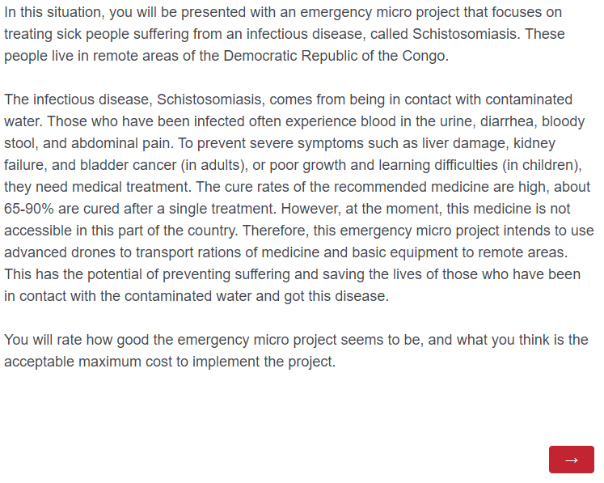
Page 3 - For participants in Control one project
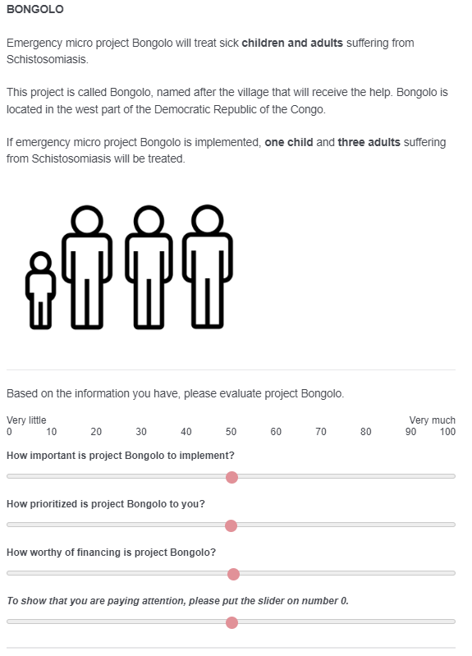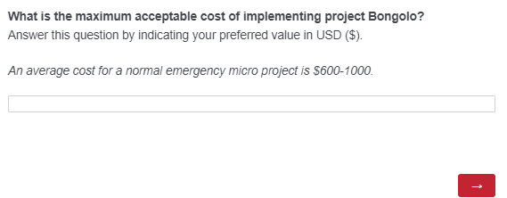

Page 3 – For participants in UA 1 child unit
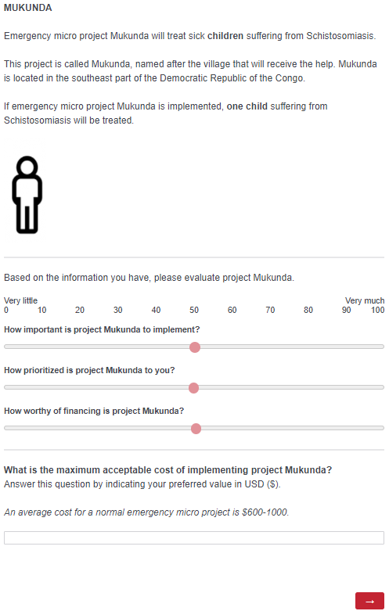
Page 3 – For participants in UA 3 adults unit
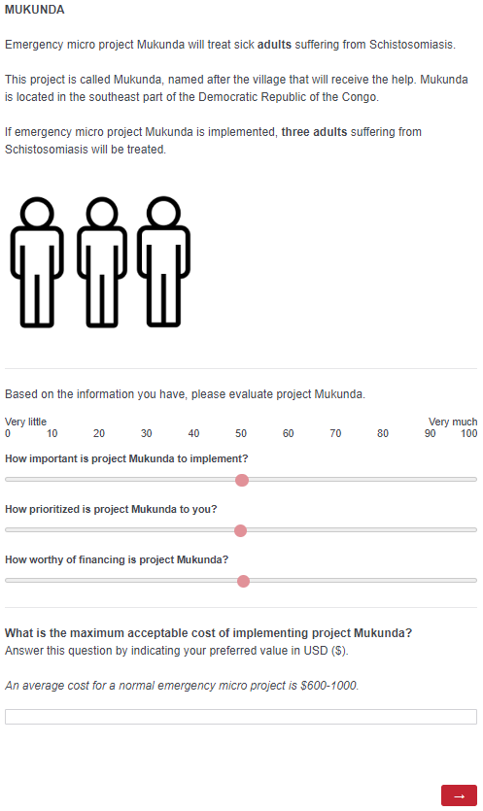
Page 3 – For participants in UA 1 adult unit
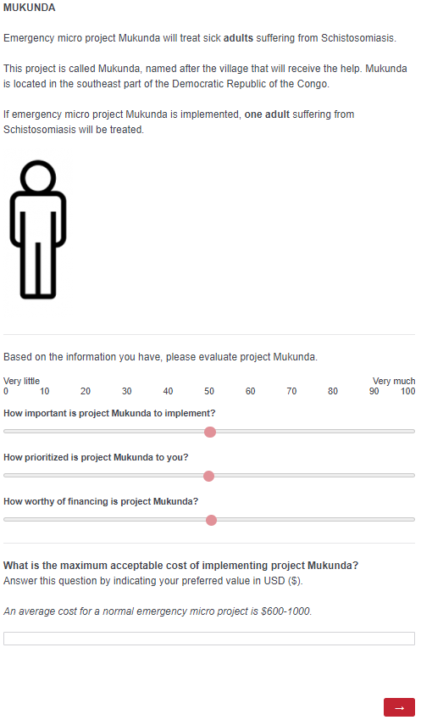

Pages 4-5 – For participants in UA-conditions and in Control two projects
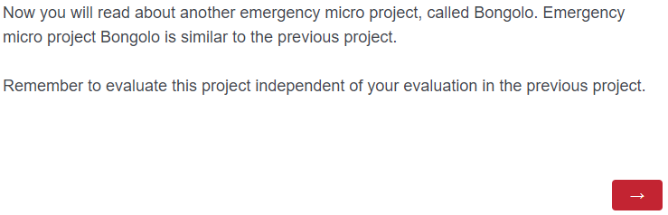

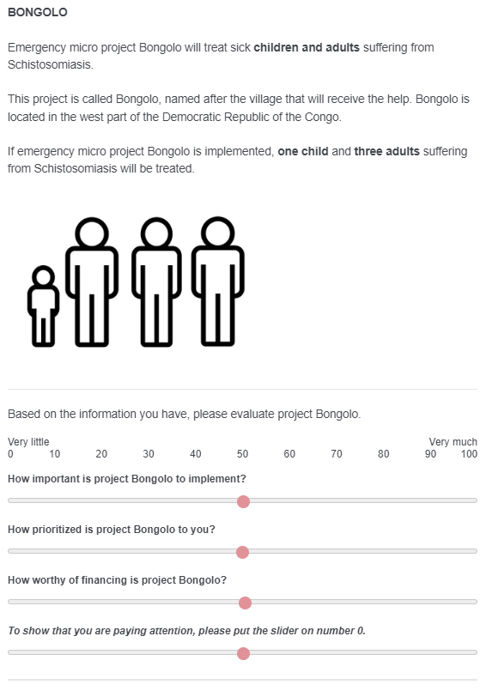
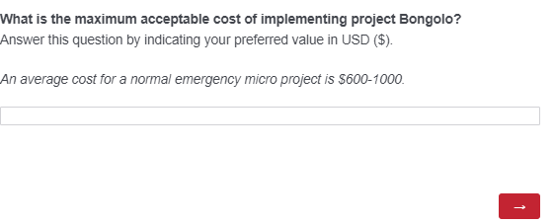

Results

Willingness to pay (WTP)
For WTP, we pre-registered to employ winsorizing for participants that would indicate extreme values, defined as a value above three standard deviations from the mean. However, when we later examined the data, the distribution of the residuals still pointed to it being skewed. Therefore, we also tested to winsorize values under and over the 5th and 95th percentile, which then improved the distribution of the residuals. Therefore, we employed and pre-registered this winsorizing technique for Study 2 and 3. To be consistent with which winsorizing technique we use, we will therefore also for Study 1 present the results for WTP based on winsorizing of 5th and 95th percentile. The results based on our pre-registered method for Study 1, three standard deviations from the mean, did not differ from the presented main results and can be found below, also in the Supplementary materials. The overall results for WTP across conditions can be found in Table 1 below.
Table 1
WTP across conditions for all three studies, both for the unit project and the main project (Bongolo)
 | Conditions | Unit project: WTP (SD) | Bongolo: WTP (SD)
Study 1 | Control one project |  | 863.7 (277.0)
 | Control two projects | 799.0 (187.9) | 809.2 (236.9)
 | UA 1 child unit | 672.8 (264.6) | 848.7 (275.8)
 | UA 3 adults unit | 748.2 (233.1) | 856.3 (277.3)
 | UA 1 adult unit | 593.8 (287.0) | 797.8 (273.4)
Study 2 | Control children |  | 426 447.6 (1 231 575.7)
 | UA children | 113 043.1 (281 039.7) | 204 917.9 (514 692.0)
 | Control adults |  | 523 578.9 (1 333 208.7)
 | UA adults | 91 320.0 (265 298.1) | 256 994.5 (801 068.8)
 | Control mix |  | 171 728.7 (408 450.1)
 | UA mix, child unit | 136 874.1 (359 649.3) | 266 429.9 (615 849.2)
 | UA mix, adult unit | 100 097.0 (266 031.5) | 190 793.3 (484 178.7)
Study 3 | Control condition |  | 353 945.0 (939 930.3)
 | UA two projects | 193 187.0 (568 434.6) | 884 797.8 (2 605 058.3)
 | UA one project | 8 732.0 (23 471.2) | 249 936.5 (700 757.4)

Similar to helping motivation, we conducted planned contrast for WTP to investigate a possible unit asking effect. The contrast between the two control conditions and the three UA conditions for project Bongolo was not significant, t(958) = 0.123, p = .902. Next, we conducted planned contrasts among the three UA conditions. Of these, only the contrast between the UA condition 1 adult unit and UA 3 adults was significant, t(958) = 2.14, p = .033, d = .22, in favor of UA 3 adults unit (i.e., indicating scope-sensitivity). Overall, these results contrasts to our hypotheses.
Last, to test for a potential age effect, we conducted a planned contrast between UA 1 child unit and UA 1 adult unit with WTP to project Mukunda as the dependent variable (i.e., 1 child vs. 1 adult). This was significant, t(763) = 3.15, p = .002, d = .32, meaning the child unit received higher WTP than the adult unit, in line with an age effect.

Results of WTP when winsorizing based on 3SD
Below are the descriptives and statistical analyses of WTP when the variable was winsorized according to values above three standard deviations from the mean (in line with our pre-registration). Below, Table 2 shows the means (SD) for the two projects across the conditions.
Table 2
Mean WTP (SD) for the two projects across the conditions
Conditions | Unit project (Mukunda):  WTP (SD) | Bongolo:  WTP (SD)
Control one project |  | 3507.3 (25 171.1)
Control two projects | 1408.3 (5037.0) | 884.3 (659.8)
UA 1 child unit | 1754.6 (10 146.3) | 1451.9 (5065.8)
UA 3 adults unit | 967.2 (1373.3) | 1181.4 (2095.5)
UA 1 adult unit | 739.9 (1206.8) | 966.7 (1350.5)

A one-way ANOVA with winsorized WTP for project Bongolo as the dependent variable and conditions as the independent variable showed that there was no significant difference between conditions in how much participants indicated WTP, F(4, 958) = 1.71, p = .145. A non-parametric Kruskal-Wallis test also revealed a similar non-significant result between conditions, χ²(4, N = 963) = 7.868, p = .097
The planned contrast between control vs. unit asking conditions for WTP was not significant, t(958) = 1.306, p = .192. The one-way ANOVA between the three unit asking conditions was not significant either, F(2, 572) = 1.077, p = .341.

Study 2

Method
In Study 1, we gave participants a range for the indicated WTP, describing what a normal cost for a project is. In Study 2, we removed this range for the WTP measure. We did this to more closely replicate the methodology of previous studies, since previous UA studies have not had such a range but have let people indicate their WTP without prescribed boundaries. As WTP has been the main dependent variable in all previous studies, this range can be a potential explanation for the lack of a UA effect in Study 1, especially as the means for WTP in Study 1 were within the indicated range (see Table 1). However, this prescribed range should not explain why we did not find a UA effect in Study 1 for helping motivation or explain the reversed UA effect we found. Therefore, this difference should be of less importance compared to the other changes made from Study 1 to Study 2.

Stimuli material
Below, the stimuli shown to participants for the first (project Mukunda) and second project (project Bongolo) are presented for the following conditions: 1) UA Only children, 2) UA Only adults, 3) UA mix, child unit, and 4) UA mix, adult unit. Prior to seeing this, all participants saw the first two pages that were described for Study 1.

- For participants in UA only children
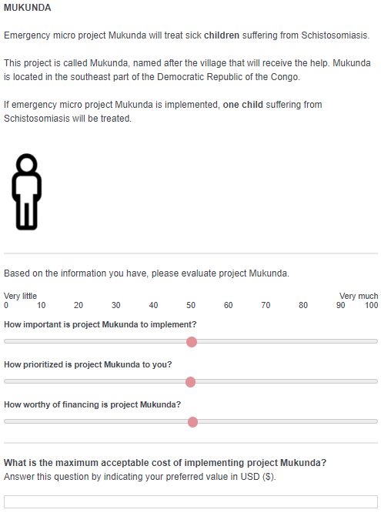
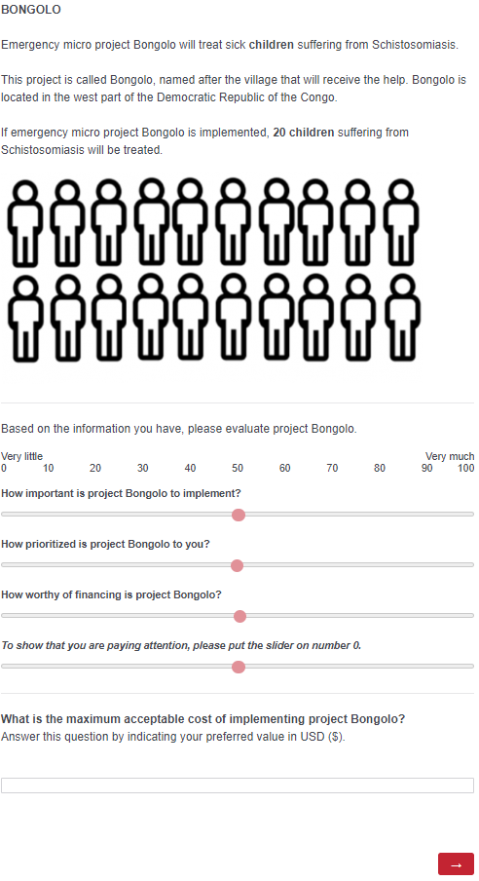
- For participants in UA only adults
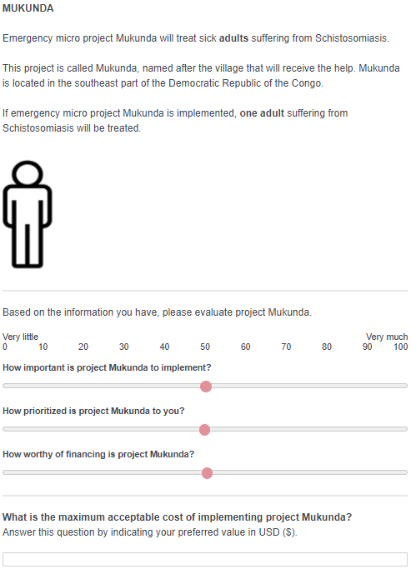
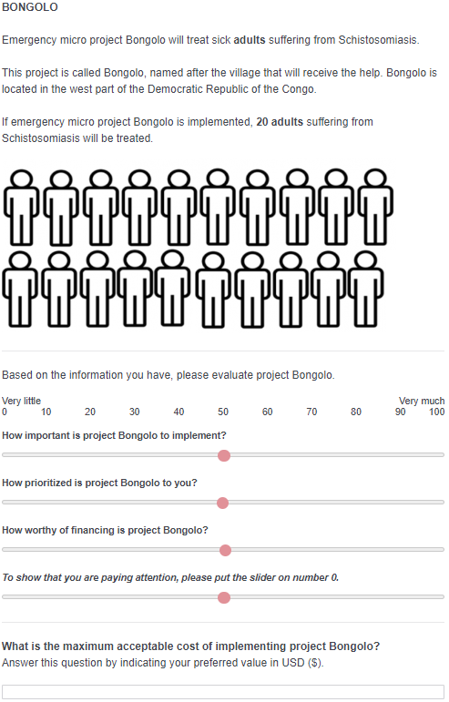

- For participants in UA mix, child unit
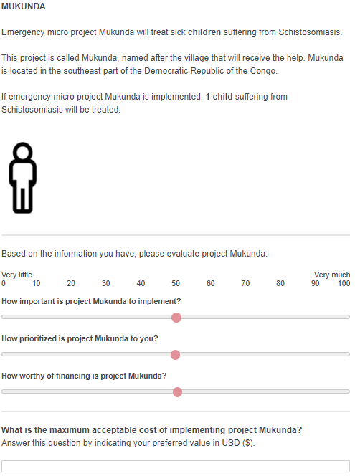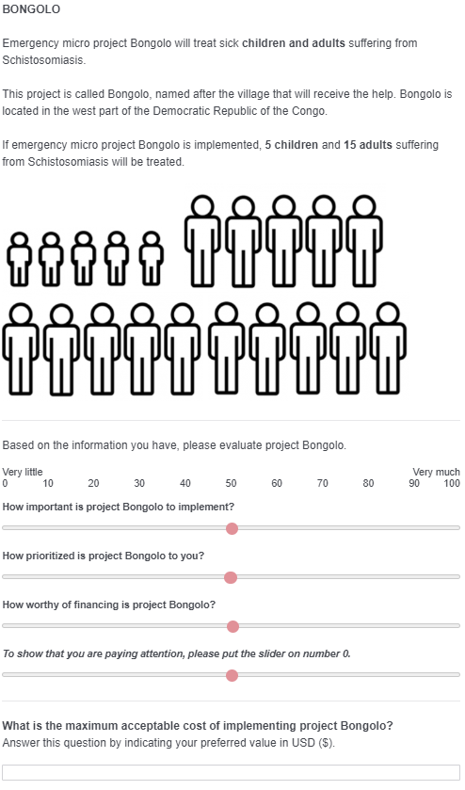
- For participants in UA mix, adult unit
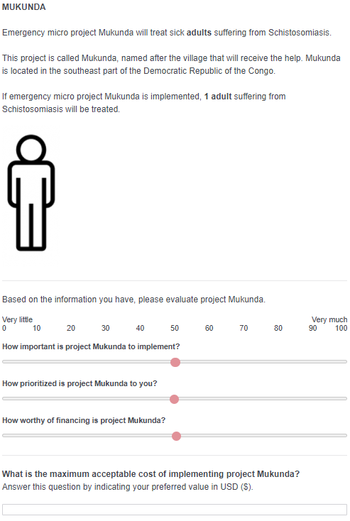

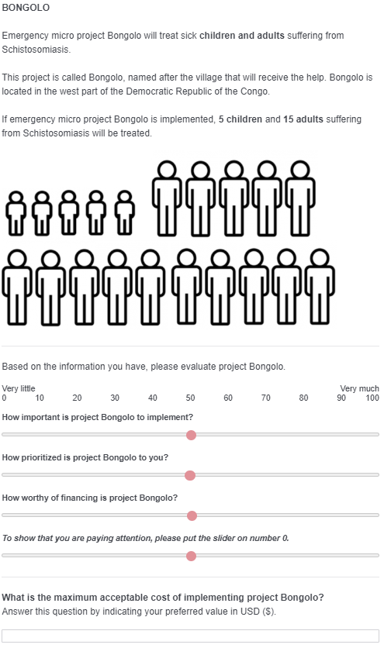

Results

Willingness to pay (WTP)
Table 1 shows the winsorized means of WTP for each condition, divided for project Mukunda and Bongolo. First, comparing the control and UA condition that helps only children, we conducted an independent t-test with winsorized WTP. The result was significant, t(385) = 2.30, p = .022, d = 0.23, showing that WTP to project Bongolo helping 20 children was significantly higher in the control condition than in the UA condition. Thus, there is no support for a UA effect and instead, we find a weak effect in the opposite direction. We also conducted a non-parametric Mann-Whitney test for this comparison, revealing a non-significant result test, U = 18,252.00, p = .671.
Second, comparing the control and UA condition that helps only adults, the result of an independent t-test was once again significant, t(383) = 2.36, p = .019, d = 0.24. Contrary to our hypothesis, the WTP to project Bongolo helping 20 adults was significantly higher in the control condition than in the UA condition. Again, this does not support a UA effect but rather weak support for an effect in the opposite direction. A Mann-Whitney test for this same comparison also revealed a significant result, U = 14 779.00, p = .001.
Third, comparing the control and UA conditions that helped a mix of children and adults, we conducted two independent t-tests. First, comparing the control condition and the UA condition with a child as the unit, the result did not reach significance, t(377) = -1.78, p = .076. A Mann-Whitney test for this same comparison also revealed a non-significant result, U = 17 775.00, p = .886. Second, to further compare the control and UA condition that helped a mix of children and adults, we compared the control condition with the second UA condition that instead had an adult as the unit. The result was not significant either, t(382) = -0.42, p = .676. A Mann-Whitney test for this same comparison also revealed a non-significant result, U = 17 451.00, p = .372. These results indicate that the WTP to project Bongolo helping 5 children and 15 adults did not differ between the unit asking conditions and the control condition.
Last, to test for a possible age effect for WTP, we conducted the same four comparisons as we did for helping motivation. First, for project Mukunda, the planned contrast between UA children and UA adults (i.e., 1 child vs. 1 adult) was not significant (p = .474) and neither was the contrast between UA mix child unit and UA mix adult unit (p = .232). For project Bongolo, the planned contrast between control adults and control children (i.e., 20 adults vs. 20 children) was not significant (p = .257), and neither was the contrast between UA children and UA adults (p = .551). Thus, there were no indications of an age effect for WTP.

Study 3

Stimuli material
Below, the stimuli shown to participants for pages 3 and 5 in the following conditions are presented: 1) Control condition, 2) UA two projects, 3) UA one project. Again, pages 1-2 were identical to those presented for Study 1. Page 4 was different only in UA one project and therefore shown below. For UA two projects, page 4 was identical to that presented in Study 1.

Page 3 - For participants control condition
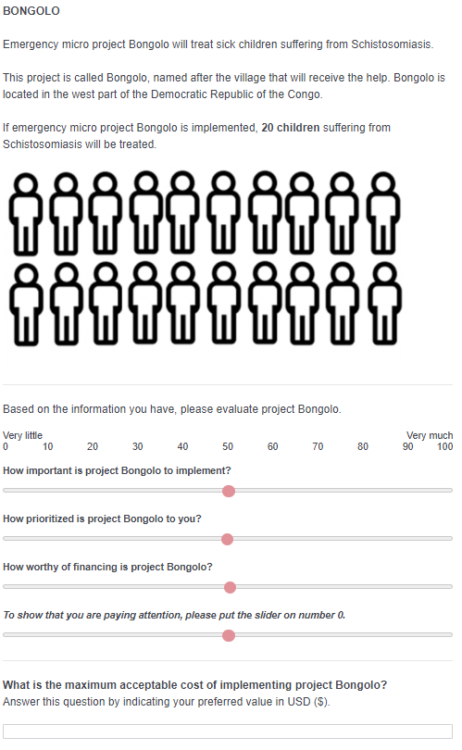

Pages 3 and 5 - For participants in UA two projects
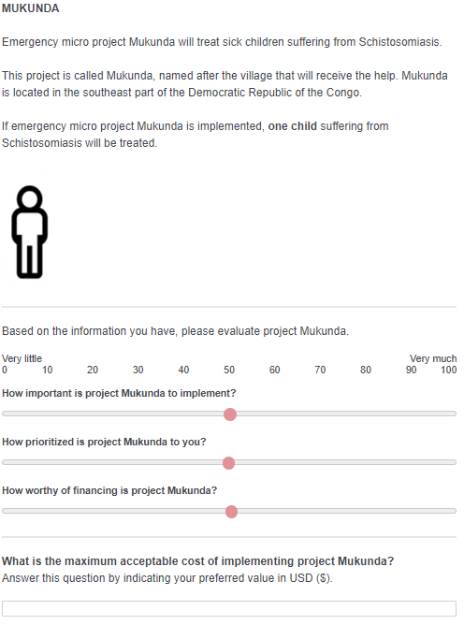

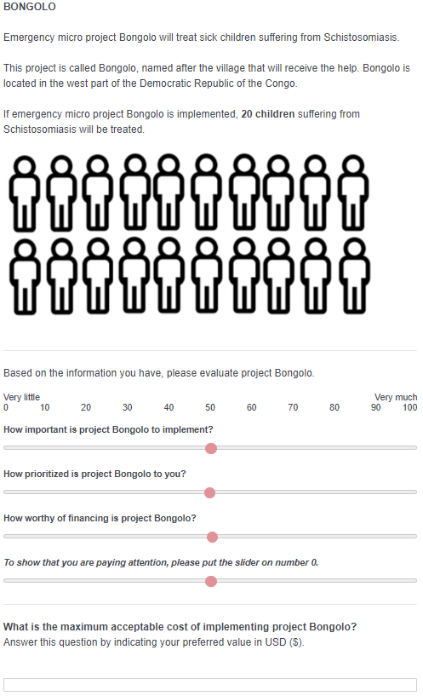

Pages 3-5 - For participants in UA one project
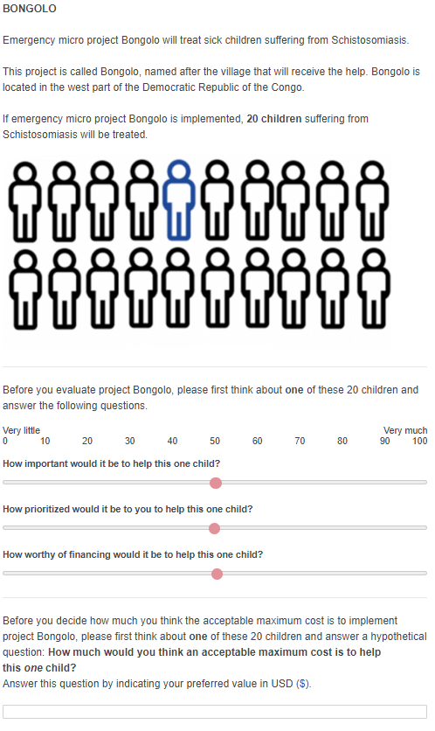
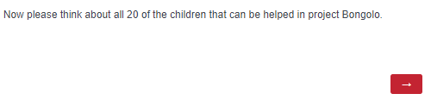
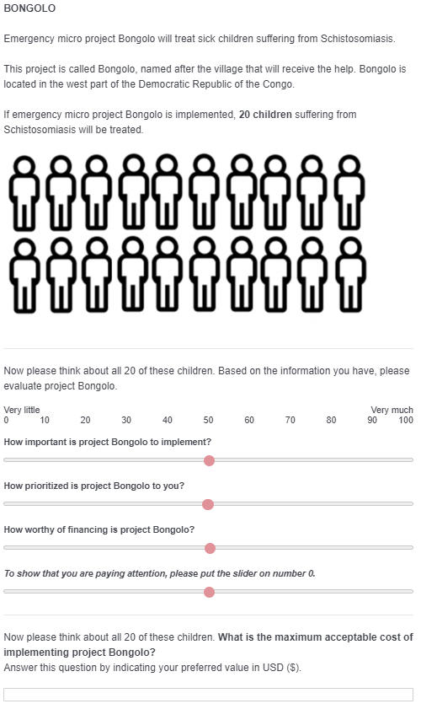

Results

Willingness to pay (WTP)
For WTP, we pre-registered to winsorize values under and over the 5th and 95th percentile. Table 1 shows the winsorized WTP for the three conditions, both for the unit project (Mukunda/one child) and project Bongolo. We conducted an ANOVA with conditions as the independent variable and WTP for project Bongolo as the dependent variable. It revealed a significant difference between the three conditions, F(2, 1138) = 16.29, p < .001, η_{p}² = .03. Contrary to our hypothesis, Bonferroni post-hoc tests revealed that project Bongolo in the UA condition with two projects received significantly higher WTP compared to both the control condition (p < .001) and the UA condition with one project (p < .001), but no significant difference between the control condition and UA one project condition was found (p = 1.00). However, this result was not confirmed with a non-parametric Kruskal-Wallis test, which did not reveal a significant difference between conditions, H(2, N = 1141) = 4.19, p = .123.

The comparison between UA 1 child unit and UA 1 adult was not significant (p = .063), and neither was the comparison between UA 1 child unit and UA 3 adults (p = .782).

