Supplementary Material
We plotted each participant’s fixations on Homophone competitor in “pronunciation judgement” (Experiment 1b and Experiment 2) in R through ggplot function. Smooth above the red line (Figure S1 and S2) indicates more fixations on phonological competitors than their co-present distractors, while below indicates less.
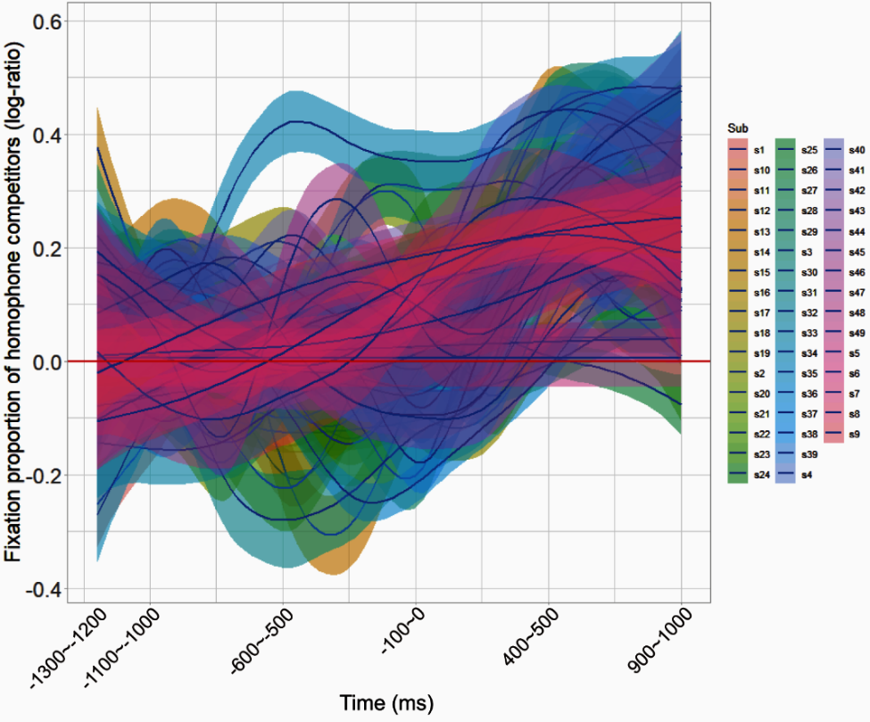
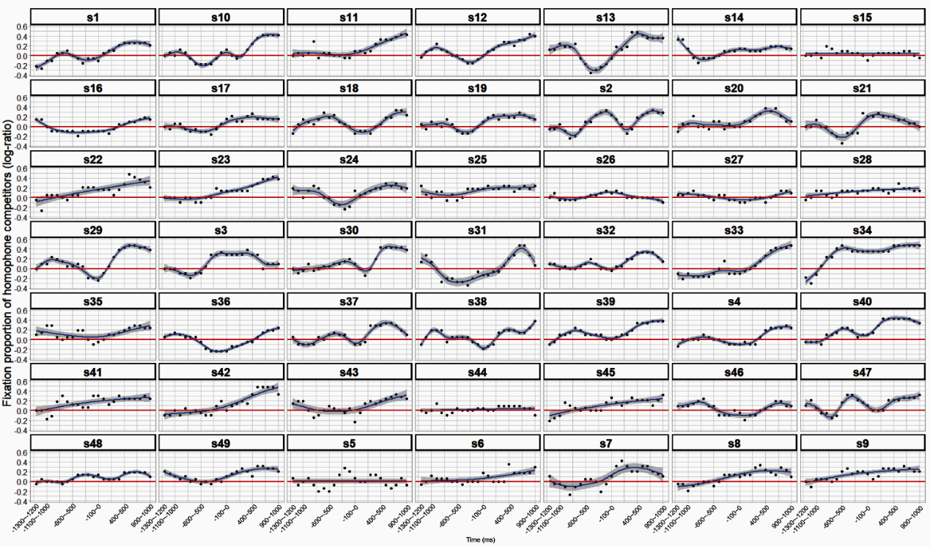
Figure S1. Non-linear smooths for Homophone competitor by each participant in Experiment 1b.

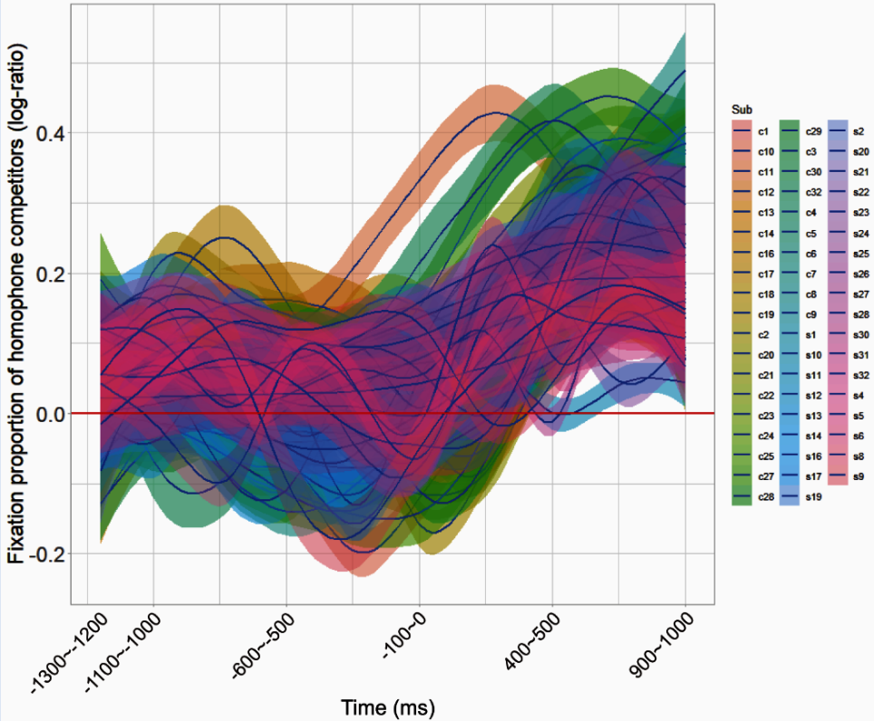
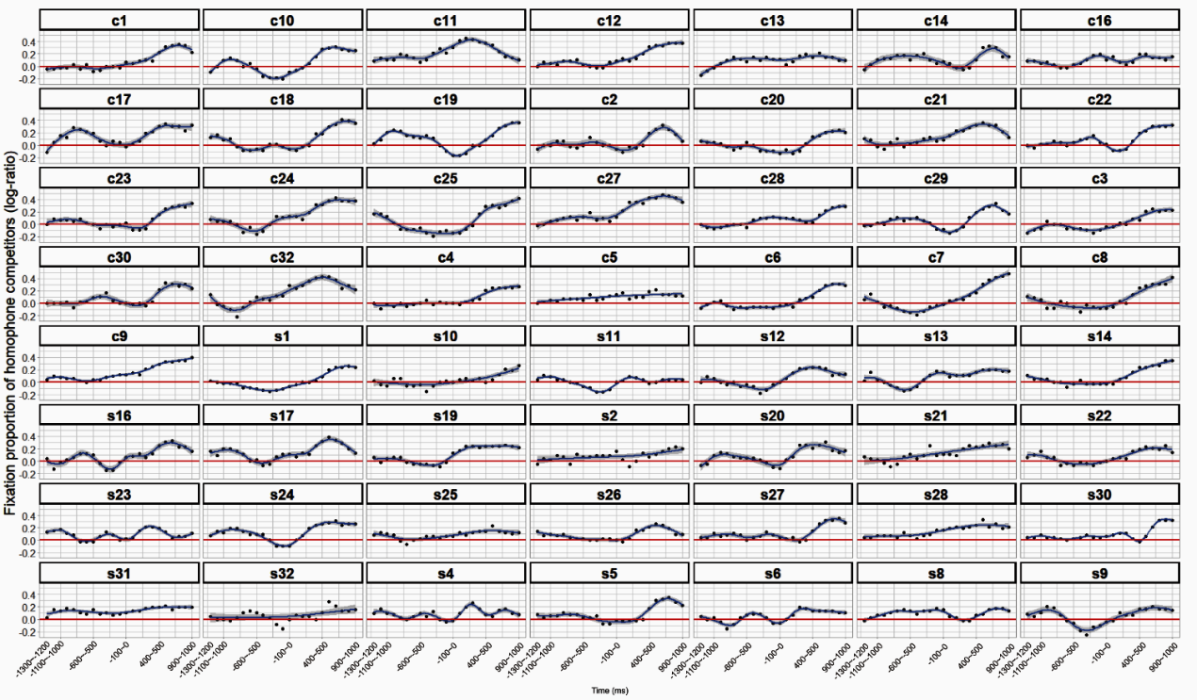
Figure S2. Non-linear smooths for Homophone competitor by each participant in the “pronunciation judgement task” of Experiment 2.

