Supplementary Material for

Embodiment of color metaphor: an image-based visual analysis of the Chinese color terms hēi ‘black’ and bái ‘white’

Jinmeng Dou¹, Meichun Liu¹ and Tong Chen²
¹Department of Linguistics and Translation, City University of Hong Kong, Hong Kong, China; ²School of Data Science, City University of Hong Kong, Hong Kong, China
Corresponding author: Jinmeng Dou; Email: jmdou2-c@my.cityu.edu.hk

The supplementary material includes tests of significance for detected emotional valence and perceptual (dis)similarity of the hēi- and bái-denoted senses (Sections 1 and 2), a correlation test between emotional valence and perceptual (dis)similarity (Section 3), re-contextualization of the detected emotional valence (Section 4), tests on robustness of the major dataset (Section 5), and an evaluation of the efficiency of the Jz dimension in profiling perceptual (dis)similarity (Section 6).

1. Tests of statistical significance for emotional valence
1.1 Emotional valence of the nine hēi-related senses
Table S1 presents the distances between the literal and metaphorical senses of the Chinese color term hēi and the two referential terms of affective polarity depicted in Figure 2 of the main text. The paired t-test reveals that the nine hēi-related senses are significantly closer to the referential term ‘Immorality/Negativity_ch’ rather than ‘Morality/Positivity_ch’, t (8) = 9.11, p < 0.01. In addition, we investigated whether the proximity of the literal sense ‘Black_ch’ to the two referential terms is significantly greater than that of the eight metaphorical senses. To this end, we first calculated the average distance of each sense to the pair of referential terms. Then, the average distances of the eight metaphorical senses were centered on the value of ‘Black_ch’. The normal distribution of the data was confirmed using the Shapiro-Wilk test (W = 0.8406, p = 0.07639). A one-sample t-test was then performed to test whether the centered distances are significantly less than 0. The results indicate that the proximity of ‘Black_ch’ to the referential terms is significantly greater than that of the eight metaphorical senses of hēi, t (7) = -8.4811, p < 0.01.

No. | Meaning | Morality/Positivity_ch | Immorality/Negativity_ch
1 | Network Attack/Hack_ch | 1.150 | 1.021
2 | Slander/Entrap_ch | 0.413 | 0.196
3 | Illegal/Underground_ch | 0.562 | 0.206
4 | Evil/Malevolent_ch | 0.736 | 0.375
5 | Unfavorable/Bad_ch | 0.435 | 0.107
6 | Angry/Sullen_ch | 0.347 | 0.138
7 | Secret/Mysterious_ch | 0.777 | 0.462
8 | Unexpected/Surprising_ch | 0.274 | 0.095
9 | Black_ch | 1.528 | 1.161
Table S1. Distances of the senses of hēi to the referential terms of affective polarity in correspondence analysis

1.2 Emotional valence of the thirteen bái-related senses
Table S2 lists the distances between the literal and metaphorical senses of the Chinese color term bái and the referential terms of affective polarity. The thirteen bái-related senses were initially divided into two groups based on their distributions to the two referential terms of affective polarity in Figure 3. The first group comprises ten senses that were closer to ‘Morality/Negativity_ch’, including ‘White_ch’, ‘Acceptable/Approved_ch’, ‘Clarify/Express_ch’, ‘Clear/Transparent_ch’, ‘Free of Charge/Cost-free_ch’, ‘Lawful/Legal_ch’, ‘Ordinary/Unflavored_ch’, ‘Empty/Blank_ch’, ‘Undisguised expression_ch’, and ‘Pure/Clean_ch’. The second group includes three senses that were closer to ‘Immorality/Negativity_ch’, including ‘In vain/For no reason_ch’, ‘Inexperience/Untalented_ch’, and ‘Sorrowful/Woeful_ch’. This grouping is supported by the result of the two-sided Welch Two Sample t-test as the distance differences of the ten meanings to the two referential terms are significantly different from those of the three senses (t (7.7989) = -5.1291, p < 0.01). Furthermore, a paired t-test indicated that the ten bái-related senses are significantly closer to ‘Morality/Negativity_ch’ than to ‘Immorality/Negativity_ch’, t (9) = -10.703, p < 0.01. It is found that the three group-2 senses show a closer proximity to ‘Immorality/Negativity_ch’ with relatively low statistical significance, t (2) = 1.9574, p < 0.1, which is acceptable to a certain extent given the very small sample size. The negative valence of these three meanings was further confirmed in Section 3.2. Lastly, we examined whether the proximity of ‘White_ch’ to the two referential terms is significantly greater than that of the twelve metaphorical senses. Same procedures were followed as outlined in Section 1.1 to obtain the centered distribution of the average proximities of the twelve metaphorical meanings. It is noted that, however, the One-sample Wilcoxon Rank Sum test was adopted to test statistical significance given the abnormal distribution of the average proximities (Shapiro-Wilk test: W = 0.74016, p < 0.05). It is revealed that ‘White_ch’ is significantly farther away from the two referential terms as compared to these metaphorical senses (p < 0.01).

No. | Meaning | Morality/Positivity_ch | Immorality/Negativity_ch
1 | In vain/For no reason_ch | 0.344 | 0.282
2 | Acceptable/Approved_ch | 0.113 | 0.612
3 | Pure/Clean_ch | 0.481 | 0.981
4 | Lawful/Legal_ch | 0.216 | 0.405
5 | Free of Charge/Cost-free_ch | 0.072 | 0.612
6 | Empty/Blank_ch | 0.364 | 0.666
7 | Clear/Transparent_ch | 0.397 | 0.872
8 | Inexperience/Untalented_ch | 0.405 | 0.164
9 | Clarify/Express_ch | 0.194 | 0.460
10 | Sorrowful/Woeful_ch | 0.321 | 0.267
11 | Undisguised Expression_ch | 0.028 | 0.544
12 | Ordinary/Unflavored_ch | 0.125 | 0.576
13 | White_ch | 0.931 | 1.300
Table S2. Distances of the senses of bái to the referential terms of affective polarity in correspondence analysis

2. Tests of significance for perceptual (dis)similarity
2.1 Perceptual (dis)similarities of the eight metaphorical senses of hēi
Based on the data in Table S3, a paired t-test was performed to examine whether the metaphorical senses of hēi exhibit significantly closer distances to ‘Black_ch’ as opposed to ‘White_ch’, as depicted in Figure 4(a) of the main text. The results show that the overall proximity of the metaphorical senses to ‘Black_ch’ are significantly less than that to ‘White_ch’, indicting a distinct perceptual similarity between the literal and metaphorical senses of hēi, t (7) = -4.6688, p < 0.01.

No. | Meanings | Black_ch | White_ch
1 | Network Attack/Hack_ch | 1.215 | 1.831
2 | Slander/Entrap_ch | 1.171 | 1.417
3 | Illegal/Underground_ch | 0.963 | 1.437
4 | Evil/Malevolent_ch | 0.804 | 1.591
5 | Unfavorable/Bad_ch | 1.089 | 1.349
6 | Angry/Sullen_ch | 1.208 | 1.436
7 | Secret/Mysterious_ch | 0.871 | 1.645
8 | Unexpected/Surprising_ch | 1.225 | 1.332
Table S3. Distances of the metaphorical senses of hēi to the literal senses of hēi and bái in correspondence analysis

As demonstrated in Figures 4(b) and 5(b) of the main text, hierarchical agglomerative clustering (HAC) analysis was conducted to further investigate perceptual (dis)similarities between the literal and metaphorical senses of hēi and bái based on their pairwise JS divergence values. To test the robustness of the clustering results, we calculated cluster modularity values (ranging from -1 to 1) of the partitions generated from the HAC outcomes and compared the modularity values with benchmark modularity distributions.
To calculate benchmark distributions, a set of terms were randomly collected from a Chinese corpus in Sketch Engine, namely the Chinese Simplified Web 2017 Sample. In specific, we first generate the top 1000 frequent nouns, adjectives, verbs, and adverbs in the corpus, respectively, using the wordlist function. We then randomly selected 10 words from each category, resulting in 40 random words, as shown in Table S4. Using the random terms, a dataset comprising 40*100 images (100 for each term) were created for the calculation of benchmark modularity distributions.

Category | Random words
Noun | 口 kǒu ‘mouth’; 信息 xìnxī ‘information’; 公路 gōnglù ‘highway’; 证书 zhèngshū ‘certificate’; 细节 xìjié ‘detail’; 人物 rénwù ‘figure’; 近年 jìnnián ‘recent years’; 今天 jīntiān ‘today’; 温度 wēndù ‘temperature’; 档案 dǎng'àn ‘file’
Adjective | 有利 yǒulì ‘advantageous’; 主动 zhǔdòng ‘initiative’; 稀缺 xīquē ‘scarce’; 可持续 kěchíxù ‘continuable’; 非 fēi ‘not’; 强悍 qiánghàn ‘tough’; 同步 tóngbù ‘synchronous’; 良好 liánghǎo ‘good’; 常见 chángjiàn ‘common’; 数字化 shùzìhuà ‘digitized’
Verb | 应用 yìngyòng ‘apply’; 见 jiàn ‘see’; 点击 diǎnjī ‘click’; 感染 gǎnrǎn ‘infect’; 骑 qí ‘ride’; 研发 yánfā ‘research and development’; 肯定 kěndìng ‘affirm’; 帮 bāng ‘help’; 加速jiāsù ‘accelerate’; 转化zhuǎnhuà ‘transform’
Adverb | 以致 yǐzhì ‘so that’; 可是 kěshì ‘but’; 有一些 yǒuyīxiē ‘there are some’; 特意 tèyì ‘specifically’; 仅仅 jǐnjǐn ‘only’; 足足 zúzú ‘fully’; 尚 shàng ‘yet’; 差不多 chàbùduō ‘almost’; 说不定shuōbuding ‘maybe’; 自我 zìwǒ ‘self’
Table S4. Random words for the calculation of benchmark modularity distributions

Based on the random dataset, the same number of words were randomly sampled from the word set to construct a mock taxonomy of the same size as hēi (i.e., 10 terms). We then ran the HAC algorithm to generate a hierarchical clustering result of the random set. By prespecifying the number of communities in each partition, we calculated the modularity of the hierarchical clustering result derived from the random set. These steps were repeated 400 times for different samples of words from the word set to obtain the benchmark distributions of modularity scores. Statistical tests were conducted to examine the statistical significance of the modularity scores observed from the HAC result of hēi. Precisely, the random benchmark distributions were first centered on the modularity value of the corresponding partition solution of hēi. Regarding their abnormal distribution, the One-sample Wilcoxon Rank Sum test was used to identify whether the centered distribution is significantly less than 0. Table S5 demonstrates the results for the metaphorical senses of hēi. The calculations were conducted by means of the Python packages NetworkX and communities.

Number of Communities | Modularity | Random Modularity (Avg.) | Significance
2 | -0.025 | -0.023 | p = 0.3491
3 | 0.198 | 0.02 | p < 0.001
4 | 0.091 | 0.014 | p < 0.001
5 | 0.1280 | 0.016 | p < 0.001
6 | 0.147 | 0.008 | p < 0.001
7 | 0.103 | 0.009 | p < 0.001
8 | 0.110 | 0.009 | p < 0.001
9 | 0.073 | -0.035 | p < 0.001
10 | 0.031 | -0.062 | p < 0.001
Table S5. Comparison of the clustering modularity scores for the metaphorical senses of hēi relative to corresponding random benchmark distribution (10 terms) with a range of prespecified communities counts.

It is suggested that the partition solutions of 3-10 communities of hēi exhibit significantly higher modularity scores than the corresponding random benchmark distributions. For the solution of 2 communities, the modularity of the HAC result of hēi is not significantly higher than the benchmark distribution.

2.2 Perceptual (dis)similarities of the twelve metaphorical senses of bái
As shown in Table S6, all the metaphorical meanings of bái have a closer proximity to ‘White_ch’ rather than ‘Black_ch’. A paired t-test reveals that this distribution is statistically significant (t (11) = 6.2367, p < 0.01), suggesting a distinct perceptual similarity between the literal and twelve metaphorical senses of bái. Besides, the result of an unpaired t-test, t (9.9029) = -6.6277, p < 0.01, indicates that the differences of the three negative senses to ‘Black_ch’ and ‘White_ch’ are significantly less than that of the nine positive metaphorical meanings. This finding confirms that opposing emotional valences can weaken the degree of perceptual similarity between a pair of literal and metaphorical senses of bái.

No. | Meanings | Black_ch | White_ch
1 | In vain/For no reason_ch | 1.528 | 1.235
2 | Acceptable/Approved_ch | 1.625 | 0.802
3 | Pure/Clean_ch | 1.811 | 0.406
4 | Lawful/Legal_ch | 1.555 | 0.953
5 | Free of Charge/Cost-free_ch | 1.642 | 0.924
6 | Empty/Blank_ch | 1.659 | 0.651
7 | Clear/Transparent_ch | 1.806 | 0.514
8 | Inexperience/Untalented_ch | 1.332 | 1.168
9 | Clarify/Express_ch | 1.592 | 0.905
10 | Sorrowful/Woeful_ch | 1.282 | 1.165
11 | Undisguised Expression_ch | 1.656 | 0.934
12 | Ordinary/Unflavored_ch | 1.702 | 0.848
Table S6. Distances of the metaphorical senses of bái to the literal senses of hēi and bái in correspondence analysis

With same procedures as in Section 2.1, Table S7 demonstrates the robustness test results for the cluster modularity of the metaphorical senses of bái. The numbers of communities range from 2 to 10, with the solutions of 2, 5, 7, 8, 9, and 10 demonstrating higher modularity than the corresponding modularity of random distribution.

Number of Communities | Modularity | Random Modularity (Avg.) | Significance
2 | 0.248 | 0.003 | p < 0.001
3 | 0.048 | 0.042 | p = 0.5489
4 | 0.039 | 0.043 | p = 0.3441
5 | 0.058 | 0.042 | p < 0.001
6 | -0.004 | 0.031 | p = 1
7 | 0.042 | 0.019 | p < 0.001
8 | 0.048 | 0.011 | p < 0.001
9 | 0.051 | 0.010 | p < 0.001
10 | 0.064 | 0.014 | p < 0.001
Table S7. Comparison of the clustering modularity score for the metaphorical senses of bái relative to corresponding random benchmark distributions (14 terms) with a range of prespecified communities counts.

3. Correlation test between emotional valence and perceptual (dis)similarity
In this section, a correlation test was conducted between the emotional valence and perceptual (dis)similarity of the metaphorical senses of hēi and bái. Specifically, we utilized the differences in proximity between the metaphorical senses and the two referential terms of emotional valence as the independent variable (X), and their differences in proximity to ‘Black_ch’ and ‘White_ch’ as the dependent variable (Y). For instance, the X of ‘Slander/Entrap’ would be 0.05 if its proximity to ‘Black_ch’ minus the value to ‘White_ch’ is 0.05, while the corresponding Y would be the value of its proximity to ‘Immorality/Negativity_ch’ minus that to ‘Morality/Positivity_ch’. As shown in Figure S1, the result reveals a strong positive correlation coefficient of 0.912 (p < 0.01) between emotional valence (X) and perceptual (dis)similarity (Y). In other words, a metaphorical sense that has a relatively stronger association with positive valence is more likely to have a distinct perceptual similarity with the literal meaning of bái.

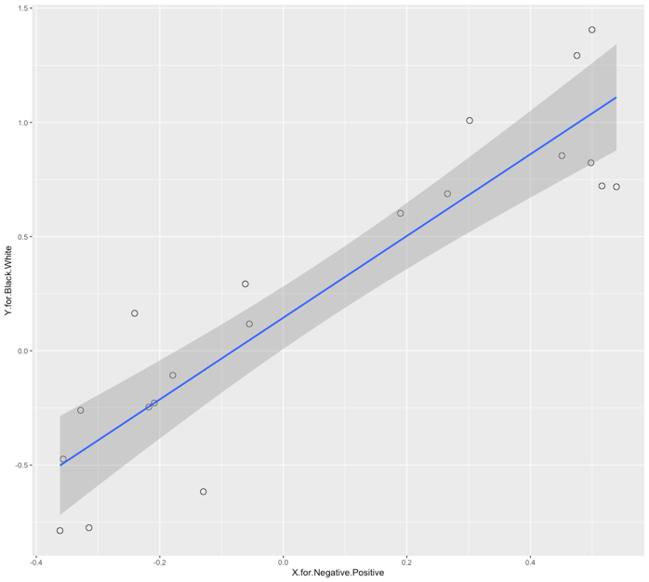
Figure S1. Scatter plot for the correspondence-analysis proximity differences of emotional valence and perceptual (dis)similarity with a regression line

4. Contextualization of emotional valence
4.1 Robustness of the referential terms in representing affective polarity
In this section, a correspondence analysis was conducted based on the color distributions of ten Chinese emotion words (Table S8) and the adopted referential terms (有道德/积极 yǒudàodé/jījí ‘Morality/Positivity’ and 不道德/消极 bùdàodé/xiāojí ‘Immorality/Negativity’) in the main text to examine their efficiency in anchoring the positive and negative emotional valence.

Valance | Terms
Positive | 开心 kāixīn ‘delightful’; 满足 mǎnzú ‘satisfy’; 幸福 xìngfú ‘happiness’; 感激 gǎnjī ‘grateful’; 舒适 shūshì ‘comfort’
Negative | 沮丧 jǔsàng ‘depression’; 担心 dānxīn ‘worry’; 恐惧 kǒngjù ‘fear’; 失望shīwàng ‘disappointment’; 厌烦 yànfán ‘boredom’
Table S8. Ten Chinese emotion words with positive and negative emotional valence

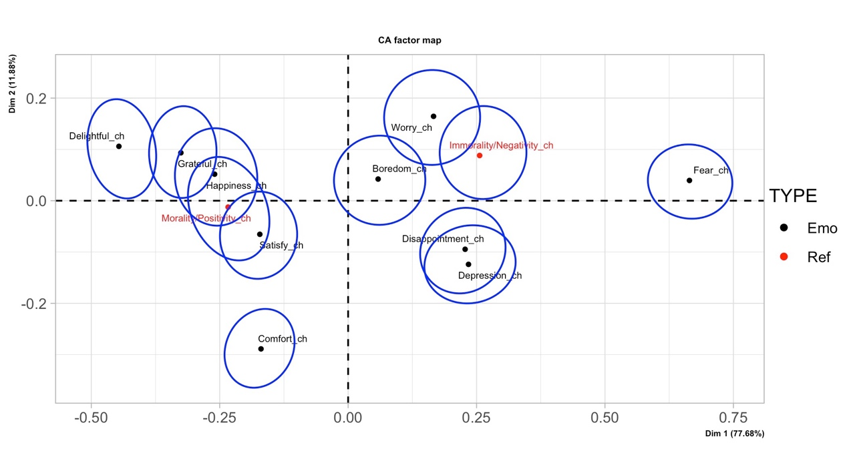
Figure S2. Correspondence analysis biplot for color distribution data of the ten Chinese emotion words and the pair of referential terms of affective polarity

Figure S2 displays the association strength among the ten Chinese emotion terms and the two referential terms of affective polarity. The visualization is based on the cumulative variance of the first two dimensions (89.56%). Precisely, the five emotion terms with positive valence are situated in the two left quadrants, with closer proximity to ‘Morality/Positivity_ch’. On the other hand, the terms representing negative emotions are located in the right two quadrants, demonstrating a stronger association with ‘Immorality/Negativity_ch’. To investigate the statistical significance of the identified distributional patterns, two paired t-tests were performed based on the distances of emotion terms to the pair of referential terms (Table S9). The results show that the distances of the five positive emotion words to ‘Morality/Positivity_ch’ are significantly smaller than those to ‘Immorality/Negativity_ch’ (t (4) = -12.1.86, p < 0.01). Furthermore, statistical significance was detected for the closer distances of the five negative emotion words to ‘Immorality/Negativity_ch’ (t (4) = -4.617, p < 0.01). In short, our findings demonstrate the high efficiency of the referential terms in anchoring the positive and negative emotional valences.

No. | Emotion Terms | Morality/Positivity_ch | Immorality/Negativity_ch
1 | Delightful_ch | 0.243 | 0.702
2 | Satisfy_ch | 0.082 | 0.455
3 | Happiness_ch | 0.069 | 0.517
4 | Grateful_ch | 0.140 | 0.582
5 | Comfort_ch | 0.284 | 0.569
6 | Depression_ch | 0.481 | 0.213
7 | Worry_ch | 0.437 | 0.118
8 | Fear_ch | 0.899 | 0.411
9 | Disappointment_ch | 0.469 | 0.185
10 | Boredom_ch | 0.297 | 0.203
Table S9. Distances of the ten emotion words to the two referential terms of affective polarity in correspondence analysis

4.2 Contextualization of the CA findings with the ten Chinese emotional words
In this section, two correspondence analyses were conducted among the nine hēi-related meanings and the thirteen bái-related meanings with the ten Chinese emotion words as referential terms of affective polarity, respectively. The results were visualized in Figures S3 and S4.
Figure S3 shows that all the five positive emotion words are situated in the two right quadrants with overlapped confidence ellipses, while all the negative ones are observed on their left side with distinguishable proximity. Table S10 presents the average proximities of the nine hēi-related senses to these positive and negative emotion words. A paired t-test reveals that the average proximity of the nine hēi-related senses to the positive emotion words is significantly greater than that to the negative ones (t (8) = 10.099, p < 0.01). Besides, it is found that these metaphorical senses exhibit significantly closer proximities to the emotion words than the literal sense of hēi (Shapiro-Wilk normality test: W = 0.81546, p = 0.04; Wilcoxon Signed Rank Exact Test: p < 0.01).

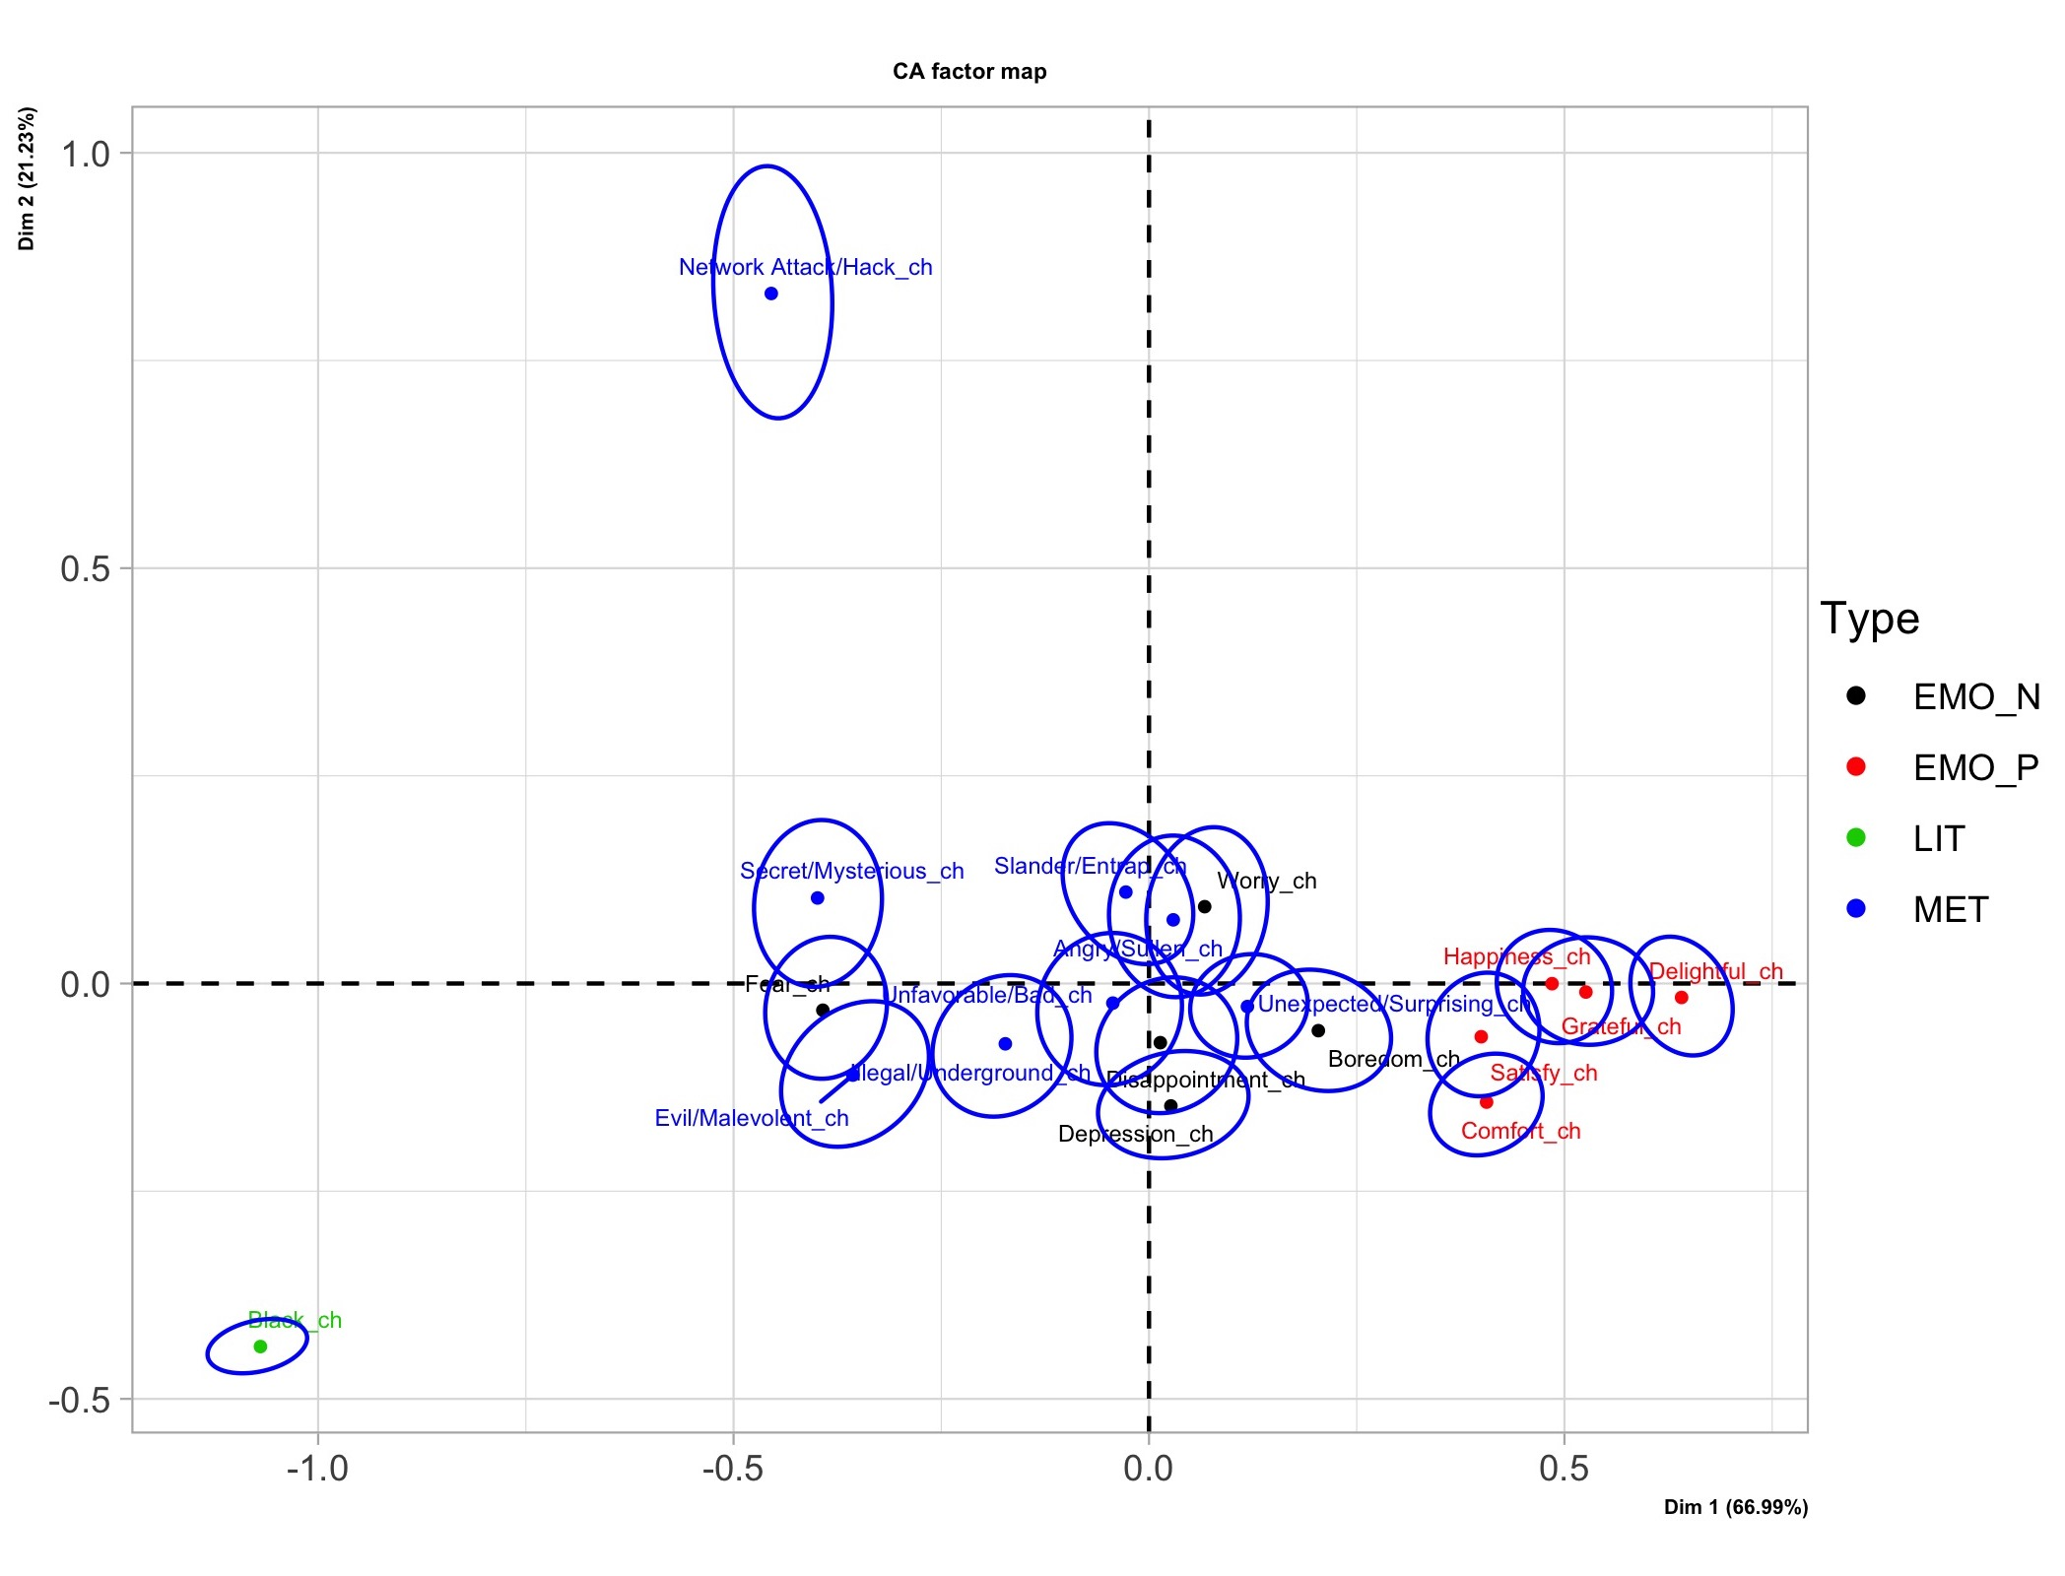
Figure S3. Correspondence analysis biplot for color distribution data of the ten Chinese emotion words and the nine hēi-related senses. The data points were color-marked for different categories – negative emotion words in black, positive emotion words in red, literal meanings in green, and metaphorical meanings in blue. Same as in Figure S4.

No. | Meanings | Positive Emotions | Negative Emotions
1 | Black_ch | 1.609 | 1.129
2 | Network Attack/Hack_ch | 1.294 | 0.996
3 | Slander/Entrap_ch | 0.547 | 0.244
4 | Illegal/Underground_ch | 0.667 | 0.258
5 | Evil/Malevolent_ch | 0.851 | 0.375
6 | Unfavorable/Bad_ch | 0.539 | 0.195
7 | Angry/Sullen_ch | 0.484 | 0.214
8 | Secret/Mysterious_ch | 0.905 | 0.433
9 | Unexpected/Surprising_ch | 0.379 | 0.199
Table S10. Average distances of the nine hēi-related senses to the positive and negative emotion words in correspondence analysis

Figure S4 depicts that most of the positive metaphorical meanings (as detected in Figure 3) and the literal meaning of bái lie in the two left quadrants where the positive emotion words are distributed. Another group is observed in the right two quadrants, consisting of three meanings (‘In vain/For no reason’, ‘Sorrowful/Woeful’, and ‘Inexperience/Untalented’) and the negative emotion words. Based on the paired t-test, it is found that the three meanings are distributed closer to these negative emotion words with high statistical significance (t (2) = 7.0828, p < 0.01). Meanwhile, the remaining nine metaphorical senses and the literal sense of bái are significantly closer to these positive emotions rather than the negative ones (t (9) = -8.3818, p < 0.01). Furthermore, statistical significance was detected for the closer proximity of the metaphorical senses to the emotion words than the literal meaning of bái (Shapiro-Wilk normality test: W = 0.71884, p < 0.01; Wilcoxon Signed Rank Exact Test: p < 0.01).

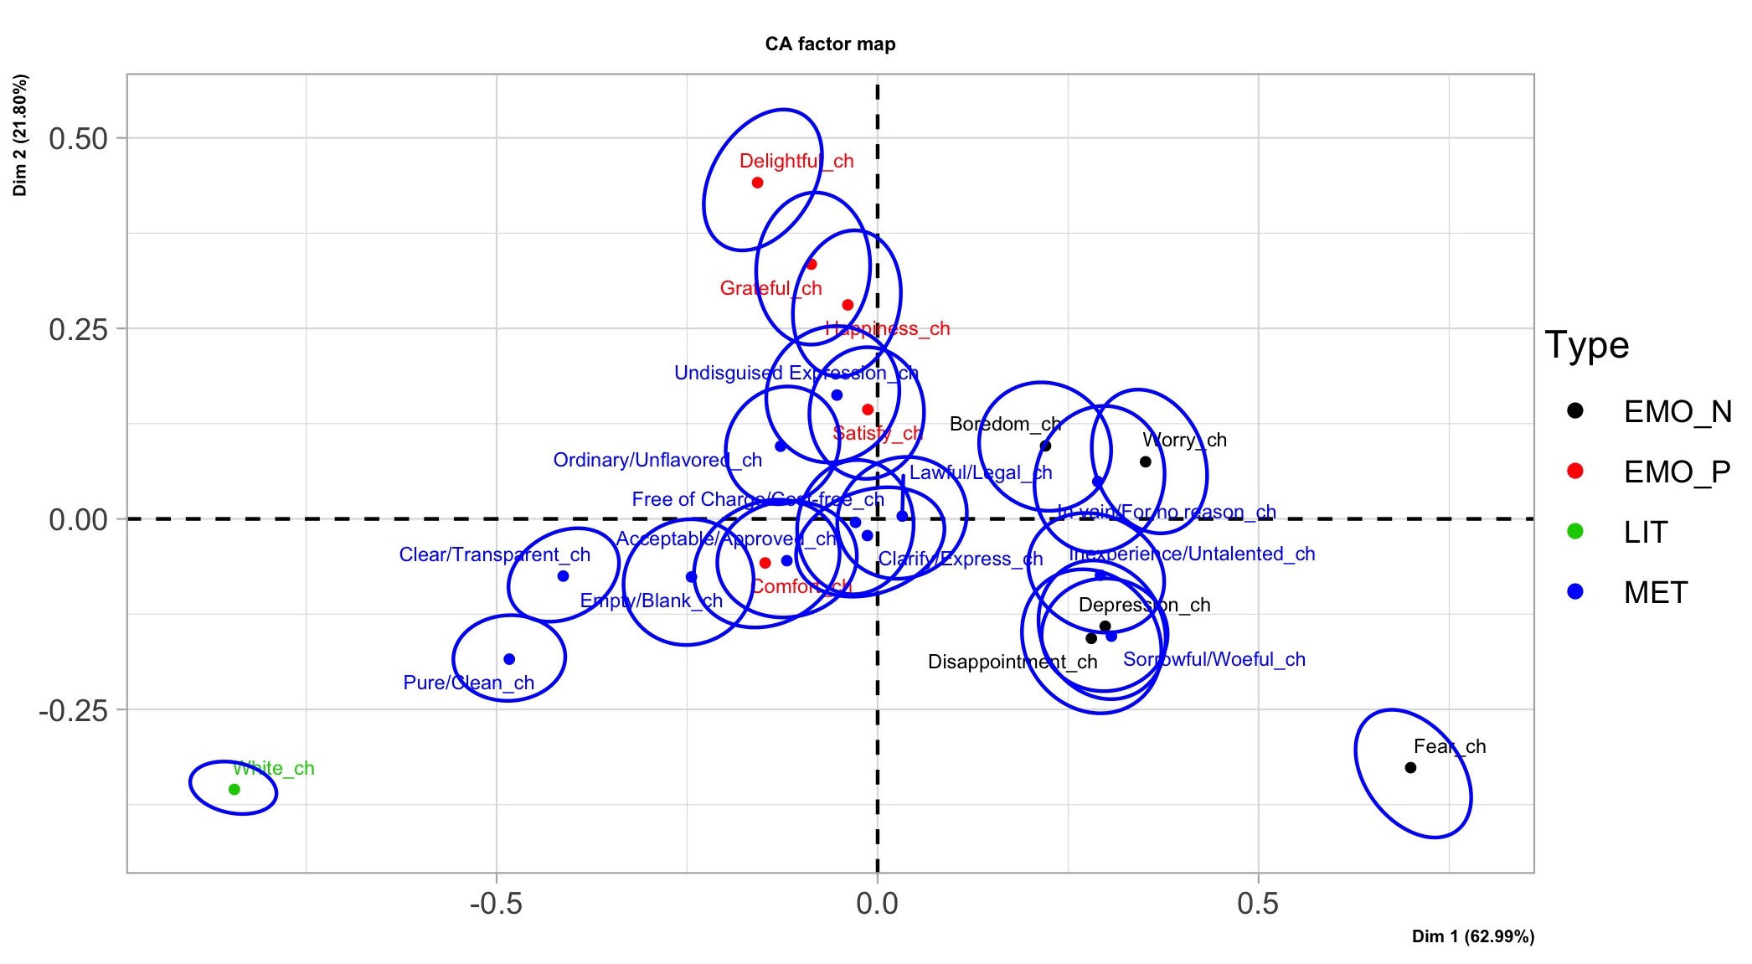
Figure S4. Correspondence analysis biplot for color distribution data of the ten Chinese emotion words and the thirteen bái-related senses

No. | Meanings | Positive Emotions | Negative Emotions
1 | White_ch | 0.965 | 1.255
2 | In vain/For no reason_ch | 0.447 | 0.221
3 | Acceptable/Approved_ch | 0.297 | 0.512
4 | Pure/Clean_ch | 0.586 | 0.874
5 | Lawful/Legal_ch | 0.290 | 0.376
6 | Free of Charge/Cost-free_ch | 0.275 | 0.431
7 | Empty/Blank_ch | 0.358 | 0.633
8 | Clear/Transparent_ch | 0.467 | 0.798
9 | Inexperience/Untalented_ch | 0.508 | 0.195
10 | Clarify/Express_ch | 0.292 | 0.414
11 | Sorrowful/Woeful_ch | 0.568 | 0.194
12 | Undisguised Expression_ch | 0.175 | 0.504
13 | Ordinary/Unflavored_ch | 0.215 | 0.544
Table S11. Average distances of the thirteen bái-related senses to the positive and negative emotion words in correspondence analysis

In summary, the results of correspondence analysis results, utilizing ten emotion words with positive and negative valence as additional referential terms, lend further support to the ascertained emotional valence of the literal and metaphorical meanings of hēi and bái presented in the main text, given the high degree of concurrence among the results.

5. Robustness test of dataset
In the main text, different Chinese terms were selected as search queries in Google Image to obtain the source data for both the literal and metaphorical meanings of hēi and bái, as well as the referential terms of affective polarity, which resulted in a major dataset comprising 24*100 images. Various techniques, including t-SNE, correspondence analysis, and hierarchical clustering analysis, were employed to scrutinize the statistical associations among the 22 hēi- and bái-related senses based on their corresponding image data. Three major findings were obtained: (i) the metaphorical meanings of hēi and bái tend to have stronger emotionality than their literal meanings; (ii) although most metaphorical meanings of hēi and bái tend to share consistent emotional valence with their corresponding literal senses, valence inconsistency does exist regarding pairs of literal and metaphorical meanings of bái; and (iii) the metaphorical meanings of hēi and bái are perceptually more similar to their corresponding literal meanings, and the distinctiveness of such perceptual similarity can be influenced by the (in)consistency of emotional valence among them. In this section, we investigated the robustness of the major dataset by testing whether the three findings can be corroborated by two additional datasets, which are: dataset 1 - image data sourced from Baidu Image, one of the Chinese largest search engines, using Chinese terms as search queries; dataset 2 - image data collected from Google Image with English terms semantically corresponding to these Chinese terms as search queries. It is noteworthy that the two additional datasets were created with the same procedures that were introduced in the main text.

5.1 Cosine similarity
Cosine value was first computed to investigate the degree of similarity between color distributions of the 22 target concepts calculated based on different datasets. In specific, the color distributions of each target concept, calculated based on the two additional datasets, were compared to that was calculated based on the major dataset, respectively. It is noted that cosine value ranges from -1 to 1, where a value of 1 indicates that the two compared vectors are identical, and a value of -1 means that they are completely opposite. The cosine values of the target concepts between the datasets extracted from Google Image with Chinese or English terms range from 0.9699 to 0.9997, with an average of 0.9874 (SD = 0.009). For the concepts between the datasets from Google and Baidu with identical Chinese terms, their average cosine value is 0.9842 (SD = 0.014), ranging from 0.9450 to 0.9997. Overall, the observed cosine values suggested a high degree of similarity between the color distributions of the target concepts, regardless of the search languages and search engines utilized in creating the dataset.

5.2 Statistical analyses based on the additional datasets
The impact of search languages and search engines on the statistical outcomes were examined by analyzing the two additional datasets with the same techniques as outlined in the main text. Firstly, t-SNE plots were utilized to visualize the overall distributional patterns of the target concepts based on the two additional datasets, as depicted in Figure S5. The results suggest a high degree of consistency in the distributional patterns of the 22 target concepts in comparison to Figure 1 of the main text. Specifically, the bái-related senses exhibit a tendency to appear visually whiter than those of hēi with regards to their color distributions in the JzAzBz colorspace. However, it is worth noting that there are slight differences in the detected neighborhood structures between Figure S5 and Figure 1. For instance, ‘Ordinary or Unflavored_ch’ is situated close to ‘Empty or Blank_ch’ in Figure 1 but not in Figure S5.

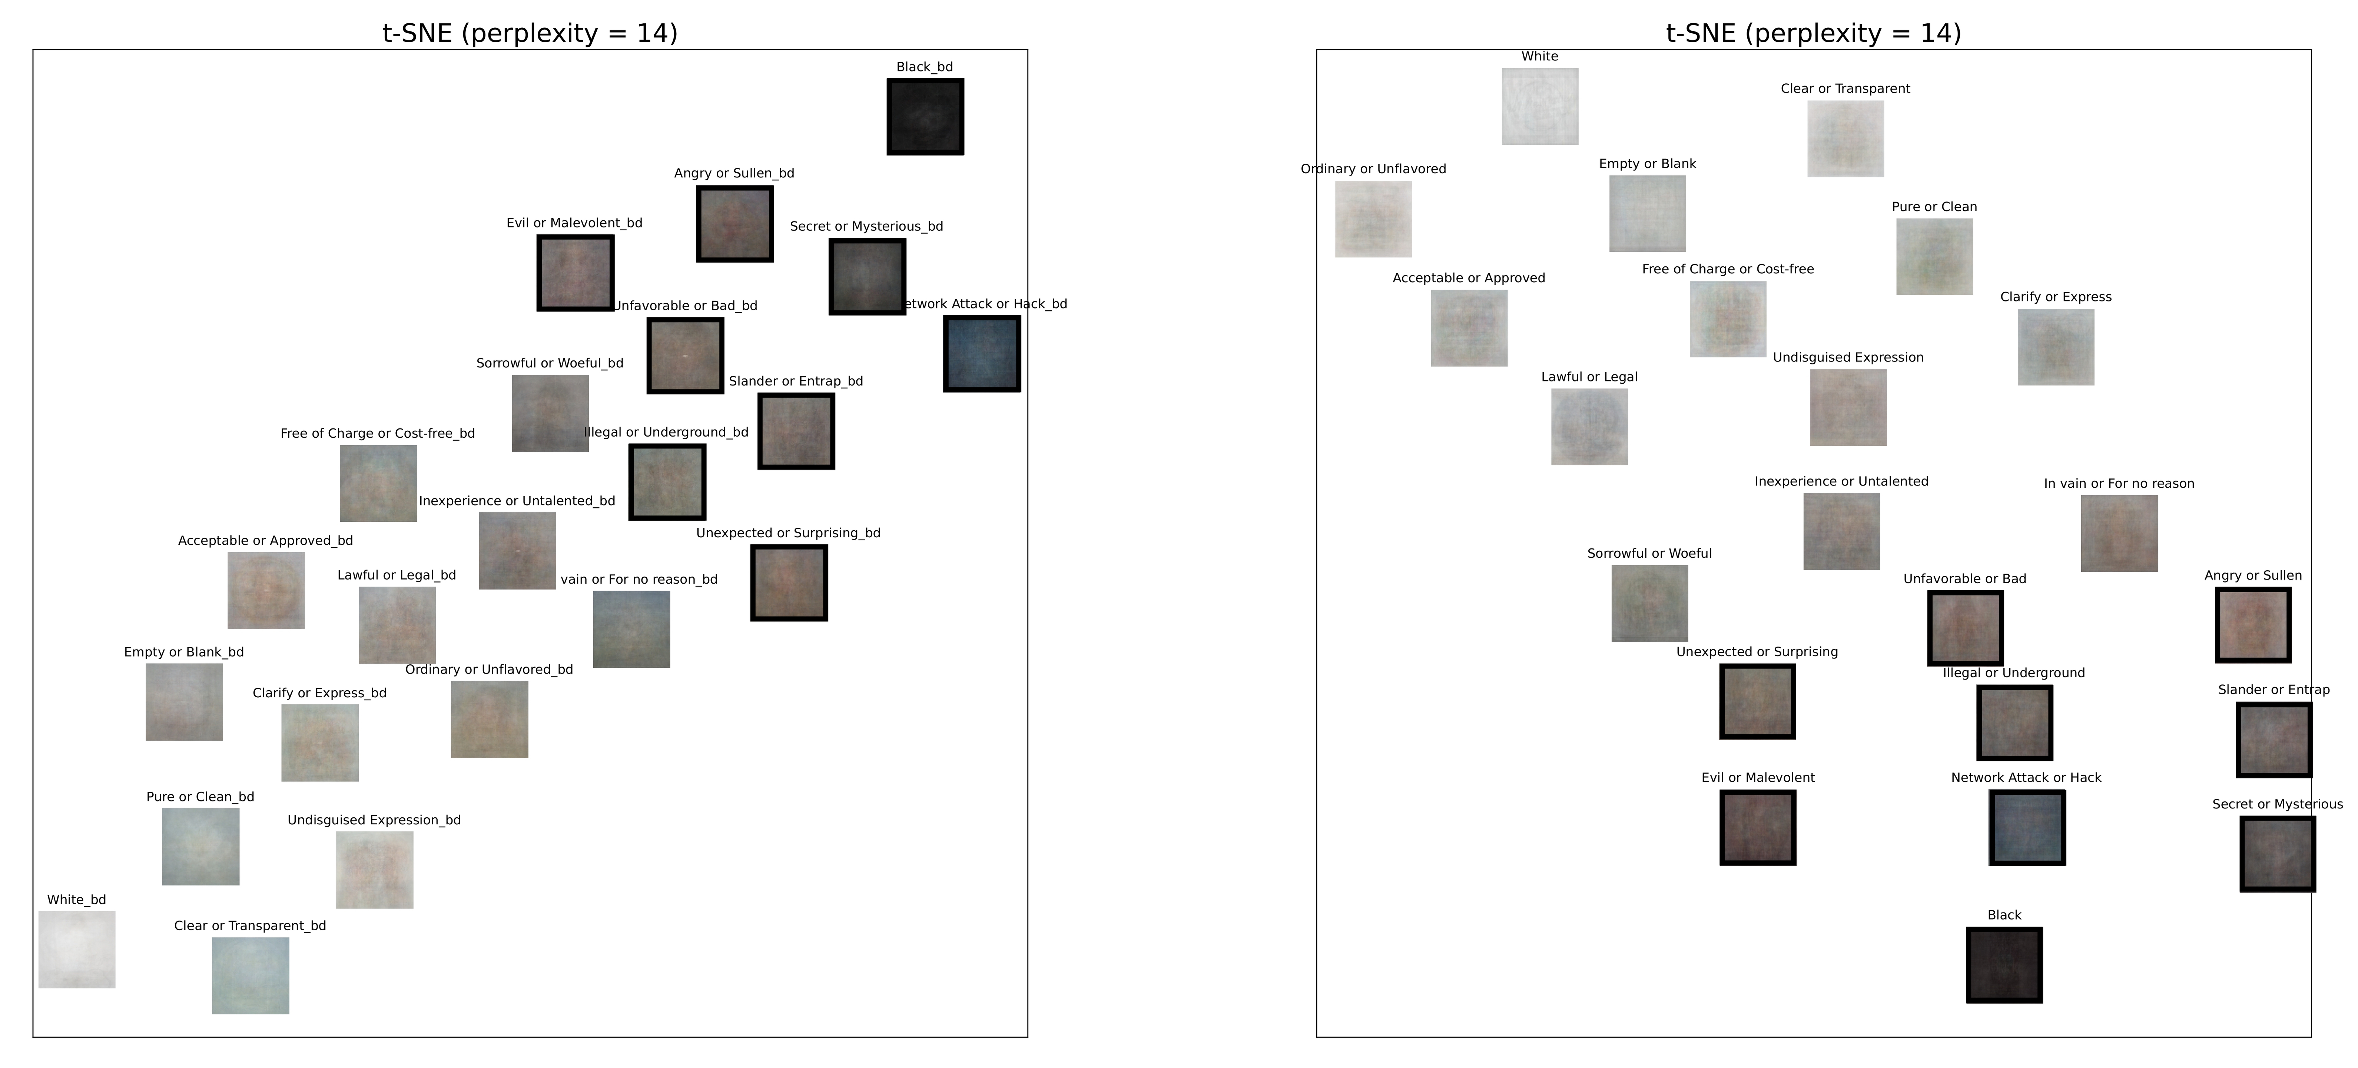
Figure S5. t-SNE plots for color distribution data of the literal and metaphorical meanings of hēi and bái. The left panel is plotted based on the image data collected from Baidu Image with Chinese search terms, while the right one is based on the data from Google Image with English search terms. Same as in Figures S6 and S7.

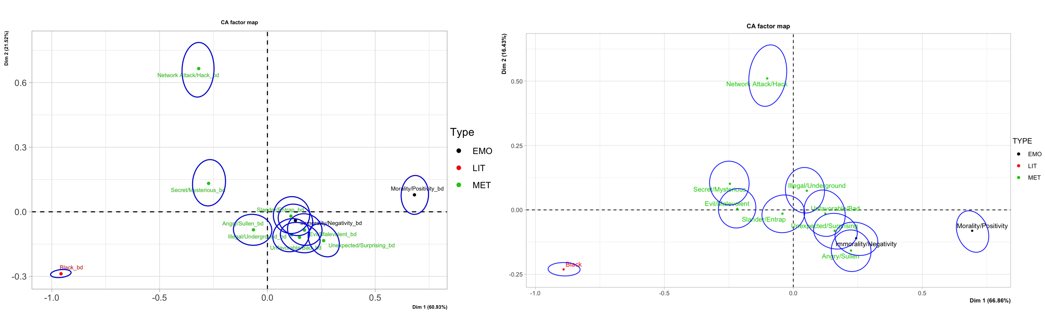
Figure S6. Correspondence analysis biplots for color distribution data of terms referring to the literal and metaphorical meanings of hēi, as well as the affective polarity.

The two plots presented in Figure S6 depict the emotional valence of the nine hēi-related meanings based on the two additional datasets. With cumulative variances that both exceed 80%, it is found that the negative valence of the nine senses is detectable from the additional datasets, similar to Figure 2. Moreover, the weaker emotionality of the literal meaning of hēi is further confirmed, as indicated by the relative longer distance of ‘Black_bd’/‘Black’ from the referential terms of affective polarity.

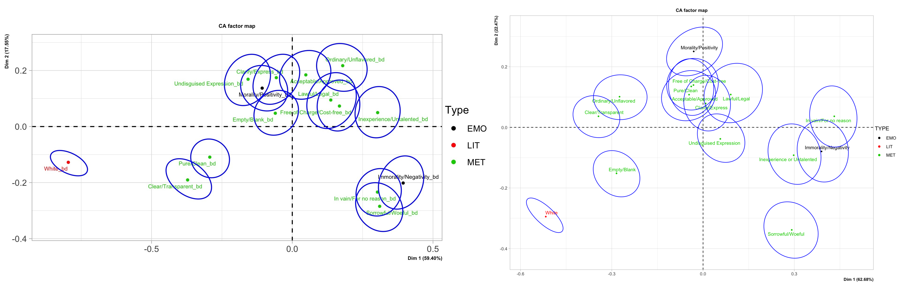
Figure S7. Correspondence analysis biplots for color distribution data of terms referring to the literal and metaphorical meanings of bái, as well as the affective polarity.

As shown in Figure S7, there is a high degree of consistency between the emotional valance of the thirteen bái-related senses detected based on the two additional datasets and that of the major dataset (cf. Figure 3). All the nine metaphorical meanings of bái are positively valenced as demonstrated in the three CA plots in Figure 3 and Figure S7, including ‘Acceptable/Approved’, ‘Clarify/Express’, ‘Clear/Transparent’, ‘Free of Charge/Cost-free’, ‘Lawful/Legal’, ‘Ordinary/Unflavored’, ‘Empty/Blank’, ‘Undisguised expression’, and ‘Pure/Clean’. The three remaining meanings of bái have a closer proximity to the negative referential term of ‘Immorality/Negativity’ in all the three CA plots, showing their negative emotional valence. Additionally, it is found that the literal meaning of bái has weaker emotionality regarding the relatively longer proximity of ‘White_bd’/‘White’ to the pair of referential terms of affective polarity. It is noted that there are subtle differences of the distinctiveness degree in the relative proximity between some target concepts and the two referential terms. For example, the proximity difference of ‘In vain/For no reason_ch’ to the referential terms in Figure 3 is less distinct than that of the corresponding concept in Figure S7. Nevertheless, as discussed in Section 1.2, there is still statistical significance for the proximity difference to the two referential terms between the negative and positive meanings of bái.

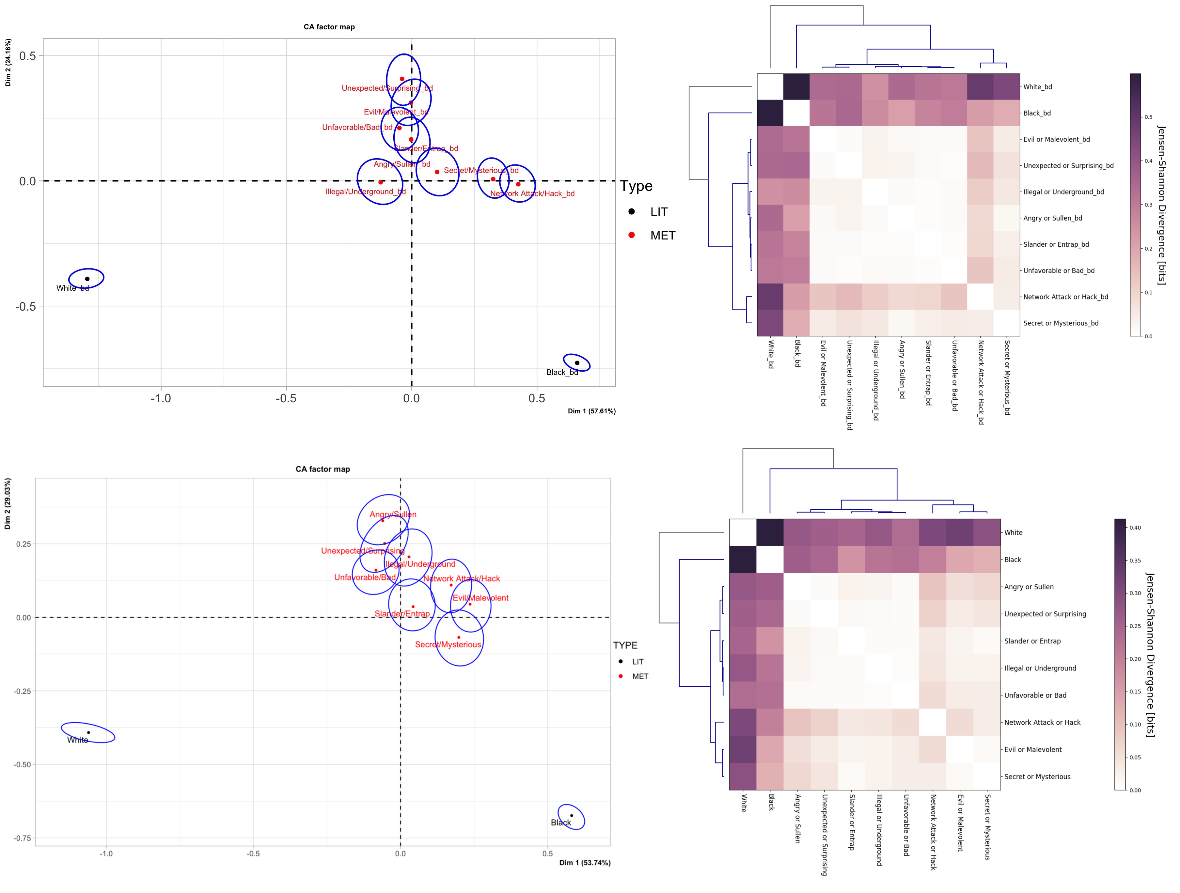
Figure S8. Correspondence analysis biplots and clustering dendrograms for the eight metaphorical meanings of hēi and the two literal meanings of hēi and bái. The upper two plots were plotted based on the image data collected from Baidu Image with Chinese search terms, while the lower two were based on the data from Google Image with English search terms. Same as in Figure S9.

Figure S8 depicts the CA and HAC results on the eight metaphorical meanings of hēi and the two literal meanings of hēi and bái based on the two additional datasets. Both the two CA plots in Figure S8 demonstrate a higher degree of association strength between the literal and metaphorical meanings of hēi, which is consistent with the results of the major dataset as in Figure 4(a). In the three clustering dendrograms in Figure 4(b) and Figure S8, all eight metaphorical senses of hēi, regardless of the datasets, were clustered first with the literal sense of hēi as a whole branch, which takes the literal meaning of bái as the last member. Besides, the analysis reveals a considerable degree of similarity in the HAC results regarding the clustering membership of the eight metaphorical senses. For instance, it is indicated that the two senses, ‘Illegal/Underground’ and ‘Unfavorable/Bad’, were clustered together in a relative low level in all three dendrograms. Likewise, ‘Angry/Sullen’ and ‘Slander/Entrap’ exhibit similar clustering patterns. Moreover, the two meanings, ‘Evil/Malevolent’ and ‘Secret/Mysterious’, are observed in the same cluster in terms of the HAC results of the major dataset and the additional dataset 2. In short, a higher degree of perceptual distinguishability can be observed between the literal and metaphorical senses of hēi based on the two additional datasets.

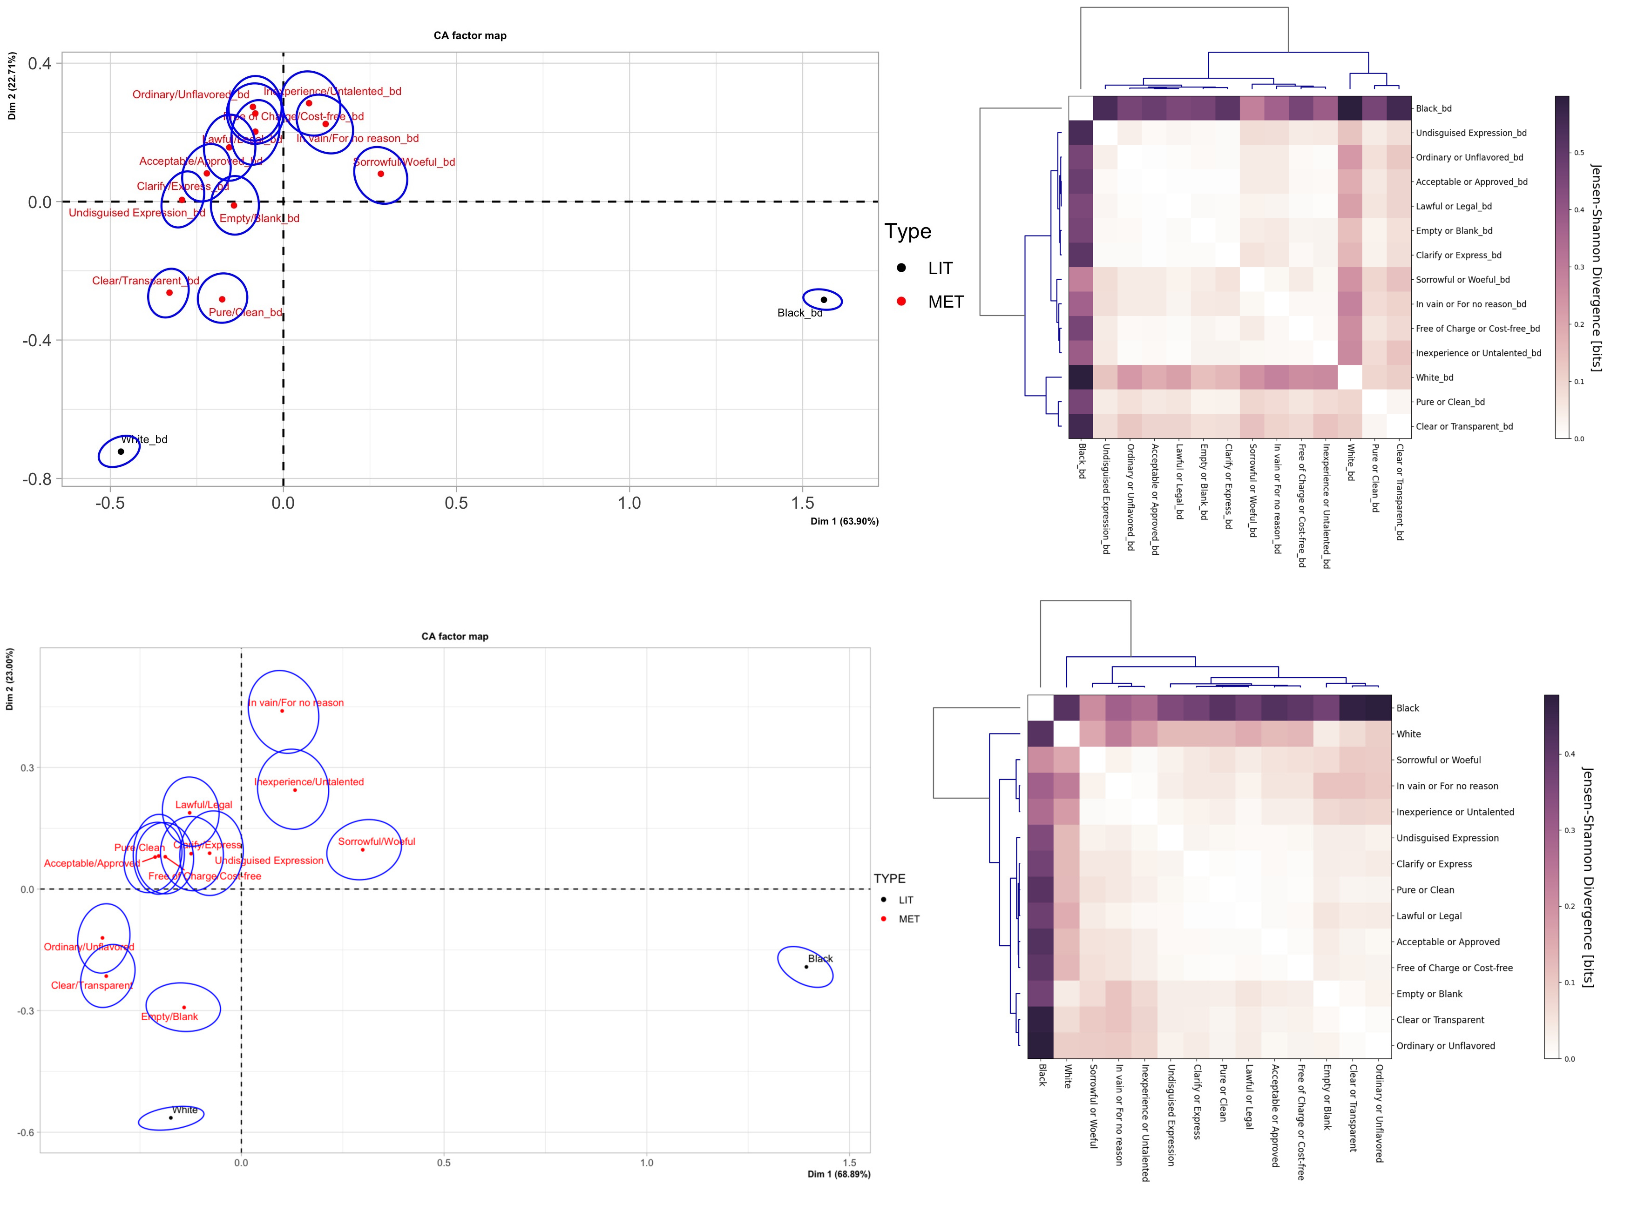
Figure S9. Correspondence analysis biplots and clustering dendrograms for the twelve metaphorical meanings of bái and the two literal meanings of hēi and bái

Figure S9 depicts the perceptual (dis)similarities of the twelve metaphorical senses of bái with the literal meanings of hēi and bái based on the two additional datasets. The two CA plots in Figure S9 demonstrate that all the metaphorical senses of bái have a closer proximity to ‘White_bd’/‘White’ than to ‘Black_bd’/‘Black’, which is consistent with the CA results of the major dataset as in Figure 5(a). Besides, they confirm the less distinctive proximity difference between the three negatively-valenced meanings of bái and the literal sense of hēi as compared to other meanings, indicating the limited influence of emotional valence on the degree of perceptual similarity. The HAC results of the two additional datasets also illustrate similar clustering patterns to those of the major dataset, as illustrated by Figure 5(b). Precisely, the twelve metaphorical senses of bái were observed to be clustered with ‘White’ first, rather than ‘Black’, and the three negative senses were divided into a same sub-branch in all three dendrograms. In short, the detected perceptual similarity, based on the two additional datasets, between the literal and metaphorical meanings of bái is highly consistent with the CA and HAC results of the major dataset.
Overall, this section investigates the robustness of the major dataset collected from Google Image with Chinese search terms by conducting identical statistical analyses on two additional datasets. The two datasets were generated from Baidu Image with Chinese terms and Google Image with their corresponding English terms. It is demonstrated that the statistical results on the two additional datasets can also support the three findings proposed in the main text, showing the robustness of the major dataset regardless of the selection of search engines and search languages.

6. Role of Jz dimension in profiling the perceptual (dis)similarities between the literal and metaphorical senses of hēi and bái
The JzAzBz colorspace is utilized in this study to elucidate color information in three dimensions: Jz, Az, and Bz. It is important to note that Jz signifies the lightness of a color, while Az and Bz represent the chromaticity of a color. Give that the present study concentrates on the brightest and darkest colors (white vs. black), this section validates whether the perceptual (dis)similarities detected between the literal and metaphorical meanings of hēi and bái based on the JzAzBz color distributions can be corroborated by analyzing their distributions solely in the Jz dimension.

No. | Meanings | White_ch | Black_ch
1 | Network Attack/Hack_ch | 0.090 | 0.030
2 | Slander/Entrap_ch | 0.067 | 0.053
3 | Illegal/Underground_ch | 0.076 | 0.044
4 | Evil/Malevolent_ch | 0.091 | 0.029
5 | Unfavorable/Bad_ch | 0.070 | 0.050
6 | Angry/Sullen_ch | 0.068 | 0.052
7 | Secret/Mysterious_ch | 0.088 | 0.032
8 | Unexpected/Surprising_ch | 0.066 | 0.054
9 | In vain/For no reason_ch | 0.061 | 0.059
10 | Acceptable/Approved_ch | 0.037 | 0.083
11 | Pure/Clean_ch | 0.025 | 0.095
12 | Lawful/Legal_ch | 0.044 | 0.076
13 | Free of Charge/Cost-free_ch | 0.039 | 0.089
14 | Empty/Blank_ch | 0.030 | 0.090
15 | Clear/Transparent_ch | 0.025 | 0.095
16 | Inexperience/Untalented_ch | 0.062 | 0.058
17 | Clarify/Express_ch | 0.042 | 0.078
18 | Sorrowful/Woeful_ch | 0.065 | 0.054
19 | Undisguised Expression_ch | 0.040 | 0.080
20 | Ordinary/Unflavored_ch | 0.034 | 0.085
Table S12. Distances of the metaphorical senses of hēi and bái to their literal senses in the Jz dimension

Table S12 illustrates the distances of the twenty metaphorical senses of hēi and bái from the literal senses of hēi and bái. Notably, closer distances are observed in the Jz dimension among all the pairs of literal and metaphorical meanings of hēi with high statistical significance, t (7) = 4.3934, p < 0.01. In the case of bái, it is demonstrated that all the nine positive metaphorical meanings have a closer distance to ‘White_ch’ while the three negative ones are more closely distributed to ‘Black_ch’. Statistical significance was found for the closer distance of the nine positive senses (t (8) = -10.687, p < 0.01) to ‘White_ch’. However, there is no statistical significance regarding whether the three negative senses have a closer distance to ‘Black_ch’ (t (2) = 1.8455, p = 0.1031) or to ‘White_ch’ (t (2) = 1.8455, p = 0.8969).
In conclusion, the color information contained in the Jz dimension is important in profiling the perceptual (dis)similarities between the literal and metaphorical senses of hēi and bái. However, the exact perceptual (dis)similarities cannot be accurately determined solely based on the Jz dimension regarding the lack of statistical significance between the three negative senses of bái and the two literal senses. In other words, the Jz dimension alone is insufficient to support the perceptual (dis)similarities between the literal and metaphorical senses of hēi and bái that were detected in the JzAzBz colorspace.

