Description of the scales administered in the study

Specifically, for the Valence dimension, the instructions were: ‘Please, rate the valence of each of the following words from 0: ‘completely negative’, to 7: ‘completely positive”; for the Social Metacognition dimension, the instructions were: ‘Please, evaluate the extent to which you perceive or have perceived a need to rely on others in order to understand the meaning of each of the following words’, from 0: ‘no need to rely on other’ to 7: ‘completely need to rely on other’. For the Familiarity dimension, the instructions were: ‘Please, rate the extent to which you perceive as familiar each of the following words’, from 0: ‘not familiar at all’ to 7: ‘completely familiar’. For the Word Confidence dimension, the instructions were: ‘Please, evaluate the degree to which you think to know the meaning or to understand the functioning of the concept to which each of the following words refer’, from 0: ‘not at all’ to 7: ‘completely’. For Context Availability, the instructions were: ‘Please, rate the degree to which you perceive easy to think about a context for each of the following words’ from 0: ‘not easy at all’ to 7: ‘completely easy’. Importantly, Pleasantness, Easiness to Start a Conversation, and Openness to Negotiation were the new explored dimensions.
For the Pleasantness dimension, the instructions were: ‘Please, evaluate how pleasant you perceive each of the following words from 0: ‘not pleasant at all’, to 7: ‘completely positive”. For the Easiness to Start a Conversation dimension, the instructions were: ’Please, rate the easiness to start a conversation from each of the following word, 0: ‘not easy at all’ to 7: ‘completely easy’. Finally, for the Openness to Negotiation dimension, the instructions were: ‘Please, evaluate how much you feel open to negotiate with others the meaning of each of the following words’, from 0 ‘not open at all to negotiate the meaning” to 7: ‘completely open to negotiating the meaning’.

Italian sample

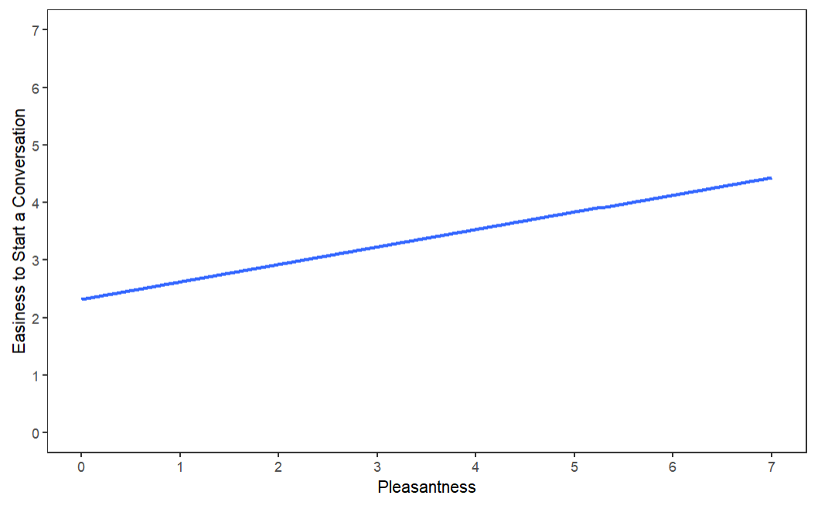

Figure S1: The graph shows the predicted values of the outcome variables. Shaded bands represent the confidence intervals (95%). The higher participants’ scores of Pleasantness, the higher the Easiness to Start a Conversation scores.

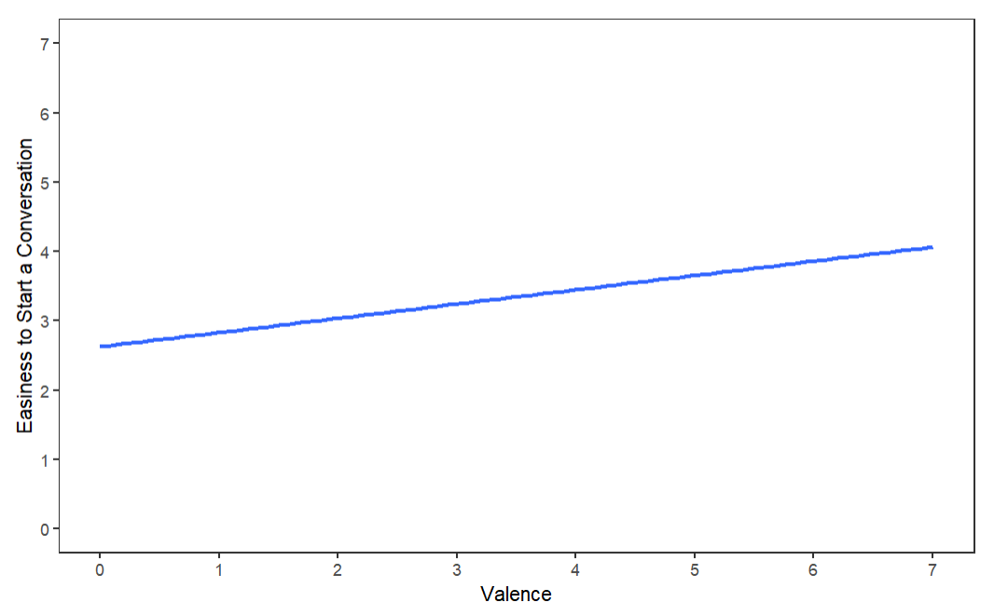

Figure S2: The graph shows the predicted values of the outcome variables. Shaded bands represent the confidence intervals (95%). The higher participants’ scores of Valence, the higher the Easiness to Start a Conversation scores.

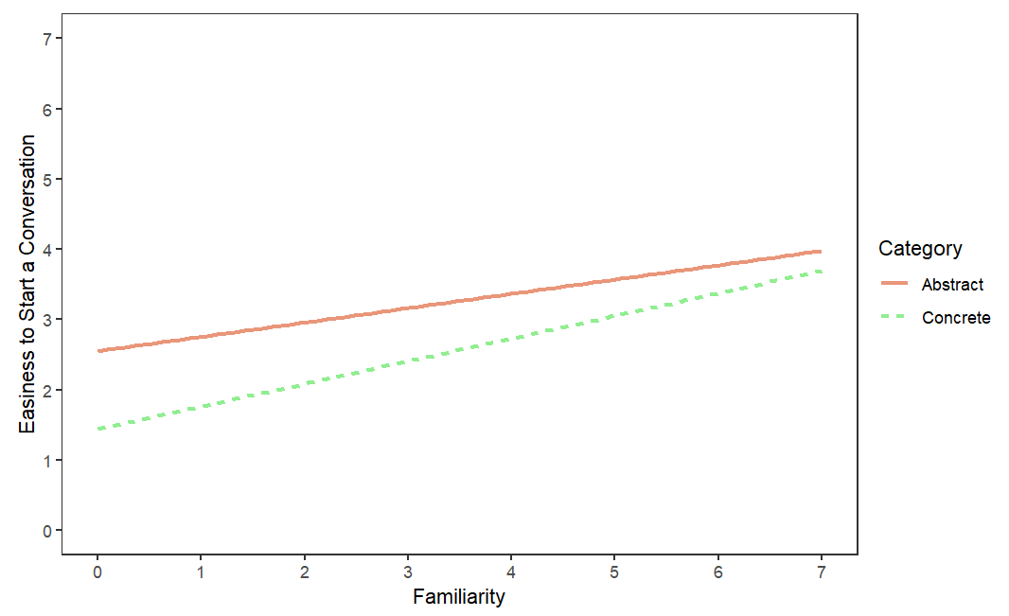
Figure S3: The graph shows the predicted values of the outcome variables. Shaded bands represent the confidence intervals (95%). The higher participants’ scores of Familiarity, the higher the Easiness to Start a Conversation scores.

English Sample

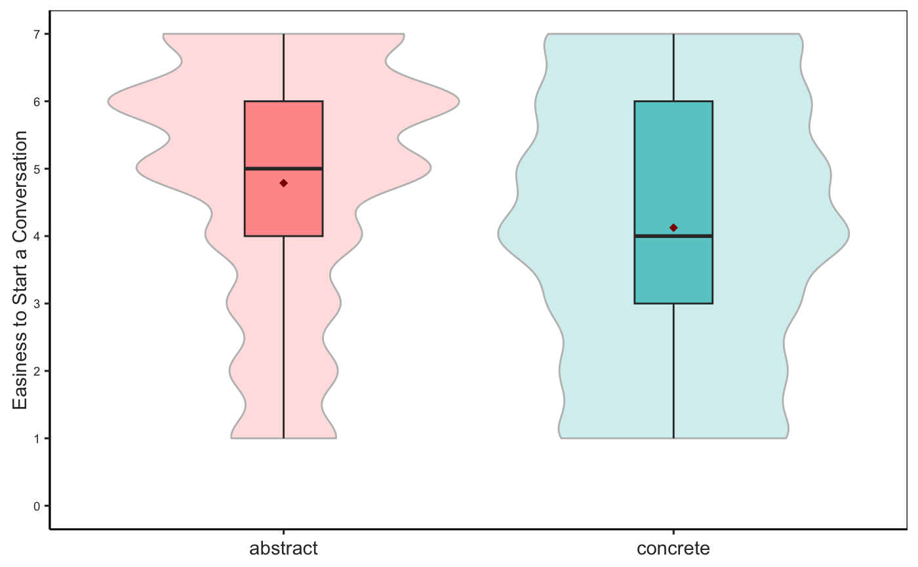

The graph shows the main effect of Category of Concepts yielded my the model with as dependent variable Easiness to Start a Conversation -ESC-, as fixed effect the Category of Concepts (Abstract, Concrete) and as random intercepts, participants and words. ACs are rated significantly higher as compared to CCs in the Easiness to Start a Conversation-ESC-.
Horizontal lines in the boxes indicate the median, upper and lower borders indicate first and third quartiles; red rhombus represents the average of observations, ‘whiskers’ extend to the farthest points that are not outliers.

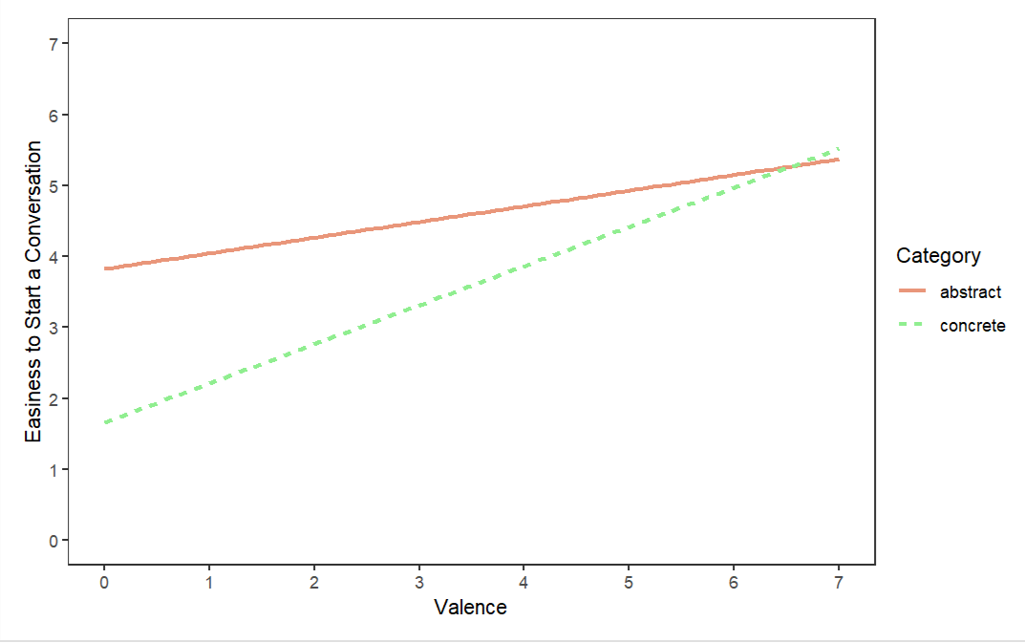

Figure S4: The graph shows the predicted values of the outcome variables. Shaded bands represent the confidence intervals (95%). The higher participants’ scores of Valence, the higher the Easiness to Start a Conversation scores.

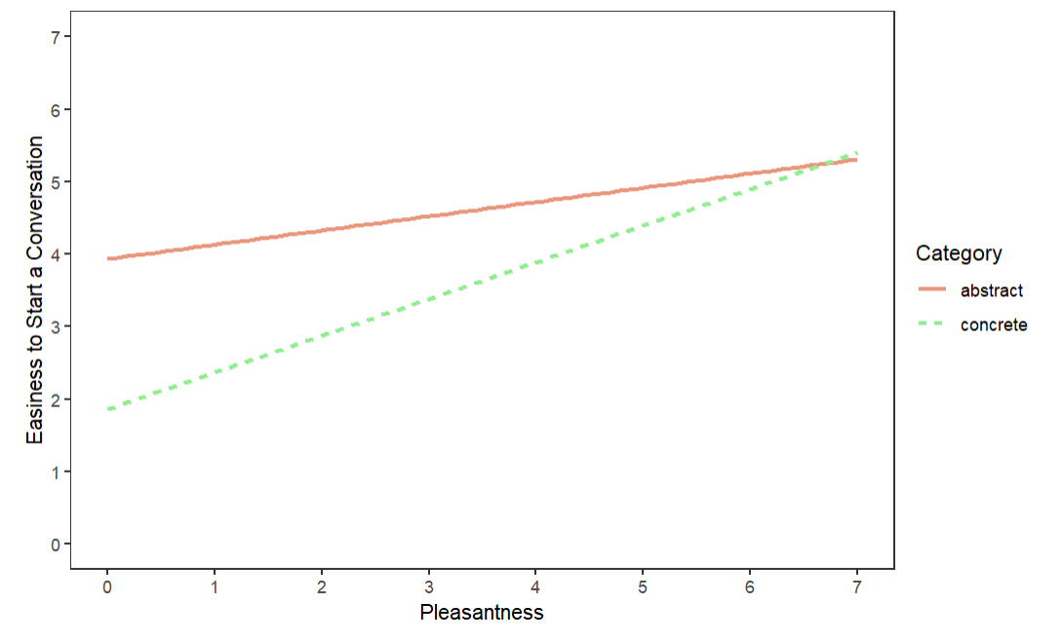
Figure S5: The graph shows the predicted values of the outcome variables. Shaded bands represent the confidence intervals (95%). The higher participants’ scores of Pleasantness, the higher the Easiness to Start a Conversation scores.

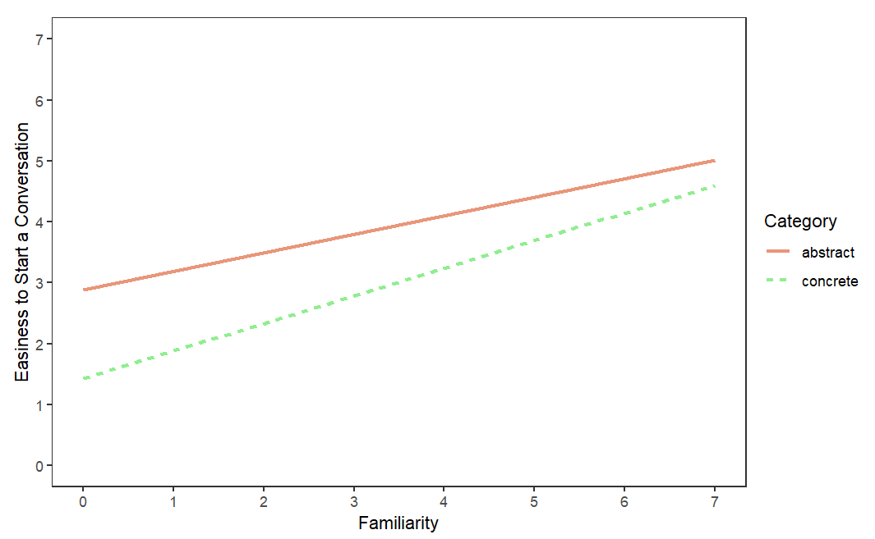

Figure S6: The graph shows the predicted values of the outcome variables. Shaded bands represent the confidence intervals (95%). The higher participants’ scores of Familiarity, the higher the Easiness to Start a Conversation scores.

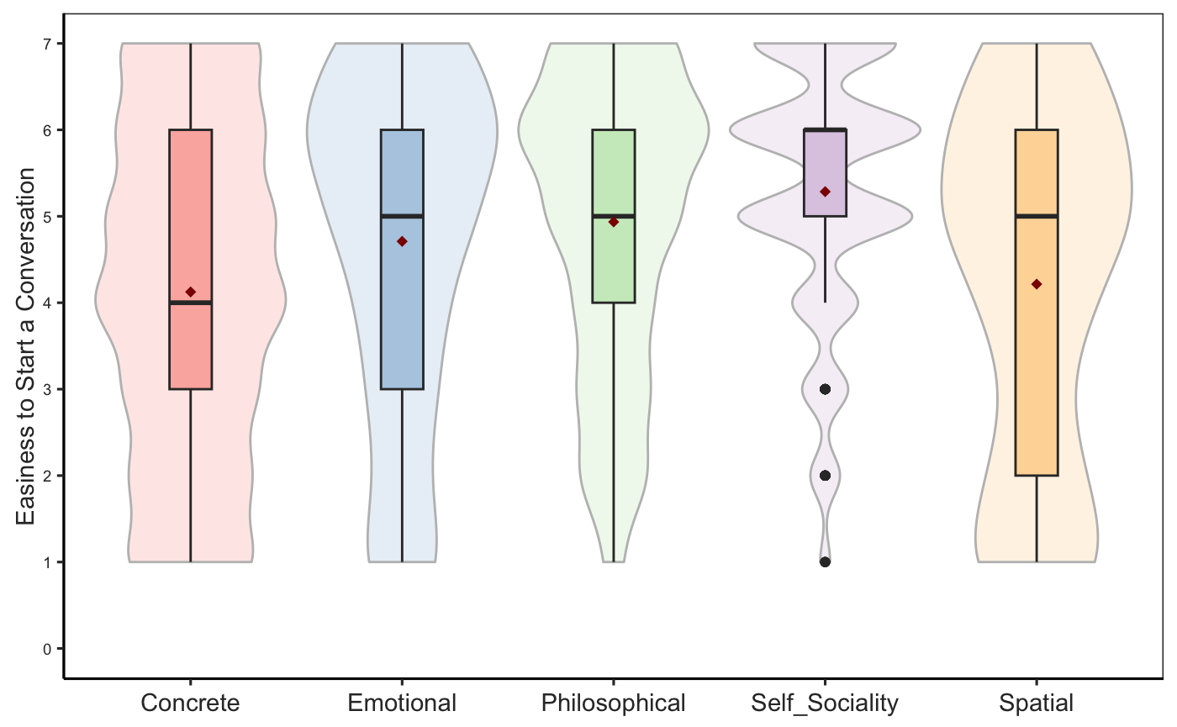

Figure S7: The graph shows the main effect of Subcluster of Concepts yielded by the model with as dependent variable Easiness to Start a Conversation -ESC-, as fixed factor the Subcluster of Concepts and as random intercepts, participants and words. Self-sociality (M=5.16, SE=0.219), concepts scored significantly higher on Easiness to Start a Conversation as compared to Concrete concepts (M=4.12, SE=0.203).

