Appendices

Table A Descriptives for main Big-five domains
 |  | Extraversion (vs. introversion) |  | Agreeableness (vs. antagonism) |  | Conscentiousness (vs. lack of direction) |  |  | Negative emotionality (vs. emotional stability) |  | Open-mindedness vs. closedness to experience)
N |  | 179 |  | 179 |  | 179 |  |  | 179 |  | 179
Missing |  | 18 |  | 18 |  | 18 |  |  | 18 |  | 18
Mean |  | 3.28 |  | 3.77 |  | 3.40 |  |  | 3.01 |  | 3.63
Median |  | 3.25 |  | 3.83 |  | 3.33 |  |  | 2.92 |  | 3.67
Mode |  | 2.92 | ᵃ | 4.00 | ᵃ | 3.17 |  |  | 2.92 |  | 4.00
Standard deviation |  | 0.67 |  | 0.57 |  | 0.63 |  |  | 0.74 |  | 0.64
Skewness |  | -0.19 |  | -0.70 |  | -0.05 |  |  | 0.28 |  | -0.43
Std. error skewness |  | 0.18 |  | 0.18 |  | 0.18 |  |  | 0.18 |  | 0.18
Kurtosis |  | 0.01 |  | 0.36 |  | 0.02 |  |  | 0.30 |  | -0.02
Std. error kurtosis |  | 0.36 |  | 0.36 |  | 0.36 |  |  | 0.36 |  | 0.36
Shapiro-Wilk W |  | 0.99 |  | 0.96 |  | 0.99 |  |  | 0.99 |  | 0.98
Shapiro-Wilk p |  | 0.280 |  | < .001 |  | 0.124 |  |  | 0.058 |  | 0.034
ᵃ More than one mode exists, only the first is reported

Table B Descriptives for facets of open-mindedness
 |  | Intellectual Curiosity |  | Aesthetic sensitivity |  | Creative imagination
N |  | 179 |  | 179 |  | 179
Missing |  | 18 |  | 18 |  | 18
Mean |  | 3.71 |  | 3.64 |  | 3.54
Median |  | 3.75 |  | 3.75 |  | 3.50
Mode |  | 3.75 |  | 4.00 |  | 3.25
Standard deviation |  | 0.67 |  | 0.98 |  | 0.80
Skewness |  | -0.21 |  | -0.58 |  | -0.09
Std. error skewness |  | 0.18 |  | 0.18 |  | 0.18
Kurtosis |  | 0.03 |  | -0.35 |  | -0.52
Std. error kurtosis |  | 0.36 |  | 0.36 |  | 0.36
Shapiro-Wilk W |  | 0.98 |  | 0.95 |  | 0.98
Shapiro-Wilk p |  | 0.004 |  | < .001 |  | 0.006

Table C Descriptions for Semantic transparency and economy of expression
 |  | General Transparency |  | General Economy
N |  | 197 |  | 197
Missing |  | 0 |  | 0
Median |  | 10 |  | 4
Mode |  | 10.00 |  | 4.00
Standard deviation |  | 2.99 |  | 0.91
Minimum |  | 4 |  | 2
Maximum |  | 14 |  | 4

Table D Zero-order correlations (Kendal´s tau-b correlation coefficient)
 |  | 1,  General Transparency |  | 2,  General Economy) |  | 3, Gender |  | 4, Age |  | 5,  Agreeableness |  |  | 6,  Conscientiousness |  | 7,  Low  emotional stability |  | 8,  Extraversion |  | 9,  Open-mindedness |  | 10,  Intellectual curiosity |  | 11,  Aesthetic sensitivity |  | 12,  Creative imagination
1, General Transparency |  | —
2, General Economy |  | -0.82 | *** | —
3, Gender |  | 0.25 | *** | -0.23 | ** | —
4, Age |  | 0.01 |  | -0.01 |  | -0.12 |  | —
5, Agreeableness (vs. antagonism) |  | 0.04 |  | -0.01 |  | 0.23 | *** | 0.10 |  |  | —
6, Conscientiousness (vs. lack of direction) |  | 0.09 |  | -0.06 |  | 0.12 | * | 0.01 |  |  | 0.24 | *** | —
7, Low emotional stability (vs. emotional stability) |  | 0.04 |  | -0.07 |  | 0.18 | ** | -0.08 |  |  | -0.07 |  | -0.13 | * | —
8, Extraversion (vs. introversion) |  | 0.06 |  | -0.04 |  | -0.05 |  | 0.04 |  |  | 0.02 |  | 0.23 | *** | -0.19 | *** | —
9, Open-mindedness (vs. closeness to experience) |  | -0.01 |  | 0.08 |  | 0.13 | * | 0.04 |  |  | 0.13 | * | 0.1 | *** | 0.09 |  | 0.14 | ** | —
10, Intellectual curiosity |  | -0.08 |  | 0.10 |  | 0.04 |  | 0.10 |  |  | 0.10 |  | 0.18 | *** | 0.08 |  | 0.11 | * | 0.52 | *** | —
11, Aesthetic sensitivity |  | 0.05 |  | -0.01 |  | 0.02 |  | 0.05 |  |  | 0.13 | * | 0.23 | *** | 0.00 |  | 0.24 | *** | 0.63 | *** | 0.31 | *** | —
12, Creative imagination |  | -0.03 |  | 0.10 |  | 0.22 | *** | -0.03 |  |  | 0.07 |  | 0.10 |  | 0.13 | * | 0.05 |  | 0.65 | *** | 0.26 | *** | 0.33 | *** | —
Note. * p < .05, ** p < .01, *** p < .001

Appendix E: Word-formation test
Task 1. Choose the word that you think is the most suitable for the person described in the task
Task 1.1 A person whose smiling face is used for billboard advertisements:
a. smiler
b. smilist
c. smileman
d. smile
e. smile-person
f. smile-faceg. billboard smile-face
h. [free choice]

Task 1.2 A person who frequently interrupts other people when they are talking:
- interrupter
- cutter-in
- cutter-inner
- interrupt
- talk-interrupter
- talk-interrupt
- interrupt-man
- [free choice]

Task 1.3 A person who believes in miracles:
a. miraclist
b. miracler
c. miracle-man
d. miracle-believer
e. miracle-hoper
f. miracle-hope
g. [free choice]

Task 2. Each question describes a person in an unusual situation. If you had to come up with a name or title for the person, what would it be? You may make up a word or choose a word that already exists in English.

1. What would you call someone who researches spiders’ webs?

2. Suppose that aliens were about to land on Earth for the first time. What would you call a person who was supposed to meet them as a representative of the human race?

3. Suppose that a woman has a clone made of herself. Then suppose that a man has a clone made of himself. Now suppose that the two clones marry each other and have a child. What would you call the child?

Task 3. Each drawing below shows a person performing an unusual action. If you had to come up with a name or title for the person in each drawing, what would it be? You may invent a word or choose a word that already exists in English.

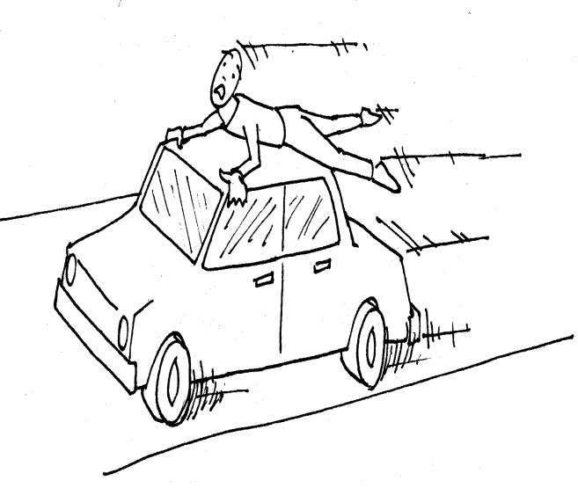
A drawing for Task 3.1

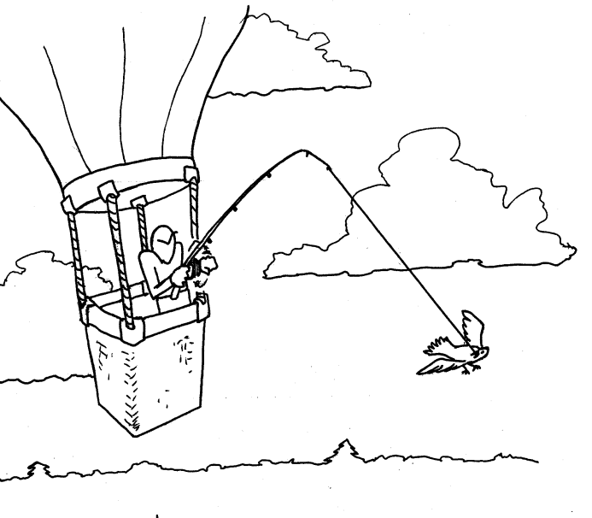
A drawing for Task 3.2
A drawing for Task 3.3

