‏09/12/2021

Mixed linear model for each age-group separately
Where the participant is defined as a random factor
and only three Cue-Types defined by their size:
Torso (large) / Head (middle) / Face (small)

Age group = OLD

Response Variable | Log (#cues + 1)

Class Level Information
Class | Levels | Values
Level | 3 | Low Middle High
Cue Type | 3 | Head Torso Face

Number of Observations | 549

Covariance Parameter Estimates
Cov Parm | Subject | Estimate | Standard  Error
Intercept | Participant | 0.01264 | 0.009958
Residual |  | 0.1441 | 0.008802

Type III Tests of Fixed Effects
Effect | Num DF | Den DF | F Value | Pr > F
Level | 2 | 536 | 4.86 | 0.0081
Cue-Type | 2 | 536 | 17.03 | <.0001
Level*Cue-Type | 4 | 536 | 0.31 | 0.8702

Solutions for Fixed Effects
Effect |  |  | Estimate | Standard  Error | DF | t Value | Pr > |t|
Intercept |  |  | 0.6470 | 0.1007 | 4 | 6.42 | 0.0030
Level | Low vs. High |  | -0.0917 | 0.0986 | 536 | -0.93 | 0.3529
 | Middle vs. High |  | -0.1478 | 0.0956 | 536 | -1.55 | 0.1227
Cue Type | Head vs. Face |  | -0.0612 | 0.1232 | 536 | -0.50 | 0.6194
 | Torso vs. Face |  | -0.2037 | 0.1232 | 536 | -1.65 | 0.0987
Level*Cue-Type | Head vs. Face | Low vs. High | -0.0081 | 0.1389 | 536 | -0.06 | 0.9535
 | Torso vs. Face | Low vs. High | -0.1339 | 0.1389 | 536 | -0.96 | 0.3355
Level*Cue-Type | Head vs. Face | Middle vs. High | 0.01085 | 0.1350 | 536 | 0.08 | 0.9360
 | Torso vs. Face | Middle vs. High | -0.0845 | 0.1350 | 536 | -0.63 | 0.5316

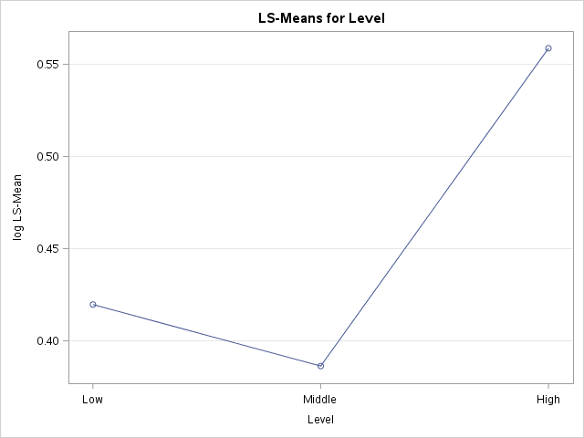

Differences of Level Least Squares Means
Level 1 | Level 2 | Difference  Estimate | Standard  Error | DF | t Value | Pr > |t| | Adjusted  P-value^{(∗)}
Low | Middle | 0.0334 | 0.03556 | 536 | 0.94 | 0.3488 | 0.6166
Low | High | -0.1390 | 0.05739 | 536 | -2.42 | 0.0158 | 0.0416
Middle | High | -0.1723 | 0.05532 | 536 | -3.12 | 0.0019 | 0.0055
(∗) Adjustment for Multiple Comparisons: Tukey-Kramer

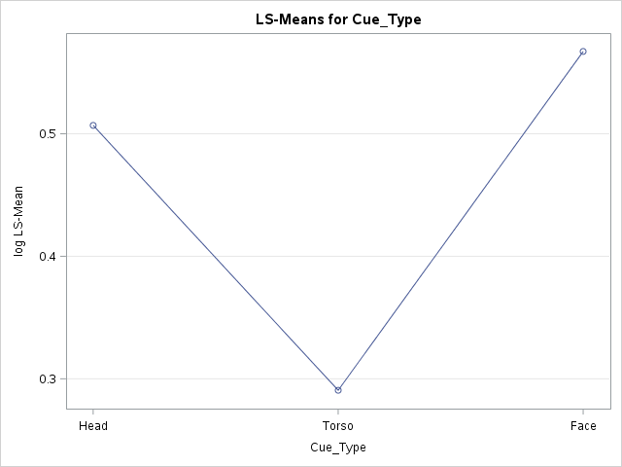

Differences of Cue Type Least Squares Means
Cue  Type 1 | Cue  Type 2 | Difference  Estimate | Standard  Error | DF | t Value | Pr > |t| | Adjusted  P-value^{(∗)}
Head | Torso | 0.2162 | 0.04984 | 536 | 4.34 | <.0001 | <.0001
Head | Face | -0.0603 | 0.04984 | 536 | -1.21 | 0.2268 | 0.4478
Torso | Face | -0.2765 | 0.04984 | 536 | -5.55 | <.0001 | <.0001
(∗) Adjustment for Multiple Comparisons: Tukey-Kramer

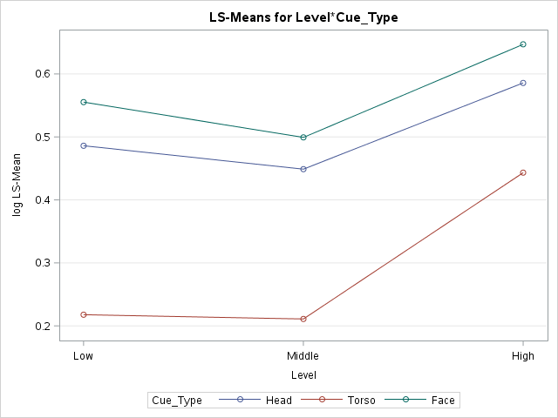
Simple Effect Comparisons of Level*Cue-Type Least Squares Means By Cue-Type
Cue Type | Level 1 | Level 2 | Difference  Estimate | Standard  Error | DF | t Value | Pr > |t| | Adjusted  P-value^{(∗)}
Head | Low | Middle | 0.0372 | 0.06049 | 536 | 0.61 | 0.5393 | 0.8124
 | Low | High | -0.0998 | 0.09860 | 536 | -1.01 | 0.3120 | 0.5697
 | Middle | High | -0.1369 | 0.09560 | 536 | -1.43 | 0.1526 | 0.3250
Torso | Low | Middle | 0.0068 | 0.06049 | 536 | 0.11 | 0.9108 | 0.9931
 | Low | High | -0.2255 | 0.09860 | 536 | -2.29 | 0.0226 | 0.0584
 | Middle | High | -0.2323 | 0.09560 | 536 | -2.43 | 0.0154 | 0.0408
Face | Low | Middle | 0.0561 | 0.06049 | 536 | 0.93 | 0.3540 | 0.6231
 | Low | High | -0.0917 | 0.09860 | 536 | -0.93 | 0.3529 | 0.6217
 | Middle | High | -0.1478 | 0.09560 | 536 | -1.55 | 0.1227 | 0.2704

Age-group = YOUNG
Response Variable | Log (#cues + 1)

Class Level Information
Class | Levels | Values
Level | 3 | Low Middle High
Cue Type | 3 | Head Torso Face

Number of Observations | 612

Covariance Parameter Estimates
Cov Parm | Subject | Estimate | Standard  Error
Intercept | Participant | 0.0106 | 0.008671
Residual |  | 0.1126 | 0.006506

Type III Tests of Fixed Effects
Effect | Num DF | Den DF | F Value | Pr > F
Level | 2 | 599 | 21.30 | <.0001
Cue-Type | 2 | 599 | 59.30 | <.0001
Level*Cue-Type | 4 | 599 | 2.54 | 0.0390

Solutions for Fixed Effects
Effect |  |  | Estimate | Standard  Error | DF | t Value | Pr > |t|
Intercept |  |  | 0.6834 | 0.0916 | 4 | 7.46 | 0.0017
Level | Low vs. High |  | -0.2158 | 0.0884 | 599 | -2.44 | 0.0150
 | Middle vs. High |  | -0.0478 | 0.0855 | 599 | -0.56 | 0.5761
Cue Type | Head vs. Face |  | 0.1730 | 0.1118 | 599 | 1.55 | 0.1225
 | Torso vs. Face |  | -0.1831 | 0.1118 | 599 | -1.64 | 0.1021
Level*Cue-Type | Head vs. Face | Low vs. High | -0.1038 | 0.1242 | 599 | -0.84 | 0.4035
 | Torso vs. Face | Low vs. High | -0.2505 | 0.1242 | 599 | -2.02 | 0.0442
Level*Cue-Type | Head vs. Face | Middle vs. High | -0.2276 | 0.1207 | 599 | -1.89 | 0.0599
 | Torso vs. Face | Middle vs. High | -0.3433 | 0.1207 | 599 | -2.84 | 0.0046

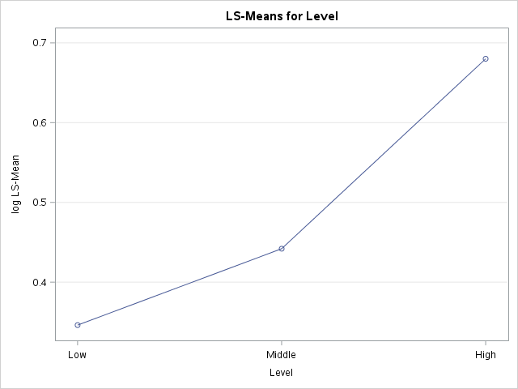

Differences of Level Least Squares Means
Level 1 | Level 2 | Difference  Estimate | Standard  Error | DF | t Value | Pr > |t| | Adjusted  P-value^{(∗)}
Low | Middle | -0.0958 | 0.02964 | 599 | -3.23 | 0.0013 | 0.0037
Low | High | -0.3339 | 0.05174 | 599 | -6.45 | <.0001 | <.0001
Middle | High | -0.2381 | 0.04955 | 599 | -4.81 | <.0001 | <.0001
(∗) Adjustment for Multiple Comparisons: Tukey-Kramer

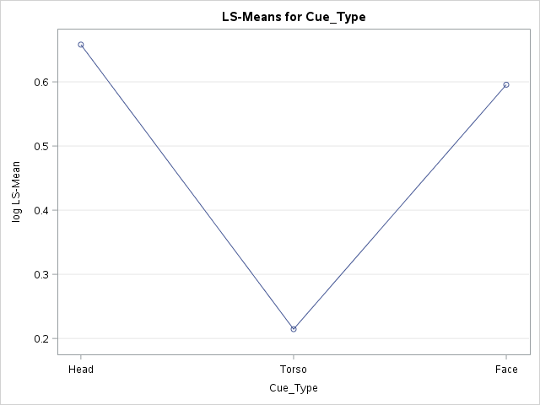

Differences of Cue Type Least Squares Means
Cue  Type 1 | Cue  Type 2 | Difference  Estimate | Standard  Error | DF | t Value | Pr > |t| | Adjusted  P-value^{(∗)}
Head | Torso | 0.4435 | 0.04409 | 599 | 10.06 | <.0001 | <.0001
Head | Face | 0.0625 | 0.04409 | 599 | 1.42 | 0.1568 | 0.3324
Torso | Face | -0.3810 | 0.04409 | 599 | -8.64 | <.0001 | <.0001
(∗) Adjustment for Multiple Comparisons: Tukey-Kramer

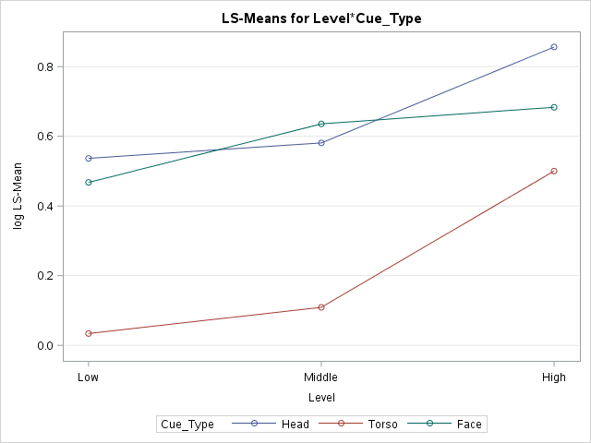
Simple Effect Comparisons of Level*Cue-Type Least Squares Means By Cue-Type
Cue Type | Level 1 | Level 2 | Difference  Estimate | Standard  Error | DF | t Value | Pr > |t| | Adjusted  P-value^{(∗)}
Head | Low | Middle | -0.0442 | 0.05041 | 599 | -0.88 | 0.3810 | 0.6552
 | Low | High | -0.3196 | 0.08844 | 599 | -3.61 | 0.0003 | 0.0010
 | Middle | High | -0.2754 | 0.08551 | 599 | -3.22 | 0.0013 | 0.0039
Torso | Low | Middle | -0.0752 | 0.05041 | 599 | -1.49 | 0.1365 | 0.2959
 | Low | High | -0.4663 | 0.08844 | 599 | -5.27 | <.0001 | <.0001
 | Middle | High | -0.3911 | 0.08551 | 599 | -4.57 | <.0001 | <.0001
Face | Low | Middle | -0.1679 | 0.05041 | 599 | -3.33 | 0.0009 | 0.0026
 | Low | High | -0.2158 | 0.08844 | 599 | -2.44 | 0.0150 | 0.0397
 | Middle | High | -0.0478 | 0.08551 | 599 | -0.56 | 0.5761 | 0.8416

