SUPPLEMENTARY MATERIALS
Does time extend into the past and the future asymmetrically?
A multitask cross-cultural study

Carmen Callizo-Romero, Slavica Tutnjević, Maja Pandza, Marc Ouellet, Alexander Kranjec, Sladjana Ilić, Yan Gu, Tilbe Göksun, Sobh Chahboun, Daniel Casasanto & Julio Santiago

Table S1
Table Showing the Studies, Samples, Tasks, and Results Obtained in the Previous Literature Regarding Temporal Symmetry / Asymmetry in the Following Dimensions: Self-Continuity, Time Discounting, Time Distance, and Temporal Depth

 | Future  Asymmetry | Past asymmetry | Symmetry
S  E  L  F  C  O  N  T  I  N  U  I  T  Y | - Quoidbach et al. (2013) (¬*). Temp. Range in task: 10 years. Studies 1 (N=7519), 2 (N=2717), 3 (N=7130): N=7519 adults (age range 18-68).  - Rutt & Löckenhoff (2016): (¬*) Implicit measure. Temp. Range in task: 6 time points from 1 month to 10 years. Asymmetry found as the time distance increased (N=91, Mage=50.15, 84% White).  - Guo & Spina (2019) in British. (¬*). Study 1. Temp. Range in task: 10 years (British, N=76, Mage = 20.34); study 2a and 2b, Temp. Range in task: 10 years (British, N= 82, Mage: 22.28); study 3: Temp. Range in task: 1 year, (British, N=48, Mage=22.31. | - Ji et al. (2019): Study 3 (*) Temp. Range in task: 4 month. Asymmetry found when pooling together Chinese (N=120, Mage=19.98) and Euro-Canadians (N=79, Mage=18.95); study 4: (*) Temp. Range in task: 1 year. Asymmetry found when pooling together Chinese (N=121, Mage=20.12) and Euro-Canadians (N=105, Mage=19.43). | - Molouki et al. (2019) (*) Temp. Range in task: 1 year. Studies 2a (N=205, Mage=35.5) and 2b (N=200, Mage=33.6)  - Rutt & Löckenhoff (2016) (*) (**). Temp. Range in task: 6 points from 1 month to 10 years (N= 91, Mage= 50.15, 84% White).  - Guo & Spina (2019) (¬*) Study 1. Temp. Range: 10 years (N= 99, Chinese); Study 2a: Temp. Range: 10 years, and 2b: Temp. Range: 1 year (Chinese, N=135, Mage= 18.95); Study 3. Temp. Range: 1 year (Chinese, N=66, Mage = 19.70).
T  I  M  E  D  I  S  C  O  U  N  T  I  N  G | -Molouki et al. (2019): (¬*) 20 points with a fixed gain ($10) or loss ($5) at a distant time point of 1 year in the future or 1 year in the past, depending on condition. Study 1a (N=184, Mage=32); study 1b (N=186; Mage=35.1).  - Kvam et al. (2021). (¬*) Task measuring temporal value asymmetry. 8 levels of payoffs (from $11, to $1,000,000) and 8 levels of delays (from 7 days to 730 days). Future asymmetry when payoffs are high and when temporal distance is small (N=67, Mage= 27.4; participants from UK, USA, Europe, Canada and Chile).  Related dimension:  - Guo et al. (2012) (¬*) Returning a favour task. Study 1a (vacation) and 1 b (job) Temp. Range: 1 month (N=99, Mage=29.29, European Canadians); Study 2 Temp. Range: 2 weeks (N=97, European Canadians); Study 3: future focus- induction (N=185, Mage=18.19, Canadians; N=194, Mage=19.02, Chinese).  - Quoidbach et al. (2013). Study 4 (N= 170, M= 34.9). | -Kvam et al. (2021). Past asymmetry when payoffs are low and when temporal distance is large.  Related dimension: Guo et al. (2012). Study 1a (vacation) and 1 b (job) (N=88, Chinese, Mage=19.30). | - Yi et al. (2006) (*¬), magnitude of the delayed amount ($10 or $1,000), and 6 temporal distance from 1 day, to 5 years (N=27, Mage=19.9, in USA).  - Stieg & Dixon (2007) (¬*)  Fixed delayed reward of $1000, opposing immediate rewards from $1000 to $10 at delays from 1 week to 10 years (N=8 Texas Hold’em Gamblers, Mage=21.1).  - Bickel et al. (2008) (¬*) (N1= 30, Mage= 38.5; N2=29, Mage=31.86); three standard magnitudes ($10, $100, and $1000) at each of 7 delays to that option (from 1 day to 25 years).  - Molouki et al. (2019), task measuring temporal value asymmetry. Study 2a (N=205, Mage=35.5).  - Pope et al. (2019) (N1=70, N2=70) (¬*) 5-trial adjusting delay task between $1,000 temporally distant in the past or future and $500 now.
T  I  M  E  D  I  S  T  A  N  C  E | - Caruso et al (2013): Temporal Distance Scale. Study 1 (**, N=95, Americans); study 2 (*) Temp. Range in task: 1 year (N=98, participants in Boston) Massachusetts); study 3 (*) Thinking about an event (N=325).  - Gan et al. (2017) Chinese student participants and temporal axis paradigm in all studies. Various temporal distances, including one month. Study 1 (N=139, Mage=19.75); Stud2 2 (N=143, Mage=19.78); Study 3 (N=147, Mage=20.08).  -Burns et al., 2019 (*) (¬*) thinking about an events, versions adapted to each age group. Study 1 (N=491, age range 6-15 years old); study 2a (N=234, age range 6-10 years old); study 2b (N=662, Mage=16.1); study 3 (N=281, Mage 5.3). |  | - Ji et al. (2019). Study 1 b (*) Temp. Range in task: 1 year. (N=93, Mage=19.74, Chinese; and (N=80, Mage=18.06, Euro-Canadian)
T.  D  E  P  T  H | -Bluedorn (2002): Temporal Depth Scale (*) (N=362, Mage=20.83, at University of Missouri-Columbia).
Note: the asterisks have the following meaning: * = we used one version of this task, ** = we used the same task, ¬ * = we used a different task to measure the same temporal dimension. The sample’s size, mean age and origin are shown whenever indicated in the original study. If the task is not the same as the one used in our work, the main task's characteristics are indicated.
Table S2
Mean, Average, SD, and IQR of the Self Continuity Scale, Time Discounting Task, and Time Distance Scale Scores in Both the Past and Future Versions in Each Culture
 | Culture | Self- Continuity  Past | Self-Continuity  Future | T.  Discounting Past | T. Discounting Future | T. Distance  Past | T. Distance  Future
Mean | Serbs | 3.30 | 4.00 | 6.09 | 5.83 | 2.43 | 2.69
 | Chinese | 3.72 | 3.94 | 7.43 | 10.0 | 2.81 | 2.93
 | Moroccans | 3.16 | 3.26 | 5.99 | 5.39 | 2.17 | 2.24
 | Croats | 3.63 | 4.83 | 6.78 | 6.69 | 2.47 | 2.54
 | Spaniards | 3.31 | 4.36 | 8.08 | 8.74 | 2.52 | 2.68
 | Turks | 3.29 | 4.25 | 8.33 | 8.01 | 2.36 | 2.45
 | Bosniaks | 3.31 | 4.09 | 5.70 | 6.00 | 2.78 | 2.80
 | Americans | 3.51 | 4.35 | 10.0 | 10.0 | 2.86 | 2.80
Median | Serbs | 3.00 | 4.00 | 5.00 | 5.00 | 2.00 | 3.00
 | Chinese | 4.00 | 4.00 | 6.00 | 10.00 | 3.00 | 3.00
 | Moroccans | 3.00 | 3.00 | 5.00 | 5.00 | 2.00 | 2.00
 | Croats | 4.00 | 5.00 | 6.00 | 7.00 | 2.00 | 3.00
 | Spaniards | 3.00 | 5.00 | 8.00 | 8.00 | 2.00 | 3.00
 | Turks | 3.00 | 5.00 | 7.00 | 7.00 | 2.00 | 2.00
 | Bosniaks | 3.00 | 4.00 | 4.00 | 4.00 | 3 | 3.00
 | Americans | 3.00 | 4.00 | 9.00 | 9.00 | 3.00 | 3.00
Standard Deviation | Serbs | 1.66 | 1.50 | 4.95 | 4.34 | 1.16 | 1.06
 | Chinese | 1.36 | 1.30 | 5.81 | 5.55 | 1.17 | 1.08
 | Moroccans | 1.88 | 1.88 | 5.52 | 4.46 | 1.26 | 1.26
 | Croats | 1.77 | 1.61 | 5.25 | 4.67 | 1.07 | 1
 | Spaniards | 1.36 | 1.40 | 5.20 | 4.84 | 1.14 | 0.97
 | Turks | 1.47 | 1.56 | 6.04 | 5.17 | 0.99 | 0.92
 | Bosniaks | 1.89 | 1.59 | 5.77 | 5.63 | 1.23 | 1.00
 | Americans | 1.36 | 1.42 | 5.94 | 5.40 | 1.11 | 1.06
IQR | Serbs | 2.00 | 2.00 | 5.00 | 5.00 | 1.00 | 1.00
 | Chinese | 2.00 | 2.00 | 8.00 | 8.00 | 1.00 | 2.00
 | Moroccans | 3.00 | 3.00 | 6.50 | 5.50 | 2.00 | 2.00
 | Croats | 3.00 | 2.00 | 7.00 | 8.00 | 1.00 | 1.00
 | Spaniards | 2.00 | 2.00 | 7.50 | 7.00 | 1.00 | 1.25
 | Turks | 3.00 | 3.00 | 7.00 | 6.00 | 1.00 | 1.00
 | Bosniaks | 2.75 | 2.00 | 7.00 | 8.75 | 2.00 | 1.00
 | Americans | 1.25 | 2.25 | 8.00 | 7.00 | 2.00 | 2.00

Table S3
Mean, Average, SD, and IQR of the Temporal Depth Task Scores in Both the Past and Future Versions in Each Culture

 | Culture | T. Depth Short  Past | T. Depth Short  Future | T. Depth Mid  Past | T. Depth Mid  Future | T. Depth Long  Past | T. Depth Long  Future
Mean | Serbs | 271 | 260 | 861 | 896 | 2663 | 2987
 | Chinese | 30.1 | 55.4 | 180 | 485 | 847 | 1848
 | Moroccans | 180 | 152 | 852 | 656 | 3094 | 2729
 | Croats | 181 | 212 | 796 | 804 | 3161 | 3776
 | Spaniards | 63.1 | 56.5 | 311 | 297 | 1366 | 1297
 | Turks | 68.9 | 118 | 367 | 621 | 1750 | 2371
 | Bosniaks | 194 | 223 | 694 | 830 | 2487 | 3111
 | Americans | 91.6 | 100 | 443 | 491 | 1611 | 1632
Median | Serbs | 30.0 | 30.0 | 365 | 365 | 1825 | 1825
 | Chinese | 7.00 | 14.0 | 90.0 | 90.0 | 365 | 1095
 | Moroccans | 30.0 | 30.0 | 365 | 365 | 2190 | 2008
 | Croats | 30.0 | 30.0 | 365 | 180 | 2190 | 1825
 | Spaniards | 14.0 | 10.5 | 120 | 90.0 | 730 | 730
 | Turks | 21.0 | 14.0 | 150 | 180 | 1095 | 1460
 | Bosniaks | 30.0 | 30.0 | 365 | 210 | 1825 | 1825
 | Americans | 10.5 | 7.00 | 180 | 165 | 730 | 730
Standard Deviation | Serbs | 903 | 919 | 1647 | 1761 | 4147 | 4149
 | Chinese | 61.5 | 162 | 235 | 1161 | 974 | 2486
 | Moroccans | 317 | 293 | 1193 | 768 | 3415 | 2710
 | Croats | 386 | 566 | 1014 | 1451 | 4537 | 5030
 | Spaniards | 140 | 147 | 485 | 509 | 1411 | 1625
 | Turks | 203 | 328 | 514 | 1104 | 1796 | 2698
 | Bosniaks | 467 | 503 | 1066 | 1282 | 4103 | 4789
 | Americans | 343 | 277 | 1636 | 1178 | 4928 | 2235
IQR | Serbs | 173 | 173 | 1081 | 1035 | 3213 | 3285
 | Chinese | 27.0 | 23.0 | 178 | 335 | 913 | 3285
 | Moroccans | 196 | 143 | 1065 | 1065 | 2920 | 3148
 | Croats | 173 | 173 | 1005 | 989 | 2920 | 2920
 | Spaniards | 35.1 | 23.0 | 335 | 335 | 1460 | 1460
 | Turks | 45.5 | 46.0 | 335 | 670 | 3103 | 3285
 | Bosniaks | 173 | 173 | 670 | 1065 | 3285 | 3285
 | Americans | 34.3 | 53.0 | 335 | 335 | 1460 | 1460

Table S4
Mean, Average, SD, and IQR of Temporal Focus Questionnaire and Temporal Focus Scale Scores in Both the Past and Future Versions in Each Culture
 | Culture | TFS Past | TFS Future | TFQ Past | TFQ Future
Mean | Serbs | 3.44 | 3.91 | 3.60 | 3.14
 | Chinese | 3.62 | 3.45 | 2.83 | 3.16
 | Moroccans | 3.32 | 3.93 | 3.60 | 3.43
 | Croats | 3.44 | 3.94 | 3.50 | 3.24
 | Spaniards | 3.61 | 3.71 | 2.74 | 3.32
 | Turks | 3.79 | 3.91 | 2.67 | 3.26
 | Bosniaks | 3.41 | 3.94 | 3.47 | 3.24
 | Americans | 3.71 | 4.10 | 3.09 | 3.16
Median | Serbs | 3.25 | 3.88 | 3.70 | 3.20
 | Chinese | 3.75 | 3.50 | 2.85 | 3.20
 | Moroccans | 3.25 | 4.25 | 3.60 | 3.50
 | Croats | 3.50 | 4.00 | 3.60 | 3.20
 | Spaniards | 3.63 | 3.75 | 2.70 | 3.30
 | Turks | 3.88 | 4.00 | 2.72 | 3.22
 | Bosniaks | 3.50 | 4.00 | 3.50 | 3.20
 | Americans | 3.75 | 4.00 | 3.10 | 3.20
Standard Deviation | Serbs | 0.83 | 0.580 | 0.67 | 0.56
 | Chinese | 0.88 | 0.773 | 0.40 | 0.45
 | Moroccans | 1.09 | 0.94 | 0.78 | 0.60
 | Croats | 0.85 | 0.67 | 0.75 | 0.511
 | Spaniards | 0.69 | 0.62 | 0.65 | 0.44
 | Turks | 0.89 | 0.76 | 0.74 | 0.58
 | Bosniaks | 0.89 | 0.77 | 0.67 | 0.46
 | Americans | 0.77 | 0.54 | 0.69 | 0.43
IQR | Serbs | 1.19 | 0.750 | 0.70 | 0.60
 | Chinese | 1.06 | 1.00 | 0.50 | 0.70
 | Moroccans | 1.75 | 1.50 | 1.10 | 0.75
 | Croats | 1.25 | 0.75 | 0.93 | 0.70
 | Spaniards | 0.75 | 0.813 | 0.73 | 0.60
 | Turks | 1.25 | 0.813 | 1.17 | 0.72
 | Bosniaks | 1.25 | 1.00 | 1.00 | 0.70
 | Americans | 1.25 | 0.75 | 0.90 | 0.60

Figure S1
Bar Graphs Representing the Effect Size of Asymmetry Indexes Computed for Each Task in Each Culture Ordered From Future-Focused (Left) to Past-Focused (Right) According to Temporal Focus Scale index: (A) Self-continuity Scale; (B) Time Discounting Scale; (C) Temporal Distance Task; (D) Temporal Depth Task
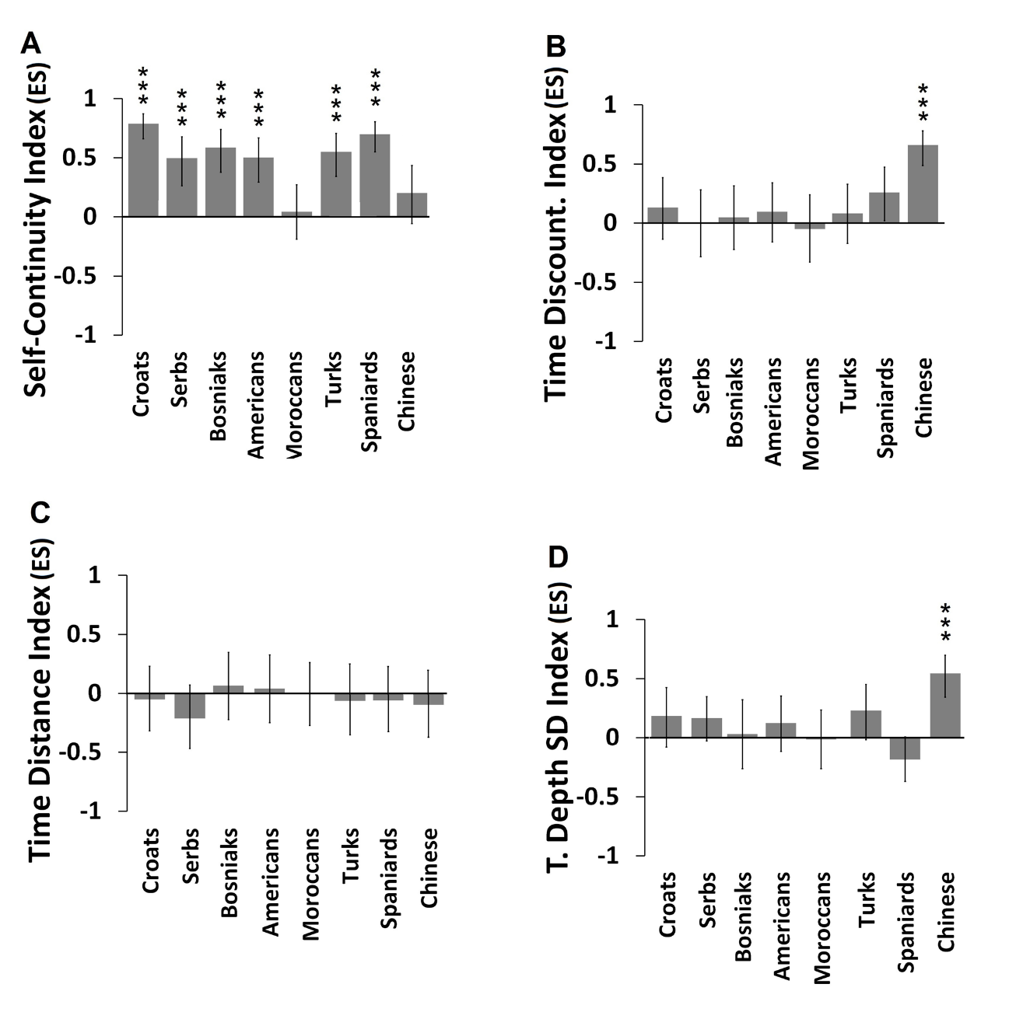
Note. Effect sizes are calculated by Rank-Biserial Correlation. The error bars show the 95% Confidence Interval of the effect size. Statistically significant results after FDR correction for multiple comparisons are marked with asterisks: *** p < .001.

