Appendices

Appendix A: Verbs used in the studies
Transitive-only verbs | Intransitive-only verbs | Alternating verbs
cut | go | break
slice | come | rip
chop | rise | shatter
mash | fall | smash
hit | tumble | grow
strike | ascend | change
bite | descend | bake
peck | exit | boil
touch | enter | cook
stroke | arrive | fry
slash | eat | burn
saw | jump | split
crush | hop | tear
squash | run | melt
kick | drink | crack
tap | talk | improve
whack | swim | inflate
punch | climb | alter
nudge | sing | shrink
kiss | sleep | freeze
kill | smile | crash
destroy | cry | fold
demolish | laugh | crease
take | frown | deflate
bring | giggle | defrost
raise | chortle | dissolve
hoist | chuckle | enlarge
lift | grin | expand
lower | groan | open
leave | moan | close
drop | glow | snap
tickle | glitter | bend
amuse | leak | slide
feed | appear | move
delight | disappear | roll
give | vanish | bounce
madden | die | turn
lend | stay | begin
pay | wait | start
offer | live | stop

Appendix B: Details of the statistical models

Judgment study: Single-predictor models

 | Age 5-6 |  |  |  | Age 9-10 |  |  |  |  |  |  |  | Adults |  |  |  |  |  |  |  | Interaction: Age Group x Predictor
 | AIC | Chi | p (Chi) |  | AIC |  | Chi |  | p (Chi) |  |  |  | AIC |  | Chi |  | p (Chi) |  |  |  | AIC |  | Chi |  | p (Chi)
Ratings of transitives
Preemption | 7556.3 | 31.2 | < .001 | *** | 6524.0 |  | 50.8 |  | < .001 |  | *** |  | 3891.5 |  | 54.4 |  | < .001 |  | *** |  | 18750.0 |  | 32.0 |  | < .001 |  | ***
Entrenchment | 7556.7 | 26.5 | < .001 | *** | 6528.3 |  | 35.5 |  | < .001 |  | *** |  | 3946.8 |  | 37.5 |  | < .001 |  | *** |  | 18783.0 |  | 18.9 |  | < .001 |  | ***
Semantics | 7565.9 | 22.8 | < .001 | *** | 6574.1 |  | 29.6 |  | < .001 |  | *** |  | 3946.7 |  | 34.4 |  | < .001 |  | *** |  | 18864.0 |  | 22.7 |  | < .001 |  | ***
Ratings of intransitives
Preemption | 7616.0 | 10.6 | .001 | ** | 6587.1 |  | 26.9 |  | < .001 |  | *** |  | 4007.9 |  | 33.7 |  | < .001 |  | *** |  | 19077.0 |  | 22.4 |  | < .001 |  | ***
Entrenchment | 7616.3 | 10.4 | .001 | ** | 6588.4 |  | 33.1 |  | < .001 |  | *** |  | 4009.4 |  | 36.2 |  | < .001 |  | *** |  | 19079.0 |  | 26.5 |  | < .001 |  | ***
Semantics | 7621.4 | 12.1 | .001 | *** | 6565.2 |  | 37.2 |  | < .001 |  | *** |  | 3988.9 |  | 33.0 |  | < .001 |  | *** |  | 19065.0 |  | 26.5 |  | < .001 |  | ***
Difference scores
Preemption¹ | 6918.7 | 44.3 | < .001 | *** | 6007.4 |  | 67.1 |  | < .001 |  | *** |  | 3671.6 |  | 82.4 |  | < .001 |  | *** |  | 17165 |  | 53.72 |  | < .001 |  | ***
Entrenchment | 6917.3 | 49.6 | < .001 | *** | 5976.6 |  | 88.9 |  | < .001 |  | *** |  | 3659.0 |  | 115.1 |  | < .001 |  | *** |  | 17110.0 |  | 70.2 |  | < .001 |  | ***
Semantics | 6939.6 | 31.6 | < .001 | *** | 6070.5 |  | 49.4 |  | < .001 |  | *** |  | 3725.8 |  | 49.5 |  | < .001 |  | *** |  | 17311.0 |  | 38.7 |  | < .001 |  | ***

1. It was necessary to remove the correlation between the random slope and the intercept in order to enable this model to converge

Judgment study: Simultaneous (multiple-predictor) models

 | Age 5-6 |  |  |  | Age 9-10 |  |  |  | Adults
 | AIC | Chi | p (Chi) |  | AIC | Chi | p (Chi) |  | AIC | Chi | p (Chi)
Ratings of transitives
Preemption | 7525.3 | 5.4 | .021 | * | 6462.3 | 13.6 | < .001 | *** | 3849.2 | 15.0 | < .001 | ***
Entrenchment | 7522.4 | 2.4 | .121 |  | 6450.6 | 1.9 | .171 |  | 3835.8 | 1.6 | .209
Semantics | 7525.7 | 5.7 | .017 | * | 6456.0 | 7.2 | .007 | ** | 3844.1 | 9.9 | .002 | **
Ratings of intransitives
Preemption | 7604.2 | 1.7 | .193 |  | 6503.2 | 2.4 | .121 |  | 3936.5 | 5.1 | .024 | *
Entrenchment | 7602.8 | 0.3 | .593 |  | 6503.8 | 3.0 | .085 |  | 3933.9 | 2.6 | .108
Semantics | 7607.8 | 5.2 | .022 | * | 6519.4 | 18.6 | < .001 | *** | 3945.8 | 14.4 | < .001 | ***
Difference scores
Preemption | 6866.1 | 1.7 | .198 |  | 5847.6 | 0.5 | .459 |  | 3518.9 | 2.7 | .100
Entrenchment | 6869.7 | 5.2 | .022 | * | 5866.0 | 19.0 | < .001 | *** | 3533.6 | 17.4 | < .001 | ***
Semantics | 6874.1 | 9.6 | .002 | ** | 5866.4 | 19.4 | < .001 | *** | 3534.5 | 18.2 | < .001 | ***

Production study.
 | Single-predictor models |  |  |  | Simultaneous models
 | AIC | Chi | p (Chi) |  | AIC | Chi | p (Chi)
Transitivisation errors for intransitive-only verbs
Preemption | 403.1 | 5.6 | .018 | * | 401.6 | 2.6 | .105
Entrenchment | 403.1 | 3.4 | .065 |  | 399.4 | 0.5 | .497
Semantics | 401.7 | 0.2 | .671 |  | 398.9 | 0.0 | .941
Intransitivisation errors for transitive-only verbs
Preemption | 454.2 | 0.0 | .971 |  | 455.4 | 0.0 | .979
Entrenchment | 454.4 | 0.7 | .392 |  | 458.1 | 2.7 | .100
Semantics | 460.9 | 1.6 | .208 |  | 457.2 | 1.8 | .180

Appendix C: Additional figures. Note that Error bars show 95% Bayesian Highest Density Intervals. These are particularly useful because they allow inferences to be read directly off the plot: two values are different if the point estimate for the former lies outside of the 95% HDI for the other.

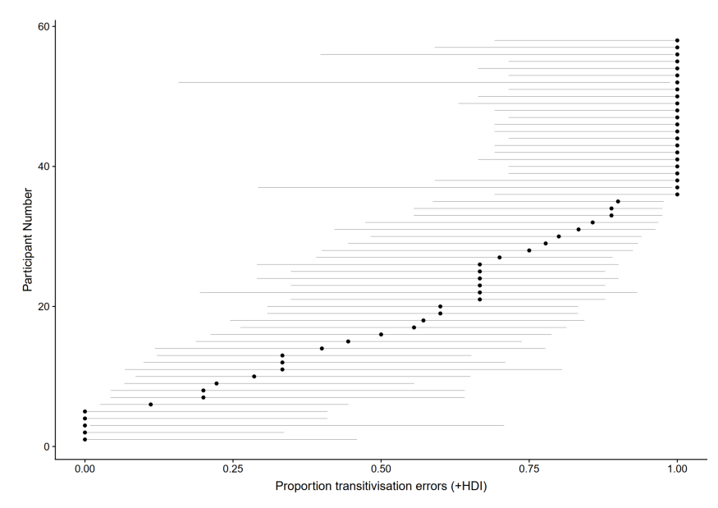
Figure 11. Mean by-child rates of transitivisation error and 95% Bayesian Highest Density Intervals.

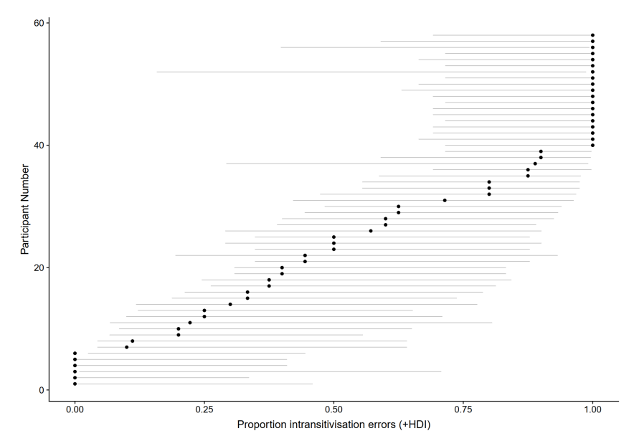
Figure 12. Mean by-child rates of intransitivisation error and 95% Bayesian Highest Density Intervals.

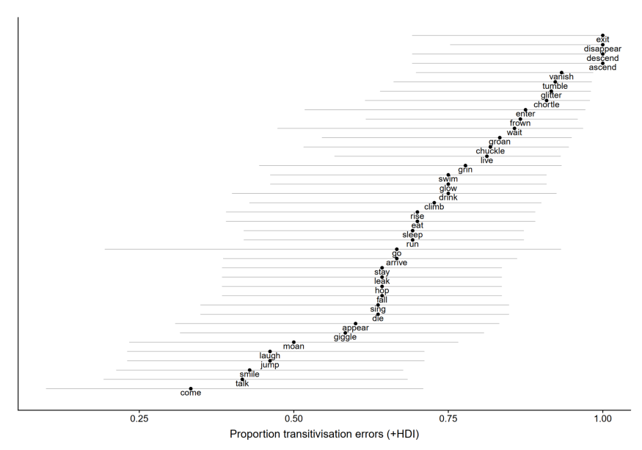
Figure 13. Mean by-verb rates of transitivisation error and 95% Bayesian Highest Density Intervals.

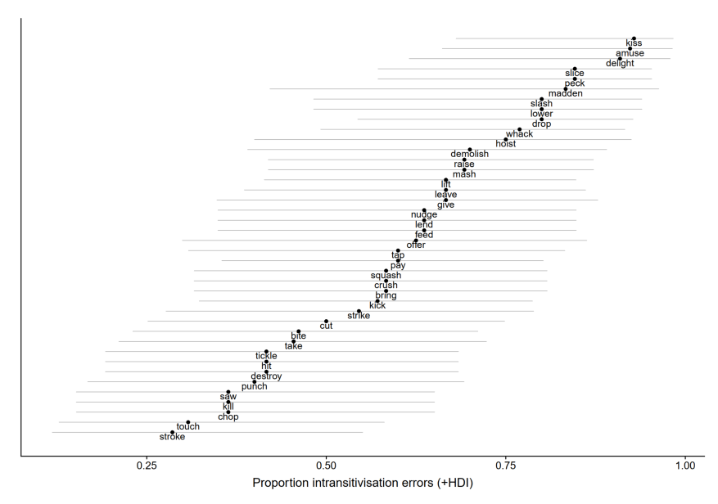
Figure 14. Mean by-verb rates of intransitivisation error and 95% Bayesian Highest Density Intervals.

