supplementary materials

The pilot study 2
简单认知任务问卷(risk taking tendency measure) 7
权力感测量(power feeling measure) 8
A 36-question guide to the Replication Recipe. 9

The pilot study
Methods
Participants
In total, 64 undergraduate students (23 male, 41 females; M_{age} = 19.38, range = 18–22) from Qufu Normal University were randomly assigned to the high power (N = 34) or low power (N = 30) group. All participants volunteered to be a part of this study without major and grade requirement. Participants received a gift (an A4 size notebook) after the completion of the tasks. All participants had normal visual acuity and none had any medical history or psychological disorders according to self-report. All participants provided written informed consent prior to the experiment. The experimental protocol was approved by the local ethics committee (Qufu Normal University).

Materials
Ten pictures of body postures and culture consistency measures could be found in the supplementary material.

Procedure
The pilot study used a between group design to avoid a potential priming effect of postures. Participants were randomly assigned to rate either 6 high power postures or 4 low power postures that were extracted from previous studies (Carney et al., 2010; Huang et al., 2011; Park et al., 2013; April et al., 2015; Cesario et al., 2013; Garrison et al., 2016; Ranehill et al., 2015; Cesario & Johnson, 2017). All postures were collected based on a key word search through Google Scholar and related reference citations. First, participants were told to rate “To what extend do you think this posture is powerful?” on a scale from 1 (very powerless) to 7 (very powerful). Then, they were told to rate the postures on a series of traits using a 7-point semantic differential scale where 1 = very (e.g., humble) and 7 = very (e.g., proud). Posture pictures keep showing on the left side of the screen while measuring questions show on the right side in a fixed order. Posture pictures also show to participants in a fixed order.

The items were:
humble–proud(reversed)
arrogant–modest
impolite–polite
rude–well-mannered
respectful–disrespectful(reversed)
responsible–irresponsible(reversed)
restrained–unrestrained(reversed)
disciplined–undisciplined(reversed)
careless–careful
cautious–reckless(reversed)
This scale had a Cronbach’s α of .914. The mean rating score of the 10 items was used in the subsequent analyses to examine the 6 high power postures and 4 low power postures. Contrary to the study by Park et al. (2013), multiple postures were included in the present study, while the former study only evaluated one posture. It was not appropriate to conduct this study through a paper-and-pencil survey; therefore, the whole procedure was conducted using a computer.

Results
Rating procedures and data analyses was similar to those used by Park et al. (2013).
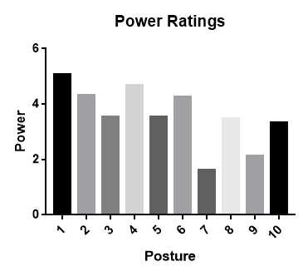
Figure 1. Rated power of the ten postures
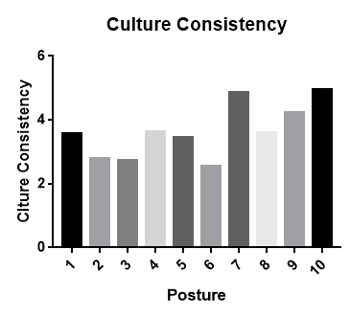
Figure 2. Rated cultural consistency of the ten postures

For high power postures (Posture 1–6), a one-way ANOVA showed a main effect of postures on rated power, F (5, 155) = 4.58, p < .01, η_{p}² = .13. Specifically, the differences in the rated power were as follows: Posture 1 > 3, p < .01; Posture 1 > 5, p < .01; Posture 4 > 3, p < .01; and Posture 4 > 5, p < .001 (see Figure 1). Additionally, there was a main effect of postures on cultural consistency, F (5, 115) = 12.18, p < .001, η_{p}² = .35. Specifically, the differences based on cultural consistency were as follows: Posture 1 > 2, p < .01; Posture 1 > 3, p < .01; Posture 1 > 6, p < .001; Posture 4 > 2, p < .001; Posture 5 > 2, p < .01; Posture 4 > 3, p < .001; Posture 5 > 3, p < .01; Posture 4 > 6, p < .001; and Posture 5 > 6, p < .001 (see Figure 2).

For low power postures (Posture 7–10), a one-way ANOVA showed a main effect of postures on rated power, F (3, 81) = 14.52, p < .001, η_{p}² = .35. Specifically, the differences in the rated power were as follows: Posture 8 > 7, p < .001; Posture 10 > 7, p < .001; Posture 8 > 9, p < .001; and Posture 10 > 9, p < .05 (see Figure 1). Additionally, there was a main effect of postures on cultural consistency, F (3, 75) = 22.3, p < .001, η_{p}² = .47. Specifically, the differences based on cultural consistency were as follows: Posture 7 > 8 and 9, p < .001; Posture 9 > 8, p < .01; Posture 10 > 8, p < .001; and Posture 10 > 9, p < .001 (see Figure 2).

It was required that the selected group of postures be significantly different between groups and not different within groups. Additionally, the scores of all postures were required to be significantly different from the neutral score on the 7-point Likert scale. Specifically, scores for the high-power postures needed to be significantly higher than “4” and those for the low power postures needed to be significantly lower than “4.”

Based on these criteria, only Posture 1 and 4 were selected as high-power postures, and Posture 7 and 9 were selected as low-power postures for the subsequent experiments.

Table 1. Ratings for ten postures
Posture | Power | Cultural Traits
1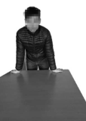 | 5.06 ± 1.83 | 3.56 ± 0.86
2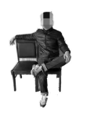 | 4.32 ± 1.84 | 2.79 ± 0.94
3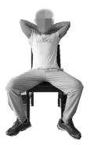 | 3.53 ± 1.83 | 2.74 ± 0.9
4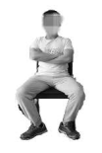 | 4.68 ± 1.25 | 3.63 ± 0.95
5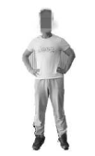 | 3.55 ± 1.46 | 3.44 ± 0.91
6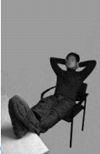 | 4.27 ± 1.83 | 2.55 ± 0.86
7 | 1.62 ± 0.78 | 4.86 ± 1.05
8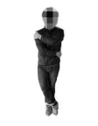 | 3.47 ± 1.61 | 3.59 ± 0.7
9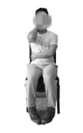 | 2.14 ± 1.33 | 4.24 ± 0.75
10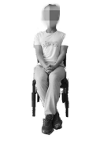 | 3.33 ± 1.63 | 4.95 ± 0.82

简单认知任务问卷(risk taking tendency measure)
同学，您好!欢迎您参加我们的研究。这是一份学术性问卷，用于探讨个体的简单反应能力。您的信息仅供学术使用，作答内容无正误之分。调查中所涉及的信息采取匿名方式，绝对不向他人公开，请您放心填写。您回答的真实性对于我们能够得出正确的研究结论非常重要，请您根据材料要求，依照材料呈现的顺序认真如实作答，请勿跳跃作答或漏填。请首先填写个人资料，然后开始分别完成问卷的第一部分（正面）和第二部分（反面）。我们对您的耐心配合与支持表示衷心地感谢！
年龄： 性别： 年级：

下面共有5个投资项目，每个项目都有两个方案（A/B），两种投资方案所得结果如下，请在两个方案中选出你认为最好的一个方案，并在下方的喜好程度中针对你的选择用“√”作出喜好程度打分。
（1表示非常喜欢方案A，5表示非常喜欢方案B，3代表中立）

1、方案A：100%的概率获得50元 | 方案B：80%的概率获得100元，同时20%概率无收获
你会选择哪一种方案？＿＿＿ | 请对两种方案作出喜好程度判断：1 2 3 4 5
2、方案A：100%的概率获得100元 | 方案B：70%的概率获得200元，同时30%概率无收获
你会选择哪一种方案？＿＿＿ | 请对两种方案作出喜好程度判断：1 2 3 4 5
3、方案A：100%的概率获得250元 | 方案B：60%的概率获得500元，同时40%概率无收获
你会选择哪一种方案？＿＿＿ | 请对两种方案作出喜好程度判断：1 2 3 4 5
4、方案A：100%的概率获得300元 | 方案B：50%的概率获得600元，同时50%概率无收获
你会选择哪一种方案？＿＿＿ | 请对两种方案作出喜好程度判断：1 2 3 4 5
5、方案A：100%的概率获得500元 | 方案B：40%的概率获得1000元，同时60%概率无收获
你会选择哪一种方案？＿＿＿ | 请对两种方案作出喜好程度判断：1 2 3 4 5

权力感测量(power feeling measure)
请根据当前的真实感觉，在下方的标尺中标出来，当前在多大程度上感觉自己是有权力的？（1代表一点都没有；4代表中等程度；7代表非常强）

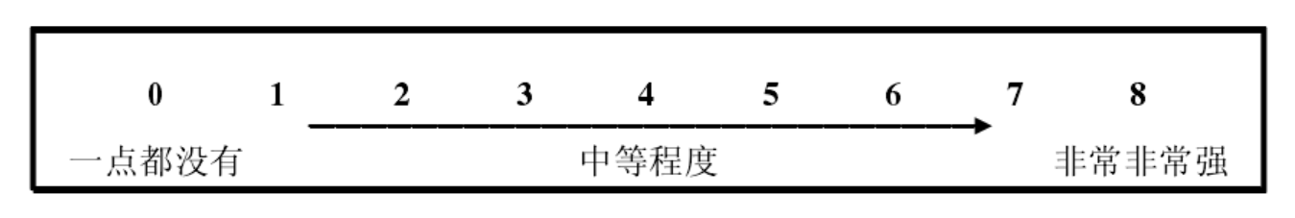

A 36-question guide to the Replication Recipe.
The Nature of the Effect
- Verbal description of the effect I am trying to replicate:
Holding different body postures could yield an effect on individuals’ risk-taking tendency.
- It is important to replicate this effect because:
Multiple replicating studies have been published, but the result is inconformity. There are a lot of factors need to be controlled during experiment which haven’t been told about in former research.
- The effect size of the effect I am trying to replicate is:
Cohen’s d_{s} = 0.63
- The conﬁdence interval of the original effect is:
95% CI = [0.02, 1.26]
- The sample size of the original effect is:
42.
- Where was the original study conducted? (e.g., lab, in the ﬁeld, online)
Lab.
- What country/region was the original study conducted in?
U.S.A
- What kind of sample did the original study use? (e.g., student, Mturk, representative)
Student.
- Was the original study conducted with paper-and-pencil surveys, on a computer, or something else?
Paper-and-pencil survey.

Designing the Replication Study
- Are the original materials for the study available from the author?
Yes, the authors of the original study reported the full procedure of the experiments.
a. If not, are the original materials for the study available elsewhere (e.g., previously published scales)?
b. If the original materials are not available from the author or elsewhere, how were the materials created for the replication attempt?
The original research paper reported as many details as possible. We assume that the details from the article is enough to create for the replication attempt
11. I know that assumptions (e.g., about the meaning of the stimuli) in the original study will also hold in my replication because:
The pilot study of my replication shows a strong validity of the materials.
- Location of the experimenter during data collection:
Qufu, Shandong province, China
Guangzhou, Guangdong province, China
- Experimenter knowledge of participant experimental condition:
College students. All participants had normal visual acuity and none had any medical history or psychological disorders according to self-report. Gender and majors are not required.
- Experimenter knowledge of overall hypotheses:
Holding a specific body postures generates different experiences and power feeling, thus affects individuals’ risk-taking tendency.
- My target sample size is:
72
- The rationale for my sample size is:
Power analysis with G*Power

Documenting Differences between the Original and Replication Study For each part of the study indicate whether the replication study is Exact, Close, or Conceptually Different compared to the original study. Then, justify the rating.
17. The similarities/differences in the instructions are: [Exact | Close | Different]
18. The similarities/differences in the measures are: [Exact | Close | Different]
19. The similarities/differences in the stimuli are: [Exact | Close | Different]
20. The similarities/differences in the procedure are: [Exact | Close | Different]
21. The similarities/differences in the location (e.g., lab vs. online; alone vs. in groups) are:
[Exact | Close | Different]
22. The similarities/differences in remuneration are: [Exact | Close | Different]
23. The similarities/differences between participant populations are: [Exact | Close | Different]
24. What differences between the original study and your study might be expected to inﬂuence the size and/or direction of the effect?:
Population and dependent variable measurement.
25. I have taken the following steps to test whether the differences listed in #24 will inﬂuence the outcome of my replication attempt:
I deployed a pilot study to discuss the hypothesize.

Analysis and Replication Evaluation
26. My exclusion criteria are (e.g., handling outliers, removing participants from analysis):
The experiments were conducted in a behavioral observation room. Participants were told to hold specific postures for two minutes. Which means they were not allowed to drastically move their body while posing. And if they do so, his or her data will be removed.
27. My analysis plan is (justify differences from the original):
Bayesian approach.
28. A successful replication is deﬁned as:
To get a result and conclusion which could support the original findings.
Registering the Replication Attempt
29. The ﬁnalized materials, procedures, analysis plan etc of the replication are registered here:
https://osf.io/a367x/?view_only=581a656bedfb4b5dbaca3e16b4fe860b
Reporting the Replication
30. The effect size of the replication is:
The result is negative.
31. The conﬁdence interval of the replication effect size is:
The result is negative.
32. The replication effect size [is/is not] (circle one) signiﬁcantly different from the original effect size?
Significantly different.
33. I judge the replication to be a(n) [success/informative failure to replicate/practical failure to replicate/inconclusive] (circle one) because:
Informative failure to replicate. This study offered an evidence that postures, like many other verbal and nonverbal language, are perceived different under different culture norms.
34. Interested experts can obtain my data and syntax here:
https://osf.io/a367x/?view_only=581a656bedfb4b5dbaca3e16b4fe860b 35. All of the analyses were reported in the report or are available here:
Reported in the paper.
36. The limitations of my replication study are:
This study conducted a modified experiment to explore the effect of body posture. But it is only a conceptual replication and extension of research on the power pose effect. We completely copied the posture manipulation procedure from Carney et al. (2010). Sample are undergraduate students. But we didn’t collect hormone levels as a dependent variable. We replaced a posture that proved to be rude under Chinese culture. Throughout our studies, there are negative evidence support for the conclusion (p ＞ .05 and BF01 between 1/3 ― 1/10). Also, the sample size varies between 5 studies due to specific conditions.

