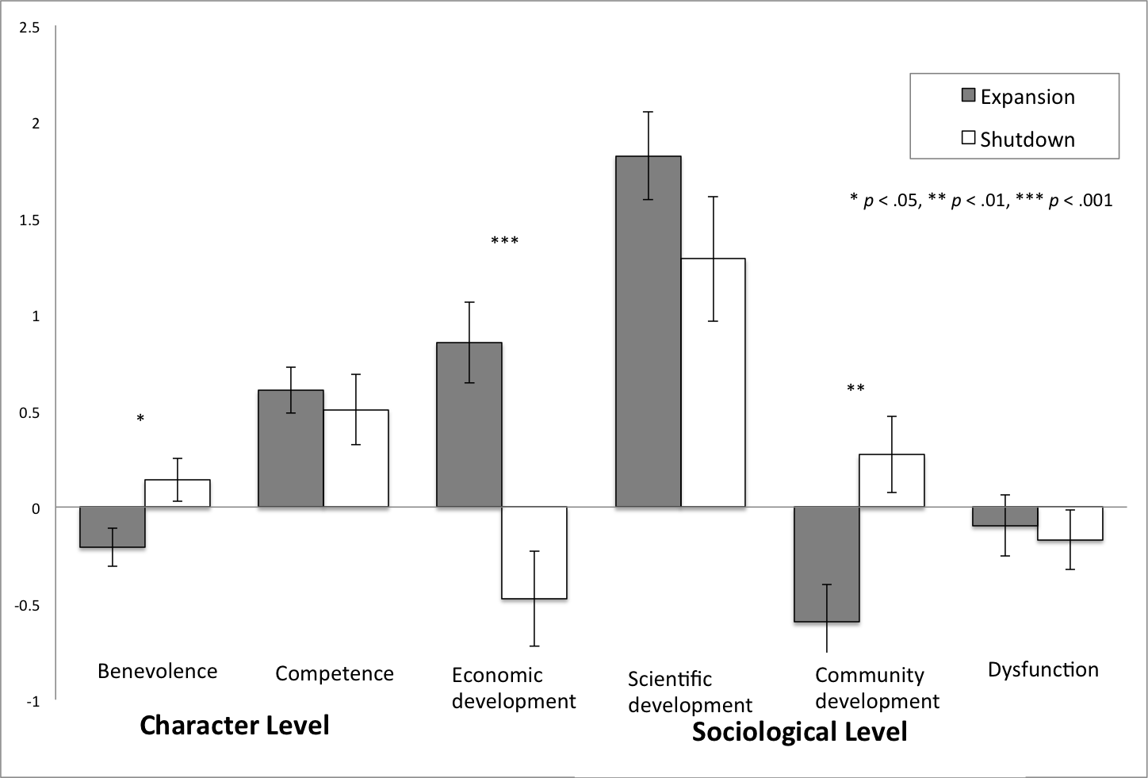
Figure 1. Means and standard errors for collective futures dimensions in nuclear power expansion and shutdown scenarios.

