Journal: Twin Research and Human Genetics
Title: DNA methylation mediated the association of body mass index with blood pressure in Chinese monozygotic twins
Authors: Jie Yao, Feng Ning, Weijing Wang, Dongfeng Zhang

(a)
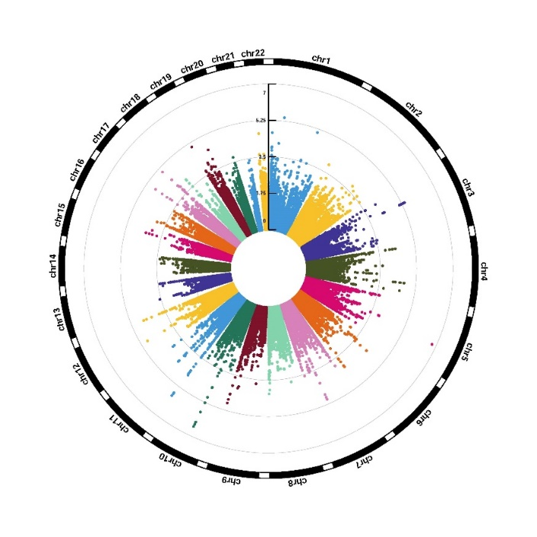

(b)
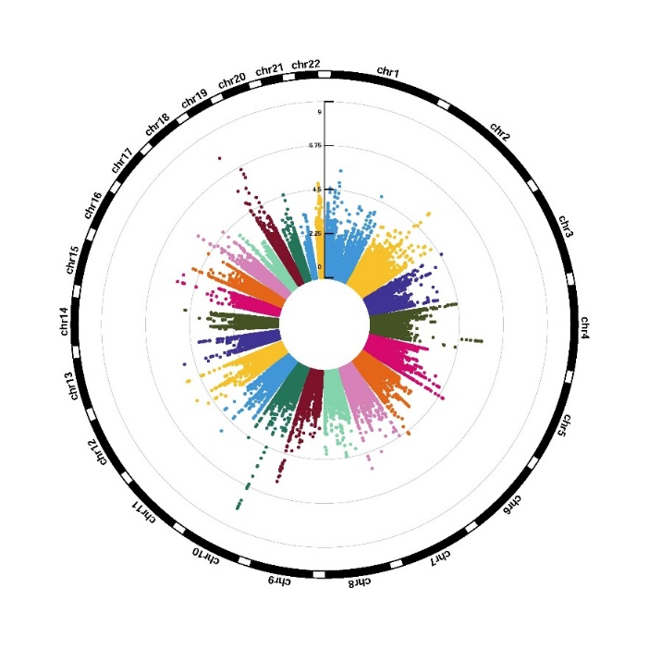
Fig. S1. Circular Manhattan plots for genome-wide DNA methylation analysis of BMI. (a) BMI-systolic blood pressure; (b) BMI-diastolic blood pressure. The numbers of chromosome and the -log₁₀ of P-values for statistical significance are shown. The dots represent the observed CpGs.

BMI-SBP
(a)
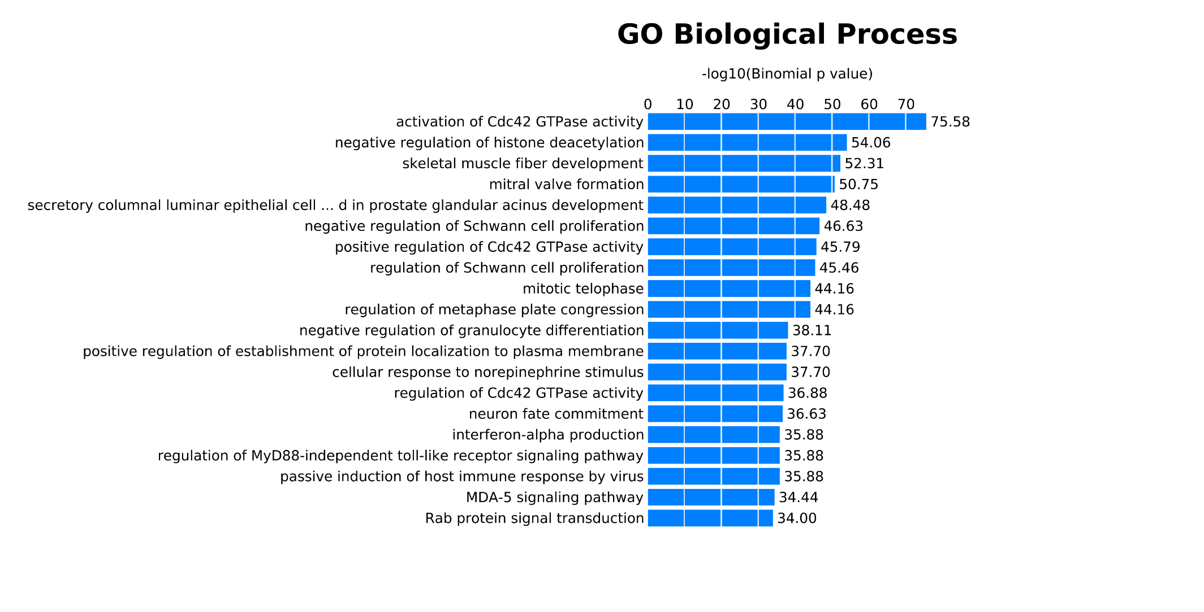

(b)
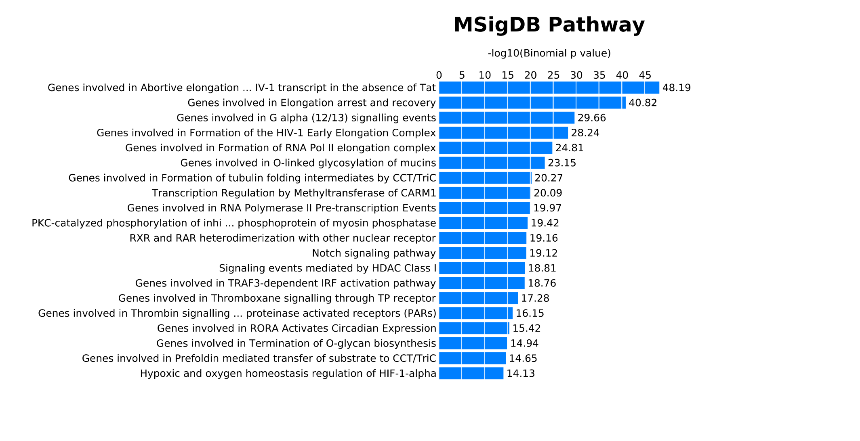

(c)
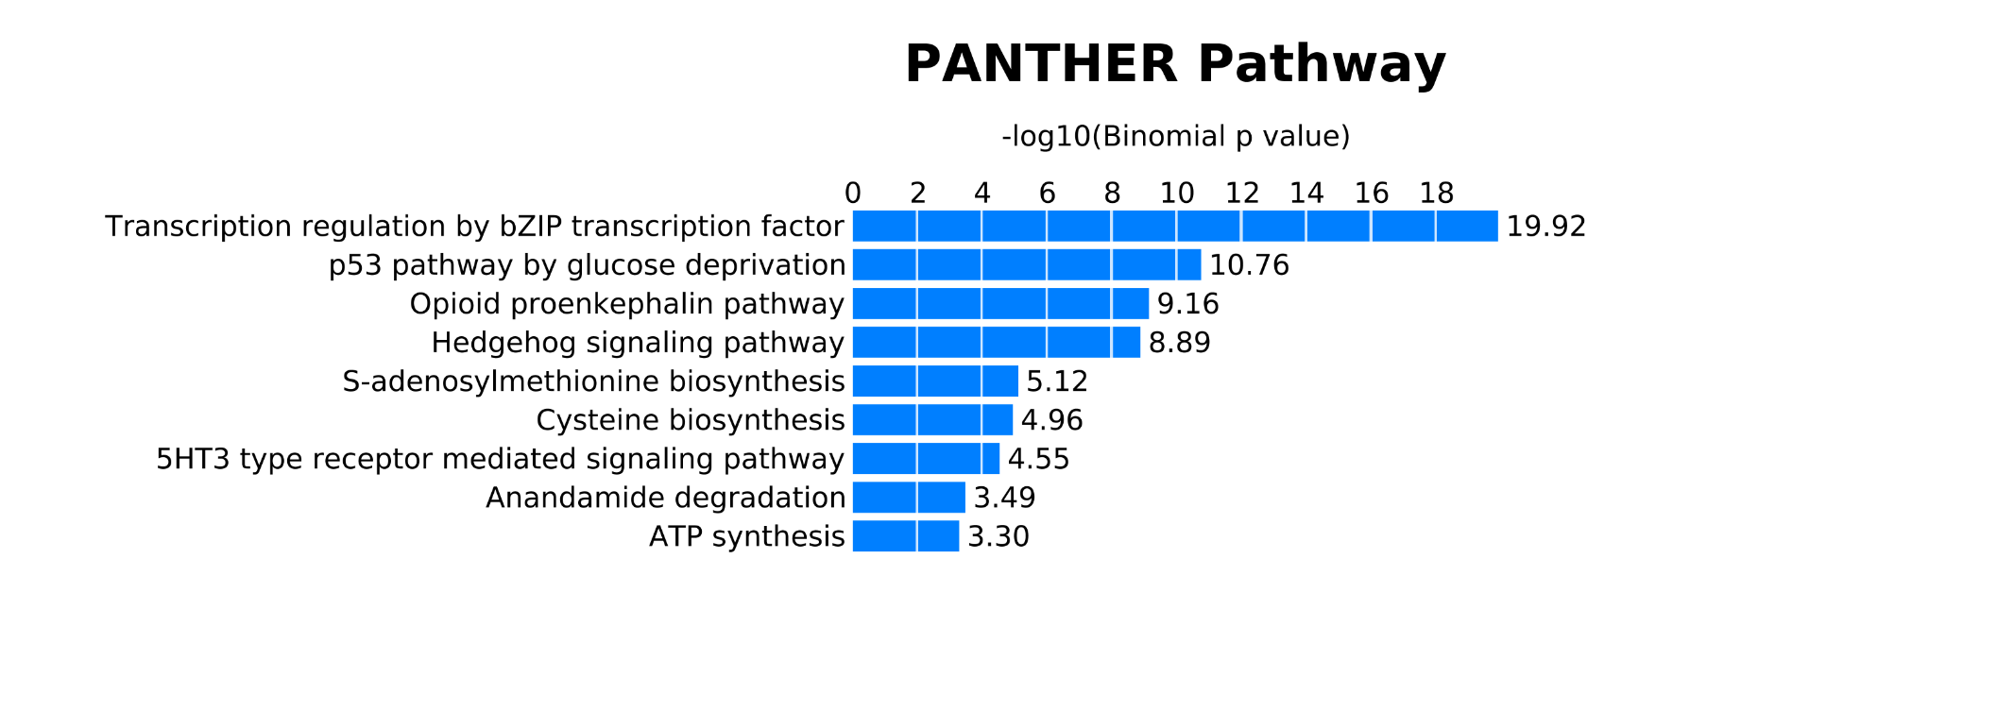

BMI-DBP
(a)
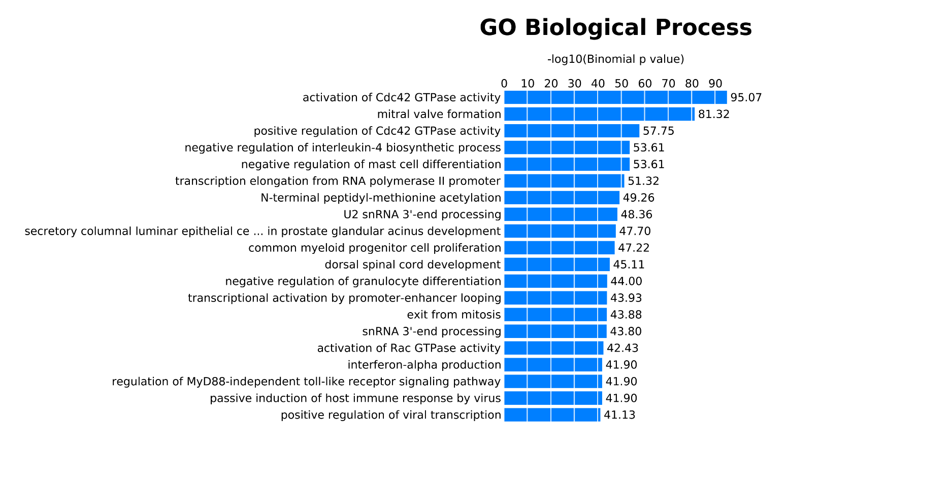

(b)
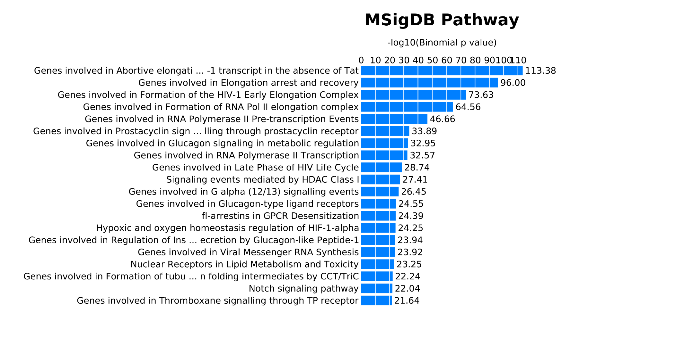

(c)
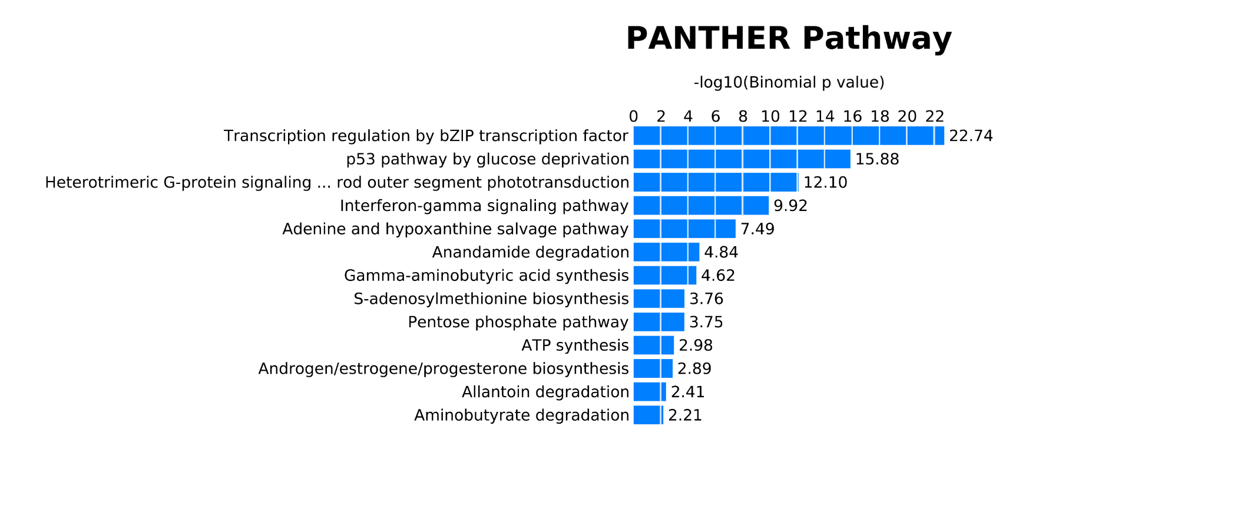
Fig. S2. The bar chart of top 20 GREAT ontology enrichments potentially related to BMI by using binomial test based on CpGs with P-values < 0.05 identified in Model 2. (a) GO-Biological Process; (b) MSigDB Pathway; (c) PANTHER Pathway. The x-axis represents the -log₁₀ of Binomial P-values and the y-axis shows the names of ontology enrichments. DBP, diastolic blood pressure; SBP, systolic blood pressure.

SBP
(a)
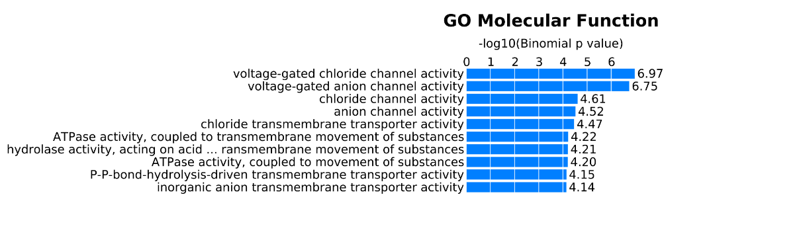
(b)
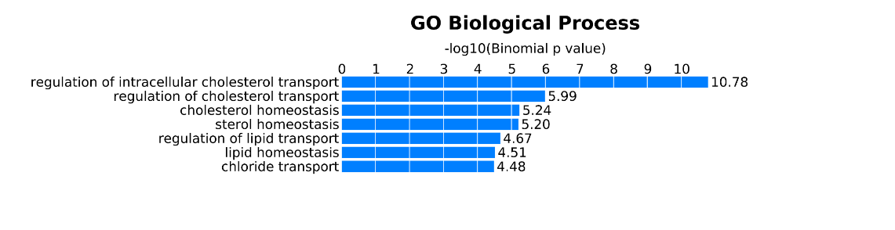
(c)
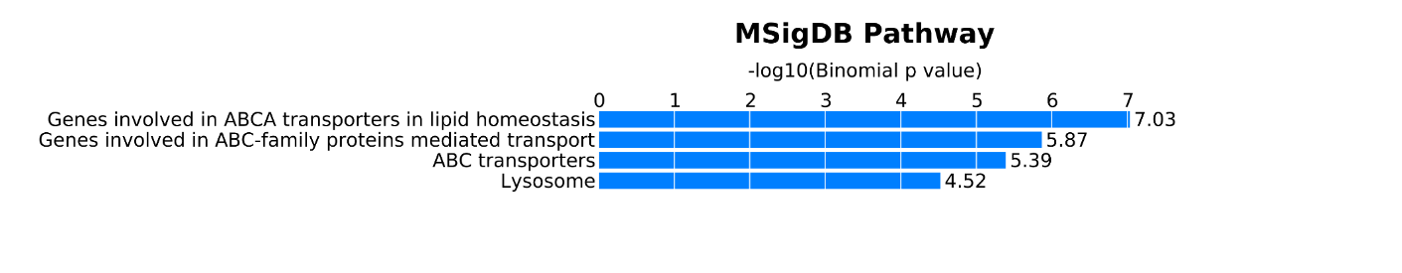

DBP
(a)
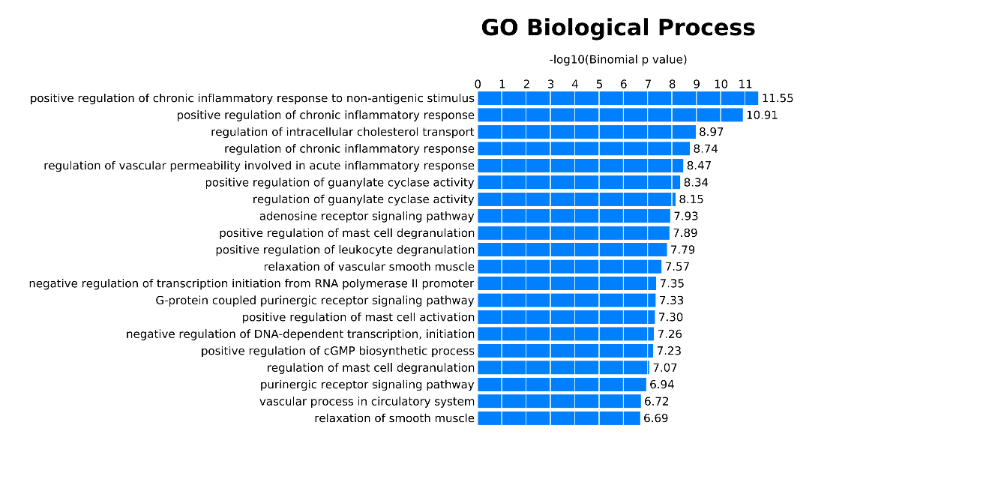

(b)
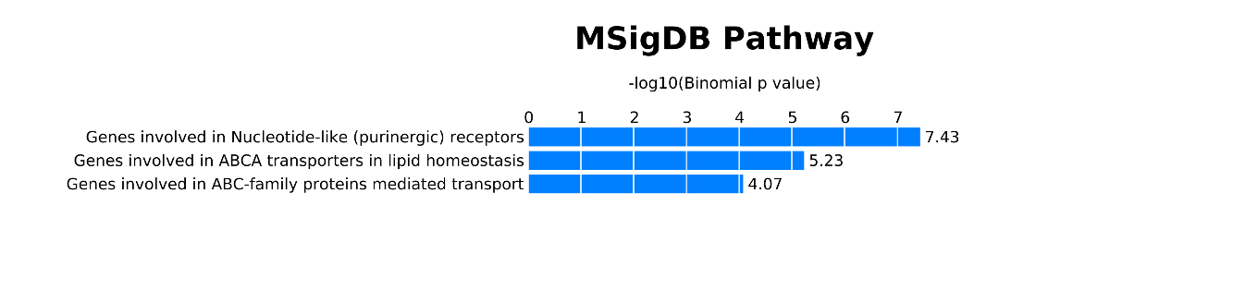
Fig. S3. The bar chart of GREAT ontology enrichments potentially related to blood pressure by using binomial test based on CpGs with P-values < 0.05 identified in Model 3. (a) GO-Biological Process; (b) MSigDB Pathway; (c) PANTHER Pathway. The x-axis represents the -log₁₀ of Binomial P-values and the y-axis shows the names of ontology enrichments. DBP, diastolic blood pressure; SBP, systolic blood pressure.

Table S1. The top five components from ReFACTor method on systolic blood pressure
Family_ID | Intra-pair | PC1 | PC2 | PC3 | PC4 | PC5
1 | 1 | 248.594 | 4.685 | -12.566 | 198.866 | -36.496
1 | 2 | 249.217 | 6.090 | -34.902 | 331.197 | -58.122
2 | 1 | -125.245 | 24.550 | 27.844 | 56.046 | -36.576
2 | 2 | -103.620 | -0.059 | 51.026 | 41.494 | -17.026
3 | 1 | 227.444 | 124.564 | -19.830 | -23.990 | -90.234
3 | 2 | 535.019 | -89.984 | 207.864 | -310.211 | -696.147
4 | 1 | -54.400 | -49.920 | 88.107 | 3.206 | 61.625
4 | 2 | 72.997 | -168.392 | 419.273 | 51.298 | 243.818
5 | 1 | 228.566 | -24.446 | 6.570 | 170.276 | 96.017
5 | 2 | 193.504 | -4.127 | -50.677 | 133.829 | 58.820
6 | 1 | 201.634 | 15.006 | 31.235 | 88.222 | 95.933
6 | 2 | 39.504 | 35.679 | -40.632 | 50.989 | 49.541
7 | 1 | -109.518 | 23.313 | 32.544 | 41.052 | -12.357
7 | 2 | -15.326 | -48.927 | 310.995 | 85.056 | 65.934
8 | 1 | 14.352 | 51.777 | -29.861 | 67.945 | 9.692
8 | 2 | 252.192 | -10.004 | -29.052 | 151.554 | 8.804
9 | 1 | 13.093 | 52.848 | -46.475 | 70.665 | 8.543
9 | 2 | -18.013 | 87.532 | -76.183 | 100.536 | -40.003
10 | 1 | 277.327 | 49.804 | 59.730 | -32.885 | 127.370
10 | 2 | 380.185 | -28.618 | -12.668 | -42.862 | 98.979
11 | 1 | -96.456 | -4.847 | 60.902 | 36.787 | 1.998
11 | 2 | -121.503 | 22.668 | 34.895 | 56.042 | -36.861
12 | 1 | -95.877 | -8.989 | 60.409 | 45.865 | -8.278
12 | 2 | -126.109 | 26.297 | 21.266 | 58.550 | -46.472
13 | 1 | 22.578 | 35.374 | -32.977 | 64.658 | 16.776
13 | 2 | -27.485 | 40.571 | -35.296 | 52.799 | -2.808
14 | 1 | -111.272 | 10.096 | 33.820 | 49.514 | -31.337
14 | 2 | -122.639 | 18.576 | 29.778 | 56.399 | -45.212
15 | 1 | -113.628 | 12.546 | 29.884 | 53.905 | -30.772
15 | 2 | -80.167 | 7.244 | 104.064 | 80.414 | -40.173
16 | 1 | 101.351 | 67.921 | -54.750 | 230.666 | -72.272
16 | 2 | -72.331 | 92.384 | -73.461 | 91.550 | -59.525
17 | 1 | -68.252 | -3.452 | 55.823 | -45.708 | 24.984
17 | 2 | -88.674 | 66.975 | 49.671 | -29.810 | -59.295
18 | 1 | -117.069 | -6.738 | 36.120 | 53.992 | -37.175
18 | 2 | -49.860 | -55.206 | 114.988 | 92.207 | -47.657
19 | 1 | -45.364 | 50.010 | -36.864 | 64.484 | -17.782
19 | 2 | 47.519 | 47.655 | -29.750 | 89.408 | 3.250
20 | 1 | -92.254 | 14.951 | 55.451 | 78.160 | -59.519
20 | 2 | -110.057 | 7.326 | 30.664 | 43.260 | -27.140
21 | 1 | -37.662 | -36.472 | 147.484 | 57.949 | 8.446
21 | 2 | -137.215 | 30.331 | 5.593 | 49.924 | -57.247
22 | 1 | -150.446 | 38.668 | 5.397 | 63.158 | -73.095
22 | 2 | -69.863 | -19.671 | 79.808 | 45.808 | -14.043
23 | 1 | 8.157 | 93.633 | -46.599 | 121.707 | -43.023
23 | 2 | -65.212 | 83.122 | -75.661 | 72.041 | -39.372
24 | 1 | -51.881 | -18.564 | 72.708 | -80.471 | 40.246
24 | 2 | 6.308 | -12.800 | 171.875 | -102.077 | 38.896
25 | 1 | -106.703 | 38.863 | 13.516 | -36.378 | -25.641
25 | 2 | -91.591 | 51.390 | 56.562 | -34.250 | -35.233
26 | 1 | -147.251 | 74.975 | -23.471 | 0.364 | -86.332
26 | 2 | -141.491 | 69.218 | -19.135 | -4.856 | -75.051
27 | 1 | -78.172 | 4.818 | 45.871 | -45.024 | -5.696
27 | 2 | -28.911 | -16.794 | 151.331 | -73.355 | 8.356
28 | 1 | -124.047 | 46.189 | -38.780 | -38.362 | -38.274
28 | 2 | -119.097 | 50.102 | -24.045 | -22.355 | -50.590
29 | 1 | 9.327 | -66.800 | 142.238 | -81.698 | -2.864
29 | 2 | -70.168 | -14.132 | 62.176 | -54.114 | 13.306
30 | 1 | -92.142 | 21.689 | 34.538 | -40.276 | -14.434
30 | 2 | -73.161 | 9.326 | 53.108 | -53.059 | 8.947
31 | 1 | -82.328 | 10.929 | -6.725 | -46.317 | -16.727
31 | 2 | -89.250 | 18.663 | 23.170 | -52.821 | -9.124
32 | 1 | 214.650 | 25.723 | 71.273 | -61.795 | 150.553
32 | 2 | 23.993 | 60.437 | -22.680 | -38.251 | 39.167
33 | 1 | 210.595 | 38.524 | 37.665 | -95.536 | 78.092
33 | 2 | -6.193 | 54.423 | -30.570 | -36.094 | 24.725
34 | 1 | -92.661 | -35.004 | 55.069 | 29.935 | -7.524
34 | 2 | -97.852 | -26.591 | 51.093 | 33.315 | -10.961
35 | 1 | -22.527 | 0.518 | 107.220 | -80.039 | 18.965
35 | 2 | -41.126 | -0.989 | 114.815 | -69.010 | 15.094
36 | 1 | 169.059 | 191.781 | -234.897 | 44.145 | -128.695
36 | 2 | 363.208 | 177.427 | -58.292 | -187.519 | 93.809
37 | 1 | -50.179 | 108.646 | -74.905 | -5.299 | -34.993
37 | 2 | -39.706 | 95.957 | -59.490 | -13.056 | -22.055
38 | 1 | -68.026 | -19.006 | 55.804 | -57.344 | 9.887
38 | 2 | -61.008 | -32.063 | 59.975 | -51.277 | 1.474
39 | 1 | 53.999 | 63.996 | -45.969 | -38.741 | 51.630
39 | 2 | 41.593 | 107.103 | -105.601 | -16.784 | 10.628
40 | 1 | 81.322 | 104.766 | -22.376 | -31.718 | -0.274
40 | 2 | -28.819 | 80.589 | -54.073 | -34.004 | 6.434
41 | 1 | -85.284 | 9.347 | 29.207 | -53.109 | 0.161
41 | 2 | -78.453 | -0.797 | 40.579 | -53.550 | 5.918
42 | 1 | 276.967 | 27.655 | 31.462 | 200.808 | 50.540
42 | 2 | 204.661 | 63.264 | -18.555 | 186.071 | -1.733
43 | 1 | -32.308 | -86.708 | 74.201 | 66.734 | -40.141
43 | 2 | -54.093 | -38.763 | 145.406 | 58.872 | -6.635
44 | 1 | 135.583 | 59.201 | -12.848 | -49.936 | 66.151
44 | 2 | 128.742 | 74.550 | 38.442 | -82.824 | 38.007
45 | 1 | 317.901 | 14.686 | -91.588 | -45.924 | 66.062
45 | 2 | 343.479 | 49.940 | 92.406 | -147.319 | 138.398
46 | 1 | -10.272 | 66.030 | -40.455 | -41.395 | 28.982
46 | 2 | 119.973 | 41.400 | -74.981 | -45.268 | 65.126
47 | 1 | -87.146 | 20.275 | 1.389 | -53.365 | -6.938
47 | 2 | -90.586 | 26.965 | 8.325 | -48.816 | -12.794
48 | 1 | -131.922 | 14.536 | 12.681 | 60.631 | -67.412
48 | 2 | -117.274 | -4.207 | 37.779 | 54.711 | -44.941
49 | 1 | -46.971 | -4.679 | 97.978 | -64.834 | 12.735
49 | 2 | -55.609 | -9.991 | 94.213 | -61.054 | 15.139
50 | 1 | -63.862 | -51.531 | -101.238 | -22.878 | 43.110
50 | 2 | -59.184 | -65.771 | -101.652 | 3.300 | 8.422
51 | 1 | -23.685 | -160.111 | -111.556 | 10.163 | -0.842
51 | 2 | 130.394 | -797.981 | -69.812 | 82.805 | -38.194
52 | 1 | 13.779 | -204.959 | -195.292 | 11.208 | 0.899
52 | 2 | -55.557 | -54.075 | -140.291 | -10.774 | 25.237
53 | 1 | -35.587 | -16.033 | -95.070 | -143.939 | 91.225
53 | 2 | -68.173 | 5.872 | -117.593 | -121.630 | 49.307
54 | 1 | -59.862 | -10.876 | -106.850 | -112.806 | 30.572
54 | 2 | 51.125 | -180.545 | -183.985 | -204.098 | 39.484
55 | 1 | -75.487 | -18.088 | -56.100 | -93.561 | 10.853
55 | 2 | -77.450 | -17.595 | -38.399 | -92.413 | 31.182
56 | 1 | -81.392 | -65.904 | -153.622 | 44.984 | -60.836
56 | 2 | -40.654 | -150.035 | -185.173 | 41.662 | -63.658
57 | 1 | 24.465 | -273.277 | -183.367 | 28.674 | 1.190
57 | 2 | -72.270 | -59.742 | -132.196 | 8.304 | 2.187
58 | 1 | -50.238 | -24.592 | -30.878 | -125.371 | 79.415
58 | 2 | -24.662 | -62.110 | -105.318 | -126.643 | 61.405
59 | 1 | -38.695 | -42.194 | -97.394 | -116.407 | 48.537
59 | 2 | -63.506 | -6.847 | -147.493 | -108.125 | 25.512
60 | 1 | -70.974 | 10.531 | -68.016 | -100.931 | 47.401
60 | 2 | -53.393 | -22.493 | -56.347 | -123.849 | 70.718

Table S2. The top five components from ReFACTor method on diastolic blood pressure
Family_ID | Intra-pair | PC1 | PC2 | PC3 | PC4 | PC5
1 | 1 | -122.622 | 47.104 | -45.646 | 35.603 | -47.288
1 | 2 | -95.871 | 34.175 | -65.405 | 16.723 | -22.341
2 | 1 | 238.107 | 109.260 | 77.754 | 9.951 | -111.462
2 | 2 | 602.306 | -17.733 | -92.706 | -449.356 | -664.795
3 | 1 | -39.108 | 0.111 | -83.910 | -22.754 | 64.592
3 | 2 | 109.160 | 38.035 | -405.490 | -89.236 | 290.085
4 | 1 | 247.141 | 18.217 | -29.400 | 195.329 | 73.797
4 | 2 | 203.023 | 4.023 | 27.633 | 176.184 | 28.419
5 | 1 | 217.068 | 51.113 | -5.439 | 109.338 | 76.320
5 | 2 | 41.848 | 28.673 | 55.319 | 75.481 | 29.249
6 | 1 | -106.106 | 44.796 | -41.793 | 21.779 | -19.772
6 | 2 | 5.065 | 105.003 | -308.615 | -35.740 | 95.932
7 | 1 | 17.529 | 52.595 | 38.744 | 86.363 | -13.318
7 | 2 | 265.887 | 11.700 | 2.963 | 191.928 | -29.916
8 | 1 | 12.894 | 45.080 | 51.743 | 92.202 | -16.705
8 | 2 | -24.584 | 66.502 | 67.495 | 125.853 | -72.550
9 | 1 | 301.443 | 77.725 | 22.604 | -18.019 | 143.674
9 | 2 | 411.391 | -28.402 | 39.777 | 7.133 | 120.457
10 | 1 | 6.201 | 106.977 | -343.268 | 5.709 | 71.758
10 | 2 | -96.795 | 41.702 | -86.472 | 22.528 | -23.363
11 | 1 | 26.064 | 35.084 | 36.258 | 83.312 | -5.580
11 | 2 | -26.043 | 36.318 | 38.094 | 67.932 | -24.330
12 | 1 | -106.529 | 35.881 | -51.796 | 27.954 | -38.685
12 | 2 | -119.628 | 42.561 | -51.777 | 34.055 | -54.206
13 | 1 | -109.825 | 36.943 | -49.812 | 33.871 | -40.799
13 | 2 | -73.077 | 68.935 | -130.813 | 30.252 | -40.769
14 | 1 | 98.948 | 82.262 | -9.897 | 259.287 | -118.438
14 | 2 | -80.104 | 70.472 | 60.668 | 111.012 | -89.916
15 | 1 | -56.213 | 18.036 | -31.926 | -63.689 | 33.585
15 | 2 | -85.853 | 78.847 | -35.873 | -56.994 | -49.240
16 | 1 | -112.517 | 22.171 | -60.490 | 27.845 | -43.743
16 | 2 | -41.104 | 21.130 | -166.609 | 38.537 | -45.232
17 | 1 | -46.396 | 44.877 | 34.956 | 76.916 | -40.315
17 | 2 | 48.532 | 51.114 | 28.518 | 104.470 | -20.220
18 | 1 | -90.145 | 53.648 | -93.823 | 45.002 | -64.730
18 | 2 | -105.731 | 31.361 | -48.581 | 24.338 | -35.370
19 | 1 | -24.865 | 44.602 | -162.327 | -1.588 | 19.018
19 | 2 | -137.311 | 40.543 | -27.227 | 35.605 | -69.914
20 | 1 | -151.637 | 50.865 | -32.550 | 46.265 | -87.427
20 | 2 | -61.567 | 29.362 | -99.341 | 10.890 | -13.500
21 | 1 | 1.988 | 89.621 | 32.821 | 135.534 | -74.609
21 | 2 | -73.537 | 57.033 | 69.474 | 93.295 | -67.455
22 | 1 | -37.093 | 7.077 | -35.927 | -98.668 | 54.759
22 | 2 | 23.648 | 50.999 | -125.726 | -156.157 | 76.795
23 | 1 | -152.259 | 57.689 | 18.364 | -5.330 | -92.979
23 | 2 | -144.996 | 54.209 | 17.798 | -10.206 | -80.406
24 | 1 | -68.594 | 22.467 | -26.510 | -59.157 | 0.106
24 | 2 | -9.800 | 46.975 | -115.018 | -122.459 | 34.998
25 | 1 | -127.447 | 20.978 | 41.726 | -32.095 | -41.765
25 | 2 | -121.556 | 32.024 | 26.168 | -21.811 | -54.520
26 | 1 | -85.428 | 31.607 | -16.139 | -53.006 | -9.485
26 | 2 | -62.656 | 26.823 | -25.944 | -68.609 | 17.959
27 | 1 | -79.322 | 1.165 | 14.014 | -47.469 | -14.351
27 | 2 | -82.462 | 21.345 | -5.083 | -60.064 | -4.205
28 | 1 | 237.723 | 56.401 | 13.233 | -48.653 | 162.956
28 | 2 | 29.944 | 45.148 | 70.854 | -13.844 | 30.984
29 | 1 | 231.177 | 47.786 | 46.358 | -74.049 | 87.142
29 | 2 | -1.701 | 36.110 | 71.672 | -13.582 | 17.242
30 | 1 | -83.662 | 3.087 | -72.474 | 4.354 | -9.479
30 | 2 | -89.456 | 9.251 | -67.527 | 9.156 | -14.516
31 | 1 | -9.182 | 39.437 | -72.867 | -113.945 | 43.414
31 | 2 | -26.153 | 43.880 | -83.765 | -106.114 | 38.640
32 | 1 | -55.140 | 68.729 | 103.885 | 23.415 | -52.702
32 | 2 | -42.862 | 62.661 | 90.505 | 11.674 | -35.818
33 | 1 | -55.888 | 2.794 | -35.588 | -74.508 | 18.959
33 | 2 | -47.726 | -6.669 | -47.835 | -72.833 | 13.336
34 | 1 | 58.705 | 37.669 | 98.266 | -1.817 | 40.013
34 | 2 | 37.193 | 51.127 | 146.137 | 34.419 | -10.202
35 | 1 | 84.373 | 86.124 | 79.365 | -10.168 | -3.265
35 | 2 | -29.769 | 47.595 | 96.244 | -8.161 | -3.521
36 | 1 | -78.610 | 15.685 | -8.017 | -64.002 | 7.211
36 | 2 | -69.266 | 12.261 | -20.400 | -66.868 | 14.041
37 | 1 | 296.261 | 79.454 | -40.359 | 233.279 | 16.025
37 | 2 | 214.249 | 90.923 | 5.843 | 227.696 | -43.998
38 | 1 | -23.433 | -31.307 | -131.451 | 24.392 | -35.796
38 | 2 | -40.826 | 44.089 | -158.945 | 1.020 | 0.370
39 | 1 | 144.856 | 47.816 | 73.808 | -25.969 | 68.569
39 | 2 | 141.903 | 80.755 | 46.906 | -68.099 | 40.120
40 | 1 | -6.454 | 26.383 | 33.585 | 50.358 | 21.166
40 | 2 | 1.486 | 24.763 | 34.885 | 54.317 | 22.749
41 | 1 | 337.401 | -23.724 | 117.638 | 30.111 | 54.635
41 | 2 | 379.420 | 78.850 | 36.237 | -113.490 | 145.273
42 | 1 | -8.301 | 39.818 | 86.885 | -17.443 | 21.034
42 | 2 | 124.029 | 2.687 | 117.010 | -0.015 | 57.745
43 | 1 | -83.554 | 11.723 | 14.938 | -54.840 | -5.176
43 | 2 | -87.337 | 22.171 | 10.099 | -53.730 | -10.414
44 | 1 | -131.601 | 32.026 | -42.560 | 39.878 | -78.298
44 | 2 | -114.107 | 25.392 | -63.871 | 25.426 | -49.132
45 | 1 | -33.255 | 33.165 | -67.173 | -98.778 | 33.857
45 | 2 | -40.848 | 27.897 | -65.421 | -92.665 | 33.476
46 | 1 | -65.953 | -91.581 | 82.086 | 10.160 | 27.267
46 | 2 | -62.299 | -100.958 | 56.025 | 31.084 | -7.435
47 | 1 | -23.138 | -185.738 | 15.982 | 40.286 | -15.101
47 | 2 | 160.281 | -737.839 | -387.328 | 157.128 | -44.880
48 | 1 | 10.447 | -264.602 | 50.936 | 75.503 | -24.974
48 | 2 | -62.192 | -111.250 | 99.761 | 32.980 | 5.370
49 | 1 | -144.405 | -11.302 | 51.703 | 35.825 | -54.183
49 | 2 | -105.196 | -32.193 | 38.995 | 12.455 | -6.649
50 | 1 | -35.887 | -79.112 | 133.862 | -99.339 | 93.598
50 | 2 | -74.042 | -66.718 | 139.823 | -75.797 | 46.443
51 | 1 | -62.439 | -72.649 | 120.090 | -73.460 | 29.122
51 | 2 | 54.170 | -265.289 | 123.013 | -143.446 | 52.223
52 | 1 | -72.828 | -52.113 | 67.568 | -75.710 | 15.011
52 | 2 | -72.590 | -43.532 | 59.602 | -76.856 | 34.301
53 | 1 | -91.536 | -115.386 | 66.622 | 78.267 | -86.455
53 | 2 | -49.931 | -205.223 | 48.779 | 87.738 | -88.802
54 | 1 | 26.660 | -310.255 | 14.807 | 90.861 | -28.756
54 | 2 | -77.933 | -106.410 | 83.393 | 46.331 | -20.836
55 | 1 | 11.836 | -145.218 | 104.024 | -127.387 | 131.889
55 | 2 | -46.955 | -71.173 | 91.892 | -97.653 | 76.801
56 | 1 | -42.669 | -51.936 | 72.339 | -102.192 | 85.189
56 | 2 | -23.872 | -121.264 | 109.830 | -86.647 | 64.334
57 | 1 | -38.492 | -98.107 | 104.158 | -78.419 | 50.633
57 | 2 | -70.980 | -87.120 | 149.076 | -55.423 | 18.645
58 | 1 | -70.695 | -34.750 | 102.071 | -73.147 | 48.012
58 | 2 | -48.415 | -61.921 | 93.235 | -95.136 | 74.793

Table S3. The top 20 CpGs in genome-wide DNA methylation analysis on BMI
Chromosome | Position (bp) | β | P-value | FDR | HGNC symbol
BMI-SBP
chr5 | 110,560,719 | -0.738 | 1.61E-07 | 2.54E-02 | CAMK4
chr10 | 50,976,750 | 0.047 | 2.93E-07 | 2.54E-02 | OGDHL
chr10 | 50,976,733 | 0.044 | 3.77E-07 | 2.54E-02 | OGDHL
chr10 | 50,976,753 | 0.047 | 4.87E-07 | 2.54E-02 | OGDHL
chr10 | 50,976,719 | 0.042 | 5.11E-07 | 2.54E-02 | OGDHL
chr11 | 2,813,238 | 0.091 | 1.58E-06 | 6.13E-02 | KCNQ1
chr10 | 50,976,711 | 0.039 | 1.72E-06 | 6.13E-02 | OGDHL
chr11 | 2,813,244 | 0.089 | 2.03E-06 | 6.31E-02 | KCNQ1
chr11 | 2,813,251 | 0.088 | 2.33E-06 | 6.44E-02 | KCNQ1
chr1 | 45,280,311 | 0.459 | 3.82E-06 | 8.89E-02 | BTBD19
chr3 | 62,358,242 | -0.431 | 4.03E-06 | 8.89E-02 | FEZF2
chr3 | 62,358,238 | -0.432 | 4.37E-06 | 8.89E-02 | FEZF2
chr3 | 62,358,235 | -0.433 | 4.69E-06 | 8.89E-02 | FEZF2
chr3 | 62,358,232 | -0.433 | 5.04E-06 | 8.89E-02 | FEZF2
chr10 | 50,976,764 | 0.049 | 5.37E-06 | 8.89E-02 | OGDHL
chr3 | 62,358,226 | -0.434 | 5.75E-06 | 8.93E-02 | FEZF2
chr3 | 62,358,223 | -0.434 | 6.27E-06 | 9.17E-02 | FEZF2
chr3 | 62,358,220 | -0.434 | 7.12E-06 | 9.84E-02 | FEZF2
chr3 | 62,358,217 | -0.434 | 7.62E-06 | 9.97E-02 | FEZF2
chr1 | 179,334,431 | -0.079 | 8.42E-06 | 1.04E-01 | AXDND1
BMI-DBP
chr10 | 50,976,753 | 0.059 | 9.93E-09 | 1.41E-03 | OGDHL
chr10 | 50,976,750 | 0.058 | 1.29E-08 | 1.41E-03 | OGDHL
chr10 | 50,976,764 | 0.062 | 1.86E-08 | 1.41E-03 | OGDHL
chr19 | 7,543,295 | -0.093 | 2.26E-08 | 1.41E-03 | PEX11G
chr10 | 50,976,768 | 0.063 | 2.88E-08 | 1.44E-03 | OGDHL
chr10 | 50,976,781 | 0.067 | 1.35E-07 | 5.62E-03 | OGDHL
chr10 | 50,976,783 | 0.068 | 1.75E-07 | 6.24E-03 | OGDHL
chr10 | 50,976,733 | 0.053 | 2.33E-07 | 6.35E-03 | OGDHL
chr10 | 50,976,785 | 0.069 | 2.35E-07 | 6.35E-03 | OGDHL
chr19 | 46,307,735 | -0.053 | 2.55E-07 | 6.35E-03 | RSPH6A
chr19 | 46,307,742 | -0.053 | 4.79E-07 | 1.08E-02 | RSPH6A
chr10 | 50,976,719 | 0.051 | 6.54E-07 | 1.36E-02 | OGDHL
chr19 | 46,307,719 | -0.050 | 7.44E-07 | 1.43E-02 | RSPH6A
chr9 | 137,240,420 | -0.057 | 1.06E-06 | 1.88E-02 | RXRA
chr9 | 137,240,415 | -0.055 | 1.86E-06 | 2.90E-02 | RXRA
chr19 | 646,099 | -0.042 | 1.93E-06 | 2.90E-02 | RNF126
chr9 | 134,703,710 | 0.298 | 2.15E-06 | 2.90E-02 | MED27
chr4 | 147,558,468 | 0.049 | 2.16E-06 | 2.90E-02 | POU4F2
chr10 | 50,976,711 | 0.048 | 2.32E-06 | 2.90E-02 | OGDHL
chr19 | 30,016,040 | 0.074 | 2.33E-06 | 2.90E-02 | OGDHL
Note: β, regression coefficient; DBP, diastolic blood pressure; SBP, systolic blood pressure

Table S4. The CpGs significantly associated with blood pressure levels (P < 0.05)
Chromosome | Position (bp) | β | P-value | HGNC symbol
BMI-SBP
chr10 | 50,489,592 | 5.223 | 5.96E-03 | C10orf71-AS1
chr4 | 181,361,733 | 5.022 | 7.06E-03 | NDUFB5P1
chr12 | 52,533,118 | -6.682 | 1.57E-02 | KRT80
chr1 | 32,196,570 | 0.954 | 1.68E-02 | BAI2
chr9 | 139,902,785 | 4.021 | 1.72E-02 | ABCA2
chr19 | 7,543,295 | 3.419 | 2.22E-02 | PEX11G
chr9 | 139,902,796 | 5.488 | 2.31E-02 | ABCA2
chr9 | 139,902,798 | 5.821 | 2.75E-02 | ABCA2
chr11 | 69,589,717 | -4.477 | 4.78E-02 | FGF4
BMI-DBP
chr19 | 2,434,321 | 2.089 | 4.51E-05 | LMNB2
chr19 | 5,070,737 | 3.520 | 1.15E-04 | KDM4B
chr10 | 50,489,592 | 3.528 | 2.31E-04 | C10orf71-AS1
chr19 | 5,070,724 | 3.626 | 2.99E-04 | KDM4B
chr16 | 3,706,626 | 2.475 | 1.52E-03 | DNASE1/TRAP1
chr2 | 122,014,456 | 2.439 | 2.31E-03 | TFCP2L1
chr17 | 73,279,760 | 7.111 | 4.05E-03 | SLC25A19
chr17 | 73,279,753 | 7.070 | 7.58E-03 | SLC25A19
chr9 | 133,300,271 | 3.001 | 7.96E-03 | HMCN2
chr19 | 46,307,742 | 3.706 | 9.82E-03 | RSPH6A
chr19 | 46,307,735 | 3.531 | 1.19E-02 | RSPH6A
chr7 | 158,217,257 | -0.773 | 1.43E-02 | PTPRN2
chr9 | 140,410,009 | 2.240 | 1.56E-02 | PNPLA7
chr19 | 10,668,281 | 1.488 | 1.62E-02 | KRI1
chr17 | 15,821,433 | -3.680 | 1.85E-02 | ADORA2B
chr16 | 3,534,976 | 0.841 | 2.19E-02 | NAA60
chr19 | 46,307,719 | 3.116 | 2.23E-02 | RSPH6A
chr16 | 3,534,973 | 0.823 | 2.44E-02 | NAA60
chr17 | 15,821,408 | -3.238 | 2.78E-02 | ADORA2B
chr1 | 47,780,754 | 2.349 | 3.14E-02 | STIL
chr1 | 9,898,437 | 2.444 | 3.22E-02 | CTNNBIP1
chr1 | 9,898,443 | 2.560 | 3.68E-02 | CTNNBIP1
chr1 | 9,898,432 | 2.311 | 3.86E-02 | CTNNBIP1
chr17 | 15,847,837 | 3.133 | 4.10E-02 | ADORA2B
chr9 | 139,902,796 | 2.622 | 4.19E-02 | ABCA2
chr19 | 46,307,704 | 3.023 | 4.28E-02 | RSPH6A
chr17 | 15,847,841 | 2.952 | 4.34E-02 | ADORA2B
chr13 | 112,830,390 | 2.212 | 4.35E-02 | LINC01070
chr9 | 139,902,785 | 1.931 | 4.41E-02 | ABCA2
chr14 | 104,662,403 | -2.725 | 4.59E-02 | KIF26A
chr8 | 10,897,486 | 0.755 | 4.68E-02 | XKR6
chr9 | 139,902,798 | 2.764 | 4.76E-02 | ABCA2
chr1 | 47,780,765 | 2.041 | 4.80E-02 | STIL
Note: β, regression coefficient; DBP, diastolic blood pressure; SBP, systolic blood pressure

Table S5. BMI mediators for the association between DNA methylation and blood pressure
CpGs Annotation |  |  |  |  | Direct Effects |  |  | Average Mediated Effects of BMI |  | Absolute value of ratio of indirect effect to direct effect
CpGs No. | Chromosome | Position (bp) | Gene symbol |  | β | 95% CI |  | β | 95% CI
DNAm→BMI→SBP
CpG1 | chr9 | 139,902,785 | ABCA2 |  | 3.9350 | (0.2736, 7.5965) |  | -1.6748 | (-3.6883, -0.2662) | 42.56%
CpG2 | chr9 | 139,902,796 | ABCA2 |  | 4.7905 | (0.0269, 9.5541) |  | -2.3493 | (-4.9707, -0.4547) | 49.04%
DNAm→BMI→DBP
CpG1 | chr19 | 2,434,321 | LMNB2 |  | 1.6514 | (0.5136, 2.7893) |  | -0.3485 | (-0.7552, -0.025) | 21.10%
CpG2 | chr19 | 5,070,737 | KDM4B |  | 2.6892 | (0.8229, 4.5554) |  | -0.5484 | (-1.2248, -0.033) | 20.39%
CpG3 | chr10 | 50,489,592 | C10orf71-AS1 |  | 4.0362 | (1.8409, 6.2314) |  | -0.7251 | (-1.6013, -0.0821) | 17.96%
CpG4 | chr19 | 5,070,724 | KDM4B |  | 2.9280 | (0.7747, 5.0814) |  | -0.6491 | (-1.3779, -0.0605) | 22.17%
CpG5 | chr16 | 3,706,626 | DNASE1 |  | 2.5188 | (1.0885, 3.949) |  | -0.5413 | (-1.125, -0.0489) | 21.49%
CpG6 | chr2 | 122,014,456 | TFCP2L1 |  | 3.0793 | (1.1388, 5.0197) |  | -0.5734 | (-1.2489, -0.0365) | 18.62%
CpG10 | chr9 | 139,902,796 | ABCA2 |  | 3.5924 | (0.8704, 6.3145) |  | -0.9025 | (-2.1116, -0.046) | 25.12%
CpG11 | chr9 | 139,902,785 | ABCA2 |  | 2.8590 | (0.7513, 4.9667) |  | -0.6813 | (-1.6292, -0.0328) | 23.83%
CpG12 | chr9 | 139,902,798 | ABCA2 |  | 3.6557 | (0.7397, 6.5716) |  | -0.9111 | (-2.0862, -0.0286) | 24.92%
Note: DBP, diastolic blood pressure; SBP, systolic blood pressure; β, regression coefficient
* Given that the direct effects and mediated effects showed the opposite direction, the absolute value of ratio of indirect effect to total effect was calculated.

Table S6. DNA methylation mediators for the association of BMI and blood pressure in parallel mediation model in males and females
CpGs No. | Chromosome | Position | Gene symbol | Direct Effects |  |  | Average/Total Mediated Effects of DNAm |  | Absolute values of ratio of indirect effect to direct effect*
 |  |  |  | β | 95% CI |  | β | 95% CI
Male
BMI→DNAm→SBP
(n = 32 pairs)
CpG1 | chr5 | 43,007,111 | ENSG00000271788 | 2.1254 | (0.6712, 3.5797) |  | -0.8071 | (-1.8512, -0.1570) | 37.97%
CpG2 | chr19 | 56,090,948 | ZNF579 | 2.1818 | (0.7703, 3.5933) |  | -0.8635 | (-1.6767, -0.2861) | 39.58%
CpG3 | chr19 | 56,090,936 | ZNF579 | 2.2713 | (0.8501, 3.6926) |  | -0.9530 | (-1.7642, -0.3432) | 41.96%
CpG4 | chr19 | 56,090,942 | ZNF579 | 2.2047 | (0.7877, 3.6217) |  | -0.8864 | (-1.7219, -0.3076) | 40.21%
CpG5 | chr5 | 43,007,082 | ENSG00000271788 | 2.0114 | (0.4802, 3.5426) |  | -0.6930 | (-1.9221, -0.0072) | 34.45%
CpG6 | chr5 | 43,007,142 | ENSG00000271788 | 2.0860 | (0.6813, 3.4906) |  | -0.7676 | (-1.6614, -0.1808) | 36.80%
CpG7 | chr5 | 43,007,156 | ENSG00000271788 | 2.0480 | (0.6739, 3.4221) |  | -0.7297 | (-1.6075, -0.1654) | 35.63%
CpG8 | chr19 | 56,090,930 | ZNF579 | 2.2967 | (0.8686, 3.7248) |  | -0.9784 | (-1.8306, -0.3260) | 42.60%
CpG9 | chr19 | 56,090,924 | ZNF579 | 2.2927 | (0.8601, 3.7254) |  | -0.9744 | (-1.8292, -0.3096) | 42.50%
CpG10 | chr6 | 1,377,611 | FOXQ1 | 1.8440 | (0.4028, 3.2852) |  | -0.5256 | (-1.3824, -0.0330) | 28.50%
Parallel mediation model# |  |  |  | 3.4936 | (1.9971, 4.9900) |  | -2.1752 | (-3.9863, -1.0700) | 62.26%
BMI→DNAm→DBP
(n = 28 pairs)
CpG1 | chr19 | 19,479,570 | MAU2 | 0.1182 | (0.0535, 0.1829) |  | -0.0423 | (-0.0898, -0.0063) | 35.79%
CpG2 | chr19 | 19,479,581 | MAU2 | 0.1129 | (0.0464, 0.1794) |  | -0.0370 | (-0.0798, -0.0053) | 32.77%
CpG3 | chr17 | 4,810,720 | CHRNE | 0.0979 | (0.0286, 0.1671) |  | -0.0219 | (-0.0561, 0.0033) | 22.37%
CpG4 | chr19 | 19,479,537 | MAU2 | 0.1150 | (0.0512, 0.1787) |  | -0.0390 | (-0.0896, -0.0015) | 33.91%
CpG5 | chr19 | 19,479,527 | MAU2 | 0.1126 | (0.0486, 0.1766) |  | -0.0367 | (-0.0855, 0.0012) | 32.59%
Parallel mediation model |  |  |  | 1.9102 | (1.0121, 2.8083) |  | -0.9267 | (-1.6496, -0.4238) | 48.51%
Female
BMI→DNAm→SBP
(n = 28 pairs)
CpG1 | chr19 | 46,307,735 | RSPH6A | 2.8850 | (1.4179, 4.3520) |  | -0.8753 | (-1.6745, -0.2950) | 30.34%
CpG2 | chr19 | 46,307,742 | RSPH6A | 2.9186 | (1.4562, 4.3810) |  | -0.9089 | (-1.7491, -0.3107) | 31.14%
CpG3 | chr19 | 46,307,719 | RSPH6A | 2.7584 | (1.2591, 4.2578) |  | -0.7487 | (-1.4697, -0.1412) | 27.14%
CpG4 | chr4 | 8,740,381 | CPZ | 2.4555 | (1.0274, 3.8837) |  | -0.4458 | (-0.9742, -0.0603) | 18.16%
CpG5 | chr4 | 8,740,373 | CPZ | 2.4330 | (0.9895, 3.8766) |  | -0.4233 | (-0.9216, -0.0372) | 17.40%
CpG6 | chr1 | 161,122,524 | UFC1 | 2.4791 | (1.0801, 3.8781) |  | -0.4694 | (-1.0407, -0.0263) | 18.93%
CpG7 | chr1 | 97,029,491 | RN7SL831P | 2.3802 | (0.9495, 3.8110) |  | -0.3705 | (-1.0521, -0.0217) | 15.57%
CpG8 | chr15 | 67,011,808 | SMAD6 | 2.4778 | (1.0873, 3.8683) |  | -0.4681 | (-0.9727, 0.0027) | 18.89%
CpG9 | chr9 | 121,571,576 | TUBB4BP6 | 2.6033 | (1.1910, 4.0157) |  | -0.5936 | (-1.2787, -0.1148) | 22.80%
CpG10 | chr20 | 23,015,092 | ENSG00000234646 | 2.4868 | (1.0672, 3.9064) |  | -0.4771 | (-1.1279, -0.0654) | 19.19%
Parallel mediation model# |  |  |  | 3.6234 | (2.1136, 5.1333) |  | -1.6137 | (-3.5354, -0.1716) | 44.54%
BMI→DNAm→DBP
(n = 28 pairs)
CpG1 | chr16 | 1,392,283 | BAIAP3 | 0.3429 | (-0.3193, 1.0052) |  | -0.3761 | (-0.7110, -0.0823) | 109.68%
CpG2 | chr1 | 30,301,506 | ENSG00000222787 | -0.4474 | (-1.0882, 0.1935) |  | 0.4142 | (0.1441, 0.8089) | 92.58%
CpG3 | chr12 | 34,498,373 | AK6P1 | 0.2925 | (-0.4190, 1.0041) |  | -0.3257 | (-0.6938, -0.0384) | 111.35%
CpG4 | chr17 | 73,279,760 | SLC25A19 | 0.5421 | (-0.1274, 1.2115) |  | -0.5753 | (-0.9626, -0.1827) | 106.12%
CpG5 | chr16 | 87,552,206 | ENSG00000260750 | 0.3828 | (-0.2757, 1.0413) |  | -0.4160 | (-0.7826, -0.0759) | 108.67%
CpG6 | chr2 | 131,046,171 | RPL19P4 | 0.3309 | (-0.3528, 1.0146) |  | -0.3641 | (-0.7275, -0.0871) | 110.03%
CpG7 | chr2 | 131,046,161 | RPL19P4 | 0.3241 | (-0.3567, 1.0049) |  | -0.3573 | (-0.7214, -0.0835) | 110.24%
CpG8 | chr2 | 131,046,184 | RPL19P4 | 0.3359 | (-0.3539, 1.0258) |  | -0.3691 | (-0.7694, -0.0725) | 109.88%
CpG9 | chr2 | 131,046,140 | RPL19P4 | 0.3012 | (-0.3714, 0.9738) |  | -0.3344 | (-0.6891, -0.0668) | 111.02%
CpG10 | chr2 | 131,046,151 | RPL19P4 | 0.3138 | (-0.3637, 0.9914) |  | -0.3470 | (-0.6953, -0.0684) | 110.58%
Parallel mediation model# |  |  |  | 0.6404 | (-0.0896, 1.3704) |  | -0.6736 | (-1.3348, 0.0070) | 105.18%
Note: DBP, diastolic blood pressure; SBP, systolic blood pressure; β, regression coefficient
* Given that the direct effects and mediated effects showed the opposite direction, the absolute value of ratio of indirect effect to total effect was calculated.
# Given the characteristics of PROCESS macro in SPSS program, choosing 10 CpGs in the parallel mediation model on the basis of absolute value of regression coefficients

