Handedness and 23 early life characteristics in 37,495 Dutch twins
Veronika V. Odintsova, Jenny van Dongen, Catharina E.M. van Beijsterveldt, Lannie Ligthart, Gonneke Willemsen, Eco J.C. de Geus, Conor V. Dolan, Dorret I. Boomsma

SUPPLEMENTARY INFORMATION

Supplementary Table 1. Overview of the association studies of handedness and early life characteristics 2
Supplementary Table 2. Early life characteristics included in the analysis of association with handedness 6
Supplementary Table 3. Cross-tabulation of handedness defined by drawing on paper and other items on handedness from the NTR survey at 5 years old 8
Supplementary Table 4. Prevalence of right-handedness, left-handedness and mixed-handedness in twins by parental handedness 9
Appendix 1. Neurodevelopmental delay 9
Supplementary Figure 1. Frequencies in categorical early life characteristics in left-handed (LH), mixed-handed (MH) and right-handed (RH) children 11
Supplementary Figure 2. Boxplots of continuous early life characteristics in left-handed (LH), mixed-handed (MH) and right-handed (RH) children 12
Supplementary Figure 3. Correlations between 23 early life characteristics 13
Appendix 2. Multiple testing correction 14
Supplementary Table 5. Results of univariate regression analysis 15
Supplementary Table 6. Prevalence of handedness in term and preterm twin births 16
Supplementary Table 7. Prevalence of left-handedness, mixed-handedness and non-right-handedness in same-sex and opposite-sex twins 16

Supplementary Table 1. Overview of the association studies of handedness and early life characteristics

First author, year | Sample size | Age of handedness measurement | Handedness measurement | Handedness phenotype | Characteristics associated with handedness | Characteristics not associated with handedness
Mixed twin-singleton population studies
De Kovel, 2019 | 421,776 | 40-69 years | Self-report | RH/LH | Being multiple, year of birth, sex, season of birth, birthweight, being breastfed | Maternal smoking
Vuoksimaa, 2009 | 30,161 | 18-69 years | Self-report on childhood and current hand preference | LH in RH/LH/MH | Being multiple, sex | Zygosity, birth order
 |  |  |  | MH in RH/LH/MH | Sex; higher MH in triplets vs singletons and twins | Zygosity, birth order
 |  |  |  | RH/NRH | Birthorder
Dragovic, 2013 | 1,031 | Mean 16.2 | Self-report | RH/NRH | Maternal smoking, low Apgar scores | Being multiple, birth order, parental age, mode of delivery
Singleton studies
Hujoel, 2019 | 62,129 | Children | Different measurements in meta-analysis | RH/NRH | Being breastfed | None
Searleman, 1989 | 46,699 | Children-adults (meta-analysis) | Different measurements in meta-analysis | RH/NRH | Mode of delivery, gestational age, sex, birthweight, fetal presentation, maternal smoking, birth order position in family | Mother's age at birth, being multiple
Zhu, 2009 | 35,206 | 7 years | Report on "Which hand does your child use most?" or "Is your child right-handed or left-handed?" (3 response categories: RH, LH, both) and Annett Hand Preference Questionnaire | RH/MH | Gestational age, parental handedness, mode of conception, maternal smoking, contraception during 1st trimester | None
Denny, 2012 | 21,847 | 7 years | Mother's survey | RH/NRH (LH+ MH) | Being breastfed
Van der Feen, 2020 | 20,539 | Mean 41.3 | Hand skill assessed by alternating key press task ("tapping task") | Continuous | Aggression score | None
Johnston, 2013 | 12,686 | Mean 7.4 | Question on writing hand | RH/LH | Being breastfed, sex, parental age at birth, birthweight | Mode of delivery, gestational age, maternal smoking, socio-economic status
Domellof, 2011 | 10,117 | 3-19 years | Different measurements in meta-analysis | RH/NRH | Gestational age, neurological and neuropsychological outcomes | None
BaileyMcKeever, 2004 | 2,151 | Undergraduate students | Writing hand | RH/LH | Mother's age at birth | List of 25 factors, including mode of delivery, gestational age, birthweight, fetal presentation
Van der Hoorn, 2010 | 2,096 | Mean 13.6 | Report on “What is the hand you are writing with?” (3 response categories: RH, LH, alternating) | RH/NRH | Thought problems, social problems, being withdrawn and depressed (psychotic items) | Obstetric factors (gestational age, birthweight, caesarean section, vacuum or forceps assisted birth), treated with oxygen or incubator as neonate, externalizing problems
Sutcliffe, 2005 | 1,525 | 5 years | McCarthy Scale of children's abilities (motor scale), parental report: child handedness for drawing and writing. | Continuous | None | Parental handedness, mode of conception
Fagard, 2021 | 1,129 | 5 years | Handedness index based on 8-item hand preference test (from LH to RH) and absolute handedness index (from non-lateralized to non-lateralized). Binomial variable based on handedness index: RH vs LH. | Continuous and RH/LH | Father's handedness, season of birth, gestational age, fetal presentation (breech), being breastfed | Sex, mother's handedness
Karev,2008 | 870 | Mean 16.6 | Drawing hand (Chapman and Chapman's inventory) | RH/MH/LH | None | Parental age at birth, season of birth
Obel, 2003 | 824 | 3 years | Mixed-handedness based on maternal report at 3 years old (use of hand in 5 activities) | RH/MH | Prenatal stress in 3d trimester | None
Logue, 2015 | 692 | 4-18 years (clinical setting, predominantly African-American ancestry) | Writing hand | RH/LH | Psychiatric diagnosis including oppositional defiant disorder | None
Dinsdale, 2011 | 395 | Mean 19.2 | Edinburgh Inventory of Handedness | Continuous | Aggression score | Sex
van der Elst, 2021 | 294 | 5.67-15.08 years | Lateral preference (hand, foot, eye, ear preference) | RH/LH (LH+MH) | None | Sex, fetal presentation, mode of delivery
Marlow, 2007 | 241 | 6 years | Neuropsychological battery (fingertip tapping) | Continuous | Gestational age | None
Van Heerwaarde, 2020 | 179 | 5 years | Movement Assessment Battery for Children second edition, Dutch version (MABC-2-NL): "the hand used to write or draw with" at school age in preterm clinical group (<28 weeks GA) | RH/NRH (MH and LH combined) | Parental handedness, gestational age | Being multiple, sex, season of birth, birthweight, Apgar scores, parental education level
Gutteling, 2007 | 110 | 6 years | Hand preference based on 8 activities assessed by independent observers | RH/MH | Gestational age, mother's handedness, prenatal stress | None
Twin studies
Sicotte, 1999 | 19,938 | Children-adults (meta-analysis) | Different measurements in meta-analysis | RH/LH | Being multiple | Zygosity
van Beijsterveldt, 2016 | 1,8222 | 5 years | Parental report about which hand is used for drawing at the survey of age 5 | RH/LH/MH | None | Chorionicity
Medland, 2003 | 14,838 | Children-adults (meta-analysis) | Self-report on "Which hand would you use to write a letter?" and "Which hand would you use to throw a ball to hit a target" | RH/LH | None | Birth order, being multiple, zygosity
Vuoksimaa, 2010 | 4,736 | 14 years | Self-report | RH/LH/MH | Sex | Birth order
Ooki, 2006 | 4,164 | 1-15 years | Parental report on "Which hand would your twin children predominantly use, if possible, to write a letter?" | RH/LH | None | Being multiple
Orlebeke, 1996 | 3,400 | Mean 17.8 | Report on "Do you consider yourself predominantly right-handed or predominantly left-handed?" | RH/LH | Birth order, being multiple, zygosity | None
Heikkila_2015 | 2,252 | Mean 12 [1-36 years] | Parental report and self-report | RH/LH | Birthweight (in triplets) | None
Derom, 1996 | 1,616 | 6 - 28 years | Parental report | RH/LH | Being multiple | Sex, birth order, chorionicity, zygosity
Elkadi, 1999 | 1,476 | Mean 23.5 | Survey on hand use for 3 activities | Continuous | None | Birth order
James&Orlebeke, 2002 | 606 | Mean 17.8 | Report on "Do you consider yourself predominantly right-handed or predominantly left-handed?" | RH/LH | Birth order | None

Abbreviations: LH, left-handedness; RH, right-handedness; MH, mixed-handedness; NRH, non-right-handedness; Continuous, score measurement. The studies in the table are ordered by sample size in three groups: mixed twin-singleton population studies, singleton population studies, and twin studies.

Supplementary Table 2. Early life characteristics included in the analysis of association with handedness

 | Characteristic | Type | Codification in our study | Expected association with handedness (non-right-handedness) | Reference*  (First author, year)
General characteristics
1 | Sex (being male) | Categorical | Female = 0, Male = 1 | Effect of being male | de Kovel, 2019 (RH/LH)
2 | Year of birth | Continuous | Scaled | Strong effect | de Kovel, 2019 (RH/LH)
3 | Mother's handedness | Categorical | LH: RH = 0, LH =1  MH: RH = 0, MH = 1  NRH: RH = 0, NRH = 1 | Strong effect | Johnston, 2010 (RH/LH), Zhu, 2010 (RH/MH)
4 | Father's handedness | Categorical | LH: RH = 0, LH =1  MH: RH = 0, MH = 1  NRH: RH = 0, NRH = 1 | Strong effect | Zhu, 2010 (RH/MH), Fagard, 2021 (Handedness score)
Prenatal characteristics
5 | Mother's age at birth | Continuous | Scaled | Effect of older mother’s age | Bailey&McKeever, 2004 (RH/LH); Johnston, 2010 (RH/LH)
6 | Father's age at birth | Continuous | Scaled | No effect | Karev, 2008 (RH/LH, RH/MH)
7 | Mode of conception | Categorical | Spontaneous = 0, Artificial (with hormones/ IVF/ICSI/IUI) = 1 | Effect of being conceived with ART | Zhu, 2010 (RH/MH)
8 | Prenatal maternal smoking | Categorical | No = 0, yes = 1 | No effect | de Kovel, 2019 (RH/LH)
9 | Maternal stress during pregnancy | Categorical | No = 0, yes = 1 | Effect | Searleman, 1989 (RH/NRH); Obel, 2003 (RH/MH); Gutteling, 2007 (RH+LH/MH)
Perinatal characteristics
10 | Season of birth (being born in summer) | Categorical | Summer months = 1, other months = 0 | Being born in the summer | de Kovel, 2019 (RH/LH)
11 | Fetal presentation at birth | Categorical | Cephalic = 0,  non-cephalic (breech and horizontal) = 1 | Effect of non-cephalic presentation (breech presentation) | Sealerman, 1989 (RH/NRH); Fagard, 2021 (Handedness score)
12 | Mode of delivery | Categorical | Vaginal spontaneous=0, intervention (caesarean section, vacuum/forceps extraction) = 1 | Effect of instrumental delivery or no effect | Sealerman, 1989 (RH/NRH)  No effect: Bailey&McKeever 2004 (RH/LH); Van der Elst, 2011 RH/LH (LH+MH); Johnston, 2010 (RH/LH)
13 | Gestational age | Continuous  Categorical | Scaled  <37 weeks, ≥37 weeks | Effect of preterm birth or no effect | Zhu, 2010 (RH/MH); Domellof, 2011 (RH/LH, RH/NRH); van Heerwaarde, 2020 (RH/LH, RH/NRH)  No effect: Bailey&McKeever, 2004 (RH/LH); Johnston, 2010 (RH/LH)
14 | Birthweight | Continuous  Categorical | Scaled  <2500g, >2500g | Effect of low birthweight | de Kovell, 2019 (RH/LH)
15 | Apgar score | Continuous  Categorical | 1-10 points, scaled  <7 points, ≥7 points | Effect of low Apgar score or no effect | Dragovic, 2013 (RH/NRH).  No effect: van Heerwaarde l, 2020 2020 (RH/LH, RH/NRH)
Postnatal characteristics
16 | Breastfeeding | Categorical | No = 0,  yes = 1 | Effect of being non-breastfed | de Kovel, 2019 (RH/LH); Hujoel, 2019 (RH/NRH), Denny, 2012 (RH/LH, RH/NRH), Johnston, 2010 (RH/LH)
17 | Neurodevelopmental delay at 5 years old | Categorical | No delay = 0,  delay = 1 | More NRH in children with neurodevelopmental delay
18 | Aggression score at 7 years old | Continuous  Categorical | Scaled  <5 points, ≥5 points | More NRH in children with higher aggression score | van der Feen, 2020; Dinsdale, 2011  No effect: van der Hoorn, 2010
Twin-specific characteristics
19 | Birthorder | Categorical | 1st born = 0,  2nd born = 1 | More NRH in 1st born | Derom, 1996 (RH/LH); Orlebeke, 1997 (RH/LH)
20 | Zygosity | Categorical | DZ = 0,  MZ = 1 | More NRH in MZ compared to DZ | Orlebeke, 1997 (RH/LH)
21 | Chorionicity | Categorical | DC = 0,  MC = 1 | No effect | Derom, 1996 (RH/LH); Carlier, 1996 (Handedness scores)
22 | Amnionicity | Categorical | DA = 0,  MA = 1 | No effect or more NRH in MA compared to DA
23 | Time interval between the birth of the 1st and 2nd twin | Continuous  Categorical | Scaled  ≤30 minutes, >30 minutes | Effect of longer time interval between birth of twins
RH, right-handed; LH, left-handed; MH, mixed-handed; NRH, non-right-handed; DZ, dizygotic; MZ, monozygotic; DC, dichorionic; MC, monochorionic; DA, diamniotic; MA, monoamniotic
* for characteristics not available in study of de Kovel et al, 2019, references on largest studies are reported.

Supplementary Table 3. Cross-tabulation of handedness defined by drawing on paper and other items on handedness from the NTR survey at 5 years old

 |  | Which hand do the children usually use to: draw on paper?
 |  | left-handed | right-handed | no hand preference | “I don't know” | Total
Which hand do the children usually use to: drink from a cup? | left-handed | 4695 | 223 | 50 | 3 | 4971
 |  | 85.90% | 0.70% | 10.20% | 5.80% | 13.40%
 | right-handed | 374 | 29929 | 198 | 11 | 30512
 |  | 6.80% | 95.90% | 40.40% | 21.20% | 82.00%
 | no hand preference | 329 | 897 | 237 | 4 | 1467
 |  | 6.00% | 2.90% | 48.40% | 7.70% | 3.90%
 | “I don't know” | 65 | 166 | 5 | 34 | 270
 |  | 1.20% | 0.50% | 1.00% | 65.40% | 0.70%
 | Total | 5463 | 31215 | 490 | 52 | 37220
Which hand do the children usually use to: eat? | left-handed | 5035 | 223 | 56 | 5 | 5319
 |  | 91.50% | 0.70% | 11.30% | 9.60% | 14.30%
 | right-handed | 290 | 30364 | 208 | 8 | 30870
 |  | 5.30% | 97.10% | 41.90% | 15.40% | 82.70%
 | no hand preference | 155 | 628 | 232 | 0 | 1015
 |  | 2.80% | 2.00% | 46.80% | 0.00% | 2.70%
 | “I don't know” | 21 | 43 | 0 | 39 | 103
 |  | 0.40% | 0.10% | 0.00% | 75.00% | 0.30%
 | Total | 5501 | 31258 | 496 | 52 | 37307
Which hand do the children usually use to: throw a ball? | left-handed | 4592 | 230 | 49 | 2 | 4873
 |  | 84.30% | 0.70% | 10.00% | 3.80% | 13.10%
 | right-handed | 373 | 29466 | 151 | 4 | 29994
 |  | 6.90% | 94.70% | 30.80% | 7.70% | 80.80%
 | no hand preference | 328 | 984 | 277 | 6 | 1595
 |  | 6.00% | 3.20% | 56.50% | 11.50% | 4.30%
 | “I don't know” | 151 | 451 | 13 | 40 | 655
 |  | 2.80% | 1.40% | 2.70% | 76.90% | 1.80%
 | Total | 5444 | 31131 | 490 | 52 | 37117
Which hand do the children usually use to: pick up a coin? | left-handed | 4543 | 264 | 45 | 2 | 4854
 |  | 83.70% | 0.80% | 9.10% | 3.90% | 13.10%
 | right-handed | 312 | 28847 | 137 | 3 | 29299
 |  | 5.80% | 92.70% | 27.70% | 5.90% | 79.00%
 | no hand preference | 415 | 1408 | 289 | 3 | 2115
 |  | 7.60% | 4.50% | 58.40% | 5.90% | 5.70%
 | “I don't know” | 156 | 591 | 24 | 43 | 814
 |  | 2.90% | 1.90% | 4.80% | 84.30% | 2.20%
 | Total | 5426 | 31110 | 495 | 51 | 37082
Which hand do the children usually use to: comb hair? | left-handed | 4346 | 204 | 40 | 4 | 4594
 |  | 79.90% | 0.70% | 8.10% | 7.70% | 12.40%
 | right-handed | 319 | 27958 | 138 | 4 | 28419
 |  | 5.90% | 89.90% | 28.00% | 7.70% | 76.60%
 | no hand preference | 315 | 1102 | 233 | 1 | 1651
 |  | 5.80% | 3.50% | 47.40% | 1.90% | 4.50%
 | “I don't know” | 459 | 1832 | 81 | 43 | 2415
 |  | 8.40% | 5.90% | 16.50% | 82.70% | 6.50%
 | Total | 5439 | 31096 | 492 | 52 | 37079
Which hand do the children usually use to: thumb suction during sleep? | left-handed | 1389 | 2207 | 47 | 0 | 3643
 |  | 26.50% | 7.40% | 10.10% | 0.00% | 10.30%
 | right-handed | 449 | 8851 | 68 | 4 | 9372
 |  | 8.60% | 29.70% | 14.60% | 7.70% | 26.40%
 | no hand preference | 198 | 1219 | 61 | 4 | 1482
 |  | 3.80% | 4.10% | 13.10% | 7.70% | 4.20%
 | “I don't know” | 3206 | 17478 | 290 | 44 | 21018
 |  | 61.20% | 58.70% | 62.20% | 84.60% | 59.20%
 | Total | 5242 | 29755 | 466 | 52 | 35515

Supplementary Table 4. Prevalence of right-handedness, left-handedness and mixed-handedness in twins by parental handedness

 | RH both parents (RH_RH) | NRH one parent (NRH_RH) | P NRH_RH vs RH_RH | NRH both parents (NRH_NRH) | P NRH_NRH vs RH_RH
Left-handedness | 13.8% (n=3120) | 18% (n=1409) | 1.79E-19 | 24.04% (n=176) | 6.48E-15
Mixed-handedness | 1.2% (n=276) | 1.41% (n=110) | 0.226 | 1.1% (n=8) | 0.892
Non-right-handedness | 15.0% (n=3396) | 19.41% (n=1519) | 7.85E-20 | 25.14% (n=184) | 1.02E-13

Appendix 1. Neurodevelopmental delay

The variable “Neurodevelopmental delay” was created based on two variables – delay in bowel control toilet skill and delay in bladder control toilet skill at 5 years based on questions “How often do the children poop in their pants?” and “How often do the children pee in their pants during the day?”. Answers for both questions were “Never”, “<1 per month”, “1 per month”, “1 per week”, and “Every day”. Coding of both variables was 1 = delay (answer “Every day”), 0 = no delay (other answers).

Crosstab of bladder and bowel skill delay
 |  | Bowel control toilet skill delay
 |  | No delay | Delay | NA
Bladder control toilet skill delay | No delay | 36073 | 145 | 47
 | Delay | 524 | 174 | 6
 | NA | 132 | 5 | 389

Neurodevelopmental delay variable:
Coded as ‘0’: bladder and/or bowel control toilet skill delay = “No delay” (blue in the table);
Coded as ‘1’: bladder and/or bowel control toilet skill delay = “Delay” (red in the table)
N _{cases} = 37106, of them N _{no delay} = 36252, N _{delay} = 854.
N _{missing} = 389.

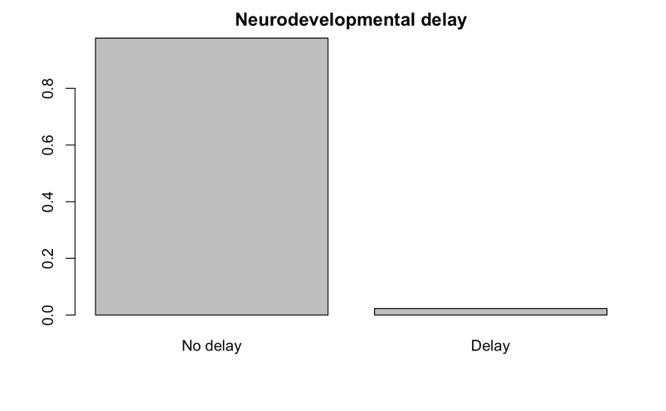

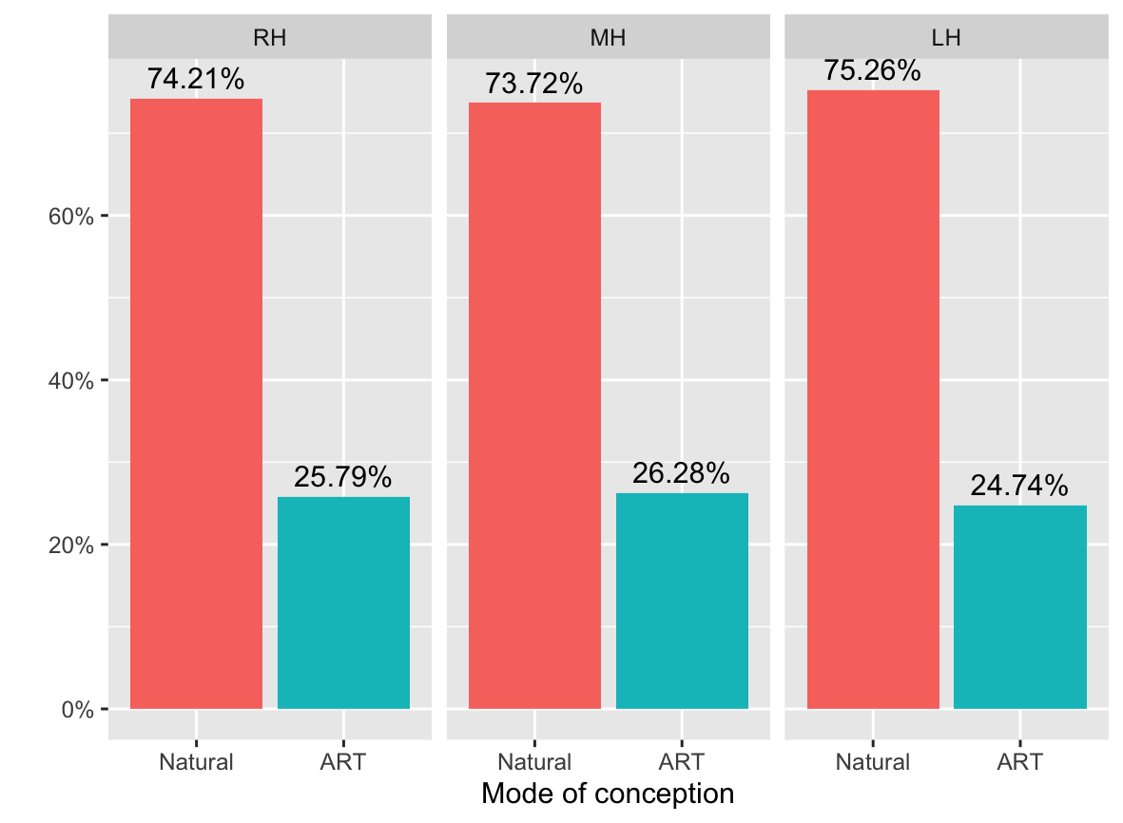
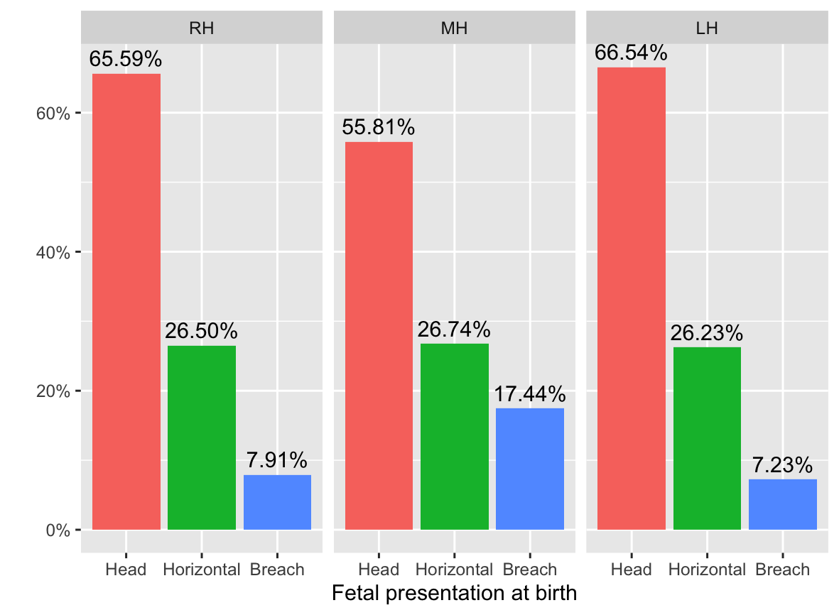
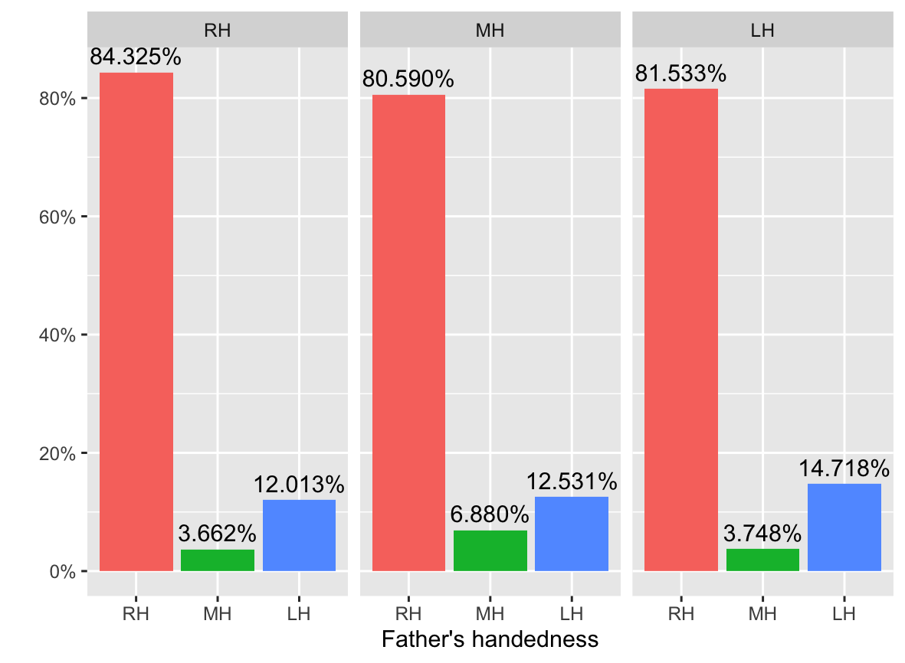
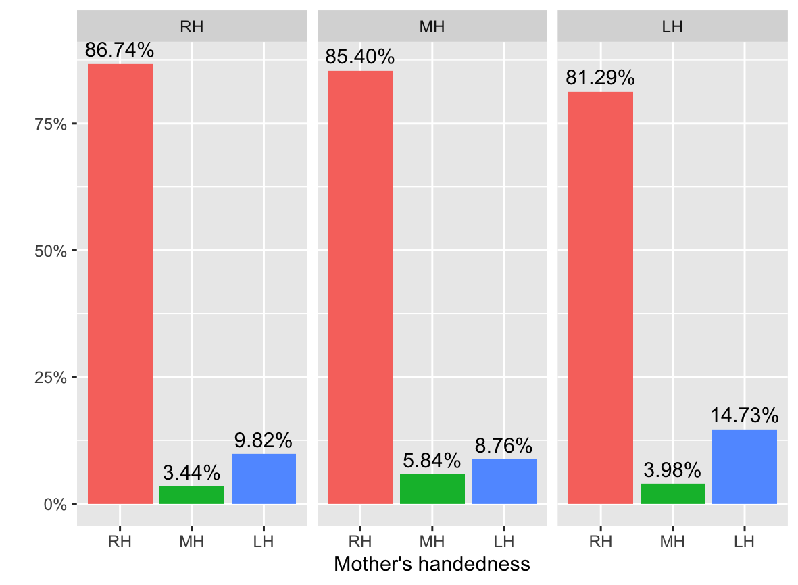
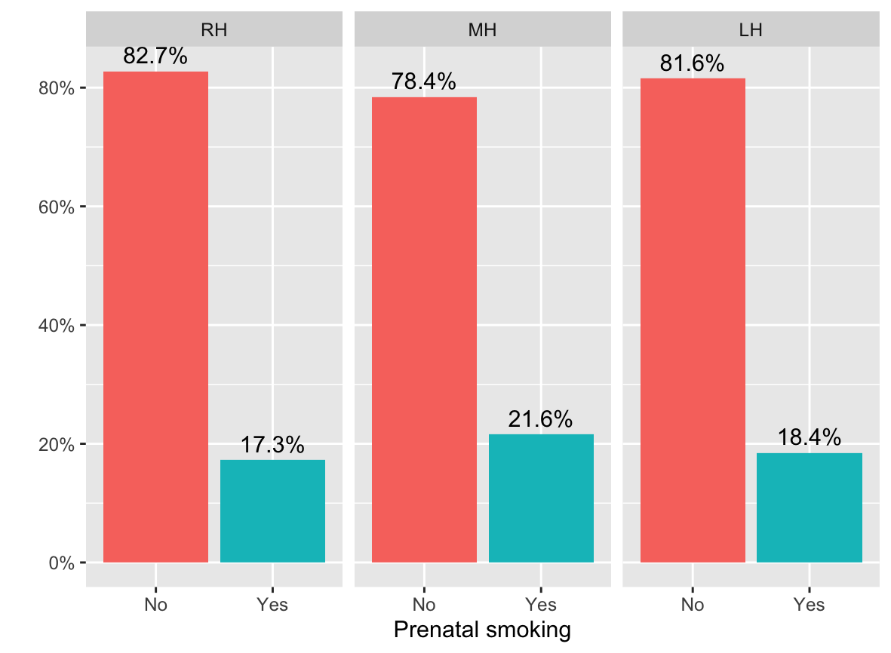
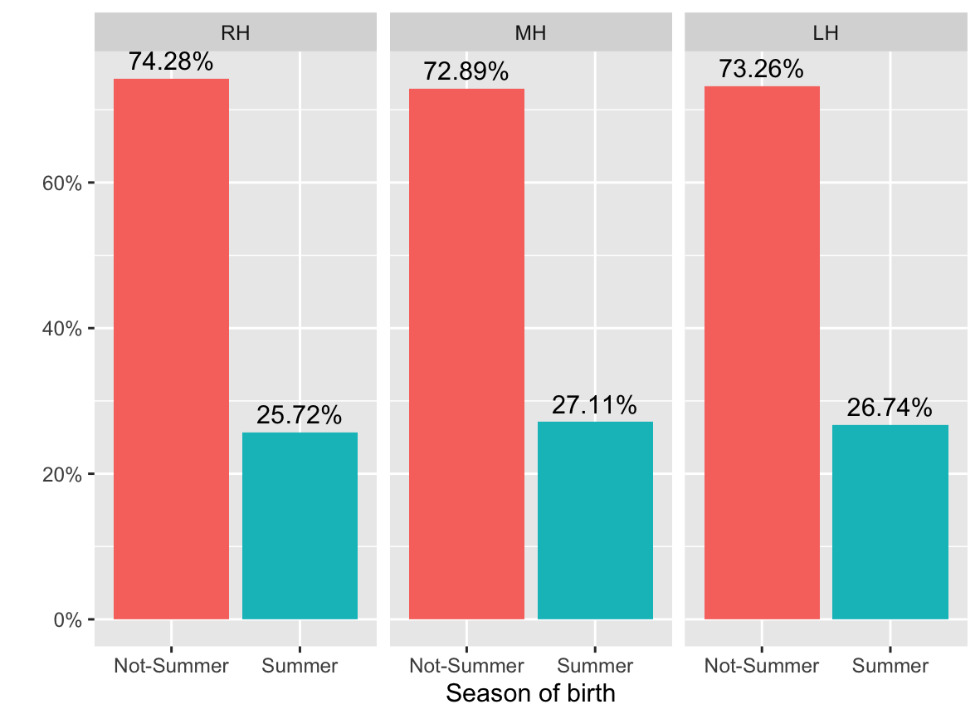
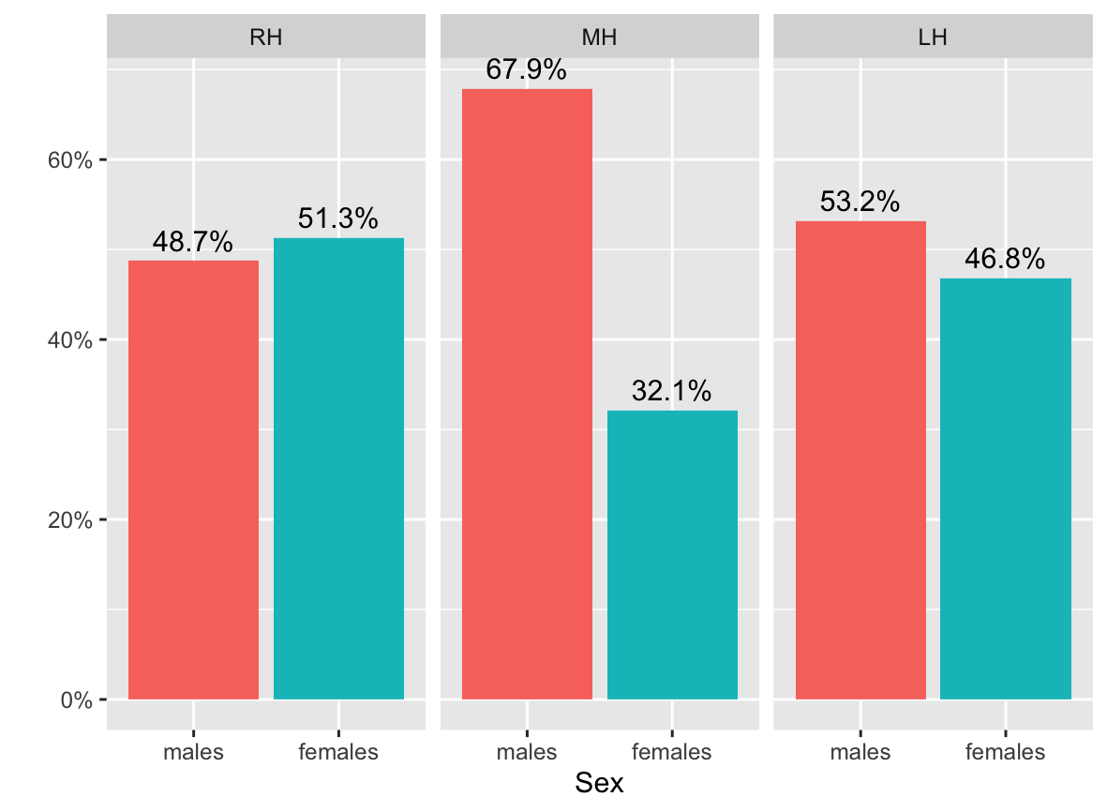
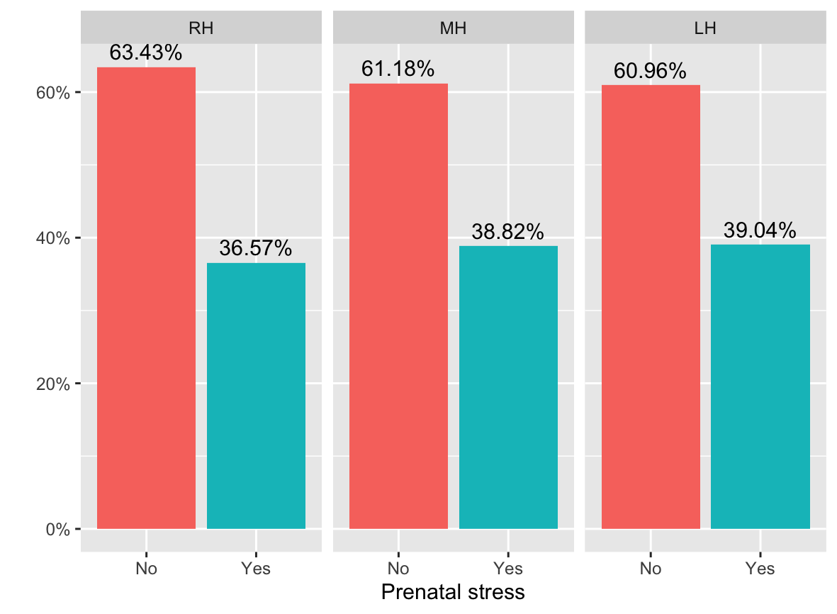
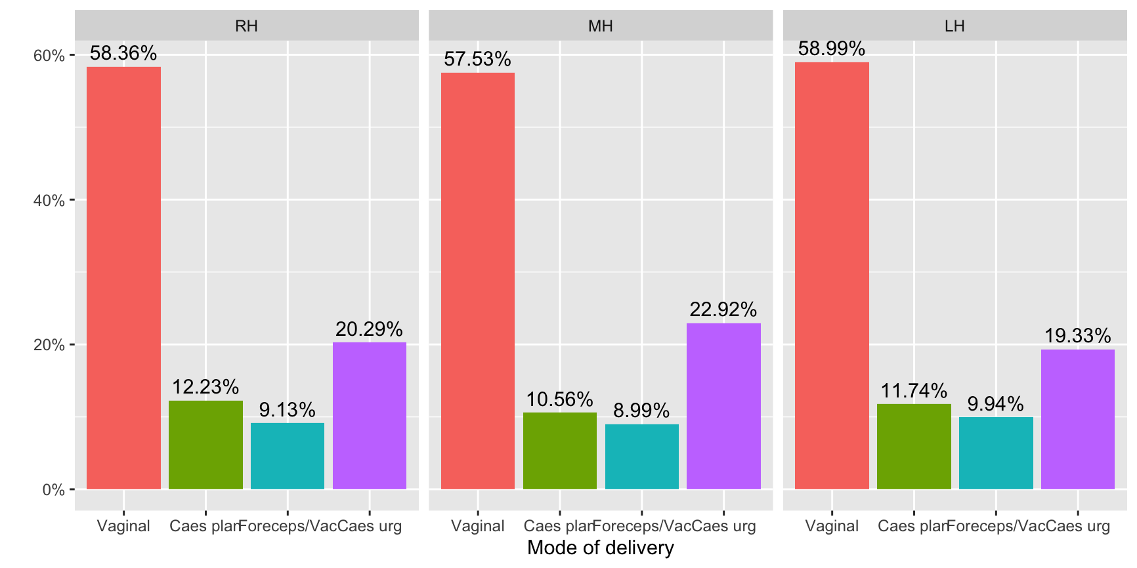
a)
b)
c)
d)
e)
f)
g)
h)
i)
j)

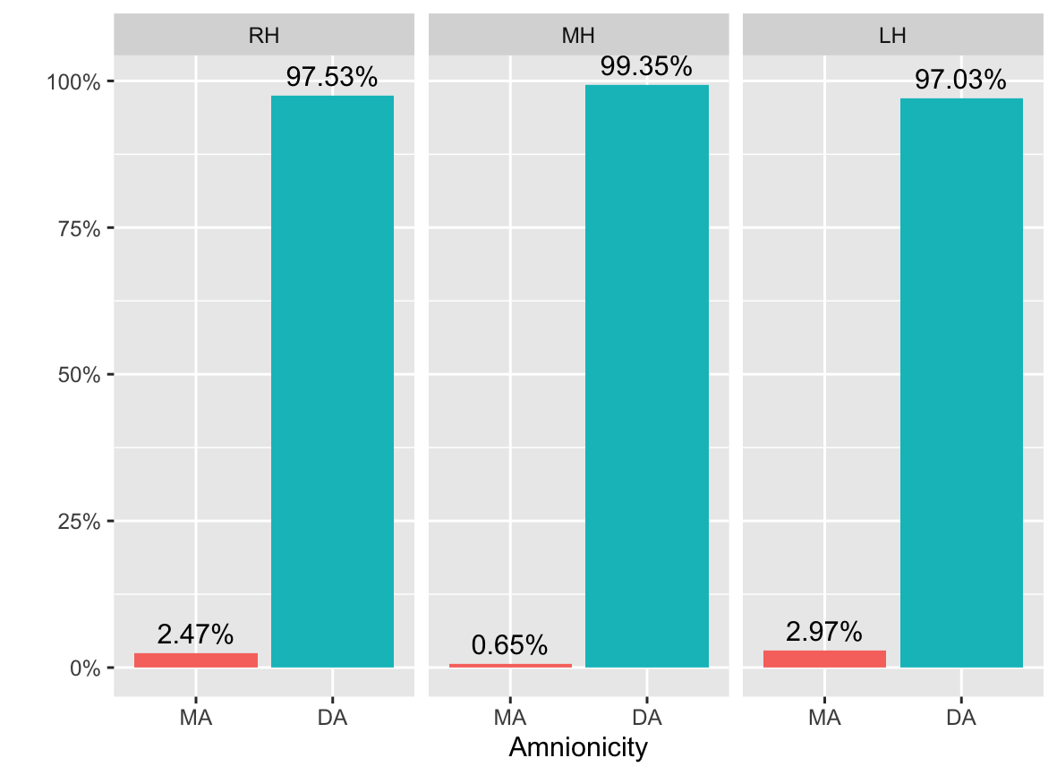
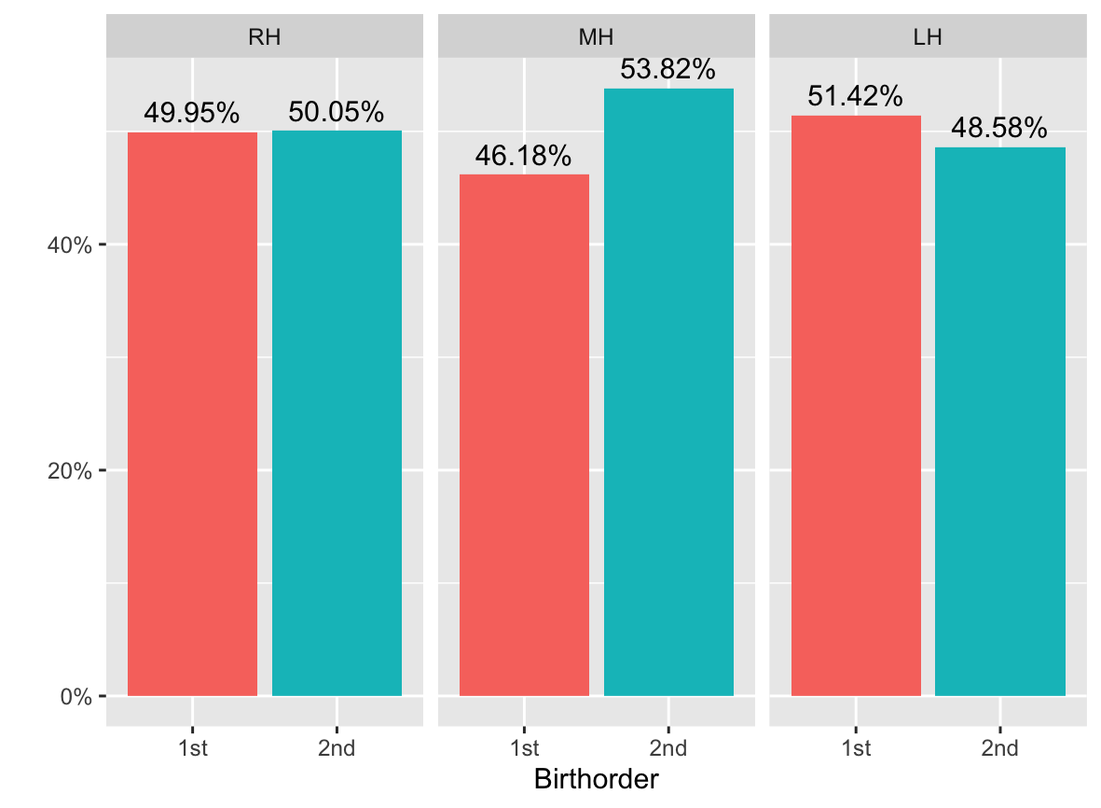
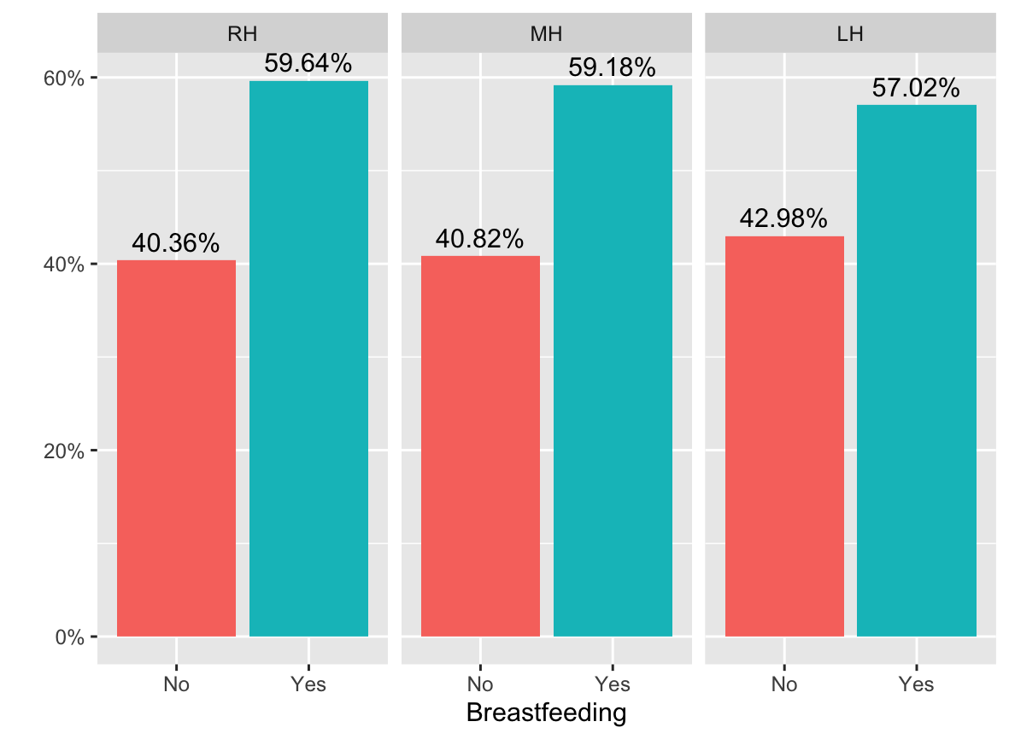
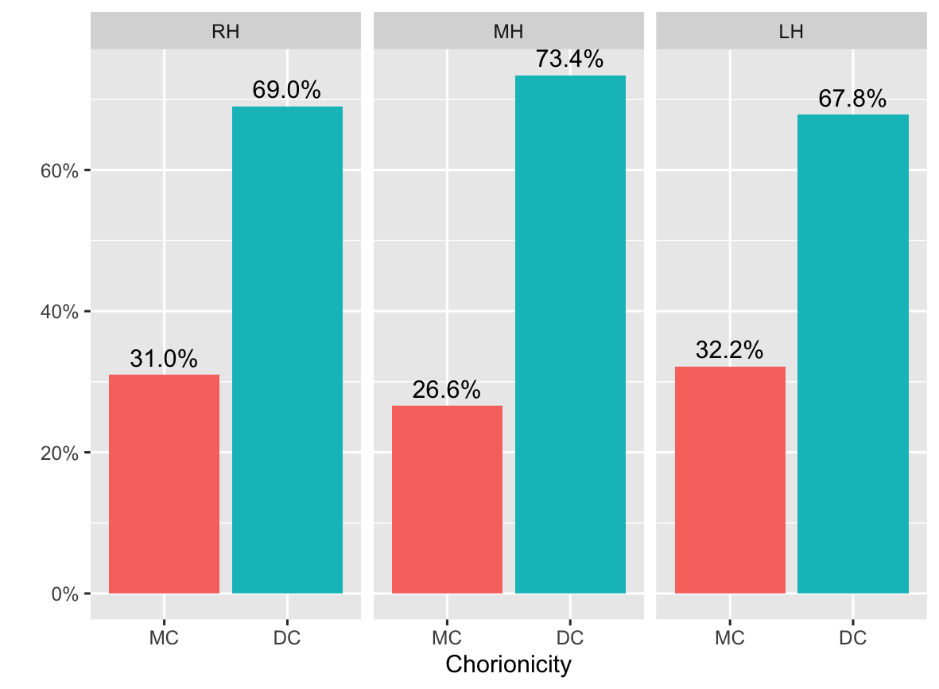
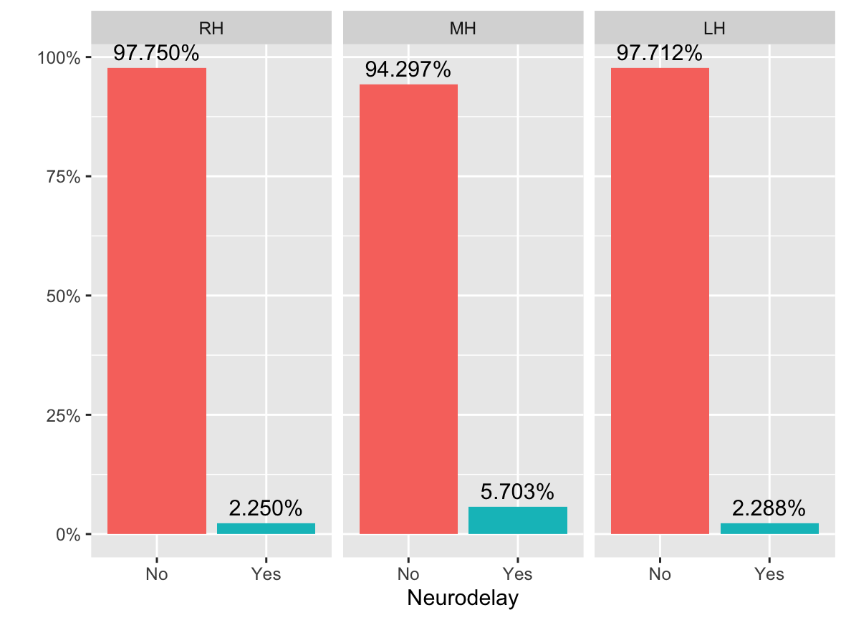
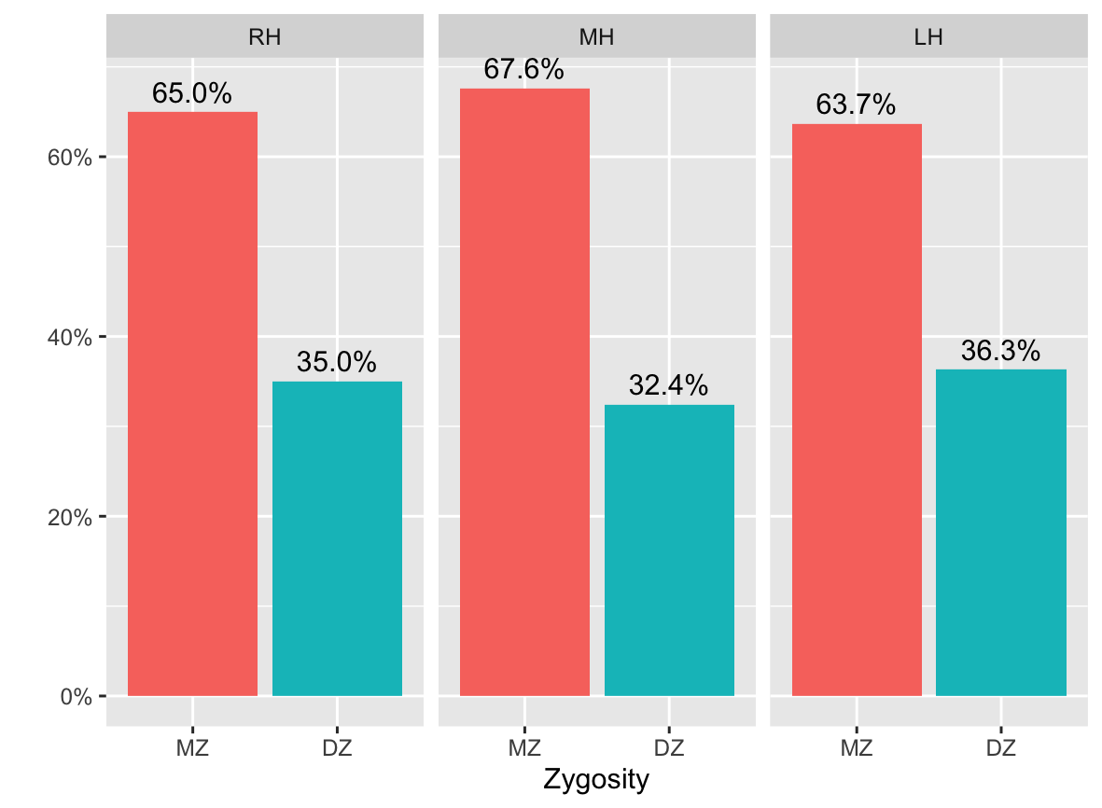
k)
l)
m)
n)
o)
p)

Supplementary Figure 1. Frequencies in categorical early life characteristics in right-handed (RH), mixed-handed (MH) and left-handed (LH) children

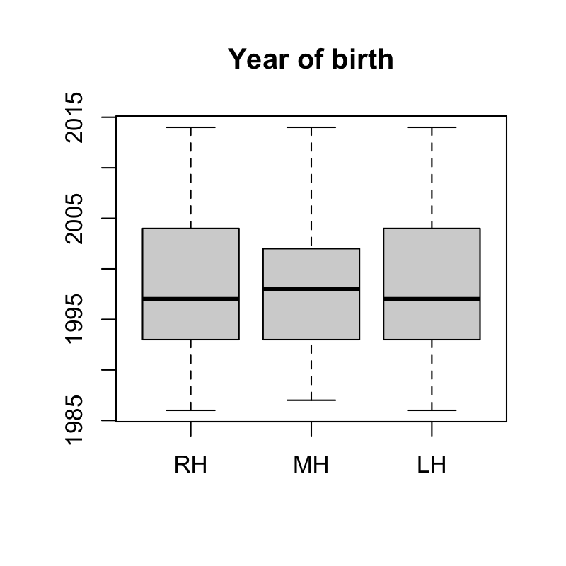
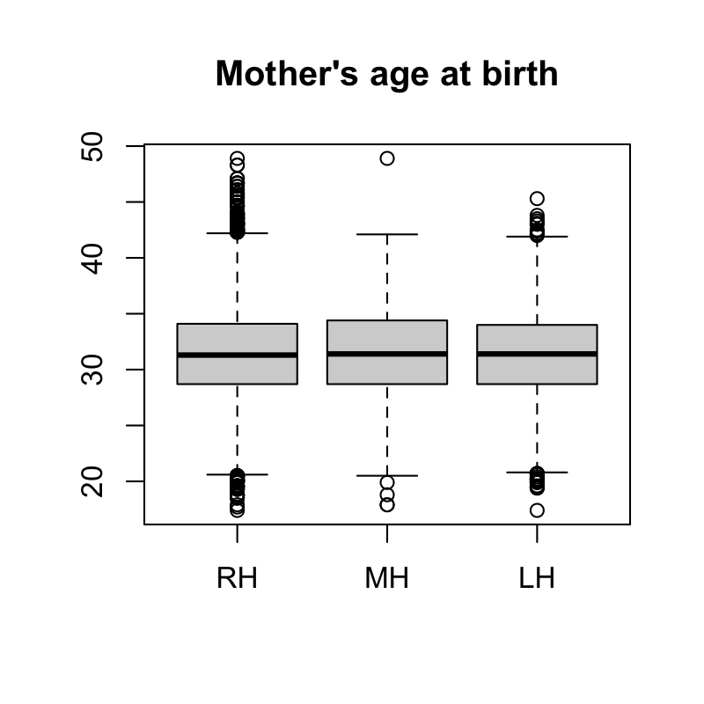
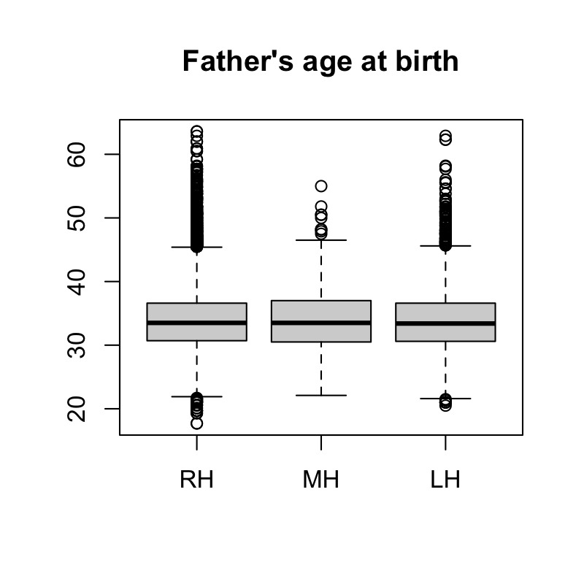
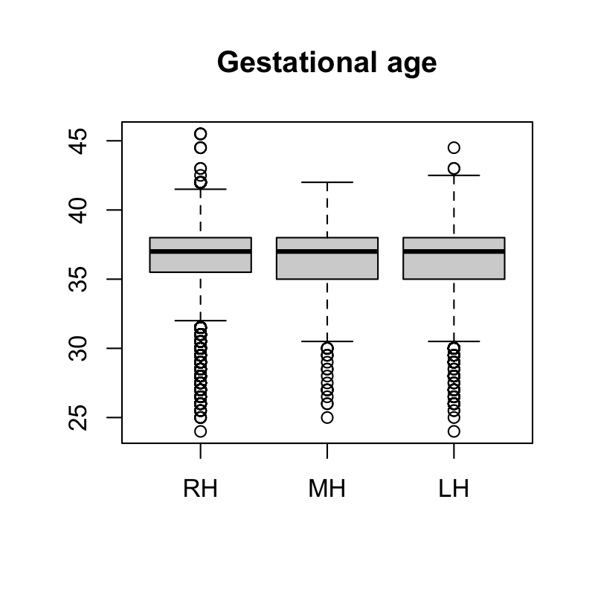
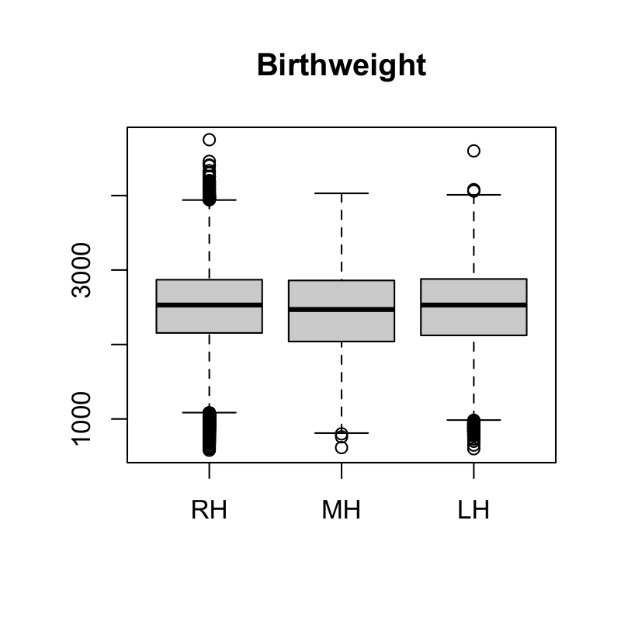
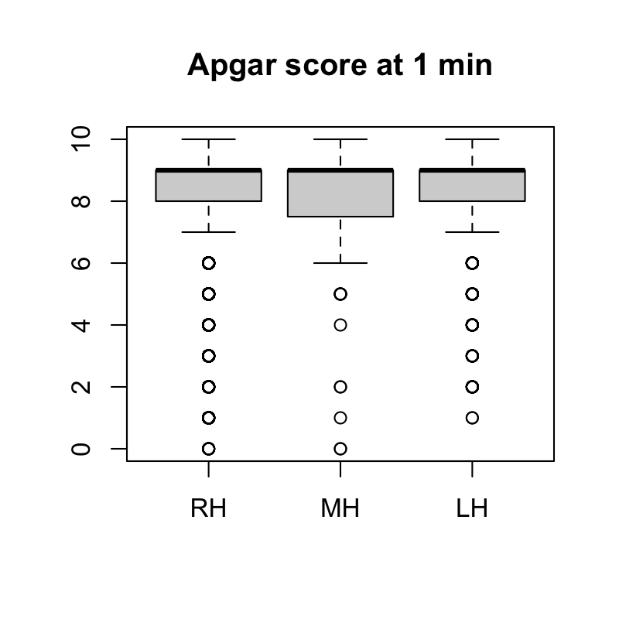
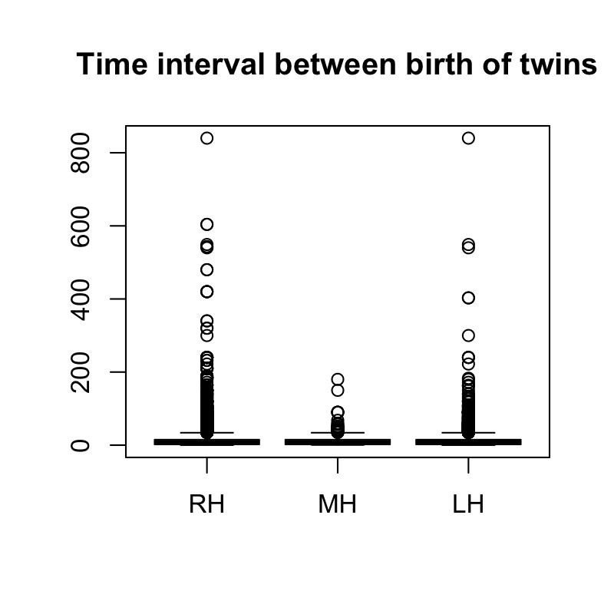
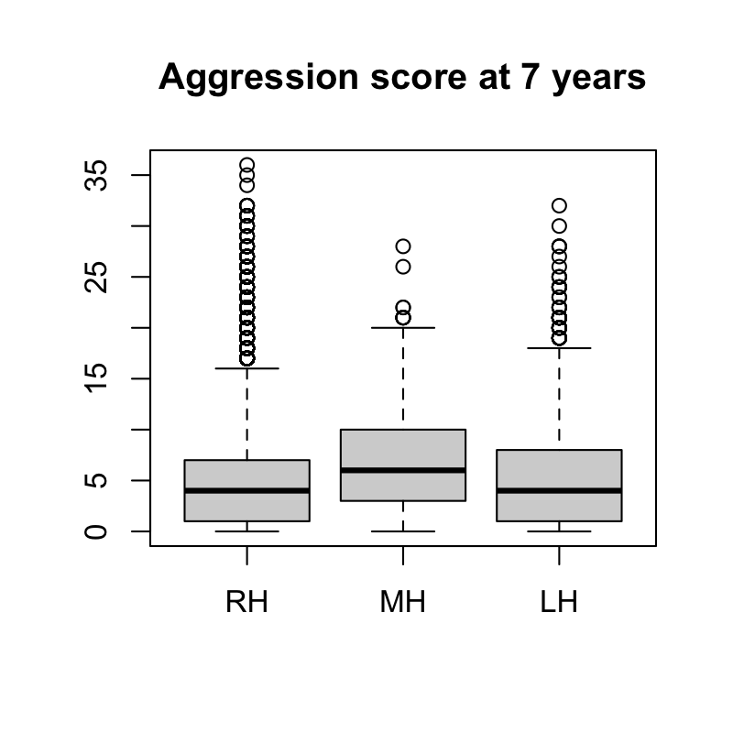

Supplementary Figure 2. Boxplots of continuous early life characteristics in right-handed (RH), mixed-handed (MH) and left-handed (LH) children

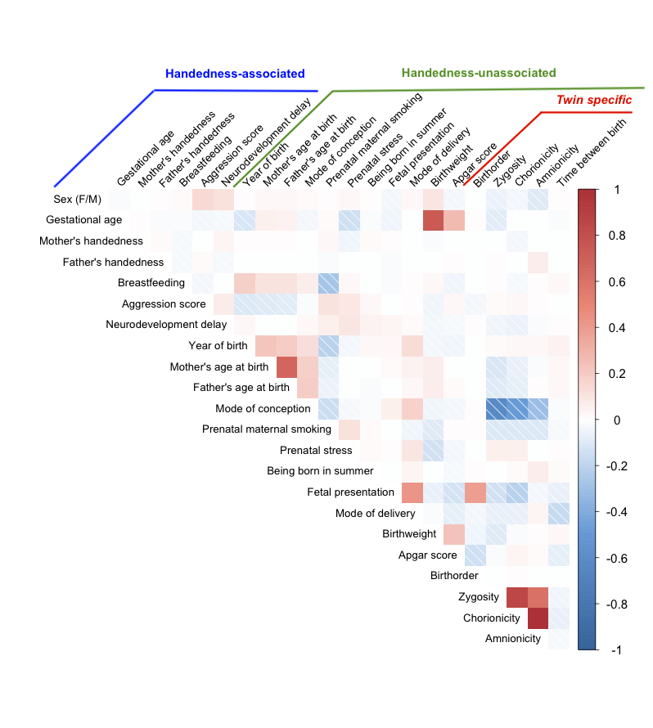

Supplementary Figure 3. Correlations between 23 early life characteristics
Pearson correlations between continuous variables, polychoric correlations between ordinal variables, and point biserial correlations between continuous and ordinal variables. Handedness-associated are the characteristics that were associated with handedness in one of three definitions in regression analysis at p<0.0011. Handedness-unassociated are the characteristics that were not associated with handedness in regression analysis. For coding of variables see Supplementary Table 1. N = 37,495.

Appendix 2. Multiple testing correction

The correction suggested by Nyholt (2004) involves calculating the effective number of tests given the currelations among the predictors. The effective number of tests (M_{eff}) taking in account the proportional reduction in the number of variables in a set that is the ratio of observed eigenvalue variance to its maximum is calculated as:

M_{eff} = 1 + (M – 1) (1 –(Var(λ_{obs})/M),

where M is the total number of variables included in the correlation matrix, Var(λ_{obs}) is the observed eigenvalue variance derived from correlation matrix (Nyholt, 2004).

There were 23 early life characteristics (predictors) in the current study. Number of calculations 23*24/2 – 23 = 253 correlations (mean 0.14, sd 0.14, range [-0.62 : 0.98]). Distribution of correlation coefficients between 23 early life characteristics is presented on histogram:

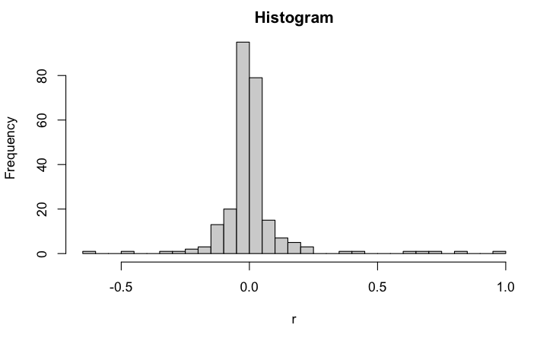

M_{eff} = 1 + (23 – 1) (1 – (0.472507/23). The effective number of tests is 22.5. Given two definitions of handedness (left-handedness and mixed-handedness), alpha-per-test equalled α = 0.05/(22.5*2) = 0.001108744.

Supplementary Table 5. Results of univariate regression analysis
 | RH vs LH |  |  |  |  | RH vs MH |  |  |  |  | RH vs NRH
 | N | β | SE | z | P | N | β | SE | z | P | N | β | SE | z | P
General characteristics
Sex (F/M) | 36,997 | 0.183 | 0.030 | 6.199 | 6.68E-10 | 31,923 | 0.811 | 0.100 | 8.113 | 1.39E-16 | 37,495 | 0.232 | 0.029 | 8.120 | 4.66E-16
Year of birth (scaled) | 36,997 | -0.010 | 0.015 | -0.668 | 0.526 | 31,923 | 0.028 | 0.044 | 0.638 | 0.621 | 37,495 | -0.007 | 0.015 | -0.485 | 0.628
Mother's handedness* | 30,349 | 0.470 | 0.047 | 9.976 | 1.14E-23 | 26,179 | -0.109 | 0.197 | -0.556 | 0.034 | 31,869 | 0.387 | 0.041 | 9.335 | 6.74E-21
Father's handedness* | 30,088 | 0.236 | 0.047 | 5.036 | 3.05E-07 | 25,922 | 0.078 | 0.162 | 0.482 | 0.002 | 31,643 | 0.202 | 0.041 | 4.950 | 4.75E-07
Prenatal characteristics
Mother's age at birth (scaled) | 35,885 | -0.019 | 0.015 | -1.269 | 0.199 | 30,955 | 0.001 | 0.054 | 0.016 | 0.912 | 36,364 | -0.018 | 0.015 | -1.240 | 0.204
Father's age at birth (scaled) | 35,520 | -0.012 | 0.015 | -0.749 | 0.454 | 30,621 | 0.043 | 0.054 | 0.797 | 0.453 | 35,990 | -0.007 | 0.015 | -0.477 | 0.626
Mode of conception (Natural/Assisted) | 34,058 | -0.056 | 0.036 | -1.558 | 0.133 | 29,380 | 0.027 | 0.111 | 0.243 | 0.764 | 34,526 | -0.049 | 0.034 | -1.424 | 0.173
Maternal smoking (no/yes) | 35,878 | 0.081 | 0.039 | 2.076 | 0.039 | 30,945 | 0.280 | 0.121 | 2.302 | 0.015 | 36,360 | 0.099 | 0.038 | 2.607 | 0.009
Prenatal stress (no/yes) | 7,117 | 0.107 | 0.071 | 1.505 | 0.135 | 6,134 | 0.103 | 0.226 | 0.456 | 0.642 | 7,202 | 0.105 | 0.069 | 1.522 | 0.126
Perinatal characteristics
Gestational age (scaled) | 35,795 | -0.055 | 0.015 | -3.764 | 0.00016 | 30,883 | -0.175 | 0.046 | -3.833 | 4.92E-05 | 36,277 | -0.066 | 0.014 | -4.640 | 2.55E-06
Being born in summer (no/yes) | 36,993 | 0.053 | 0.034 | 1.558 | 0.102 | 31,919 | 0.071 | 0.111 | 0.639 | 0.473 | 37,491 | 0.054 | 0.033 | 1.650 | 0.083
Fetal presentation (cephalic/non-cephalic) | 7,182 | -0.044 | 0.070 | -0.630 | 0.479 | 6,189 | 0.399 | 0.220 | 1.809 | 0.077 | 7,268 | -0.009 | 0.067 | -0.134 | 0.826
Mode of delivery (vaginal/instrumental) | 31,373 | -0.026 | 0.033 | -0.791 | 0.426 | 27,090 | 0.018 | 0.102 | 0.180 | 0.799 | 31,818 | -0.021 | 0.032 | -0.656 | 0.510
Birth weight (scaled) | 35,568 | -0.023 | 0.015 | -1.538 | 0.125 | 30,677 | -0.147 | 0.051 | -2.895 | 0.002 | 36,045 | -0.034 | 0.015 | -2.318 | 0.019
Apgar score 1 min (scaled) | 5,217 | 0.016 | 0.023 | 0.684 | 0.506 | 4,515 | -0.133 | 0.059 | -2.247 | 0.025 | 5,281 | 0.001 | 0.022 | 0.054 | 0.971
Postnatal characteristics
Breastfeeding (no/yes) | 31,624 | -0.107 | 0.033 | -3.289 | 0.00099 | 27,261 | -0.001 | 0.109 | -0.006 | 0.953 | 32,038 | -0.100 | 0.032 | -3.184 | 0.0014
Neurodevelopmental delay (no/yes) | 36,615 | 0.019 | 0.098 | 0.197 | 0.844 | 31,599 | 0.920 | 0.218 | 4.225 | 2.38E-05 | 37,106 | 0.134 | 0.091 | 1.466 | 0.143
Aggression score at 7 y (scaled) | 20,327 | 0.022 | 0.019 | 1.157 | 0.244 | 17,516 | 0.325 | 0.048 | 6.846 | 1.46E-12 | 20,595 | 0.053 | 0.018 | 2.892 | 0.004
Twin-specific characteristics
Birthorder (1st/2nd) | 36,968 | -0.059 | 0.028 | -2.077 | 0.042 | 31,896 | 0.164 | 0.084 | 1.948 | 0.077 | 37,465 | -0.041 | 0.027 | -1.503 | 0.138
Zygosity (DZ/MZ) | 36,827 | -0.056 | 0.031 | -1.790 | 0.076 | 31,777 | 0.119 | 0.106 | 1.122 | 0.261 | 37,321 | -0.042 | 0.030 | -1.386 | 0.169
Chorionicity (DC/MC) | 11,043 | 0.055 | 0.059 | 0.923 | 0.347 | 9,544 | -0.209 | 0.201 | -1.040 | 0.304 | 11,201 | 0.032 | 0.057 | 0.557 | 0.567
Amnionicity (DA/MA) | 11,000 | 0.190 | 0.167 | 1.143 | 0.260 | 9,506 | -1.396 | 1.004 | -1.391 | 0.153 | 11,155 | 0.119 | 0.164 | 0.723 | 0.479
Time between birth of 1st and 2nd twin (scaled) | 30,312 | 0.022 | 0.014 | 1.517 | 0.113 | 26,167 | -0.059 | 0.067 | -0.880 | 0.368 | 30,746 | 0.017 | 0.015 | 1.246 | 0.213
β, regression coefficient, SE, standard error; z, z-statistics; P, p-value. GEE with correction for relatedness. RH, right-handed; LH, left-handed; MH, mixed-handed; NRH, non-right-handed (LH+MH); MZ, monozygotic; DZ, dizygotic; MC, monochorionic; DC, dichorionic; MA, monoamniotic; DA, diamniotic. *Mother’s and father’s handedness are included in the same definition as the offspring handedness.

Supplementary Table 6. Prevalence of handedness in term and preterm twin births

 | Full-term >37 weeks | Preterm <37 weeks | P
Left-handedness | 14.39% (n=3102) | 15.58% (n=2292) | 0.00018
Mixed-handedness | 1.21% (n=261) | 1.5% (n=221) | 0.019
Non-righthandedness | 15.60% (n=3363) | 17.08% (n=2513) | 0.00017
N_{full-term}=21563. N_{preterm}=14714. P, p-value in 2-sample test for equality of proportions.

Supplementary Table 7. Prevalence of left-handedness, mixed-handedness and non-right-handedness in same-sex and opposite-sex twins

 | Females from same-sex pairs (SSF) | Females from opposite-sex pairs (OSF) | P SSF vs OSF | Males from same-sex pairs (SSM) | Males from opposite-sex pairs (OSM) | P SSM vs OSM
Left-handedness | 14.22% (n=1818) | 12.91% (n=776) | 0.017 | 15.71% (1970) | 16.38% (980) | 0.255
Mixed-handedness | 0.8% (n=102) | 0.93% (n=56) | 0.393 | 1.72% (216) | 2.01% (120) | 0.197
Non-right-handedness | 15.01% (n=1920) | 13.85% (n=823) | 0.037 | 17.43% (2186) | 18.38% (1100) | 0.118
N_{SSF} = 12788, N_{OSF}=6009, N_{SSM}=12540, N_{OSM}= 5984. P, p-value in 2-sample test for equality of proportions.

