Twin Research and Human Genetics
SUPPLEMENTARY MATERIALS

Genetic Susceptibility to Pneumonia: A GWAS Meta-Analysis Between the UK Biobank and FinnGen
Adrian I. Campos, Pik Fang Kho, Karla X. Vazquez-Prada, Luis M. García-Marín, Nicholas G. Martin, Gabriel Cuéllar-Partida, Miguel E. Rentería

Supplementary Table 1. ICD-10 codes for pneumonia in UK Biobank
Code | Description
B012 | Varicella pneumonia
J100 | Influenza with pneumonia, influenza virus identified
J111 | Influenza with pneumonia, virus not identified
J120 | Adenoviral pneumonia
J121 | Respiratory syncytial virus pneumonia
J122 | Parainfluenza virus pneumonia
J123 | Human metapneumovirus pneumonia
J128 | Other viral pneumonia
J129 | Viral pneumonia unspecified
J13 | Pneumonia due to Streptococcus pneumoniae
J14 | Pneumonia due to Haemophilus influenzae
J150 | Pneumonia due to Klebsiella pneumoniae
J151 | Pneumonia due to Pseudomonas
J152 | Pneumonia due to staphylococcus
J153 | Pneumonia due to streptococcus, group B01
J154 | Pneumonia due to other streptococci
J155 | Pneumonia due to Escherichia coli
J156 | Pneumonia due to other aerobic Gram-negative bacteria
J157 | Pneumonia due to Mycoplasma pneumoniae
J158 | Other bacterial pneumonia
J159 | Bacterial pneumonia, unspecified
J16 | Pneumonia due to other infectious organisms, not elsewhere classified
J160 | Chlamydial pneumonia
J168 | Pneumonia due to other specified infectious organisms
J170 | Pneumonia in bacterial diseases classified elsewhere
J171 | Pneumonia in viral diseases classified elsewhere
J172 | Pneumonia in mycoses
J173 | Pneumonia in parasitic diseases
J178 | Pneumonia in other diseases classified elsewhere
J180 | Bronchopneumonia, unspecified
J181 | Lobar pneumonia, unspecified
J182 | Hypostatic pneumonia, unspecified
J188 | Other pneumonia, organism unspecified
J189 | Pneumonia, unspecified
J851 | Abscess of lung with pneumonia

Supplementary Table 2. Genes identified by fastBAT analysis
Gene | CHR | Start | End | No_SNPs | Pvalue | P adj smoking phenotypes*
MAPKAP1 | 9 | 128199672 | 128469513 | 185 | 2.56E-05 | 0.0024
PBX3 | 9 | 128509616 | 128729655 | 147 | 2.20E-05 | 0.00032
ADAMTS7 | 15 | 79051544 | 79103773 | 163 | 1.62E-05 | 0.68
CHRNA3 | 15 | 78885394 | 78913637 | 84 | 4.00E-09 | 0.5
CHRNA5 | 15 | 78857861 | 78887611 | 73 | 3.41E-09 | 0.57
CHRNB4 | 15 | 78916635 | 78933587 | 83 | 6.94E-09 | 0.43
HYKK | 15 | 78799905 | 78829715 | 65 | 1.68E-09 | 0.43
IREB2 | 15 | 78730517 | 78793798 | 97 | 9.80E-09 | 0.53
LOC646938 | 15 | 79044378 | 79045734 | 117 | 9.49E-06 | 0.43
PSMA4 | 15 | 78832746 | 78841563 | 58 | 4.57E-10 | 0.33
APOBR | 16 | 28505969 | 28510291 | 45 | 1.82E-05 | 0.00038
CLN3 | 16 | 28477973 | 28503623 | 43 | 1.56E-05 | 0.0003
EIF3C | 16 | 28390902 | 28437775 | 17 | 3.54E-06 | 0.000045
EIF3CL | 16 | 28390899 | 28415162 | 14 | 8.09E-06 | 0.00011
IL27 | 16 | 28510682 | 28518155 | 51 | 2.59E-05 | 0.00052
MIR6862-1 | 16 | 28402302 | 28402372 | 6 | 6.76E-06 | 0.00011
MIR6862-2 | 16 | 28402302 | 28402372 | 6 | 6.76E-06 | 0.00011
NPIPB6 | 16 | 28353838 | 28374181 | 40 | 2.60E-05 | 0.00075
Showing significant (FDR<0.05) results for fastBAST gene-based association analysis for pneumonia meta-analysis. *P values for sensitivity gene based test on the pneumonia gwas conditioned on smoking history and cigarettes per day adjusted for multiple testing (bonferroni correction for 18 comparisons)

Supplementary Table 3. Colocalization of blood eQTLs with pneumonia GWASMA loci
Gene | COLOC Posterior Probability
 | PP0 | PP1 | PP2 | PP3 | PP4 | PP3+PP4 | PP4/(PP3+PP4)
EIF3C | 0.026 | 0.031 | 0.102 | 0.123 | 0.718 | 0.841 | 0.854
APOBR | 0.431 | 0.523 | 0.016 | 0.020 | 0.010 | 0.029 | 0.325
EIF3CL | 0.414 | 0.503 | 0.036 | 0.044 | 0.003 | 0.047 | 0.066
NPIPB6 | 0.187 | 0.227 | 0.123 | 0.149 | 0.314 | 0.463 | 0.678
IL27 | 0.004 | 0.005 | 0.446 | 0.541 | 0.004 | 0.545 | 0.007
CLN3 | 0.007 | 0.008 | 0.430 | 0.522 | 0.033 | 0.555 | 0.059
PSMA4 | 2.43E-09 | 9.75E-07 | 0.002 | 0.989 | 0.009 | 0.998 | 0.009
CHRNA5 | 0.001 | 0.210 | 0.002 | 0.774 | 0.013 | 0.787 | 0.017
IREB2 | 9.19E-24 | 3.69E-21 | 2.49E-03 | 9.97E-01 | 1.28E-05 | 0.997511 | 1.29E-05
HYKK | 0.002 | 0.842 | 3.40E-04 | 0.136 | 0.020 | 0.156 | 0.126
PBX3 | 0.805 | 0.099 | 0.085 | 0.010 | 0.001 | 0.011 | 0.071
ADAMTS7 | 0.002 | 0.835 | 3.43E-04 | 0.138 | 0.025 | 0.163 | 0.156
MAPKAP1 | 0.851 | 0.104 | 0.040 | 0.005 | 3.86E-04 | 0.005 | 0.073
PP0 - no association with gene expression and pneumonia risk; PP1- association with pneumonia GWAS only; PP2 - association with gene expression only; PP3 - association with gene expression and pneumonia GWAS, but two distinct SNP; PP4 - association with gene expression and pneumonia GWAS, shared SNP; Genes not shown could not be assessed due to lack of expression in the relevant tissue or lack of eQTL data. Genes showed evidence of colocalization are in bold.

Supplementary Table 4. Conditional analysis results for smoking associated variants
SNP (Conditioned on) | P-value
rs16969968(rs2009746;rs588765;rs578776) | 0.20477
rs588765(rs2009746;rs16969968;rs578776) | 0.0698019
rs578776(rs2009746;rs588765;rs16969968) | 0.588421
rs2009746(rs16969968;rs588765;rs578776) | 0.00232078
Logistic regression was performed by adjusting for all relevant covariates plus the relevant SNPs shown in parenthesis. UK Biobank data only

Supplementary Table 5. Results of a multivariate logistic regression for pneumonia
 | Before adjusting for smoking history |  |  | After adjusting for smoking history
 | OR | std err | P | OR | std err | P
Male | 0.67 | 0.08 | 2.8e-7 | 0.67 | 0.079 | 2.9e-7
Smoking history | NA | NA | NA | 1.23 | 0.084 | 0.012
Age | 1.03 | 0.002 | 1.5e-38 | 1.03 | 0.002 | 9.5e-31
Pneumonia PRS | 1.11 | 0.03 | 0.001 | 1.11 | 0.03 | 0.002
Pneumonia PRS adjusted for smoking | 1.11 | 0.03 | 0.001 | 1.11 | 0.03 | 0.002
Total sample size with available data N = 5595. Std err - standard error on the logistic scale

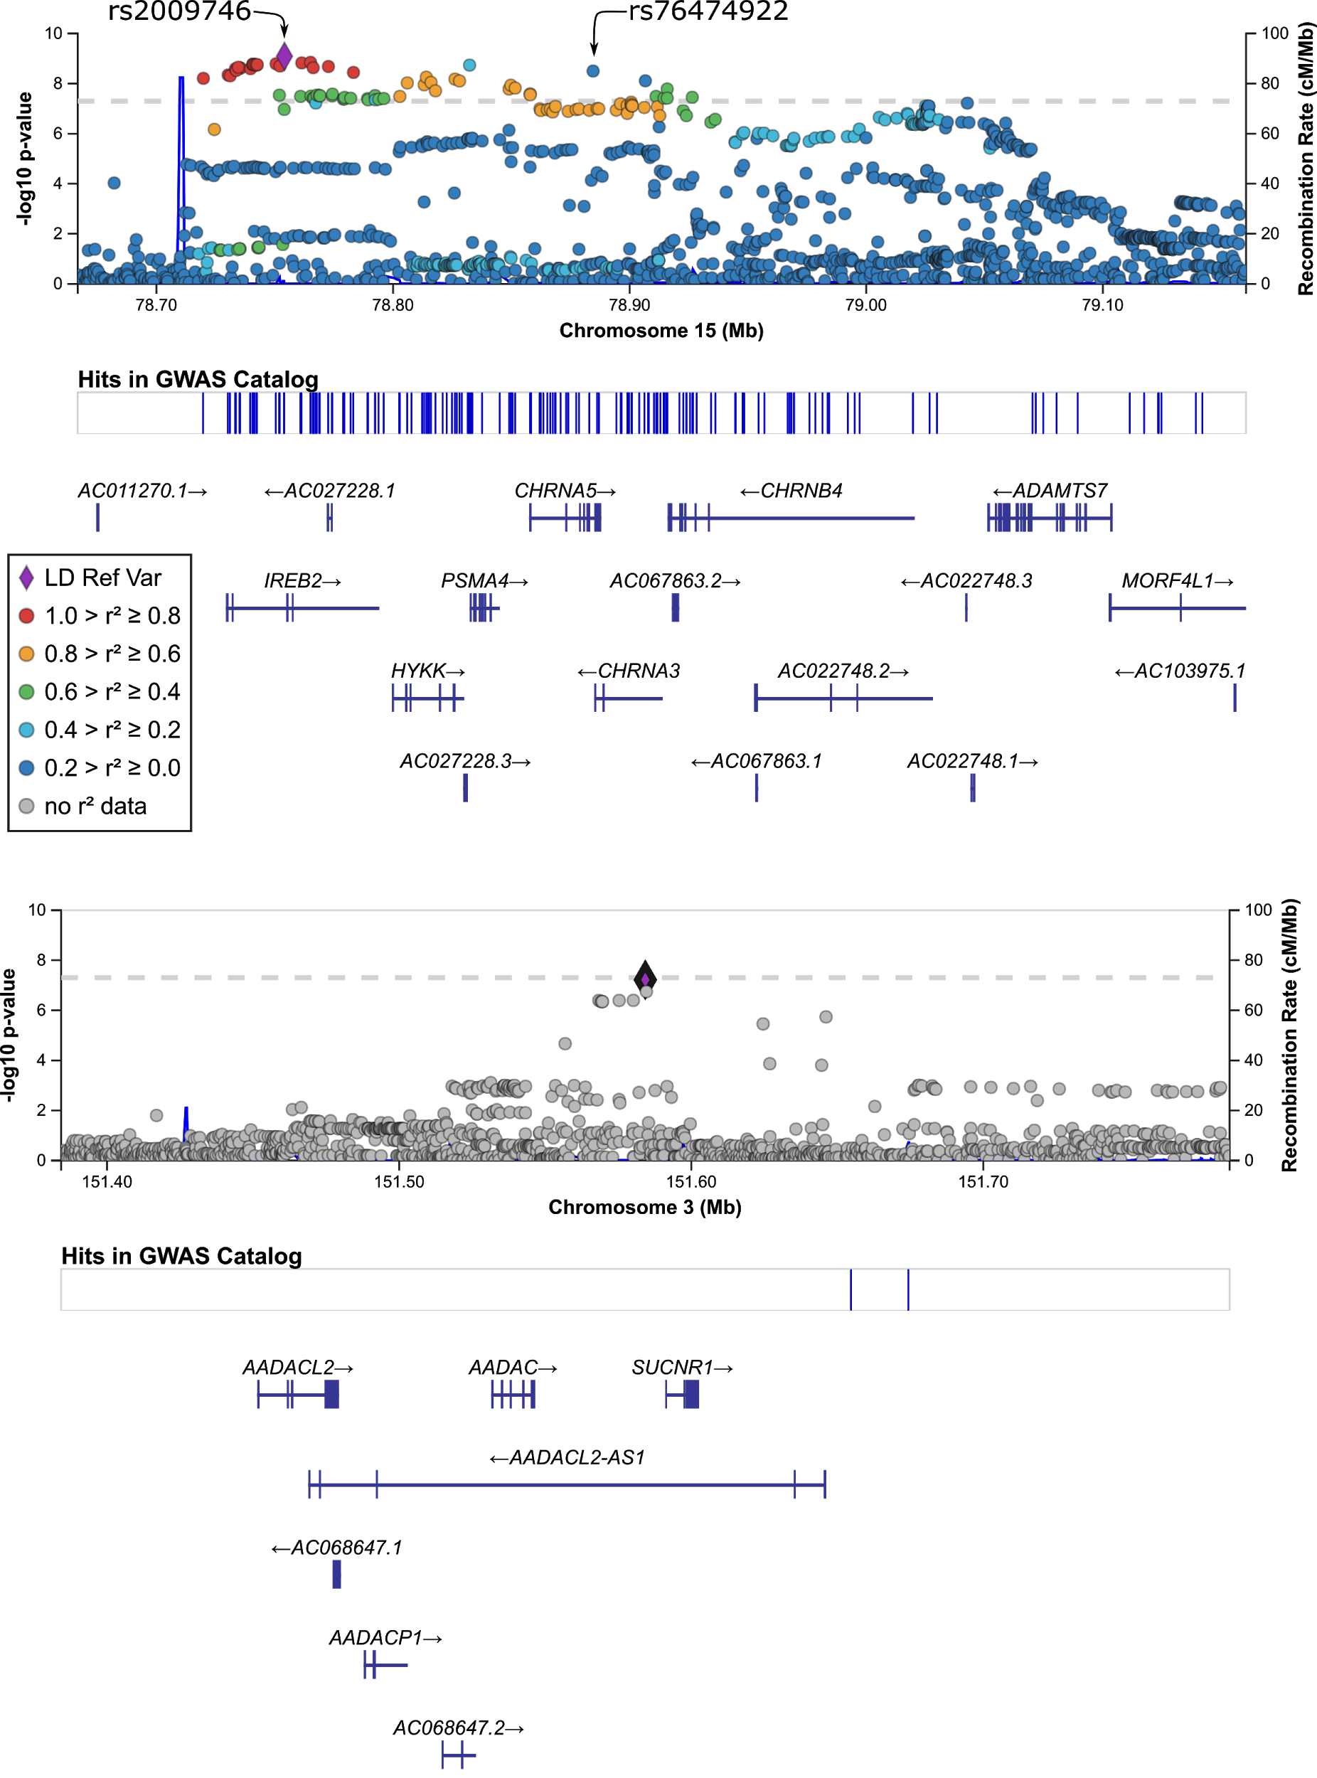
Supplementary Figure 1. Locus Zoom plot of the genome-wide significant hits.
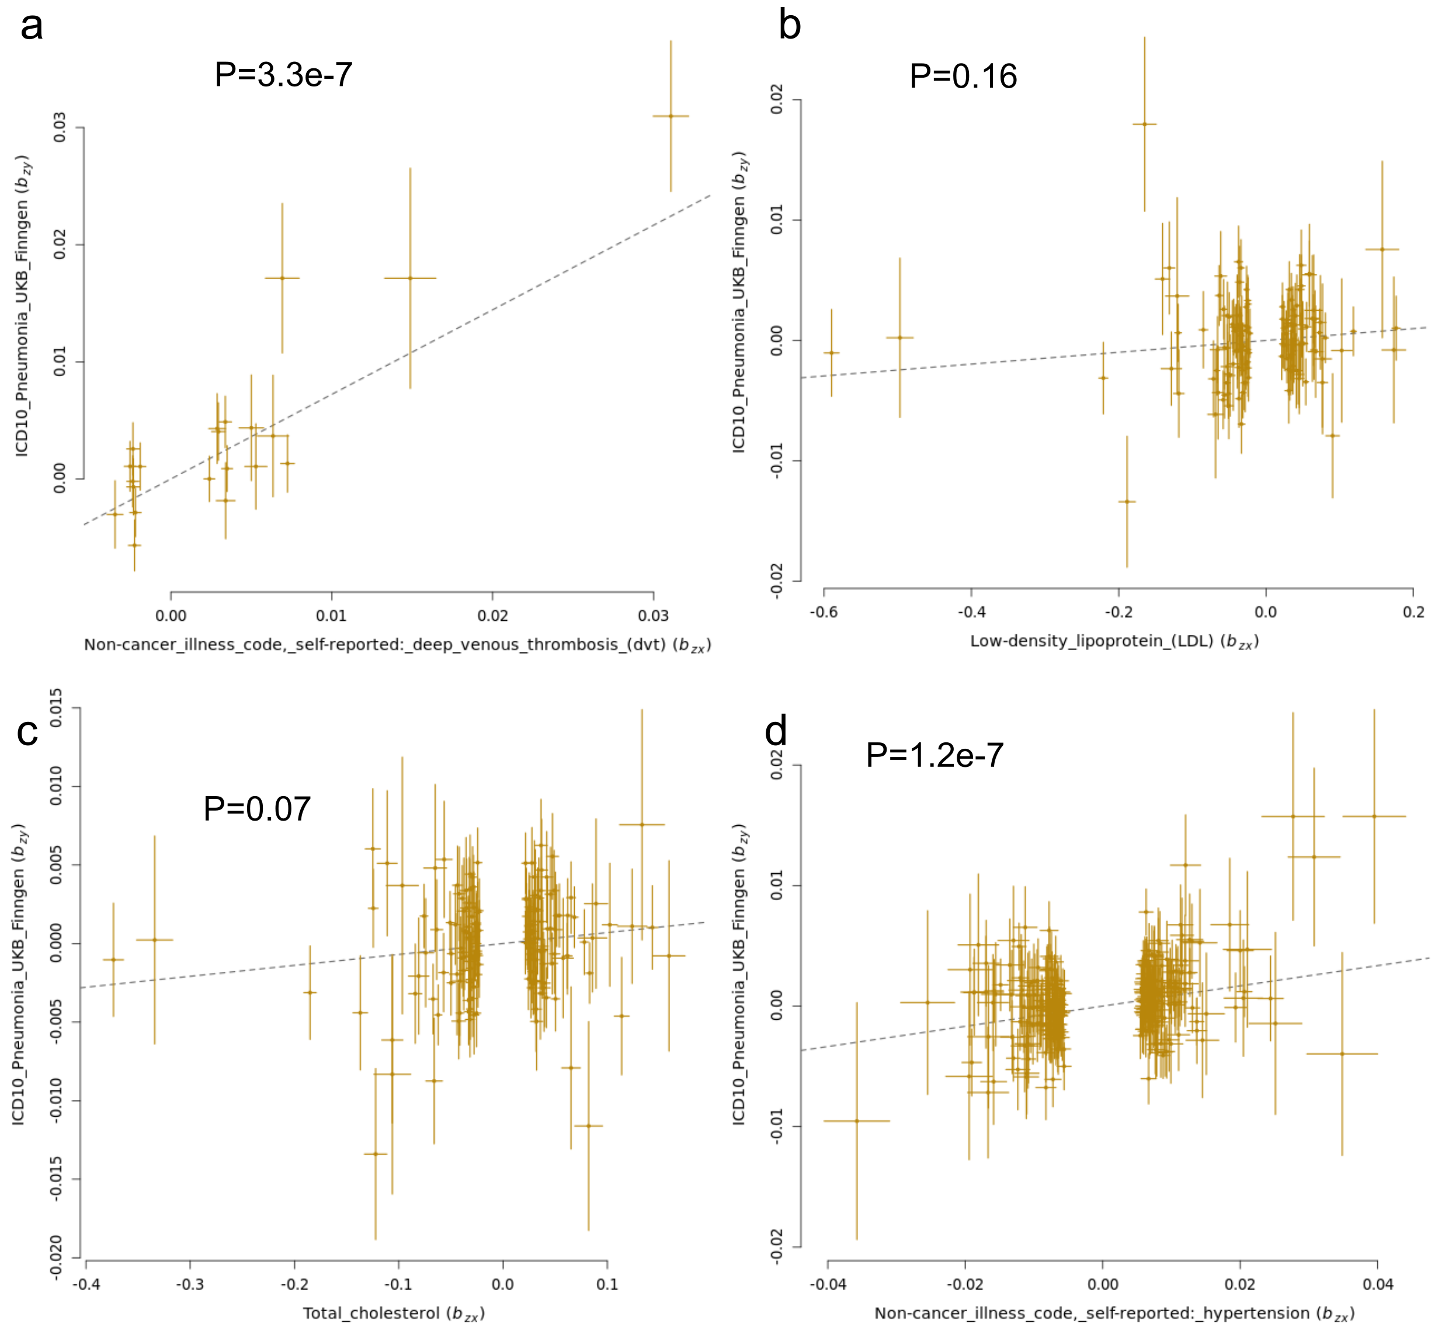
Supplementary Figure 2. GSMR analysis of selected LCV significant traits
Pickrell plots show the results of a GSMR analysis to further assess evidence for causality from the LCV results. The x-axis depicts the effect sizes for SNPs associated with an exposure of interest, the y axis shows those SNP’s effect sizes on pneumonia. A significant slope (positive or negative) could be considered evidence for causality.

SUPPLEMENTARY SOFTWARE REFERENCES
1. Loh, Po-Ru, et al. "Efficient Bayesian mixed-model analysis increases association power in large cohorts." Nature genetics 47.3 (2015): 284.
2. Loh, Po-Ru, et al. "Mixed-model association for biobank-scale datasets." Nature genetics 50.7 (2018): 906-908.
3. Willer, Cristen J., Yun Li, and Gonçalo R. Abecasis. "METAL: fast and efficient meta-analysis of genomewide association scans." Bioinformatics 26.17 (2010): 2190-2191.
4.Yang, J., Lee, S. H., Goddard, M. E., & Visscher, P. M. (2011). GCTA: a tool for genome-wide complex trait analysis. The American Journal of Human Genetics, 88(1), 76-82.
5.Yang, Jian, et al. "Genome-wide complex trait analysis (GCTA): methods, data analyses, and interpretations." Genome-wide association studies and genomic prediction. Humana Press, Totowa, NJ, 2013. 215-236.
6. Lloyd-Jones, Luke R., et al. "Improved polygenic prediction by Bayesian multiple regression on summary statistics." Nature communications 10.1 (2019): 1-11.
7. Purcell, Shaun, et al. "PLINK: a tool set for whole-genome association and population-based linkage analyses." The American journal of human genetics 81.3 (2007): 559-575.
8.Chang, Christopher C., et al. "Second-generation PLINK: rising to the challenge of larger and richer datasets." Gigascience 4.1 (2015): s13742-015.
9. Zhu, Z. et al. (2018) Causal associations between risk factors and common diseases inferred from GWAS summary data. Nat. Commun. 9, 224.
10. Grotzinger, Andrew D., et al. "Genomic SEM provides insights into the multivariate genetic architecture of complex traits." BioRxiv (2018): 305029.

