Twin Research and Human Genetics

Supplementary figures

Safe Linkage of Cohort and Population-Based Register Data in a Genomewide Association Study on Health-Care Expenditure
Eveline L. de Zeeuw¹, Lykle Voort⁵, Ruurd Schoonhoven⁵, Michel G. Nivard^{2,3}, Thomas Emery⁶, Jouke-Jan Hottenga², Gonneke A. H. M. Willemsen^{2,3}, Pearl A. Dykstra⁷, Narges Zarrabi⁴, John D. Kartopawiro⁵, Dorret I. Boomsma^{2,3,8}

Figure S1. Architecture of the ODISSEI Secure Supercomputer (OSSC)
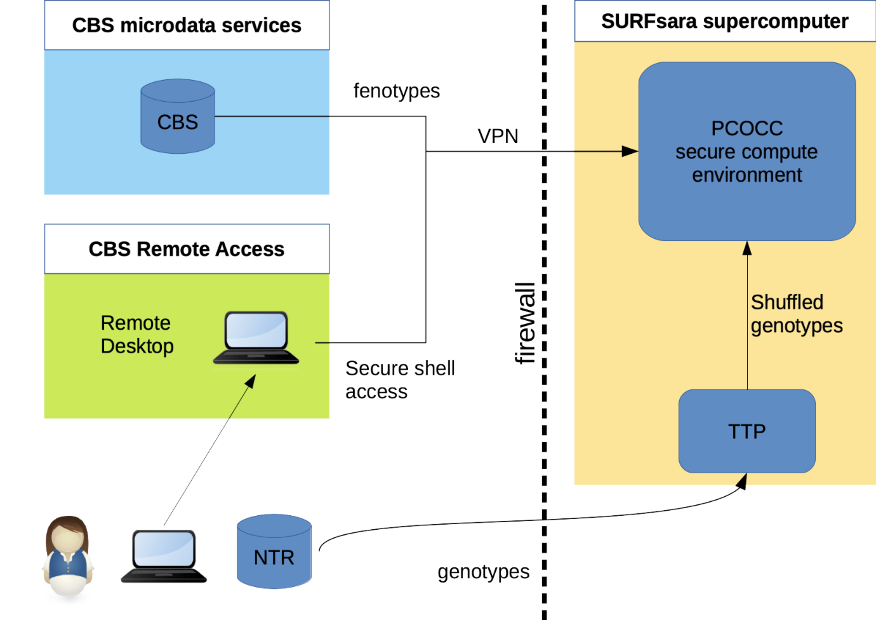

Figure S2. Histogram of health care expenditure for (A) mental health care, (B) medication, (C) primary care and (D) hospital care
A B

C D

Figure S3. (A) Q-Q plot and (B) Manhattan plot of P-values of the genome-wide association analysis for mental health care expenditure
A
B
Note. The top line is the genome-wide significance threshold (p < 5x10⁻⁸) and the bottom line indicates the threshold for suggestive significance (p < 1x10⁻⁵)

Figure S4. (A) Q-Q plot and (B) Manhattan plot of P-values of the genome-wide association analysis for medication expenditure
A
B
Note. The top line is the genome-wide significance threshold (p < 5x10⁻⁸) and the bottom line indicates the threshold for suggestive significance (p < 1x10⁻⁵)

Figure S5. (A) Q-Q plot and (B) Manhattan plot of P-values of the genome-wide association analysis for primary care expenditure
A
B
Note. The top line is the genome-wide significance threshold (p < 5x10⁻⁸) and the bottom line indicates the threshold for suggestive significance (p < 1x10⁻⁵)

Figure S6. (A) Q-Q plot and (B) Manhattan plot of P-values of the genome-wide association analysis for hospital care expenditure
A
B
Note. The top line is the genome-wide significance threshold (p < 5x10⁻⁸) and the bottom line indicates the threshold for suggestive significance (p < 1x10⁻⁵)

