Twin Research and Human Genetics

‘Essential Tremor’ Phenotype in FMR1 Premutation/Grey Zone Sibling Series: Exploring Possible Genetic Modifiers
Danuta Z. Loesch, David L. Duffy, Nicholas G. Martin, Flora Tassone, Anna Atkinson, and Elsdon Storey

Supplement
Case descriptions
Case 1. MD282. Male tested at the age of 62. Occupation: Fitter and turner. His CGG repeat size of 70 is within premutation range. He has two sons and one daughter (of unknown CGG score), who do not present with any problems and do not have their own children. No significant medical history except insomnia for the last few years, otherwise good general health and no medications
He first noticed hand tremor at the age of 59. Neurological examination revealed moderate action/intention tremor of right upper and left lower limbs, with slight action/intention tremor of left upper and right lower limbs. In addition, there was slight postural tremor of both hands and voice. There was no tremor of face, head, tongue, trunk, and no orthostatic tremor was evident. Stands and gait were normal (including tandem gait), and there were no parkinsonian features. His prorated IQ was average (see Table 1), and specific cognitive testing listed in Table 1, were within normal range. Three domains of SCL-90 (OC, D and A) and overall measure of distress (GSI) were unremarkable (see Table 1).
FLAIR MR images showed scattered T2 hyperintense white matter foci in thalami, frontal, and parietal and occipital regions, and thick periventricular bands in frontal, parietal and occipital regions. No specific features of FXTAS.
Case 2. PD273. Male tested at the age of 61. Occupation: Horticulture business owner/manager. His CGG repeat size of 63 is within premutation range. He has 2 sons and 3 daughters of 66,68, and 65 CGG repeats, respectively, who are reportedly normal, and do not yet have their own offspring. Has been suffering from migraines for the last 10 years, had knee reconstruction 10 years ago. Otherwise in good general health and no medications.
He was not aware of tremor, but neurological testing revealed a moderate action/intention tremor in both upper limbs and the left lower limb (the natural pattern may have been altered by a left knee replacement and right tendon repair). There was a slight action/intention tremor in the right lower limb, and slight postural tremor of both upper limbs and the left lower limb. There was a slight tremor of the protruded tongue (but not the tongue at rest). There was apparent orthostatic tremor evident on clinical examination in both thighs on standing. There was no tremor of head or voice. Stands and gait revealed a slight increase in body sway with feet together and eyes closed, but gait itself was entirely normal (including tandem gait). In addition to postural and action tremor of the arms, there was slight neck rigidity with co-activation and mild bradykinesia on finger tapping on the left. There were no other features of parkinsonism. His prorated IQ was above average, and other cognitive tests, given in Table 1, were within normal range. Three domains of SCL-90 (OC, D and A) and overall measure of distress (GSI 90) were unremarkable.
FLAIR MR images showed a few small hyperintensities in frontal and parietal white matter, with a thin periventricular band around the occipital horn. Neither finding was considered abnormal for age. There were not features typical of FXTAS.
Case 3. TD289. Male tested at the age 55. Occupation: Unit controller at the power plant. CGG expansion size within grey zone range (47). He has no offspring. Medical history: Burkitt’s lymphoma in 2004, treated with chemotherapy but not radiotherapy. Has had occasional panic attacks and periods of depression and anxiety. Otherwise in good general health, no medications.
He noticed slight tremor at the age of approximately 53. Neurological testing showed moderate action/intention tremor in the right upper limb and slight - in the left. There was also a slight postural tremor in the right upper limb. There was no tremor, either postural or action/intention, in the lower limbs. There was no tremor of tongue, voice, face, head or trunk. There was no clinically apparent orthostatic tremor. His stands and gait were normal, and he had no difficulty with tandem gait. Apart from a slight postural and action tremor of the right upper limb, there was mild bradykinesia of the left wrist on pronation/supination. There were no other features of parkinsonism. Prorated IQ was high average. His psychomotor speed on Part A of TMT was superior, and the remaining cognitive tests were within average to above average range (see Table 1). Apart from a markedly low level of anxiety (2 SD below average) and of psychiatric symptomatology overall, the remaining domains on SCL90 are unremarkable.
His MR images were not available.
Case 4. KH354. Female tested at the age of 53. Occupation: Health administrator. CGG expansion size within grey zone range (44/29), AR=0.1 (skewed), FMR1 mRNA=0.94. She has 2 sons, one with possible developmental delay, but not yet tested. Medical history: episodes of depression at younger age treated with medications; currently anxiety and occasional panic attacks, otherwise in good general health. Age of menopause-49 years.
She was aware of the tremor approximately 3-4 years ago-after learning about fragile X in her family. Neurological examination showed moderate action/intention tremor in the lower limbs bilaterally accompanied by a slight postural tremor of the right lower limb. There was also a slight action/intention tremor of the upper limbs bilaterally with a slight postural tremor bilaterally. There was no resting tremor of the limbs, no tremor of the head, face, tongue or voice, and no orthostatic tremor was evident clinically. One stance condition (feet together, eyes open) was mildly abnormal, resulting in slight oscillations of the trunk. No parkinsonian features, and total UPDRS score of 4 is attributable to intention tremor. Prorated IQ was in the above average to superior, and consistently with this result, more detailed cognitive testing revealed superior performance on WAIS III. She displayed a modern increase in the depression domain of SCL90, as well as a moderate level of overall psychiatric symptomatology.
FLAIR MR images at that time revealed T2 hyperintense apical caps on the frontal horns, which are mildly atypical for age. There were a few scattered T2 hyperintensities in the cerebral white matter, and mild T2 hyperintensity in the central pons. There were no core radiological features of FXTAS.
Case 5. DH350. Female tested at the age of 62. Occupation: School administrator. CGG expansion size within premutation range (67/29), AR inconclusive, FMR1 mRNA=1.15. She has three daughters, one of whom is a premutation carrier of 70 CGG repeats, and one son, who is a carrier of 67 repeats; they do not have their own offspring. Medical history: she reported anorexia and periods of depression in adolescence. Recurrent depression between 40-45 years of age was treated by counselling. Broke r. femur and the wrist about 10 years ago. Presently -no health problems or medications. Age of menopause-between 38 and 39 years of age.
She noticed deterioration of handwriting at the age of 57, and at 61-obvious hand tremor and unsteadiness. Neurological examination showed moderate action/intention tremor in the upper limbs bilaterally, a slight action/intention tremor of the lower limbs bilaterally, and a moderate vocal tremor on holding a sustained note (that is, postural vocal tremor), but not on speaking. There was no resting tremor of the limbs. There was no tremor of the head or face, or tongue, and no orthostatic tremor was apparent clinically. Gait and stance were normal, as was tandem gait. Only slight parkinsonian signs were present: mild (grade 1) bradykinesia of left foot tapping and slight neck rigidity. There was apparent moderate (grade 2) bradykinesia of the right wrist on pronation/supination, but this was deemed likely due to previous pinned wrist fracture. Cognitive assessment revealed a prorated IQ in the above average to superior range, and more detailed cognitive testing was unremarkable. The SCL90 domains and overall level of psychiatric distress were unremarkable.
FLAIR MR images performed several months later revealed numerous T2 hyperintensities (moderate for age) towards the periphery of the frontoparietal white matter. There were no specific radiological features of FXTAS.
Case 6. MW353. Female tested at the age of 66. Occupation: Nurse. CGG expansion size within premutation range (75/29), AR=0.9 (skewed). She has three daughters, one is a carrier of premutation (121/30 CGGs), one is carrying the low-range full mutation (274/30 CGGs) and has developmental delay. Her third daughter in not a carrier (30/30 CGGs). Both her sons are apparently not affected, and have not been tested for the CGG size. Medical history: lupus (treated with Plaquinol), sleep apnoea, episodes of mild depression (not treated). Age of menopause: between 39 and 40 years of age.
She first noticed tremor in the upper limbs at the age of 57. Neurological examination showed marked action/intention tremor and moderate postural tremor in the left upper limb, with slight action/ intention and postural tremor of the right upper limb. There was also a slight postural tremor, without accompanying action/intention component, of the left lower limb. There was no resting tremor of the upper or lower limbs. There was a moderate postural voice tremor (on holding a sustained note), and a slight postural tremor of the protruded tongue. There was no tremor of the head or face, and no orthostatic tremor was apparent clinically. Gait and stance were normal, including tandem gait. Only slight parkinsonian signs were present. A prorated IQ was in the above average range. Detailed cognitive testing was unremarkable -in the average to above average range-the exception being processing speed (SDMT), on which her performance was very superior. The SCL90 domains and overall level of psychiatric distress were unremarkable. FLAIR MR images only revealed few scattered small T2 hyperintensities, but no changes either specific or specific to FXTAS.

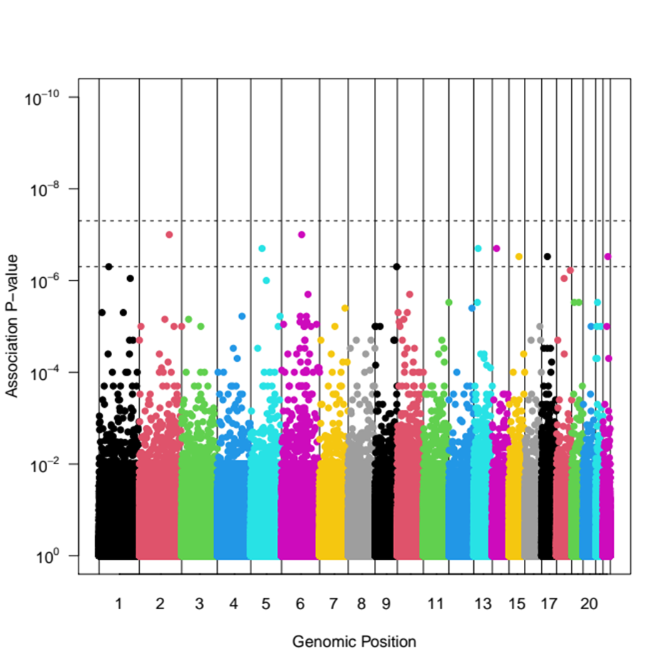
Supplementary Figure 1. Genomewide association analysis for the 6 sibling series versus 45,000 Australian controls. Both case and control samples contain families, so association p-values have been calculated by gene-dropping simulation in the Sib-pair package. None exceed the genomewide significance level of 5x10⁻⁸.

