Supplementary figures

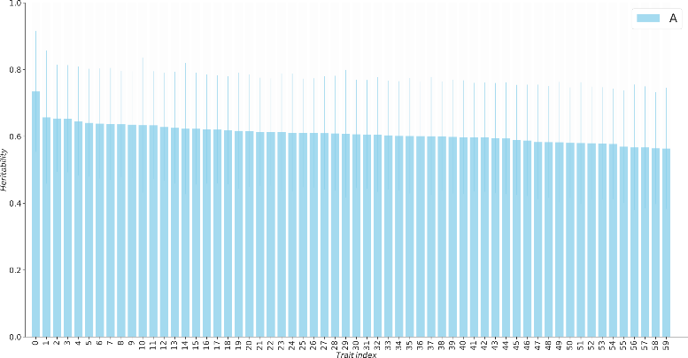 | 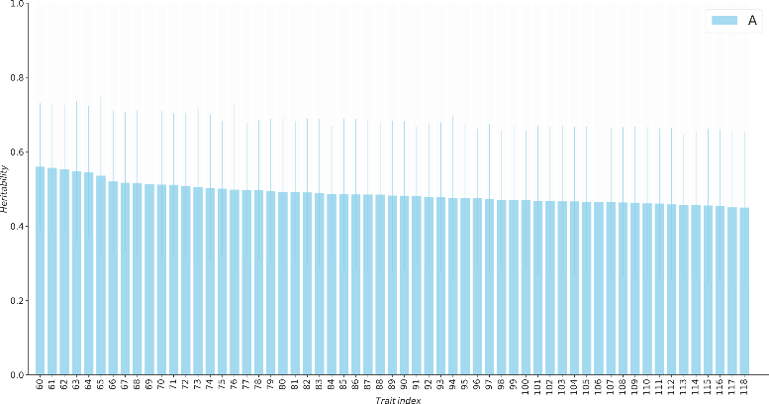
Percentile 75 – 100 | Percentile 50 – 75
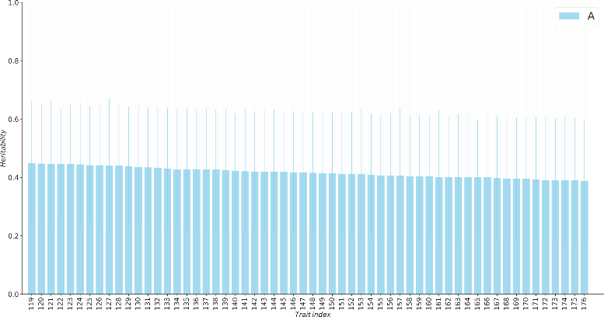 | 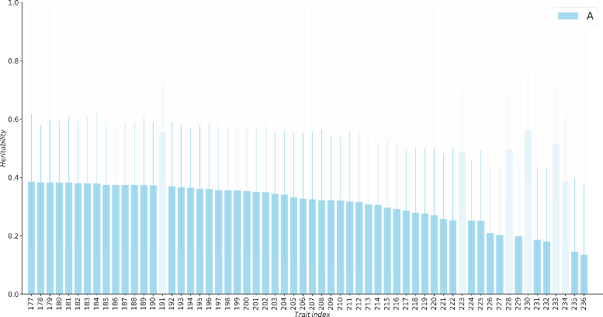
Percentile 25 – 50 | Percentile 0 – 25
Figure S1 Heritabilities for twin AE models. The transparent bars represent the 6 metabolites (“Ca-EDTA”, “Methanol”, “Formate”, “Glucose” and “Methionine” of platform NMR-LUMC and “PC” of platform Nightingale) exhibiting a significant contribution of C was observed (χ² > 3.84).
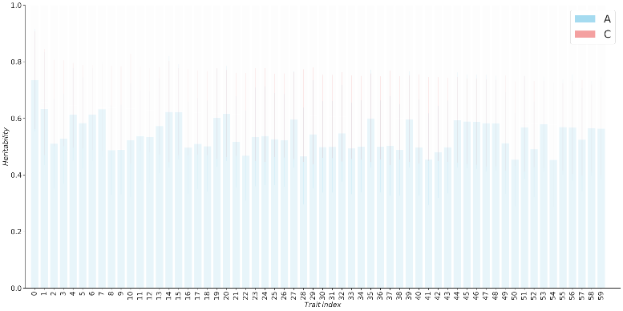 | 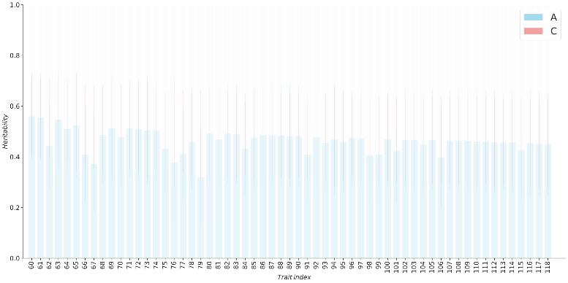
Percentile 75 – 100 | Percentile 50 – 75
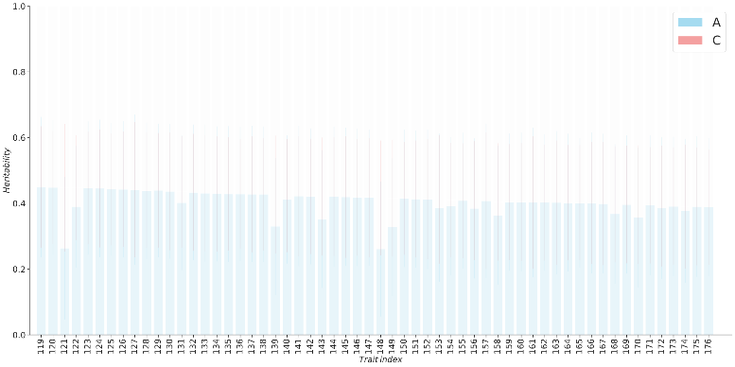 | 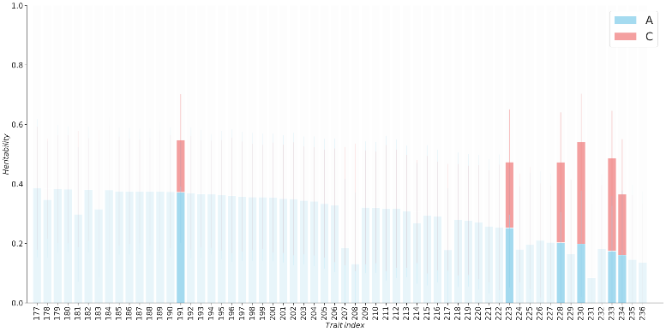
Percentile 25 – 50 | Percentile 0 – 25
Figure S2 Heritabilities for twin ACE models. The opaque bars represent the 6 metabolites (“Ca-EDTA”, “Methanol”, “Formate”, “Glucose” and “Methionine” of platform NMR-LUMC and “PC” of platform Nightingale) exhibiting a significant contribution of C was observed (χ² > 3.84).

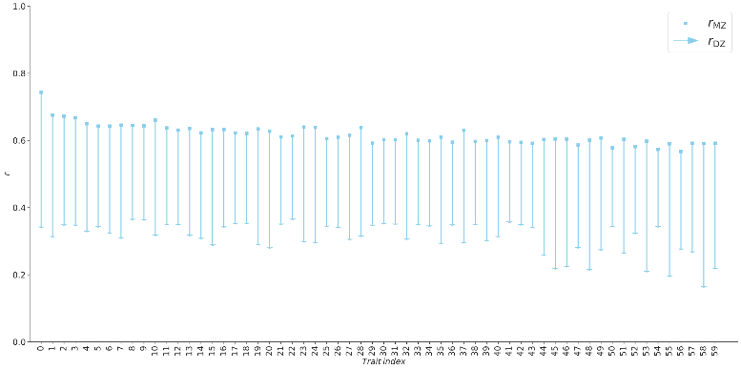 | 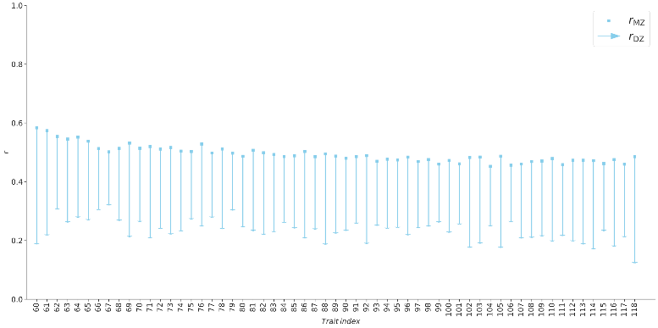
Percentile 75 – 100 | Percentile 50 – 75
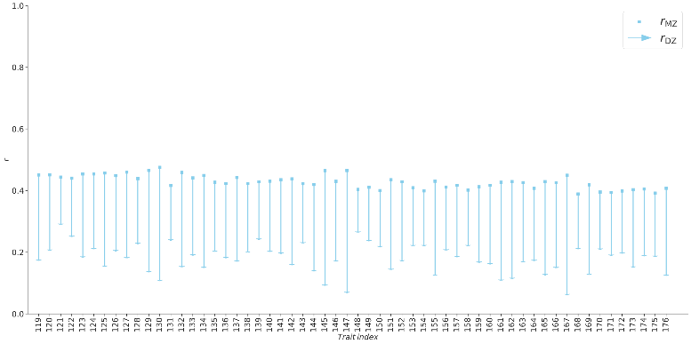 | 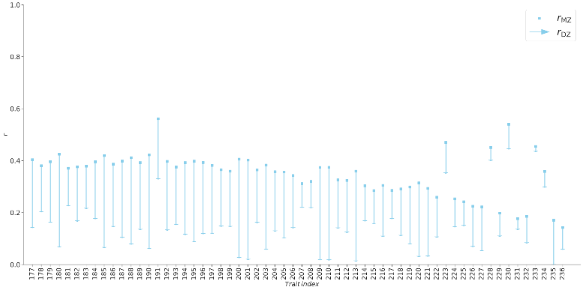
Percentile 25 – 50 | Percentile 0 – 25
Figure S3 MZ twin correlations r_{MZ} and DZ twin correlation r_{DZ} for each metabolite studied.

