Supplemental Figure.

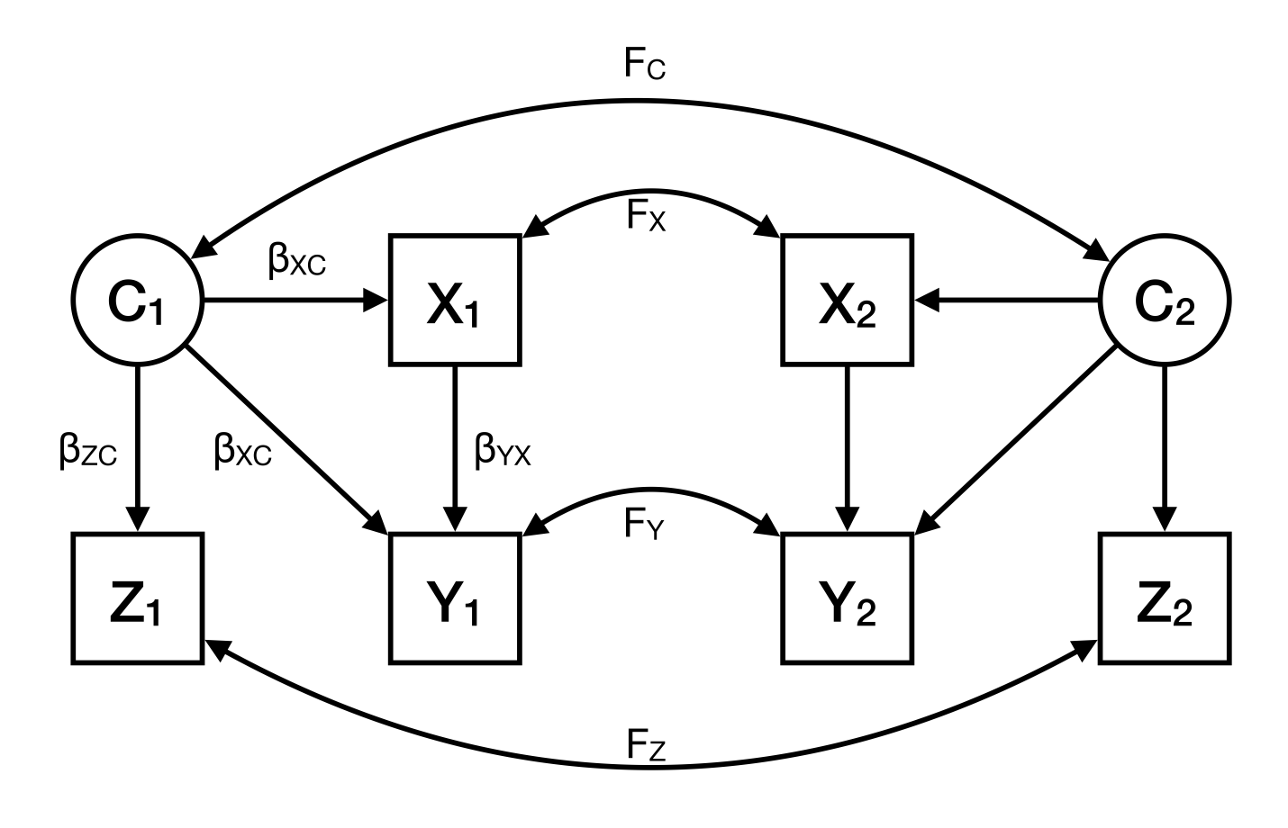

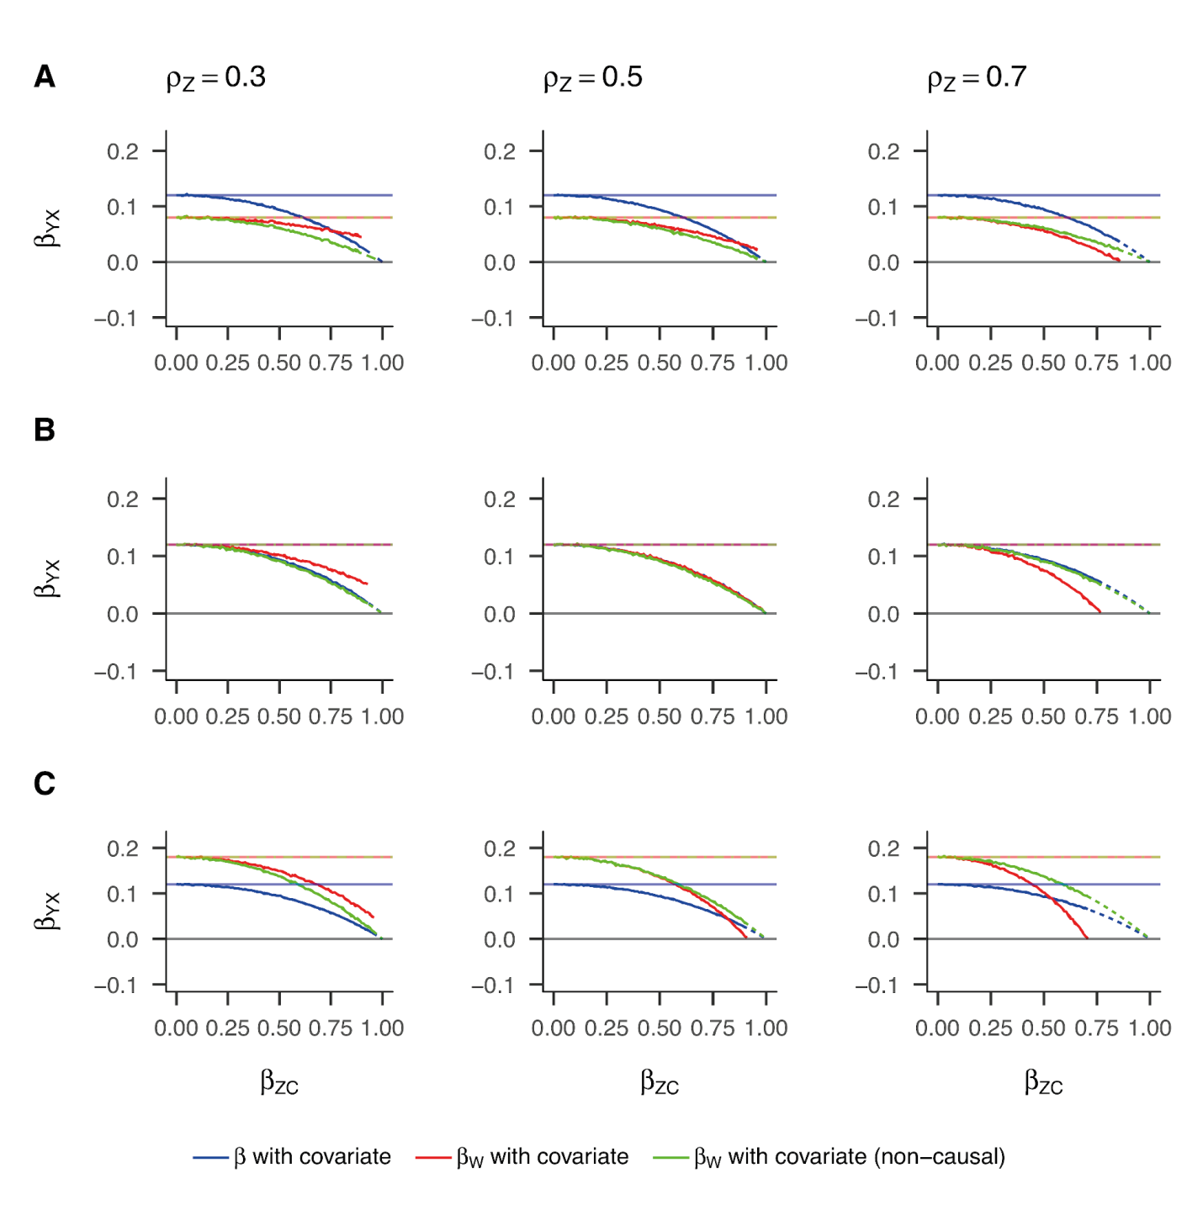

*Supplemental Figure.* Exposure effect estimates with the inclusion of a covariate from individual-level and within-pair models when A) the within-pair correlation in the exposure is less than the within-pair correlation in the confounder; B) the within-pair correlation in the exposure equals the within-pair correlation in the confounder; C) the within-pair correlation in the exposure is more than the within-pair correlation in the confounder. For each scenario = 0.5, while varies between 0.3, 0.5, and 0.7 (consistent with Figure 2). Additionally, each column represents a different value of , the within-pair correlation in the covariate.  is the effect of the confounder on the covariate. Blue lines denote the exposure estimate from individual-level models, red lines denote the exposure estimate from CTC models as specified in equation 4, and green lines denote the exposure estimate from CTC models as specified in equation 3. Simulation results (solid lines) are overlaid on the derivation results (dashed lines) to show their concordance. Darker lines denote the exposure effect estimate with covariate inclusion while lighter shaded lines denote the same estimate without covariate inclusion. The true causal exposure effect is zero ().