# Supplemental material.

Table S1. Beginning of follow up in the NorTwinCan cohort, by country and birth cohort

|  |  |  |  |
| --- | --- | --- | --- |
|  | Birth year cohort | Beginning of follow up in the current study | Remarks |
| Denmark | 1870-1930  1931-1/4 1968  2/4-1968-2004 | 1/1-1943  2/4-1968*  Date of birth | * 2 Apr 1968 (start of the Danish Civil registration System) was chosen as beginning of follow up although ascertainment of 25% of twin pairs born 1931-1952 was been based on other information sources that existed before that date. |
| Finland | 1890-1957 | 1/5-1976 | Cohort compiled in 1974 with questionnaire study for zygosity (and risk factors) in autumn of 1975 |
| Norway | 1895-1945  1915-1960  1967-1979 | 1/1-1964  1/1-1978  18 years of age | Reported as identified in 1961, but first dead is registered in 1964. |
| Sweden | 1886-1925  1926-1958  1959-1985  1985-1986  1987-1991  1992, 1995  1993, 1996  1994, 1997  1998  1999  2000 | 1/1-1962  1/1-1973  1/1-2005  1/7-1994  Date of birth  1/1-2004  1/1-2005  1/1-2006  1/1-2007  1/1-2008  1/1-2009 |  |

Figure S1. Number of twin individuals included in study, by country and birth year (each bar represents one year). Only twins from same-sexed twin pairs.



Figure S2. Standardised mortality ratios (SMR) for same-sexed twins in the Nordic twin registers, by country, birth year, age at follow-up, period of follow-up, and time since beginning of the follow up. Excluding first year of life.

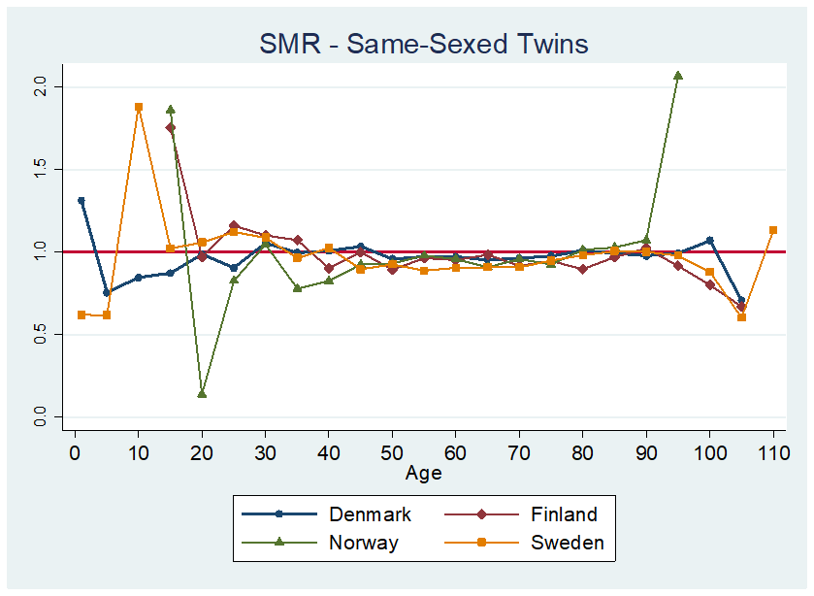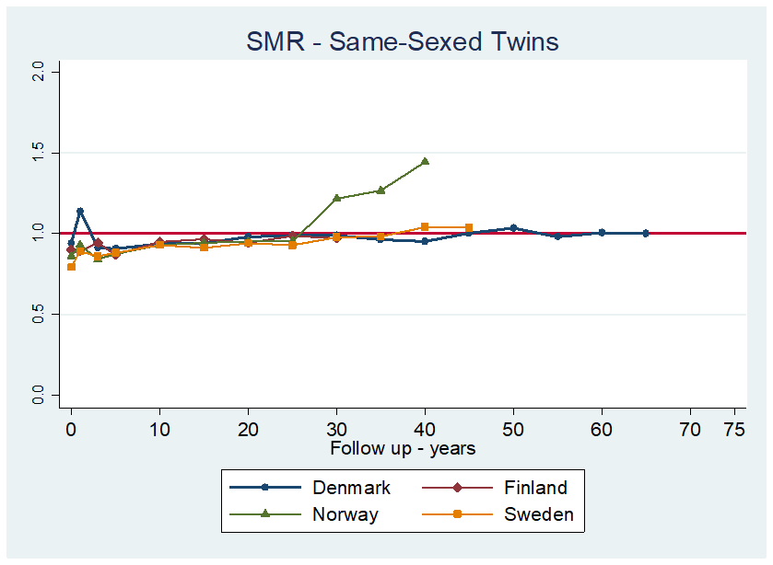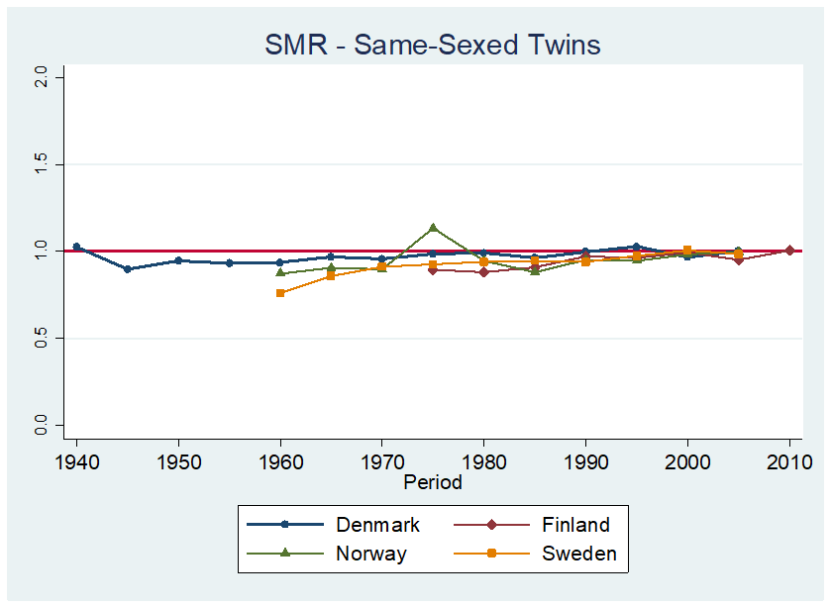

Figure S3. Effect of excluding / including UZ in SMR for Same-sexed twins

