Twin Research and Human Genetics

Fetal Origins of Mental Disorders? An Answer Based on Mendelian Randomization
Subhi Arafa and Camelia C. Minică
Department of Biological Psychology, Vrije Universiteit, Amsterdam, the Netherlands

Supplementary Material
Supplementary Table S1: Association between the genetic variants used to instrument our main Mendelian randomization analyses and potential confounders. There are 13 variants (displayed in bold) showing an association with either educational attainment, cigarettes per day (CPD) or ever smoking, given a liberal threshold of 0.05. The MR analyses were re-run by removing these variants to check the robustness of our results.

SNP | Educational attainment |  | CPD |  | Ever smoked |  | Removed
 | Beta | P-value | Beta | P-value | Beta | P-value
rs1011939 | -0.004 | 0.164 | NA | NA | NA | NA | No
rs10402712 | -0.005 | 0.08 | NA | NA | NA | NA | No
rs10830963 | 0.003 | 0.243 | -0.073 | 0.493 | -0.011 | 0.463 | No
rs10935733 | 0.001 | 0.601 | NA | NA | NA | NA | No
rs1101081 | 0 | 0.944 | NA | NA | NA | NA | No
rs11055034 | -0.003 | 0.253 | -0.074 | 0.447 | -0.013 | 0.326 | No
rs113086489 | -0.002 | 0.425 | NA | NA | NA | NA | No
rs11719201 | 0.006 | 0.0467* | NA | NA | NA | NA | Yes
rs11765649 | 0.005 | 0.089 | NA | NA | NA | NA | No
rs12543725 | 0.003 | 0.245 | -0.088 | 0.304 | -0.013 | 0.266 | No
rs12823128 | 0.002 | 0.374 | -0.07 | 0.391 | 0.004 | 0.722 | No
rs12906125 | 0.002 | 0.563 | NA | NA | NA | NA | No
rs12942207 | -0.004 | 0.141 | NA | NA | NA | NA | No
rs13266210 | -0.002 | 0.62 | 0.046 | 0.649 | 0.004 | 0.749 | No
rs13322435 | 0 | 0.887 | 0.003 | 0.97 | -0.007 | 0.606 | No
rs134594 | -0.001 | 0.68 | -0.081 | 0.338 | 0.008 | 0.491 | No
rs1351394 | 0.007 | 0.003* | -0.026 | 0.746 | 0.002 | 0.805 | Yes
rs1374204 | -0.002 | 0.581 | -0.494 | 0.012* | 0 | 0.979 | Yes
rs138715366 | -0.001 | 0.970 | NA | NA | NA | NA | No
rs139975827 | 0.003 | 0.333 | NA | NA | NA | NA | No
rs1415701 | -0.004 | 0.116 | 0.121 | 0.231 | 0.002 | 0.859 | No
rs144843919 | -0.013 | 0.105 | NA | NA | NA | NA | No
rs1819436 | -0.006 | 0.134 | NA | NA | NA | NA | No
rs2150052 | -0.003 | 0.19 | 0.001 | 0.990 | 0.009 | 0.439 | No
rs2229742 | -0.002 | 0.624 | -0.109 | 0.442 | 0 | 0.977 | No
rs2242116 | 0.004 | 0.145 | -0.048 | 0.584 | 0.017 | 0.172 | No
rs2324499 | -0.001 | 0.621 | 0.104 | 0.273 | -0.017 | 0.204 | No
rs2421016 | 0.008 | 0.001* | -0.063 | 0.435 | -0.011 | 0.307 | Yes
rs2473248 | 0.002 | 0.524 | NA | NA | NA | NA | No
rs28510415 | -0.004 | 0.391 | NA | NA | NA | NA | No
rs28530618 | 0 | 0.898 | NA | NA | NA | NA | No
rs2854355 | -0.003 | 0.342 | NA | NA | NA | NA | No
rs35261542 | 0.004 | 0.205 | NA | NA | NA | NA | No
rs3753639 | 0 | 0.924 | NA | NA | NA | NA | No
rs6016377 | 0.001 | 0.736 | 0.068 | 0.445 | -0.003 | 0.784 | No
rs6040076 | 0 | 0.893 | NA | NA | NA | NA | No
rs61154119 | 0.006 | 0.062 | NA | NA | NA | NA | No
rs61830764 | -0.006 | 0.016* | NA | NA | NA | NA | Yes
rs61862780 | -0.006 | 0.01* | NA | NA | NA | NA | Yes
rs62240962 | -0.013 | 0.004* | NA | NA | NA | NA | Yes
rs62466330 | 0.006 | 0.26 | NA | NA | NA | NA | No
rs6537307 | -0.003 | 0.274 | 0.025 | 0.754 | 0 | 0.955 | No
rs6959887 | 0 | 0.871 | 0.063 | 0.446 | 0.001 | 0.878 | No
rs6989280 | -0.002 | 0.447 | -0.037 | 0.692 | 0.012 | 0.349 | No
rs700059 | -0.002 | 0.543 | -0.012 | 0.922 | -0.013 | 0.451 | No
rs7076938 | 0.004 | 0.114 | -0.054 | 0.557 | 0.016 | 0.229 | No
rs72480273 | 0.005 | 0.102 | NA | NA | NA | NA | No
rs72851023 | 0.009 | 0.068 | NA | NA | NA | NA | No
rs7402982 | 0.008 | 0.001* | NA | NA | NA | NA | Yes
rs74233809 | 0.005 | 0.263 | NA | NA | NA | NA | No
rs7575873 | 0.003 | 0.434 | NA | NA | NA | NA | No
rs7729301 | -0.009 | 0.001* | NA | NA | NA | NA | Yes
rs7742369 | 0.002 | 0.452 | -0.023 | 0.831 | 0 | 0.979 | No
rs7847628 | -0.002 | 0.58 | NA | NA | NA | NA | No
rs7964361 | 0.012 | 0.007* | 0.035 | 0.810 | 0.016 | 0.451 | Yes
rs798489 | -0.001 | 0.825 | -0.136 | 0.151 | 0.014 | 0.27 | No
rs854037 | 0.007 | 0.038* | -0.063 | 0.563 | -0.015 | 0.322 | Yes
rs925098 | -0.01 | 0.0001* | -0.015 | 0.867 | 0 | 0.975 | Yes
rs9379832 | -0.01 | 0.0002* | NA | NA | NA | NA | Yes
SNP = Single Nucleotide Polymorphisms. CPD = Cigarettes Per Day.

Supplementary Table S2. Results of the MR-PRESSO Global test (that tests the null hypothesis of ‘no horizontal pleiotropy’) and of the outlier-corrected MR-PRESSO analyses (excluding instruments with horizontal pleiotropic effects).

 | MDD | Schizophrenia | ADHD
MR-PRESSO Global | 102.3998 | 239.6523 | 103.4139
P value | <0.001 | <0.001 | <0.001
Outlier corrected MR
Beta | -0.057 | 0.060 | -0.116
P value | 0.219 | 0.085 | 0.243

Supplementary Figure S1: Forest plots showing the effects of BW on single SNPs included in the Mendelian randomization analyses. The black points represent causal estimates of BW (SD units) on each outcome (beta coefficients), produced using each instrument individually. The causal effect estimated based on all the SNPs used to instrument the analysis are provided at the bottom of the figure along with the 95% CI. Note that the 95% CI associated with the estimates of the causal effect estimates all cross zero (regardless of the method used) indicating the association between exposure and the outcomes of interest is not causal.

A.
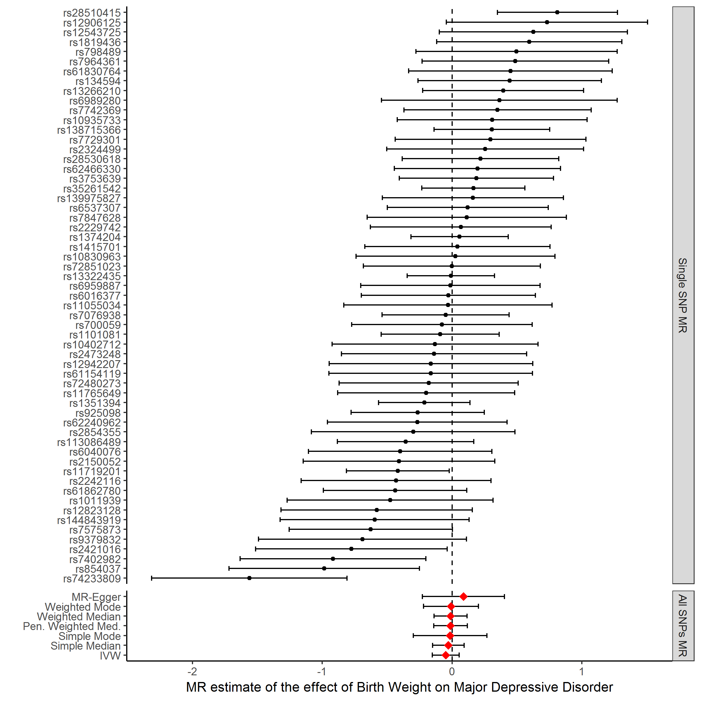

B.
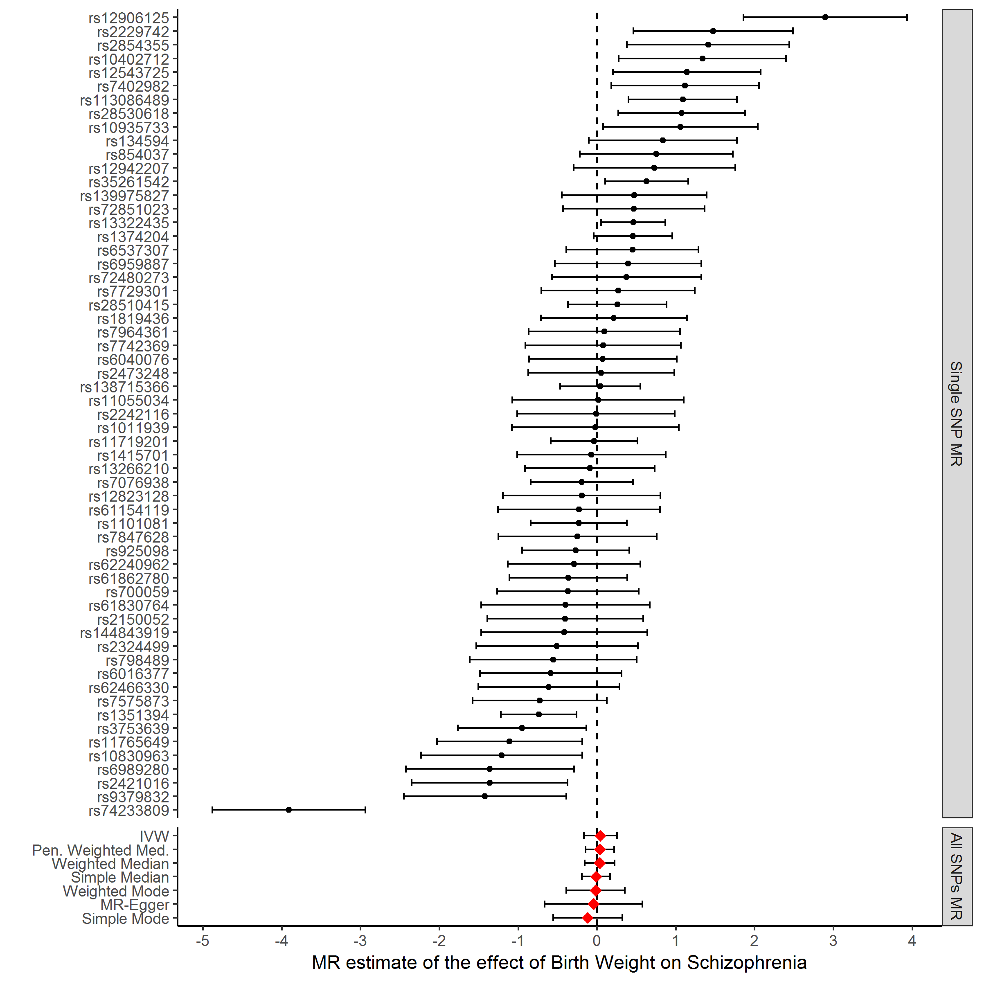

C.
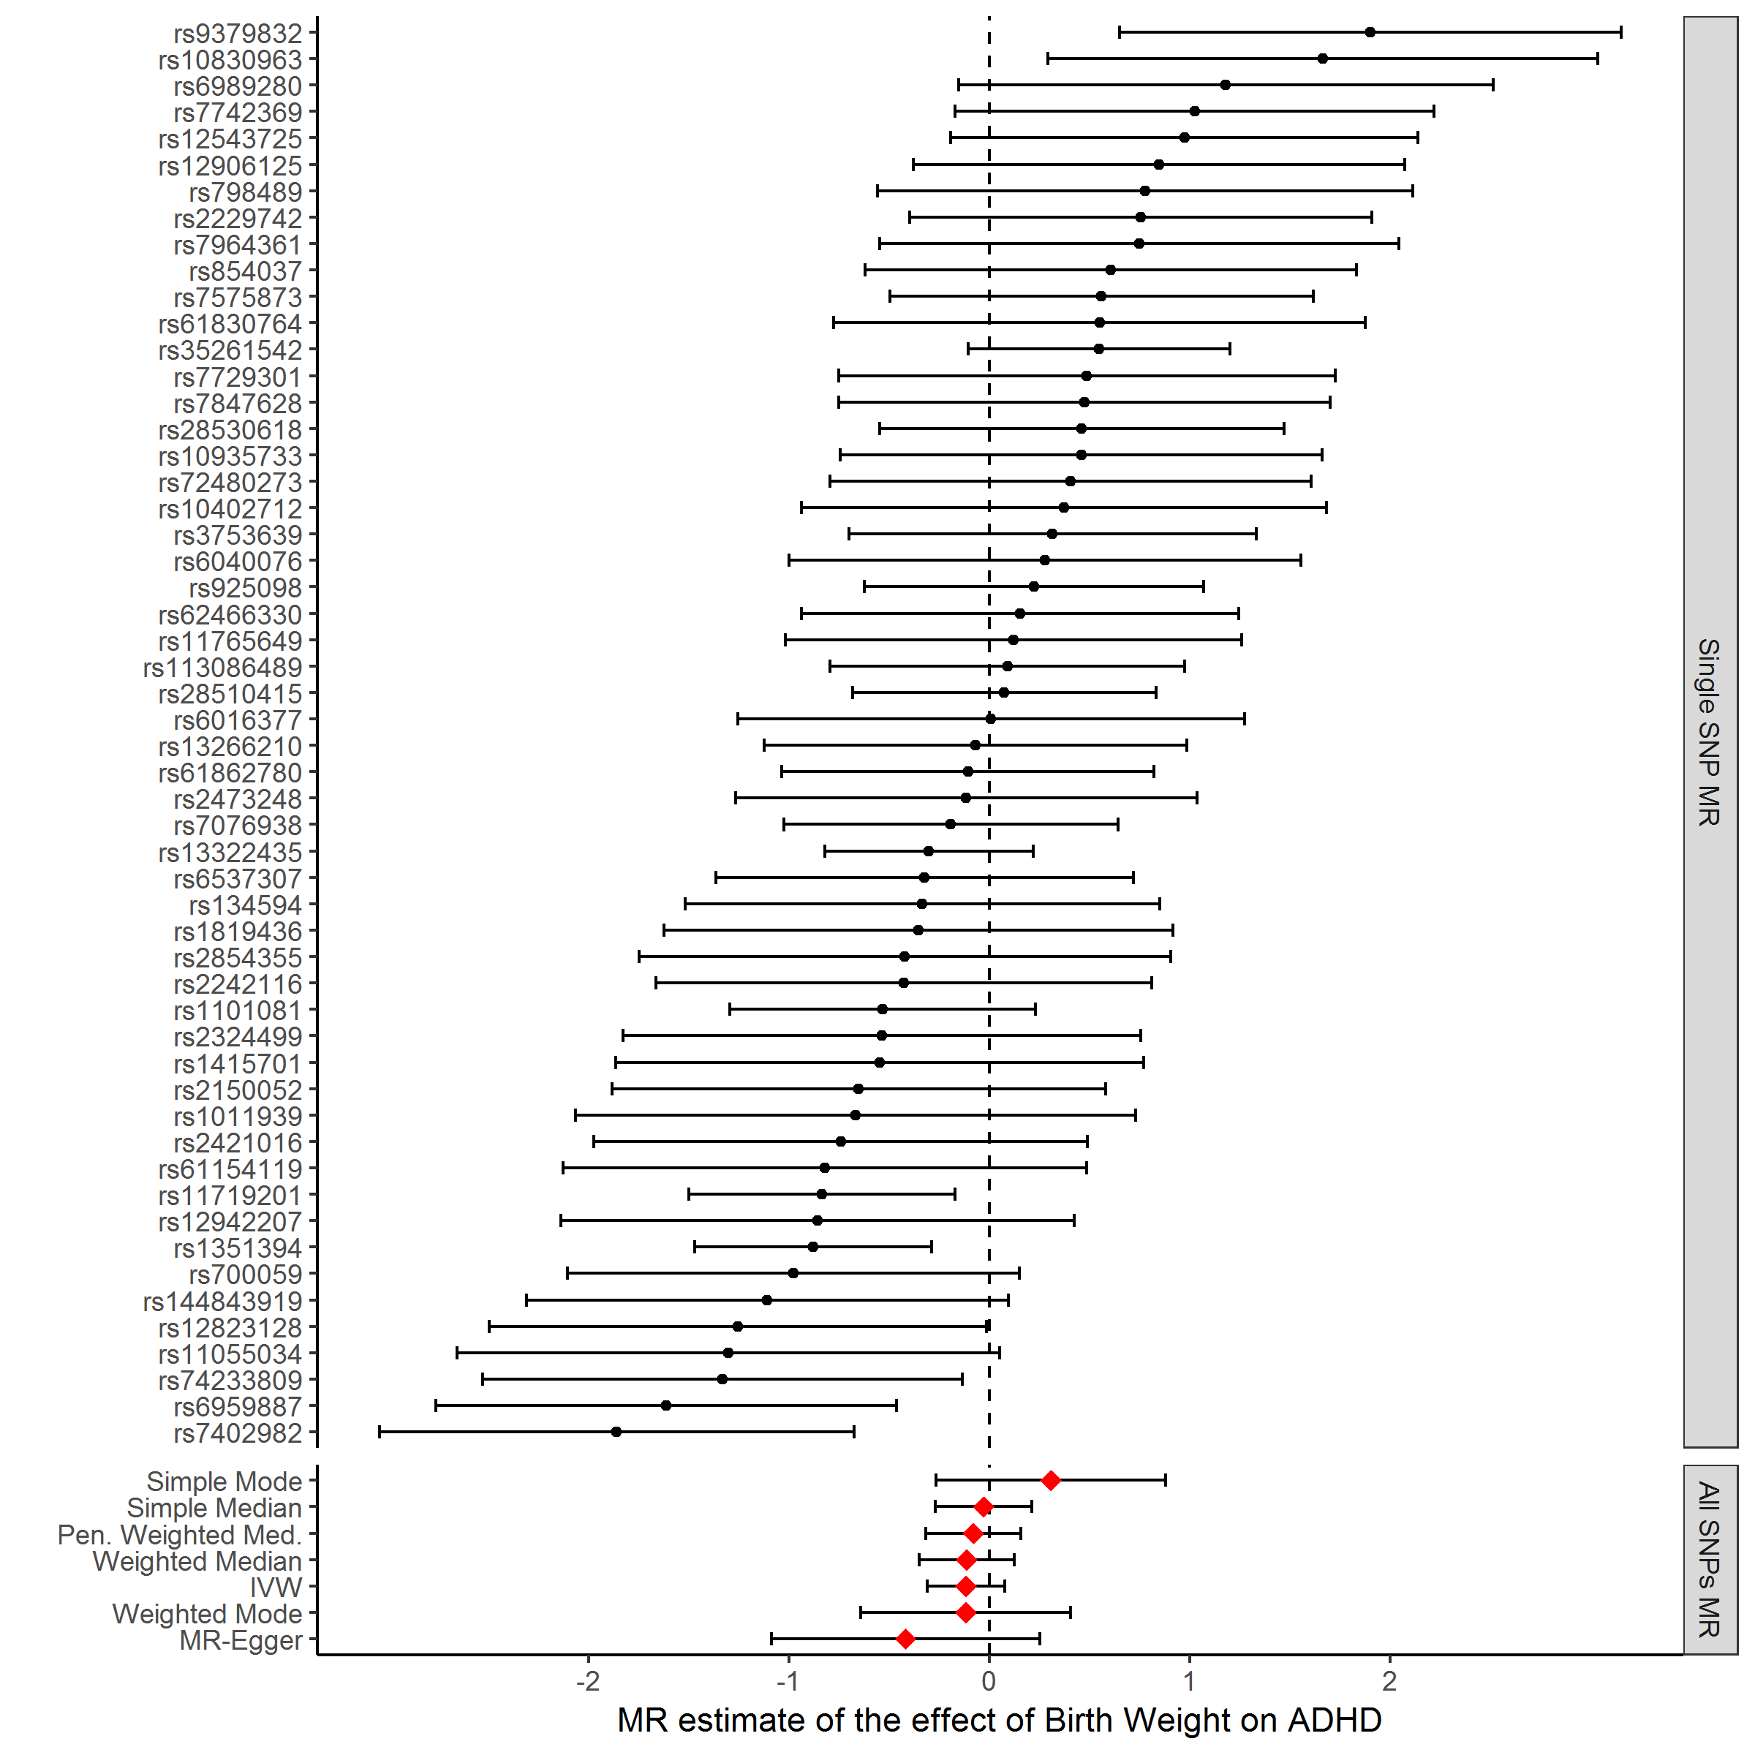

Supplementary Figure S2: Forrest plot showing the Mendelian Randomization results based on single-SNP and based on all SNPs, after removing 13 SNPs associated with potential confounders of the relationship between birth weight and major depressive disorder, schizophrenia and attention deficit/hyperactivity disorder (ADHD).

A.
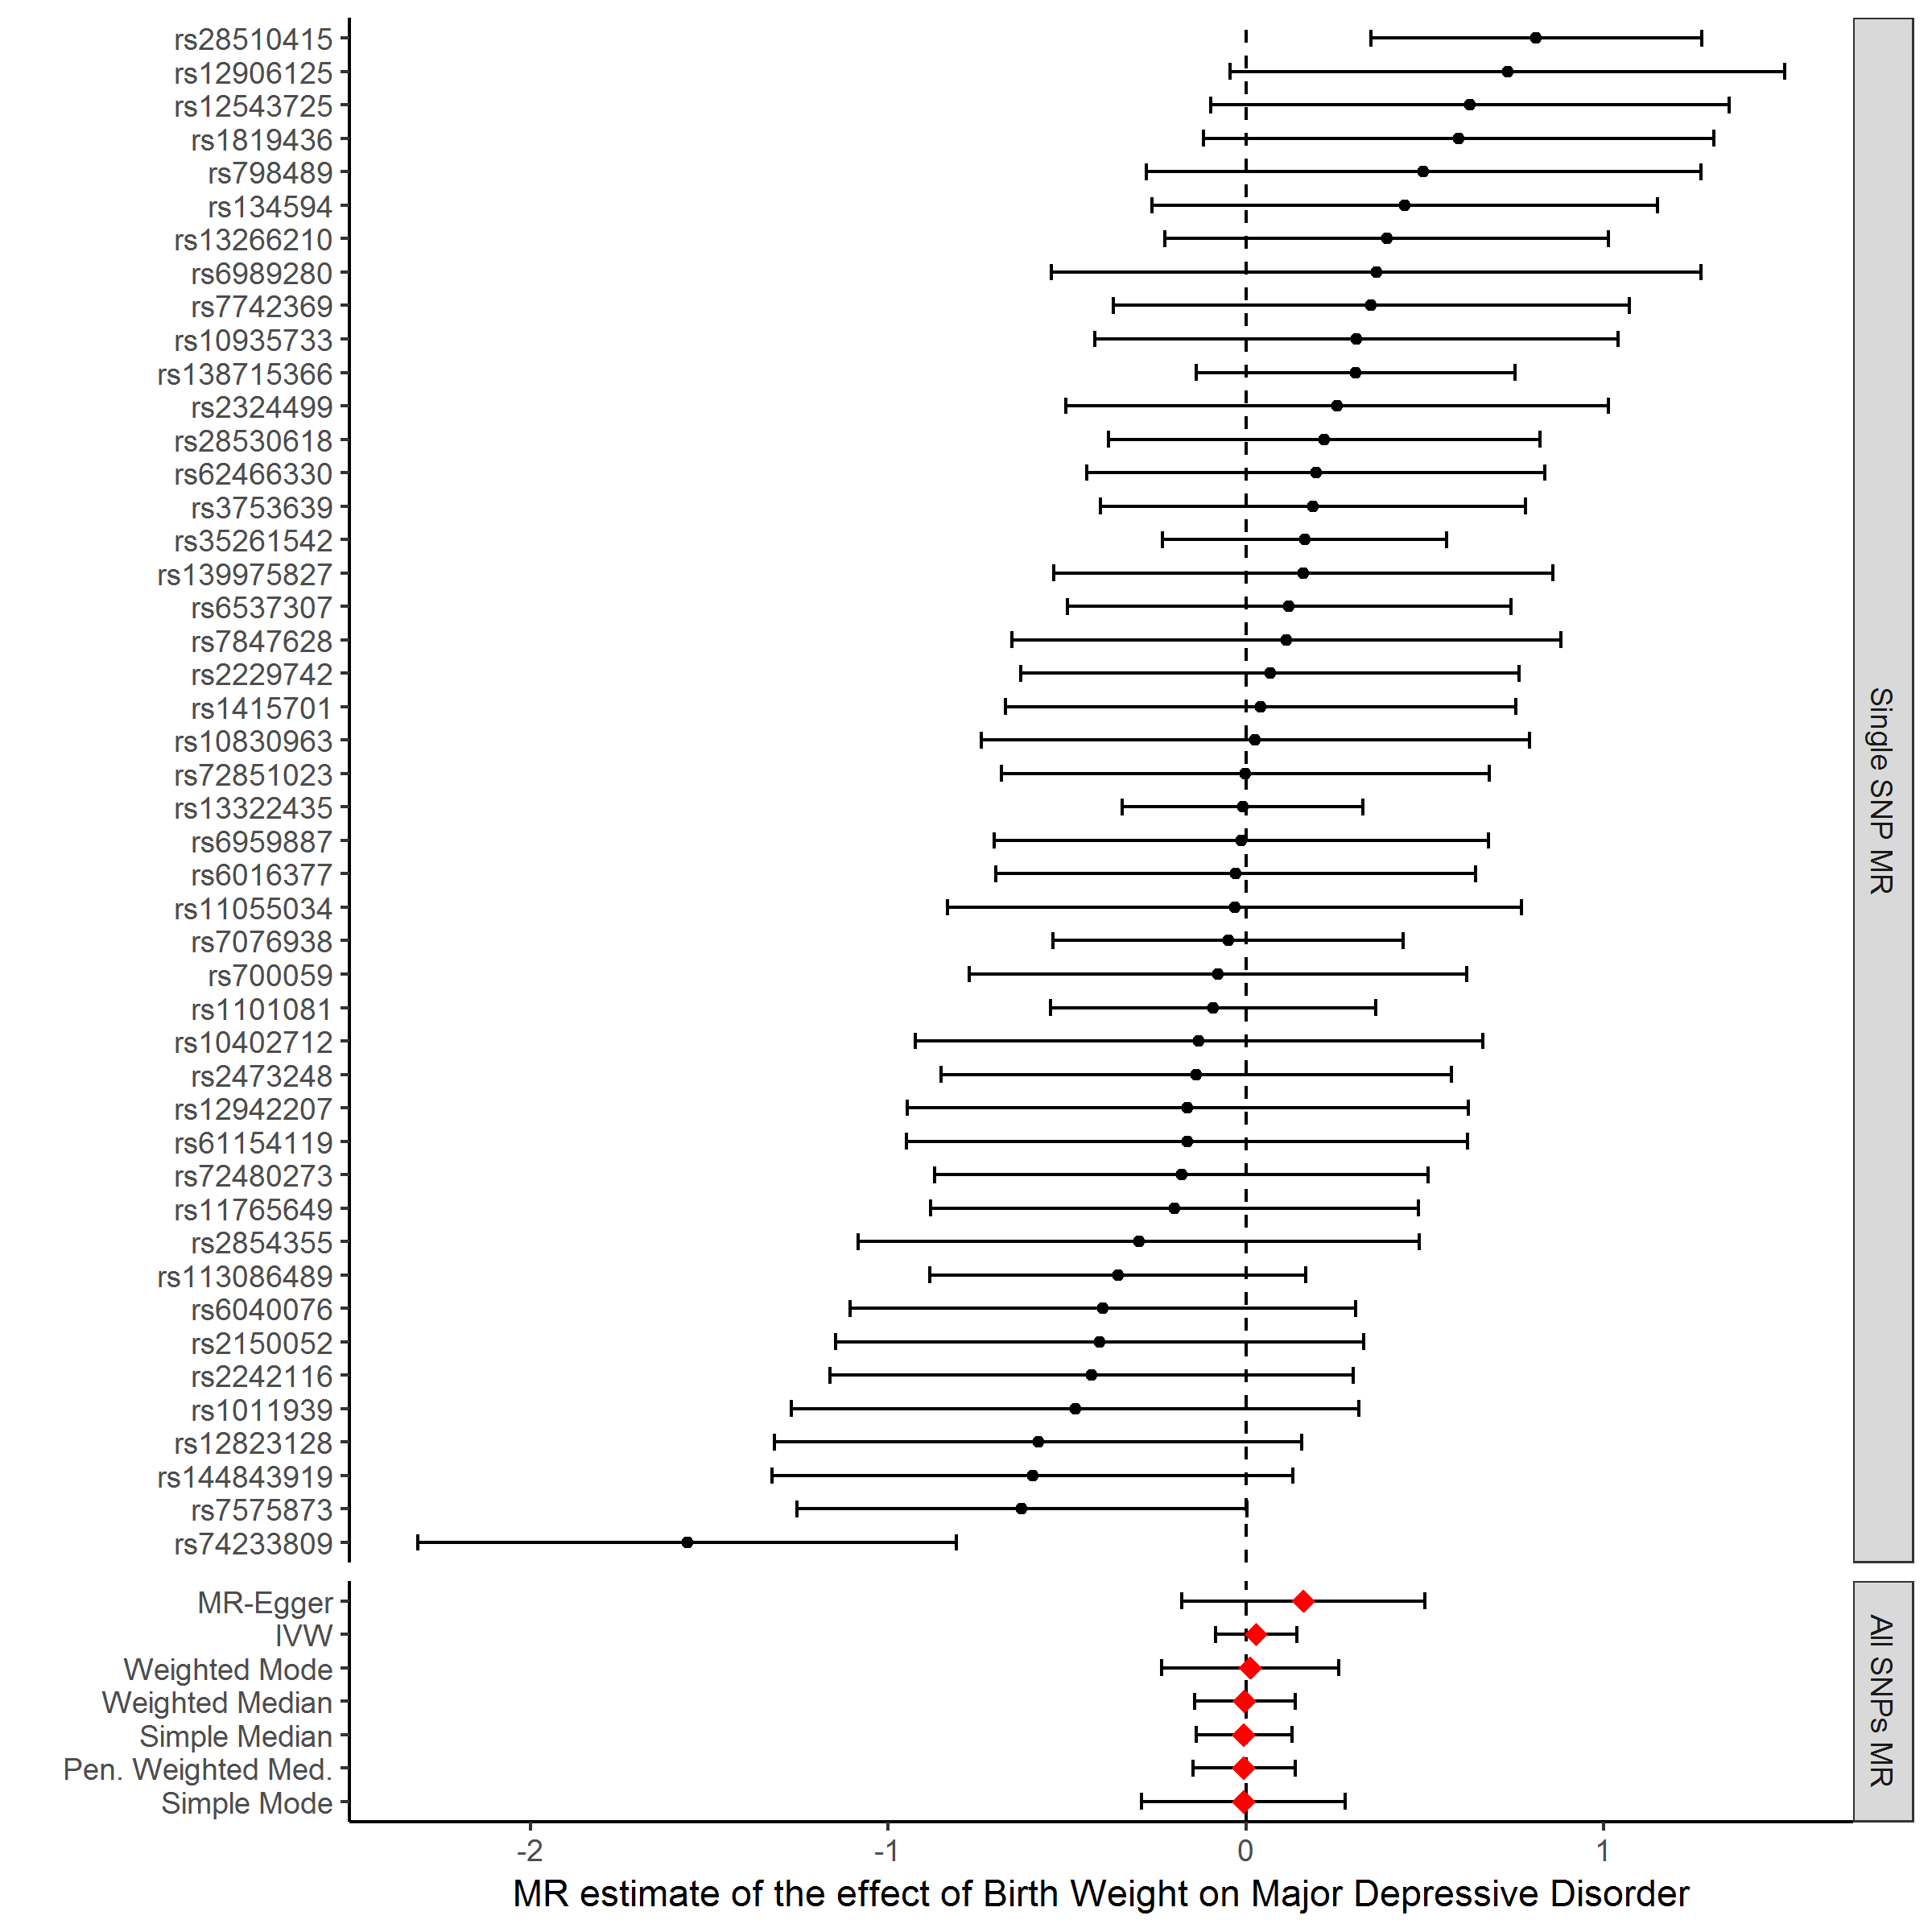

B.
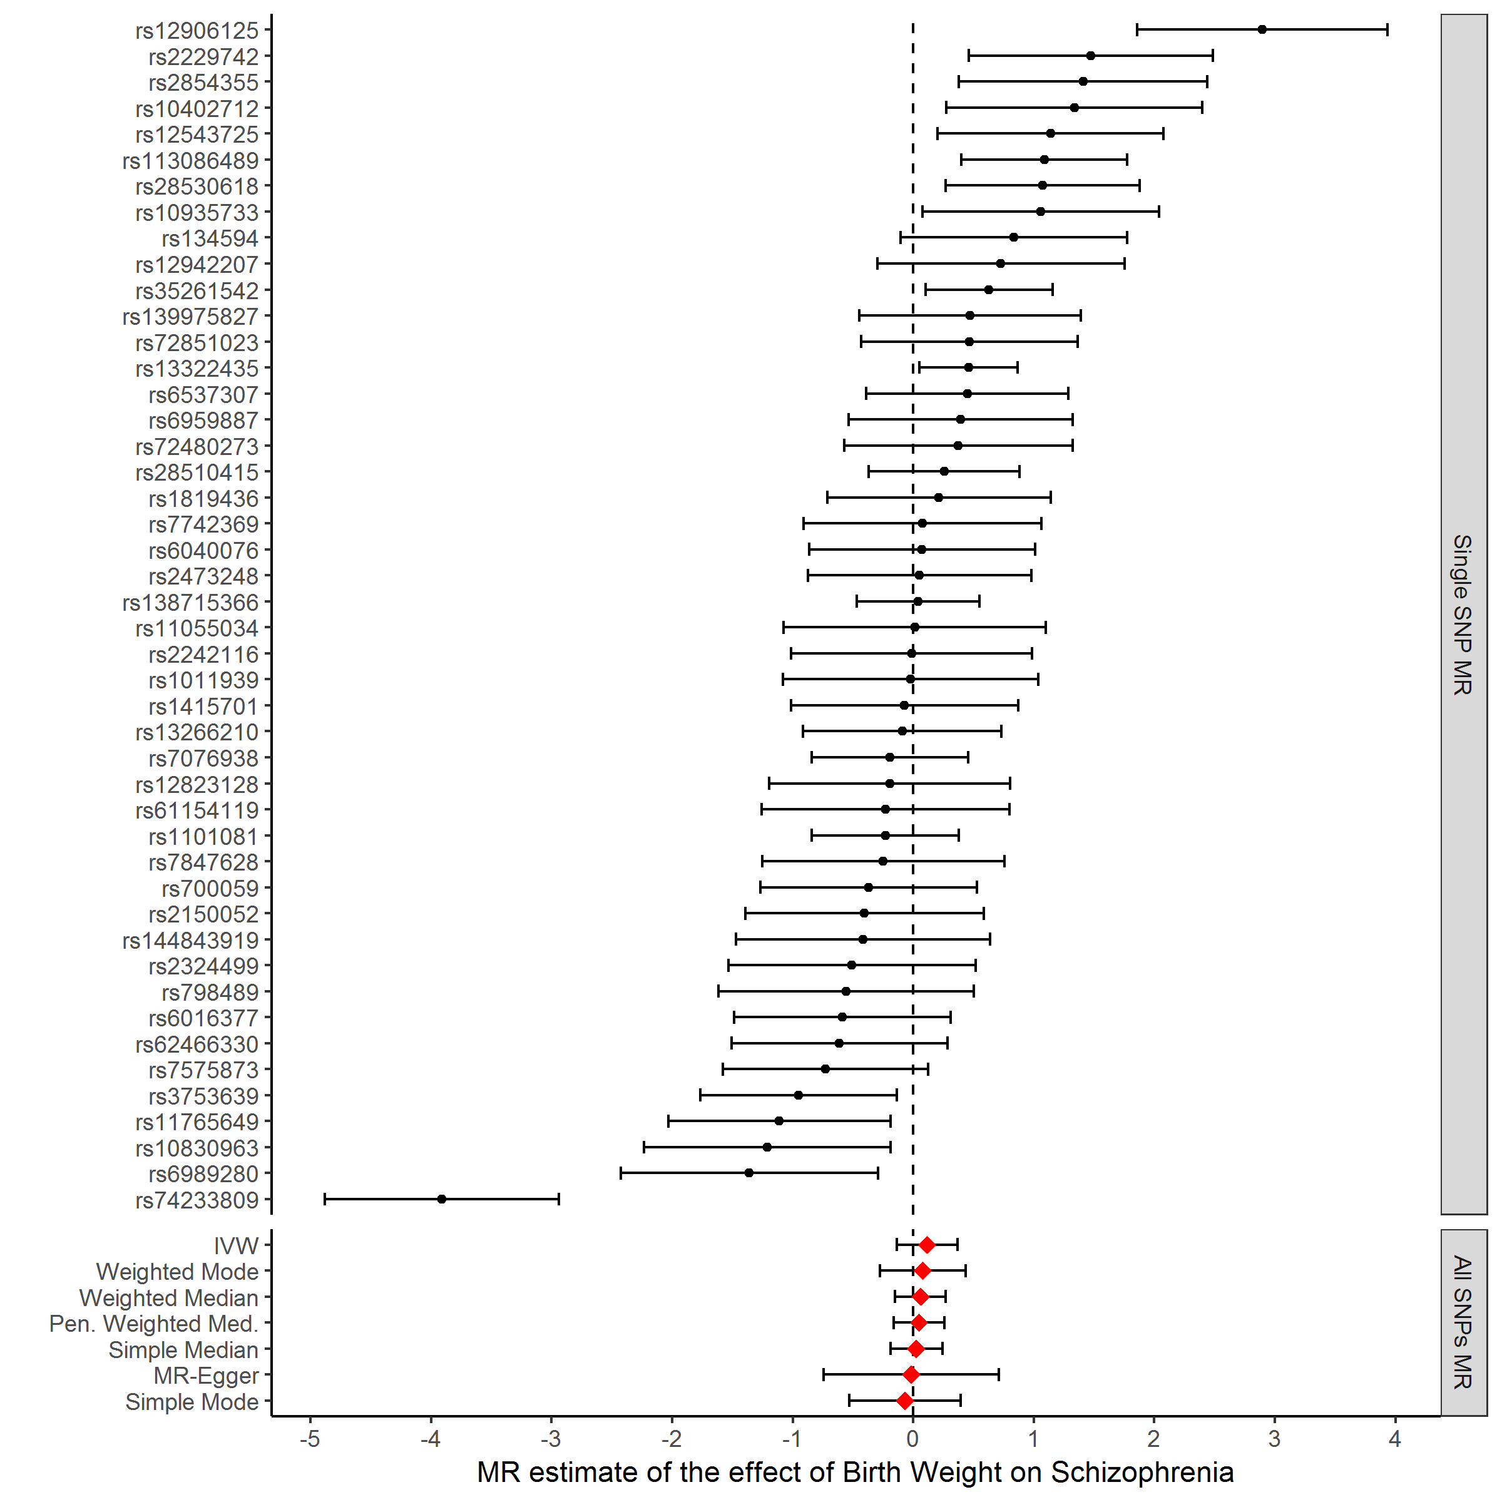

C.
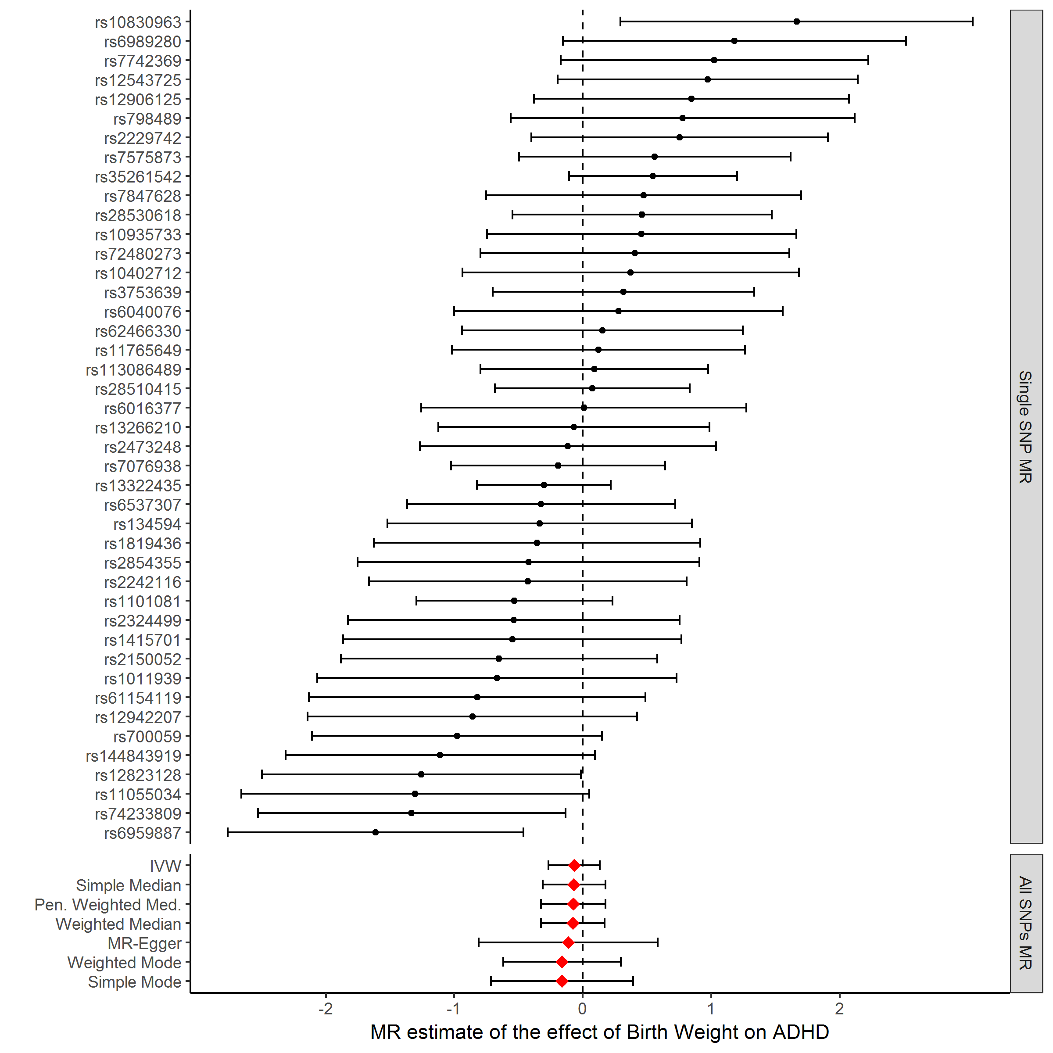

Supplementary Figure S3: Forest plot showing the results based on single- and all SNPs included in the Mendelian randomization analyses of gestational age and major depressive disorder (MDD; fig. A), schizophrenia (fig. B) and attention deficit hyperactivity disorder (ADHD; fig. C). The black points represent causal estimates of BW on each outcome, produced using each instrument individually. The causal effect estimated based on all the SNPs used to instrument the analysis are displayed as red diamonds at the bottom of the figure along with the 95% confidence intervals (CI). Note that the 95% CI associated with the estimates of the causal effect estimates all cross zero (regardless of the method used) indicating the causal association is not significantly different from zero.

A.
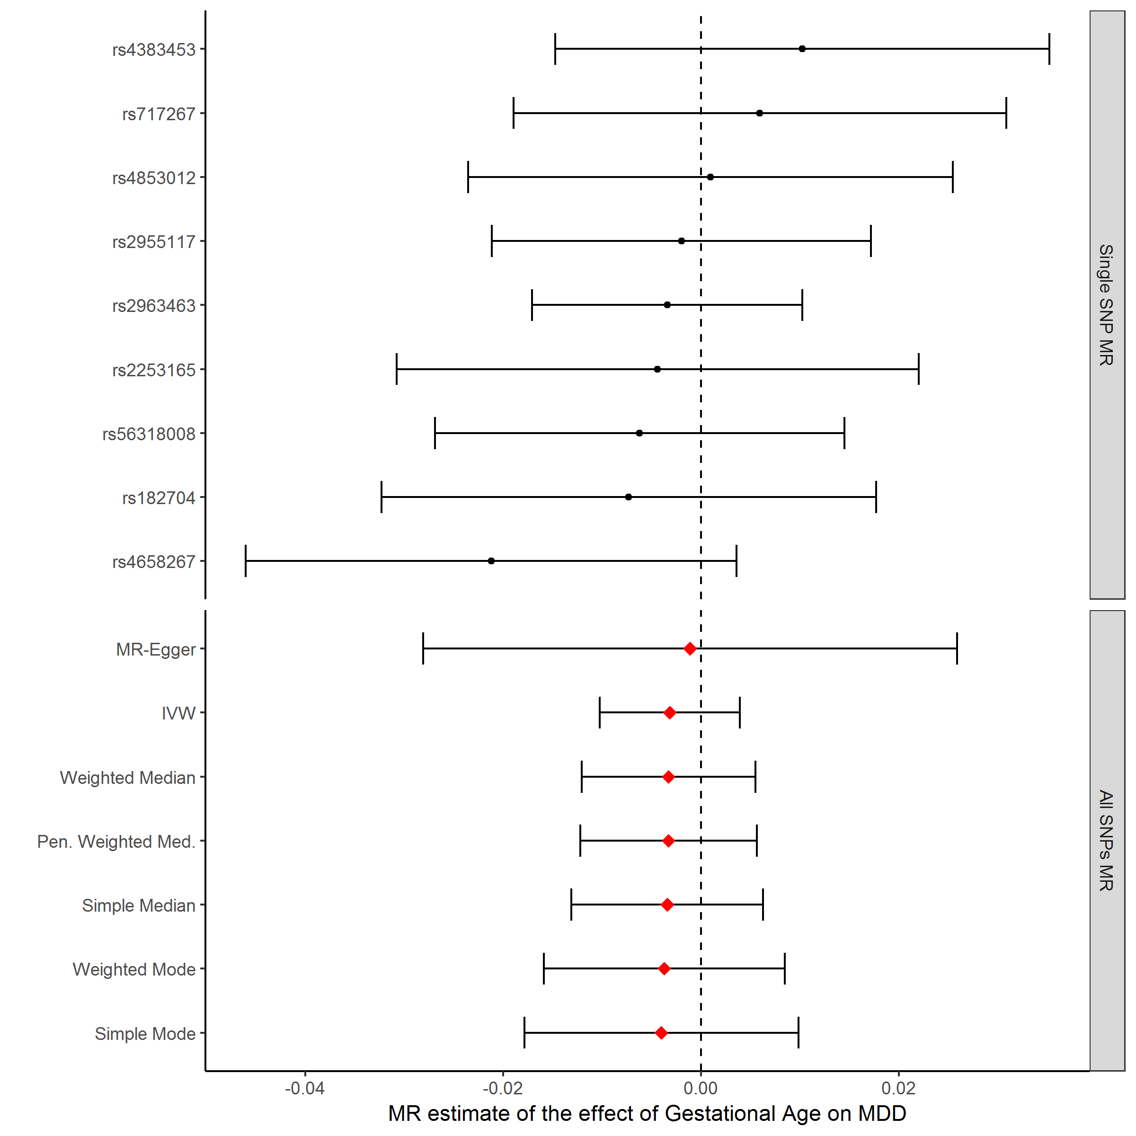

B.
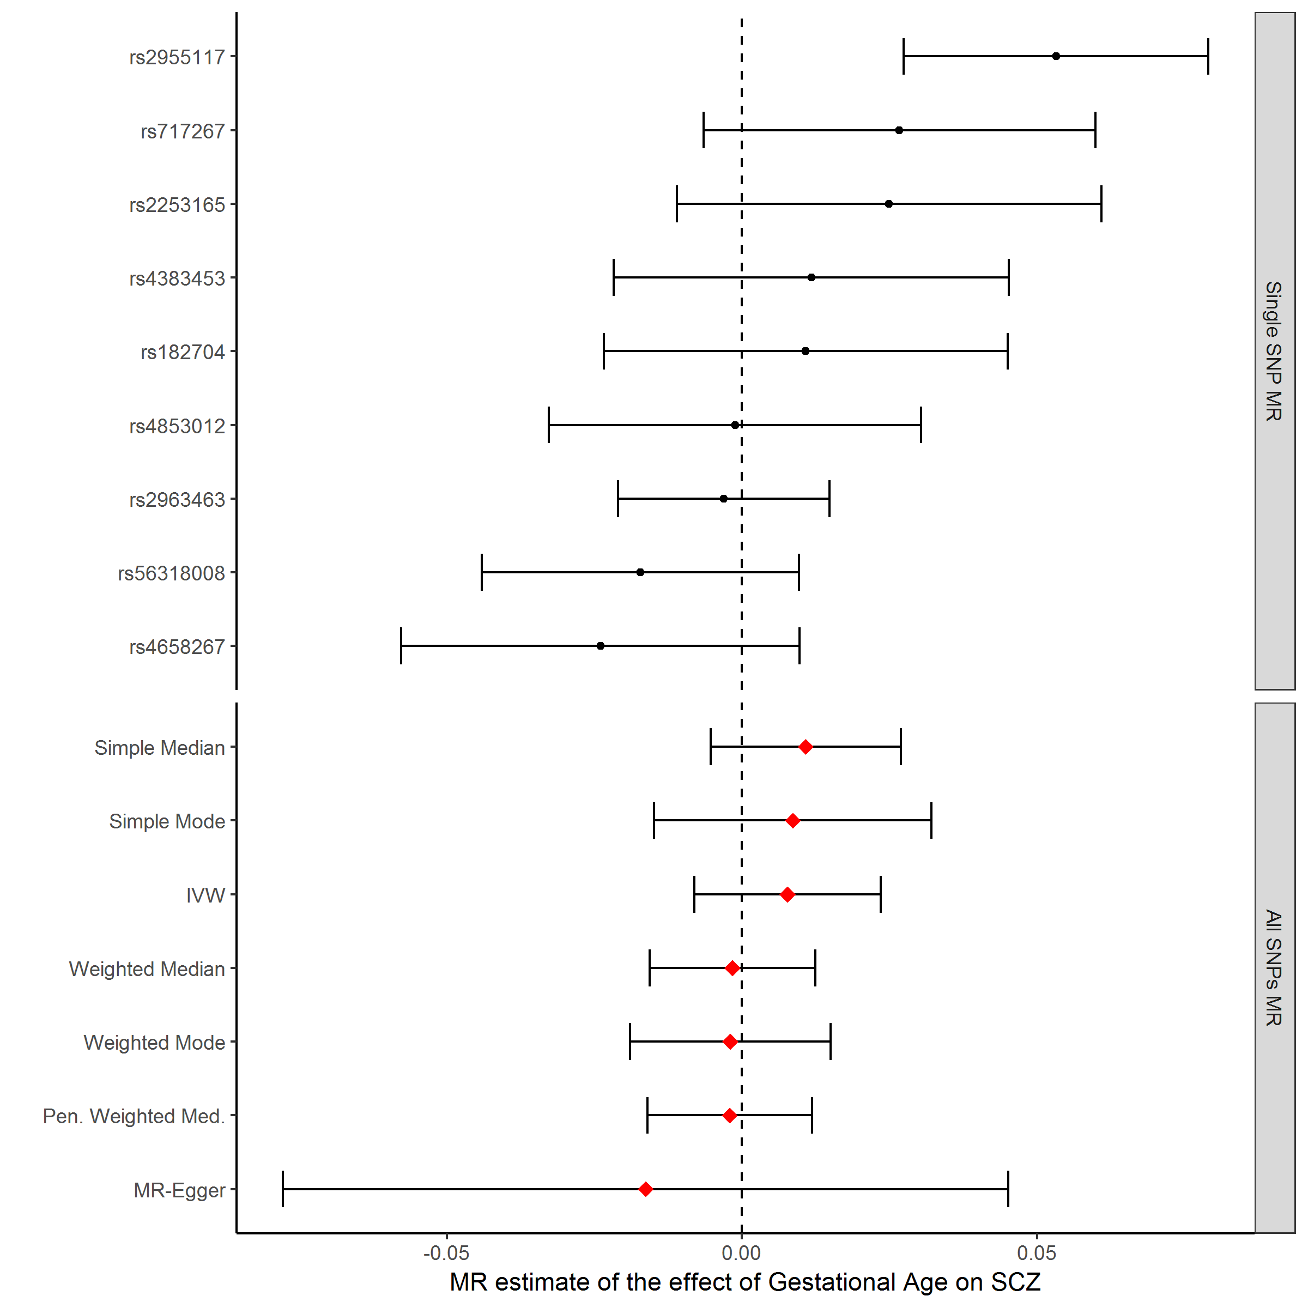

C.
