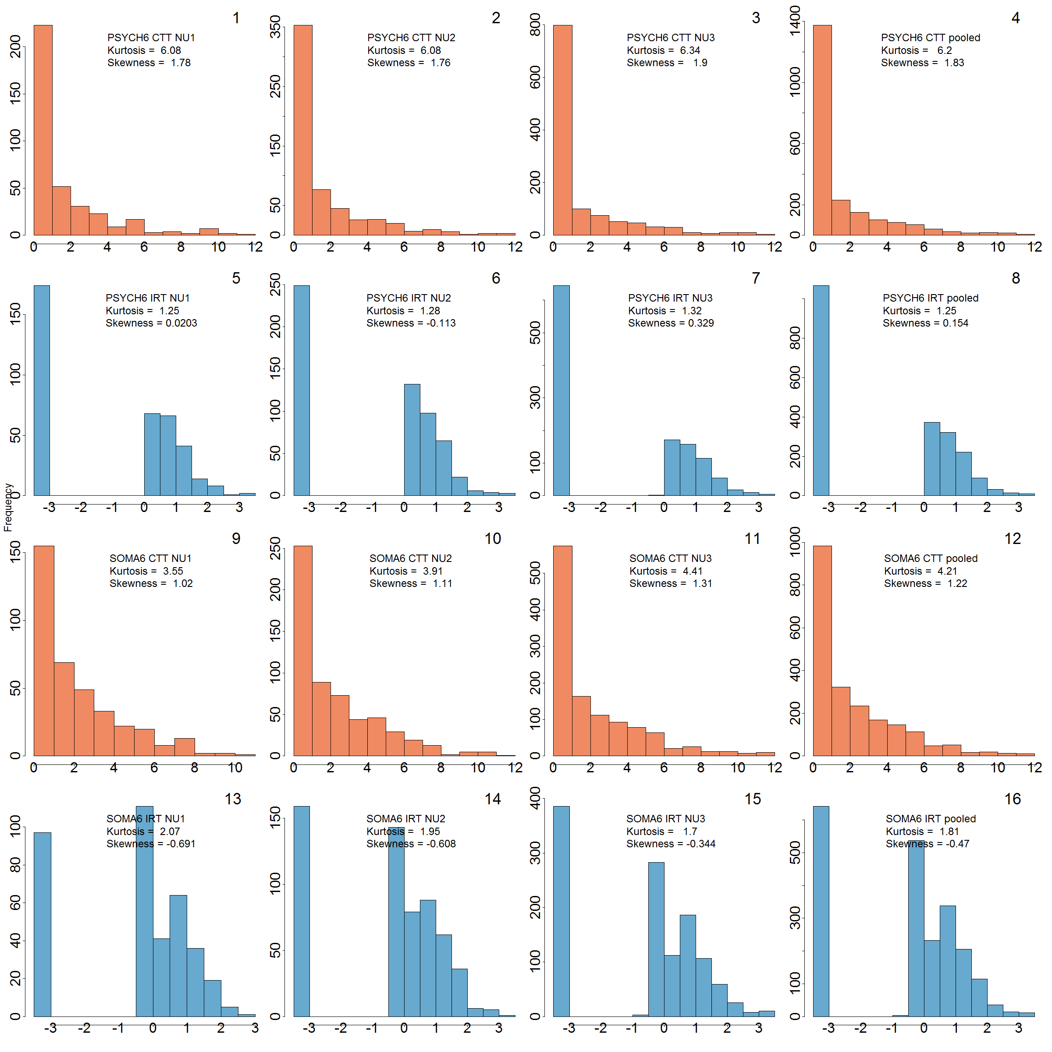

**Figure S1** **Distribution of psychological distress (PSYCH6) and somatic distress (SOMA6) summed scores (CTT) and IRT scores (IRT) in three study waves (left to right: NU1, NU2 and NU3) and across the three waves (pooled)**. The colors contrast the summed scores (orange) by classical test theory (CTT) and IRT scores (blue) generated by IRT modelling.



**Figure S2 Nonparametric item response theory (IRT) model for each of the six items of psychological (PSYCH6) distress subscale of the SPHERE12 questionnaire**. For each item, the blue item response step functions (IRSF) was computed to estimate the probability of having the symptom more than sometimes. The orange IRSF was computed to estimate the probability of having the symptom most of the time. Dotted curves represented the 95% confidence interval of the IRSFs. In nonparametric IRT, IRSFs are not constrained to be logistic.



**Figure S3 Nonparametric IRT model for each of the six items of somatic (SOMA6) distress subscale of the SPHERE12 questionnaire**. See Figure S2 for details of IRSFs.



**Figure S4 Nonparametric IRT model for six binary diagnoses of affective disorders and psychosis (AD)**. These diagnoses included (1) agoraphobia, (2) depressive episodes, (3) major depressive disorder, (4) panic attack, (5) panic disorder, and (6) social anxiety. These items were included because they showed acceptable monotonically nondecreasing in their item response step function (IRSF). Dotted curves represented the 95% confidence interval of the IRSFs.



**Figure S5 Nonparametric IRT model for three ordinal diagnoses of substance use (SU): DSM-V diagnoses of alcohol use disorder, cannabis use disorder, and degree of drug use**. We quantified the degree of drug use from the use of 9 drugs, including amphetamines, analgesics, cocaine, ecstasy, hallucinogens, inhalants, opioids, sedatives and stimulants. This variable was coded as 0 for using none of these 9 drugs, 1 for using any one of them, 2 for using any two of them, and 3 for using 3 of them or more. Dotted curves represented the 95% confidence interval of the IRSFs.

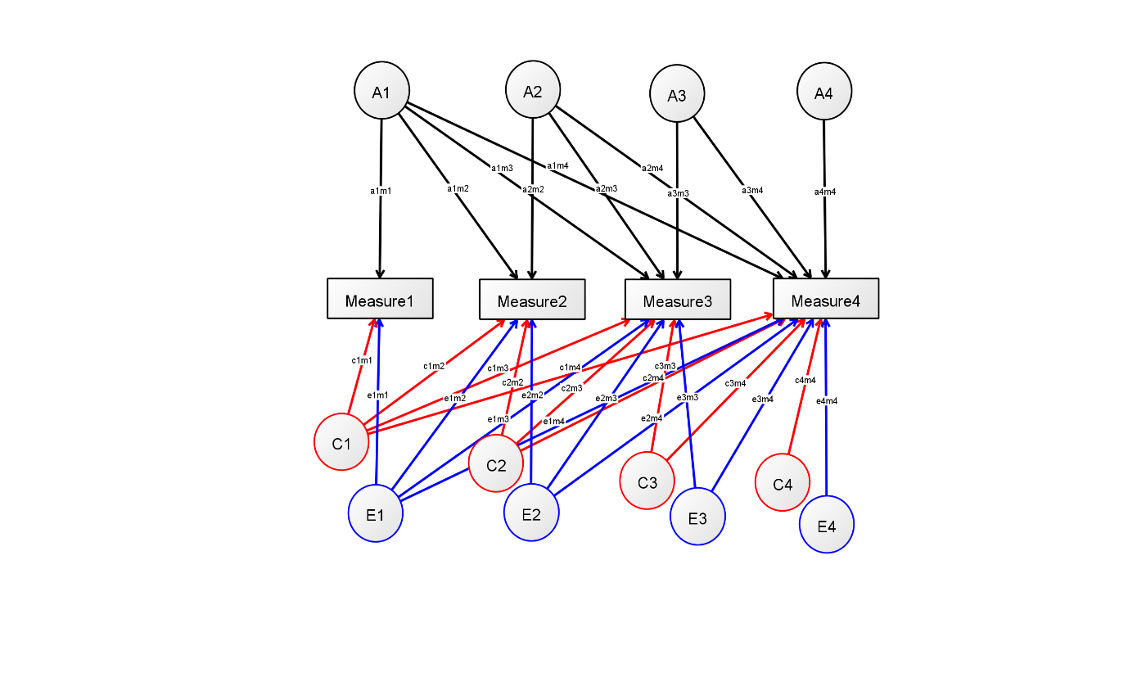

**Figure S6 Path diagram of a Cholesky ACE model with four observed variables (Measure1 to Measure4) and three sets of latent variables - additive genetic factors (A1-A4), shared environmental factors (red C1-C4) and unique environmental factors (blue E1-E4).** Circlesindicate latent variables and rectangles indicate observed variables (Measure1 to Measure4). Hypothesized loading of each factor is indicated by the initial of the observed and latent variable names (e.g. a1m1 for the loading of A1 onto Measure1)**.**

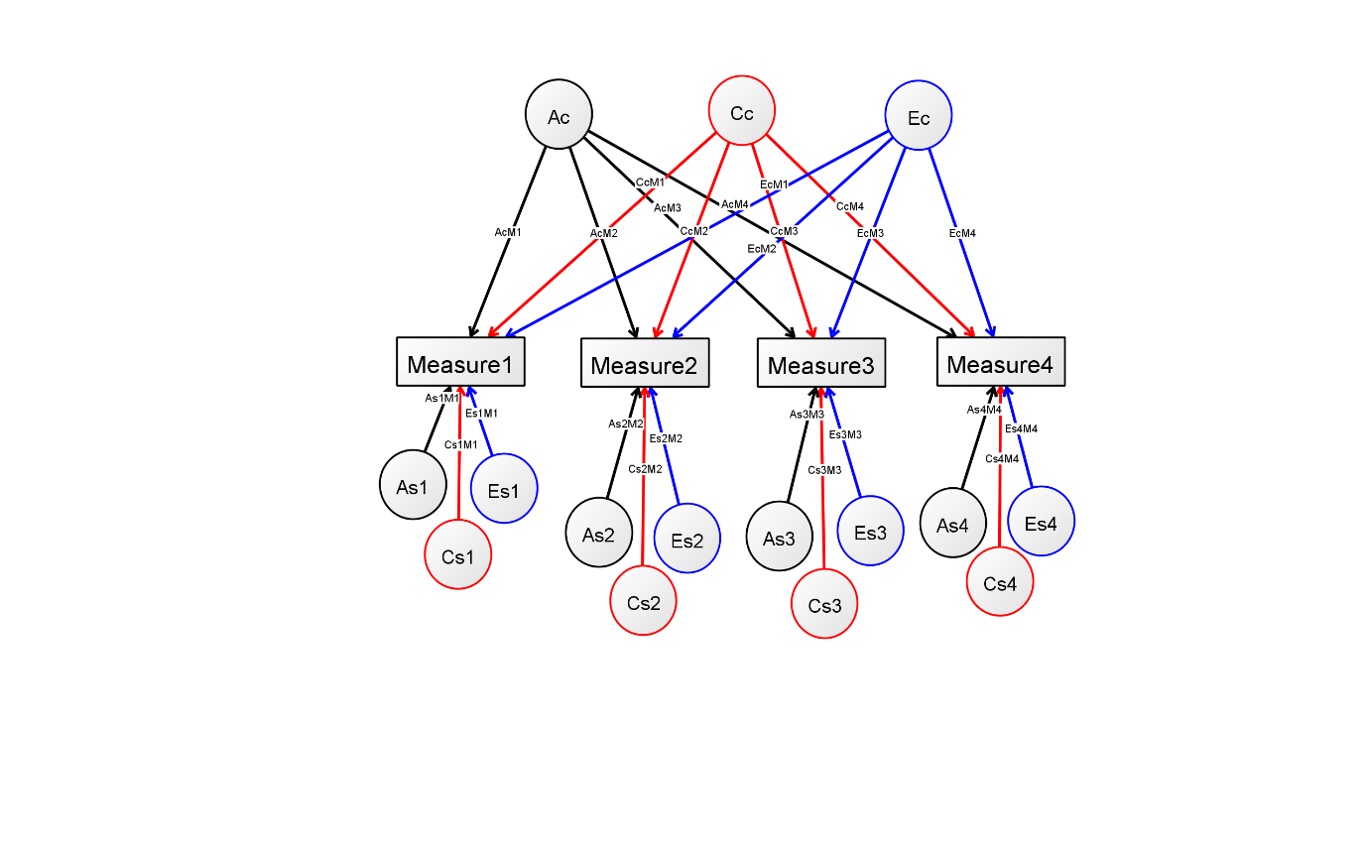

**Figure S7 Path diagram of an independent pathway model with four observed variables and three sets of latent variables - additive genetic factors (Ac, As1- As4), shared environmental factors (red Cc, Cs1-Cs4) and unique environmental factors (blue Ec, Es1-Es4).** Lower-case “c” indicates the latent factor is common to all the observed variables whereas “s” indicates that the latent variable is specific to an observed variable. Factor loading of a latent variable onto an observed variable is indicated by the combination of the latent variable name and the initial of the observed variable name (e.g. AcM1 for loading of Ac onto Measure1).

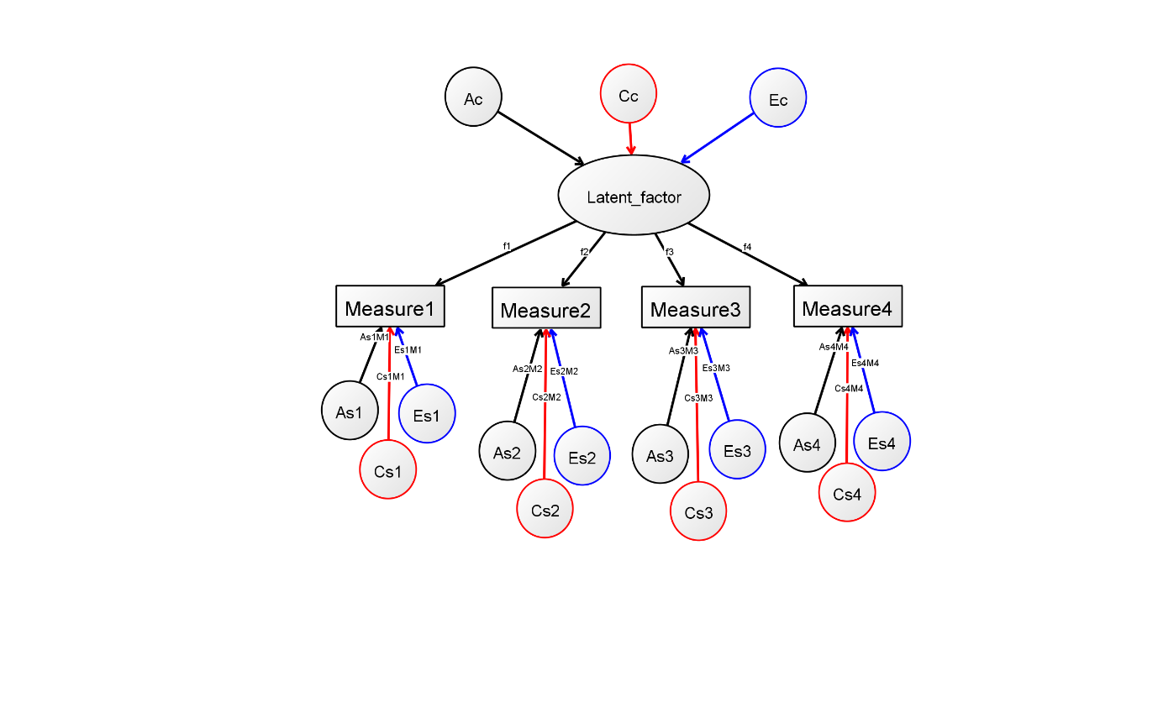

**Figure S8 Path diagram of a common pathway model with four observed variables (Measure1 to Measure4) and three sets of latent variables - additive genetic factors (Ac, As1- As4), shared environmental factors (red Cc, Cs1-Cs4) and unique environmental factors (blue Ec, Es1-Es4).** Thismodel assumes that Ac, Cc and Ec are best explained by a latent factor (Latent_factor), which influences the four observed variables with loading f1-f4. The assumption of the influences of specific genetic factors (As1-As4), specific shared environmental factors (Cs1-Cs4) and specific shared environmental factors (Es1-Es4) is similar to that of the independent pathway model.