Twin Research and Human Genetics

Genetic influences on evening preference overlap with those for bipolar disorder in a sample of Mexican Americans and American Indians

Whitney E. Melroy-Greif, Ian R. Gizer, Kirk C. Wilhelmsen & Cindy L. Ehlers

Supplementary Information

Supplementary Table S1…………………………………………………………………………….….2
Supplementary Table S2…………………………………………………………………………….….4
Supplementary Figure S1……………………………………………………………………………….6
Supplementary Figure S2……………………………………………………………………………….7
Supplementary Figure S3……………………………………………………………………………….8
References…….………………………………………………………………………………………….9

Supplementary Table S1. Top 50 hits from the mixed linear model association in GCTA on the “owl” phenotype in the combined American Indian and Mexican American samples.
Chrª | dbSNP 138 | BP (hg19) | A1^{b} | A2^{c} | Freq^{d} | Effect | se^{e} | p | Gene (refGene) | Function (refGene) | Ref^{f} | Alt^{g} | 1000G (all)^{h} | 1000G (eur)^{i}
11 | rs10768009 | 33632390 | A | C | 0.4227 | -0.1104 | 0.0238 | 3.53E-06 | KIAA1549L | intronic | C | A | 0.3466 | 0.3817
11 | rs7115532 | 33633523 | T | A | 0.4239 | -0.1103 | 0.0238 | 3.77E-06 | KIAA1549L | intronic | A | T | 0.3908 | 0.3807
11 | rs2073174 | 33630891 | T | A | 0.4233 | -0.1095 | 0.0238 | 4.04E-06 | KIAA1549L | intronic | A | T | 0.3397 | 0.3807
11 | rs2076622 | 33631423 | A | G | 0.4305 | -0.1078 | 0.0238 | 6.11E-06 | KIAA1549L | exonic (synon) | G | A | 0.4517 | 0.3857
9 | rs6477769 | 113193574 | T | C | 0.1817 | -0.1274 | 0.0300 | 2.23E-05 | SVEP1 | intronic | C | T | 0.2999 | 0.1451
9 | rs7031072 | 113185801 | G | A | 0.1769 | -0.1269 | 0.0303 | 2.84E-05 | SVEP1 | intronic | A | G | 0.2987 | 0.1412
9 | rs7042836 | 113191819 | G | T | 0.1984 | -0.1182 | 0.0290 | 4.54E-05 | SVEP1 | intronic | T | G | 0.3147 | 0.1521
9 | rs7865430 | 113199768 | T | C | 0.1990 | -0.1178 | 0.0290 | 4.74E-05 | SVEP1 | intronic | C | T | 0.3097 | 0.1511
9 | rs7855991 | 113200806 | C | T | 0.1990 | -0.1178 | 0.0290 | 4.74E-05 | SVEP1 | intronic | T | C | 0.3097 | 0.1511
17 | rs904381 | 71390366 | A | C | 0.4814 | -0.0914 | 0.0226 | 5.44E-05 | SDK2 | exonic (synon) | C | A | 0.2073 | 0.4354
17 | rs12949882 | 71392512 | A | G | 0.4808 | -0.0902 | 0.0227 | 6.97E-05 | SDK2 | intronic | G | A | 0.2081 | 0.4364
7 | rs13241786 | 100486656 | T | G | 0.2932 | -0.0978 | 0.0252 | 1.04E-04 | UFSP1 | exonic (synon) | T | G | 0.6518 | 0.5427
1 | rs2070803 | 155157715 | A | G | 0.4155 | 0.0921 | 0.0245 | 1.68E-04 | MUC1; TRIM46 | down-stream | A | G | 0.5070 | 0.4145
10 | rs1888922 | 91070701 | C | T | 0.1193 | -0.1365 | 0.0366 | 1.89E-04 | IFIT2; IFIT3 | inter-genic | T | C | 0.0693 | 0.1650
9 | rs7038903 | 113221247 | C | T | 0.1613 | -0.1142 | 0.0313 | 2.62E-04 | SVEP1 | exonic (non-synon) | T | C | 0.1755 | 0.1421
10 | rs61151381 | 105370496 | G | C | 0.1595 | 0.1171 | 0.0321 | 2.68E-04 | SH3PXD2A | intronic | C | G | 0.1356 | 0.1988
10 | rs1888921 | 91070699 | C | T | 0.1205 | -0.1319 | 0.0365 | 2.98E-04 | IFIT2; IFIT3 | inter-genic | T | C | 0.0741 | 0.1650
7 | rs1799806 | 100488658 | C | G | 0.2620 | -0.0936 | 0.0260 | 3.17E-04 | ACHE | exonic (non-synon) | G | C | 0.2694 | 0.4533
9 | rs7852962 | 113196733 | C | A | 0.1625 | -0.1121 | 0.0312 | 3.33E-04 | SVEP1 | exonic (non-synon) | A | C | 0.1789 | 0.1421
9 | rs7863519 | 113208250 | G | T | 0.2086 | -0.1014 | 0.0283 | 3.43E-04 | SVEP1 | exonic (non-synon) | T | G | 0.3397 | 0.1918
7 | rs2720392 | 100486035 | A | C | 0.2746 | -0.0923 | 0.0258 | 3.44E-04 | SRRT | intronic | C | A | 0.2766 | 0.4811
7 | rs12666785 | 100476229 | C | T | 0.3195 | -0.0877 | 0.0245 | 3.48E-04 | SRRT | intronic | C | T | 0.5567 | 0.5149
10 | rs3740471 | 105363289 | C | T | 0.1577 | 0.1151 | 0.0322 | 3.52E-04 | SH3PXD2A | exonic (synon) | T | C | 0.1356 | 0.1998
2 | rs2361502 | 234698790 | C | T | 0.2974 | -0.0880 | 0.0247 | 3.60E-04 | MROH2A | intronic | T | C | 0.2817 | 0.2485
10 | rs17468739 | 91065949 | C | A | 0.1169 | -0.1309 | 0.0368 | 3.73E-04 | IFIT2 | exonic (non-synon) | A | C | 0.0517 | 0.1531
11 | rs7949404 | 33583840 | G | A | 0.3729 | -0.0867 | 0.0245 | 4.07E-04 | KIAA1549L | intronic | A | G | 0.3896 | 0.3867
2 | rs1431087 | 226483833 | A | G | 0.3082 | 0.0899 | 0.0256 | 4.39E-04 | NYAP2 | intronic | A | G | 0.5435 | 0.5825
14 | rs382179 | 69179829 | T | C | 0.3555 | 0.0846 | 0.0242 | 4.85E-04 | RAD51B; ZFP36L1 | inter-genic | T | C | 0.5697 | 0.6491
1 | rs423144 | 155169355 | G | T | 0.4209 | 0.0842 | 0.0241 | 4.88E-04 | THBS3 | intronic | G | T | 0.4567 | 0.4155
1 | rs7366775 | 155168930 | G | A | 0.4227 | 0.0843 | 0.0242 | 4.99E-04 | THBS3 | intronic | G | A | 0.4571 | 0.4155
20 | rs62208003 | 62043227 | G | A | 0.0126 | -0.3638 | 0.1047 | 5.10E-04 | KCNQ2 | intronic | A | G | 0.0060 | 0.0209
2 | rs12615891 | 226476675 | A | G | 0.3076 | 0.0885 | 0.0256 | 5.33E-04 | NYAP2 | intronic | A | G | 0.5435 | 0.5825
2 | rs13421400 | 226481145 | C | T | 0.3076 | 0.0885 | 0.0256 | 5.33E-04 | NYAP2 | intronic | C | T | 0.5439 | 0.5825
1 | rs4971100 | 155155731 | G | A | 0.4221 | 0.0839 | 0.0242 | 5.41E-04 | TRIM46 | intronic | G | A | 0.4565 | 0.4135
9 | rs59712735 | 113209482 | C | T | 0.1625 | -0.1079 | 0.0312 | 5.53E-04 | SVEP1 | intronic | T | C | 0.1763 | 0.1421
9 | rs3739450 | 113192427 | C | T | 0.2512 | -0.0931 | 0.0270 | 5.56E-04 | SVEP1 | intronic | T | C | 0.3550 | 0.2515
7 | rs314375 | 100457344 | G | A | 0.3177 | -0.0845 | 0.0245 | 5.57E-04 | SLC12A9 | intronic | G | A | 0.5745 | 0.5159
7 | rs314377 | 100458049 | A | G | 0.3177 | -0.0845 | 0.0245 | 5.57E-04 | SLC12A9 | intronic | A | G | 0.5745 | 0.5149
7 | rs314378 | 100458795 | T | C | 0.3177 | -0.0845 | 0.0245 | 5.57E-04 | SLC12A9 | exonic (synon) | T | C | 0.5785 | 0.5159
7 | rs4729615 | 100462332 | A | G | 0.3177 | -0.0845 | 0.0245 | 5.57E-04 | SLC12A9 | intronic | A | G | 0.5787 | 0.5159
7 | rs4729616 | 100462565 | G | T | 0.3177 | -0.0845 | 0.0245 | 5.57E-04 | SLC12A9 | intronic | G | T | 0.5739 | 0.5149
2 | rs12468481 | 226485264 | T | A | 0.3064 | 0.0881 | 0.0256 | 5.68E-04 | NYAP2 | intronic | T | A | 0.5421 | 0.5825
1 | rs4971101 | 155157635 | G | A | 0.4221 | 0.0833 | 0.0242 | 5.78E-04 | MUC1; TRIM46 | down-stream | G | A | 0.4573 | 0.4145
17 | rs1554227 | 40818451 | A | G | 0.4856 | -0.0795 | 0.0232 | 6.09E-04 | TUBG2 | exonic (synon) | G | A | 0.5038 | 0.5189
20 | rs6011891 | 62173279 | G | C | 0.0186 | -0.2951 | 0.0864 | 6.41E-04 | SRMS | Intronic | C | G | 0.0319 | 0.0348
20 | rs34969822 | 62173817 | T | C | 0.0186 | -0.2951 | 0.0864 | 6.41E-04 | SRMS | exonic (non-synon) | C | T | 0.0421 | 0.0348
1 | rs9426886 | 155151754 | A | T | 0.4209 | 0.0827 | 0.0243 | 6.61E-04 | TRIM46 | intronic | A | T | 0.4651 | 0.4145
2 | rs6711137 | 226444996 | T | G | 0.2734 | 0.0905 | 0.0266 | 6.64E-04 | NYAP2 | intronic | T | G | 0.5351 | 0.6928
1 | rs6426254 | 247697624 | T | C | 0.4371 | -0.0789 | 0.0232 | 6.67E-04 | GCSAML | intronic | C | T | 0.4876 | 0.6630
1 | rs2075571 | 155174106 | C | T | 0.4191 | 0.0822 | 0.0242 | 6.70E-04 | THBS3 | intronic | C | T | 0.4573 | 0.4175
ªChromosome
^{b}Effect allele
^{c}Other allele
^{d}Frequency of the effect allele
^{e}Standard error
^{f}Reference allele
^{g}Alternate allele
^{h}Alternate allele frequency from the 1000 Genomes Project (Oct. 2014; all populations)
^{i}Alternate allele frequency from the 1000 Genomes Project (Oct. 2014; European ancestry)

Supplementary Table S2. Single variant association statistics from the mixed linear model association for genes previously reported to be associated with chronotype from large-scale GWAS in the combined American Indian and Mexican American sample.
Chrª | BP (hg19) | snp138 | A1^{b} | A2^{c} | Freq^{d} | Effect | se^{e} | p | Gene (refGene) | Function (refGene) | Ref^{f} | Alt^{g} | 1000G (all)^{h} | 1000G (eur)^{i}
1 | 182569626 | rs1144566 | T | C | 0.0132 | -0.0229 | 0.0983 | 0.8157 | RGS16 | exonic (nonsynon) | T | C | 0.9860 | 0.9781
1 | 77690858 | rs1253226^{j} | G | A | 0.1805 | 0.0154 | 0.0306 | 0.6159 | PIGK; AK5 | intergenic | A | G | 0.1915 | 0.0706
1 | 77966756 | rs2803152^{j} | C | T | 0.3939 | 0.0421 | 0.0248 | 0.0898 | AK5 | intronic | T | C | 0.4956 | 0.3439
6 | 55142337 | rs2653349^{k} | A | G | 0.1097 | 0.0083 | 0.0375 | 0.8245 | HCRTR2 | exonic (nonsynon) | A | G | 0.8788 | 0.8161
6 | 55144956 | rs2292040^{l} | T | C | 0.2380 | -0.0165 | 0.0273 | 0.5459 | HCRTR2 | intronic | C | T | 0.0980 | 0.0030
6 | 55148103 | rs9367630^{l} | A | G | 0.2380 | -0.0165 | 0.0273 | 0.5459 | HCRTR2 | downstream | G | A | 0.0988 | 0.0030
6 | 55149379 | rs12665239^{l} | A | G | 0.2380 | -0.0165 | 0.0273 | 0.5459 | HCRTR2; GFRAL | intergenic | G | A | 0.0988 | 0.0030
6 | 55149734 | rs61216006^{l} | C | T | 0.2380 | -0.0165 | 0.0273 | 0.5459 | HCRTR2; GFRAL | intergenic | T | C | 0.1136 | 0.0030
6 | 55154930 | rs9382475^{l} | G | A | 0.2374 | -0.0166 | 0.0273 | 0.5427 | HCRTR2; GFRAL | intergenic | A | G | 0.1136 | 0.0030
6 | 55159736 | rs9357856^{l} | G | A | 0.2374 | -0.0166 | 0.0273 | 0.5427 | HCRTR2; GFRAL | intergenic | A | G | 0.0992 | 0.0030
6 | 55161314 | rs9382478^{l} | C | T | 0.2374 | -0.0166 | 0.0273 | 0.5427 | HCRTR2; GFRAL | intergenic | T | C | 0.0992 | 0.0030
7 | 102553603 | rs17135923 | G | C | 0.0354 | -0.0957 | 0.0622 | 0.1240 | FBXL13^{m} | exonic (nonsynon) | C | G | 0.1022 | 0.0378
7 | 102568624 | rs12056296 | C | T | 0.1847 | -0.0283 | 0.0299 | 0.3452 | FBXL13; LRRC17 | intronic | T | C | 0.2654 | 0.1382
7 | 102571960 | rs73408250 | T | C | 0.1847 | -0.0283 | 0.0299 | 0.3452 | FBXL13; LRRC17 | intronic | C | T | 0.2638 | 0.1382
7 | 102572121 | rs12673840 | T | C | 0.0270 | 0.0392 | 0.0728 | 0.5902 | FBXL13; LRRC17 | intronic | C | T | 0.0679 | 0.0368
7 | 102575952 | rs6942688 | A | G | 0.0276 | 0.0248 | 0.0721 | 0.7303 | FBXL13; LRRC17 | intronic | G | A | 0.0707 | 0.0368
7 | 102577176 | rs6465884 | A | G | 0.0270 | 0.0392 | 0.0728 | 0.5902 | FBXL13; LRRC17 | intronic | G | A | 0.0677 | 0.0368
7 | 102577433 | rs6465885 | T | C | 0.1847 | -0.0283 | 0.0299 | 0.3452 | FBXL13; LRRC17 | intronic | C | T | 0.2650 | 0.1382
7 | 102580738 | rs12532495 | A | G | 0.1847 | -0.0283 | 0.0299 | 0.3452 | FBXL13; LRRC17 | intronic | G | A | 0.2628 | 0.1382
7 | 102624227 | rs7789252 | A | C | 0.3375 | 0.0104 | 0.0242 | 0.6665 | FBXL13 | intronic | C | A | 0.4407 | 0.3082
7 | 102632247 | rs869332 | G | A | 0.3369 | 0.0093 | 0.0242 | 0.7021 | FBXL13 | intronic | A | G | 0.4407 | 0.3082
7 | 102650631 | rs117374106 | C | T | 0.0288 | 0.0495 | 0.0706 | 0.4830 | FBXL13 | intronic | T | C | 0.0735 | 0.0427
7 | 102660284 | rs117313790 | C | T | 0.0342 | 0.0585 | 0.0653 | 0.3701 | FBXL13 | intronic | T | C | 0.1064 | 0.0437
7 | 102665620 | rs61749912 | G | C | 0.0342 | 0.0585 | 0.0653 | 0.3701 | FBXL13 | exonic (nonsynon) | C | G | 0.1060 | 0.0437
7 | 102670933 | rs11543780 | T | C | 0.0336 | 0.0471 | 0.0659 | 0.4747 | FBXL13 | intronic | C | T | 0.1026 | 0.0437
7 | 102674811 | rs79049204 | A | G | 0.0336 | 0.0471 | 0.0659 | 0.4747 | FBXL13 | intronic | G | A | 0.1026 | 0.0437
7 | 102701632 | rs59099783 | G | T | 0.0294 | 0.0577 | 0.0699 | 0.4085 | FBXL13 | intronic | T | G | 0.0739 | 0.0427
ªChromosome
^{b}Effect allele
^{c}Other allele
^{d}Frequency of the effect allele
^{e}Standard error
^{f}Reference allele
^{g}Alternate allele
^{h}Alternate allele frequency from the 1000 Genomes Project (Oct. 2014; all populations)
^{i}Alternate allele frequency from the 1000 Genomes Project (Oct. 2014; European ancestry)
^{j}Not in linkage disquilibrium (LD) at r²>0.5 in subjects of Northern and Western European ancestry (CEU) from the 1000 Genomes Pilot 1 data with rs11162296 (Jones et al., 2016), rs76681500 (Lane et al., 2016), or rs10493596 (Hu et al., 2016), as assessed by SNAP (Johnson et al., 2008)
^{k}Not in LD at r²>0.5 in CEU panel from the 1000 Genomes Pilot 1 data with rs35833281 (Hu et al., 2016), as assessed by SNAP
^{l}No matching proxy SNPs found in 1000 Genomes Pilot 1 data
^{m}SNPs in FBXL13 associated with chronotype from previous work, rs372229746 (Jones et al., 2016; Lane et al., 2016) and rs3972456 (Hu et al., 2016), were not in the 1000 Genomes Pilot 1 data and thus we were unable to assess LD between those SNPs and the ones included in this study

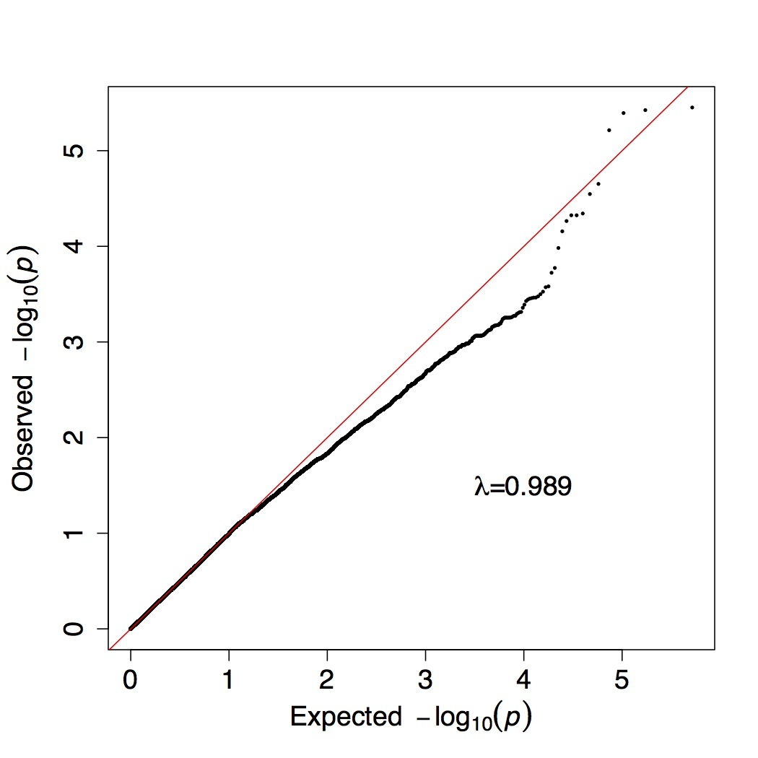
Supplementary Figure S1. Quantile-Quantile (QQ) plot for the GWAS on the owl phenotype in the combined American Indian and Mexican American cohorts.

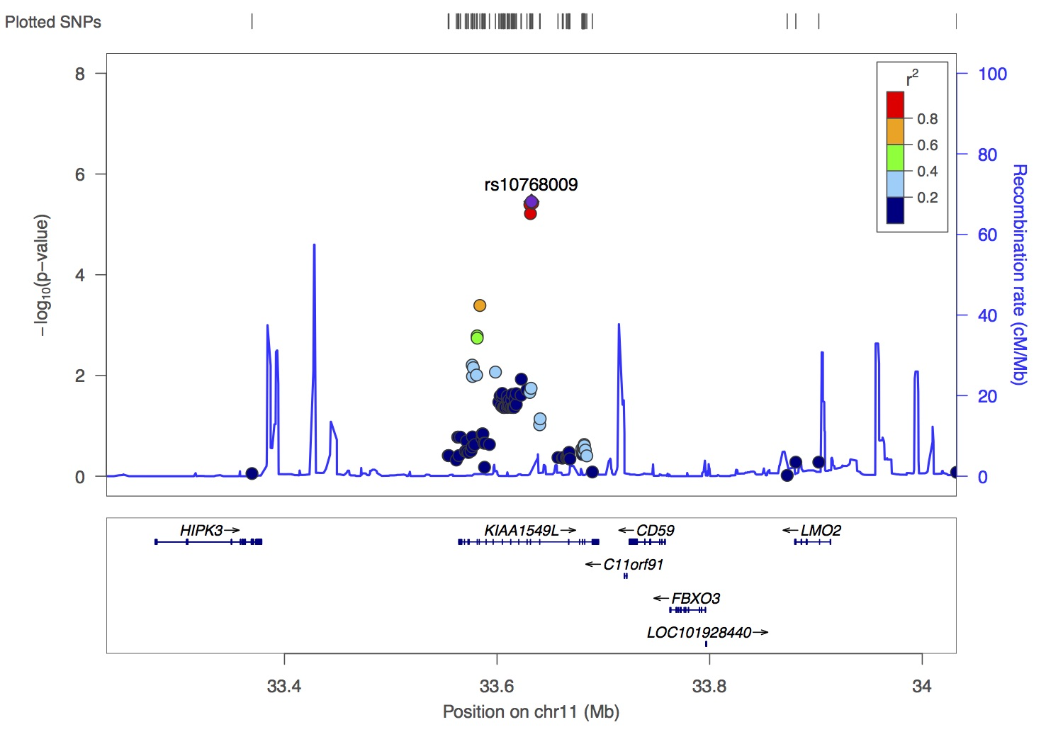
Supplementary Figure S2. Locus zoom plot of the KIAA1549L region. The plot was generated using the 1000G American (AMR) population as a reference population and the hg19 build.

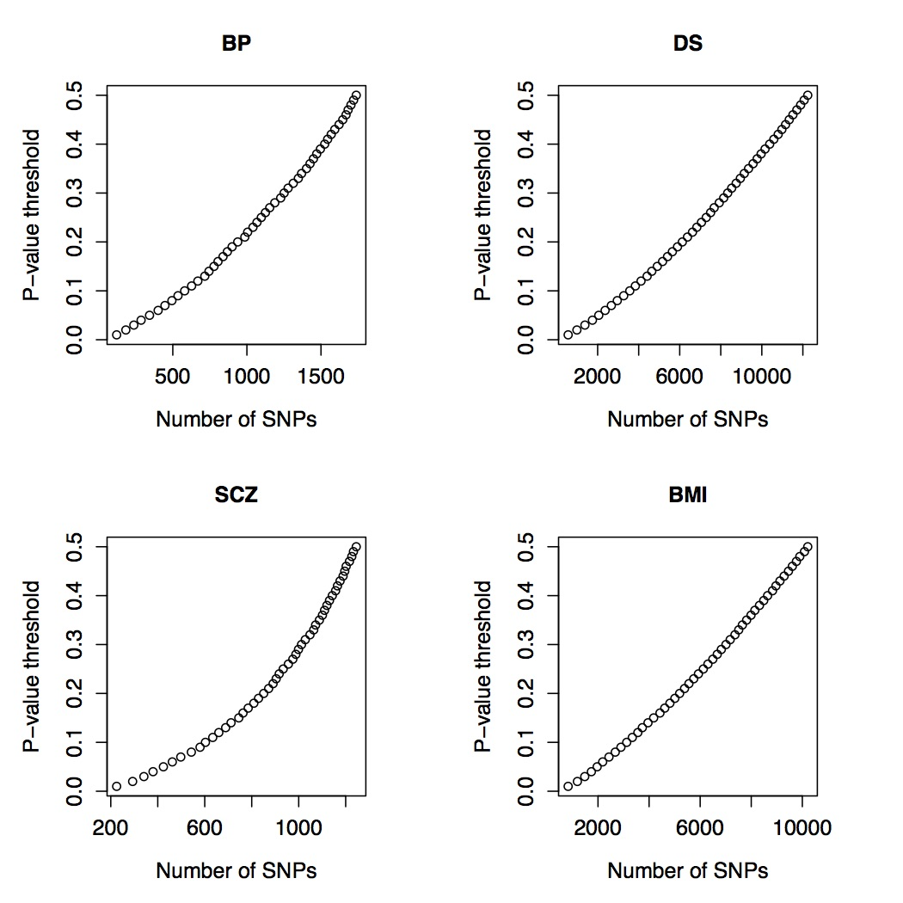

Supplementary Figure S3. Plots showing the number of SNPs used in generating each genetic risk score given the p-value threshold for bipolar disorder (BP; top left), depressive symptoms (DS; top right), schizophrenia (SZ; bottom left) and body mass index (BMI; bottom right).
References

Hu, Y., Shmygelska, A., Tran, D., Eriksson, N., Tung, J. Y., & Hinds, D. A. (2016). GWAS of 89,283 individuals identifies genetic variants associated with self-reporting of being a morning person. Nature Communications, 7, 10448.
Johnson, A. D., Handsaker, R. E., Pulit, S. L., Nizzari, M. M., O'Donnell, C. J., & de Bakker, P. I. (2008). SNAP: a web-based tool for identification and annotation of proxy SNPs using HapMap. Bioinformatics, 24(24), 2938-2939.
Jones, S. E., Tyrrell, J., Wood, A. R., Beaumont, R. N., Ruth, K. S., Tuke, M. A., . . . Weedon, M. N. (2016). Genome-Wide Association Analyses in 128,266 Individuals Identifies New Morningness and Sleep Duration Loci. PLoS Genetics, 12(8), e1006125.
Lane, J. M., Vlasac, I., Anderson, S. G., Kyle, S. D., Dixon, W. G., Bechtold, D. A., . . . Saxena, R. (2016). Genome-wide association analysis identifies novel loci for chronotype in 100,420 individuals from the UK Biobank. Nature Communications, 7, 10889.

