Twin Research and Human Genetics

Genome-wide association study of post-traumatic stress disorder in two
high-risk populations
Whitney E. Melroy-Greif, Kirk C. Wilhelmsen, Rachel Yehuda, & Cindy L. Ehlers

Supplementary Information

Supplementary Table S1. Top 50 hits for PTSD in the Mexican American sample.
CHR | End BP (hg19) | dbSNP 138 | Minor allele | Major allele | BETAª | STAT | P | EMP1^{b} | # Permu-tations | MAF^{c} | Gene.refGene | Ref^{d} | Alt^{e} | X1000g2014oct_all^{f} | X1000g2014oct_eur^{g}
1 | 248004296 | rs6681483 | G | A | 4.183 | 4.898 | 1.83E-06 | 3.00E-06 | 1000000 | 0.084 | OR11L1 | A | G | 0.149 | 0.101
1 | 248004614 | rs6667389 | G | A | 4.183 | 4.898 | 1.83E-06 | 3.00E-06 | 1000000 | 0.084 | OR11L1 | G | A | 0.847 | 0.899
1 | 248004687 | rs10888255 | C | G | 4.183 | 4.898 | 1.83E-06 | 3.00E-06 | 1000000 | 0.084 | OR11L1 | C | G | 0.870 | 0.899
1 | 248004877 | rs10888257 | C | T | 4.183 | 4.898 | 1.83E-06 | 3.00E-06 | 1000000 | 0.084 | OR11L1 | C | T | 0.871 | 0.899
1 | 248004775 | rs10888256 | C | T | 4.147 | 4.872 | 2.05E-06 | 3.00E-06 | 1000000 | 0.080 | OR11L1 | C | T | 0.891 | 0.899
1 | 248004848 | rs4607924 | G | C | 4.147 | 4.872 | 2.05E-06 | 3.00E-06 | 1000000 | 0.080 | OR11L1 | G | C | 0.890 | 0.899
3 | 176592050 | rs1601949 | C | T | -2.551 | -4.278 | 2.77E-05 | 2.80E-05 | 1000000 | 0.267 | LINC01209; TBL1XR1 | C | T | 0.640 | 0.831
4 | 21476630 | rs146145060 | C | - | 2.013 | 4.065 | 6.60E-05 | 7.57E-05 | 528203 | 0.346 | KCNIP4 | C | - | 0.689 | 0.660
4 | 21476830 | rs358593 | A | T | 2.013 | 4.065 | 6.60E-05 | 7.57E-05 | 528203 | 0.346 | KCNIP4 | A | T | 0.697 | 0.661
4 | 21476990 | rs358592 | C | T | 2.013 | 4.065 | 6.60E-05 | 7.57E-05 | 528203 | 0.346 | KCNIP4 | C | T | 0.690 | 0.661
4 | 21481537 | rs358588 | G | A | 2.013 | 4.065 | 6.60E-05 | 7.57E-05 | 528203 | 0.346 | KCNIP4 | G | A | 0.690 | 0.661
3 | 56665355 | rs75058227 | C | T | 2.744 | 4.022 | 7.81E-05 | 7.49E-05 | 534047 | 0.181 | FAM208A | T | C | 0.200 | 0.101
14 | 104394850 | rs9324066 | C | T | -1.974 | -4.01 | 8.21E-05 | 9.64E-05 | 415029 | 0.468 | TDRD9 | C | T | 0.461 | 0.402
17 | 39025633 | rs4890136 | A | G | 2.996 | 3.869 | 1.43E-04 | 1.48E-04 | 270941 | 0.104 | KRT12;  KRT20 | G | A | 0.093 | 0.101
22 | 36123313 | rs2073198 | A | G | 2.471 | 3.848 | 1.54E-04 | 1.87E-04 | 214119 | 0.214 | APOL5 | G | A | 0.315 | 0.289
3 | 56627048 | rs1388256 | A | G | 2.47 | 3.802 | 1.84E-04 | 1.99E-04 | 200619 | 0.193 | CCDC66 | A | G | 0.736 | 0.896
3 | 56630653 | rs282525 | A | C | 2.47 | 3.802 | 1.84E-04 | 1.99E-04 | 200619 | 0.193 | CCDC66 | A | C | 0.735 | 0.896
3 | 56635313 | rs282542 | G | A | 2.47 | 3.802 | 1.84E-04 | 1.99E-04 | 200619 | 0.193 | CCDC66 | G | A | 0.742 | 0.896
3 | 56639458 | rs9841851 | C | G | 2.47 | 3.802 | 1.84E-04 | 1.99E-04 | 200619 | 0.193 | CCDC66 | C | G | 0.723 | 0.896
3 | 56642618 | rs59331585 | - | TTTTGTATTTCTTT | 2.47 | 3.802 | 1.84E-04 | 1.99E-04 | 200619 | 0.193 | CCDC66 | - | TTTTGTATTTCTTT | 0.728 | 0.891
3 | 56644358 | rs282530 | A | G | 2.47 | 3.802 | 1.84E-04 | 1.99E-04 | 200619 | 0.193 | CCDC66 | A | G | 0.736 | 0.896
3 | 56644680 | rs282531 | A | G | 2.47 | 3.802 | 1.84E-04 | 1.99E-04 | 200619 | 0.193 | CCDC66 | A | G | 0.736 | 0.896
3 | 56658314 | rs2291500 | A | G | 2.45 | 3.761 | 2.15E-04 | 2.08E-04 | 192735 | 0.195 | FAM208A | G | A | 0.265 | 0.105
3 | 56658871 | rs2291498 | C | T | 2.45 | 3.761 | 2.15E-04 | 2.08E-04 | 192735 | 0.195 | FAM208A | T | C | 0.292 | 0.105
3 | 56660896 | NA | CTGCTT | - | 2.45 | 3.761 | 2.15E-04 | 2.08E-04 | 192735 | 0.195 | FAM208A | - | CTGCTT | 0.288 | 0.105
3 | 56662727 | rs10222629 | T | A | 2.45 | 3.761 | 2.15E-04 | 2.08E-04 | 192735 | 0.195 | FAM208A | A | T | 0.265 | 0.105
3 | 56663552 | rs4681937 | G | A | 2.45 | 3.761 | 2.15E-04 | 2.08E-04 | 192735 | 0.195 | FAM208A | A | G | 0.292 | 0.105
3 | 56664048 | rs11712664 | T | C | 2.45 | 3.761 | 2.15E-04 | 2.08E-04 | 192735 | 0.195 | FAM208A | C | T | 0.265 | 0.105
3 | 56664184 | rs11712799 | A | G | 2.45 | 3.761 | 2.15E-04 | 2.08E-04 | 192735 | 0.195 | FAM208A | G | A | 0.288 | 0.105
3 | 56665231 | rs9868059 | C | T | 2.45 | 3.761 | 2.15E-04 | 2.08E-04 | 192735 | 0.195 | FAM208A | T | C | 0.281 | 0.105
3 | 56665673 | rs139834324 | A | G | 2.45 | 3.761 | 2.15E-04 | 2.08E-04 | 192735 | 0.195 | FAM208A | G | A | 0.292 | 0.105
3 | 56669010 | rs75830054 | C | T | 2.45 | 3.761 | 2.15E-04 | 2.08E-04 | 192735 | 0.195 | FAM208A | T | C | 0.292 | 0.105
3 | 56670651 | rs78522019 | A | G | 2.45 | 3.761 | 2.15E-04 | 2.08E-04 | 192735 | 0.195 | FAM208A | G | A | 0.292 | 0.105
3 | 56671593 | rs55742226 | G | A | 2.45 | 3.761 | 2.15E-04 | 2.08E-04 | 192735 | 0.195 | FAM208A | A | G | 0.293 | 0.105
3 | 56671733 | rs11719726 | G | T | 2.45 | 3.761 | 2.15E-04 | 2.08E-04 | 192735 | 0.195 | FAM208A | T | G | 0.292 | 0.105
3 | 56675215 | rs3215018 | - | TTGTAAC | 2.45 | 3.761 | 2.15E-04 | 2.08E-04 | 192735 | 0.195 | FAM208A | TTGTAAC | - | 0.292 | 0.105
3 | 56677182 | rs9883842 | T | C | 2.45 | 3.761 | 2.15E-04 | 2.08E-04 | 192735 | 0.195 | FAM208A | C | T | 0.265 | 0.105
3 | 56677762 | rs9834239 | A | G | 2.45 | 3.761 | 2.15E-04 | 2.08E-04 | 192735 | 0.195 | FAM208A | G | A | 0.277 | 0.105
3 | 56678364 | rs55646706 | T | - | 2.45 | 3.761 | 2.15E-04 | 2.08E-04 | 192735 | 0.195 | FAM208A | - | T | 0.292 | 0.105
3 | 56681406 | rs4681955 | A | G | 2.45 | 3.761 | 2.15E-04 | 2.08E-04 | 192735 | 0.195 | FAM208A | G | A | 0.293 | 0.105
3 | 56681653 | rs9311609 | G | A | 2.45 | 3.761 | 2.15E-04 | 2.08E-04 | 192735 | 0.195 | FAM208A | A | G | 0.293 | 0.105
3 | 56682414 | rs7649872 | A | G | 2.45 | 3.761 | 2.15E-04 | 2.08E-04 | 192735 | 0.195 | FAM208A | G | A | 0.292 | 0.105
3 | 56684648 | rs9867302 | T | C | 2.45 | 3.761 | 2.15E-04 | 2.08E-04 | 192735 | 0.195 | FAM208A | C | T | 0.292 | 0.105
3 | 56684873 | rs9816100 | C | T | 2.45 | 3.761 | 2.15E-04 | 2.08E-04 | 192735 | 0.195 | FAM208A | T | C | 0.292 | 0.105
11 | 2810731 | rs2237886 | T | C | -2.911 | -3.745 | 2.28E-04 | 2.70E-04 | 147918 | 0.116 | KCNQ1 | C | T | 0.113 | 0.095
11 | 36004699 | rs7952702 | C | T | 3.968 | 3.733 | 2.38E-04 | 1.82E-04 | 219330 | 0.048 | LDLRAD3 | T | C | 0.206 | 0.019
11 | 36005241 | rs7927809 | C | T | 3.968 | 3.733 | 2.38E-04 | 1.82E-04 | 219330 | 0.048 | LDLRAD3 | T | C | 0.209 | 0.019
17 | 80900645 | rs2292965 | A | G | 2.125 | 3.731 | 2.40E-04 | 2.03E-04 | 202031 | 0.250 | TBCD | G | A | 0.296 | 0.298
17 | 80901020 | rs1044661 | A | G | 2.125 | 3.731 | 2.40E-04 | 2.03E-04 | 202031 | 0.250 | TBCD | G | A | 0.295 | 0.294
1 | 53580449 | rs150708334 | T | C | 7.029 | 3.729 | 2.42E-04 | 2.28E-04 | 175759 | 0.012 | SLC1A7 | C | T | 0.001 | NA
ªThe direction of the regression coefficient represents the effect of each extra minor allele whereby a positive regression coefficient means that the minor allele increases risk
^{b}Derived from phenotype permutations
^{c}Minor allele frequency
^{d}Reference allele
^{e}Alternate allele
^{f}Alternate allele frequency for all populations from the 1000G data
^{g}Alternate allele frequency for the European population from the 1000G data
Supplementary Table S2. Top 50 hits for PTSD in the American Indian sample.
CHR | BP (hg19) | dbSNP 138 | Tested Allele | Other Allele | Freqª | beta | se^{b} | p | Gene.refGene | Ref^{c} | Alt^{d} | X1000g2014__oct_all^{e} | X1000g2014oct_eur^{f}
17 | 48072225 | rs33937843 | A | G | 0.200 | 2.862 | 0.685 | 2.96E-05 | DLX3 | G | A | 0.154 | 0.039
12 | 96153846 | rs7134025 | C | T | 0.399 | -2.245 | 0.563 | 6.72E-05 | NTN4 | C | T | 0.774 | 0.843
12 | 96154298 | rs6538671 | G | A | 0.399 | -2.245 | 0.563 | 6.72E-05 | NTN4 | G | A | 0.774 | 0.843
17 | 80804371 | rs7208121 | A | G | 0.463 | 2.210 | 0.573 | 1.13E-04 | TBCD | A | G | 0.478 | 0.411
12 | 96148540 | rs7294430 | C | T | 0.401 | -2.172 | 0.563 | 1.14E-04 | NTN4 | C | T | 0.773 | 0.842
12 | 96149288 | rs4341610 | A | C | 0.401 | -2.172 | 0.563 | 1.14E-04 | NTN4 | A | C | 0.775 | 0.843
12 | 96150420 | rs11108235 | G | A | 0.401 | -2.172 | 0.563 | 1.14E-04 | NTN4 | G | A | 0.774 | 0.843
12 | 96153658 | rs7316122 | C | T | 0.401 | -2.172 | 0.563 | 1.14E-04 | NTN4 | C | T | 0.775 | 0.847
17 | 80793900 | rs9903208 | A | C | 0.463 | 2.229 | 0.583 | 1.31E-04 | TBCD; ZNF750 | A | C | 0.464 | 0.420
17 | 80790611 | rs11077947 | A | G | 0.465 | 2.207 | 0.579 | 1.38E-04 | TBCD; ZNF750 | A | G | 0.474 | 0.420
12 | 40594722 | rs2638233 | C | A | 0.287 | -2.143 | 0.578 | 2.10E-04 | SLC2A13; LRRK2 | C | A | 0.649 | 0.617
17 | 80796671 | rs8069699 | C | T | 0.467 | 2.122 | 0.576 | 2.32E-04 | TBCD; ZNF750 | C | T | 0.471 | 0.413
17 | 80793850 | rs9897676 | A | G | 0.465 | 2.104 | 0.573 | 2.42E-04 | TBCD; ZNF750 | A | G | 0.464 | 0.420
17 | 80793833 | rs9903483 | T | G | 0.469 | 2.140 | 0.584 | 2.49E-04 | TBCD; ZNF750 | T | G | 0.434 | 0.420
17 | 80792728 | rs11654320 | C | T | 0.475 | 2.160 | 0.591 | 2.60E-04 | TBCD; ZNF750 | C | T | 0.433 | 0.420
12 | 40592388 | rs2708419 | C | T | 0.289 | -2.089 | 0.574 | 2.70E-04 | SLC2A13; LRRK2 | C | T | 0.634 | 0.610
17 | 80799248 | rs1317387 | C | T | 0.477 | 2.125 | 0.588 | 3.00E-04 | TBCD | C | T | 0.430 | 0.411
17 | 80795625 | rs28706217 | G | A | 0.469 | 2.086 | 0.579 | 3.12E-04 | TBCD; ZNF750 | G | A | 0.470 | 0.411
17 | 80801904 | rs11655723 | G | A | 0.469 | 2.086 | 0.579 | 3.12E-04 | TBCD | A | G | 0.523 | 0.591
17 | 80802353 | rs9897808 | A | C | 0.469 | 2.086 | 0.579 | 3.12E-04 | TBCD | A | C | 0.472 | 0.412
8 | 3253768 | rs3802303 | T | C | 0.310 | 2.194 | 0.609 | 3.19E-04 | CSMD1 | C | T | 0.300 | 0.424
8 | 3255336 | rs7833969 | T | C | 0.310 | 2.194 | 0.609 | 3.19E-04 | CSMD1 | C | T | 0.294 | 0.425
17 | 80801745 | rs7219521 | G | A | 0.473 | 2.094 | 0.583 | 3.29E-04 | TBCD | G | A | 0.430 | 0.410
2 | 160600789 | rs62173031 | A | G | 0.043 | 4.557 | 1.269 | 3.30E-04 | MARCH7 | G | A | 0.048 | 0.071
17 | 17292491 | rs7223406 | G | A | 0.200 | 2.444 | 0.684 | 3.53E-04 | NT5M; MED9 | A | G | 0.427 | 0.187
17 | 80792802 | rs11654361 | C | T | 0.471 | 2.110 | 0.592 | 3.65E-04 | TBCD; ZNF750 | C | T | 0.433 | 0.419
3 | 44635461 | rs13319803 | A | G | 0.585 | -1.965 | 0.553 | 3.79E-04 | ZNF660 | G | A | 0.531 | 0.425
4 | 16770235 | rs189988 | T | A | 0.308 | 2.095 | 0.590 | 3.86E-04 | LDB2 | T | A | 0.784 | 0.931
12 | 40600696 | rs2723259 | G | A | 0.289 | -2.031 | 0.573 | 3.91E-04 | SLC2A13; LRRK2 | G | A | 0.649 | 0.618
12 | 40602224 | rs1491932 | T | G | 0.289 | -2.031 | 0.573 | 3.91E-04 | SLC2A13; LRRK2 | T | G | 0.649 | 0.618
12 | 40604075 | rs2638230 | T | G | 0.289 | -2.031 | 0.573 | 3.91E-04 | SLC2A13; LRRK2 | T | G | 0.654 | 0.618
12 | 40605916 | rs2263419 | G | A | 0.289 | -2.031 | 0.573 | 3.91E-04 | SLC2A13; LRRK2 | G | A | 0.649 | 0.618
12 | 40606007 | rs2263420 | C | T | 0.289 | -2.031 | 0.573 | 3.91E-04 | SLC2A13; LRRK2 | C | T | 0.649 | 0.618
6 | 31332527 | rs2523548 | G | A | 0.428 | 1.959 | 0.555 | 4.15E-04 | HLA-B; MICA | G | A | 0.453 | 0.437
4 | 16772305 | rs207683 | G | A | 0.314 | 2.053 | 0.582 | 4.16E-04 | LDB2 | G | A | 0.760 | 0.931
4 | 16773219 | rs207684 | A | G | 0.314 | 2.053 | 0.582 | 4.16E-04 | LDB2 | A | G | 0.715 | 0.932
1 | 13802325 | rs3013105 | C | T | 0.341 | 1.899 | 0.539 | 4.26E-04 | LRRC38 | T | C | 0.462 | 0.384
12 | 40592501 | rs2708420 | G | T | 0.287 | -2.010 | 0.573 | 4.50E-04 | SLC2A13; LRRK2 | G | T | 0.648 | 0.617
12 | 40593676 | rs2708422 | T | C | 0.287 | -2.010 | 0.573 | 4.50E-04 | SLC2A13; LRRK2 | T | C | 0.648 | 0.617
12 | 40594173 | rs2708423 | G | A | 0.287 | -2.010 | 0.573 | 4.50E-04 | SLC2A13; LRRK2 | G | A | 0.648 | 0.617
17 | 80790772 | rs12603419 | T | C | 0.477 | 2.059 | 0.593 | 5.21E-04 | TBCD; ZNF750 | T | C | 0.426 | 0.420
21 | 48017197 | rs2839349 | G | A | 0.545 | -1.878 | 0.543 | 5.40E-04 | DIP2A; S100B | G | A | 0.463 | 0.385
3 | 168162869 | rs6802578 | T | C | 0.401 | -1.855 | 0.540 | 5.96E-04 | EGFEM1P | C | T | 0.232 | 0.109
17 | 80800818 | rs12942471 | G | A | 0.477 | 2.017 | 0.588 | 5.99E-04 | TBCD | G | A | 0.431 | 0.412
17 | 80803648 | rs11652203 | G | A | 0.477 | 2.017 | 0.588 | 5.99E-04 | TBCD | G | A | 0.431 | 0.410
3 | 168157367 | rs9852456 | A | G | 0.403 | -1.840 | 0.537 | 6.08E-04 | EGFEM1P | G | A | 0.232 | 0.112
3 | 44599103 | rs2293600 | G | T | 0.587 | -1.880 | 0.550 | 6.37E-04 | ZKSCAN7 | T | G | 0.530 | 0.419
2 | 179484054 | rs1864243 | T | C | 0.161 | -2.516 | 0.737 | 6.41E-04 | MIR548N;  TTN-AS1 | C | T | 0.076 | 0.033
2 | 179487683 | rs2366752 | G | T | 0.161 | -2.516 | 0.737 | 6.41E-04 | MIR548N | T | G | 0.078 | 0.034
2 | 179528335 | rs10204913 | C | T | 0.161 | -2.516 | 0.737 | 6.41E-04 | MIR548N | T | C | 0.070 | 0.033
ªFrequency of the tested allele
^{b}Standard error
^{c}Reference allele
^{d}Alternate allele
^{e}Alternate allele frequency for all populations from the 1000G data
^{f}Alternate allele frequency for the European population from the 1000G data

Supplementary Table S3. Top 50 hits from the meta-analysis on PTSD in the Mexican American and American Indian cohorts.

CHR | BP (hg19) | dbSNP 138 | A1ª | P^{b} | P(R)^{c} | BETA^{d} | BETA  (R)^{e} | Q^{f} | I^{g} | Ref^{h} | Alt^{i} | Gene.refGene | X1000g2014oct_all^{j} | X1000g2014oct_eur^{k}
8 | 104420200 | rs3134255 | A | 3.20E-05 | 3.20E-05 | 1.692 | 1.692 | 0.909 | 0 | T | A | SLC25A32 | 0.255 | 0.232
8 | 104440751 | rs3098227 | T | 3.75E-05 | 3.75E-05 | 1.686 | 1.686 | 0.923 | 0 | C | T | DCAF13 | 0.246 | 0.231
8 | 104430225 | rs3134250 | A | 3.94E-05 | 3.94E-05 | 1.673 | 1.673 | 0.950 | 0 | G | A | DCAF13 | 0.248 | 0.231
8 | 104410420 | rs3098259 | A | 4.16E-05 | 4.16E-05 | 1.668 | 1.668 | 0.963 | 0 | G | A | SLC25A32 | 0.250 | 0.232
8 | 104426045 | rs3134292 | A | 4.59E-05 | 4.59E-05 | 1.667 | 1.667 | 0.964 | 0 | C | A | SLC25A32 | 0.248 | 0.231
8 | 104441923 | rs3134265 | A | 4.89E-05 | 4.89E-05 | 1.652 | 1.652 | 0.997 | 0 | G | A | DCAF13 | 0.252 | 0.231
5 | 60233836 | rs2694518 | G | 4.91E-05 | 4.91E-05 | -1.635 | -1.635 | 0.990 | 0 | G | A | ERCC8 | 0.693 | 0.570
8 | 104426245 | rs3133817 | G | 4.94E-05 | 4.94E-05 | 1.660 | 1.660 | 0.981 | 0 | A | G | SLC25A32 | 0.248 | 0.230
8 | 104438653 | rs3134261 | T | 4.97E-05 | 4.97E-05 | 1.653 | 1.653 | 0.996 | 0 | C | T | DCAF13 | 0.253 | 0.231
8 | 104435734 | rs3134258 | G | 5.05E-05 | 5.05E-05 | 1.657 | 1.657 | 0.987 | 0 | T | G | DCAF13 | 0.248 | 0.232
8 | 104416693 | rs1865853 | T | 5.41E-05 | 5.41E-05 | 1.635 | 1.635 | 0.965 | 0 | C | T | SLC25A32 | 0.255 | 0.232
8 | 104421720 | rs3133814 | G | 5.41E-05 | 5.41E-05 | 1.635 | 1.635 | 0.965 | 0 | A | G | SLC25A32 | 0.250 | 0.232
8 | 104419442 | rs3133813 | C | 5.47E-05 | 5.47E-05 | 1.642 | 1.642 | 0.980 | 0 | T | C | SLC25A32 | 0.250 | 0.232
5 | 60237984 | rs158935 | C | 5.73E-05 | 5.73E-05 | -1.614 | -1.614 | 0.966 | 0 | C | T | ERCC8 | 0.693 | 0.570
5 | 60238696 | rs158932 | C | 5.73E-05 | 5.73E-05 | -1.614 | -1.614 | 0.966 | 0 | C | G | ERCC8 | 0.693 | 0.570
5 | 60239443 | rs158572 | G | 5.73E-05 | 5.73E-05 | -1.614 | -1.614 | 0.966 | 0 | G | A | ERCC8 | 0.694 | 0.570
5 | 60239698 | rs158931 | C | 5.73E-05 | 5.73E-05 | -1.614 | -1.614 | 0.966 | 0 | C | G | ERCC8 | 0.693 | 0.570
8 | 104427578 | rs3134297 | C | 6.41E-05 | 6.41E-05 | 1.626 | 1.626 | 0.946 | 0 | T | C | DCAF13 | 0.254 | 0.231
8 | 104432545 | rs3134253 | G | 6.41E-05 | 6.41E-05 | 1.626 | 1.626 | 0.946 | 0 | A | G | DCAF13 | 0.253 | 0.232
8 | 104435022 | rs3098236 | C | 6.41E-05 | 6.41E-05 | 1.626 | 1.626 | 0.946 | 0 | A | C | DCAF13 | 0.254 | 0.232
5 | 60241946 | rs158919 | T | 6.58E-05 | 6.58E-05 | -1.614 | -1.614 | 0.965 | 0 | T | G | NDUFAF2 | 0.693 | 0.570
5 | 60245533 | rs158915 | G | 6.58E-05 | 6.58E-05 | -1.614 | -1.614 | 0.965 | 0 | G | A | NDUFAF2 | 0.693 | 0.570
5 | 60251851 | rs158924 | C | 6.58E-05 | 6.58E-05 | -1.614 | -1.614 | 0.965 | 0 | C | A | NDUFAF2 | 0.694 | 0.570
5 | 60234329 | rs290516 | T | 6.70E-05 | 6.70E-05 | -1.606 | -1.606 | 0.947 | 0 | T | C | ERCC8 | 0.693 | 0.570
8 | 104411282 | rs1061195 | C | 7.06E-05 | 7.06E-05 | 1.609 | 1.609 | 0.909 | 0 | T | C | SLC25A32 | 0.256 | 0.232
8 | 104417350 | rs3133811 | G | 7.06E-05 | 7.06E-05 | 1.609 | 1.609 | 0.909 | 0 | A | G | SLC25A32 | 0.255 | 0.232
8 | 104422854 | rs3133815 | G | 7.06E-05 | 7.06E-05 | 1.609 | 1.609 | 0.909 | 0 | A | G | SLC25A32 | 0.255 | 0.231
8 | 104424337 | rs3133816 | G | 7.80E-05 | 7.80E-05 | 1.608 | 1.608 | 0.905 | 0 | C | G | SLC25A32 | 0.251 | 0.231
8 | 104416785 | rs1865854 | T | 8.25E-05 | 8.25E-05 | 1.594 | 1.594 | 0.876 | 0 | C | T | SLC25A32 | 0.255 | 0.234
8 | 104431198 | rs3134251 | G | 8.84E-05 | 8.84E-05 | 1.603 | 1.603 | 0.893 | 0 | A | G | DCAF13 | 0.253 | 0.231
5 | 60241142 | rs158921 | G | 9.28E-05 | 9.28E-05 | -1.561 | -1.561 | 0.854 | 0 | G | A | NDUFAF2 | 0.693 | 0.570
11 | 16007446 | rs66830472 | A | 1.23E-04 | 1.23E-04 | 1.427 | 1.427 | 0.946 | 0 | A | G | SOX6 | 0.478 | 0.402
6 | 32674318 | rs12192620 | A | 1.26E-04 | 1.26E-04 | 1.429 | 1.429 | 0.782 | 0 | G | A | HLA-DQB1;  HLA-DQA2 | 0.506 | 0.418
2 | 219007060 | rs11677534 | C | 1.47E-04 | 1.47E-04 | 1.329 | 1.329 | 0.452 | 0 | T | C | CXCR2;  CXCR1 | 0.563 | 0.504
2 | 219007752 | rs13009946 | G | 1.47E-04 | 1.47E-04 | 1.329 | 1.329 | 0.452 | 0 | T | G | CXCR2;  CXCR1 | 0.563 | 0.504
5 | 94261260 | rs13171147 | T | 1.49E-04 | 1.49E-04 | -3.381 | -3.381 | 0.697 | 0 | C | T | MCTP1 | 0.022 | 0.052
17 | 40086986 | rs34516580 | T | 1.63E-04 | 2.77E-03 | -4.042 | -4.042 | 0.208 | 37.01 | C | T | TTC25 | 0.016 | 0.043
2 | 219008000 | rs7594532 | C | 1.70E-04 | 1.70E-04 | 1.320 | 1.320 | 0.436 | 0 | T | C | CXCR2;  CXCR1 | 0.583 | 0.504
6 | 29565287 | rs9468559 | C | 1.76E-04 | 1.76E-04 | 4.744 | 4.744 | 0.535 | 0 | A | C | OR2H2;  GABBR1 | 0.066 | 0.016
4 | 21476990 | rs358592 | C | 1.94E-04 | 6.57E-02 | 1.354 | 1.313 | 0.050 | 73.95 | C | T | KCNIP4 | 0.690 | 0.661
4 | 21481537 | rs358588 | G | 1.94E-04 | 6.57E-02 | 1.354 | 1.313 | 0.050 | 73.95 | G | A | KCNIP4 | 0.690 | 0.661
5 | 94264884 | rs34619416 | G | 2.08E-04 | 2.08E-04 | -3.339 | -3.339 | 0.733 | 0 | A | G | MCTP1 | 0.022 | 0.052
5 | 94269748 | rs35329539 | G | 2.08E-04 | 2.08E-04 | -3.339 | -3.339 | 0.733 | 0 | A | G | MCTP1 | 0.022 | 0.052
5 | 94269898 | rs34846897 | G | 2.08E-04 | 2.08E-04 | -3.339 | -3.339 | 0.733 | 0 | A | G | MCTP1 | 0.022 | 0.052
14 | 64988830 | rs45512391 | A | 2.26E-04 | 2.26E-04 | 1.563 | 1.563 | 0.685 | 0 | C | A | ZBTB1 | 0.055 | 0.075
6 | 32674343 | rs28371271 | A | 2.32E-04 | 2.32E-04 | 1.373 | 1.373 | 0.910 | 0 | G | A | HLA-DQB1;  HLA-DQA2 | 0.506 | 0.418
5 | 60235240 | rs158938 | G | 2.41E-04 | 2.41E-04 | -1.504 | -1.504 | 0.894 | 0 | G | A | ERCC8 | 0.710 | 0.617
1 | 245245378 | rs10927386 | C | 2.55E-04 | 2.55E-04 | 1.444 | 1.444 | 0.850 | 0 | T | C | EFCAB2 | 0.302 | 0.446
2 | 71052940 | rs67290967 | G | 2.63E-04 | 1.09E-02 | 1.321 | 1.276 | 0.172 | 46.32 | A | G | CLEC4F;  CD207 | 0.396 | 0.369
6 | 32652687 | rs9275162 | T | 2.72E-04 | 2.72E-04 | -1.440 | -1.440 | 0.873 | 0 | T | C | HLA-DQB1;  HLA-DQA2 | 0.592 | 0.502
ªMinor allele
^{b}Fixed-effects meta-analysis p-value
^{c}Random-effects meta-analysis p-value
^{d}Fixed-effects beta estimate (relative to A1; if positive, A1 is interpreted as the risk allele)
^{e}Random-effects beta estimate
^{f}P-value for Cochrane's Q statistic
^{g}I² heterogeneity index (0-100)
^{h}Reference allele
^{i}Alternate allele
^{j}Alternate allele frequency for all populations from the 1000G data
^{k}Alternate allele frequency for the European population from the 1000G data
Supplementary Table S4. Remaining clusters with enrichment score > 1.3 from the functional annotation clustering tool in DAVID v6.8.

Annotation cluster 2: enrichment score 2.60
Category | Term | Countª |  | %^{b} | Modified Fisher Exact p-value | Benjamini corrected p-value
UP_SEQ_FEATURE | glycosylation site:N-linked (GlcNAc...) | 50 |  | 31.25 | 5.28E-05 | 0.0343
UP_KEYWORDS | Glycoprotein | 52 |  | 32.50 | 1.24E-04 | 0.0137
UP_SEQ_FEATURE | topological domain:Cytoplasmic | 41 |  | 25.62 | 3.55E-04 | 0.0753
UP_SEQ_FEATURE | topological domain:Extracellular | 35 |  | 21.88 | 4.42E-04 | 0.0704
UP_KEYWORDS | Transmembrane helix | 58 |  | 36.25 | 6.17E-04 | 0.0270
UP_KEYWORDS | Transmembrane | 58 |  | 36.25 | 6.72E-04 | 0.0246
GOTERM_CC_DIRECT | GO:0016021~integral component of membrane | 55 |  | 34.38 | 7.42E-04 | 0.1322
UP_SEQ_FEATURE | transmembrane region | 52 |  | 32.50 | 1.18E-03 | 0.1448
UP_SEQ_FEATURE | disulfide bond | 34 |  | 21.25 | 2.02E-03 | 0.1993
UP_KEYWORDS | Receptor | 23 |  | 14.37 | 2.17E-03 | 0.0521
UP_KEYWORDS | Disulfide bond | 37 |  | 23.13 | 4.56E-03 | 0.0965
UP_KEYWORDS | Membrane | 65 |  | 40.63 | 1.67E-02 | 0.2670
GOTERM_CC_DIRECT | GO:0005886~plasma membrane | 39 |  | 24.38 | 3.94E-02 | 0.6169
UP_KEYWORDS | Cell membrane | 30 |  | 18.75 | 5.37E-02 | 0.5585
UP_SEQ_FEATURE | signal peptide | 30 |  | 18.75 | 9.93E-02 | 0.9829
UP_KEYWORDS | Signal | 36 |  | 22.50 | 1.11E-01 | 0.7116
Annotation cluster 3: enrichment score 1.78
Category | Term |  | Countª | %^{b} | Modified Fisher Exact p-value | Benjamini corrected p-value
INTERPRO | IPR002035:von Willebrand factor, type A |  | 5 | 3.13 | 5.19E-03 | 0.2583
UP_SEQ_FEATURE | domain:VWFA |  | 4 | 2.50 | 1.04E-02 | 0.6281
SMART | SM00327:VWA |  | 3 | 1.88 | 8.28E-02 | 0.8441
Annotation cluster 4: enrichment score 1.73
Category | Term |  | Countª | %^{b} | Modified Fisher Exact p-value | Benjamini corrected p-value
KEGG_PATHWAY | hsa04612:Antigen processing and presentation |  | 6 | 3.75 | 2.93E-04 | 0.0342
KEGG_PATHWAY | hsa04915:Estrogen signaling pathway |  | 6 | 3.75 | 9.89E-04 | 0.0385
KEGG_PATHWAY | hsa05145:Toxoplasmosis |  | 6 | 3.75 | 2.16E-03 | 0.0624
KEGG_PATHWAY | hsa04144:Endocytosis |  | 8 | 5.00 | 3.68E-03 | 0.0840
GOTERM_CC_DIRECT | GO:0072562~blood microparticle |  | 6 | 3.75 | 3.74E-03 | 0.3007
GOTERM_BP_DIRECT | GO:0042026~protein refolding |  | 3 | 1.88 | 5.01E-03 | 0.6280
INTERPRO | IPR013126:Heat shock protein 70 family |  | 3 | 1.88 | 5.02E-03 | 0.3029
INTERPRO | IPR018181:Heat shock protein 70, conserved site |  | 3 | 1.88 | 5.02E-03 | 0.3029
GOTERM_MF_DIRECT | GO:0001664~G-protein coupled receptor binding |  | 4 | 2.50 | 7.54E-03 | 0.4111
KEGG_PATHWAY | hsa05164:Influenza A |  | 6 | 3.75 | 1.12E-02 | 0.1737
KEGG_PATHWAY | hsa05162:Measles |  | 5 | 3.13 | 1.98E-02 | 0.2568
GOTERM_MF_DIRECT | GO:0031072~heat shock protein binding |  | 3 | 1.88 | 3.60E-02 | 0.8538
KEGG_PATHWAY | hsa04141:Protein processing in endoplasmic reticulum |  | 5 | 3.13 | 4.24E-02 | 0.3492
KEGG_PATHWAY | hsa05169:Epstein-Barr virus infection |  | 5 | 3.13 | 6.04E-02 | 0.4111
KEGG_PATHWAY | hsa05134:Legionellosis |  | 3 | 1.88 | 6.63E-02 | 0.3995
KEGG_PATHWAY | hsa03040:Spliceosome |  | 4 | 2.50 | 8.52E-02 | 0.4448
GOTERM_BP_DIRECT | GO:1900034~regulation of cellular response to heat |  | 3 | 1.88 | 1.00E-01 | 0.9946
UP_KEYWORDS | Stress response |  | 3 | 1.88 | 1.49E-01 | 0.7624
GOTERM_MF_DIRECT | GO:0051082~unfolded protein binding |  | 3 | 1.88 | 1.81E-01 | 0.9905
KEGG_PATHWAY | hsa04010:MAPK signaling pathway |  | 4 | 2.50 | 3.21E-01 | 0.8653
GOTERM_MF_DIRECT | GO:0031625~ubiquitin protein ligase binding |  | 3 | 1.88 | 6.17E-01 | 0.9998
Annotation cluster 5: enrichment score 1.32
Category | Term |  | Countª | %^{b} | Modified Fisher Exact p-value | Benjamini corrected p-value
UP_SEQ_FEATURE | domain:Sushi 1 |  | 3 | 1.88 | 3.79E-02 | 0.8806
UP_SEQ_FEATURE | domain:Sushi 2 |  | 3 | 1.88 | 3.79E-02 | 0.8806
SMART | SM00032:CCP |  | 3 | 1.88 | 5.00E-02 | 0.8898
UP_KEYWORDS | Sushi |  | 3 | 1.88 | 5.72E-02 | 0.5585
INTERPRO | IPR000436:Sushi/SCR/CCP |  | 3 | 1.88 | 6.28E-02 | 0.9024
ªNumber of genes involved in the term from the imported gene list
^{b}Percentage of genes involved in the term from the list
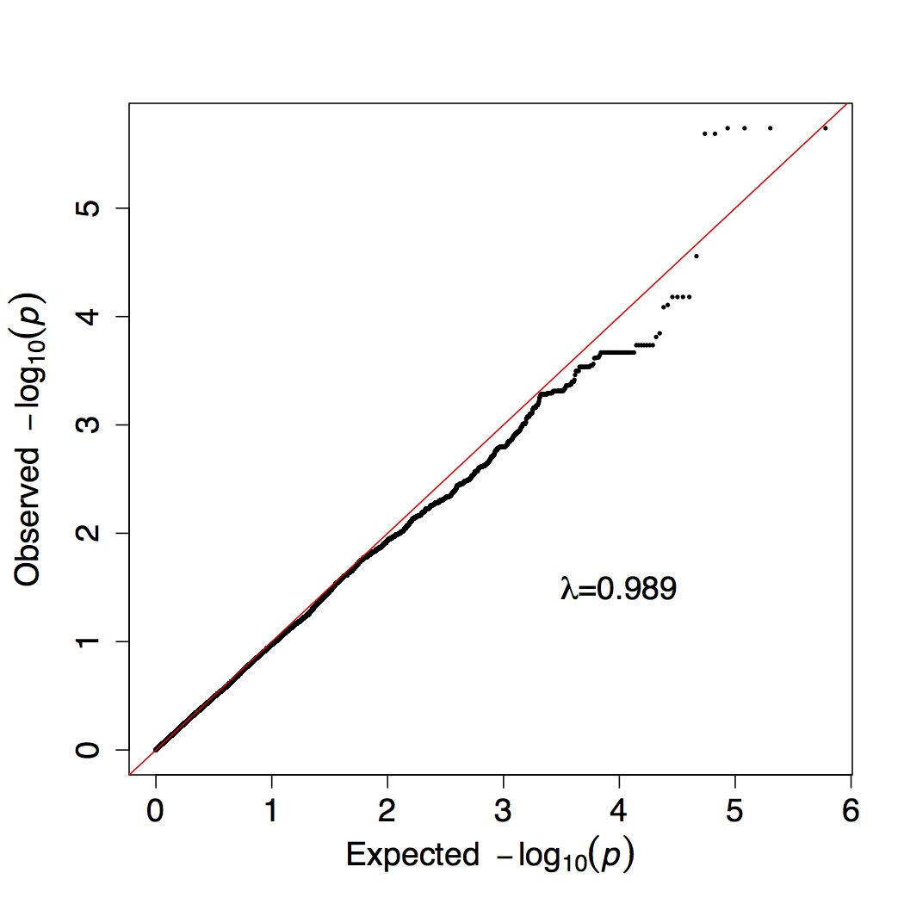

Supplementary Figure S1. Quantile-Quantile (QQ) plot for the GWAS on PTSD in the Mexican American cohort.
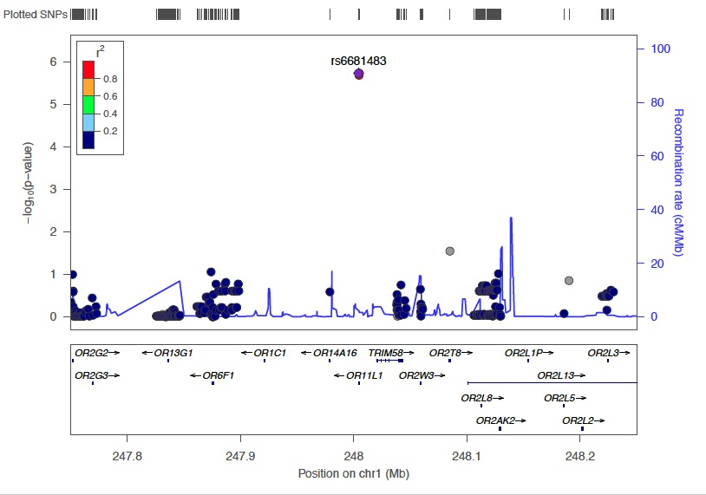

Supplementary Figure S2. Locus zoom plot of the OR11L1 region in the Mexican American sample. The plot was generated using the 1000G American (AMR) population as a reference population and the hg19 build.

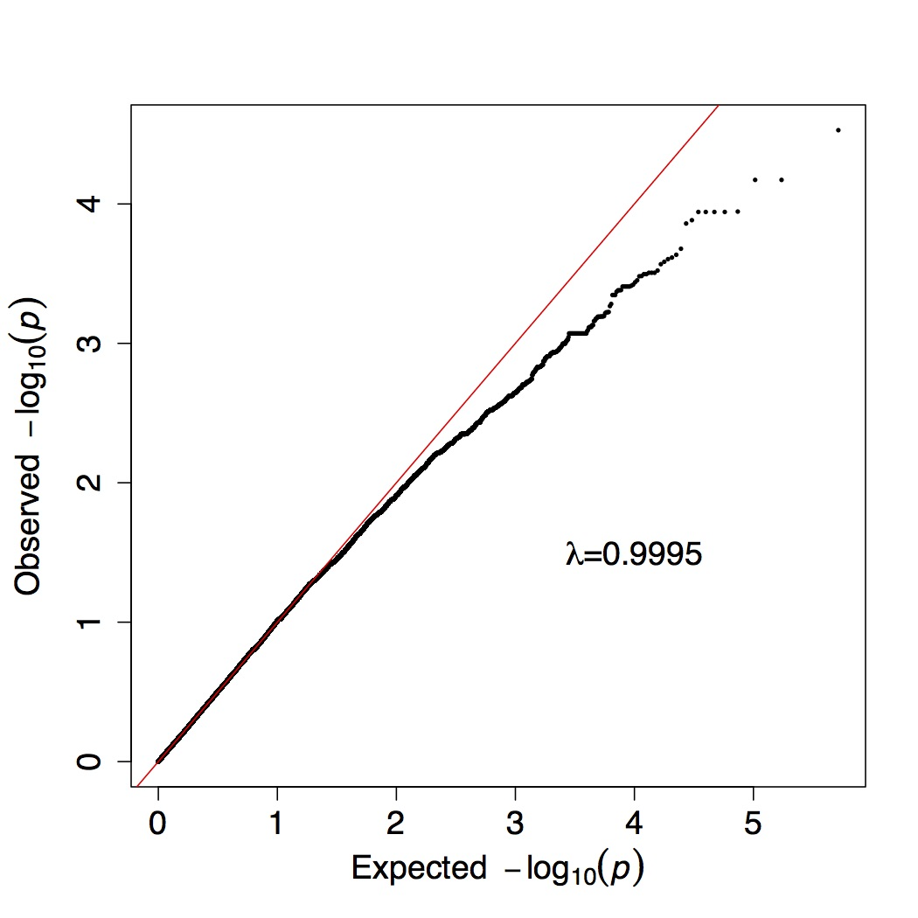

Supplementary Figure S3. QQ plot from the mixed linear model association (MLMA) in GCTA on PTSD in the American Indian sample.
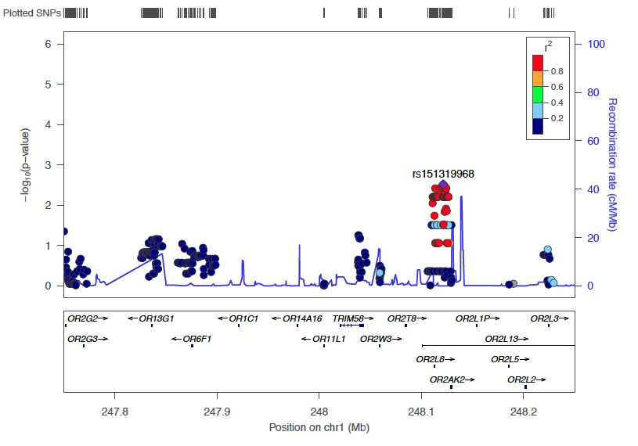

Supplementary Figure S4. Locus zoom plot of the OR11L1 region in the American Indian sample. The plot was generated using the 1000G American (AMR) population as a reference population and the hg19 build.

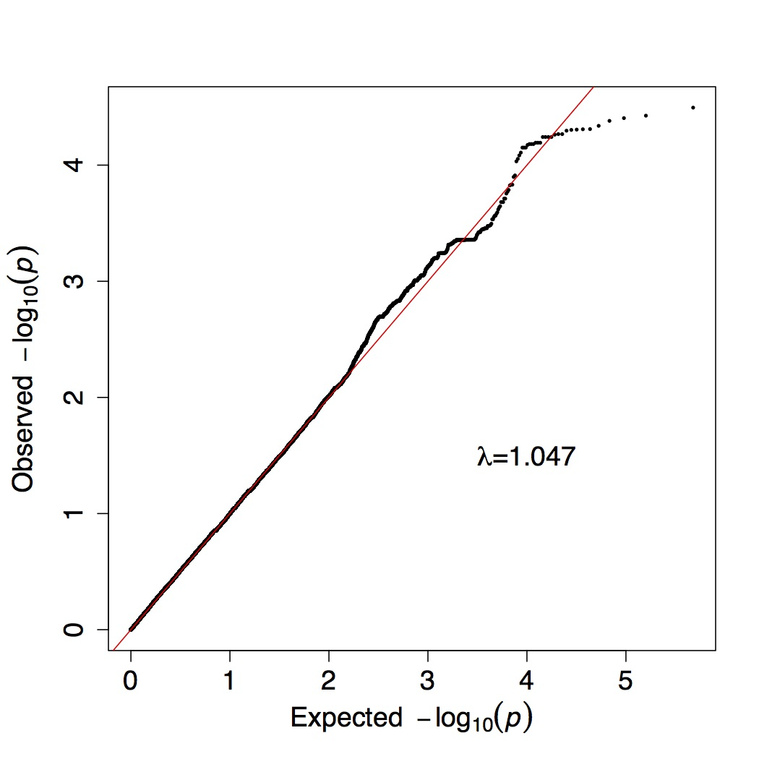

Supplementary Figure S5. QQ plot from the fixed effects meta-analysis of the Mexican American and American Indian cohorts.

