Twin Research and Human Genetics
Shared genetic factors in the co-occurrence of depression and fatigue
Elizabeth C. Corfield, Nicholas G. Martin, and Dale, R. Nyholt

Supplementary Table S1: Cross-tabulationª of depression and fatigue status within twin pairs
 |  | Non-depressed | MiDD | MDD | Total
Complete twin pairs | Non-fatigued | 784 | 61 | 14.5 | 859.5
 | Fatigued | 301.5 | 48.5 | 10.5 | 360.5
 | Total | 1085.5 | 109.5 | 25 | 1220
MZ  Total | Non-fatigued | 411 | 29.5 | 5.5 | 446
 | Fatigued | 157.5 | 31.5 | 8 | 197
 | Total | 568.5 | 61 | 13.5 | 643
MZ  female | Non-fatigued | 307.5 | 19 | 5 | 331.5
 | Fatigued | 124 | 28.5 | 7 | 159.5
 | Total | 431.5 | 47.5 | 12 | 491
MZ  male | Non-fatigued | 103.5 | 10.5 | 0.5 | 114.5
 | Fatigued | 33.5 | 3 | 1 | 37.5
 | Total | 137 | 13.5 | 1.5 | 152
DZ_{ss}  Total | Non-fatigued | 212 | 16.5 | 6 | 234.5
 | Fatigued | 90.5 | 10.5 | 0.5 | 101.5
 | Total | 302.5 | 27 | 6.5 | 336
DZ_{ss}  female | Non-fatigued | 164.5 | 15 | 4 | 183.5
 | Fatigued | 70 | 9 | 0.5 | 79.5
 | Total | 234.5 | 24 | 4.5 | 263
DZ_{ss}  male | Non-fatigued | 47.5 | 1.5 | 2 | 51
 | Fatigued | 20.5 | 1.5 | 0 | 22
 | Total | 68 | 3 | 2 | 73
DZ_{os}  female-male | Non-fatigued | 163 | 11 | 5 | 179
 | Fatigued | 54 | 7 | 1 | 62
 | Total | 217 | 18 | 6 | 241
DZ_{os}  male-female | Non-fatigued | 159 | 19 | 1 | 179
 | Fatigued | 53 | 6 | 3 | 62
 | Total | 212 | 25 | 4 | 241
ªTables were made symmetrical in same-sex twin pairs by averaging over using either twin 1 or twin 2 as proband. For example, within the complete twin pairs there was 298 twin pairs where twin 1 was fatigued and twin 2 was non-depressed and 305 twin pairs where twin 2 was fatigued and twin 1 was non-depressed. Therefore, the cross-tabulation averaging over twin 1 or twin 2 as proband is (298+305)/2=301.5.

Supplementary Table S2: Relative riskª of depression and fatigue in males and females.
Proband–co-twin | Depressed–non-fatigued | Depressed–fatigued | Fatigued–non-depressed | Fatigued–depressed
Complete cohort (n = 1220) | 0.78 (0.67-0.91) | 1.58 (1.28-1.96) | 0.92 (0.87-0.96) | 1.86 (1.36-2.56)
MZ total (n = 643) | 0.65 (0.51-0.83) | 1.91 (1.49-2.46) | 0.87 (0.80-0.94) | 2.56 (1.67-3.90)
MZ female (n = 491) | 0.57 (0.41-0.78) | 2.08 (1.61-2.68) | 0.84 (0.77-0.92) | 3.07 (1.90-4.98)
MZ male (n = 152) | 0.97 (0.71-1.34) | 1.09 (0.45-2.65) | 0.99 (0.87-1.12) | 1.11 (0.38-3.28)
DZ_{ss} total (n = 336) | 0.96 (0.75-1.23) | 1.10 (0.66-1.84) | 0.99 (0.91-1.07) | 1.13 (0.57-2.23)
DZ_{ss} female (n = 262) | 0.95 (0.72-1.25) | 1.12 (0.64-1.95) | 0.98 (0.89-1.08) | 1.15 (0.55-2.40)
DZ_{ss} male (n = 73) | 1.00 (0.55-1.82) | 1.00 (0.25-3.98) | 1.00 (0.87-1.15) | 0.99 (0.16-6.30)
DZ_{os} female-male (n=241) | 0.88 (0.67-1.16) | 1.37 (0.77-2.46) | 0.96 (0.86-1.06) | 0.96 (0.86-1.08)
DZ_{os} male-female (n=241) | 0.92 (0.71-1.19) | 1.34 (0.73-2.47) | 1.44 (0.65-3.21) | 1.30 (0.62-2.70)
ªRelative risks were calculated with respect to non-depressed or non-fatigued status in twin 1.

Supplementary Table S3: Relative riskª of depression and fatigue within monozygotic (MZ), same-sex dizygotic (DZ_{ss}), and opposite-sex dizygotic (DZ_{os}) twin pairs.
Proband–co-twin | MZ (n = 643) | DZ_{ss} (n = 336) | DZ_{os} (n = 241)  (Female-Male) | DZ_{os} (n = 241)  (Male-Female)
MiDD–non-fatigued | 0.67 (0.52-0.87) | 0.87 (0.64-1.18) | 1.01 (0.80-1.28) | 0.81 (0.56-1.19)
MiDD–fatigued | 1.86 (1.41-2.45) | 1.31 (0.79-2.16) | 0.96 (0.46-2.00) | 1.56 (0.84-2.92)
MDD–non-fatigued | 0.56 (0.30-1.07) | 1.22 (0.89-1.66) | 0.33 (0.06-1.82) | 1.11 (0.77-1.60)
MDD–fatigued | 2.14 (1.35-3.39) | 0.48 (0.08-2.98) | 3.00 (1.63-5.53) | 0.67 (0.11-4.07)
Fatigued–MiDD | 2.41 (1.51-3.86) | 1.48 (0.71-3.09) | 1.84 (0.75-4.53) | 0.91 (0.38-2.18)
Fatigued–MDD | 3.29 (1.12-9.61) | 0.39 (0.05-3.17) | 0.58 (0.07-4.85) | 8.66 (0.92-81.74)
ªRelative risks were calculated with respect to non-depressed or non-fatigued status in twin 1.

Supplementary Table S4: Polychoric correlations with their 95% confidence intervals for fatigue and depression in twin pairs according to zygosity.
Minor depression (non-depressed, MiDD)
 |  | Twin 1 |  |  |  | Twin 2
 |  | MiDD |  | Fatigue |  | MiDD |  | Fatigue
Monozygotic twin pairs (n = 643 pairs)
Twin 1 | MiDD | 1.00
 | Fatigue | 0.49 (0.35-0.64)ª |  | 1.00
Twin 2 | MiDD | 0.37 (0.17-0.56)^{b} |  | 0.32 (0.16-0.47)^{c} |  | 1.00
 | Fatigue | 0.32 (0.16-0.49)^{c} |  | 0.43 (0.31-0.54)^{b} |  | 0.42 (0.28-0.57)ª |  | 1.00
Dizygotic twin pairs (n = 577 pairs)
Twin 1 | MiDD | 1.00
 | Fatigue | 0.49 (0.34-0.64)ª |  | 1.00
Twin 2 | MiDD | 0.21 (-0.04-0.45)^{b} |  | 0.18 (-0.01-0.37)^{c} |  | 1.00
 | Fatigue | 0.03 (-0.17-0.22)^{c} |  | 0.14 (0.001-0.28)^{b} |  | 0.54 (0.40-0.69)ª |  | 1.00
Major depression (non-depressed, MDD)
 |  | Twin 1 |  |  |  | Twin 2
 |  | MDD |  | Fatigue |  | MDD |  | Fatigue
Monozygotic twin pairs (n = 643 pairs)
Twin 1 | MDD | 1.00
 | Fatigue | 0.36 (0.12-0.59)ª |  | 1.00
Twin 2 | MDD | 0.46 (-0.01-0.93)^{b} |  | 0.43 (0.15-0.70)^{c} |  | 1.00
 | Fatigue | 0.28 (0.03-0.52)^{c} |  | 0.43 (0.31-0.54)^{b} |  | -ª |  | 1.00
Dizygotic twin pairs (n = 577 pairs)
Twin 1 | MDD | 1.00
 | Fatigue | 0.47 (0.20-0.74)ª | 1.00
Twin 2 | MDD | -^{b} | -0.32 (-0.67-0.02)^{c} |  | 1.00
 | Fatigue | 0.14 (-0.18-0.46)^{c} | 0.14 (0.001-0.28)^{b} |  | 0.56 (0.33-0.79)ª |  | 1.00
Three-category depression (non-depressed, MiDD, MDD)
 |  | Twin 1 |  |  |  | Twin 2
 |  | Depression |  | Fatigue |  | Depression |  | Fatigue
Monozygotic twin pairs (n = 643 pairs)
Twin 1 | Depression | 1.00
 | Fatigue | 0.46 (0.33-0.59)ª |  | 1.00
Twin 2 | Depression | 0.48 (0.33-0.62)^{b} |  | 0.36 (0.22-0.50)^{c} |  | 1.00
 | Fatigue | 0.32 (0.18-0.47)^{c} |  | 0.43 (0.31-0.54)^{b} |  | 0.51 (0.39-0.64)ª |  | 1.00
Dizygotic twin pairs (n = 577 pairs)
Twin 1 | Depression | 1.00
 | Fatigue | 0.50 (0.36-0.64)ª |  | 1.00
Twin 2 | Depression | 0.24 (0.04-0.43)^{b} |  | 0.05 (-0.13-0.23)^{c} |  | 1.00
 | Fatigue | 0.06 (-0.12-0.24)^{c} |  | 0.14 (0.001-0.28)^{b} |  | 0.57 (0.45-0.70)ª |  | 1.00
ªPhenotypic correlation between depression and fatigue. ^{b}Twin correlation. ^{c}Cross-twin cross-trait correlation

Supplementary Table S5: Bivariate heritability model fits
Model | Minus 2 log likelihood | χ² | Δ df | P-value | AIC
MiDD
ACE | 4228.32 |  |  |  | -5401.68
AE | 4228.71 | 0.39 | 3 | 0.94 | -5407.29
CE | 4239.54 | 11.21 | 3 | 0.01 | -5396.46
E | 4295.28 | 66.96 | 6 | 1.71 × 10⁻¹² | -5346.72
ADE | 4227.72 | -0.61 | 0 | 1.00 | -5402.28
MDD
ACE | 3330.32 |  |  |  | -5961.68
AE | 3330.62 | 0.30 | 3 | 0.96 | -5967.38
CE | 3342.63 | 12.32 | 3 | 0.01 | -5955.37
E | 3381.46 | 51.14 | 6 | 2.78 × 10⁻⁹ | -5922.50
ADE | 3327.68 | -2.64 | 0 | 1.00 | -5964.33
Three-category depression
ACE | 4647.74 |  |  |  | -5080.26
AE | 4649.28 | 1.54 | 3 | 0.67 | -5084.72
CE | 4661.68 | 13.94 | 3 | 3.00 × 10⁻³ | -5072.32
E | 4724.88 | 77.14 | 6 | 1.39 × 10⁻¹⁴ | -5015.12
ADE | 4647.42 | -0.32 | 0 | 1.00 | -5080.58
Note: Fit statistics are compared to ACE model and best fitting models are indicated in bold.
χ²: likelihood-ratio chi-squared test; Δ df: difference in degrees of freedom.

Supplementary Table S6: co-twin control of minor depression and fatigue [nª].
Sample | Risk factor: MiDD  Outcome: fatigue | Risk factor: fatigue  Outcome: MiDD
General Population | 7.39 (4.33-12.61) [1,247] | 7.39 (4.33-12.61) [1,247]
Discordant DZ | 5.75 (2.89-11.48) [78] | 5.47 (2.58-11.59) [201]
Discordant MZ | 1.77 (0.96-3.25) [85] | 1.83 (0.97-3.46) [192]
MiDD: Minor depressive disorder. ªWithin the General Population sample n is is the number of individuals, while within the Discordant MZ and DZ samples n is the number of discordant twin pairs.
Supplementary Table S7: Cross-tabulationª of depression and fatigue status within twin pairs independent of overlapping symptoms
 |  | Non-depressed | MiDD | MDD | Total
MZ  Total | Non-fatigued | 264.5 | 4.5 | 0 | 269
 | Fatigued | 34 | 2 | 0 | 36
 | Total | 298.5 | 6.5 | 0 | 305
DZ_{ss}  Total | Non-fatigued | 126.5 | 2.5 | 0 | 129
 | Fatigued | 24 | 1 | 0 | 25
 | Total | 150.5 | 3.5 | 0 | 154
DZ_{os}  female-male | Non-fatigued | 90 | 2 | 0 | 92
 | Fatigued | 10 | 1 | 0 | 11
 | Total | 100 | 3 | 0 | 103
DZ_{os}  male-female | Non-fatigued | 84 | 4 | 0 | 88
 | Fatigued | 15 | 0 | 0 | 15
 | Total | 99 | 4 | 0 | 103
ªTables were made symmetrical in same-sex twin pairs by averaging over using either twin 1 or twin 2 as proband.

Supplementary Table S8: Relative riskª of depression and fatigue estimated independently of overlapping symptoms within monozygotic (MZ), same-sex dizygotic (DZ_{ss}), and opposite-sex dizygotic (DZ_{os}) twin pairs.
Proband - co-twin | MZ (n = 319) | DZ_{ss} (n = 160) | DZ_{os} (n = 119)  (Female-Male) | DZ_{os} (n = 119)  (Male-Female)
Depressed -non-fatigued | 0.78 (0.47-1.31) | 0.85 (0.44-1.65) | 1.18 (1.08-1.28) | 0.74 (0.33-1.65)
Depressed - fatigued | 2.70 (0.82-8.93) | 1.79 (0.33-9.77) | 0 | 3.33 (0.61-18.34)
Fatigued - non-depressed | 0.96 (0.89-1.04) | 0.98 (0.90-1.06) | 0.93 (0.41-42.45) | 1.05 (1.00-1.10)
Fatigued - depressed | 3.32 (0.65-16.93) | 2.06 (0.21-20.16) | 4.18 (0.41-42.45) | 0
ªRelative risks were calculated with respect to non-depressed or non-fatigued status in twin 1.

Supplementary Table S9: Polychoric correlations with their 95% confidence intervals for fatigue and depression independent of overlapping symptoms in twin pairs according to zygosity.
 |  | Twin 1 |  | Twin 2
 |  | MiDD | Fatigue | MiDD | Fatigue
Monozygotic twin pairs (n = 643 pairs)
Twin 1 | MiDD | 1.00
 | Fatigue | 0.38 (0.01-0.74)ª | 1.00
Twin 2 | MiDD | -^{b} | 0.37 (-0.05-0.80)^{c} | 1.00
 | Fatigue | 0.23 (-0.18-0.65)^{c} | 0.20 (-0.07-0.48)^{b} | -0.77 (-1.00-1.00)ª | 1.00
Dizygotic twin pairs (n = 577 pairs)
Twin 1 | MiDD | 1.00
 | Fatigue | 0.50 (0.19-0.80)ª | 1.00
Twin 2 | MiDD | -^{b} | 0.16 (-0.38-0.71)^{c} | 1.00
 | Fatigue | 0.08 (-0.33-0.49)^{c} | 0.10 (-0.18-0.38)^{b} | 0.40 (-0.04-0.85)ª | 1.00
ªPhenotypic correlation between depression and fatigue. ^{b}Twin correlation. ^{c}Cross-twin cross-trait correlation.

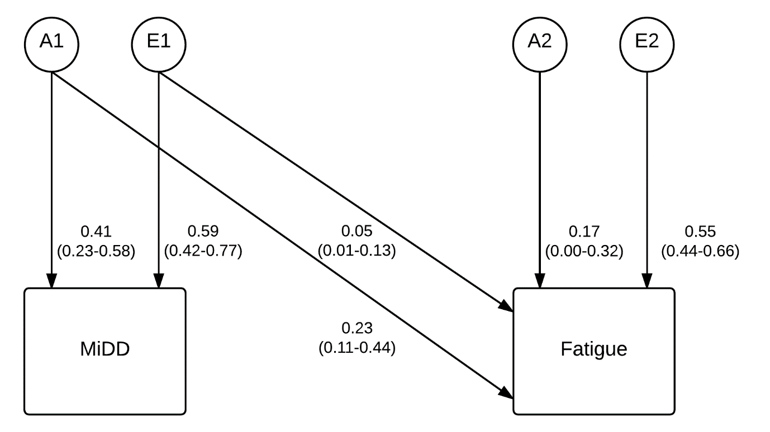
Figure S1: Path diagram of the bivariate Cholesky model variance estimates (with their 95% confidence intervals) for minor depressive disorder (MiDD) and fatigue. The observed traits are shown in the rectangles. Similarly, the latent variables (additive genetic factors: A, and unique environmental factors: E) are depicted by circles. The arrows depict the relationship between the variables. The genetic and environmental correlations between MiDD and fatigue were 0.76 (0.52-1.00) and 0.29 (0.11-0.46), respectively.

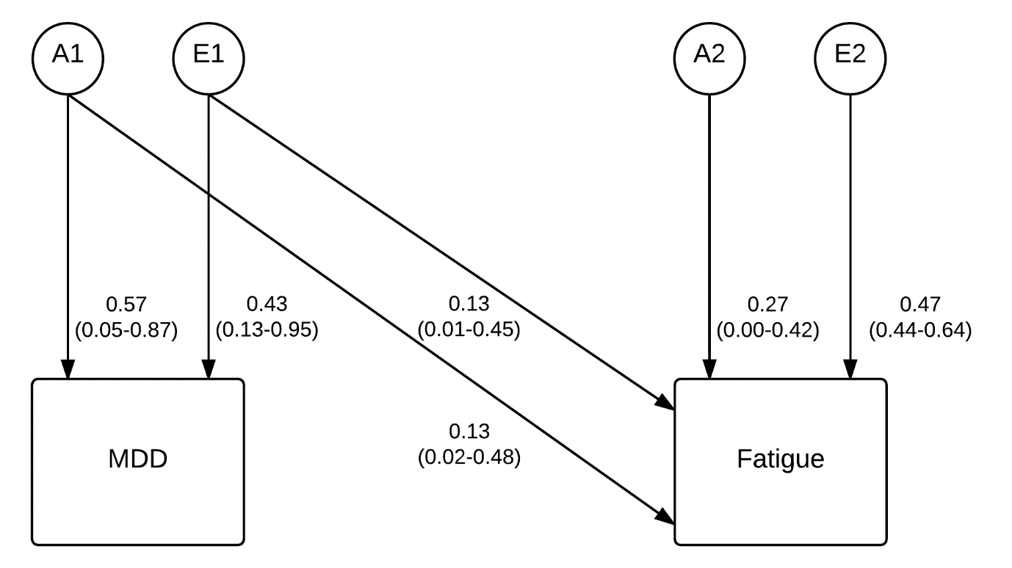
Figure S2: Path diagram of the bivariate Cholesky model variance estimates (with their 95% confidence intervals) for major depressive disorder (MDD) and fatigue. The observed traits are shown in the rectangles. Similarly, the latent variables (additive genetic factors: A, and unique environmental factors: E) are depicted by circles. The arrows depict the relationship between the variables. The genetic and environmental correlations between MDD and fatigue were 0.57 (0.21-1.00) and 0.46 (0.09-0.52), respectively.

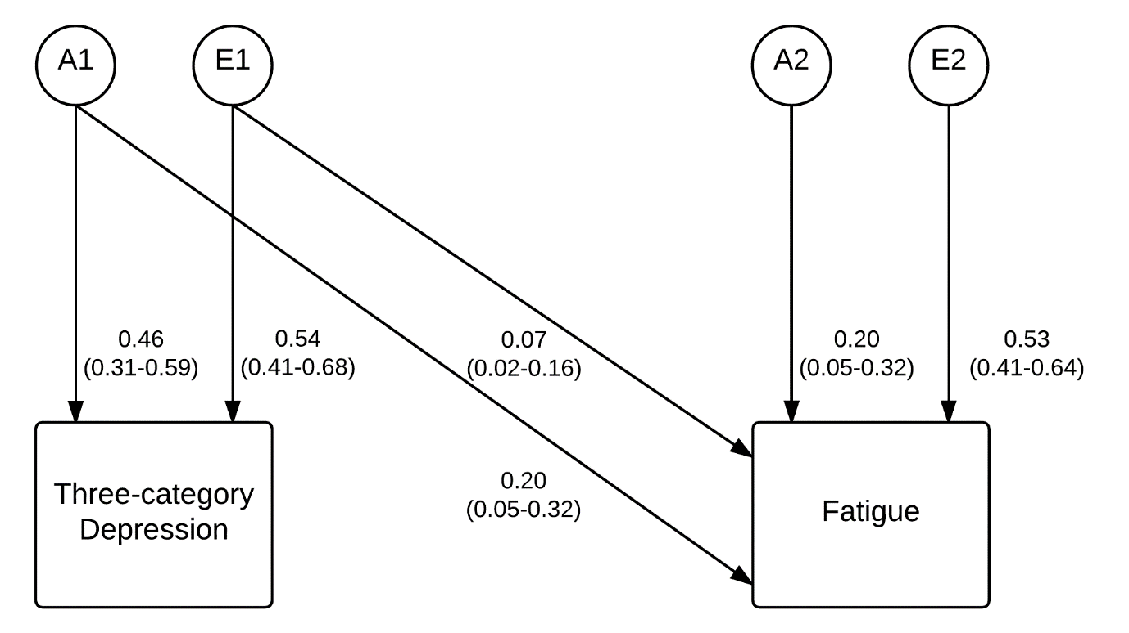
Figure S3: Path diagram of the bivariate Cholesky model variance estimates (with their 95% confidence intervals) for three-category depression (non-depressed, MiDD, MDD) and fatigue. The observed traits are shown in the rectangles. Similarly, the latent variables (additive genetic factors: A, and unique environmental factors: E) are depicted by circles. The arrows depict the relationship between the variables. The genetic and environmental correlations between MiDD and fatigue were 0.71 (0.51-0.93) and 0.35 (0.18-0.51), respectively.

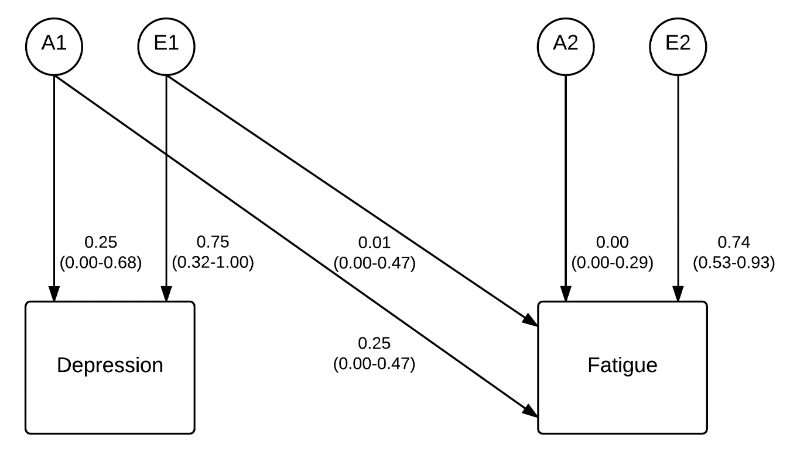
Figure S4: Path diagram of the bivariate Cholesky model variance estimates (with their 95% confidence intervals) for depression and fatigue independent of their overlapping symptomology. The observed traits are shown in the rectangles. Similarly, the latent variables (additive genetic factors: A, and unique environmental factors: E) are depicted by circles. The arrows depict the relationship between the variables. The genetic and environmental correlations between MiDD and fatigue were 1.00 (0.43-1.00) and 0.11 (0.00-0.43), respectively.

