Twin Research and Human Genetics

Whole-Exome Sequencing in Nine Monozygotic Discordant Twins
Rong Zhang, Holger Thiele, Peter Bartmann, Alina C. Hilger, Christoph Berg, Ulrike Herberg, Dietrich Klingmüller, Peter Nürnberg, Michael Ludwig, and Heiko Reutter

Twin pair 02, TDRD6, p.E1185D
Affected twin
Healthy
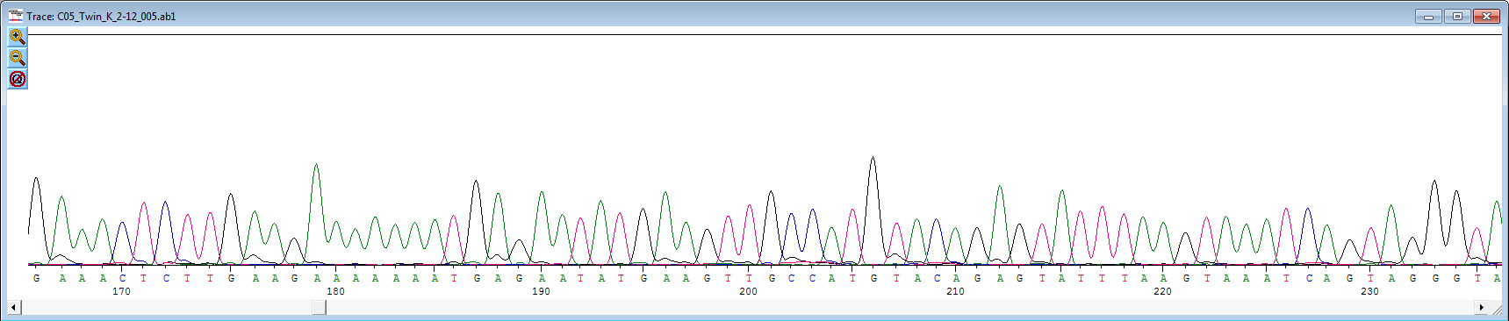
Sanger sequencing shows absence of the T-to-G transversion

Twin pair 02, FAM84B, p.P298T
Affected
Healthy
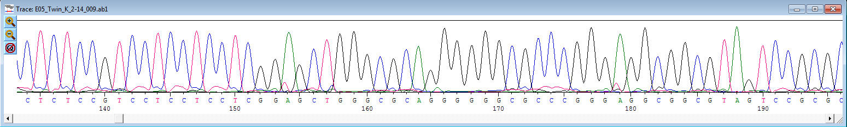
Sanger sequencing shows absence of the G-to-T transversion

