Twin Research and Human Genetics
Epigenome-Wide Association Study of Wellbeing
Bart M.L. Baselmans^{1,2}, Jenny van Dongen^{1,2}, Michel G. Nivard¹, Bochao D. Lin¹, BIOS consortium⁴, Nuno R. Zilhão¹, Dorret I. Boomsma^{1,2,3}, Meike Bartels^{1,2,3},
¹ Department of Biological Psychology, VU University, Amsterdam, Van der Boechorststraat 1
1081BT, Amsterdam, The Netherlands
² EMGO institute for Health and Care Research, VU University Medical Center, Amsterdam, The Netherlands
³ Neuroscience Campus Amsterdam, Amsterdam, the Netherlands
⁴ The Biobank-based Integrative Omics Study (BIOS) Consortium. A full list of authors is provided below.

BIOS Consortium
(Biobank-based Integrative Omics Study)
Management Team Bastiaan T. Heijmans (chair)¹, Peter A.C. ’t Hoen², Joyce van Meurs³, Aaron Isaacs⁴, Rick Jansen⁵, Lude Franke⁶.
Cohort collection Dorret I. Boomsma⁷, René Pool⁷, Jenny van Dongen⁷, Jouke J. Hottenga⁷ (Netherlands Twin Register); Marleen MJ van Greevenbroek⁸, Coen D.A. Stehouwer⁸, Carla J.H. van der Kallen⁸, Casper G. Schalkwijk⁸ (Cohort study on Diabetes and Atherosclerosis Maastricht); Cisca Wijmenga⁶, Lude Franke⁶, Sasha Zhernakova⁶, Ettje F. Tigchelaar⁶ (LifeLines Deep); P. Eline Slagboom¹, Marian Beekman¹, Joris Deelen¹, Diana van Heemst⁹ (Leiden Longevity Study); Jan H. Veldink¹⁰, Leonard H. van den Berg¹⁰ (Prospective ALS Study Netherlands); Cornelia M. van Duijn⁴, Bert A. Hofman¹¹, Aaron Isaacs⁴, André G. Uitterlinden³ (Rotterdam Study).
Data Generation Joyce van Meurs (Chair)³, P. Mila Jhamai³, Michael Verbiest³, H. Eka D. Suchiman¹, Marijn Verkerk³, Ruud van der Breggen¹, Jeroen van Rooij³, Nico Lakenberg¹.
Data management and computational infrastructure Hailiang Mei (Chair)¹², Maarten van Iterson¹, Michiel van Galen², Jan Bot¹³, Dasha V. Zhernakova⁶, Rick Jansen⁵, Peter van ’t Hof¹², Patrick Deelen⁶, Irene Nooren¹³, Peter A.C. ’t Hoen², Bastiaan T. Heijmans¹, Matthijs Moed¹.
Data Analysis Group Lude Franke (Co-Chair)⁶, Martijn Vermaat², Dasha V. Zhernakova⁶, René Luijk¹, Marc Jan Bonder⁶, Maarten van Iterson¹, Patrick Deelen⁶, Freerk van Dijk¹⁴, Michiel van Galen², Wibowo Arindrarto¹², Szymon M. Kielbasa¹⁵, Morris A. Swertz¹⁴, Erik. W van Zwet¹⁵, Rick Jansen⁵, Peter-Bram ’t Hoen (Co-Chair)², Bastiaan T. Heijmans (Co-Chair)¹.
1. Molecular Epidemiology Section, Department of Medical Statistics and Bioinformatics, Leiden University Medical Center, Leiden, The Netherlands
2. Department of Human Genetics, Leiden University Medical Center, Leiden, The Netherlands
3. Department of Internal Medicine, ErasmusMC, Rotterdam, The Netherlands
4. Department of Genetic Epidemiology, ErasmusMC, Rotterdam, The Netherlands
5. Department of Psychiatry, VU University Medical Center, Neuroscience Campus Amsterdam, Amsterdam, The Netherlands
6. Department of Genetics, University of Groningen, University Medical Centre Groningen, Groningen, The Netherlands
7. Department of Biological Psychology, VU University Amsterdam, Neuroscience Campus Amsterdam, Amsterdam, The Netherlands
8. Department of Internal Medicine and School for Cardiovascular Diseases (CARIM), Maastricht University Medical Center, Maastricht, The Netherlands
9. Department of Gerontology and Geriatrics, Leiden University Medical Center, Leiden, The Netherlands
10. Department of Neurology, Brain Center Rudolf Magnus, University Medical Center Utrecht, Utrecht, The Netherlands
11. Department of Epidemiology, ErasmusMC, Rotterdam, The Netherlands
12. Sequence Analysis Support Core, Leiden University Medical Center, Leiden, The Netherlands
13. SURFsara, Amsterdam, the Netherlands
14. Genomics Coordination Center, University Medical Center Groningen, University of Groningen, Groningen, the Netherlands
15. Medical Statistics Section, Department of Medical Statistics and Bioinformatics, Leiden University Medical Center, Leiden, The Netherlands

Supplementary Figures and Tables
Supplementary Figure S1: Heatmap correlations between PCs and the covariates.
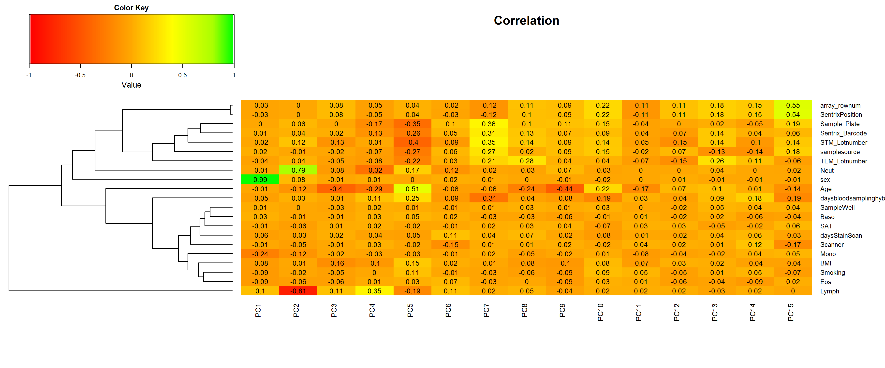
Supplementary Figure S2: Distribution of wellbeing scores used in this EWAS.
