Twin Research and Human Genetics
Supplementary material
Epigenome-wide association study of aggressive behavior
Jenny van Dongen^{1,2}, Michel G. Nivard¹, Bart Baselmans¹, Nuno R. Zilhão¹, Lannie Ligthart¹,
BIOS consortium³, Bastiaan T. Heijmans⁴, Meike Bartels^{1,2}, Dorret I. Boomsma^{1,2}
¹ Department of Biological Psychology, VU University, Amsterdam, Van der Boechorststraat 1
1081BT, Amsterdam, The Netherlands
² EMGO institute for Health and Care Research, VU University Medical Center, Amsterdam, The Netherlands
³ The Biobank-based Integrative Omics Study (BIOS) Consortium. A full list of authors is provided on the next page.
⁴ Department of Molecular Epidemiology, Leiden University Medical Center, Postal zone S-05-P, PO Box 9600, 2300 RC Leiden, The Netherlands

BIOS Consortium
(Biobank-based Integrative Omics Study)
Management Team Bastiaan T. Heijmans (chair)¹, Peter A.C. ’t Hoen², Joyce van Meurs³, Aaron Isaacs⁴, Rick Jansen⁵, Lude Franke⁶.
Cohort collection Dorret I. Boomsma⁷, René Pool⁷, Jenny van Dongen⁷, Jouke J. Hottenga⁷ (Netherlands Twin Register); Marleen MJ van Greevenbroek⁸, Coen D.A. Stehouwer⁸, Carla J.H. van der Kallen⁸, Casper G. Schalkwijk⁸ (Cohort study on Diabetes and Atherosclerosis Maastricht); Cisca Wijmenga⁶, Lude Franke⁶, Sasha Zhernakova⁶, Ettje F. Tigchelaar⁶ (LifeLines Deep); P. Eline Slagboom¹, Marian Beekman¹, Joris Deelen¹, Diana van Heemst⁹ (Leiden Longevity Study); Jan H. Veldink¹⁰, Leonard H. van den Berg¹⁰ (Prospective ALS Study Netherlands); Cornelia M. van Duijn⁴, Bert A. Hofman¹¹, Aaron Isaacs⁴, André G. Uitterlinden³ (Rotterdam Study).
Data Generation Joyce van Meurs (Chair)³, P. Mila Jhamai³, Michael Verbiest³, H. Eka D. Suchiman¹, Marijn Verkerk³, Ruud van der Breggen¹, Jeroen van Rooij³, Nico Lakenberg¹.
Data management and computational infrastructure Hailiang Mei (Chair)¹², Maarten van Iterson¹, Michiel van Galen², Jan Bot¹³, Dasha V. Zhernakova⁶, Rick Jansen⁵, Peter van ’t Hof¹², Patrick Deelen⁶, Irene Nooren¹³, Peter A.C. ’t Hoen², Bastiaan T. Heijmans¹, Matthijs Moed¹.
Data Analysis Group Lude Franke (Co-Chair)⁶, Martijn Vermaat², Dasha V. Zhernakova⁶, René Luijk¹, Marc Jan Bonder⁶, Maarten van Iterson¹, Patrick Deelen⁶, Freerk van Dijk¹⁴, Michiel van Galen², Wibowo Arindrarto¹², Szymon M. Kielbasa¹⁵, Morris A. Swertz¹⁴, Erik. W van Zwet¹⁵, Rick Jansen⁵, Peter-Bram ’t Hoen (Co-Chair)², Bastiaan T. Heijmans (Co-Chair)¹.
1. Molecular Epidemiology Section, Department of Medical Statistics and Bioinformatics, Leiden University Medical Center, Leiden, The Netherlands
2. Department of Human Genetics, Leiden University Medical Center, Leiden, The Netherlands
3. Department of Internal Medicine, ErasmusMC, Rotterdam, The Netherlands
4. Department of Genetic Epidemiology, ErasmusMC, Rotterdam, The Netherlands
5. Department of Psychiatry, VU University Medical Center, Neuroscience Campus Amsterdam, Amsterdam, The Netherlands
6. Department of Genetics, University of Groningen, University Medical Centre Groningen, Groningen, The Netherlands
7. Department of Biological Psychology, VU University Amsterdam, Neuroscience Campus Amsterdam, Amsterdam, The Netherlands
8. Department of Internal Medicine and School for Cardiovascular Diseases (CARIM), Maastricht University Medical Center, Maastricht, The Netherlands
9. Department of Gerontology and Geriatrics, Leiden University Medical Center, Leiden, The Netherlands
10. Department of Neurology, Brain Center Rudolf Magnus, University Medical Center Utrecht, Utrecht, The Netherlands
11. Department of Epidemiology, ErasmusMC, Rotterdam, The Netherlands
12. Sequence Analysis Support Core, Leiden University Medical Center, Leiden, The Netherlands
13. SURFsara, Amsterdam, the Netherlands
14. Genomics Coordination Center, University Medical Center Groningen, University of Groningen, Groningen, the Netherlands
15. Medical Statistics Section, Department of Medical Statistics and Bioinformatics, Leiden University Medical Center, Leiden, The Netherlands

Supplementary Figures and Tables
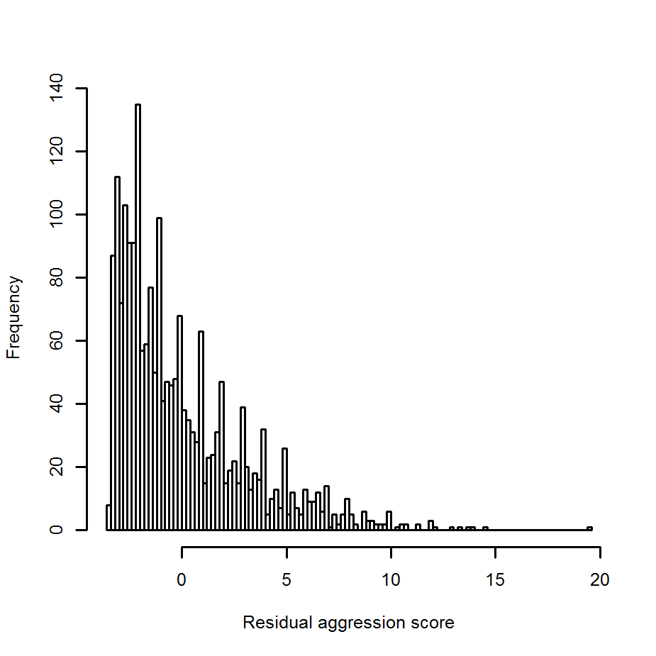
Supplementary Figure S1: Distribution of aggression scores in the EWAS.
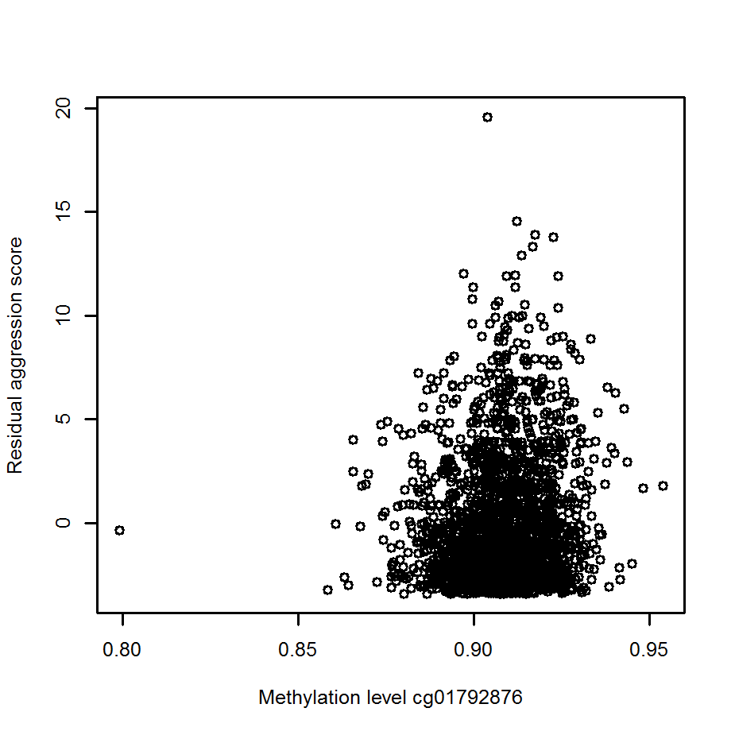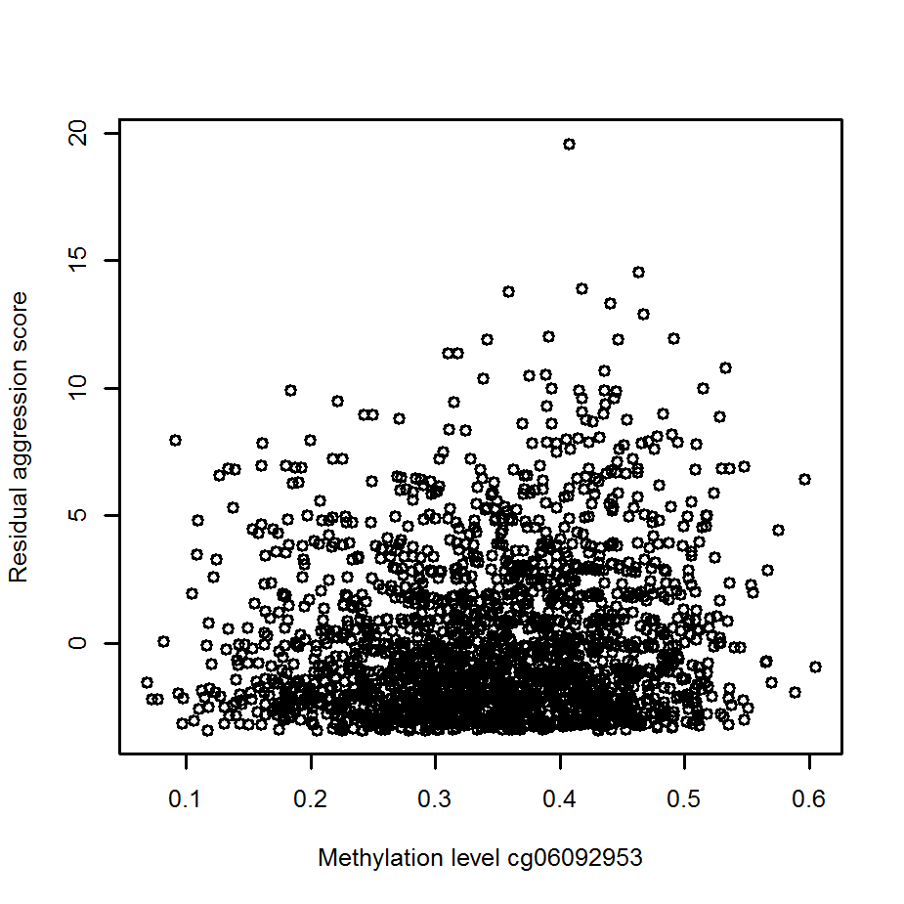
Supplementary Figure S2: Scatterplots for the two top CpGs. Residual aggression scores are plotted against methylation level.
Supplementary Table S1: Sex and Age and Effects on Aggression
 | N | Intercept | Beta age (standardized beta)^{A} | Robust SE age | P value age | Beta sex (standardized beta)^{B} | Robust SE sex | p value sex
Survey 8 | 14,173 | 3.49 | -0.03 (0.01 SD) | 0.0017 | 4.19E⁻⁸¹ | 0.48 (0.15 SD) | 0.05 | 9.60E⁻¹⁹
Survey 10 | 15,535 | 3.26 | -0.03 (0.01 SD) | 0.0017 | 2.37E⁻⁷² | 0.46 (0.15 SD) | 0.05 | 2.26E⁻²⁰
Note: Estimates from a generalized estimation equation (GEE) model with ASR aggression score as outcome and age and sex as predictors. ^{A}Change in aggression score associated with a one year increase of age. The value between brackets (standardized beta) represents the effect expressed relative to the standard deviation of aggression score in the entire study sample. ^{B}Difference in aggression scores between the sexes (women minus men). The value between brackets (standardized beta) represents the effect expressed relative to the standard deviation of aggression score in the entire study sample.

 | B | jack SE | jack T | jack P
(Intercept) | 1.020733 | 0.012342 | 82.70206 | 0
Mean methylation level | -0.03733 | 0.010074 | -3.70617 | 0.00021
SD methylation level | 0.546277 | 0.207655 | 2.6307 | 0.008521
Downstream region | 0.009512 | 0.01956 | 0.486281 | 0.626768
Gene body | 0.01138 | 0.007546 | 1.507976 | 0.131561
Proximal promotor | 0.040094 | 0.008323 | 4.817295 | 1.46E-06
Distal promotor | 0.006778 | 0.0132 | 0.513502 | 0.6076
CpG island (CGI) | 0.004634 | 0.007114 | 0.651411 | 0.514781
CGI shelf | -0.00259 | 0.008718 | -0.29693 | 0.766517
CGI shore | -0.0047 | 0.006976 | -0.67422 | 0.500168
DNase I hypersensitive site | 0.023931 | 0.005261 | 4.548676 | 5.40E-06
Aggression loci | 0.036608 | 0.067437 | 0.542851 | 0.587232
Supplementary Table S2: Jackknife Estimates for the Regression of EWAS Test Statistics on Genomic Annotation Categories

